UBUNTU & CENTOS SERVER ADMINISTRATION

This is the keyword-rich, attention-grabbing subtitle

MD. TANVIR RAHMAN

To my niece Safiyah Nawar and Nujaira Zaynab

UBUNTU & CENTOS SERVER ADMINISTRATION
Copyright © 2019 by MD. Tanvir Rahman.

For information contact :
(Address, website)
http://www.tanvirrahman.ml

First Edition: December 2019

CONTENTS
UBUNTU & CENTOS SERVER ADMINISTRATION i
INTRODUCTION 1
VMware Installation 11
Ubuntu Server Installation 14
CENTOS Server Installation 20
5 could be a subtitle 28
ABOUT THE AUTHOR 35
Acknowledgments 36

INTRODUCTION
subtitle
An operating system is a software that runs on our computer. Handling all the instructions between a user and the Computer hardware .But the operating system is not just one software it also consists of a lot of other smaller program that runs on this operating system to that helps users to do their work. we run this smaller program on top of this operating system to do everything.
Liunx is just another operating system. Its a rock solid operating system. Linux work both as a server and Desktop operating system.
Linux operating system is great for a lot of reason . thease are the following

* Multi user OS: Linux is a multi user operating system. That means more than one user can work on a system at the same name
* Multi tasking OS: Linux is a multi taking operating system you can run multiple program at once .this allows the operating system to run several process all at once.
* Multi Platform OS: Linux can run currently more that 24 types of platform and 64-bit Intel based personal computer .All variants of Apple mac,Sun Spark and ipod ,even the Microsoft xbox.

* Interoprable OS: Linux can operate with most network protocols and also most Language it can easily interact with Windows OS,NOVEL,UNIX and other operating system that has a smaller market

* Scalabel OS: Linux operating system has support for even Raspberry pi which is a credit card size computer to Very powerful Server. Most of the server of the world is running Linux OS. They have also run in low power computer

* Portable OS: Linux is portable operating system. Linux is mostly written in C programming language .C is a language that is specially for writing operating system level software. And it can be ported to run on a new computer.
* Flexible OS: Linux operating system can be used to make a router,graphical workstation,home entertainment computer,file server,web server,mail server,cluster, just any computing purpose.
* Stable: Linux kernel is very mature. For being stable it is used for most of the server in the world.

* Efficient: The design of the Linux enables you to include on only the thing you needed thats why it can run on both raspberry pi to a big server.

* Free : Linux is a Free operating system.

GNU PROJECT
GNU Stands for (GNU is NOT UNIX). To make a free clone of the UNIX OS GNU project started 1984.To maintain the free software FSF(Free Software Foundation) is created. It Creates the GNU C compiler ,EMACS Text editor and many other software.
The GNU General Public License (GPL) is a very creative license that used to copyright to protected the freedom of the software user. When a software is licensed under the GPL recipients are bound by the copyright to respect freedom of anyone to use and share the software and also change the source code if necessary.

HISTORY OF LINUX
Linux is a clone of the UNIX based operating system. Unix is created at BEL LABS for AT&T corporation. To make a free clone of the unix Linus Trovalds created a minix .he wrote the kernel which is the heart of the linux .After that a lot of developer helped him to add more feature and functionality .and at that time the GNU Project was making free software for the computer and to make an OS they need a functional kernel which can communicate with the hardware .They took the linux kernel and add the GNU software on top of the kernel and made the GNU/LINUX Operating system.
Linux Trovalds is still considered as the dictator of the Linux kernel. He ultimately determines which feature will be added in the linux kernel and what features are not.

Packaging Linux:Distribution
A complete linux system is called distribution. A linux distribution contains the Linux kernel and the GNU project Tools and any number of software that can make the OS diverse functionality.
There are a lot of distribution on linux .Some of them specifically for servers and some of them are Desktop. Every customized distribution includes software packages for different users.
A single linux distribution often appears in different version .For example CENTOS distribution comes with a full core distribution and a LIVE CD version.
Ubuntu is based on Debian Distribution And Centos is community version of the Commercial RED HAT linux distribution.

Core Linux Distribution
Core linux distribution contains the Linux Kernel and GNU operating system one or more DE(Desktop Environment) and application that is available ready to install and run. The core linux Distribution are the compete linux distribution. These are the popular distribution

* Red Hat linux
* Fedora Core
* Centos Linux
* SUSE linux
* Ubuntu Linux
* Gentoo Linux
* Debian Linux
* Slackware Linux
* Mandriva Linux
* Turbo Linux
* Puppy Linux
we use the UBUNTU linux and the CENTOS linux to illustrate how the servers work.

PRINCIPLE OF LINUX

* Everything works as a file , even the system hardware
* Small work is done by the individual program
* Any complected work will be divided into smaller part and then process this by different different module.
* All the configuration will be stored in a text file
* linux OS use a standard hierarchical file structure in which the files/user files are arranged

***

UBUNTU SERVER

Ubuntu is built on the Debian architecture and comprised linux server and Dsktop. Ubuntu release updates every six months Ubuntu packages are based on packages from Debians unstable branch. Ubuntu is currently funded by the Canonical LTD.And GENOME 3 is the default GUI interface for the ubuntu from 17.10 version. We are goinf to use Ubuntu Server 18.04.3 LTS for our work.you can download the latest long term varsion of ubuntu server in this URL
https://ubuntu.com/download/server

CENTOS SERVER

Ubuntu is built on the Debian architecture and comprised linux server and Dsktop. Ubuntu release updates every six months Ubuntu packages are based on packages from Debians unstable branch. Ubuntu is currently funded by the Canonical LTD.And GENOME 3 is the default GUI interface for the ubuntu from 17.10 version. We are goinf to use Ubuntu Server 18.04.3 LTS for our work.you can download the latest long term varsion of ubuntu server in this URL
https://ubuntu.com/download/server

VMware Installation

Step 1:
install the required build packages
=> sudo apt install build-essential

Step 2:
Download VMware workstation player from the
website.

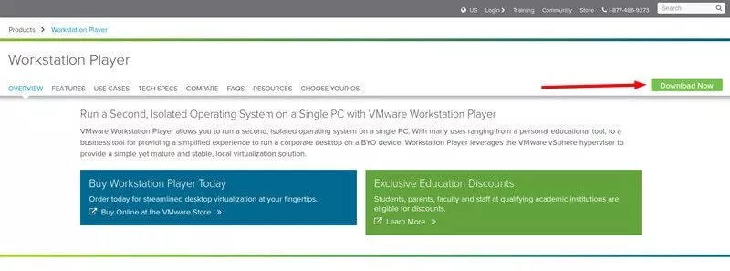

Step 3:
go to the installed directory make the file executable
=> chmod 777 Vmware-Player*
[we will talk about the chmod 777 later for now just use it]

Step 4:
execute the program with sudo
=>sudo ./Vmware-Player*

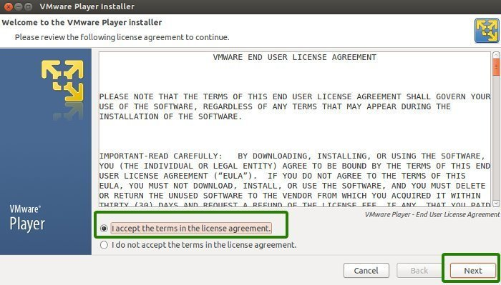

[no license key is required .If you want to install vmware workstation instead of vmware player you need to have the license key]

after a successful installation screen will show to you

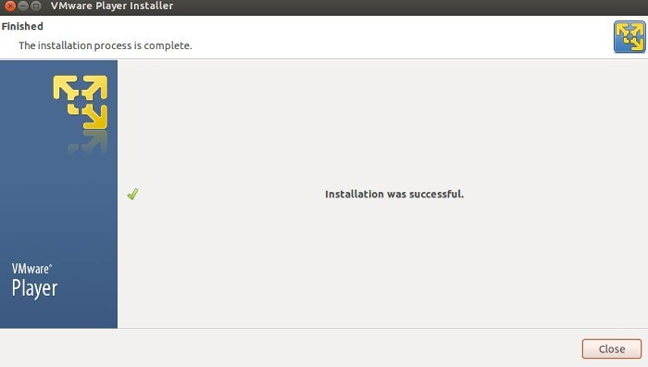

***

Ubuntu Server Installation
Ubuntu

Requirements:
1)Host PC with at least 4GB of ram
2)VMware Workstation/Virtualbox
3)Ubuntu server ISO image

Step 1:
Lunch VMware Workstation New Virtual Machine Wizard
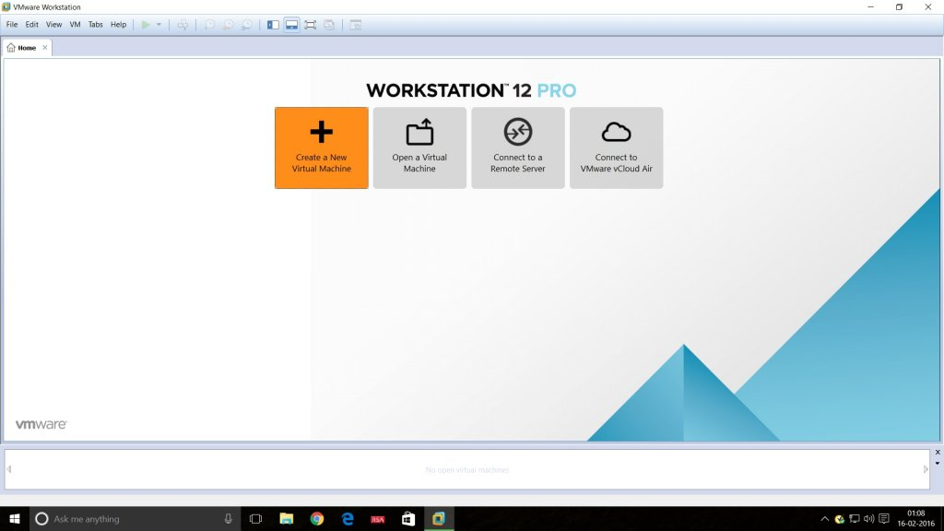
Step 2:
Select the installation media or source and choose the disk size.
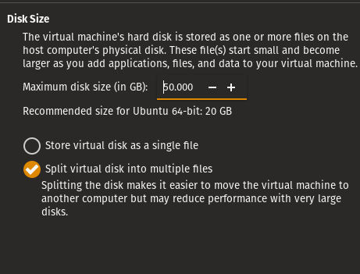

Step 3:
final configuration of the Vmware will be like this
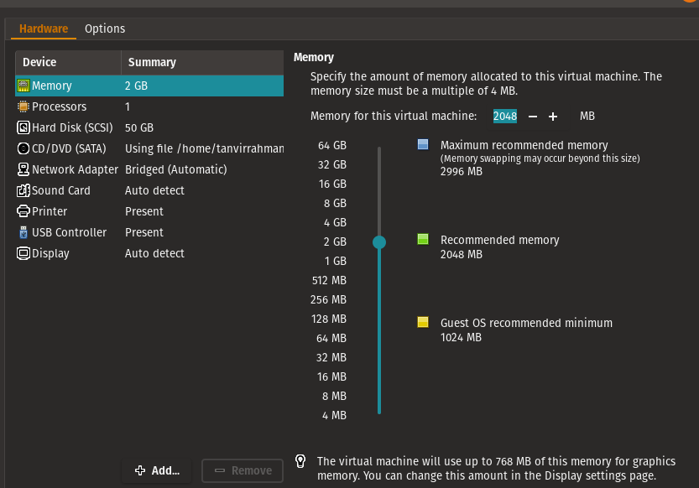

Step 4:
start the installation ,first set the language

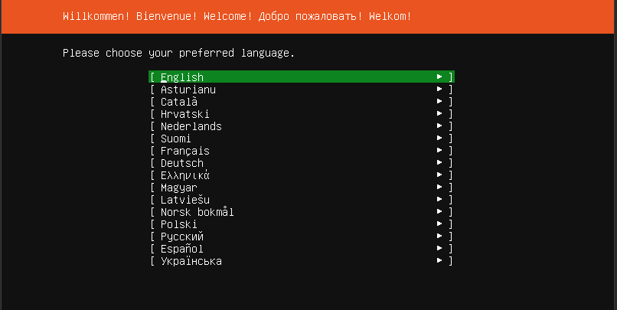
Step 5:
select DHCP for network for now .we change the ip address of the server later
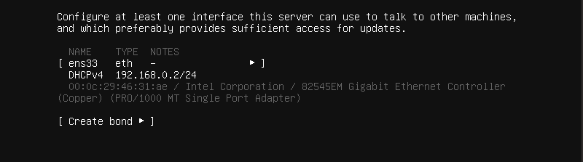

Step 5:
Select “install openSSH server” so we can connect to the computer with our hosts
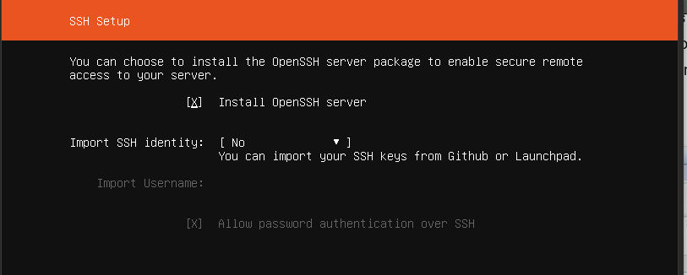
Step 6:
There are three types of partition

* Guided : use entire disk : it use the entire disk with guided partition system

* Manual : In manual partition user have to allocate the space manually.
For minimal settings three partition is a mandatory
1) /boot
2) /swap
3) /root
* Guided : on LVM :this option allow user to set a LVM based partition

Select the entire disk for installation .we select the Entire disk guided partition will talk about the other boot system later.

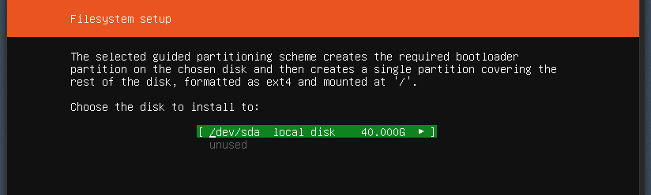

Step 7:
login to the system with your credential .

SUMMARY:
we learn how to set up a ubuntu server on Vmware Virtual machine with a dhcp network. Using guided partition.

***

CENTOS Server Installation
Centos

Requirements:
1)Host PC with at least 4GB of ram
2)VMwareWorkstation/Virtualbox 3)CENTOS7 server ISO image

Step 1:
Lunch VMware Workstation New Virtual Machine Wizard

Step 2:
Select the installation media or source and choose the disk size.

Step 3:
final configuration of the Vmware will be like this
Step 4:
start the installation , First set the language
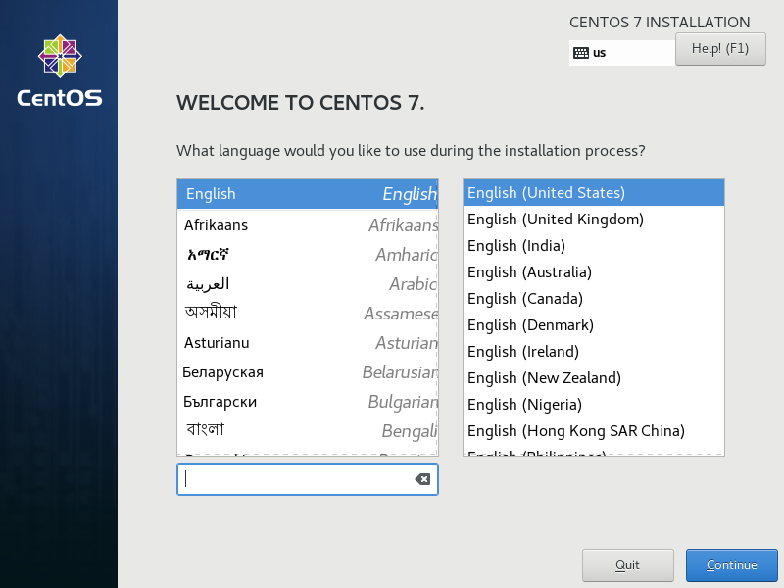
Step 5:
From the software selection select server with a GUI
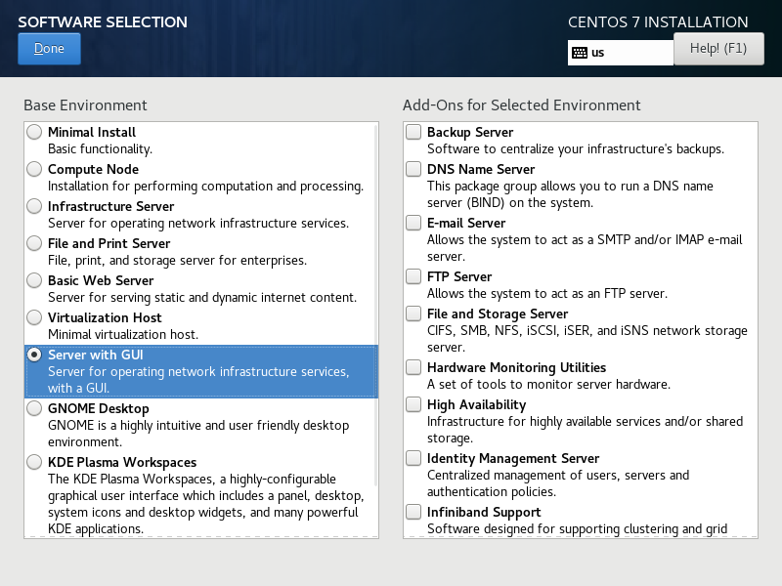

Step 6:
Select the volume for installing .in this installation we go for the entire disk guided partition

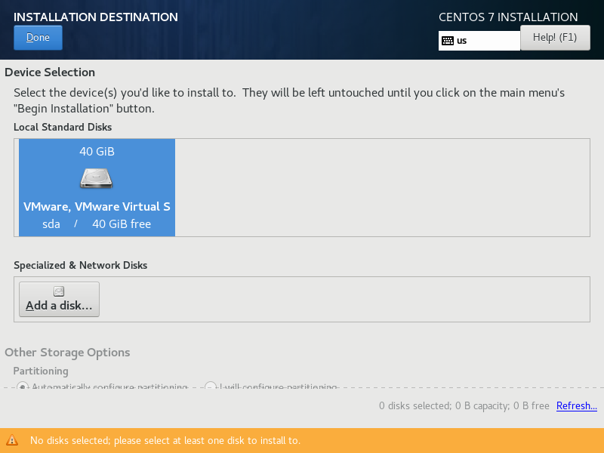

Step 7 :
Enter the root password and confirm it. and create a user and set password for the user

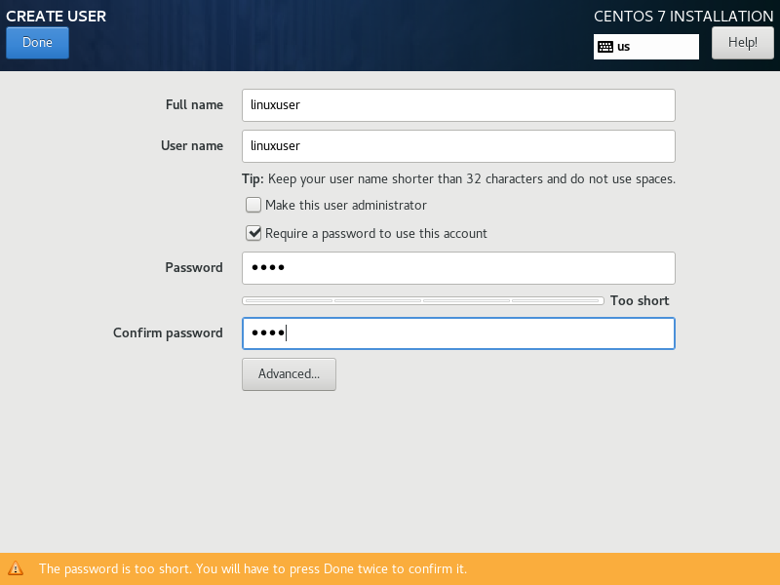

Step 7 :
wait for the installation to finished. After that reboot the system

Step 8 :
login with root credentials

SUMMARY:
we learn how to set up a Centos server on Vmware Virtual machine with Using guided partition.

***

COMMAND LINE IN LINUX
Every workstation version of linux has a Beautiful GUI(Graphical User Interface ) but most of the server Ubuntu ot CENTOS run on command line mode.you can add graphical user interface to that but without the command line you cant manage the server properly. Once you learn Command line you will find that it is more powerful and flexible for user to manage your server than a graphical mode.

WORKING AS ROOT

By default every linux OS creates a user root.Many operating system like CENTOS ask for a root password .But Ubuntu server dont do what .There is a very good reason behind that.in Linux OS root has a limitless power.root can do anything ,change anything even can delete anything from the server.so it is very important to be careful when you work as root .Thats why in ubuntu server every time you do anything that need superuser privileges you use the command ‘sudo’

Aecenas portt
itor ante a rhoncus convallis. Pellentesque tincidunt metus vel congue hendrerit. Aenean vehicula, odio nec dapibus auctor, mi nibh rutrum felis, nec molestie ipsum nisi nec purus. Ut felis mauris, volutpat at vulputate et, sodales sed arcu. Nunc ac velit condimentum, imperdiet turpis id, accumsan dolor. Ut ornare velit in tempus ullamcorper.
Vivamus mauris velit, congue eget ultrices eu, pharetra id nisi. Curabitur eget lacus quis justo ultricies consequat id ultricies lacus. Donec et tempor augue, at consequat ipsum. Donec sapien urna, feugiat id interdum vitae, pretium vel nisi. Nullam suscipit consectetur pulvinar. Aliquam ac libero nisl. Ut pretium nisi cursus scelerisque dictum. Sed vitae bibendum tortor.
Maecenas scelerisque felis sed diam pretium, ac adipiscing neque elementum. Quisque mi sapien, tristique et tristique a, euismod vitae lectus. Aenean sed cursus neque. Etiam molestie luctus egestas. Sed molestie iaculis consequat. Quisque euismod erat est, sed vehicula mi convallis viverra. Cum sociis natoque penatibus et magnis dis par- turient montes, nascetur ridiculus mus. Cras et odio iaculis, eleifend justo at, pretium elit. Phasellus tincidunt sit amet nibh quis gravida. Quisque auctor aliquet justo et volutpat. Aenean a felis in tortor ultri- cies feugiat non et eros. Phasellus sapien justo, congue sit amet diam ut, euismod ornare arcu. Proin mollis justo ut nulla lacinia, at pellen- tesque sem fringilla. Donec vel feugiat odio, vel viverra sapien. Curabi- tur sed lacus enim.

The rest of this template is just dummy text that you can replace or delete.
Cras lectus ante, egestas quis blandit non, mattis quis metus. Viva- mus sapien dui, ornare nec massa eget, porttitor gravida tellus. Donec hendrerit posuere placerat. Nulla facilisi. Cras non orci at nisi rutrum sagittis ac congue dolor. Aliquam pellentesque libero sed libero male- suada laoreet. In venenatis dignissim sagittis. Mauris ligula elit, accum- san vel arcu et, dignissim rutrum dolor. Praesent vehicula lacus nunc, sed feugiat ligula semper et. Nunc id massa venenatis magna ornare faucibus quis sit amet arcu. Nam hendrerit mauris vitae urna pharetra lacinia. Aenean blandit nisi quis urna porta, id euismod magna condi- mentum.
Vivamus non arcu dolor. Integer in pulvinar orci, ac viverra purus. Pellentesque congue eleifend elit, et blandit arcu fringilla sit amet. Nulla blandit neque sed nisi tempus pretium. Aenean lacinia vel mau- ris sit amet tincidunt. Sed eget quam rhoncus, egestas mi id, facilisis sapien. Donec ut risus pulvinar enim imperdiet suscipit eget vitae lec- tus.

***
Vestibulum vehicula tortor ut metus tincidunt, sed feugiat do- lor tempus. Class aptent taciti sociosqu ad litora torquent per conu- bia nostra, per inceptos himenaeos. Aliquam ut erat ipsum. Donec blandit, sem quis adipiscing adipiscing, diam magna laoreet purus, eu gravida dui justo sit amet risus. Nulla varius a libero eget ultricies. Etiam in pharetra augue. Pellentesque dui dui, egestas eu nisi vel, euismod feugiat ante. Sed consequat euismod nisl a sollicitudin. Nunc ac nisl cursus, mollis eros at, imperdiet ipsum. Fusce vehicula neque sit amet tortor bibendum interdum. Aliquam posuere elit eget tellus eleifend, eget molestie nunc scelerisque. Cras ut commodo enim, eget semper magna. Fusce ut pretium augue. Lorem ipsum dolor sit amet, consectetur adipiscing elit. Mauris in scelerisque quam.
Praesent laoreet ante et ornare mollis. Mauris libero leo, accum- san vitae leo sit amet, aliquam bibendum diam. Sed in odio eget tel- lus tempus tincidunt. Aenean et nunc quis erat hendrerit imperdiet nec vitae felis. Vivamus pharetra diam aliquam nisi tempus gravida. Vestibulum posuere auctor iaculis. Etiam convallis nunc ac accumsan vehicula. Etiam varius bibendum nisl non molestie. Phasellus facilisis rhoncus suscipit. Donec vel felis eget quam imperdiet eleifend.
In hac habitasse platea dictumst. Sed cursus ornare fermentum. Sed tempus sodales sapien id ultricies. Sed nec varius orci. Nullam consequat est ac velit posuere elementum. Proin nec lorem sceler- isque lacus vehicula facilisis sit amet at ligula. Pellentesque volutp feugiat suscipit. Integer lacinia est sed placerat scelerisque. In tem- por scelerisque faucibus. Cras eu turpis ut mi tincidunt facilisis a sed est. Vestibulum ultricies, tellus eget dignissim hendrerit, lacus ligula vulputate leo, pulvinar tincidunt dui ligula vitae dui. Ut sit amet con- vallis tellus. Vestibulum ante ipsum primis in faucibus orci luctus et ul- trices posuere cubilia Curae; Aliquam ligula lacus, luctus ut tellus nec, ultricies imperdiet urna. Phasellus fermentum lacinia arcu, nec hen- drerit mauris euismod tempor. Nullam quis felis eleifend urna laoreet consectetur vitae quis orci.
In a sapien tincidunt, ultrices magna ultrices, eleifend urna. In sed nisi sapien. Donec eu tortor et erat dictum elementum sed nec justo. Etiam sit amet dignissim erat. Fusce elementum eget augue vel fer- mentum. Vestibulum bibendum nec nulla sit amet lobortis. Aenean ac hendrerit risus. Nullam placerat suscipit enim et fringilla. Donec luctus enim eget ornare ullamcorper. Vivamus dolor lectus, varius at mi la- cinia, auctor lobortis sem.
Maecenas aliquam sagittis augue in condimentum. Etiam ac enim quis mi mollis rutrum a eget metus. Sed ut orci libero. Donec pretium fringilla enim id posuere. Nulla rutrum pulvinar laoreet. Nam iaculis metus convallis massa molestie tristique. Etiam at dolor at massa euis- mod luctus vitae non sapien.
Nunc id libero et mi dictum aliquam a sed nunc. Sed congue me- tus nec leo pretium, eu pulvinar neque porttitor. Sed mauris lectus, ultrices ut ultricies in, facilisis nec lorem. Suspendisse ornare vel massa eu convallis. Phasellus consectetur nunc et tristique tempor. Integer lorem risus, sagittis et adipiscing eu, imperdiet id est. Proin in tristique turpis, lobortis imperdiet sem. Fusce lacinia mi quis sollicitudin auctor. Aenean eget odio orci. Sed vulputate scelerisque diam, id mollis do- lor. Nullam id felis porta, malesuada est sed, feugiat sem. Suspendisse at neque sed est viverra consequat. Curabitur ac libero non lorem lo- bortis vestibulum vel quis sapien. Vivamus quis aliquam libero. Morbi viverra eleifend nibh eu tristique.
Maecenas pulvinar erat quis libero molestie, id consequat est tem- por. Nunc elementum orci ullamcorper convallis laoreet. In ac justo commodo, ornare dolor sit amet, viverra leo. Nam dictum mauris tor- tor, eu commodo neque venenatis eget. Pellentesque habitant mor- bi tristique senectus et netus et malesuada fames ac turpis egestas. Praesent sodales est nec ipsum semper consectetur. Integer pulvinar molestie luctus. Vivamus quis aliquam lorem, in interdum nisi. Morbi iaculis non mi porta consectetur. Sed vulputate viverra felis, eu adipi- scing arcu facilisis ut. Aliquam nec massa rhoncus, ullamcorper ante sed, commodo tellus. Nullam libero quam, volutpat in metus nec, condimentum malesuada est. Proin scelerisque dapibus purus, eu elementum elit consectetur in. Nulla blandit ligula non est rhoncus suscipit. Aenean pretium ligula vel enim hendrerit, ac interdum lectus vestibulum. Duis varius metus sit amet tortor feugiat mattis.
Aliquam eget faucibus orci, eu mollis dolor. Aenean sed libero porttitor, faucibus purus et, auctor nisl. Aliquam tincidunt nulla felis, ac tempus lorem suscipit vitae. Integer rhoncus molestie leo, id ul- lamcorper lorem ullamcorper convallis. Duis dapibus, ligula sit amet vehicula auctor, nisi ligula bibendum turpis, eget gravida lectus augue non arcu. Pellentesque lacus nisi, tristique dictum tincidunt id, adipi- scing eu mi. Phasellus erat ligula, consectetur in aliquam rutrum, com- modo fringilla nibh. Ut sit amet orci ligula. Ut tincidunt metus vitae libero condimentum molestie. Proin tristique, nibh quis vulputate porttitor, magna mi vestibulum est, sit amet imperdiet nunc urna et elit. Fusce ultrices, libero a luctus bibendum, dolor nibh porttitor lig- ula, vitae condimentum lacus felis lobortis odio. Mauris rhoncus tur- pis dolor, eget varius risus sagittis eget. Mauris placerat convallis risus eget rhoncus. Duis ullamcorper orci orci, eu volutpat nunc porta non. Nunc eget adipiscing quam, eget vestibulum turpis. In aliquam ornare libero, in dignissim velit elementum eget.

5 could be a subtitle

ENAS PORTITOR ANTE. Pellentesque tincidunt metus vel congue hendrerit. Aenean vehicula, odio nec dapibus auctor, mi nibh rutrum felis, nec molestie ipsum nisi nec purus. Ut felis mauris, volutpat at vulputate et, sodales sed arcu. Nunc ac velit condimentum, imperdiet turpis id, accumsan dolor. Ut ornare velit in tempus ullamcorper. Vivamus mauris velit, congue eget ultrices eu, pharetra id nisi. Curabitur eget lacus quis justo ultricies consequat id ultricies lacus. Donec et tempor augue, at consequat ipsum. Donec sapien urna, feugiat id interdum vitae, pretium vel nisi. Nullam suscipit consectetur pulvinar. Aliquam ac libero nisl. Ut pretium nisi cursus scelerisque dictum. Sed vitae bibendum tortor.
Cras a dui at quam fringilla conse- quat. Vestibulum ante ipsum primis in faucibus orci luctus et ultrices posuere cubilia Curae; Duis at ornare libero. Nunc rutrum volutpat tortor, a faucibus augue congue non. Integer ultricies et magna nec iaculis. Sed tincidunt quis felis vel euismod. Nam pretium elit elementum est ullamcorper dic- tum. Praesent dapibus dolor ut lorem hendrerit volutpat. Curabitur vulputate placerat turpis at luctus. Suspendisse vel aliquam nulla. Nam tristique sed ipsum eget cursus. Aliquam in adipiscing magna. In quis elit nisi. Donec eu lorem ut nisl adipiscing suscipit eget eu libero.

The rest of this template is just dummy text that you can replace or delete.
Maecenas scelerisque felis sed diam pretium, ac adipiscing neque elementum. Quisque mi sapien, tristique et tristique a, euismod vitae lectus. Aenean sed cursus neque. Etiam molestie luctus egestas. Sed molestie iaculis consequat. Quisque euismod erat est, sed vehicula mi convallis viverra. Cum sociis natoque penatibus et magnis dis par- turient montes, nascetur ridiculus mus. Cras et odio iaculis, eleifend justo at, pretium elit. Phasellus tincidunt sit amet nibh quis gravida. Quisque auctor aliquet justo et volutpat. Aenean a felis in tortor ultri- cies feugiat non et eros. Phasellus sapien justo, congue sit amet diam ut, euismod ornare arcu. Proin mollis justo ut nulla lacinia, at pellen- tesque sem fringilla. Donec vel feugiat odio, vel viverra sapien. Curabi- tur sed lacus enim.
Cras lectus ante, egestas quis blandit non, mattis quis metus. Viva- mus sapien dui, ornare nec massa eget, porttitor gravida tellus. Donec hendrerit posuere placerat. Nulla facilisi. Cras non orci at nisi rutrum sagittis ac congue dolor. Aliquam pellentesque libero sed libero male- suada laoreet. In venenatis dignissim sagittis. Mauris ligula elit, accum- san vel arcu et, dignissim rutrum dolor. Praesent vehicula lacus nunc, sed feugiat ligula semper et. Nunc id massa venenatis magna ornare faucibus quis sit amet arcu. Nam hendrerit mauris vitae urna pharetra lacinia. Aenean blandit nisi quis urna porta, id euismod magna condi- mentum.
Vivamus non arcu dolor. Integer in pulvinar orci, ac viverra purus. Pellentesque congue eleifend elit, et blandit arcu fringilla sit amet. Nulla blandit neque sed nisi tempus pretium. Aenean lacinia vel mau- ris sit amet tincidunt. Sed eget quam rhoncus, egestas mi id, facilisis sapien. Donec ut risus pulvinar enim imperdiet suscipit eget vitae lec- tus.
Vestibulum vehicula tortor ut metus tincidunt, sed feugiat do- lor tempus. Class aptent taciti sociosqu ad litora torquent per conu- bia nostra, per inceptos himenaeos. Aliquam ut erat ipsum. Donec blandit, sem quis adipiscing adipiscing, diam magna laoreet purus, eu gravida dui justo sit amet risus. Nulla varius a libero eget ultricies. Etiam in pharetra augue. Pellentesque dui dui, egestas eu nisi vel, euismod feugiat ante. Sed consequat euismod nisl a sollicitudin. Nunc ac nisl cursus, mollis eros at, imperdiet ipsum. Fusce vehicula neque sit amet tortor bibendum interdum. Aliquam posuere elit eget tellus eleifend, eget molestie nunc scelerisque. Cras ut commodo enim, eget semper magna. Fusce ut pretium augue. Lorem ipsum dolor sit amet, consectetur adipiscing elit. Mauris in scelerisque quam.
Praesent laoreet ante et ornare mollis. Mauris libero leo, accum- san vitae leo sit amet, aliquam bibendum diam. Sed in odio eget tel- lus tempus tincidunt. Aenean et nunc quis erat hendrerit imperdiet nec vitae felis. Vivamus pharetra diam aliquam nisi tempus gravida. Vestibulum posuere auctor iaculis. Etiam convallis nunc ac accumsan vehicula. Etiam varius bibendum nisl non molestie. Phasellus facilisis rhoncus suscipit. Donec vel felis eget quam imperdiet eleifend.
In hac habitasse platea dictumst. Sed cursus ornare fermentum. Sed tempus sodales sapien id ultricies. Sed nec varius orci. Nullam consequat est ac velit posuere elementum. Proin nec lorem sceler- isque lacus vehicula facilisis sit amet at ligula. Pellentesque volutp feugiat suscipit. Integer lacinia est sed placerat scelerisque. In tem- por scelerisque faucibus. Cras eu turpis ut mi tincidunt facilisis a sed est. Vestibulum ultricies, tellus eget dignissim hendrerit, lacus ligula vulputate leo, pulvinar tincidunt dui ligula vitae dui. Ut sit amet con- vallis tellus. Vestibulum ante ipsum primis in faucibus orci luctus et ul- trices posuere cubilia Curae; Aliquam ligula lacus, luctus ut tellus nec, ultricies imperdiet urna. Phasellus fermentum lacinia arcu, nec hen- drerit mauris euismod tempor. Nullam quis felis eleifend urna laoreet consectetur vitae quis orci.
In a sapien tincidunt, ultrices magna ultrices, eleifend urna. In sed nisi sapien. Donec eu tortor et erat dictum elementum sed nec justo. Etiam sit amet dignissim erat. Fusce elementum eget augue vel fer- mentum. Vestibulum bibendum nec nulla sit amet lobortis. Aenean ac hendrerit risus. Nullam placerat suscipit enim et fringilla. Donec luctus enim eget ornare ullamcorper. Vivamus dolor lectus, varius at mi la- cinia, auctor lobortis sem.
Maecenas aliquam sagittis augue in condimentum. Etiam ac enim quis mi mollis rutrum a eget metus. Sed ut orci libero. Donec pretium fringilla enim id posuere. Nulla rutrum pulvinar laoreet. Nam iaculis metus convallis massa molestie tristique. Etiam at dolor at massa euis- mod luctus vitae non sapien.
Nunc id libero et mi dictum aliquam a sed nunc. Sed congue me- tus nec leo pretium, eu pulvinar neque porttitor. Sed mauris lectus, ultrices ut ultricies in, facilisis nec lorem. Suspendisse ornare vel massa eu convallis. Phasellus consectetur nunc et tristique tempor. Integer lorem risus, sagittis et adipiscing eu, imperdiet id est. Proin in tristique turpis, lobortis imperdiet sem.
Fusce lacinia mi quis sollicitudin auctor. Aenean eget odio orci. Sed vulputate scelerisque diam, id mollis do- lor. Nullam id felis porta, malesuada est sed, feugiat sem. Suspendisse at neque sed est viverra consequat. Curabitur ac libero non lorem lo- bortis vestibulum vel quis sapien. Vivamus quis aliquam libero. Morbi viverra eleifend nibh eu tristique.
Maecenas pulvinar erat quis libero molestie, id consequat est tem- por. Nunc elementum orci ullamcorper convallis laoreet. In ac justo commodo, ornare dolor sit amet, viverra leo. Nam dictum mauris tor- tor, eu commodo neque venenatis eget. Pellentesque habitant mor- bi tristique senectus et netus et malesuada fames ac turpis egestas. Praesent sodales est nec ipsum semper consectetur. Integer pulvinar molestie luctus. Vivamus quis aliquam lorem, in interdum nisi. Morbi iaculis non mi porta consectetur. Sed vulputate viverra felis, eu adipi- scing arcu facilisis ut. Aliquam nec massa rhoncus, ullamcorper ante sed, commodo tellus. Nullam libero quam, volutpat in metus nec, condimentum malesuada est. Proin scelerisque dapibus purus, eu elementum elit consectetur in. Nulla blandit ligula non est rhoncus suscipit. Aenean pretium ligula vel enim hendrerit, ac interdum lectus vestibulum. Duis varius metus sit amet tortor feugiat mattis.
Aliquam eget faucibus orci, eu mollis dolor. Aenean sed libero porttitor, faucibus purus et, auctor nisl. Aliquam tincidunt nulla felis, ac tempus lorem suscipit vitae. Integer rhoncus molestie leo, id ul- lamcorper lorem ullamcorper convallis. Duis dapibus, ligula sit amet vehicula auctor, nisi ligula bibendum turpis, eget gravida lectus augue non arcu. Pellentesque lacus nisi, tristique dictum tincidunt id, adipi- scing eu mi. Phasellus erat ligula, consectetur in aliquam rutrum, com- modo fringilla nibh.
Ut sit amet orci ligula. Ut tincidunt metus vitae libero condimentum molestie. Proin tristique, nibh quis vulputate porttitor, magna mi vestibulum est, sit amet imperdiet nunc urna et elit. Fusce ultrices, libero a luctus bibendum, dolor nibh porttitor lig- ula, vitae condimentum lacus felis lobortis odio. Mauris rhoncus tur- pis dolor, eget varius risus sagittis eget. Mauris placerat convallis risus eget rhoncus. Duis ullamcorper orci orci, eu volutpat nunc porta non. Nunc eget adipiscing quam, eget vestibulum turpis. In aliquam ornare libero, in dignissim velit elementum eget.
Aliquam tempus, diam sit amet pharetra egestas, diam massa grav- ida nunc, eget aliquet leo libero in elit. Aenean eget neque et magna tincidunt ornare non id erat. Quisque vel dolor turpis. Pellentesque hendrerit dignissim auctor. Mauris et justo et odio dapibus blandit. Nunc vestibulum, nunc et commodo venenatis, orci justo fermentum eros, accumsan tincidunt velit augue sed elit. Aliquam erat volutpat. Sed leo velit, semper sed magna tristique, rhoncus vehicula velit. Ali- quam suscipit pulvinar risus sollicitudin fermentum. Praesent quis tel- lus vitae justo accumsan fringilla.

ABOUT THE AUTHOR

Your book should have two “about the author” sections. The little blip on the back of your book cover is part of the sales copy: You add anything that makes you sound or appear more attractive to your target audience. You want to seem human. It’s short: a sentence or two about where you live, what you enjoy, preferably something that ties in with your genre.
This section in the back of the book can be longer: you can give more history. This is for readers who have finished your book and want to get to know you better. It’s also where you should remind them to leave a book review, or go sign up on your email list for a special bonus, or follow you on Facebook or Twitter. You can add links in here, and they’ll work when you convert to ebook, (so link to your Twitter and Facebook as well if you want). But remember the links won’t work on the print book, so you’ll need to edit it to display the full link.

www.website.com

Acknowledgments

Aliquam tempus, diam sit amet pharetra egestas, diam massa grav- ida nunc, eget aliquet leo libero in elit. Aenean eget neque et magna tincidunt ornare non id erat. Quisque vel dolor turpis. Pellentesque hendrerit dignissim auctor. Mauris et justo et odio dapibus blandit. Nunc vestibulum, nunc et commodo venenatis, orci justo fermentum eros, accumsan tincidunt velit augue sed elit. Aliquam erat volutpat. Sed leo velit, semper sed magna tristique, rhoncus vehicula velit. Ali- quam suscipit pulvinar risus sollicitudin fermentum. Praesent quis tel- lus vitae justo accumsan fringilla.

Thanks for reading! Please add a short review on Amazon
and let me know what you thought!

It’s nice to have a final call to action like this in the back to drive reviews. I would also add an optin offer, like “download the next book in the series for free!”/ “Get the quickstart guide to implementing the tools in this book!” A very simple 10 page PDF can be a great optin offer for non-fiction. For fiction you can offer future books, prequels or short stories. Also add an optin offer at the front of the book; people who just “Look Inside” can still see your offer and click the link, leading to more subscribers.

If this template was useful for you, why not share it with your writer friends? You could even write a blog post about your book formatting learning curve, and link to www.diybookformats.com so more authors can get the free templates and tutorials.

Thanks and good luck!
Derek Murphy

