Routing Real Life Implementation(Mikrotik)

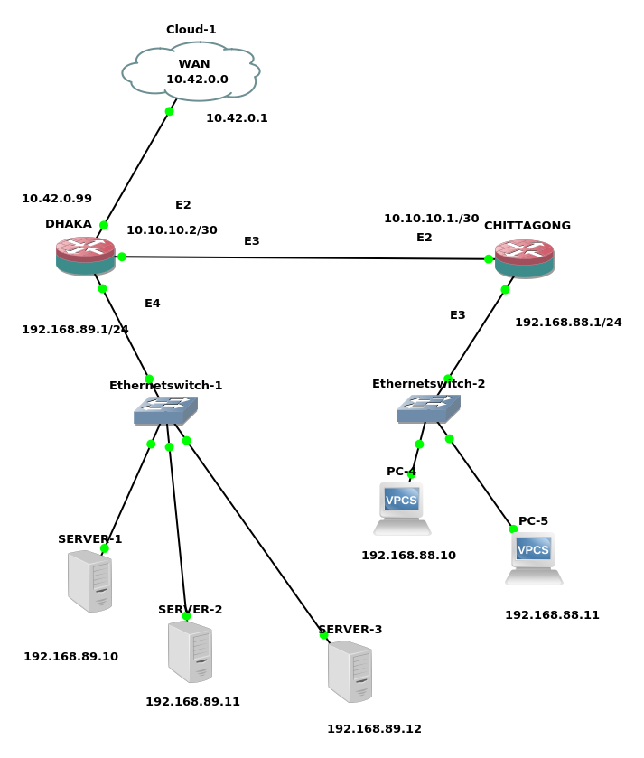

DHAKA BRANCH(HEAD)

1) First change the ip services:

[admin@MikroTik] /ip service> disable 1,2,3,5,7
[admin@MikroTik] /ip service> print

2) Change The interface Name:
[admin@MikroTik] /interface> set 1 name=DHK-WAN
[admin@MikroTik] /interface> set 2 name=DHK-TO-CTG
[admin@MikroTik] /interface> set 3 name=DHAKA-LAN

3) Change The identity:
[admin@MikroTik > system identity set name=DHK-HEAD-BRANCH

4) Add IP address to the interface:
[admin@DHK-HEAD-BRANCH] > ip address add address=10.42.0.99/24 interface=DHK-WAN
[admin@DHK-HEAD-BRANCH] > ip address add address=10.10.10.2/30 interface=DHK-TO-CTG
[admin@DHK-HEAD-BRANCH] > ip address add address=192.168.89.1/24 interface=DHAKA-LAN

5) Add gateway:
[admin@DHK-HEAD-BRANCH] > ip route add gateway=10.42.0.1

6) Add DNS:

[admin@DHK-HEAD-BRANCH] > ip dns set servers=8.8.8.8
[admin@DHK-HEAD-BRANCH] > ip dns set allow-remote-requests=yes

6) Add NAT :
[admin@DHK-HEAD-BRANCH] > ip firewall nat add chain=srcnat action=masquerade

7) Add Routing :
[admin@DHK-HEAD-BRANCH] > ip route add dst-address=192.168.88.0/24 gateway=10.10.10.1

7) Add ip address to 3 VPCS SERVER :

VPCS1> ip 192.168.89.10/24 192.168.89.1
Checking for duplicate address...
PC1 : 192.168.89.10 255.255.255.0 gateway 192.168.89.1

VPCS2> ip 192.168.89.11/24 192.168.89.1
Checking for duplicate address...
PC1 : 192.168.89.11 255.255.255.0 gateway 192.168.89.1

VPCS> ip 192.168.89.12/24 192.168.89.1
Checking for duplicate address...
PC1 : 192.168.89.12 255.255.255.0 gateway 192.168.89.1

7) ping Test from 3 SERVER :

VPCS1> ping 8.8.8.8

84 bytes from 8.8.8.8 icmp_seq=1 ttl=116 time=59.398 ms

VPCS2> ping 8.8.8.8

84 bytes from 8.8.8.8 icmp_seq=1 ttl=116 time=58.859 ms

VPCS3> ping 8.8.8.8

84 bytes from 8.8.8.8 icmp_seq=1 ttl=116 time=66.714 ms

CHITTAGONG BRANCH(SLAVE)
1) First change the ip services:

[admin@MikroTik] /ip service> disable 1,2,3,5,7
[admin@MikroTik] /ip service> print

2) Change The interface Name:
[admin@MikroTik] /interface> set 1 name=DHK-TO-CTG
[admin@MikroTik] /interface> set 2 name=CTG-LAN

3) Giving IP address:
[admin@MikroTik] > ip address add address=10.10.10.1/30 interface=DHK-TO-CTG
[admin@MikroTik] > ip address add address=192.168.88.1/24 interface=CTG-LAN

4) Adding Gateway:
[admin@MikroTik] > ip route add gateway=10.10.10.2

5) Adding Routing:
[admin@MikroTik] > ip route add dst-address=192.168.89.0/24 gateway=10.10.10.2

6) Adding IP address to PC:

PC-4> ip 192.168.88.10/24 192.168.88.1
Checking for duplicate address...
PC1 : 192.168.88.10 255.255.255.0 gateway 192.168.88.1
PC-4> ip dns 8.8.8.8

PC-5> ip 192.168.88.11/24 192.168.88.1
Checking for duplicate address...
PC1 : 192.168.88.11 255.255.255.0 gateway 192.168.88.1

PC-5> ip dns 8.8.8.8

6) Testing With Ping from PC:

PC-5> ping yahoo.com
yahoo.com resolved to 98.137.246.8

84 bytes from 98.137.246.8 icmp_seq=1 ttl=48 time=313.686 ms

PC-4> ping yahoo.com
yahoo.com resolved to 72.30.35.10

84 bytes from 72.30.35.10 icmp_seq=1 ttl=48 time=278.168 ms
84 bytes from 72.30.35.10 icmp_seq=2 ttl=48 time=278.859 ms

