Briding what and why its necessery:

suppose you bought 5 public address .to run 4 different server. And you have a mikrotik router which as 5 port. And its a must requirement that they have to connect with the public ip. Not through NAT. and you have also some client device that you have to connect. But you have only 5 port.you can use the 5 port to access the 5 server and you have to configure all of the port.even if you do that you dont have any port left for the client pc.

Or you can do the one thing which is called bridging. Suppose your wan is connected with port 1 and its ip is 122.152.53.34 and you want a direct connection through the wan. so take another port which is port3 and bridge it to port1 and make a logical port(which is theoritical) and then connect the port with a switch and then assign the server with the switch and the public address 122.152.53.35 122.152.53.36 122.152.53.37 122.152.53.38 .thats actually means this four server go through the port3 to port 1 to internet.or we can say that through the logical port1.so we can save the other port for the lan .

Logical port means the port1 has access to internet and port 3 is accessed with the server. so the two logical port made with two has access to the server and the wan.

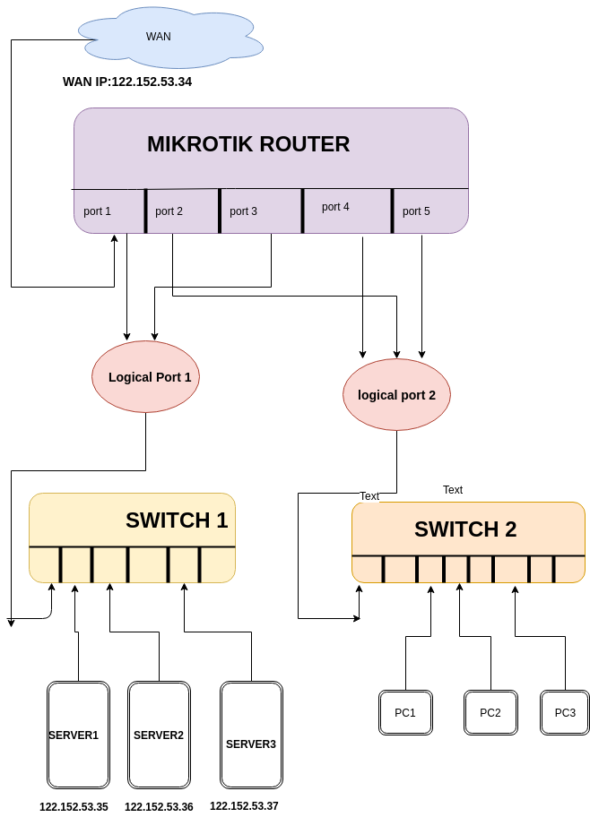

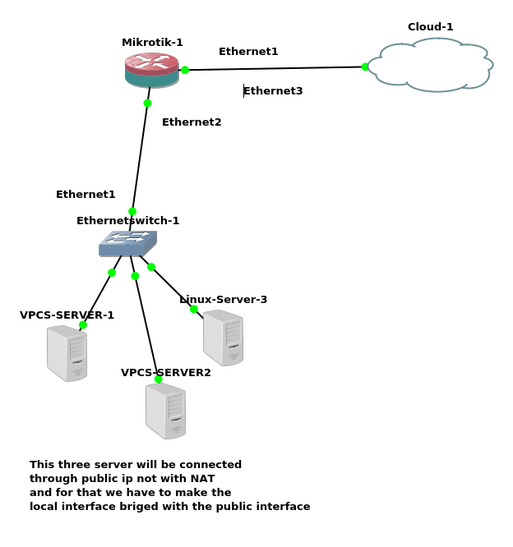

Configuring bridge with gns:

1)router has 5 port
2) 1 and 3 is the wan port
3) 2,4,6 is the LAN port
4) 1+3 make logical port
5) 2+4+6 make a logical port
6)server directly connected with WAN
7)client is connected through NAT

//first omit the local interface we dont do anything with that whcich is connected to pc

1)Setting up ip address,gateway,and dns server
Ethernet1 port is connected with WAN,
(in router its ether2)

[admin@MikroTik] /ip address> print
Flags: X - disabled, I - invalid, D - dynamic
# ADDRESS NETWORK INTERFACE

[admin@MikroTik] /ip address> add address=10.42.0.99/24 interface=ether2
[admin@MikroTik] /ip address> add address=192.168.99.0/24 interface=ether3
[admin@MikroTik] /ip address> /ip route add gateway=10.42.0.1
[admin@MikroTik] /ip address> /ping 8.8.8.8
SEQ HOST SIZE TTL TIME STATUS
0 8.8.8.8 56 117 60ms
1 8.8.8.8 56 117 58ms
sent=2 received=2 packet-loss=0% min-rtt=58ms avg-rtt=59ms max-rtt=60ms

[admin@MikroTik] /ip address> /ip dns set servers=8.8.8.8
[admin@MikroTik] /ip address> /ping yahoo.com
SEQ HOST SIZE TTL TIME STATUS
0 98.137.246.7 56 50 297ms
sent=1 received=1 packet-loss=0% min-rtt=297ms avg-rtt=297ms
max-rtt=297ms

3)setting the name

[admin@MikroTik] /interface> set 1 name=WAN
[admin@MikroTik] /interface> set 2 name=LAN

2)adding the ether3(in router ) interface bridged with the ether2 which is connected with the WAN.

2-1) first create a bridge
[admin@MikroTik] /interface bridge> add name=Bridge-WAN

2-2)assign the port with the Bridge

[admin@MikroTik] /interface bridge> port add interface=WAN bridge=Bridge-WAN
[admin@MikroTik] /interface bridge> port add interface=LAN bridge=Bridge-WAN

3)adding public ip to the servers and test [and the gateway will be public gateway]

server1
VPCS> ip 10.42.0.100/24 10.42.0.1
Checking for duplicate address...
PC1 : 10.42.0.100 255.255.255.0 gateway 10.42.0.1

VPCS> ping 8.8.8.8

84 bytes from 8.8.8.8 icmp_seq=1 ttl=117 time=61.386 ms
84 bytes from 8.8.8.8 icmp_seq=2 ttl=117 time=74.394 ms
84 bytes from 8.8.8.8 icmp_seq=3 ttl=117 time=80.417 ms\

server2
VPCS> ip 10.42.0.110/24 10.42.0.1
Checking for duplicate address...
PC1 : 10.42.0.110 255.255.255.0 gateway 10.42.0.1

VPCS> ping 8.8.8.8

84 bytes from 8.8.8.8 icmp_seq=1 ttl=117 time=59.775 ms

linux-server:
adding ip and gw

gns3@box:~$ sudo ifconfig eth0 10.42.0.200 netmask 255.255.255.0 up
gns3@box:~$ sudo route add default gw 10.42.0.1

test it
gns3@box:~$ ping 8.8.8.8
PING 8.8.8.8 (8.8.8.8): 56 data bytes
64 bytes from 8.8.8.8: seq=0 ttl=117 time=61.799 ms

