Real life implementation of of Ststic and Ospf routing using Mikrotik

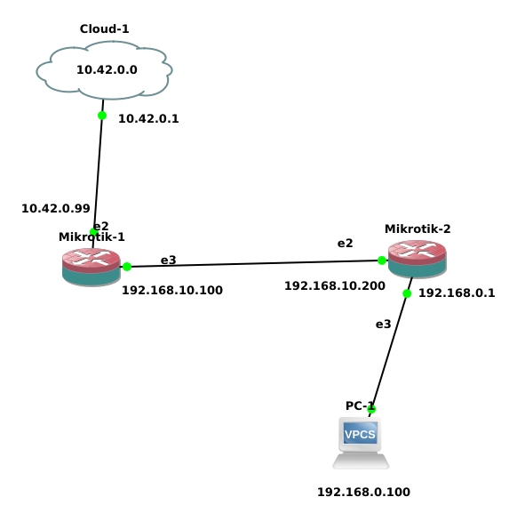

there are two router first router is connected to public network. Second router is connected with the first router and also the local network.
Now we have to do routing because there are two router.
Another thing we must have to do is NAT .we have to it in both router. We know public network only capable of surfing the internet .so in the first router we have to NAT the 192.168.10.0 network to 10.42.0.0 .and after that the router 2 can communicate through the internet(after routing).but to access the internet from the second router local network we have to do NAT ing in the 192.168.0.0 network with the 192.168.10.0

192.168.0.100 → NAT → 192.168.10.200 → routing → 192.168.10.100 → NAT → 10.42.0.99 → 10.42.0.1 → cloud

[ router can ping from 192.168.10.100 to 192.168.10.200 but if not routing done local network cant send packet]

METHOD:

router1(connected with the cloud):

[admin@MikroTik] > ip address add address=10.42.0.99/24 interface=ether2
[admin@MikroTik] > ip address add address=192.168.10.100/24 interface=ether3
[admin@MikroTik] > ip route add gateway=10.42.0.1
[admin@MikroTik] /ip firewall nat> add chain=srcnat src-address=192.168.10.0/24
action=masquerade
[admin@MikroTik] > ip route add dst-address=192.168.0.0/24 gateway=192.168.10.200

router2:

[admin@MikroTik] > ip address add address=192.168.10.200/24 interface=ether2
[admin@MikroTik] > ip address add address=192.168.0.1/24 interface=ether3
[admin@MikroTik] > ip route add dst-address=10.42.0.0/24 gateway=192.168.10.100
[admin@MikroTik] /ip firewall nat> add chain=srcnat src-address=192.168.0.0/24 action=masquerade

pc(under Router2):

PC-1> ip 192.168.0.100/24 192.168.0.1
Checking for duplicate address...
PC1 : 192.168.0.100 255.255.255.0 gateway 192.168.0.1

PC-1> ping 10.42.0.1

84 bytes from 10.42.0.1 icmp_seq=1 ttl=62 time=4.432 ms
84 bytes from 10.42.0.1 icmp_seq=2 ttl=62 time=3.434 ms
84 bytes from 10.42.0.1 icmp_seq=3 ttl=62 time=2.971 ms

[but we cant communicate with the 8.8.8.8 through the PC1]
[we see about that later]

