Static Routing With Three Router And With The DHCP

Router1
WAN interface ip:10.0.0.1
LAN interface ip:192.168.10.1
pc1:192.168.10.100

Router2:
WAN interface ip from router1: 10.0.0.2
WAN interface ip to router3: 11.0.0.1
LAN interface ip:192.168.20.1
pc1:192.168.20.100

Router3:
WAN interface ip:11.0.0.2
LAN interface ip:192.168.30.1
pc1:192.168.30.100

the design:

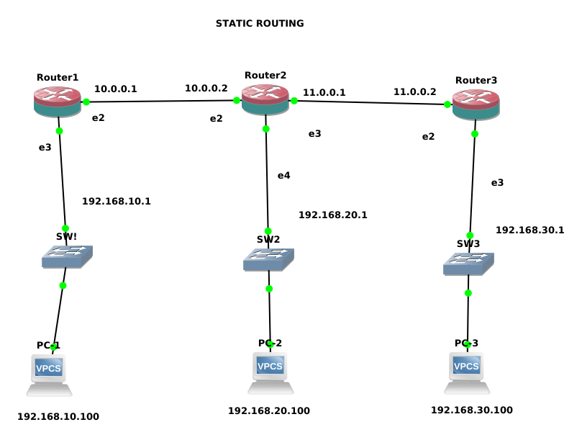

Router1 configuration:

[admin@MikroTik] > ip address add address=10.0.0.1/8 interface=ether2
[admin@MikroTik] > ip address add address=192.168.10.1/24 interface=ether3
[admin@MikroTik] > ip route add dst-address=192.168.20.0/24 gateway=10.0.0.2
[admin@MikroTik] > ip route add dst-address=192.168.30.0/24 gateway=10.0.0.2

pc1:
PC-1> ip 192.168.10.100/24 192.168.10.1
Checking for duplicate address...
PC1 : 192.168.10.100 255.255.255.0 gateway 192.168.10.1

Router2 configuration:

[admin@MikroTik] > ip address add address=10.0.0.2/8 interface=ether2
[admin@MikroTik] > ip address add address=192.168.20.1/24 interface=ether4
[admin@MikroTik] > ip address add address=11.0.0.1/8 interface=ether3
[admin@MikroTik] > ip route add dst-address=192.168.10.0/24 gateway=10.0.0.1
[admin@MikroTik] > ip route add dst-address=192.168.30.0/24 gateway=11.0.0.2

PC2:
PC-2> ip 192.168.20.100/24 192.168.20.1
Checking for duplicate address...
PC1 : 192.168.20.100 255.255.255.0 gateway 192.168.20.1

Router3 Configuration:
[admin@MikroTik] > ip address add address=11.0.0.2/8 interface=ether2
[admin@MikroTik] > ip address add address=192.168.30.1/24 interface=ether3
[admin@MikroTik] > ip route add dst-address=192.168.20.0/24 gateway=11.0.0.1
[admin@MikroTik] > ip route add dst-address=192.168.10.0/24 gateway=11.0.0.1

PC3:

testing:

