Routing in mikrotik router

Routing is the process of selecting a path for traffic in a network, or between or across multiple networks. It perform routing between router to router.

Static routing/Manual Routing:

Static routing is a form of routing that occurs when a router uses a manually-configured routing entry, rather than information from a dynamic routing traffic. Every router is configured in such a way that router is that router know which router it has pass the packet.

We configure the Router in this schematics .

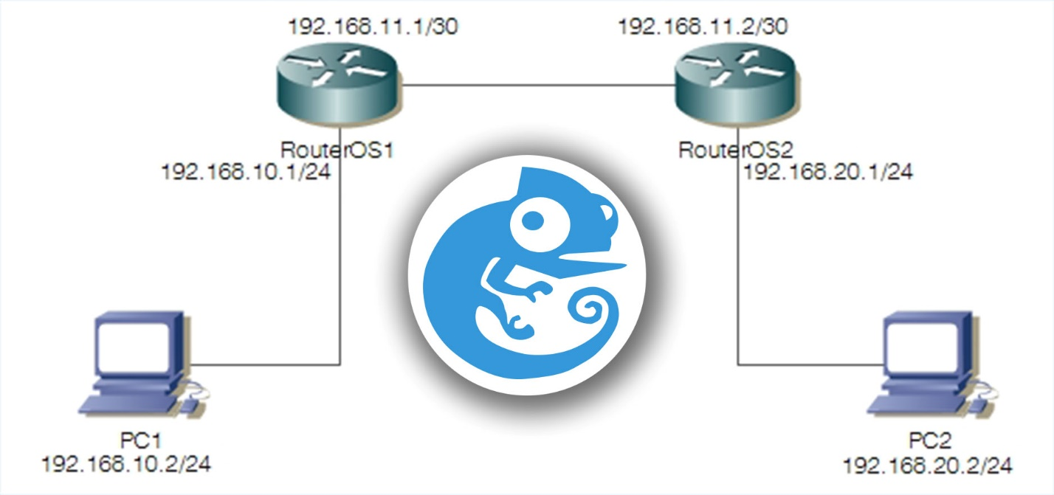

And also we do it with a different ip address. And with three router.
Since this is a simulation we will use the 192.168.11 series ip address as a public ip and the 192.168.10 series as a private ip.

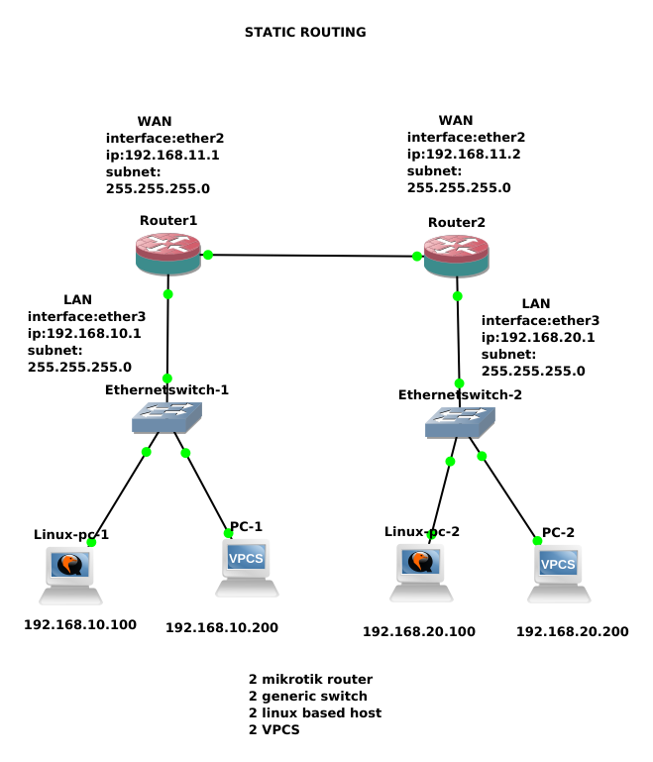

METHOD

1) setting up ip of the PC under router 1

→ VPCS
PC-1> ip 192.168.10.200/24 192.168.10.1
Checking for duplicate address...
PC1 : 192.168.10.200 255.255.255.0 gateway 192.168.10.1

→ Linux PC
gns3@box:~$ sudo ip add add 192.168.10.100/24 dev eth0
gns3@box:~$ sudo route add default gw 192.168.10.1

2) Adding ip address in two different interface in the router1

[admin@MikroTik] /ip address> add address=192.168.11.1/24 interface=ether2
[admin@MikroTik] /ip address> add address=192.168.10.1/24 interface=ether3

3) Adding ip address in two different interface in the router2

[admin@MikroTik] > ip address
[admin@MikroTik] /ip address> add address=192.168.11.2/24 interface=ether2
[admin@MikroTik] /ip address> add address=192.168.20.1/24 interface=ether3

4) adding ip address to the pc under Router 2

→VPCS
PC-2> ip 192.168.20.200/24 192.168.20.1
Checking for duplicate address...
PC1 : 192.168.20.200 255.255.255.0 gateway 192.168.20.1
→ Linux PC
gns3@box:~$ sudo ip add add 192.168.20.100/24 dev eth0
gns3@box:~$ sudo route add default gw 192.168.20.1
gns3@box:~$ ping 192.168.20.1

5) ping through the router to router to check before routing
[admin@MikroTik] /ip address> /ping 192.168.11.1
SEQ HOST SIZE TTL TIME STATUS
0 192.168.11.1 56 64 1ms
1 192.168.11.1 56 64 1ms
sent=2 received=2 packet-loss=0% min-rtt=1ms avg-rtt=1ms max-rtt=1ms

5) testing pc to pc before routing from router1-PC1 to router2-pc2

PC-1> ping 192.168.20.200
Destination network unreachable

so its not get a ping

6) adding routing

the syntax is

#ip route add dst-address=<destination local network> gateway=<destination gateway/next entry ip of the router/wan ip>

from both router

from router 1:
[admin@MikroTik] > ip route add dst-address=192.168.20.0/24 gateway=192.168.11.2

from router 2:
[admin@MikroTik] > ip route add dst-address=192.168.10.0/24 gateway=192.168.11.1

7) ping from pc1 to pc2

PC-1> ping 192.168.20.200

84 bytes from 192.168.20.200 icmp_seq=1 ttl=62 time=3.807 ms
84 bytes from 192.168.20.200 icmp_seq=2 ttl=62 time=3.060 ms

8)ping from pc2 to pc1

PC-2> ping 192.168.10.200

84 bytes from 192.168.10.200 icmp_seq=1 ttl=62 time=3.063 ms
84 bytes from 192.168.10.200 icmp_seq=2 ttl=62 time=3.218 ms

