Second Way of giving ip address (Centos7/Redhat7)

First:

first:

you need to select a static ip address , subnet mask and the gateway that you give your machine .according to your network specifications.

we give the following ip address subnet mask ,gate way and Dns

ip address : 192.168.0.10
subnet mask: 255.255.255.0
Gateway:192.168.0.1
DNS: 8.8.8.8

second:

you need to find the network interface that you give the static ip address
A Server can have multiple network interface.

In our virtual machine there are two network interface. We can see the interface from this command

=>ifconfig
or
=> ip address show

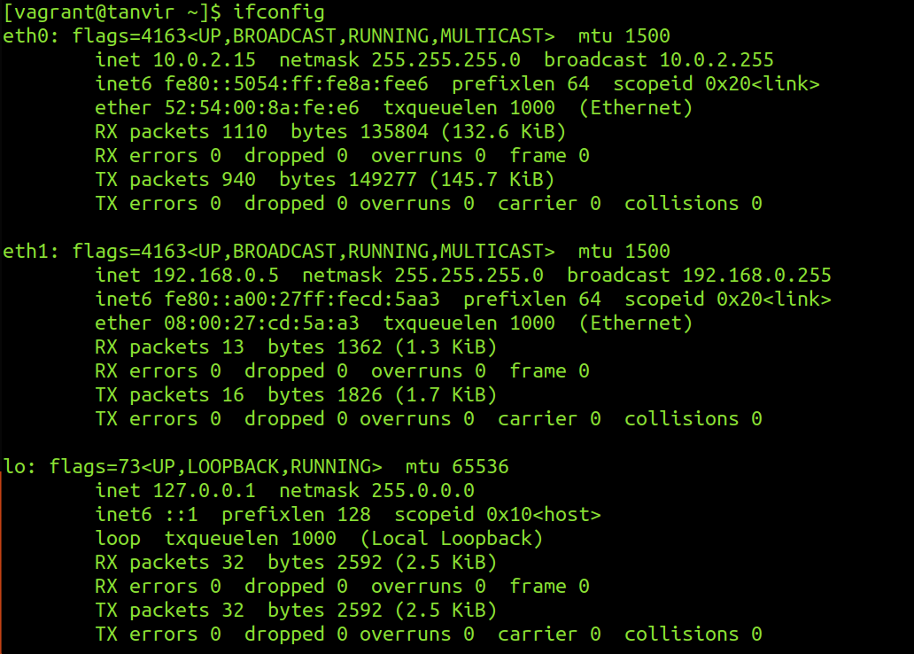

we are currently connected to the server with a ssh connection through eth0.So we cant change the ip address to eth0.this will disconnect the ssh connectivity .we are going to give the static ip address to the eth1 interface

Third:
we have to do to the ‘/etc/sysconfig/network-scripts’ directory

=> cd /etc/sysconfig/network-scripts

In this directory There are a lot of files .From there we have to select the ‘ifcfg-eth1’ [yours can be different .select the file based on your interface it will be like ifcfg-<interface>]

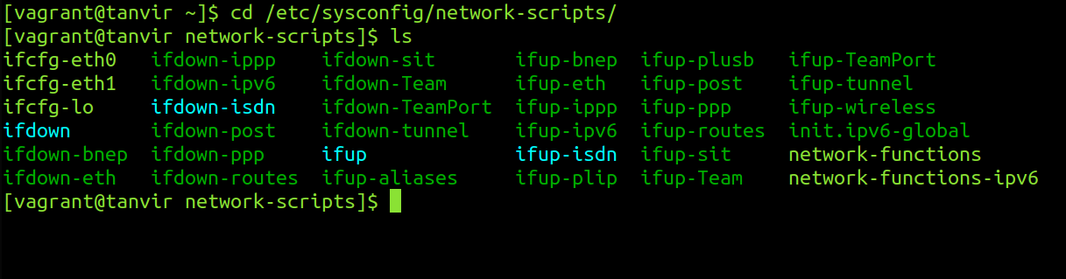

Fourth:

we have to edit the file with a text editor with root privileges.

In that file we have to change the

BOOTPROTO=static
ONBOOT=yes
IPADDR=192.168.0.10
PREFIX=24
GATEWAY=192.168.0.1
DNS1=8.8.8.8
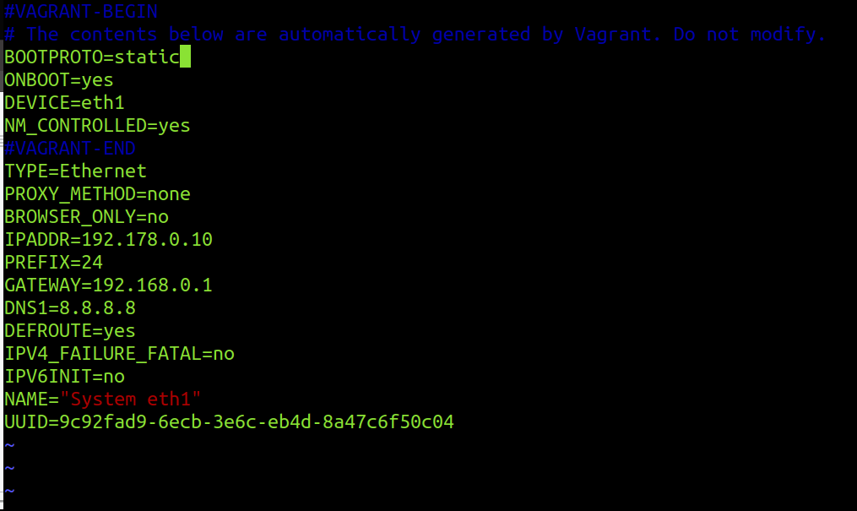

fifth:
if we see our ip address we can see the the ip address still dont change.to make the change we need to restart the interface.

We shutdown the interface with this command

=>sudo ifdown eth1

Then we start the interface again

=>sudo ifup eth1

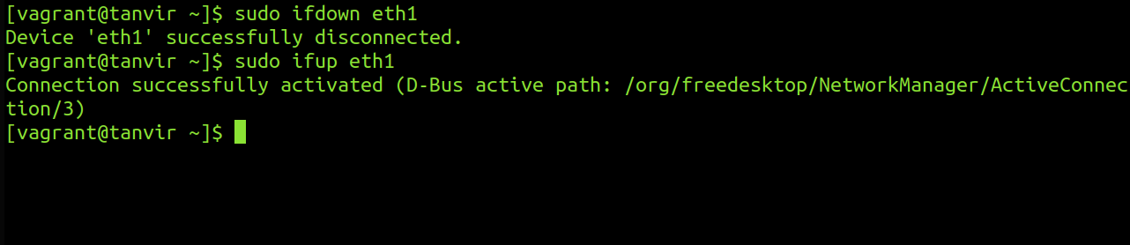

Sixth:
Then if we check ip address using
=>ifconfig eth1

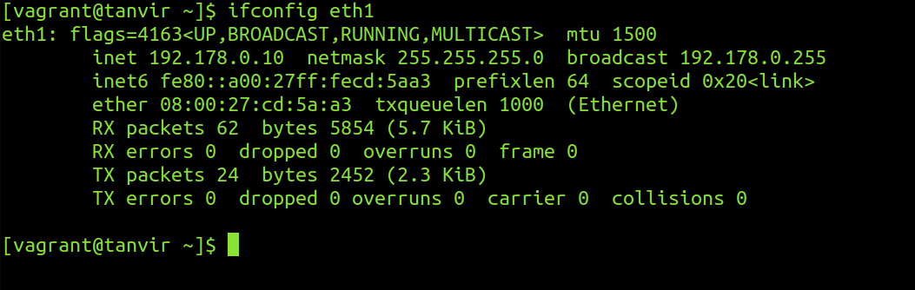

we can see the ip address changed .

Seventh:

We have to test the connection via pinging a network.

=>ping 8.8.8.8

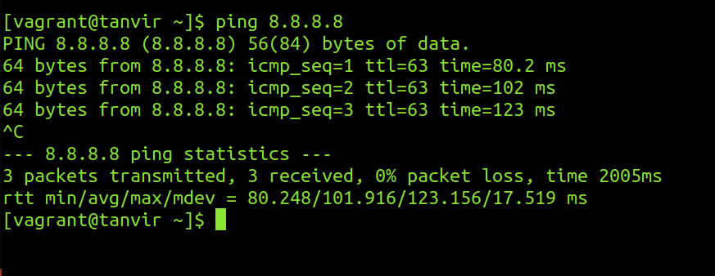

So the connection is up and running. Thats is the another way of giving an ip address to a cenos7/Redhat7 server a static address.

