Enterprise Computing

when we talk about the home computer we always think about the convenience .we just install these devices and we forget about them .but the enterprise computing is not like that they need constant monitoring that may involve updating the system,checking the software vulnerability and backup and checking the data integrity. Offsite backup .we need to consider cost,security and business continuity .Enterprises computing based on the necessity not the convenience .you may work on a very expensive hardware in the enterprise computing which you will now face in the home computer.for example you may use wifi router in your home.but in the enterprise computing you may use the Cisco Router that are far more exapensive and you need special skills based on the hardware to control this devices .Enterprise Computing based on this Four things

1)Reliability
2)Scalability
3)Manageability
4)Cost

Reliability : It means you have to focus how often hardware or your resources crash . You have to be careful about the MTBF (Mean Time Between Failure) . You need enterprise grade hardware and software that has more reliability than the devices in the personal use.because your personal computer may not be used at all the time but if you think about the a university or a company web server it has to be online all the time and also it needs to process request all the time

Scalability: you need to to adjust the hardware based on the capacity of your work environment.you need to be concerned about the networking devices based on the host computer that you need to cover .you also need to be concerned about the power consumption. Because you need power to run all the computer in the enterprise system.Your network,system or your organization should be ready to handle the demand and should be adaptable to the changing needs

Manageability : manageability means manage the whole enterprise devices of your system. You need to manage the sensitive data and all the host of a sytem that includes the server also. This may involves installing certain software and some skill to manage all the devices in a network.in a industrial controll system you may need to add automation to controll the system to manage the cost.

Cost: in a enterprise you need to think about the cost.you may need to worry about the resources .the storage facility and the printers the backup facility and also their cost.you need to think about the security and the cost based on different lavel of security.

System Management

System administration covers many different task.you may be network administrator,database administration,or server administration.
In general the system administrator does this jobs

1) Provisoning a service : that means putting a system into production.your company may need to introduce a new service into the web as a system administration its your job to do that,

2) Gathering requirments: you may need to deploy your services as the user requirements

3) You have to Scale your system beased on the user who will use the system.this may be a department of the company or may be public users

4) Integration : your application may need integration database,authentication, load balancing the webservers

other Common task that system administrator do

1) adding modifying ,deleting users
2) Changing permission
3) Logging activity and analyze them
4) Maintaining security in a system
5) Threat detection and taking necessary steps for them
6) Troubleshooting
7) monitoring latency between transaction ,manage data and protect the database .access control the database
8) make sure the database is running properly with the web server.
9) monitor firewall,routers,switches, firewall rules,granting permission,revoking permission to users.

You need to understand four different knowledge
1) System knowledge
2) How the user use the system and how many user use it
3) How the system runs and the performance of the system
4) Security

Networking in Enterprise System

In a enterprise system you should not use the wireless technology to connect with the system that need to be connected all the time. Because wireless connection can be interfered.And wireless connection create a lot of sessions.you must avoid the wireless if the connection the Financial and Personal information.

To design a network for enterprise you may consider three things

1) keeping outsiders out
2) keeping insiders out
3) keeping insiders in

1) Keeping outsiders out : you need to protect the internal network separate from the outsiders who does not belong in the company.If consider a bank you make sure the the employee of the system shoulb be on the separate network and the guest cant access this network .you can do that with firewall and user authentication .

2) keeping insiders out: even you are on a organization based on your position you may not have permission to access all the resources .for example in a university if you are a student you are insiders but you cant get access to the grading application and the admin section . As a system administrator you may separate this network with vlan and proper access control .so the insiders can get access only the have the permission to get access.

3) keep insiders in: That mean you should assure that the insiders in a network can communicate without any problem. And the inside network is safe from the outsider .also make sure that people inside the network do not waste the resources going outside for entertainment. this include may blocking access to specfic website.you have to assure that any upstream device can compromise the security of the downstream network

What is the broadcast address of the network 128.198.5.0/255.255.254.0 5.255

What is the broadcast address of the network 128.198.5.0/24 5.255

IP address Subnet and CIDR Calculation

[all the method to calculate
cidr to subnet mask
cidr to host number
subnet mask to subnet number
host range]

Virtualization

virtualization allwos us to take a snapshot,use less power and less space.with the virtualization you can run multiple server that in completely different in a physical server with less cost and less power also less space because you dont need to set up a physical server for that. A virtualization need three requirements

1)Equivalence: It shroud be run exactly like a real system
2) Resource control : the host needs complete control and the guest should not be able to control other system
3) efficiency: instruction must be executed without the help of the host

In virtualization we run program like we running on a real system.and virtualization can be nested .

How The Kernel is Built

1) instruction are executed in “Rings”
2) privileged instruction are executed on the Ring 0
3)user instruction are executed at ring level 3
4) There are may or may not be ring 1 or 2 in some operating system
5) devices drivers may live at rings 1 and 2 if there are built in driver program
6) the chip now a days can do second level address translation that allow use the perform nested virtualization

hardware virtualization

Platform Virtualization: plat from virtualization is a software implementation of a entire computer system
It emulates everything like RAM,CPU like a complete normal computer

it has three types
1) full or binary Translation
this is a full virtualization. Execute the direct instruction .it translate the instruction that the underlying hardware can understand.it has is
own bios so you can treat the system exactly like a computer .This requires now extra hardware .It runs on great speed compared to all other virtualization. Some example are vmware esxi,quemu for linux and parallel for mac

2)Hardware-assisted virtualization :
in the hardware assisted virtualization non root privileged instructions are executed bellow the Ring 0.privileged instruction are trapped to hypervisor .and you cant send direct instruction in hardware

3) OS Assisted virtualization/para virtualization
it use an a api to integrate. it is a os assisted process so it has less compatibility .example is Docker.

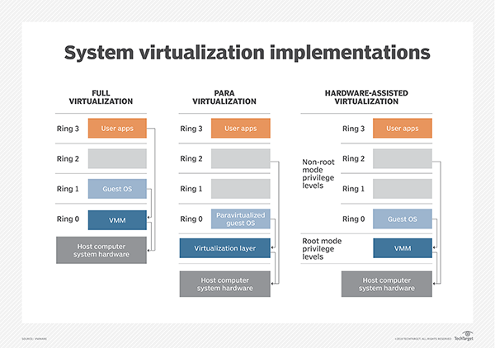

[lean about that a lot more]
software virtualization

software virtualization allow he application to run on a virtual platform or a container .it allows us to write cross platform application .the best example can be java. The java virtual machine or JVM .with that we can write a program and we can run on any platform like windows linux or mac.

Network virtualization

in network virtualization we take what we used in hardware and we put that in software so we can use in different place like VPN, and VLAN(virtual Local Area Network)

the reason we use virtualization that when we use the physical servers a lot of resources are wasted. and it require a lot of power and temperature control and they are expensive. In a specific hardware we run different types of application and the application may not utilize the full resources so we can use virtualization to run several virtualization unit and run different application in a one physical server. And use the resources more efficiently. A virtual server can be run from anywhere. If you use the multiple virtualization in a physical server instead of running each of them in the physical server you can reduce the cost and you may have to run cooling system in just one physical server. But you need proper planning before deploying virtual server. And there is a risk that if the physical server failed you may lost multiple server running on the instead of one.

Virtualization is now used in personal computer for building and testing application. You can make a isolated environment and test and develop your software without affecting the main operating system .you can use the hyper-V on windows and virtualbox for free in home computer.

Some security Principle for system administrator ans users

1) apply software updates regularly and consistently
2) Always use the firewall
3) using unique password
4) making Routine Backup
5) Not opening any unknown email
6) Not installing application that is not needed
7) if any application use plain text for password input. then avoid posting username and password
8) making strong user policy for the users in a company

