If hardware is the physical stuff that you can pick up and hold software is the intangible instruction that tell the hardware what to do

Types of software
1) application software
2) System software
3) Firmware

Application software:

any software created to fulfill a specific need like text editor web browser,or graphic editor

System software:

software used to keep out core system running ,like operating system tools and utilities

Firmware:

Software that’s permanently stored on a computer component
a perfect example is BIOS. Its located in a parmanent location BIOS is used to boot up your computer

Software version:
there are different rules for software versioning but the most used is
like [node 1.2.3]

1 => is the major version.
2 => is the minor upgrade
3 => is the patch

patch means bug fixes in the software. on the same version you may work fine with the minor and patch change if you upgrade the software but if you upgrade the software to new major version then your old application may break.

Binary translation depends on the type of hardware too . Different vendor software may work differently .but there are so many hardware vendor. so we use the abstraction layer .like we use a programming language to make software .a program built for a specific CPU can run on this CPU or CPU family .so we need that we can run a program that can be run on many CPU. Then comes the Compiled languages .compiled language use human readable language and then compiled into something that a computer can understand .compiler is the key component for programming .There is another language called the scripting language. The script is run by an interpreter .which interprets the code into CPU instruction just in time to run them

software can be done for many use

like driver is kind of software that are using for the interfacing

there are are utility software and other software for special need

in a IT support you will never install any software without the permission for the administrator

Operating system Level

Operating system has two main components

1) Kernel Space
2) User space

In the kernel space kernel does four different thngs

1) Process management
2) Memory management
3) File management
4) I/O management

File Management: file management is how we store and manage file which can be anything in the system. The file does not stored in a system randomly there are different file system and different file system have different feature for the file management.in a system we can store thousands of file but if the computer store it without any tracking mechanism it will be impossible to find and make use of it for handling file we need three key components

1) File System
2) Metadata
3) Data

1) File system : when we bought a hard drive we need to erase it and configure it before using it so the operating system can read and write data to it.this way the os can keep track of our file and for this purpose different file system is used.

A file system provides a way of separating the data on the drive into individual parts which are the files and define a way of storing the data

. there are a lot of file system depending on the encryption,speed and size that includes the encryption and faster speed

windows OS use the NTFS file system .

For MAC os the default file system is APFS this file system is journled .thats means it does a better job for saving your disk state in case of the disk failure

For linux the default system is ext4. Different file system may not compatible with each other.

2) Data : The data is stored in the system in the form of data blocks .when we save the data is stored in multiple piece .this is called block storage because the data is not stored in a single piece ,it broken down so it can be accessed quickly

3)Meta data : the last part of the file management is storing metadata. metadata is information attached to the file that may not be visible on the face of the file
metadata include this information

1) File owner
2) Permission
3) File size
4) Date Modified
5) Date Created
6) File type
7) file extension

Process management: we need to run multiple different types of program in our system but they may have different priority and different order and dependency and different memory requirement .kernel do that with its process management . when we run a program like firefox or text editor it execute one or multiple process. In a computer thee are a limited number of resources if we want to run multiple program kernel have to allocate the resources depending o their priority. kernel handle multiple process using proper management of the resources You may do multitasking in your system . Like programming and listening to music .this multitasking is possible using a kernel feature that is call process scheduler . The cpu does not actually does thing work together .the process scheduler switches the execution so fast the you think you are doing multiple task at once. CPU does not execute multiple process at once.the process scheduler changes job so fast that it just create a illusion that you are running multiple task at once.if the your resources is maxed out the process execution time interval (also called Time Slice ) can be longer so your machine can slow down. This also may cause unusual termination of application.

Memory management: Kernel optimize the memory usage and make sure that the application we are getting sufficient memory. Kernel uses a concept called the virtual memory that is the combination of swap memory and the RAM. So we have memory more that the ram .this swap memory is a part of the hard drive which is used as a backup if the memory maxed out. So to avoid the un usal termination of program but this swap space is much slower that the RAM. When we run a program we first take the data and then divide in pieces that is called pages then we store it to the virtual memory then this pages are send to the physical memory for execution

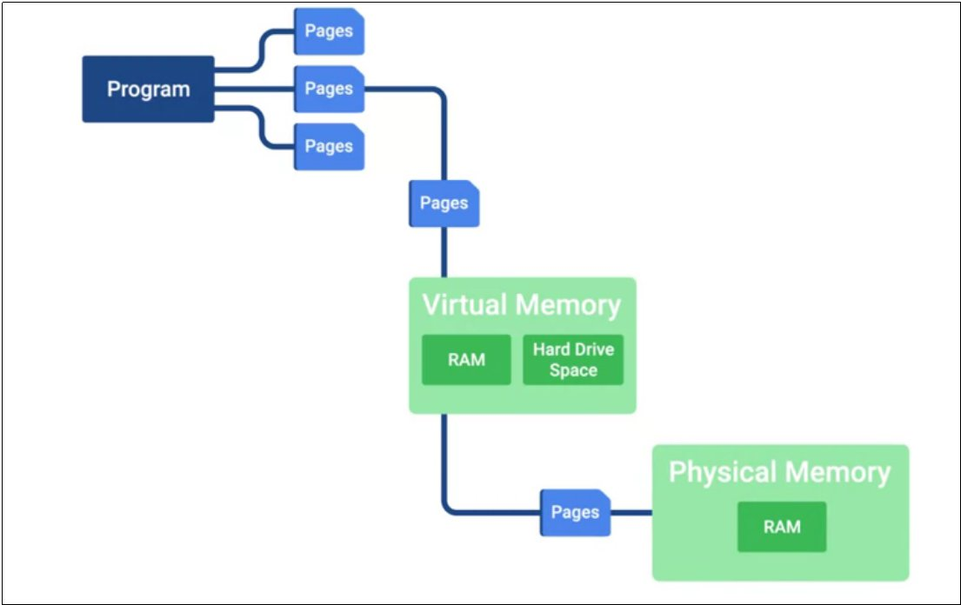

I/O management: I/O manager in kernel helps the computer to connect to the other peripheral device like disk ,keyboard etc kernel load the drivers to communicate with the devices and handle the communication between them

User space : User space is something that outside the kernel like program,system settings etc

