
AMERICAN INTERNATIONAL UNIVERSITY-BANGLADESH
Faculty of Engineering
Department of Electrical and Electronic Engineering

Midterm Lab Performance Test Evaluation Sheet

Experiment 14
Experiment Title: Make a red LED turn ON and a green LED turn OFF if the Arduino gets HIGH at one of its input pins and then do the opposite if the same input pin gets LOW, but both LEDs turn OFF after 5 s since the switch is pressed using the delay() function. Write the program in an IDE and implement it to show its functionality.

Date of Perform: | 17 November 2025 | Date of Submission: | 17 November 2025
Course Title: | Microprocessor and Embedded Systems Lab
Course Code: | EEE4103 | Section: | T
Semester: | Fall 2025-26 | Degree Program: | BSc in CSE
Course Teacher: | Prof. Dr. Engr. Muhibul Haque Bhuyan

General Instructions:
- One student will answer one question as per his/her ID numbers using Proteus Simulator within 30 minutes.

Declaration and Statement of Authorship:
- I understand that Plagiarism is the presentation of the work, idea, or creation of another person as though it is your own. It is a form of cheating and is a very serious academic offense that may lead to expulsion from the University. Plagiarized material can be drawn from and presented in written, graphic, and visual forms, including electronic data and oral presentations. Plagiarism occurs when the origin of the source is not appropriately cited.
- I also understand that enabling plagiarism is the act of assisting or allowing another person to plagiarize or copy my/our work.
* Student(s) must complete all details except the faculty use part.
** Please submit all assignments to your course teacher or the office of the concerned teacher.

Group #
Sl No | Name | ID | PROGRAM | SIGNATURE
14 | Md. Tanvir Islam Shishir | 23-53454-3 | BSc in CSE

Faculty use only
FACULTY COMMENTS | Marks Obtained
 | Total Marks | 30

Marking Rubrics (to be filled up by the Faculty:

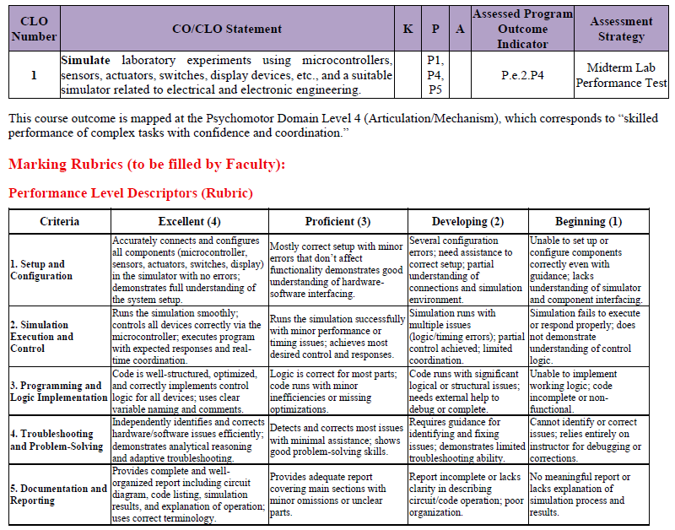

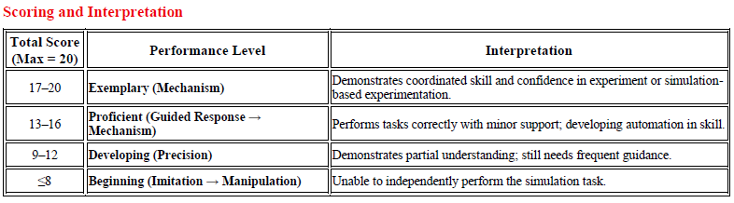

Experiment # Experiment Title | Student ID # | Name
- Make an LED blink continuously every 2 s while using Arduino and one of its timers to generate the delay without the built-in delay() function. Write the program in an IDE and implement it to show its functionality. | 21-45286-2 | SAZZAD, HOSSEN
- Make an LED turn ON for 6 s if it gets HIGH at the input pin of the Arduino and then turn OFF by using Arduino and one of its timers to generate the delay without the built-in delay() function. Write the program in an IDE and implement it to show its functionality. | 22-47807-2 | ALAM, MD. SHIFUL
- Make a red LED turn ON and a green LED turn OFF if the Arduino gets HIGH at one of its input pins, and then do the opposite if it gets a LOW. Write the program in an IDE and implement it to show its functionality. | 22-49620-3 | ABDULLAH, NAQIB
- Make two LEDs (red and green) turn ON and OFF for 2 s alternatively by using Arduino and its delay() function. Write the program in an IDE and implement it to show its functionality. | 22-49926-3 | KABIR, MOHAMMAD SADMAN
- Make two LEDs (red and green) turn ON and OFF for 2 s alternatively by using Arduino and one of its timers. Write the program in an IDE and implement it to show its functionality. | 23-50578-1 | MAHIN, MD. SAIDUR RAHMAN
- Implement a 4-lane junction traffic light control system having 4 LEDs (2 red and 2 green) using Arduino and built-in delay() function for the delay. Write the program in an IDE and implement it to show its functionality. | 23-50847-1 | BARIA, CHOWDHURY TAZNIN KARIM
- Make two LEDs (red and green) turn ON and OFF for 4 s alternatively by using Arduino and one of its timers. Write the program in an IDE and implement it to show its functionality. | 23-52254-2 | RAFEE, RAFEEU AHMED
- Make an LED blink continuously every 2 s while using the STM32 system frequency and its built-in function to generate the delay. Write the program in STM32CubeIDE and implement it to test the functionality. | 23-53027-3 | ROSHNI, SUMAIYA AKTER
- Make an LED blink continuously every 4 s while using the STM32 system frequency and its built-in function to generate the delay. Write the program in STM32CubeIDE and implement it to test the functionality. | 23-53227-3 | PRACHI, PROTITI SAHAJEE
- Implement a 4-lane junction traffic light control system having 2 red and 2 green LEDs using Arduino and one of its timers to generate the delay without any application of the built-in delay() function for the delay. | 23-53229-3 | PRANJAL, ABRAR ADNAN
- Make two LEDs (red and green) turn ON and OFF for 2 s alternatively by using STM32 and its delay() function. Write the program in STM32CubeIDE and implement it to show its functionality. | 23-53232-3 | HAQ, PROGGA FARIBA
- Make two LEDs (red and green) turn ON and OFF for 2 s alternatively by using STM32 and one of its timers. Write the program in STM32CubeIDE and implement it to show its functionality. | 23-53449-3 | SHAH, MD. TANZIM WASIF
- Implement a 4-lane junction traffic light control system having 2 red and 2 green LEDs using STM32 and its delay function. Write the program in STM32CubeIDE and implement it to show its functionality. | 23-53450-3 | RAHIN, MD. RAYATUL BARI
- Make a red LED turn ON and a green LED turn OFF if the Arduino gets HIGH at one of its input pins and then do the opposite if the same input pin gets LOW, but both LEDs turn OFF after 5 s since the switch is pressed using the delay() function. Write the program in an IDE and implement it to show its functionality. | 23-53454-3 | SHISHIR, MD. TANVIR ISLAM
- Make a red LED turn ON and a green LED turn OFF if the Arduino gets HIGH at one of its input pins and then do the opposite if the same input pin gets LOW, but both LEDs turn OFF after 5 s since the switch is pressed using a timer for the delay. Write the program in an IDE and implement it to show its functionality. | 23-53457-3 | NIPUN, IBNA AL SHAID
- Make two LEDs (red and green) turn ON and OFF for 4 s alternatively by using STM32 and one of its timers. Write the program in STM32CubeIDE and implement it to show its functionality. | 23-53570-3 | ROY, PROTTOY
- Implement a simple traffic light control system using Arduino and its built-in delay() function for the delay. Write the program in an IDE and implement it to show its functionality. | 23-53629-3 | AYSHE, JANNATUL FERDOUSI
- Implement a simple traffic light control system using STM32 and its built-in delay() function for the delay. Write the program in STM32CubeIDE and implement it to show its functionality. | 23-54073-3 | MONDAL, MD. JOHA
- Make an LED turn ON for 4 s, turn OFF for 2 s, and finally blink another LED 5 times every 1 s using an Arduino and one of its timers to generate the delay without the built-in delay() function for the delay. Write the program in an IDE and implement it to show its functionality. | 23-54079-3 | ROY, BIPRO
- Make an LED turn ON for 4 s, turn OFF for 2 s, and finally blink another LED 5 times every 2 s using an Arduino and built-in delay() function. Write the program in an IDE and implement it to show its functionality. | 23-54120-3 | SALEHIN, MD. SALFI
- Make an LED blink 5 times every 3 s and then turn ON this LED forever using an Arduino and built-in delay() function to generate the delay. Write the program in an IDE and implement it to show its functionality. | 23-54121-3 | BHATTACHARJEE, DIP
- Make an LED blink 5 times every 2 s and then turn ON this LED indefinitely using an Arduino and one of its timers to generate the delay. Write the program in an IDE and implement it to show its functionality. | 23-54484-3 | HASAN, MD. RAKIBUL
- Make an LED blink 5 times every 2 s and turn ON another LED indefinitely using an Arduino and one of its timers to generate the delay. Write the program in an IDE and implement it to show its functionality. | 23-54486-3 | JIM, MD JARIF ISLAM
- Make an LED blink 4 times every 1 s and turn ON another LED indefinitely using an Arduino and one of its timers to generate the delay. Write the program in an IDE and implement it to show its functionality. | 23-54488-3 | ANIN, MD. MOHAIMINUL HASAN
- Make an LED blink 4 times every 1 s and turn ON another LED forever using an Arduino and its built-in delay() function to generate the delay. Write the program in an IDE and implement it to show its functionality. | 23-54491-3 | OSMANY, WASEE BIN
- Make an LED blink 4 times every 2 s, turn ON another LED for 4 s, and finally turn OFF both LEDs using an Arduino and delay() function. Write the program in an IDE and implement it to show its functionality. | 23-54500-3 | SIMLA, SAMIA AFROZE
- Make an LED blink 4 times every 2 s, turn ON another LED for 4 s, and finally turn OFF both LEDs using an Arduino and one of its timers to generate the delay. Write the program in an IDE and implement it to show its functionality. | 23-54504-3 | SALMA, UMMAY
- Make an LED turn ON for 2 s using an Arduino and its built-in delay() function to generate the delay if an input switch is pressed to HIGH; otherwise, it remains turned OFF. Write the program in an IDE and implement it to show its functionality. | 23-54513-3 | AFRIN, SADIA
- Make a green LED to turn ON for 2 seconds and a red LED to turn OFF using an Arduino and its delay() function to generate the delay if an input switch is at HIGH, otherwise it remains turned OFF, but at that time the red LED will turn ON indefinitely. Write the program in an IDE and implement it to show its functionality. | 23-54595-3 | NAEEM, MD HOZRAT ALI
- Make an LED blink 4 times every 2 s using an Arduino and its built-in millis() function for the delay. Write the program in an IDE and implement it to show its functionality. | 23-54716-3 | BORSHA, J.M.EFATA NUSRAT
- Make two LEDs (red and green) turn ON and OFF for 4 s each. The red LED will turn ON and the green LED will turn OFF for 2 s if the Arduino gets a HIGH at one of its input pins and then do the opposite if the input pin gets a LOW. Use STM32’s built-in functions, HAL_GPIO_ReadPin(), HAL_GPIO_WritePin(), and HAL_Delay() functions. to generate the delay. Write the program and implement it to show its functionality. | 23-54908-3 | AKTER, SURMA
- Make an LED turn ON for 2 s, turn OFF for 1 s, and finally blink another LED for 5 times every 1 s using an Arduino and one of its timers to generate the delay without any application of delay() function to generate the delay. Write the program in an IDE and implement it to show its functionality. | 23-54985-3 | TASNIM, JARIN
- Make an LED turn ON for 3 s, turn OFF for 2 s, and finally blink another LED 4 times every 1 s using an Arduino and one of its timers to generate the delay without any application of delay() function for the delay. Write the program in an IDE and implement it to show its functionality. | 23-54986-3 | ARIAN, M.SAKIB SADMAN
- Make two LEDs blink continuously every 2 s and 4 s using an STM32 microcontroller using its built-in functions HAL_GPIO_WritePin() and HAL_Delay(). Write the program in STM32CubeIDE and implement it to test the functionality. | 23-55016-3 | PURNIMA, SOUROVI AKTER
- Make a series of 3 LEDs (red, green, and yellow) to flash in a specific sequence, and upon pressing the switch connected to an I/O pin, the sequence will reverse the direction using an Arduino and its in-built delay() function to generate the delay. Write the program in an IDE and implement it to show its functionality. | 23-55111-3 | SHANTO, MD NAZMUL ALAM
- Make a series of 4 LEDs (red, green, white, and yellow) to flash in a specific sequence, and upon pressing the switch connected to an I/O pin, the sequence will reverse the direction using an Arduino and one of its timers to generate the delay. Write the program in an IDE and implement it to show its functionality. | 23-55332-3 | ANIKA, ANIMA FERDUSHI
- Make a series of 4 LEDs (red, green, white, and yellow) to flash in a specific sequence, and upon pressing the switch connected to an I/O pin, the sequence will reverse the direction using an Arduino and its in-built millis() function to generate the delay. Write the program in an IDE and implement it to show its functionality. | 23-55618-3 | NIBIR, BADHON ROY
- Make two LEDs blink continuously every 2 s using an Arduino and one of its timer interrupt vectors as well as timer interrupt mask (TIMSKn) and output compare (OCRnx) registers (n = 0-2, x = A, B) to blink the LEDs. Write the program in an IDE and implement it to show its functionality. | 23-55693-3 | ISLAM, MUHAMMAD TANZIMUL

Simulation:
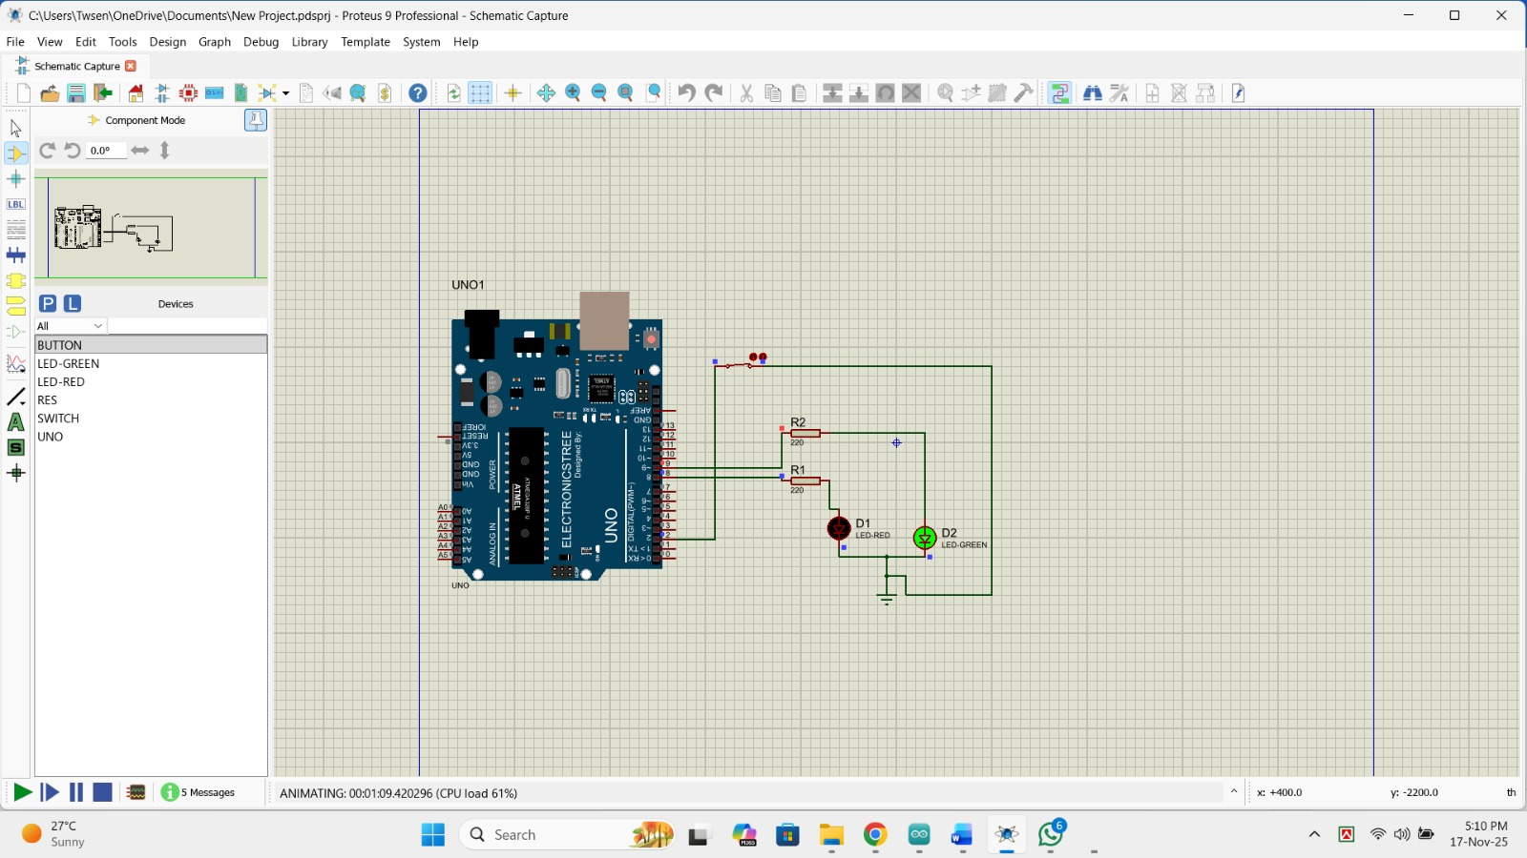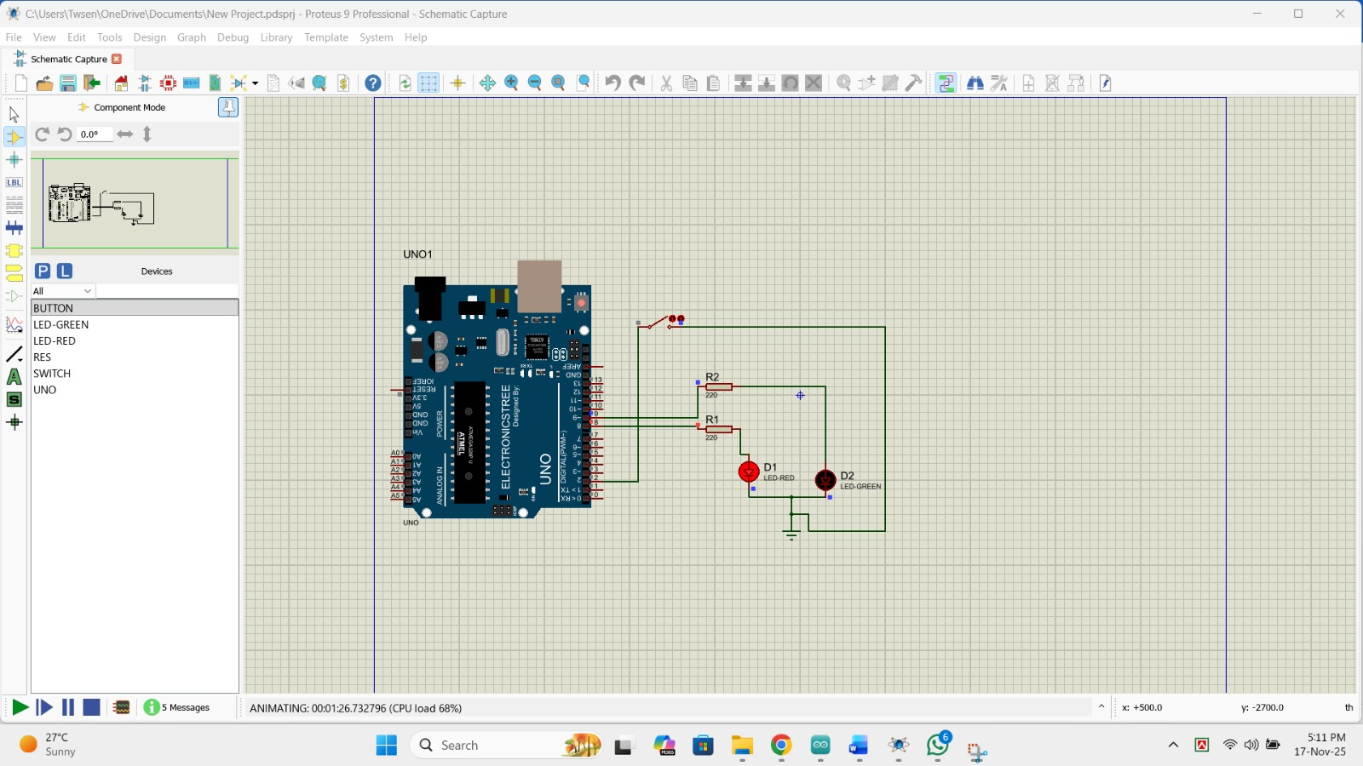

CODE:

