**FashioNXT Project**

**Team Members and Roles:**

* Chienpeng Huang (Scrum Master)
* Xiaomeng Liu (Project Owner)
* Jiahua Cheng
* Mingyu Tao
* Elizabeth Park
* Szukai Chen
* Chunjung Huang

**Customer meeting:**

We scheduled meetings with customers on 04/16/2021 at 4pm. We showed the customer what we have developed and showed him the bugs we found in the current application. Then we discussed which bugs we’re going to solve and which features we’re going to develop for this week.

**Summary:**

We have picked 2 user stories and done many UI improvements asked by the customer. We divided the main project into two parts which is landing page and personal profile page. There is one user story finished under the landing page and many UI improvements finished under both pages.

**Design diagram of part A:**

Create a link for redirecting to the search engine page.

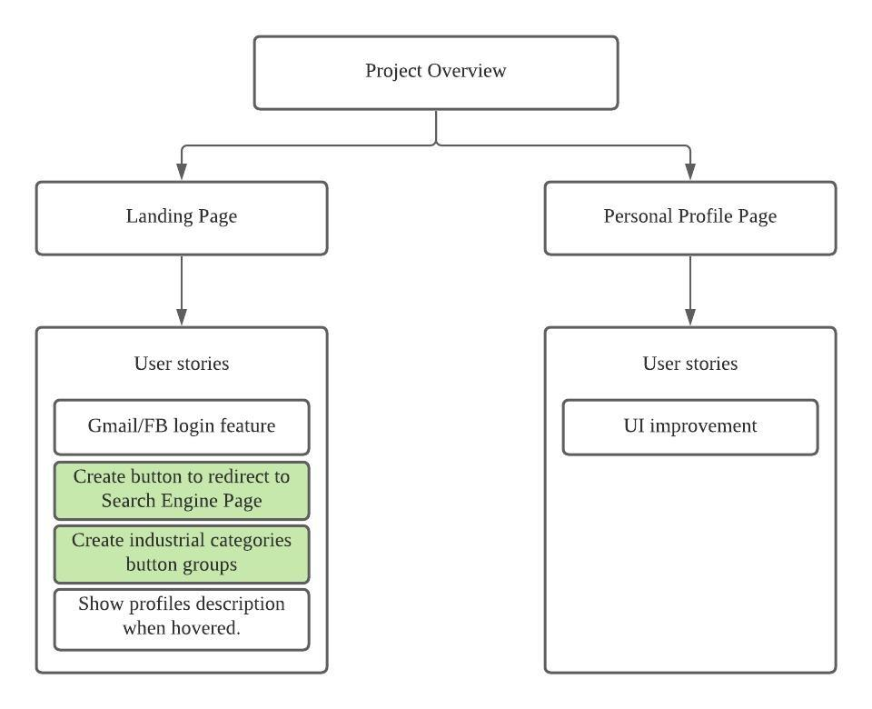

**Result of part A:**

**Before**

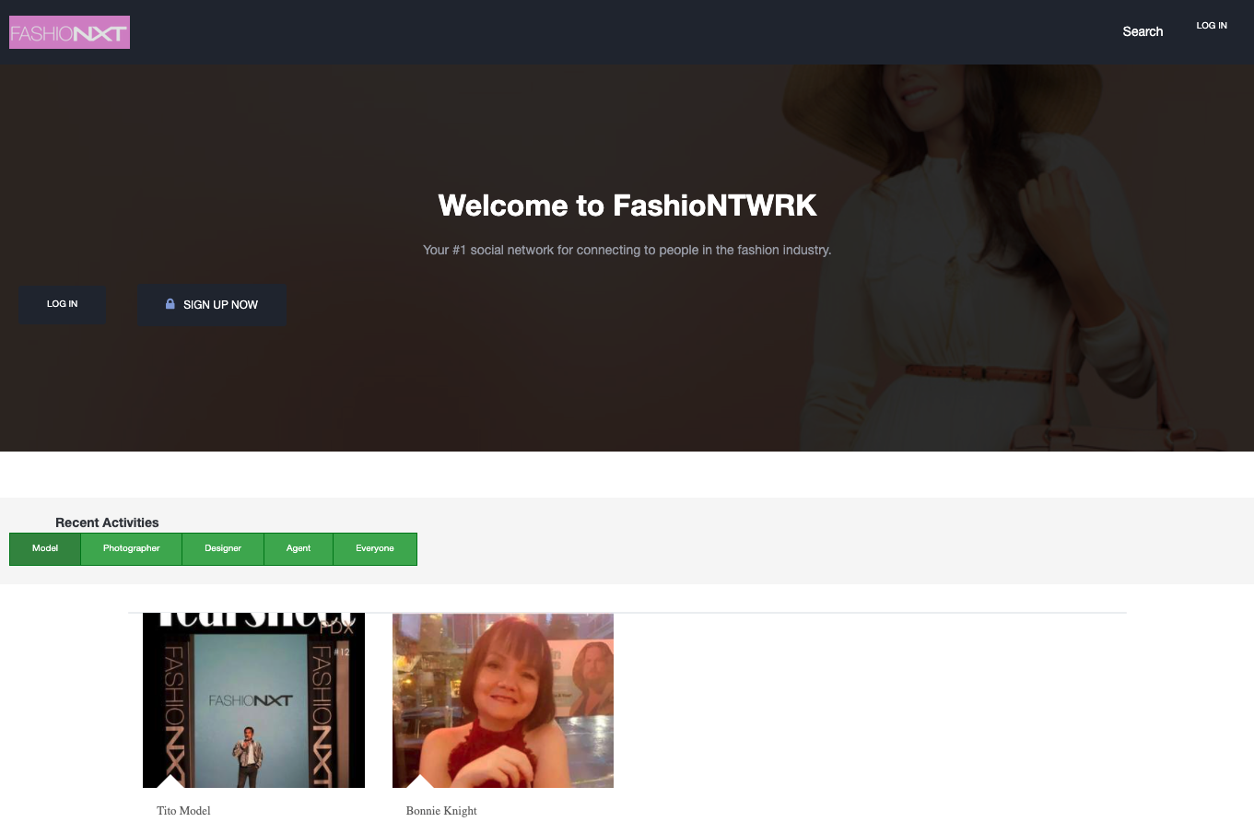

**After**

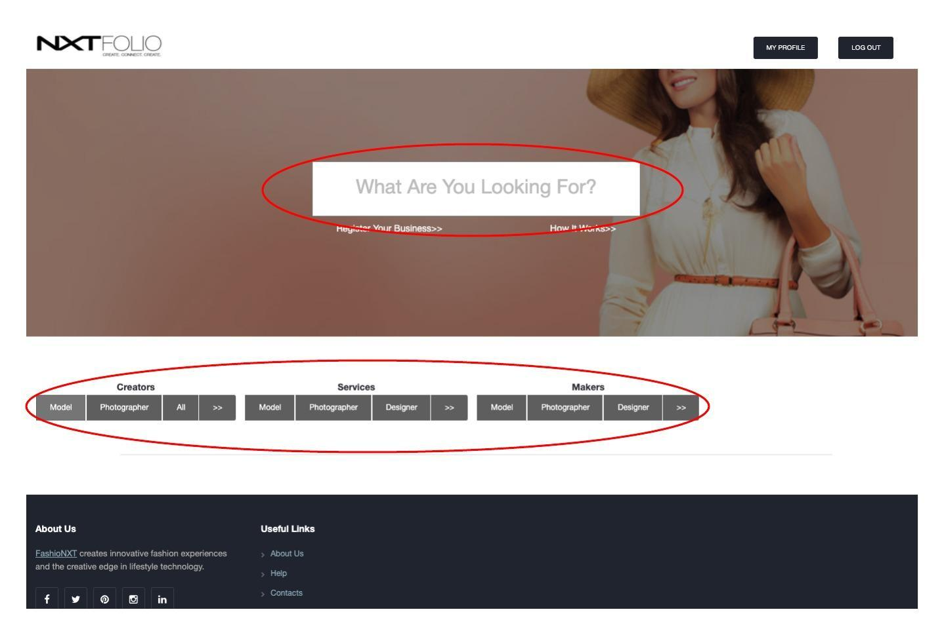

**Test result of features in part A:**

We create the cucumber test code to test the new feature button. Besides it, we enhance the functionality which allows us to test external URLs.



**What else we do in this iteration:**

1. **[Chienpeng Huang, Jiahua Cheng] Using partials to DRY code:** For example, each page has their own header html and they are almost the same. This would make code fat and not easy to maintain. To solve this, we build a header partial under view/shared and render it on every page when we need. It’s also easier to control display and user experience.
2. **[Elizabeth Park] Gmail/FB authentication:** We have built the feature which lets users login through their Gmail/FB account. Currently, we have success to login through facebook. Next, we’ll implement the Gmail login function and include the whole feature result in the next iteration report.

**What we are still working on:**

1. We have built the structure of the second user story, we’re working on building test cases and then developing the detailed features based on the test codes.
2. Build test code for the third user story which is letting users login by Gmail/FB account.

**Design diagram of B:**

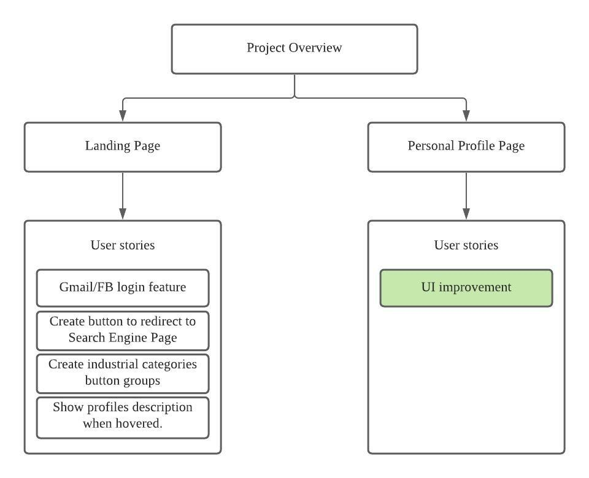

**Result of B:**

**Before**

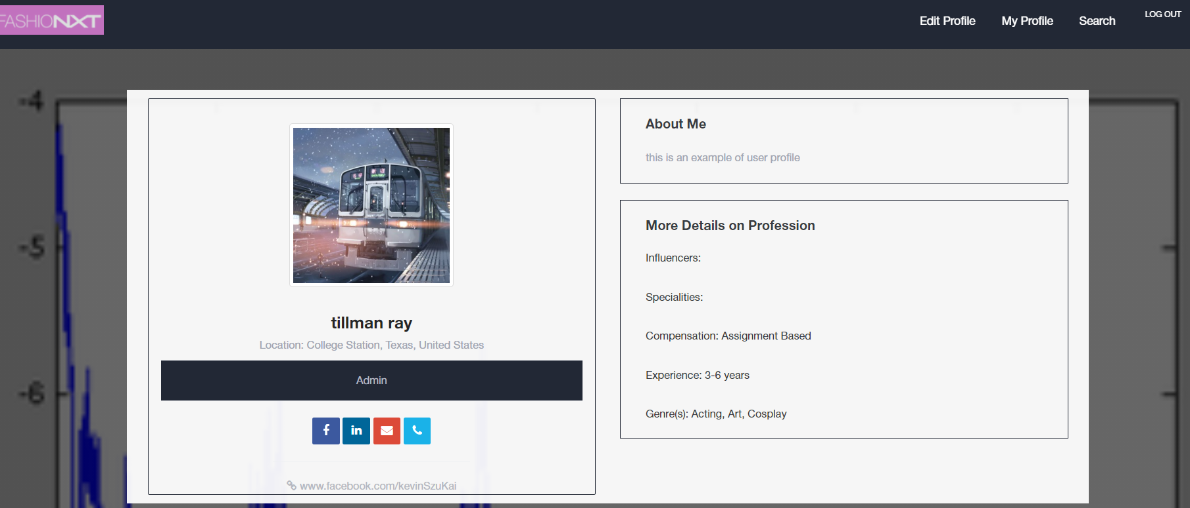

**After**

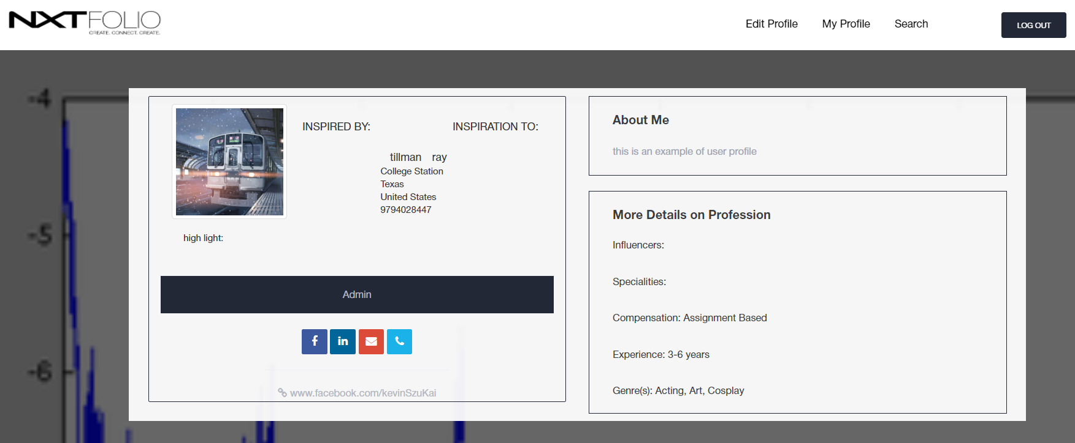

**Test result of feature B:**

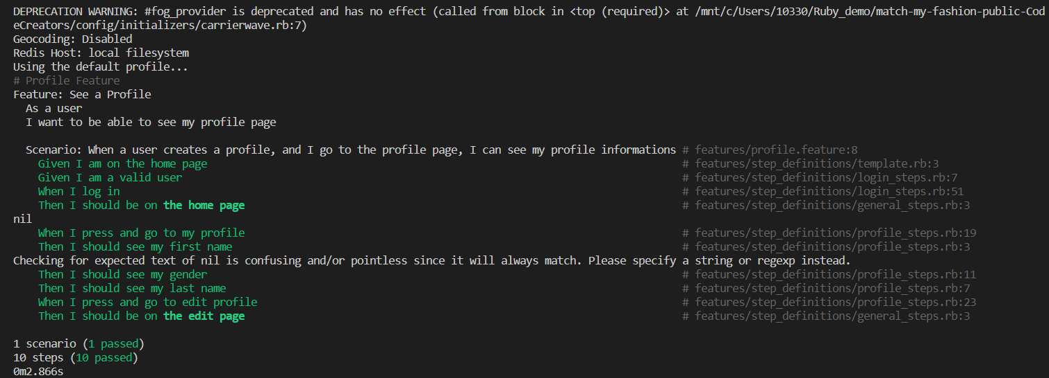

**What else we do in this iteration:**

1. **[Szu-Kai Chen] Improve Gallery in personal profile:** It contains several errors in the gallery. For example, after uploading the new project pictures, the previous project would not show in the gallery. Also, users could only upload their pictures as a project, but they could not add the titles and descriptions.
2. **[Mingyu Tao] Improve UI in personal profile:** Improve the edit-personal profile page. The previous edit page is unable to update the designer’s information. Users can only edit the designer's page when First sign up.

**What we are still working on:**

1. We continue to modify the user interface to provide better user experience for the users. For example, the highlight block that the users could add some sentences to shine their profile.
2. We are still working on a page that users could upload their projects, including title, pictures, and descriptions.
3. Following the customer’s request to do more improvement in the UI page.

**Github:** [**https://github.com/chienpeng/match-my-fashion-public-CodeCreators**](https://github.com/chienpeng/match-my-fashion-public-CodeCreators)

**Heroku:** [**https://polar-chamber-51045.herokuapp.com/**](https://polar-chamber-51045.herokuapp.com/)