**FashioNXT Project**

**Team Members and Roles:**

* Chienpeng Huang (Scrum Master)
* Xiaomeng Liu (Project Owner)
* Jiahua Cheng
* Mingyu Tao
* Elizabeth Park
* Szukai Chen
* Chunjung Huang

**Customer meeting:**

We scheduled meetings with customers on 04/23/2021 at 4pm. In the previous iteration, we have completed three of the user stories that we promised in iteration 0. Besides, we deployed our code on Heroku. At the meeting, we presented our application to the customer and discussed the plan for the next iteration. The customer asked us to deliver two main tasks for the upcoming week. First, we will need to complete the user story of the project gallery. Second, we will improve the search engine for the web application.

**Summary:**

In this iteration, we picked three user stories at the beginning. We finished two of them at the end of the week. First, we completed the user story “Show profile description when hover”. When the user hovers the member picture at the home page, it would show the member’s information, including name, location, and description. Besides, when the user clicks the picture, he would be redirected to the member's profile page. Second, we added the Gmail/FB login feature into our web application. Right now, users could use third-party authorization to log in into their account.

We also worked on the “project gallery” feature this week. However, we could not implement the feature into the application on time. This feature is too complicated to deliver within one week. We will continue to work on this feature for the upcoming week. Besides, after the meeting with our customer, he asked our team to improve the search engine. Therefore, our team would divide into two groups and work on two features, which are “project gallery” and “search engine” for the next week.

**User stories implemented in this iteration:**

1. It shows information of members when hovered on the profile.
2. Login to FashionNXT via Facebook account.

**Design diagram:**

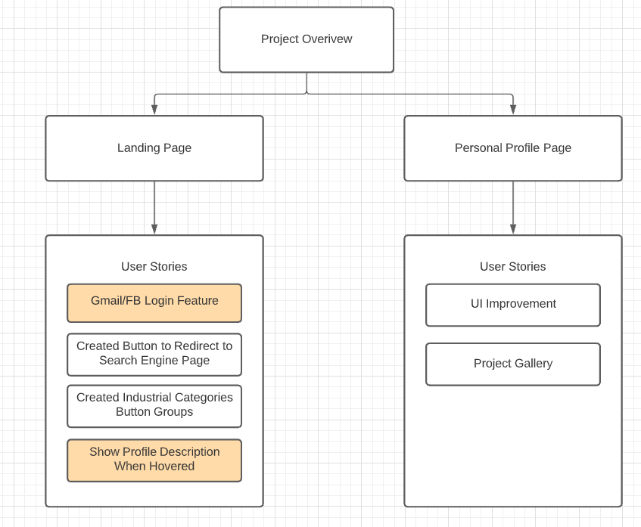

|  |
| --- |
| **User Stories:**  It shows information of members when hovered on the profile.  **Before**    **After**    **Test result of features:** |

|  |
| --- |
| **User Stories:**  Login to FashionNXT via Facebook account.  **Before**    **After**    **Test result of features:** |

**What else we do in this iteration:**

1. **[Mingyu Tao and Szu-Kai Chen]Project Gallery Feature:** Based on customer’s requirement, the project gallery should contain multiple pictures, description, and rating system. As a result, we plan to create a new table in the database, and to create two or more pages to implement this feature into our web application.

**What we are still working on:**

1. We will continue to work on the “project gallery” feature for the next week.
2. We would discuss and plan how to improve the search engine in our web application, including user experience improvements and search engine optimization.
3. As a legacy project, we will continue to improve the code quality and try to do refactoring.

**Github:** [**https://github.com/chienpeng/match-my-fashion-public-CodeCreators**](https://github.com/chienpeng/match-my-fashion-public-CodeCreators)

**Heroku:** [**https://fashionnxt.herokuapp.com/**](https://fashionnxt.herokuapp.com/)