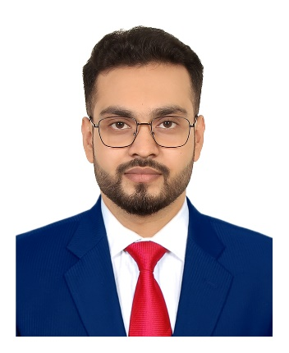**RESUME OF**

**TANVIR MAHMUD**

Contact address

97/B Mahbub-Ara Villa,

1st Lane, Malibagh, Dhaka.

**Mobile: +088 01701744799**

**E-mail: tanvirmahmud.cse66@gmail.com**

**CARRIER OBJECTIVE**

I am a self-motivated, dynamic, energetic, ambitious and hard-working person looking for a challenging job where I can apply my knowledge and honesty to do something innovative and creative and that gives me mental satisfaction and develops myself for upcoming challenging world.

**EDUCATION QUALIFICATION**

**B.SC (Bachelor of Science)**

Institution : Stamford University Bangladesh

Department : Computer Science & Engineering (CSE)

Result : Approximate CGPA: 3.12 out of 4.00

Session : 2018-2022

**H.S.C (Higher Secondary School Certificate)**

Institution : New Govt. Degree College Rajshahi

Group : Science

Result : GPA 5.00

Board : Rajshahi

Passing Year : 2016

**S.S.C (Secondary School Certificate)**

Institution : Islami Academy High School

Group : Science

Result : GPA 5.00

Board : Rajshahi

Passing Year : 2014

**COMPUTER SKILL**

Languages : C, C++ (expert), JAVA (advance), PYTHON (basic),

JAVASCRIPT (advance)

Programming Skill : Data Structure(advanced), Algorithms(advanced), Object

Oriented Programming(expert)

Web Development : HTML5, CSS3, SASS, BOOTSTRAP, JAVASCRIPT

Operating System : Linux (Ubuntu), Windows

Application Software : Adobe Premier Pro, Figma, Illustrator, Adobe Photoshop

Microsoft Office (Word, Excel, PowerPoint)

Problem Solving Platform : Codeforces, CodeSafe, HackerRank, Toph & LeetCode

Others Skill : Working Proficiency with Terminal, 58WPM Typing Speed With

Punctuation (Touch Typing), Video Editing, Youtube Content Creation

**LANGUAGE PROFICIENCY**

|  |  |  |  |  |
| --- | --- | --- | --- | --- |
| Language | Writing | Reading | Speaking | Understanding |
| Bengali | Expert | Expert | Expert | Expert |
| English | Expert | Expert | Advanced | Advanced |

**PERSONAL INFORMATION**

Father’s Name : Md. Abdur Rashid

Mother’s Name : Mahmud Begum

Permanent Address : Vill: Uttor Millik Bagha, P.O: Bagha-6280, P.S: Bagha, Dist: Rajshahi.

Present Address : 97/B – 1st Lane Malibagh, Dhaka-1217.

Date of Birth : 05th March, 1998.

Nationality : Bangladesh (By birth)

Blood Group : O+ (ve)

Religion : Islam

Sex : Male

Marital Status : Unmarried

**EXTRA CURRICULAM ACTIVITIES**

* Member of Stamford University ACM Student Chapter.
* Member of Stamford University Computer Society (SUCS).

**CERTIFICATE**

* Inter-University Programming Contest (IUPC) 2022, RUET.
* Inter-University Programming Contest (IUPC) 2022, BUET.

**REFERENCE**

**Ref-1:**

Name : Eng. Mahedy Hasan

Occupation : Senior Executive Officer, Technical, Credit Risk Management(CRM-CD)

Organization : IDLC Finance Ltd.

Email : mahedy@idlc.com

**Ref-2:**

Name : Dr Mst. Mahmuda Parvin

Occupation : Assistant Professor, Dept. of Environmental Science, Stamford University

Bangladesh.

Email : mahmudaalam@yahoo.com

**DECLARATION**

I do hereby declare that the particulars written above are true to the best of my knowledge. I also promise to work hard to perform my duties properly for a successful career.



(Tanvir Mahmud)