**Project: Employee Attrition Analysis using Power BI**

**Project Overview**

This project analyzes employee attrition data to identify key factors that contribute to employee turnover. The objective is to provide insights that can help in developing strategies to reduce attrition rates. The analysis was conducted using a Power BI dashboard to visualize and interpret data trends effectively.

**Data Source and Description**

The dataset contains information on various employee attributes, including:

* Demographic details: Age, Gender, Education Level, Job Role
* Work-related factors: Job Level, Department, Business Travel, Distance From Home
* Employee satisfaction: Environment Satisfaction, Work-Life Balance, Relationship Satisfaction
* Performance indicators: Percent Salary Hike, Performance Rating, Years at Company

The data helps in understanding the relationship between these factors and employee attrition.

**Key Insights and Analysis**

Through the Power BI dashboard, the following insights were derived:

* **Department-Wise Attrition**:
  + The highest attrition rates are observed in the *Sales* and *Research & Development* departments, suggesting a need for closer examination of these areas.
  + *Human Resources* has a relatively lower attrition rate.
* **Impact of Job Roles**
  + Job roles such as *Laboratory Technicians* and *Sales Executives* have higher attrition rates, indicating possible dissatisfaction or better opportunities outside the company.
  + *Research Scientists* show relatively better retention.
* **Influence of Education Level**
  + Employees with a *Diploma/High School* level of education show higher attrition compared to those with higher education (e.g., *Masters*, *Doctorate*). This could indicate that education level may correlate with job stability.
* **Work-Life Balance and Satisfaction**
  + Employees with poor work-life balance ratings are more likely to leave, reinforcing the importance of maintaining a positive work environment.
  + Dissatisfied and very dissatisfied employees in terms of environmental satisfaction show higher attrition rates.
  + Relationship satisfaction also plays a significant role; *low satisfaction* is a strong indicator of higher attrition.
* **Demographic Trends**
  + *Younger employees* (ages 20-30) are more likely to leave compared to older age groups, potentially indicating a trend where younger employees are more willing to seek new opportunities.
  + *Gender* does not show a major disparity in attrition, suggesting that other factors play a more significant role.
* **Effect of Business Travel**
  + Employees who frequently travel for business have higher attrition rates than those who rarely or never travel, indicating possible stress or dissatisfaction related to travel.
* **Performance and Compensation**
  + Employees with lower performance ratings and percent salary hikes are more likely to leave, showing that competitive compensation and acknowledgment of good performance can aid in retention.

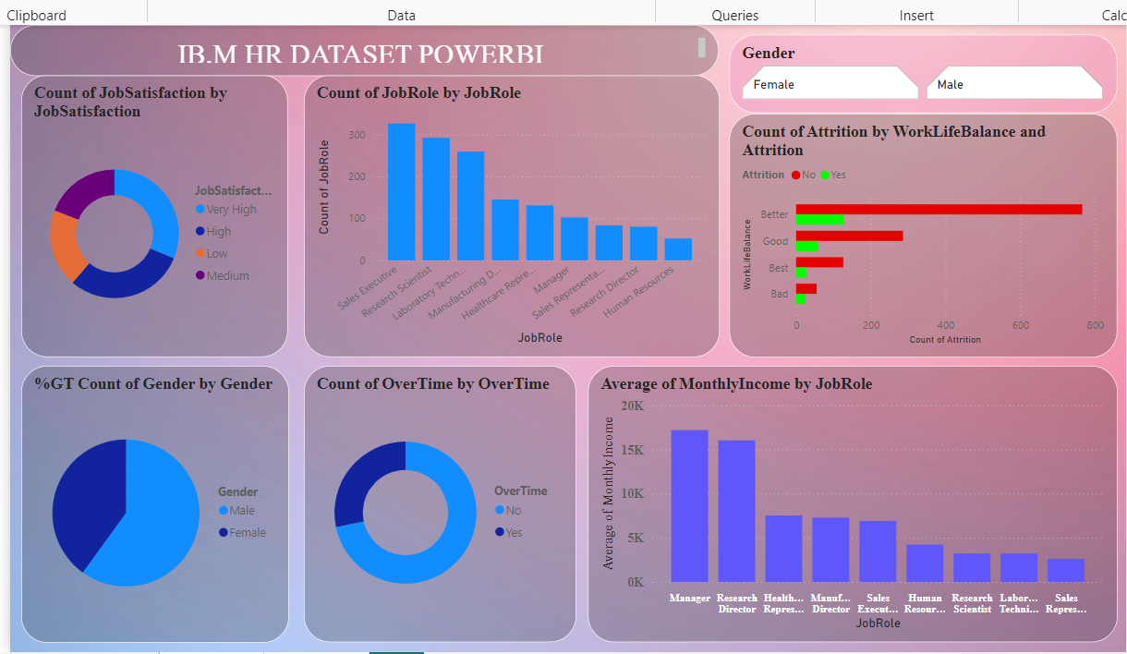

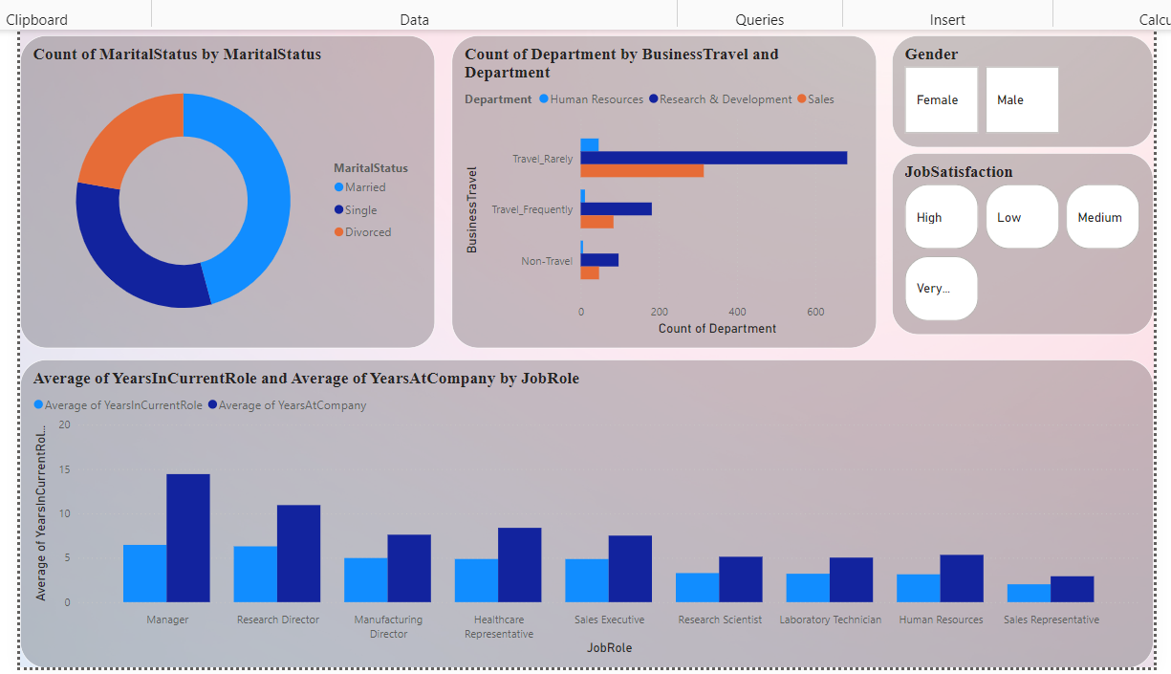

**Visualizations Included-**

The Power BI dashboard includes:

* **Attrition Overview:** Provides a general view of overall attrition rates.
* **Departmental Analysis:** Visuals comparing attrition rates across different departments.
* **Demographics Insights**: Charts showing how age, gender, and other demographic factors relate to attrition.
* **Satisfaction Metrics:** Graphs and metrics indicating the impact of satisfaction levels on employee retention.
* **Attrition Rate by Department:** Highlights which departments have the highest rates of employee attrition.
* **Attrition Rate by Job Role:** Shows which job roles are more prone to attrition.
* **Attrition Rate by Education Level:** Demonstrates how education level impacts attrition.
* **Attrition Rate by Work-Life Balance:** Displays the correlation between work-life balance ratings and attrition.

**How to Use the Power BI Dashboard-**

* **Filter Options**: Use the filters on the dashboard to explore data based on specific criteria (e.g., Department, Gender, Job Level).
* **Interactive Charts-** Click on segments of the charts to drill down into more detailed information.
* **Export Functionality:** Insights and charts can be exported for reporting purposes.

**Conclusion-**

The analysis provides valuable insights into the factors contributing to employee attrition, enabling companies to implement targeted strategies to improve retention. The visualizations facilitate easy understanding and exploration of the data, making it a useful tool for HR teams.