Carbon Leakage Signals in EU Industry
An exploratory assessment of production, emissions, trade, imported carbon and carbon credit project records
  - EU27 | Historical analysis: 2008–2022 | Conditional scenarios through 2030
Research report for a nontechnical audience

Main finding
The data show descriptive patterns that warrant attention, especially in chemicals (C20) and other non-metallic mineral products (C23). They do not establish that EU climate policy caused production to move abroad. The 2030 values illustrate what past trends would imply if continued; they are not forecasts.
Prepared 23 September 2026

Executive Summary
This report explores whether changes in EU27 industrial production, domestic emissions and extra-EU imports are consistent with carbon-leakage risk. Carbon leakage is a concern when climate policy contributes to production moving to places with weaker climate constraints, or when imports from those places replace EU production and emissions. Establishing that this happened requires evidence about cause and displaced production. The data assembled here support screening for risk, not a causal verdict.
Across five broad industrial divisions, C20 (chemicals) and C23 (other non-metallic mineral products, including cement-related activity) show the clearest combination of lower EU production value and emissions alongside higher extra-EU import values and higher modelled emissions embodied in imports between 2008 and 2022. These are endpoint comparisons. Statistical trend tests show clear movements in some component series, but not a statistically established persistent four-part pattern.
- C20: production value −3.9%; domestic emissions −34.8%; extra-EU import value +66.2%; embodied emissions in imports +10.4%.
- C23: production value −12.5%; domestic emissions −29.5%; extra-EU import value +26.4%; embodied emissions in imports +51.9%.
- C19 (coke and refined petroleum products) has severe product-coverage limitations in the production extract. Its apparent production increase is not a reliable sector-wide result.
- For C19, C20 and C23, modelled emissions embodied in extra-EU imports exceeded those embodied in extra-EU exports in 2008 and 2022. The balance widened, but it does not show that EU policy caused the difference.
- OffsetsDB records 19.31 million credits issued and 13.70 million retired for projects hosted in EU27 countries in its June 2026 snapshot. Registry events are not measured industrial leakage. Three project reports document different project-level accounting and cannot be added or directly compared.
- Conditional 2030 scenarios extend historical trends. Results depend on the chosen time window and omit future policy, technology, prices and shocks.
The most defensible conclusion is that the analysis identifies descriptive leakage-risk signals and examples of project-reported leakage accounting. It does not identify causally established leakage. Stronger product, facility, trade and counterfactual evidence would be needed for a causal conclusion.

How to read this report
“Risk signal” means a pattern consistent with leakage that deserves follow-up. “Project-reported leakage” means a carbon project’s documents estimate, deduct or discuss leakage under that project’s rules. “Causally established leakage” means evidence supports the claim that a policy or intervention caused emissions to shift elsewhere. The report keeps these evidence levels separate.

Contents
- 1 Research question and scope
- 2 What carbon leakage means
- 3 Data and coverage
- 4 Measures and analytical approach
- 5 Industry-level findings
- 6 Product-level findings
- 7 Embodied emissions in imports and exports
- 8 The monetary perspective
- 9 Carbon credit projects and leakage accounting
- 10 Conditional scenarios through 2030
- 11 Conclusions and next research steps
- Glossary
- References

1 Research question and scope
The study asks whether EU27 industries show a descriptive pattern of declining domestic production and emissions alongside growing extra-EU imports and imported embodied emissions. It also reviews what EU-hosted carbon-credit project records say about issuance, retirement and leakage within those projects, and illustrates what selected historical patterns would imply through 2030 if they continued.

Research questions
- Which broad sectors show falling production and emissions with rising extra-EU imports and imported embodied emissions?
- Are these directions persistent over time or visible only between the first and last years?
- How do emissions embodied in extra-EU imports compare with those embodied in EU exports?
- What do EU-hosted project and registry records reveal about credits and project-reported leakage?
- What conditional paths to 2030 follow from extending historical trends, and how sensitive are they to the fitted period?

Geographic and industry scope
Geography is EU27 throughout. The industry analysis covers 2008–2022, the common window across selected measures. NACE divisions include C17 paper and paper products; C19 coke and refined petroleum products; C20 chemicals and chemical products; C23 other non-metallic mineral products; and C24 basic metals. C24 includes steel and other metals, so this is not a steel-only study. These are economic activity codes, not product codes [8].
OffsetsDB projects form a separate evidence stream. A project hosted in an EU country does not necessarily offset EU industrial emissions, and project host country does not identify the credit buyer.

2 What carbon leakage means
The European Commission describes carbon leakage as a situation in which companies transfer production to countries with less stringent greenhouse-gas constraints, or EU products are replaced by more carbon-intensive imports, causing emissions to rise outside the EU. The concern is that domestic emissions fall while global emissions fall by less, or may increase. [1]
For this study, a descriptive leakage-risk signal is the joint pattern of EU production down, EU production-side emissions down, extra-EU imports up, and emissions embodied in those imports up. This is a screening rule, not a finding that leakage occurred. Changes in demand, product mix, prices, productivity, trade routes, technology, fuel mix and global economic conditions can create similar patterns.

Three evidence levels
Evidence level | What it can say | What it cannot say
1 Descriptive risk signal | Observed production, emissions and trade are consistent with possible leakage risk. | It cannot show what caused the pattern or whether an import displaced EU production.
2 Project-reported leakage accounting | A particular project reports or applies a leakage estimate, deduction or factor. | It is not an EU industrial leakage measure; projects use different methods and periods.
3 Causally established leakage | A credible analysis links a policy or intervention to displaced production and resulting emissions elsewhere using a counterfactual. | The current data do not meet this standard.

Working hypothesis
The working hypothesis is shorthand: EU production down + EU emissions down + imports up + imported carbon up = a potential leakage signal. The four movements need not share a cause. The pattern does not prove imported emissions are additional because of EU policy.

3 Data and coverage
The analysis combines statistical and modelled sources that describe different things. Eurostat production data cover sold production for included products [4, 5]; Air Emissions Accounts describe emissions associated with resident economic activity [6]; trade data record goods crossing the EU external boundary [7]; and OECD embodied-emissions estimates allocate emissions through global supply chains using an economic model [2, 3].
Source | Contribution | Main limitation
Eurostat PRODCOM | Annual manufactured sold-production value and quantity. | Coverage varies; sold production is not all physical output.
Eurostat trade / Comext | Extra-EU import and export values and product codes. | Trade values change with prices; matching product codes over time is difficult.
Eurostat Air Emissions Accounts | GHG emissions associated with resident economic activities. | Not a full consumption footprint; excludes some indirect and land-use emissions.
OECD GHG Footprint Indicators | Modelled emissions embodied in bilateral trade and industry flows. | Model estimates and sector mapping limit coverage.
Eurostat price indices / HICP | Deflators for selected values expressed in 2020 euros. | Deflation does not make unlike economic concepts equivalent.
OffsetsDB and project reports | Registry credit events and project-specific leakage statements. | Project boundaries, methods and periods vary; credits are not leakage measures.

Industry code guide
Code | Plain-language description | Coverage note
C17 | Paper and paper products | Broad industry division.
C19 | Coke and refined petroleum products | Production extract has only one product code; highly incomplete.
C20 | Chemicals and chemical products | Broad division, not one product or technology.
C23 | Other non-metallic mineral products | Includes cement and other mineral products.
C24 | Basic metals | Includes steel and other basic metals.

The EU27 composition was held constant across the historical analysis. This improves comparability, but the historical EU27 aggregate uses today’s membership rather than membership in each past year.

4 Measures and analytical approach

Four core indicators
Indicator | Definition here | Interpretation
Production | PRODCOM sold-production value in constant 2020 euros. | Value of products made and sold; not total physical output.
Domestic emissions | Eurostat production-side Air Emissions Accounts in Mt CO2e. | Emissions associated with resident industry activity.
Extra-EU imports | Imports from outside EU27 in constant 2020 euros. | Trade value, not tonnes or import dependency.
Imported embodied emissions | OECD-modelled GHG embodied in extra-EU imports, Mt CO2e. | Supply-chain emissions attributed to imports by a model.

Changes and statistical tests
Endpoint change compares 2008 with 2022: (2022 − 2008) ÷ 2008. It is simple to explain but can hide the path between endpoints. One-sided Spearman rank tests screen for expected-direction trends over time. Benjamini–Hochberg adjustment accounts for the many tests. The tests do not account for serial correlation between adjacent years, and a trend does not establish cause.

Product matching
PRODCOM product codes were linked to combined nomenclature (CN) trade codes using strict official concordances. Of 1,317 product records, 666 had a strict match and complete sold-quantity observations from 2008 to 2022. This is an exploratory subset rather than a complete product census.

Embodied-emissions balance and monetary measures
The embodied-emissions balance is emissions in extra-EU imports minus emissions in extra-EU exports. Positive means the model attributes more emissions to imports. It is not the EU consumption footprint or a causal leakage estimate. Money values are in 2020 euros, after price adjustment using Eurostat indices [10]. A separate illustrative “shadow carbon value” applies the 2022 average EU allowance price of €80.18/tCO2e [11], restated in 2020 euros. It is not actual company payments, import costs, offset revenue or monetary leakage.

OffsetsDB cross-check
OffsetsDB is used to describe EU-hosted projects and registry events and to locate public project reports [12, 13]. A project type names the activity being credited, such as forest restoration, improved forest management, sustainable agriculture or mine methane capture. Project methods define leakage pathways in different ways [14, 15]. The label does not establish whether leakage occurred.

5 Industry-level findings
Table 1 compares 2008 with 2022. These are endpoint changes; read them with trend-test results and coverage caveats.
Division | Production value | Domestic emissions | Extra-EU import value | Imported embodied GHG | Reading
C17 | −3.2% | −27.8% | +6.0% | Unavailable | Incomplete screen
C19 | +101.9%* | −20.7% | +8.0% | +30.8% | Not reliable sector-wide*
C20 | −3.9% | −34.8% | +66.2% | +10.4% | All four endpoint directions; mixed trend evidence
C23 | −12.5% | −29.5% | +26.4% | +51.9% | Strong endpoint pattern; production trend not persistent
C24 | −19.6% | −31.2% | +3.5% | Unavailable | Incomplete screen

*C19 production appears to rise sharply, but the underlying PRODCOM extract contains only one product code. Do not interpret this as a full-sector estimate.
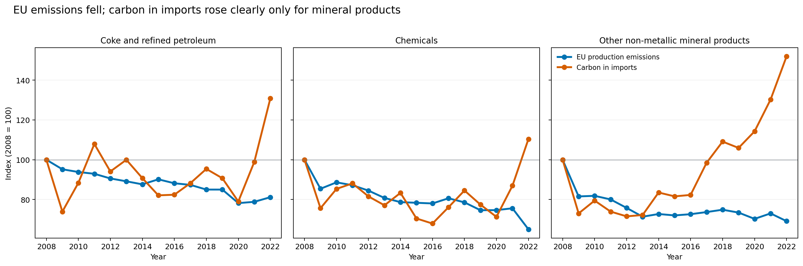
Figure 1. Selected sector emissions and imported embodied-emissions series indexed to 2008 = 100. The lines show direction, not cause.
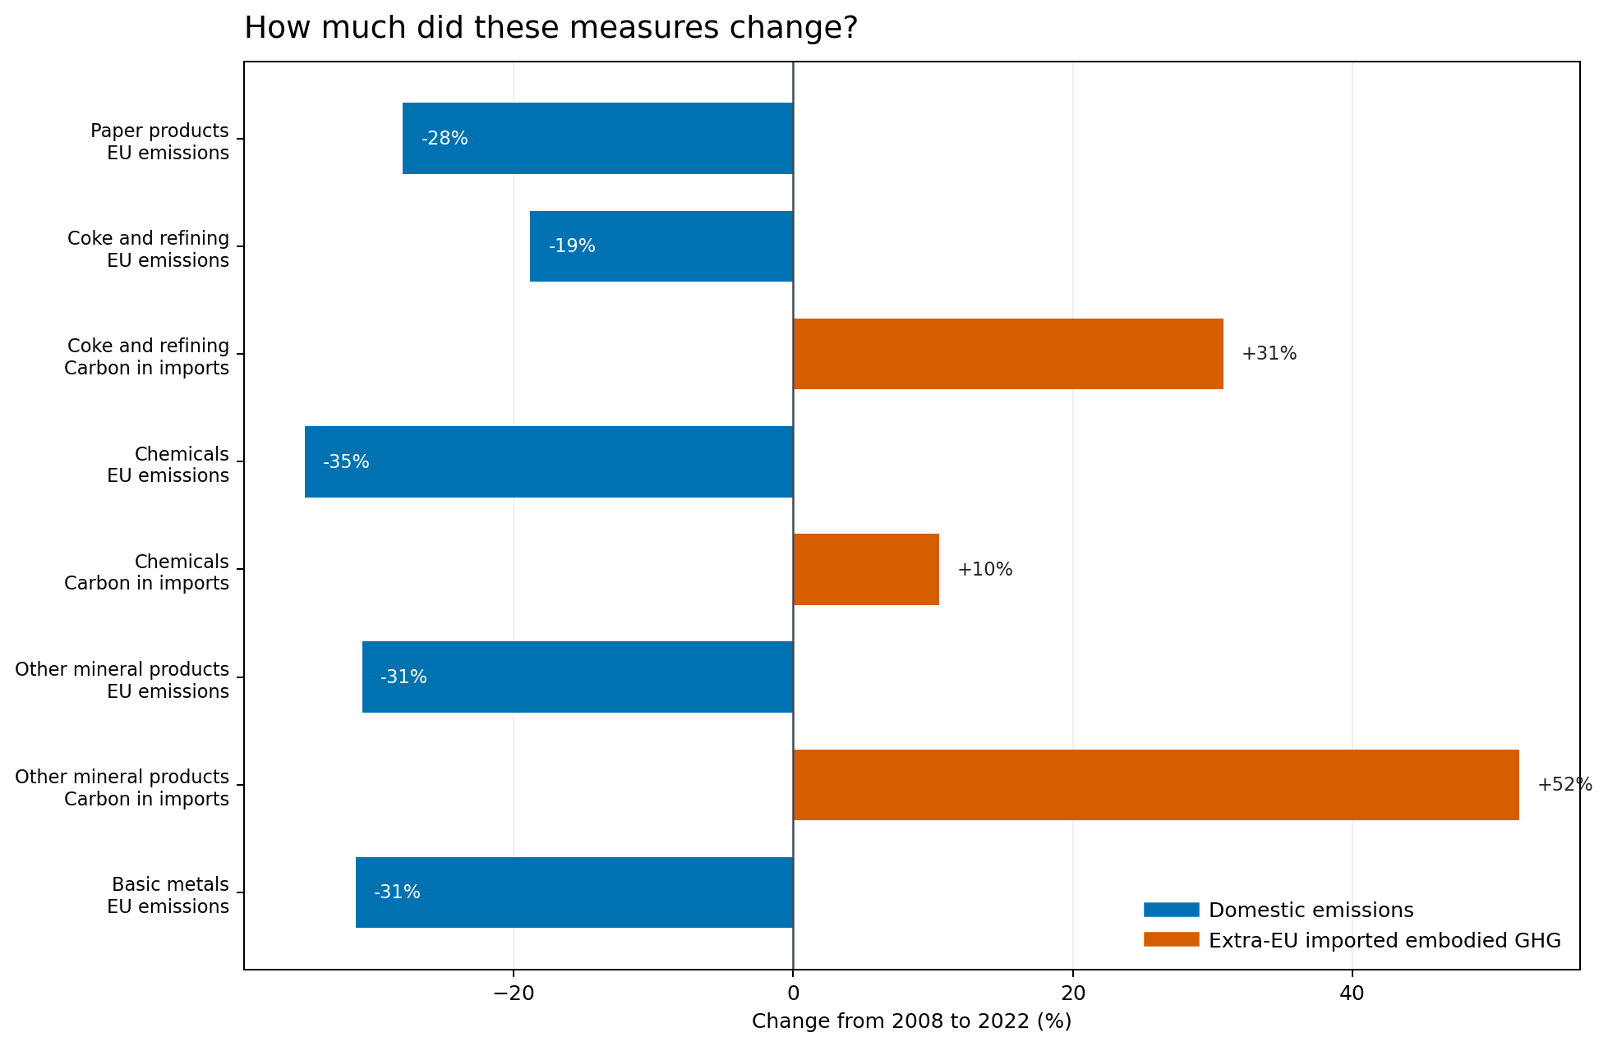
Figure 2. Endpoint changes in domestic emissions and embodied emissions in imports. Import-carbon coverage is not available for all divisions.

What the statistical screens show
For C20, domestic emissions and extra-EU import value show statistically clear expected-direction trends after multiple-testing adjustment. Production value does not show a clear downward monotonic trend, and imported embodied emissions do not show a clear monotonic trend. For C23, emissions, import value and embodied imports show clear expected-direction trends; production does not show a clear downward monotonic trend. Neither sector therefore has a statistically established persistent four-indicator pattern, despite all four expected endpoint directions.
C17 and C24 lack imported embodied-emissions estimates, and C19 production coverage is inadequate. These gaps prevent a complete screen; they do not demonstrate absence of risk.

6 Product-level findings
Among 666 matched products, 141 had lower EU sold quantity and higher extra-EU import value at the endpoints. Another 138 could not be classified because the import baseline was missing or zero. These are candidates for investigation, not proof that imports displaced domestic output.
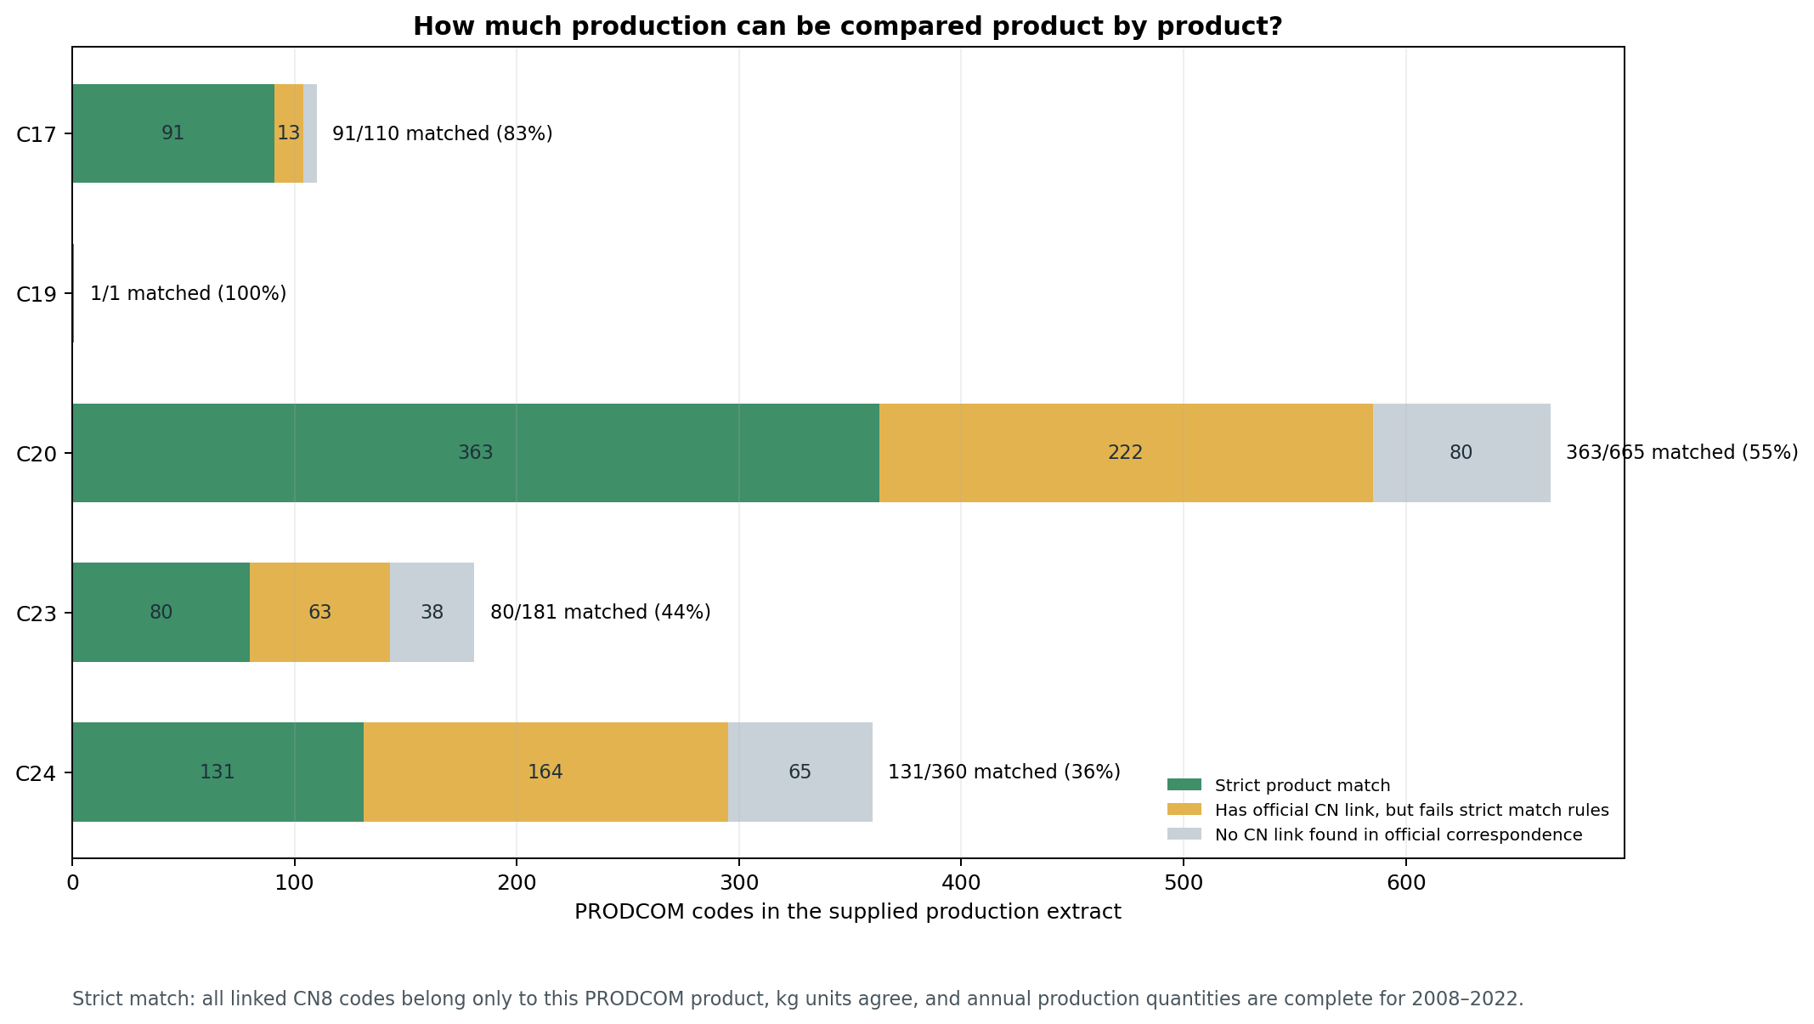
Figure 3. Strictly matched products with complete production quantities, by industry division.
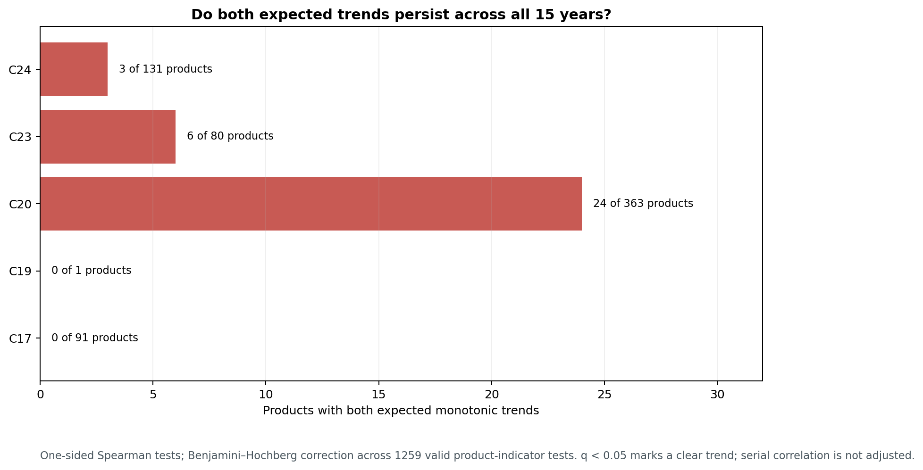
Figure 4. Products passing endpoint and trend screens. Product-level embodied-carbon series were unavailable.
Thirty-three products met both the endpoint and expected-direction monotonic trend screens after multiple-test adjustment: 24 in C20, six in C23 and three in C24. None were in C17 or C19. The output-versus-import screen prioritises products; it does not estimate leakage.
Example product | EU sold quantity change | Extra-EU import value change | Interpretation
Polypropylene | +1.3% | +163.5% | Imports rose but production did not fall.
Ethylene | −23.9% | −13.6% | Both output and imports fell.
Cement clinker | −30.0% | −30.8% | Both output and imports fell.
Ready-mixed concrete | −29.8% | −80.2% | Imports also fell substantially.

A simplified import share used in exploratory work, imports ÷ (production + imports), omits exports, intra-EU trade, inventories and full market flows. It is not a complete measure of domestic market dependence.

7 Embodied emissions in imports and exports
Both trade directions matter. Looking only at embodied emissions in imports can overstate the external carbon exposure relative to the net position. OECD estimates emissions along supply chains and allocates them to trade flows. Here the balance compares extra-EU imports and exports for the same industry division.
Division | 2008 imports minus exports | 2022 imports minus exports | Direction
C19 | +33.4 Mt CO2e | +87.1 Mt CO2e | Widened
C20 | +25.4 Mt CO2e | +42.3 Mt CO2e | Widened
C23 | +5.2 Mt CO2e | +21.9 Mt CO2e | Widened

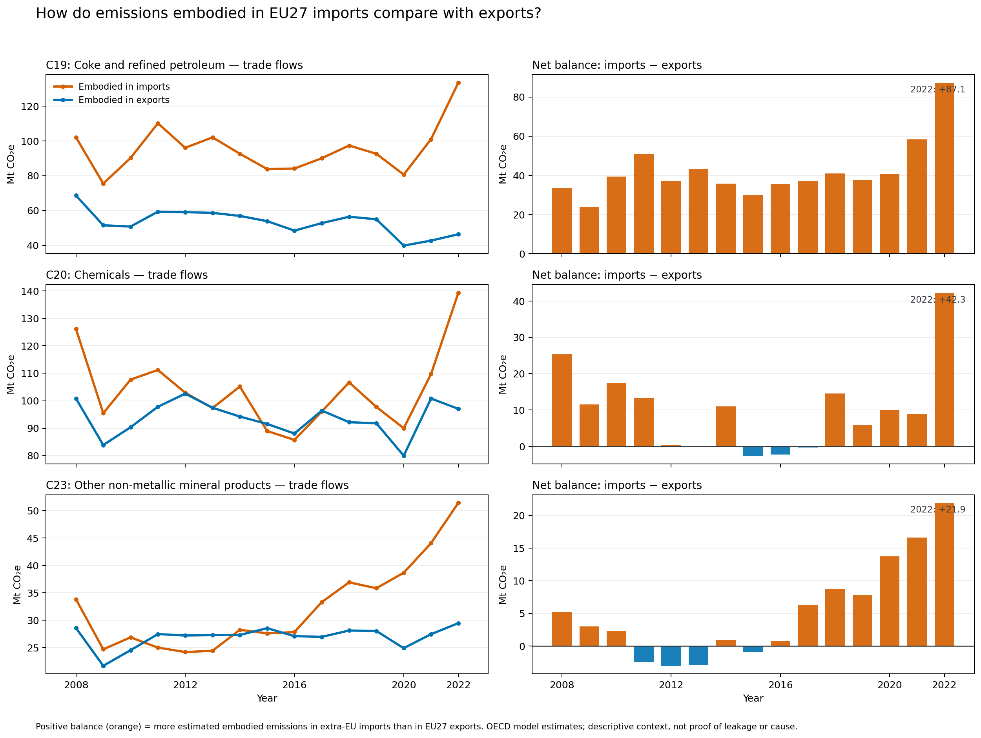
Figure 5. OECD-modelled embodied emissions in extra-EU imports and exports and their difference.
A positive or widening balance is useful descriptive context. It still cannot establish that EU policy caused the balance, nor that imported products displaced goods previously made in the EU.

8 The monetary perspective
The real-euro layer contains two distinct production concepts. PRODCOM sold-production value is one measure. A separate broad-sector gross-output series was reconstructed from emissions intensity and deflated using producer-price indices. It differs from PRODCOM and is not a precise measure of value lost to leakage.
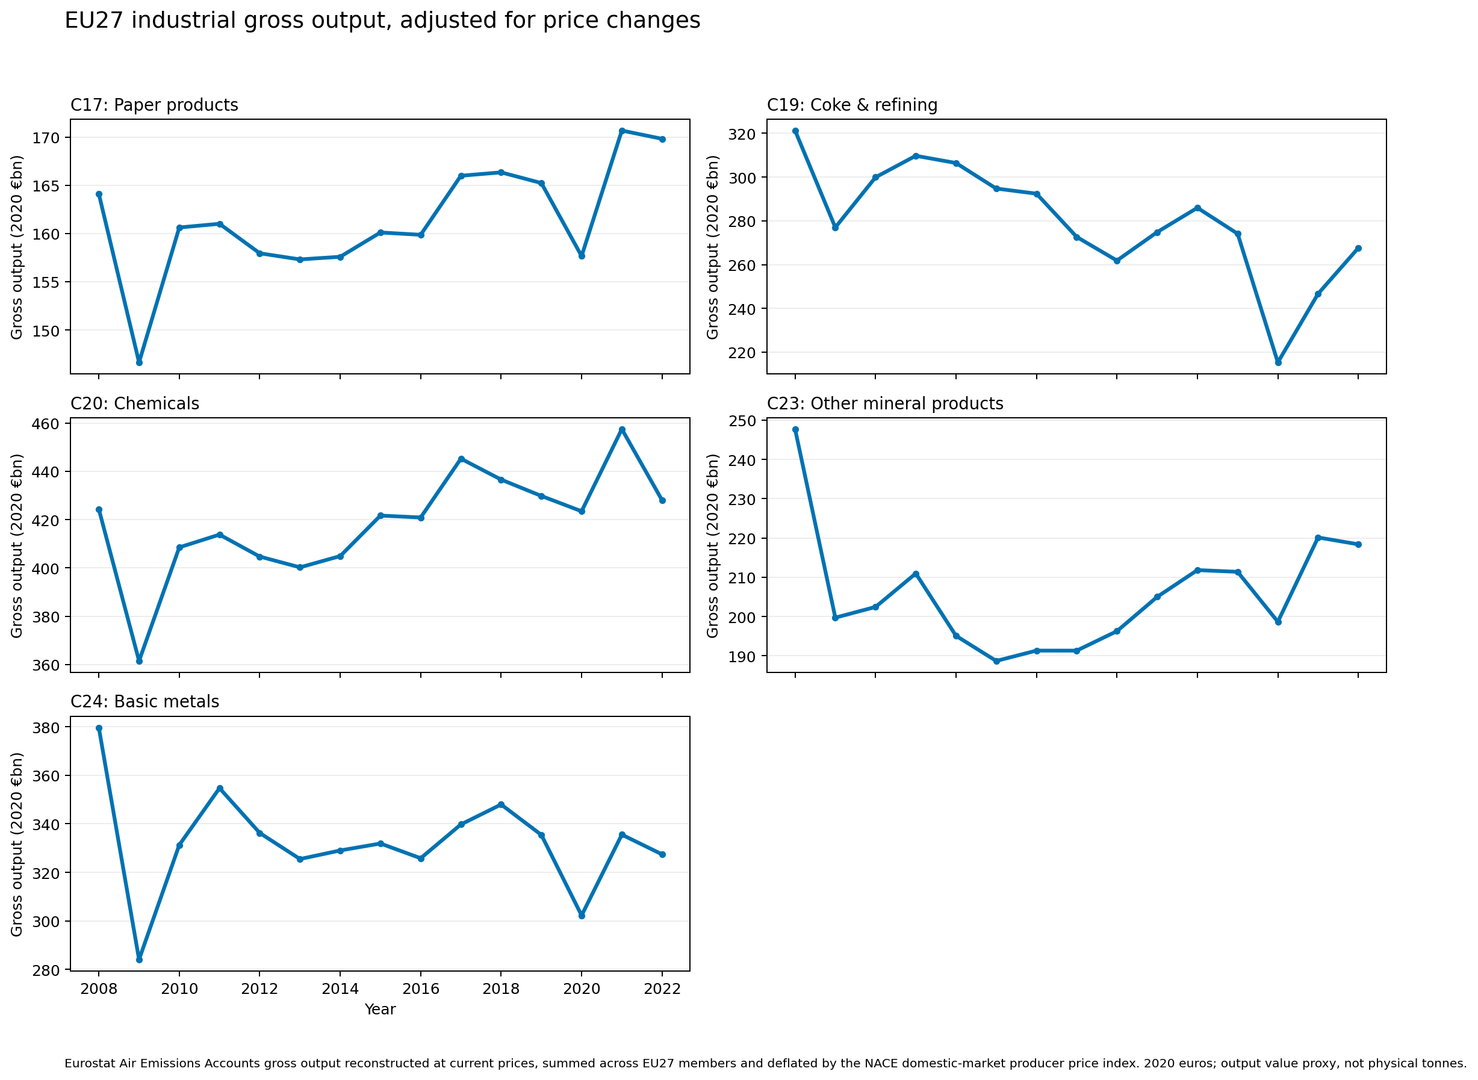
Figure 6. Reconstructed real gross output in 2020 euros; this differs from PRODCOM sold-production value.

Hypothetical carbon value
At the common 2022 EU ETS allowance price of €80.18/tCO2e, the 2020-euro shadow value of C20 domestic emissions fell from about €14.25 billion in 2008 to €9.25 billion in 2022. For C20 embodied emissions in extra-EU imports, the illustration rose from €9.01 billion to €9.94 billion. For C23, the domestic value fell from €18.04 billion to €12.47 billion; the imported embodied-emissions value rose from €2.42 billion to €3.67 billion.
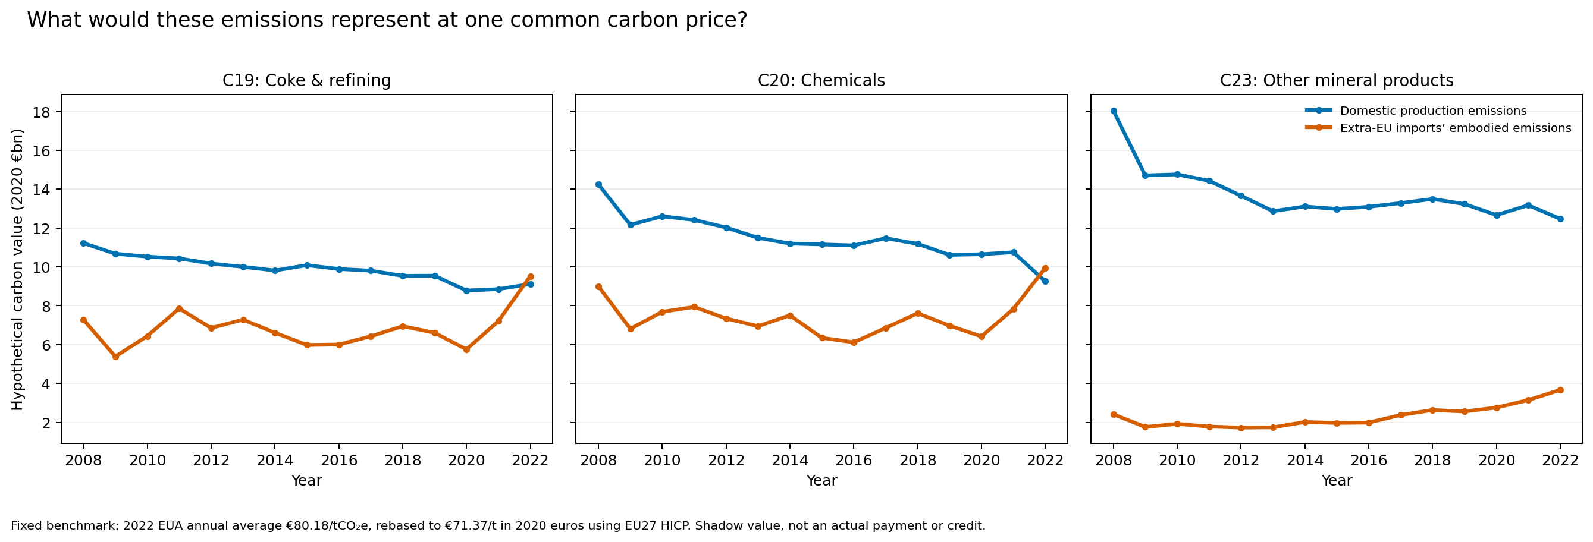
Figure 7. Common-price shadow value of emissions, restated in 2020 euros. These are illustrative values, not actual payments or costs.
The calculation assigns a benchmark carbon price to emissions quantities. Actual obligations, free allocation, electricity costs, product prices, non-EU carbon constraints and offset use are not represented. It is a familiar monetary scale, not a financial transfer estimate.

9 Carbon credit projects and leakage accounting

What issued and retired credits mean
A credit is a registry unit representing a claimed greenhouse-gas reduction or removal under a programme’s rules. “Issued” means units were created in the registry after the programme’s accounting and review process. “Retired” means units were permanently removed from circulation, often to support a claim or meet a requirement. Issuance does not alone prove an additional global reduction; retirement does not by itself identify the buyer or beneficiary.
In the June 1, 2026 OffsetsDB snapshot, 178 projects were hosted across 21 EU27 countries. The data contain 19.31 million issued units and 13.70 million retired units. 2026 observations are partial through June 1. These figures describe registry events by project host location, not EU industrial leakage. Issued minus retired is not a verified stock of climate benefit.
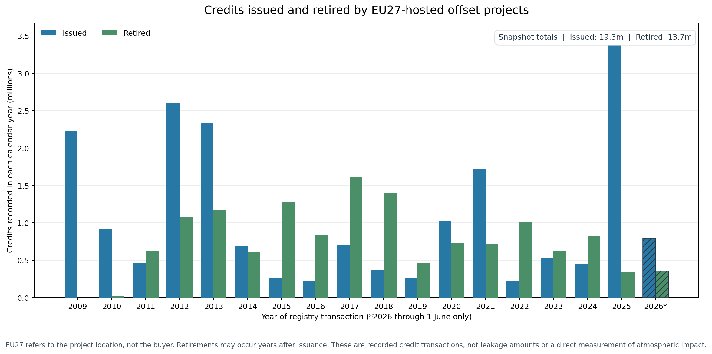
Figure 8. Annual credit issuance and retirement associated with EU27-hosted projects; the final year is partial.

Project type in plain language
Project type names the activity said to generate credits. Afforestation or reforestation plants or restores forest; improved forest management changes management of an existing forest; sustainable agriculture changes farming practices; mine methane projects capture or destroy methane. These describe the intervention. They do not tell us whether the activity moved elsewhere or emissions rose outside the project boundary.

Examples in project documents
Project and activity | What its source reports | Interpretation
AgreenaCarbon, Denmark; sustainable agriculture / soil carbon | Validation report presents an ex-ante leakage estimate of 87,250.58 tCO2e over a 20-year crediting period [16]. | Prospective estimate reviewed at validation, not an observed monitoring-period total.
Silvador Climate Action, Romania; forest project | Report summary gives 6,893 tCO2e leakage for verified period 2020–2022. It applies a 10% market leakage factor and discusses a 17.4% default alternative [17]. | Tonnage and percentage are different outputs. The percentage is not 6,893 tonnes.
Westphalen Forest Carbon, Germany; forest project | Monitoring report says no activity-shifting leakage occurred in 2022–2024. A 20% market factor is used in net calculations [18]. | No activity shifting does not mean all leakage pathways are zero. The factor is not tonnes.

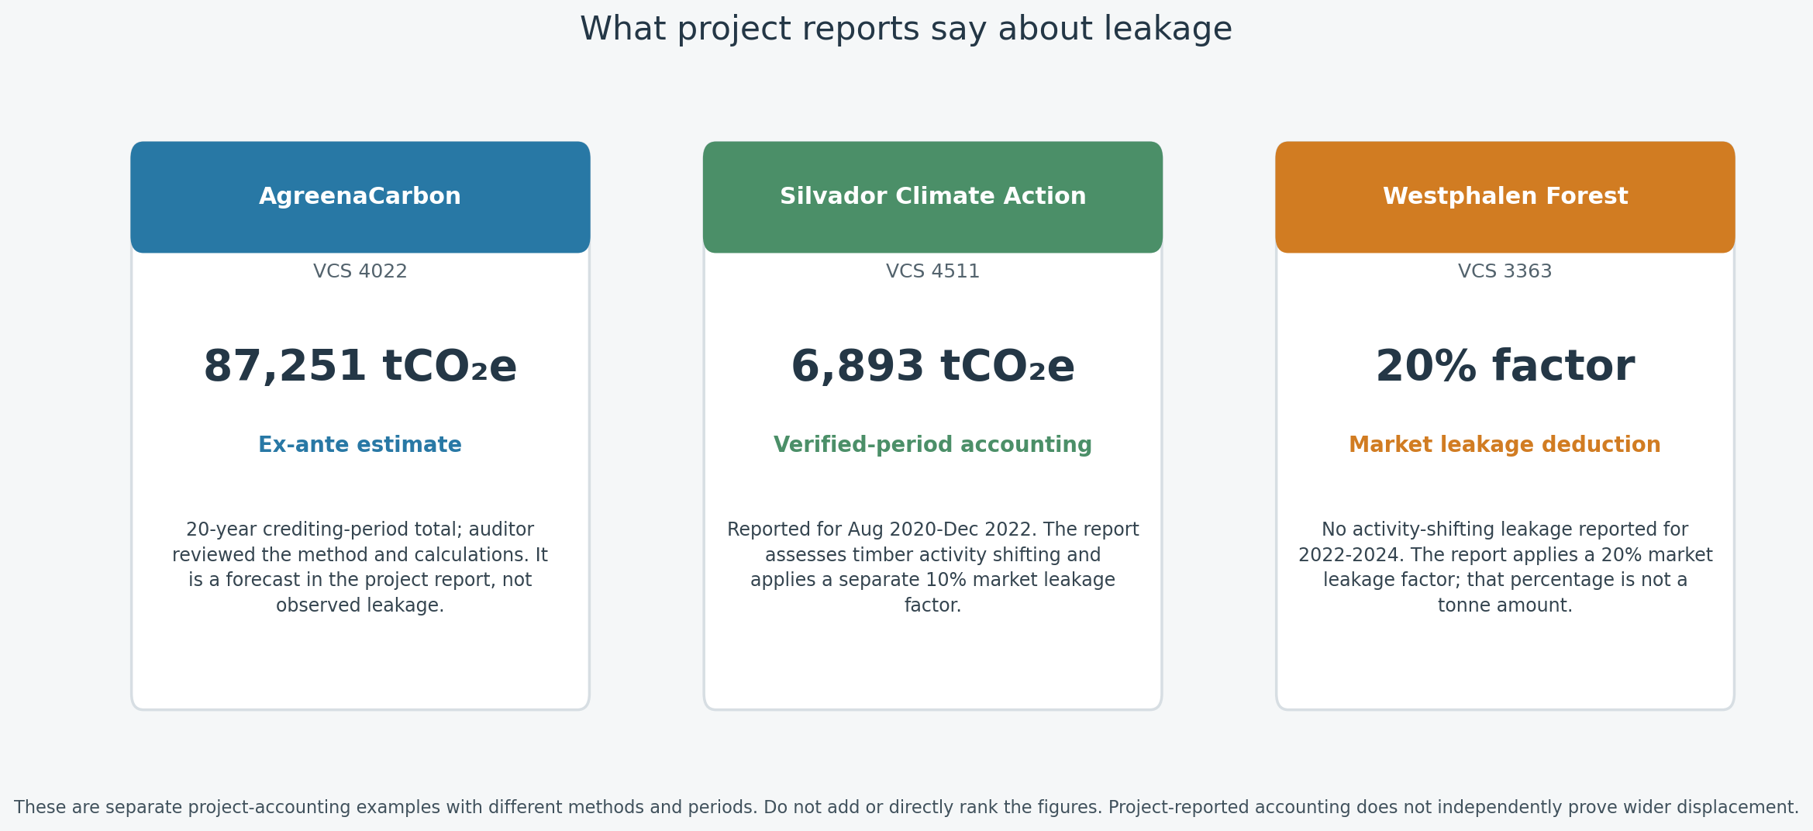
Figure 9. Project-report examples distinguish estimated tonnes, percentage deductions and a finding that one pathway was not observed.
The projects use different activities, accounting periods and methods. Their reported values should not be summed or ranked. They illustrate project-level leakage accounting, not EU industrial-sector leakage.

10 Conditional scenarios through 2030
For C20 and C23, simple log-linear paths were fitted over 2008–2022, 2013–2022 and 2018–2022. Each series is rebased to 2022 = 100. The scenario asks what 2030 would look like if the fitted historical growth rate continued. It is not a forecast, confidence interval or probability statement.
Sector and measure | Trend 2008–22 | Trend 2013–22 | Trend 2018–22
C20 production value | 104 | 101 | 93
C20 domestic emissions | 86 | 88 | 75
C20 extra-EU imports | 135 | 139 | 135
C20 imported embodied GHG | 100 | 122 | 168
C23 production value | 100 | 113 | 114
C23 domestic emissions | 89 | 99 | 88
C23 extra-EU imports | 122 | 143 | 150
C23 imported embodied GHG | 139 | 182 | 200

For the embodied-emissions import-minus-export balance, imports and exports were projected separately and then subtracted. Across the three time windows, 2030 balances are C19 102–209 Mt CO2e, C20 43–121 Mt CO2e and C23 40–72 Mt CO2e. The range illustrates sensitivity to the chosen historical period.
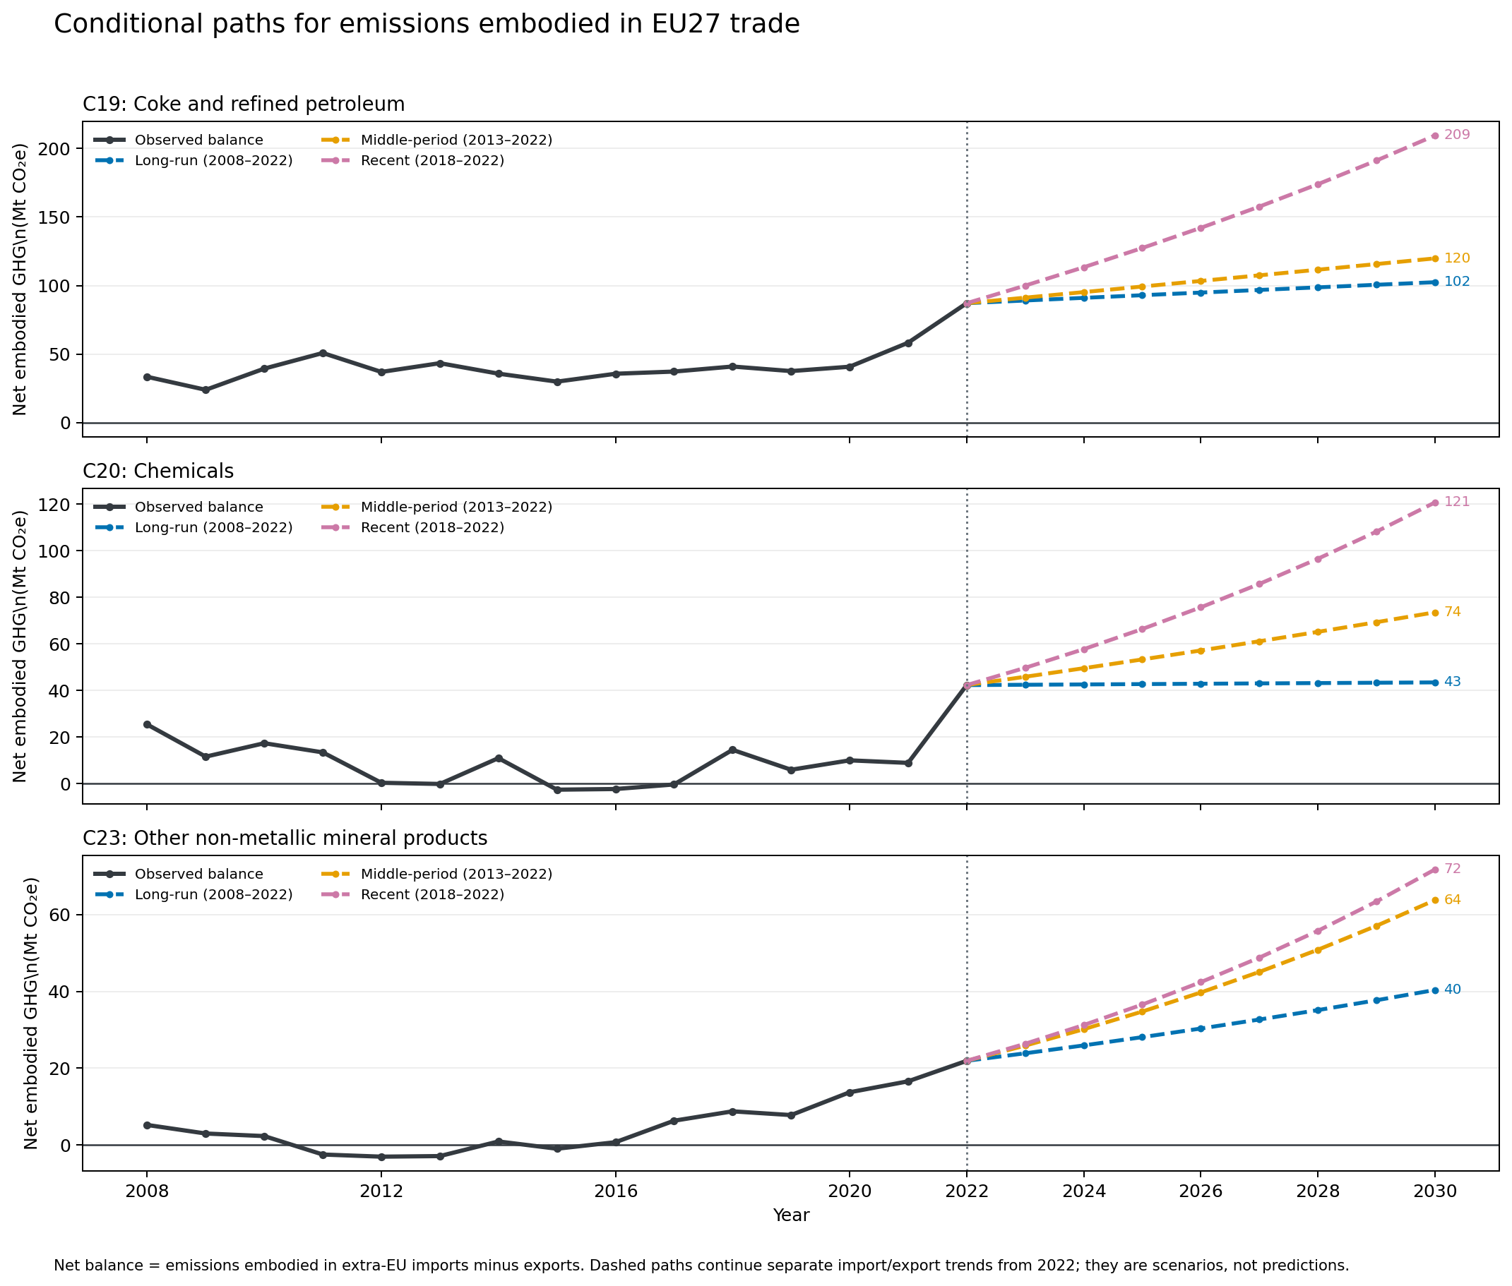
Figure 10. Conditional paths for embodied-emissions trade balances under three historical trend windows.
The scenarios assume past average movements continue despite changes in policy, technology, energy prices, demand, capacity and trade. Those drivers are not modelled. Short recent windows can amplify unusual years. Use the scenarios to frame questions, not as expected 2030 outcomes.

11 Conclusions and next research steps
C20 and C23 show the clearest descriptive leakage-risk patterns across 2008–2022. Their endpoints combine lower production value and domestic emissions with higher extra-EU imports and imported embodied emissions. Trend tests support several components, but production does not show an expected persistent decline in either sector. Product screening identifies candidates, with gaps in mapping and carbon data.
The embodied-emissions balance provides additional context: modelled emissions in extra-EU imports exceed those in exports for C19, C20 and C23, with a larger balance in 2022 than in 2008. The monetary layer presents an illustrative shadow value rather than actual cost. OffsetsDB documents crediting activity; project reports disclose project-specific leakage accounting; neither measures industrial leakage.
Causally established leakage is not identified. The data do not link a policy change to a specific production shift, destination facility, resulting emissions and counterfactual outcome absent the policy. The conclusion is about risk signals and evidence quality, not attribution.

Priorities for the next stage
- Improve product and sector coverage, especially C19 and imported embodied-carbon availability for C17 and C24.
- Add product quantities for imports and exports and document product-code concordances across years.
- Investigate priority C20 and C23 products using facility, capacity, trade-route and non-EU emissions-intensity evidence.
- For causal claims, define policy exposure and a comparison group, then estimate shifts against a credible counterfactual.
- In the later Streamlit dashboard, show definitions, data coverage, uncertainty and evidence level alongside each chart.
Machine learning is not needed for the current descriptive objective. It can be reconsidered if a clear prediction target and consistent data become available. For now, transparent historical trend scenarios are easier to explain.

Glossary
Air Emissions Accounts (AEA) Economic accounts recording emissions associated with resident industries and households. Their boundary differs from territorial inventories.
Allowance Permit under a cap-and-trade system authorising emissions of a specified quantity, commonly one tonne CO2e under the EU ETS.
Benjamini–Hochberg adjustment Method for adjusting many statistical tests to limit the expected share of false positives among results called significant.
Carbon credit Registry unit representing a claimed reduction or removal under a programme’s rules; quality depends on method, monitoring and verification.
Carbon intensity Emissions per unit of output, for example tonnes CO2e per tonne of product.
Carbon leakage A rise in emissions outside a jurisdiction associated with climate policy there, such as production shifting or imports replacing domestic goods.
Carbon price Price assigned to greenhouse-gas emissions by a tax, emissions trading permit or other policy.
C17 NACE division for manufacture of paper and paper products.
C19 NACE division for manufacture of coke and refined petroleum products.
C20 NACE division for manufacture of chemicals and chemical products.
C23 NACE division for manufacture of other non-metallic mineral products, including cement-related goods.
C24 NACE division for manufacture of basic metals, including steel and other metals.
CN code Combined Nomenclature classification code used for goods in EU trade statistics.
CO2 equivalent (CO2e) Common unit that expresses different greenhouse gases by their warming effect relative to carbon dioxide over a chosen time horizon.
Comext Eurostat’s detailed international trade in goods database.
Counterfactual Estimate of what would have happened without the policy, project or event being studied.
Deflation Adjustment of money values for price changes so different years can be compared in prices of a chosen reference year.
Embodied emissions Emissions generated along the supply chain to produce a good or service and attributed to it through accounting or modelling.
EU ETS European Union Emissions Trading System, the EU cap-and-trade system for greenhouse-gas emissions in covered sectors.
Extra-EU trade Trade between the EU27 as a group and countries outside the EU27.
HICP Harmonised Index of Consumer Prices, Eurostat’s comparable measure of consumer-price inflation.
Import dependency Extent to which domestic use relies on imports. The simplified ratio in this project omits several market flows.
Mt CO2e Megatonnes of carbon dioxide equivalent. One megatonne is one million metric tonnes; 5 Mt CO2e means five million tonnes expressed as CO2-equivalent.
NACE EU statistical classification of economic activities. C20 is an industry division, not a product code.
OffsetsDB Research database compiling carbon-credit project and registry information from several sources; coverage depends on its snapshot and processing.
PRODCOM Eurostat statistics on manufactured goods. Sold production is product made and sold or invoiced in the period, not necessarily total output.
Project boundary Area, activities, sources and sinks included in a carbon project’s accounting.
Retired credit Credit permanently removed from circulation in a registry, often to support a claim or compliance use.
Risk signal Observed pattern consistent with possible leakage that merits investigation but does not prove occurrence or cause.
Sold-production value Value of manufactured goods sold or invoiced in a year; it changes with prices, quantities and product mix.
Spearman rank trend test Nonparametric test of whether two variables tend to move monotonically together; here year is compared with an indicator.
tCO2e Tonnes of carbon dioxide equivalent, a mass unit for greenhouse gases expressed in a common CO2-based unit.
Trade balance in embodied emissions Here, embodied emissions in extra-EU imports minus those in extra-EU exports. Positive means modelled imports embody more.
Trend window Years used to estimate a historical trend; another window can produce another scenario.
Verified period Dates covered by a project monitoring report that has undergone review; distinct from the full crediting period.
Issued credit Registry unit created after programme issuance requirements are met; alone it does not prove an additional global climate benefit.
2020 euros Money restated to price levels associated with 2020; the underlying transaction did not necessarily happen in 2020.

References
[1] European Commission. Carbon leakage. EU ETS policy overview.
[2] OECD. Greenhouse gas footprint indicators.
[3] OECD. Measuring greenhouse gas footprints in global production networks (2024).
[4] Eurostat. PRODCOM information and data.
[5] Eurostat. PRODCOM metadata.
[6] Eurostat. Air Emissions Accounts metadata.
[7] Eurostat. International trade in goods information and data.
[8] Eurostat. NACE Rev. 2.1 classification manual.
[9] UNFCCC. Greenhouse gas data frequently asked questions.
[10] Eurostat. Harmonised Index of Consumer Prices overview.
[11] European Environment Agency. EU Emissions Trading System report 2025. 2022 annual average auction price used for shadow valuation.
[12] CarbonPlan. OffsetsDB data processing documentation.
[13] CarbonPlan. OffsetsDB data access documentation.
[14] Verra. Estimating leakage from displacement of agricultural activities, VMD0054.
[15] Verra. Tool for estimating carbon leakage from improved forest management activities.
[16] AgreenaCarbon Project VCS 4022. Validation report.
[17] Silvador Climate Action VCS 4511. Validation report, project data room.
[18] Westphalen Forest Carbon Project VCS 3363. Monitoring report.

Project analysis materials
Numerical findings, figures and scenarios are from the project’s exploratory notebook and derived local CSV outputs: the EU27 industry screen, product mapping and trend screen, embodied-emissions trade balance, monetary illustrations, OffsetsDB summary, project report examples and 2030 scenario paths. These are analysis outputs, not external published studies.

