University of Science and Technology Chittagong


Computer Graphics and Image Processing Lab
Course Code: CSE 418

Project No. 02
Image Classification Problem
Fruit Image Classification Using Hand-crafted Features and CNN

Submitted To: Submitted By:
Md. Zainal Abedin Name: Md. Sazzadur Rahman
Associate Professor ID: 23010108
CSE, FSET, USTC Batch: 40th
Date of Submission: 16-06-2026

Abstract
This project presents an image classification system for identifying fruit images into three classes: apple, banana, and orange. The work compares two approaches. The first approach uses hand-crafted features such as Color Histogram, Histogram of Oriented Gradients (HOG), and Local Binary Pattern (LBP), followed by a Support Vector Machine (SVM) classifier. The second approach uses a Convolutional Neural Network (CNN), where useful image features are learned automatically from pixel data. The project demonstrates fundamental image processing, feature extraction, machine learning, deep learning, and model evaluation concepts.

1. Introduction
Image classification is an important task in computer vision where a system learns to assign an image to a specific class. In this project, fruit images are classified into apple, banana, and orange categories. The project is suitable for Computer Graphics & Image Processing because it includes image representation, image preprocessing, feature extraction, classification, and result visualization.

2. Objectives
- To understand the basic workflow of an image classification problem.
- To apply hand-crafted feature extraction techniques on image data.
- To train a machine learning classifier using extracted image features.
- To develop a CNN model for automated feature learning.
- To compare traditional machine learning and deep learning based image classification methods.

3. Dataset Description
The project uses a fruit image dataset with three classes: apple, banana, and orange. The provided notebook can generate a small demo dataset automatically, so the project can run without external files. For a more realistic submission, the generated dataset folder can be replaced with a real image dataset using the same class folder structure.
Class Name | Example | Reason for Selection
Apple | Red/green fruit images | Color and shape are distinguishable
Banana | Yellow curved fruit images | Shape and color are strong features
Orange | Orange round fruit images | Texture and color help classification

4. Methodology
The overall workflow of the project is shown below.
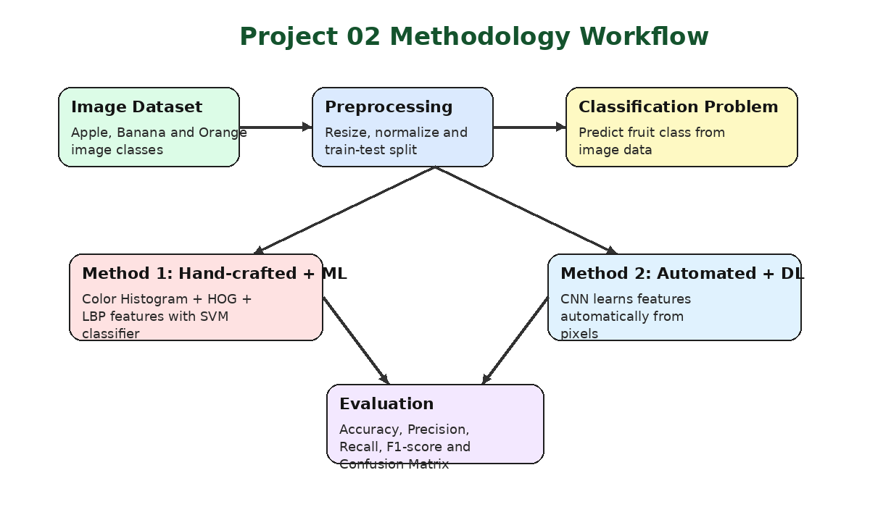

4.1 Method 1: Hand-crafted Feature + ML
In this method, important image features are manually extracted using image processing techniques. These features are then passed to a machine learning classifier. In this project, SVM is used because it performs well for small and medium-sized classification problems.
Feature | Purpose | Use in Project
Color Histogram | Extracts color distribution | Useful for separating apple, banana, and orange
HOG | Extracts edge and shape information | Useful for fruit shape representation
LBP | Extracts texture information | Useful for surface pattern analysis

4.2 Method 2: Automated Feature + DL
In this method, a CNN model automatically learns features from image pixels. The CNN contains convolution layers, pooling layers, a flatten layer, dense layers, and an output layer. Unlike hand-crafted feature extraction, the CNN does not require manual feature design.
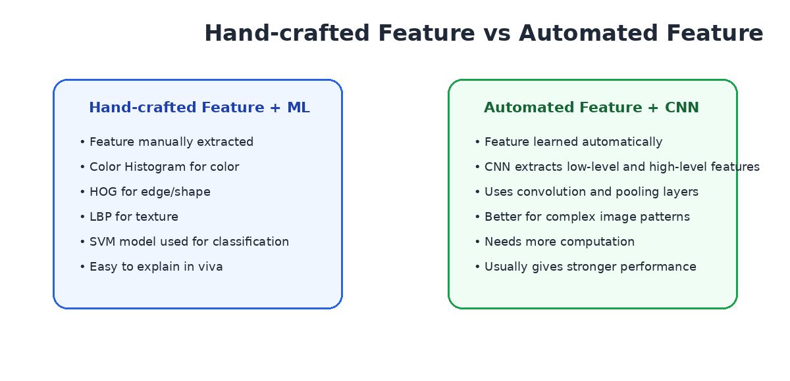

5. Algorithms Used

5.1 Support Vector Machine
SVM is a supervised machine learning algorithm used for classification. It tries to find an optimal boundary between classes using the extracted feature vectors.

5.2 Convolutional Neural Network
CNN is a deep learning model widely used for image classification. It uses convolution filters to learn local patterns such as edges, colors, textures, and shapes.

6. Implementation Tools
Tool | Purpose
Python | Main programming language
Pillow/OpenCV | Image loading and preprocessing
Scikit-image | HOG and LBP feature extraction
Scikit-learn | SVM training and evaluation
TensorFlow/Keras | CNN model development
Matplotlib | Graph and result visualization

7. Evaluation Metrics
Metric | Meaning
Accuracy | Measures total correct predictions among all test images.
Precision | Measures how many predicted positive samples are actually correct.
Recall | Measures how many actual positive samples are correctly identified.
F1-score | Harmonic mean of precision and recall.
Confusion Matrix | Shows class-wise correct and incorrect predictions.

8. Expected Result Comparison
The actual accuracy may vary depending on dataset size, image quality, train-test split, and training epochs. The comparison format below can be used to present the final output after running the notebook.
Method | Feature Type | Model | Expected Output
Method 1 | Hand-crafted | SVM | Accuracy, report, confusion matrix
Method 2 | Automated | CNN | Accuracy, training graph, confusion matrix

9. Learning Outcomes
- Learned how images are represented as pixel arrays.
- Learned how to preprocess images before classification.
- Learned how to extract color, shape, and texture features.
- Learned how to train and evaluate an SVM classifier.
- Learned how CNN automatically extracts useful image features.
- Learned how to compare machine learning and deep learning models.

10. Conclusion
This project successfully demonstrates an image classification problem using both traditional and deep learning approaches. The hand-crafted feature based method is simple, explainable, and useful for understanding the role of image features. The CNN based method is more automated and can learn complex patterns directly from image pixels. Therefore, this project provides a practical understanding of image processing, machine learning, and deep learning for classification tasks.

