**Tanvir Shaikh**

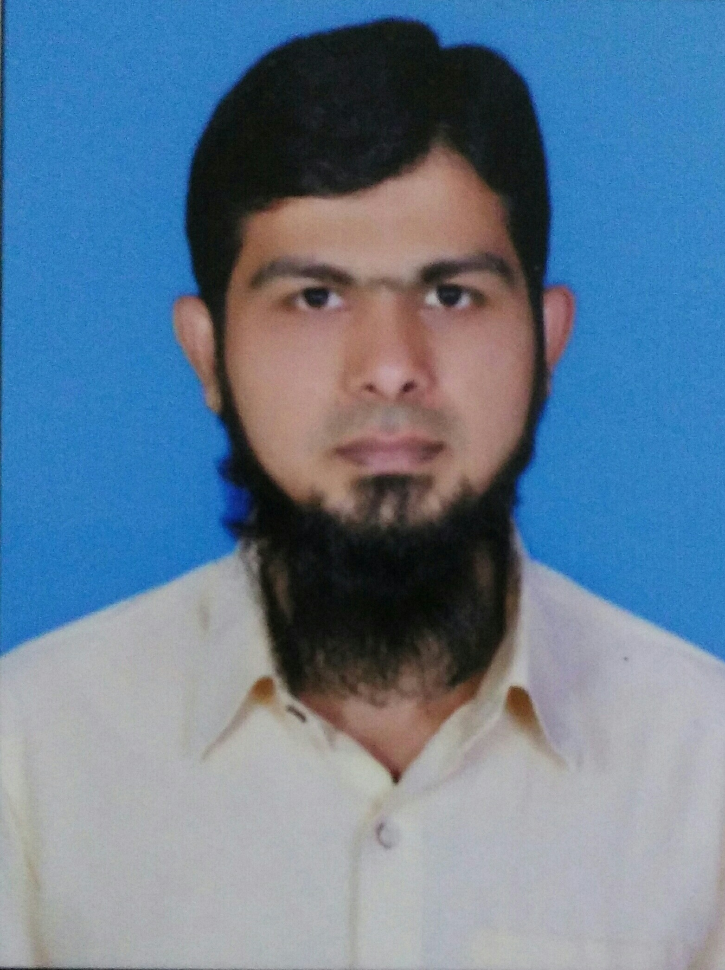

|  |  |
| --- | --- |
| **Title:** | IT Consultant |
| **Location:** | Mumbai, India |
| **Languages:** | Hindi (native),English (intermediate),Marathi (native) |

# Experience Summary

Tanvir Shaikh is an IT consultant with over 5+ years of professional experience in the software industry. He is currently working as an IT Consultant in Hybrid Mobile Applications Development. He has been managing projects that spread across Client Server and Web technologies. He has managed Maintenance as well as Development projects. Tanvir has worked projects mainly in the Public Health Care domains.

**KEY SKILLS:**

* **Functional:** Project Management, Team Leader, Strategic/Tactical Planning, Business Analysis and Development.
* **Technical: Cordova**, PhoneGap, **Angular 5, ReactJS, React Native, Ionic 2**, Xcode, Android SDK, JavaScript, **jQuery**, jQuery Mobile, Framework7, Bootstarp, **PHP**, Codeigniter, WordPress, MySQL, HTML5, CSS3, Highcharts, Google Maps, Leaflet.js, MEAN stack and **Node.js** (beginner).

# Experience

|  |  |  |
| --- | --- | --- |
| **01** | **Type of Industry:** | **Oil and Gas (Schlumberger)** |
|  | **Project Description:** | Hybrid Mobile Application for Tools Summary called “**Bit Run Summary**”. This is one module of “**QTrac**” web application built on Microsoft .NET MVC. BRS Mobile is wrapped in Cordova Framework for Android and iOS mobiles and Tabs. |
|  | **Role/Title:** | Consultant |
|  | **Project Duration:** | Nov 2017 to current |
|  | **Responsibilities:** | * Worked closely with the client to discuss various ideas/solutions, issues and timelines * Requirement gathering through various meetings and interactions with the client. * Established processes to facilitate better execution of project |
|  | **Operating Systems:** | Windows and OSX |
|  | **Software / Languages:** | JavaScript, HTML, CSS etc. |
|  | **Special Tools:** | Cordova, Cordova CLI @6.0.0, Android SDK. |

|  |  |  |
| --- | --- | --- |
| **02** | **Type of Industry:** | **Oil and Gas (Schlumberger)** |
|  | **Project Description:** | Hybrid Mobile Application for **DQR** “**D&M Data Quality Report**”. This is one module of “**QTrac**” web application built on Microsoft .NET MVC. DQR Mobile app is wrapped in Cordova Framework for Android and iOS mobiles and Tabs. |
|  | **Role/Title:** | Consultant |
|  | **Project Duration:** | Nov 2017 to current |
|  | **Responsibilities:** | * Worked closely with the client to discuss various ideas/solutions, issues and timelines * Requirement gathering through various meetings and interactions with the client. * Established processes to facilitate better execution of project |
|  | **Operating Systems:** | Windows and OSX |
|  | **Software / Languages:** | JavaScript, HTML, CSS etc. |
|  | **Special Tools:** | Cordova, Cordova CLI @6.0.0, Android SDK. |

|  |  |  |
| --- | --- | --- |
| 03 | Type of Industry | **Public Health** |
|  | **Project Description:** | Real Time Monitoring solution to support targeted Intervention among MSW, FSW, and OVP. The RTM solution would be implemented by capturing data by using mobile application, and providing services to the registered patients as well as track the record of past medical history. All the registered and services information is reflected in dashboard in the form of indicators, infographics and charts. |
|  | **Role/Title:** | Mobile Application Developer |
|  | **Responsibilities:** | * Worked closely with the client/OSC to discuss various ideas/solutions, issues and timelines * Participated in requirement gathering through various meetings and interactions with the client and onsite as required. * Established processes to facilitate better execution of project * Responsible to place app on Google Play Store as well as on Apple iTunes Store. * Responsible for application functional testing |
|  | **Operating Systems:** | Windows and OSX |
|  | **Software / Languages:** | JavaScript, jQuery, Framewoerk7, REST API, HTML , CSS etc. |
|  | **Special Tools:** | Cordova. |
| **04** | **Type of Industry:** | **Public Health Care** |
|  | **Project Description:** | The project mainly involves real time cohort monitoring system. This system will track the history of peoples who is leaving with HIV. The project has multiple phases of which I’m working on Mobile App Design and development for android/IOS as well as leading the team of dashboard design and development. |
|  | **Role/Title:** | Mobile Application Development |
|  | **Responsibilities:** | * Worked closely with the client/OSC to discuss various ideas/solutions, issues and timelines * Participated in requirement gathering through various meetings and interactions with the client and onsite as required. * Established processes to facilitate better execution of project * Responsible to place app on Google Play Store as well as on Apple iTunes Store. * Responsible for application functional testing |
|  | **Operating Systems:** | Windows and OSX |
|  | **Software / Languages:** | Cordova, JavaScript, jQuery, Framewoerk7, REST API, HTML , CSS etc. |
| **05** | **Type of Industry:** | **Event Management System** |
|  | **Project Description:** | The project is a product development of DureTech which mainly involves creation of event, registration of users for the particular event, send invitations for the attendees generate reports of attendees, get feedback from attendees, and send individual, archive events. The project has multiple phases of which I’m worked on Backend as well as Frontend coding and database design. |
|  | **Role/Title:** | Web Application Developer |
|  | **Responsibilities:** | * Worked closely with the client/OSC to discuss various ideas/solutions, issues and timelines * Participated in requirement gathering through various meetings and interactions with the client and onsite as required. * Established processes to facilitate better execution of project * Responsible for application functional testing |
|  | **Operating Systems:** | Windows |
|  | **Software / Languages:** | PHP, MySQL, Codeigniter, WordPress, Bootstrap, JavaScript, jQuery, REST API, HTML , CSS etc. |

##### 

# Training, Certifications & Affiliations

* Completed “**Node.JS”** training arranged by Capgemini L & D.
* Completed Certificate course “**Bootstrap and jQuery**” arranged by Dure Technologies.

# Published & Presented / Awards

* Awarded as “**Employee of the month**” in **Dure Technologies Pvt. Ltd.**
* Secured **1st Prize in Project Exhibition** held at K.K. Wagh COE Nasik.
* Secured **2nd Prize in Code – Competition** held at K.K. Wagh COE Nasik.

# Higher Education

* Pune University – Bachelor of Engineering, Computer.