# Lab 1:

## Cable to connect devices:

**Straight** through: **Different** Device (connect hub with pc/laptop)

**Cross-over: Same** type device (laptop to laptop)

click on pc > desktop > IP configuration > set ipv4 static value 4 octate

x.x.x.x

each x= 8 bit binary value in decimal 0 to 255 (2^8 combinations) but avoid 0 and 255 as they show problems.

0<x<255

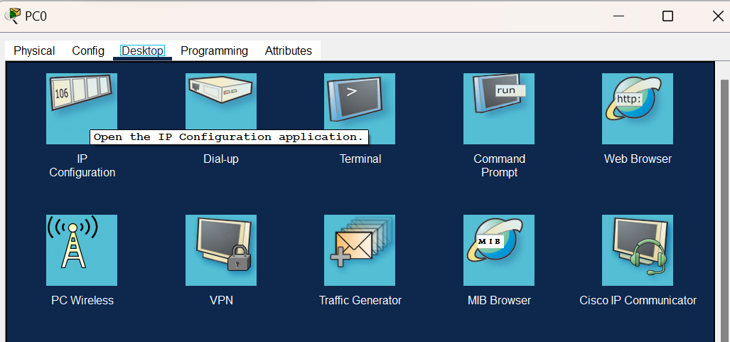

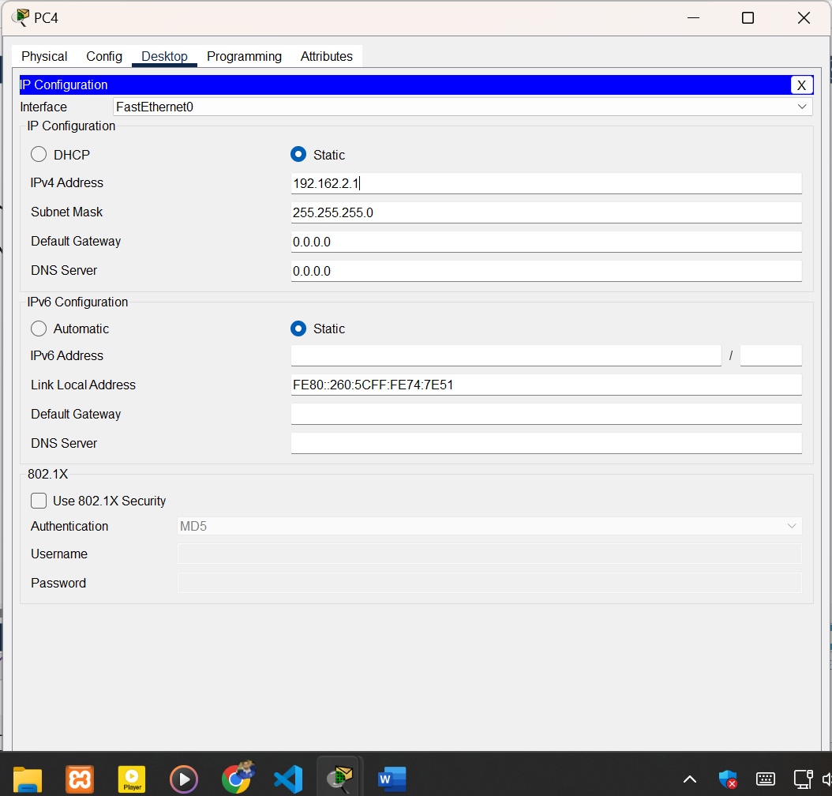

# Lab2:

## IP address setting:

subnet mask: 255.255.255.0 for C type N.N.N.H

Ip address of 1st 3 octate of each device should be same 🡪same network

USB don’t support peer to peer connection.

Use crossover ethernet wire to make Peer to Peer connection.

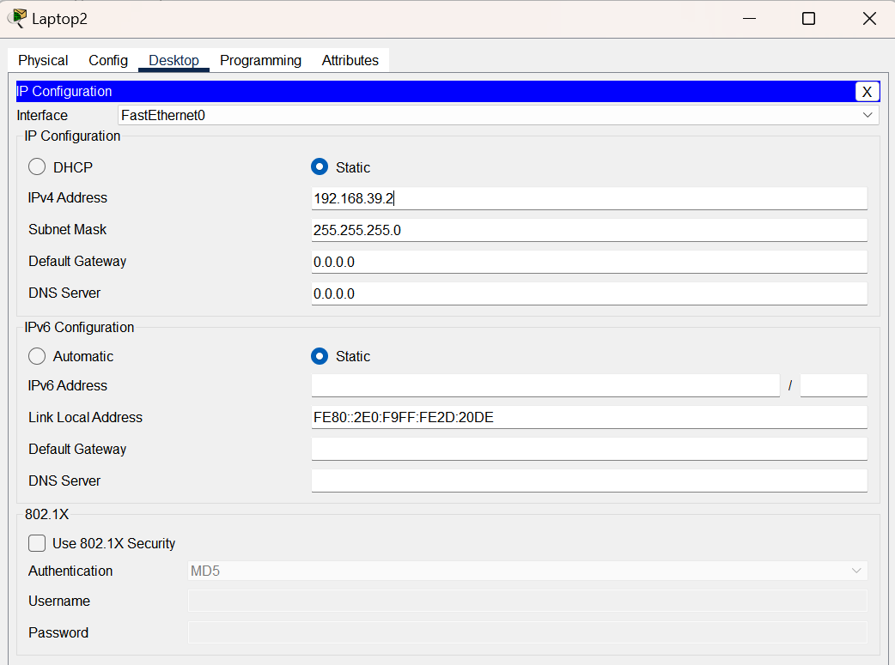

## Add new port in switch:

Click on switch > turn power off > drag and drop ethernet cable port(From Module section-> click on different modules to know their property)

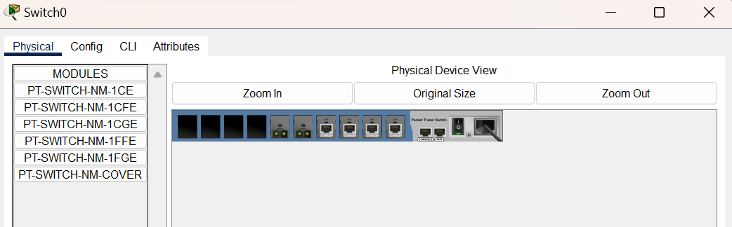

## OSI:

Bridge and Switch: Data Link Layer device 🡪 work in same Network

1. Application Layer
2. Presentation Layer
3. Session
4. Trasportation Layer
5. Network **(Different Network)🡪Router**
6. Datalink **(Same Network)🡪Bridge, Switch**
7. Physical 🡪Hub 🡪 can’t work with Address.

Connect a star topology of Hub with Start topology of Switch with Bridge:

Conditons:

1. Use Same Network (if C type N.N.N.H used 1st 3 octate same for all laptop/desktop)
2. Each device of 2 star topology must have different unique IP address.
3. Connect Laptop with Switch with Straight Through cable
4. Connect Laptop with Hub with Straight Through cable
5. Connect Bridge with Switch with Crossover cable
6. Connect Bridge with Hub with Crossover cable

# Lab3:

Preferences> always show port logical address

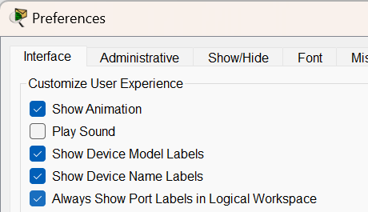

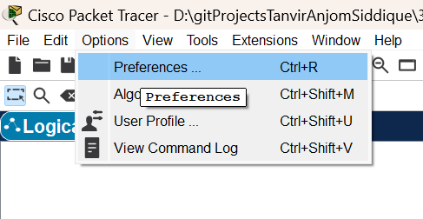

## Set default gateway:

1. Click on Laptop/desktop > IP Configuration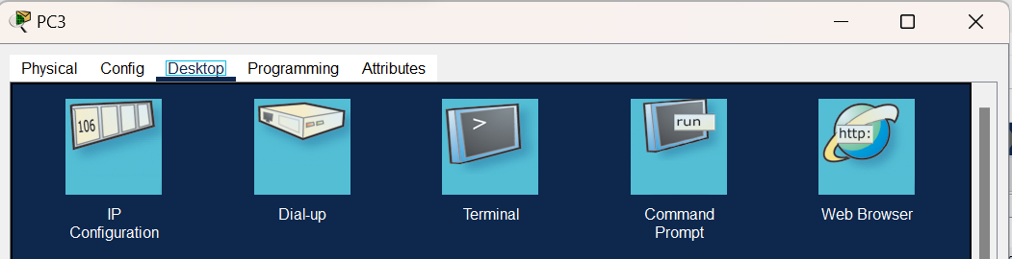
2. Set IP address(unique for **each PC** of same network) & Default gateway(Unique for 1 hub/switch of same network= all pc under it will have same Default Gateway) 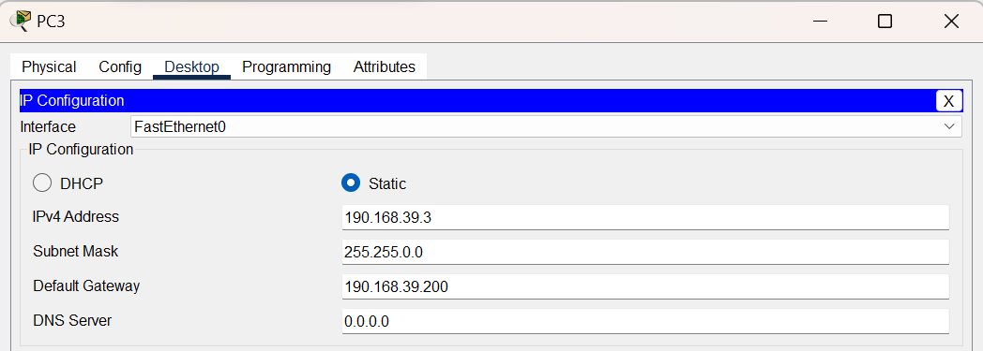
3. Click on Router > Config > Fast Ethernet0 (with which port the Hub is connected to router) > turn **Port Status on** >Set **IPv4 Address = Default gatway** address of each PC of the Connected Hub > Enter (Subnet Mask will be automatically set.)
4. 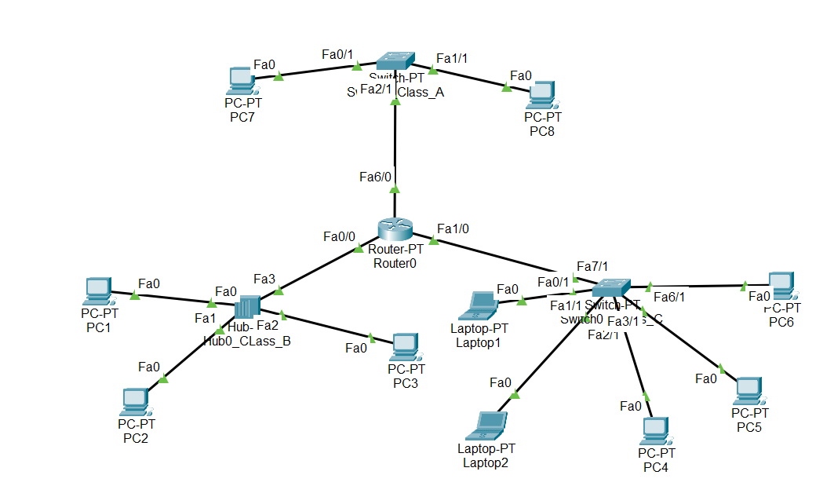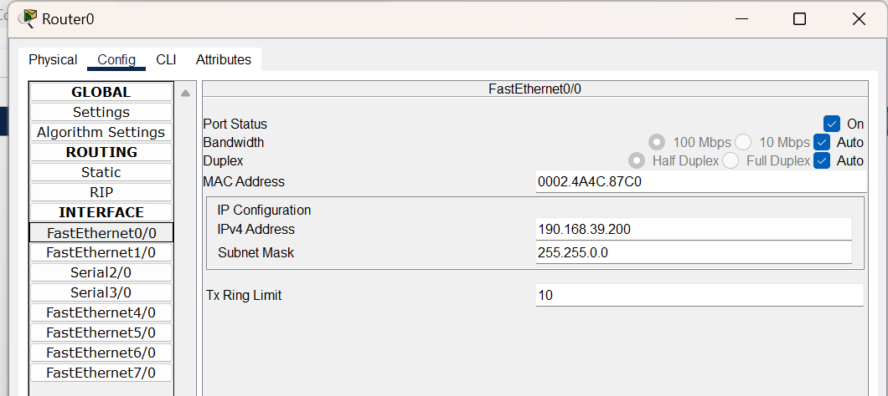
5. Follow this procedure for each Hub/Switch connected to Router.

## Increase Fast Ethernet Port in Router:

1. Click on Router >Turn Router Off > click & Drag PT-ROUTER-NM-1CFE to Router emtyp space for port > Turn Router on
2. If you turn off & then on Router > all ports will be turned off > hence you need to turn ports of Router connected to Hub/Switches on.
3. If you click on a Module : Details information about the Module will be shown below.
4. 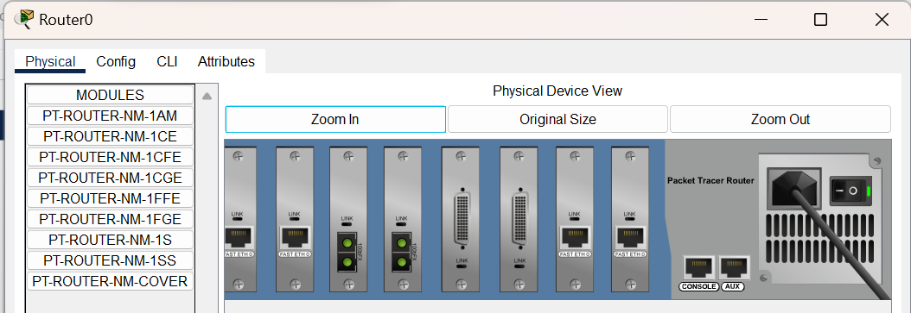
5. 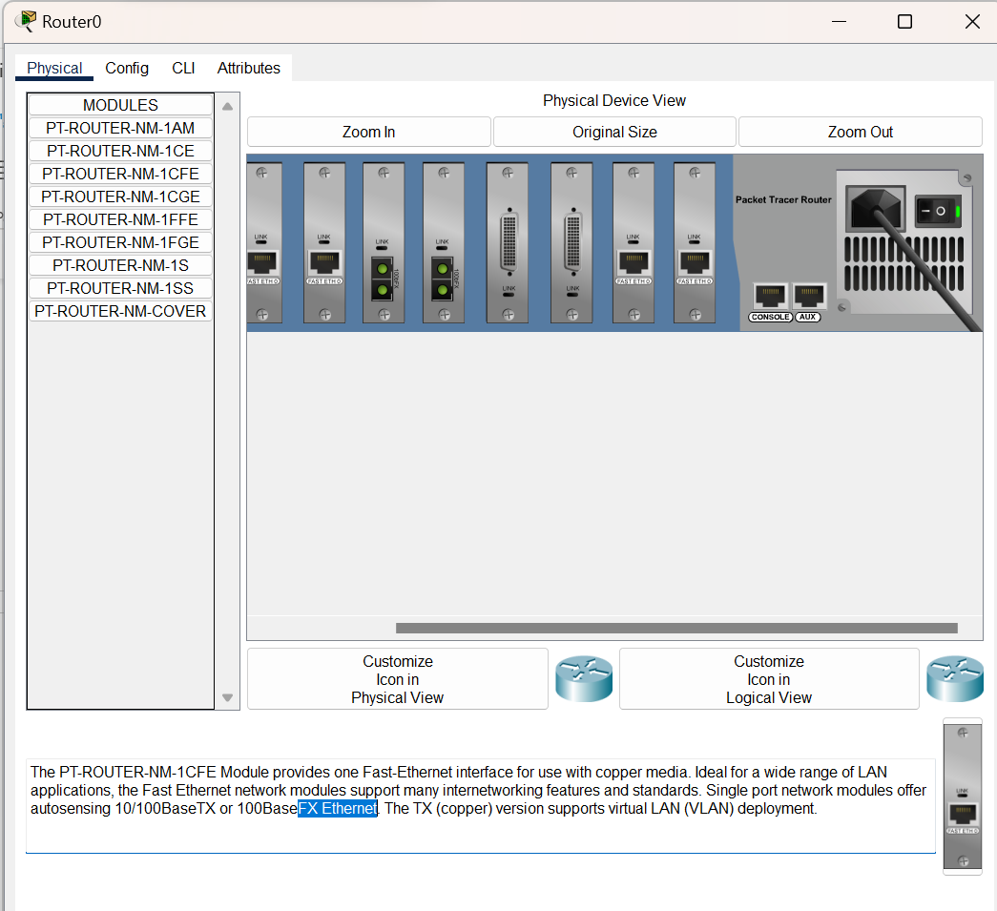

## Connection wire:

1. Laptop + Switch/Hub = Straight Through (Fast Ethernet port)
2. Switch/Hub + Router = Straight Through (Fast Ethernet port)
3. Hub+Switch = Cross Over
4. Laptop/Destop + Laptop/Desktop = Cross Over

## Delete a message: click on a message > Delete

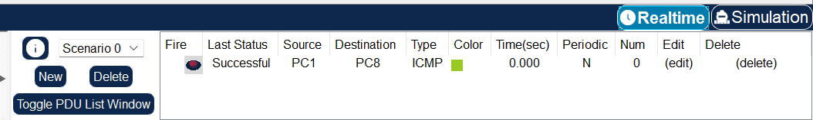

## Full Network Figure : 3 star topology of different netwok connected by Router

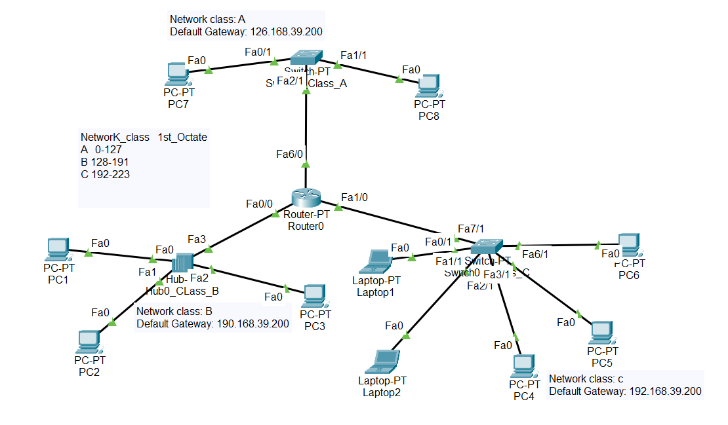

# Lab4:

Suppose a company is given IP address 192.168.100.0/24

Now the company wants to divide into two subdepartment

1. Marketing (4hosts)
2. Production (5hosts)

Design the network:

MarketingSite—Router0—Router1—ProductionSite

## Production site:

We need 2 different network (fixed length subnetting)

1 bit🡪 address 2 subnet

IP: 192.168.100.0/24

Given Subnet Mask: 255.255.255.0 🡪 24 consecutive 1

Our subnet Mask for each subnet:

255.255.255.10000000 🡪 255.255.255.128 🡪 25 consecutive 1 for network

Rest 7 lower bits 🡪 for host

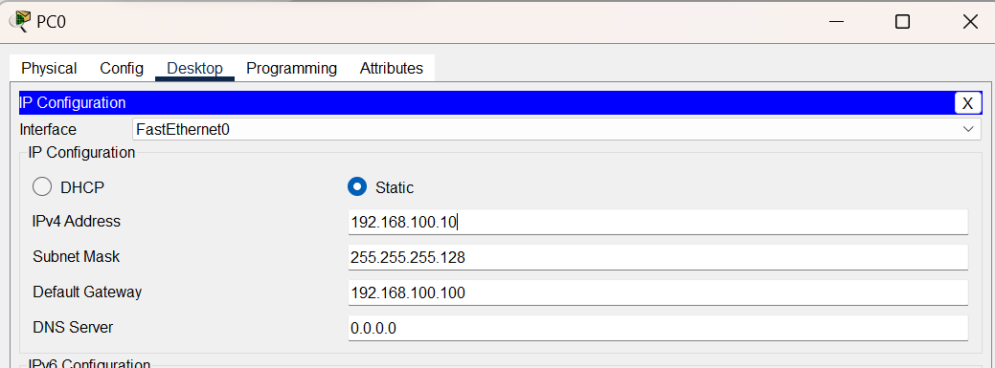

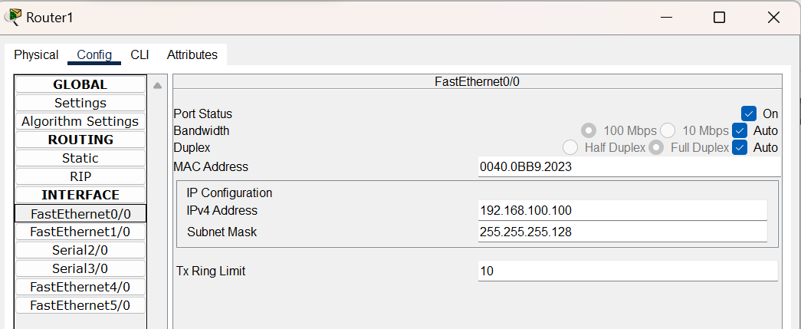

## Production:

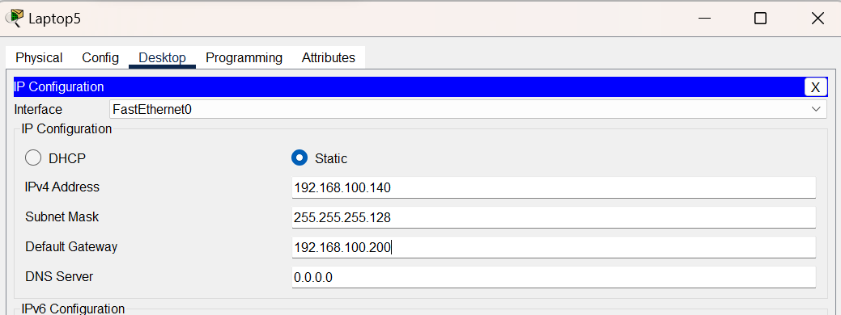

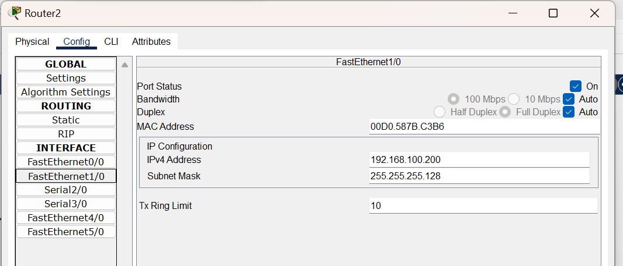

## Router to Router connection:

2 routers are connected as a other network.Set their ip address.

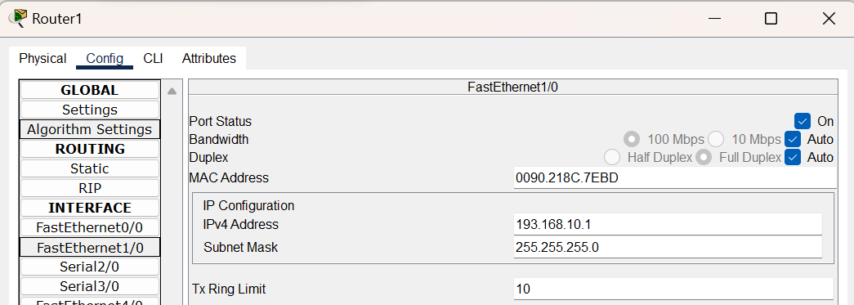

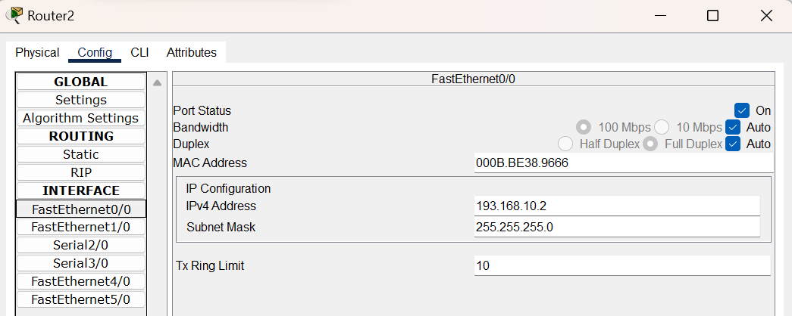

## Select Destination PC’s Network address & subnet mask

## & Network hop: IP of the destination routers Port

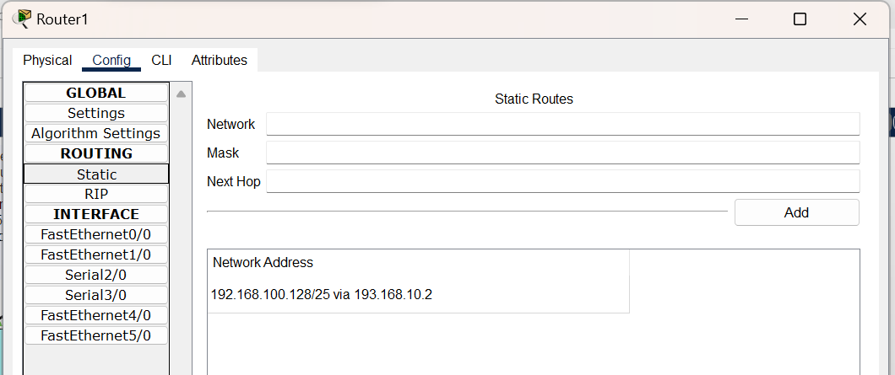

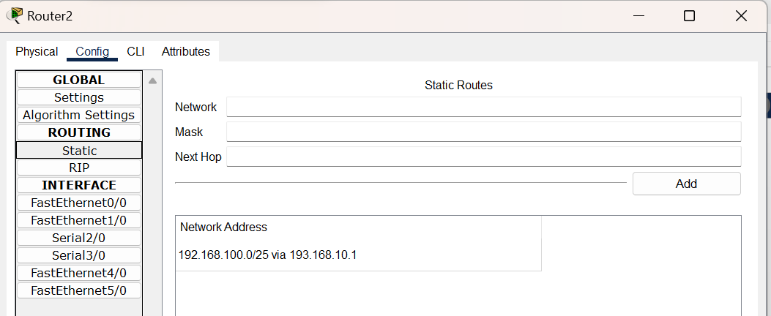

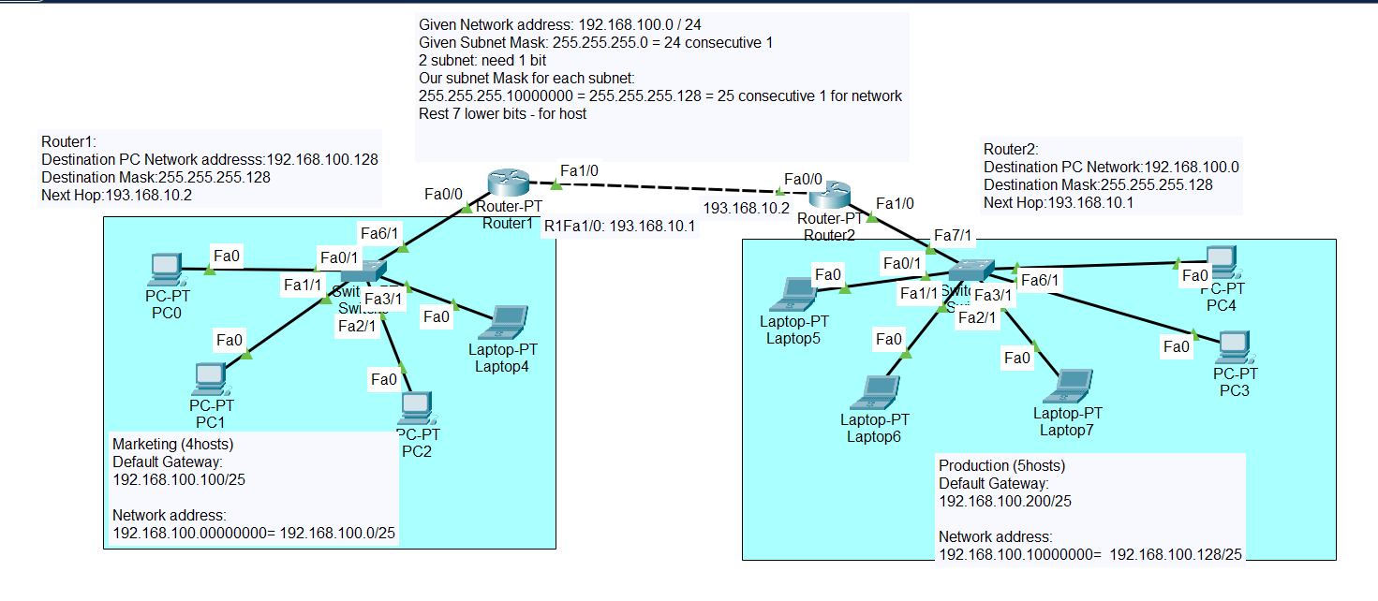

# Lab 5:

<https://drive.google.com/file/d/1ifcxtDInQ9PbyCbFAPe9eOV-J3Crfl0s/view>

download this file and subnet.

## Problem Statement:

**Packet Tracer - Subnet Scenario 2**

**Addressing Table**

|  |  |  |  |  |
| --- | --- | --- | --- | --- |
| **Device** | **Interface** | **IP Address** | **Subnet Mask** | **Default Gateway** |
| R1 | G0/0 |  |  | N/A |
| S0/0/0 |  |  | N/A |
| R2 | G0/0 |  |  | N/A |
| S0/0/0 |  |  | N/A |
| S0/0/1 |  |  | N/A |
| R3 | G0/0 |  |  | N/A |
| S0/0/0 |  |  | N/A |
| S0/0/1 |  |  | N/A |
| R4 | G0/0 |  |  | N/A |
| S0/0/0 |  |  | N/A |
| S1 | VLAN 1 |  |  |  |
| S2 | VLAN 1 |  |  |  |
| S3 | VLAN 1 |  |  |  |
| S4 | VLAN 1 |  |  |  |
| PC1 | NIC |  |  |  |
| PC2 | NIC |  |  |  |
| PC3 | NIC |  |  |  |
| PC4 | NIC |  |  |  |

**Objectives**

**Part 1: Design an IP Addressing Scheme**

**Part 2: Assign IP Addresses to Network Devices and Verify Connectivity**

**Scenario**

In this activity, you are given the network address of 172.31.1.0 /24 to subnet and provide the IP addressing for the network shown in the Topology. The required host addresses for each WAN and LAN link are labeled in the topology.

**Part 1:     Design an IP Addressing Scheme**

**Step 1:     Subnet the 172.31.1.0/24 network based on the maximum number of hosts required by the largest subnet.**

a.     Based on the topology, how many subnets are needed?

b.    How many bits must be borrowed to support the number of subnets in the topology table?

c.     How many subnets does this create?

d.    How many usable host addresses does this create per subnet?

**Note:** If your answer is less than the 14 maximum hosts required for the R3 LAN, then you borrowed too many bits.

e.     Calculate the binary value for the first five subnets. Subnet zero is already shown.

Net 0: 172 . 31 . 1 . 0 0 0 0 0 0 0 0

Net 1: 172 . 31 . 1 . ___ ___ ___ ___ ___ ___ ___ ___

Net 2: 172 . 31 . 1 . ___ ___ ___ ___ ___ ___ ___ ___

Net 3: 172 . 31 . 1 . ___ ___ ___ ___ ___ ___ ___ ___

Net 4: 172 . 31 . 1 . ___ ___ ___ ___ ___ ___ ___ ___

f.     Calculate the binary and decimal value of the new subnet mask.

11111111.11111111.11111111. ___ ___ ___ ___ ___ ___ ___ ___

255 . 255 . 255 . ______

g.    Complete the **Subnet Table**,listing all available subnets, the first and last usable host address, and the broadcast address. The first subnet is done for you. Repeat until all addresses are listed.

**Note**: You may not need to use all rows.

**Subnet Table**

|  |  |  |  |  |
| --- | --- | --- | --- | --- |
| **Subnet Number** | **Subnet IP** | **First Usable Host IP** | **Last Usable Host IP** | **Broadcast Address** |
| 0 | 172.31.1.0 | 172.31.1.1 | 172.31.1.14 | 172.31.1.15 |
| **1** |  |  |  |  |
| **2** |  |  |  |  |
| **3** |  |  |  |  |
| **4** |  |  |  |  |
| **5** |  |  |  |  |
| **6** |  |  |  |  |
| **7** |  |  |  |  |
| **8** |  |  |  |  |
| **9** |  |  |  |  |
| **10** |  |  |  |  |
| **11** |  |  |  |  |
| **12** |  |  |  |  |
| **13** |  |  |  |  |
| **14** |  |  |  |  |
| **15** |  |  |  |  |

**Step 2:     Assign the subnets to the network shown in the topology.**

When assigning the subnets, keep in mind that routing is necessary to allow information to be sent throughout the network.

a.     Assign Subnet 0 to the R1 LAN:

b.    Assign Subnet 1 to the R2 LAN:

c.     Assign Subnet 2 to the R3 LAN:

d.    Assign Subnet 3 to the R4 LAN:

e.     Assign Subnet 4 to the link between

f.     Assign Subnet 5 to the link between

g.    Assign Subnet 6 to the link between

**Step 3:     Document the addressing scheme.**

Complete the **Addressing Table** using the following guidelines:

a.     Assign the first usable IP addresses to routers for each of the LAN links.

b.    Use the following method to assign WAN link IP addresses:

·         For the WAN link between R1 and R2, assign the first usable IP address to R1 and last usable IP address R2.

·         For the WAN link between R2 and R3, assign the first usable IP address to R2 and last usable IP address R3.

·         For the WAN link between R3 and R4, assign the first usable IP address to R3 and last usable IP address R4.

c.     Assign the second usable IP addresses to the switches.

d.    Assign the last usable IP addresses to the hosts.

**Part 2:     Assign IP Addresses to Network Devices and Verify Connectivity**

Most of the IP addressing is already configured on this network. Implement the following steps to complete the addressing configuration.

**Step 1:     Configure IP addressing on R1 and R2 LAN interfaces.**

**Step 2:     Configure IP addressing on S3, including the default gateway.**

**Step 3:     Configure IP addressing on PC4, including the default gateway.**

**Step 4:     Verify connectivity.**

You can only verify connectivity from R1, R2, S3, and PC4. However, you should be able to ping every IP address listed in the **Addressing Table**.

**Suggested Scoring Rubric**

|  |  |  |  |
| --- | --- | --- | --- |
| **Activity Section** | **Question Location** | **Possible Points** | **Earned Points** |
| Part 1: Design an IP Addressing Scheme | Step 1a | 1 |  |
| Step 1b | 1 |  |
| Step 1c | 1 |  |
| Step 1d | 1 |  |
| Step 1e | 4 |  |
| Step 1f | 2 |  |
| Complete Subnet Table | Step 1g | 10 |  |
| Assign Subnets | Step 2 | 10 |  |
| Document Addressing | Step 3 | 40 |  |
| **Part 1 Total** | | **70** |  |
| **Packet Tracer Score** | | **30** |  |
| **Total Score** | | **100** |  |

## Answer:

Given IP: 172.31.1.0/24

Given Subnet Mask: 255.255.255.0

Need 16 subnets. 2^4=16

So, in 4th octet 1st 4 bit for subnet network

Last 4 bit for Host

|  |  |  |  |  |
| --- | --- | --- | --- | --- |
| **Subnet Number** | **Subnet IP** | **First Usable Host IP** | **Last Usable Host IP** | **Broadcast Address** |
| 0  R1 | 172.31.1.0 | 172.31.1.0  R1 G0/0 | 172.31.1.14  PC1 | 172.31.1.15 |
| 1 | 172.31.1.16 | 172.31.1.17  R2 G0/0 | 172.31.1.30  PC2 | 172.31.1.31 |
| 3 | 172.31.1.32 | 172.31.1.33  R3 G0/0 | 172.31.1.46  PC3 | 172.31.1.47 |
| 4 | 172.31.1.48 | 172.31.1.49  R4 G0/0 | 172.31.1.62  PC4 | 172.31.1.63 |
| 5 | 172.31.1.64 | 172.31.1.65 | 172.31.1.78 | 172.31.1.79 |
| 6 | 172.31.1.80 | 172.31.1.81 | 172.31.1.94 | 172.31.1.95 |
| 7 | 172.31.1.96 | 172.31.1.97 | 172.31.1.110 | 172.31.1.111 |
|  |  |  |  |  |
|  |  |  |  |  |
|  |  |  |  |  |
|  |  |  |  |  |
|  |  |  |  |  |
|  |  |  |  |  |
|  |  |  |  |  |
|  |  |  |  |  |
|  |  |  |  |  |
|  |  |  |  |  |
|  |  |  |  |  |

Router1 click > CLI >Enter > en (enable router)>

We will do Configuration:

* config terminal
* Interface G0/0

.

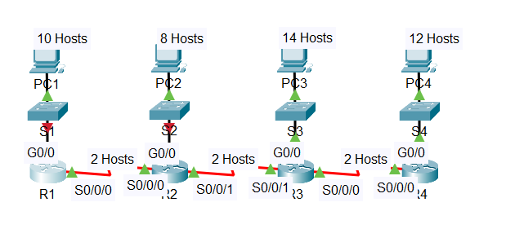

IP configuration:

|  |
| --- |
| R1>en  R1#conf t  R1(config)#int g0/0  R1(config-if)#ip address 172.31.1.1 255.255.255.240  R1(config-if)#no shut  R1(config-if)#int s0/0/0  R1(config-if)#ip address 172.31.1.65 255.255.255.240  R1(config-if)#no shut  R2>en  R2#conf t  R2(config)#int g0/0  R2(config-if)#ip address 172.31.1.17 255.255.255.240  R2(config-if)#no shut  R2(config-if)#int s0/0/1  R2(config-if)#ip address 172.31.1.81 255.255.255.240  R2(config-if)#no shut  R2(config)#int s0/0/0  R2(config-if)#ip address 172.31.1.78 255.255.255.240  R2(config-if)#no shut  S3>en  S3#conf t  S3(config)#int vlan1  S3(config-if)#ip address 172.31.1.34 255.255.255.240  S3(config-if)#no shut  S3(config-if)#exit  S3(config)#ip default-gateway 172.31.1.33 |

## Show IP addresses of all running devices:

S3>**en**

S3# **show running-config**

