Routine 3-2 , CSE_19A (Alvi Siddique)
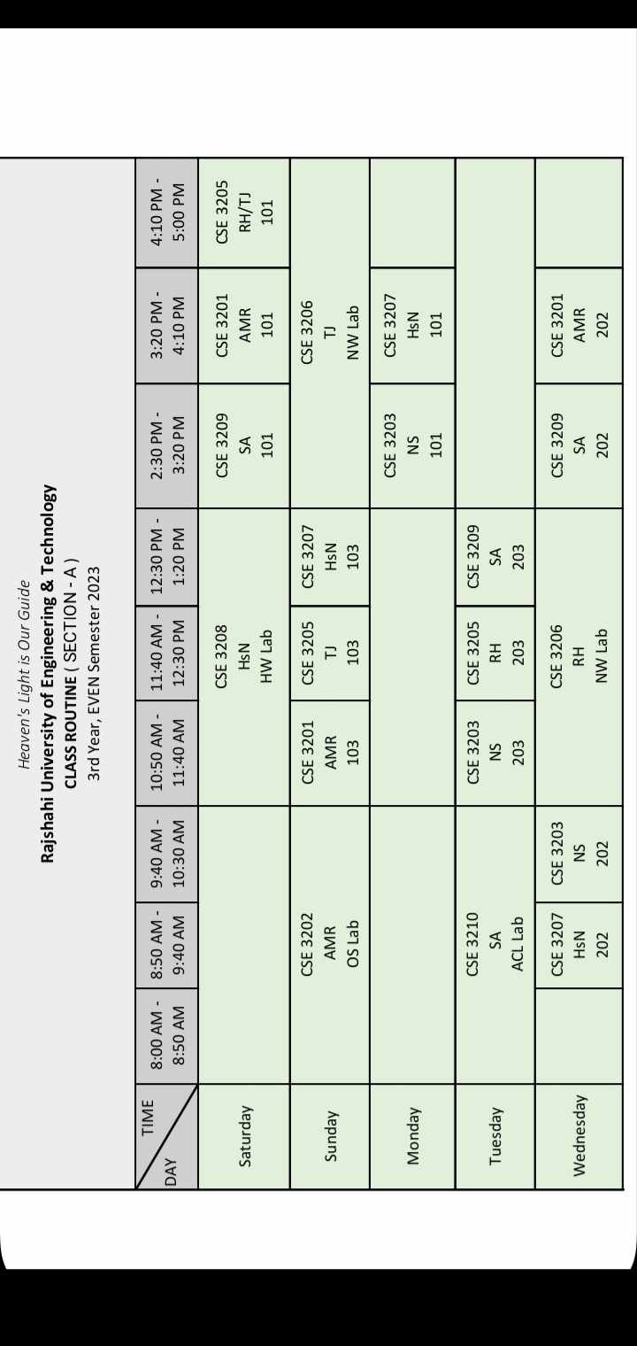
Hbe na
CSE 3207
101
Odd: 2nd
Even:2nd

Odd:1st
Even:1st

Odd: 2nd
Even: 1st

Odd: 2nd
Even: 1st

Odd: 1st
Even:2nd

Odd week- 1st 30: 3108(Saturday), 3106(Wednesday) 2nd 30: 3102(Sunday Morning 8.30),

