**Roll No:  1903039**

**Lab Performance Evaluation [No]**

**Lab Task Q[No]**

## Question Q1:

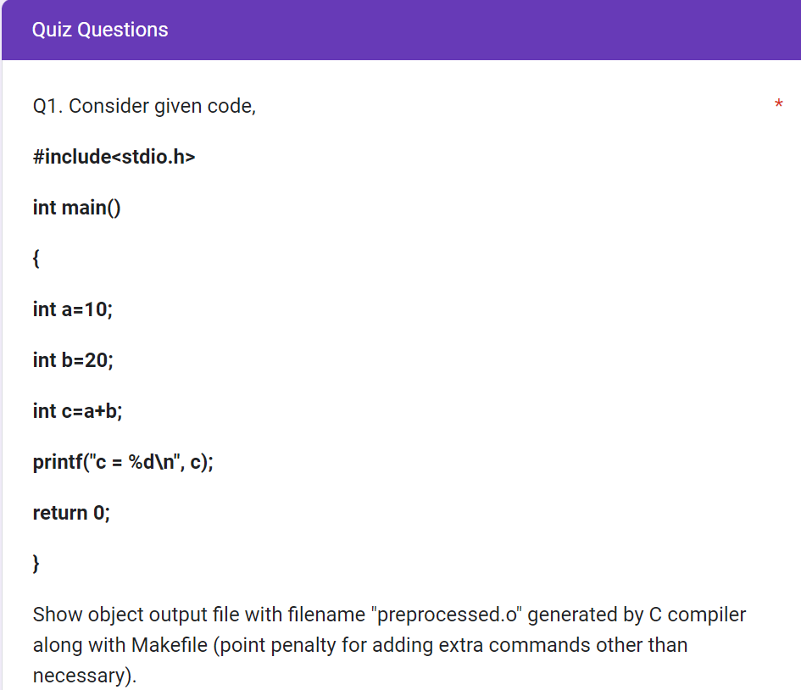

**Solution (Bold your own written code):**

**Makefile**

|  |
| --- |
| main:      gcc -E preprocessed.c > preprocessed.i      gcc -S -masm=intel preprocessed.i      as -o preprocessed.o preprocessed.s |

**Output (Screen/SnapShot):**

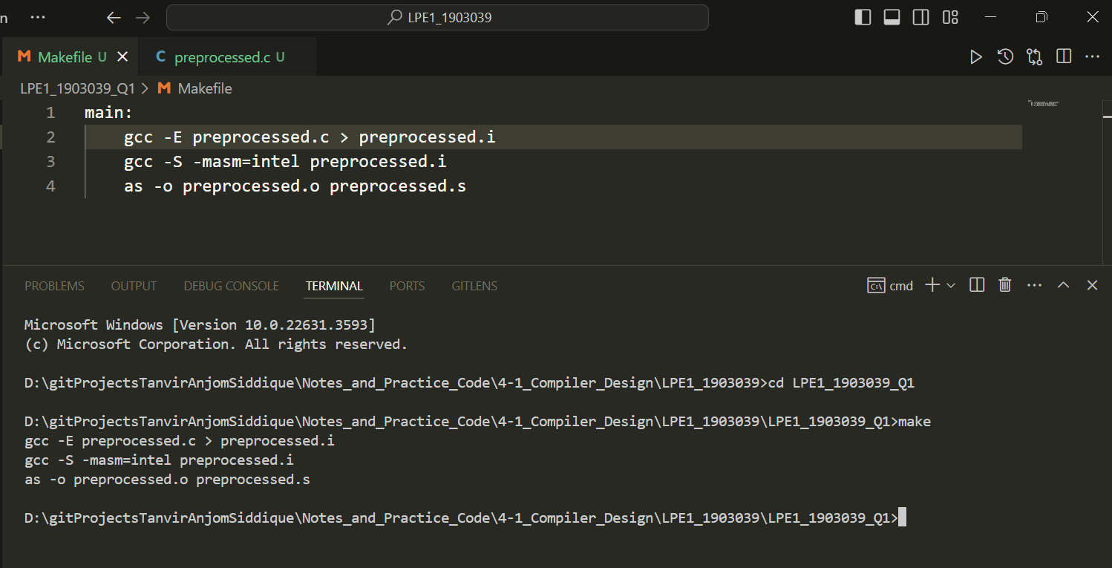

Or, **Makefile**

|  |
| --- |
| **main:**  **gcc -c -o preprocessed.o preprocessed.c** |

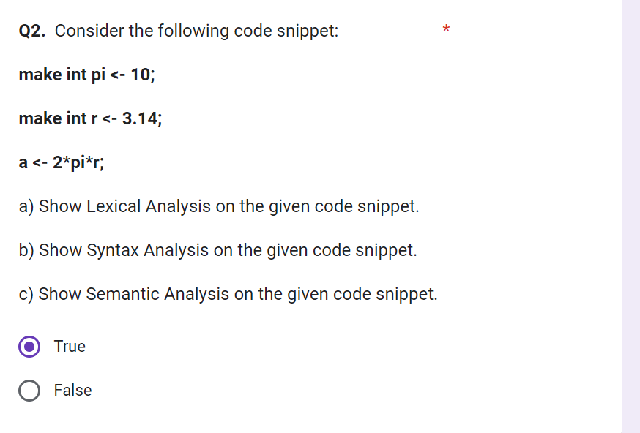

**Question Q2a:**

**make int pi <- 10;**

**make int r <- 3.14;**

**a <- 2*pi*r;**

a) Show Lexical Analysis on the given code snippet.

**Solution (Bold your own written code):**

**Flex (lex.l)**

|  |
| --- |
| %option noyywrap  %{   #include <stdio.h>   #include<stdlib.h>  %}  letter [a-zA-Z]  digit [0-9]  ID (_|{letter})(_|{letter}|{digit})*  ws [ \n]  %%  ({ws}) {}  "make" { printf("%s -> KEYWORD_MAKE\n", yytext); }  "int" { printf("%s -> INT_TYPE\n", yytext); }  {digit}*"."{digit}+ { printf("%s -> REAL_NUM\n", yytext); }  {digit}+ { printf("%s -> INT_NUM\n", yytext); }  {ID} { printf("%s -> ID\n", yytext); }  "<-" { printf("%s -> ASSIGN\n", yytext); }  "*" { printf("%s -> MUL\n", yytext); }  ";" { printf("%s -> SEMI\n", yytext); }  %%  *int* main(){   yylex();   return 0;  } |

**Output (Screen/SnapShot):**

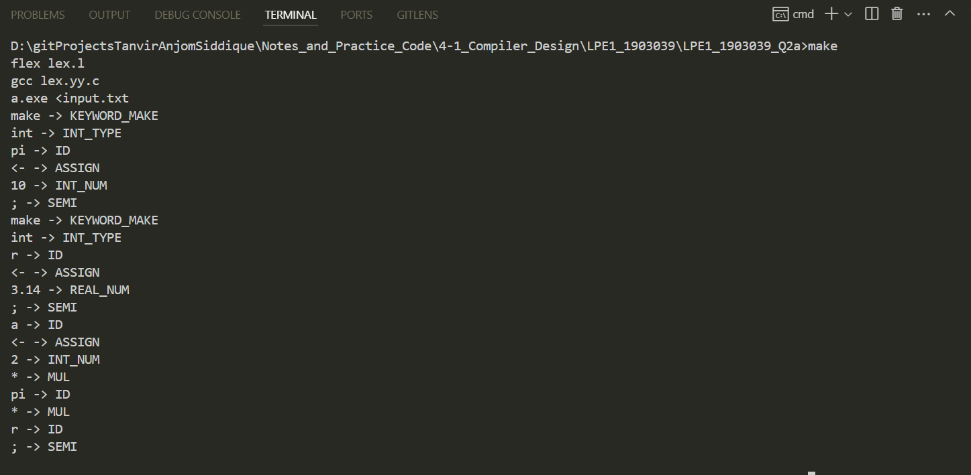

## Question: Q2B

**Solution (Bold your own written code):**

**lex.l**

|  |
| --- |
| %option noyywrap  %{      // Roll - 1903001      #include <stdio.h>      #include<stdlib.h>      #include "bis.tab.h"  *int* lineno=1;  *void* yyerror();  %}  letter [a-zA-Z]  digit [0-9]  ID ({letter})({letter}|{digit})*  quo ["]  ws [ ]  sc [ :=+-_]  literal ({quo})({letter}|{digit}|{sc})*({quo})  %%  ({ws}) {}  "int" { return(INT); }  "make" { return(MAKE); }  {digit}*"."{digit}+ { return(REAL_NUM); }  {digit}+ { return(INT_NUM); }  {ID} { return(ID); }  "<-" { return(ASSIGN); }  "*" { return(MUL); }  ";" { return(SEMI); }  "\n" {lineno+=1;}  %%  // int main(){  //  yylex();  //  return 0;  // } |

bis.y

|  |
| --- |
| %{      #include <stdio.h>      #include <stdlib.h>  *void* yyerror();      extern *int* lineno;      extern *int* yylex();  %}  %union  {      char str_val[100];      int int_val;  }  %token INT MAKE REAL_NUM INT_NUM ID ASSIGN MUL SEMI  %start code  %%  code: L1 L2 L3;  L1: MAKE INT ID ASSIGN INT_NUM SEMI  L2: MAKE INT ID ASSIGN REAL_NUM SEMI  L3: ID ASSIGN INT_NUM MUL ID MUL ID SEMI  %%  *int* main()  {      yyparse();      printf("Parsing Finshed\n");      return 0;  }  *void* yyerror(*char* \**err*){      printf("Syntax error at line %d\n", lineno);      exit(1);  } |

Makefile

|  |
| --- |
| main:      bison -d bis.y      flex lex.l      gcc bis.tab.c lex.yy.c      a < input.txt |

**Output (Screen/SnapShot):**

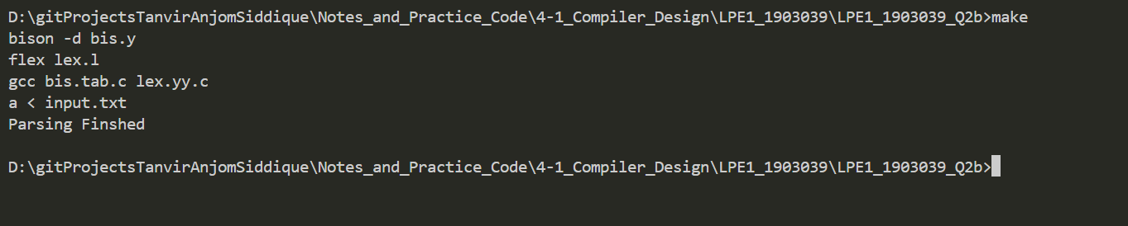

**Question: Q2c**

**Solution (Bold your own written code):**

|  |
| --- |
|  |

**Output (Screen/SnapShot):**