Figure 1: Resource Group with Storage Account Created
Task: Task 1- Explore Azure Portal & Create a Resource Group
Description:
A Resource Group named resource_tanvi was successfully created in the Central India region using the Azure for Students subscription. The Resource Group contains the Storage Account tanvi001, confirming successful resource deployment within the Azure Portal.
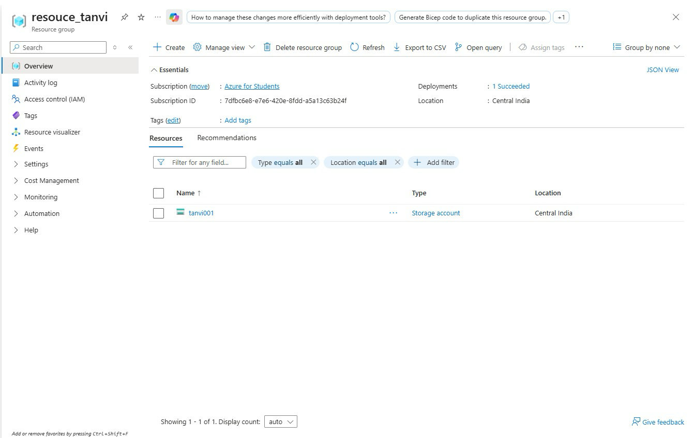

Figure 2: Storage Account and Blob Containers Created
Task: Task 2 – Storage Setup
Description:
A Storage Account named tanvi001 was successfully created in Azure. Inside the Storage Account, Blob Containers were created, including source-data for storing the Superstore CSV dataset and the default $logs container generated by Azure. These containers will be used as the source location for the Azure Data Factory pipeline.
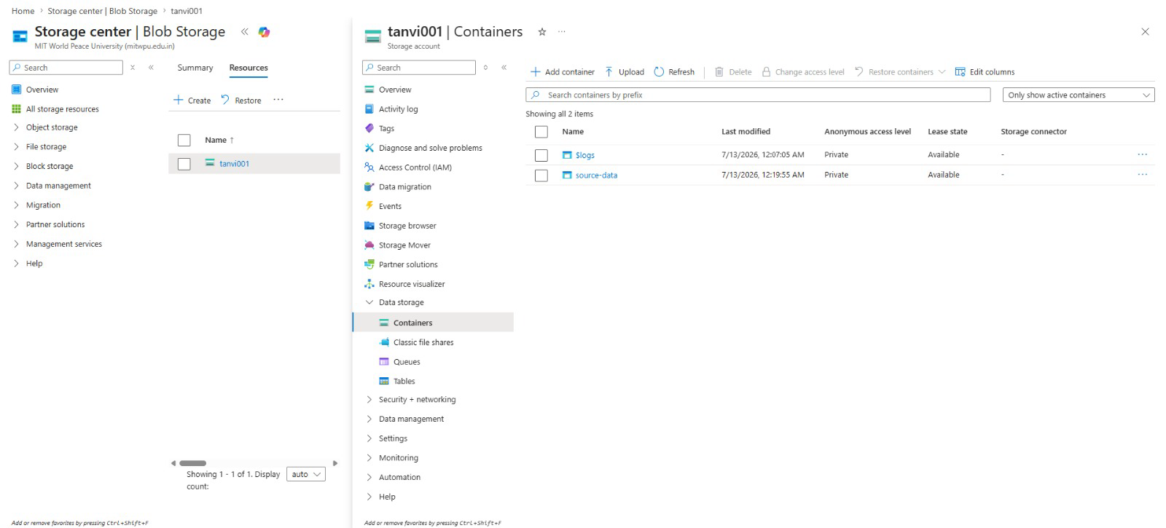

Figure 3: CSV File Uploaded to Blob Container
Task: Task 2 – Storage Setup
Description:
The Sample - Superstore.csv dataset was successfully uploaded to the source-data Blob Container in Azure Storage Account tanvi001. This CSV file serves as the source dataset for the Azure Data Factory pipeline.
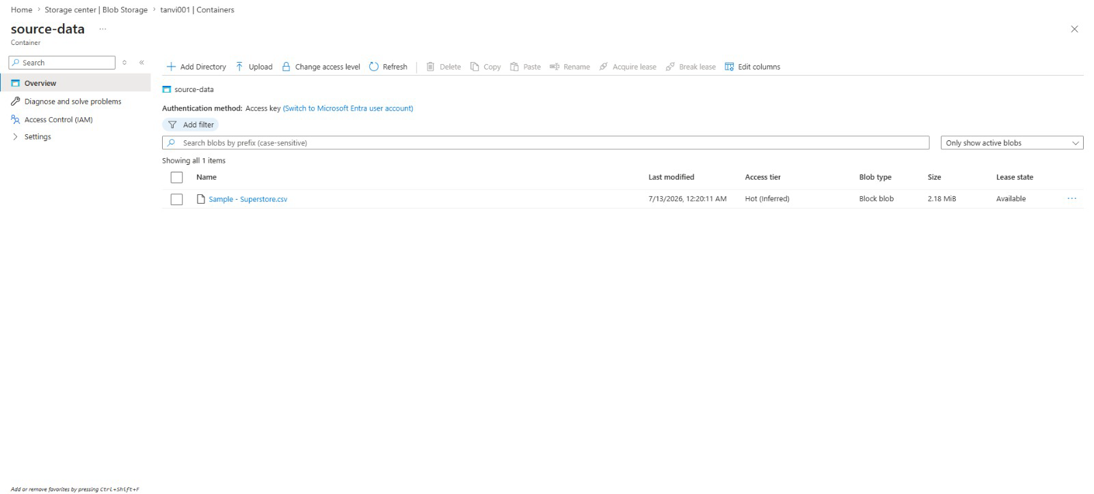

Figure 4: Azure Data Factory Overview
Task: Task 3 – ADF Basics
Description:
An Azure Data Factory instance named adftanvi001 was successfully created. The ADF Studio interface was explored, including the Author, Monitor, and Manage sections, which are used to build, execute, and manage data integration pipelines.
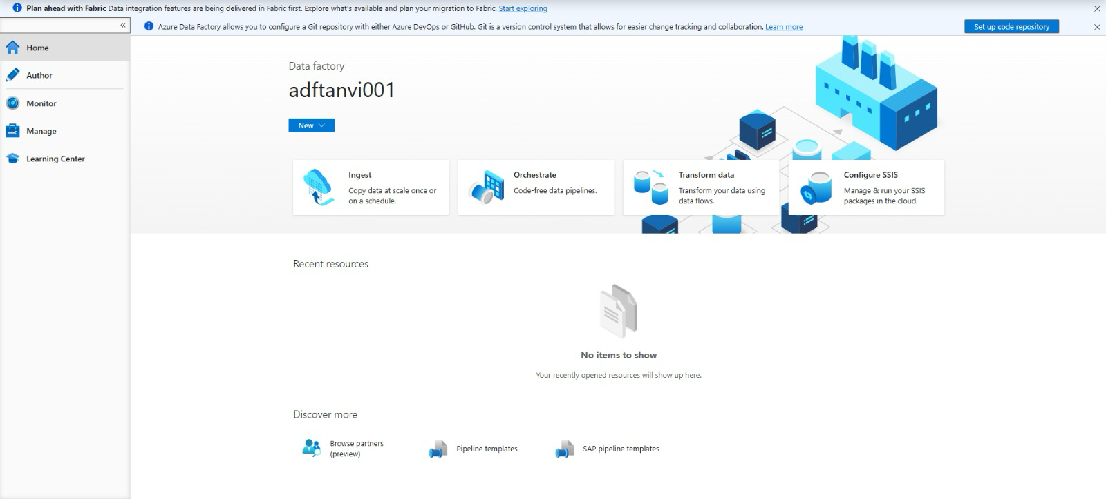

Figure 5: Azure Blob Storage Linked Service
Task: Task 3 – ADF Basics
Description:
A Linked Service named LS_BlobStorage was successfully created in Azure Data Factory to establish a secure connection with the Azure Blob Storage account. This connection enables ADF to access the source and destination data stored in Blob Storage.
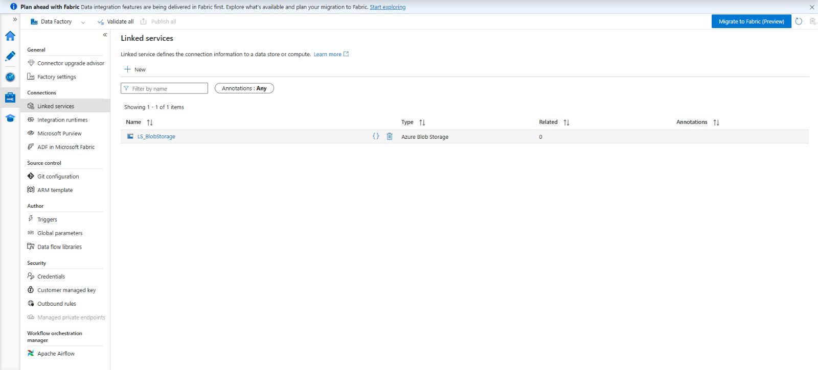

Figure 6: Source Dataset Configuration
Task: Task 3 – ADF Basics
Description:
A source dataset named DS_SourceCSV was created and configured using the LS_BlobStorage Linked Service. The dataset is connected to the Sample - Superstore.csv file stored in the source-data Blob Container and will be used as the input for the Azure Data Factory pipeline.
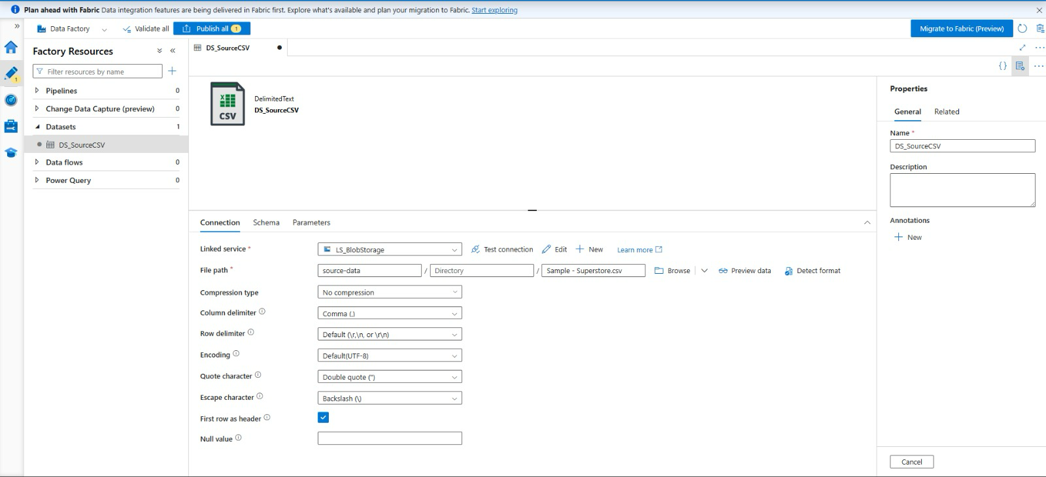

Figure 7: Get Metadata Activity Configuration
Task: Task 3 – ADF Basics
Description:
A Get Metadata activity was created in Azure Data Factory to validate the source file before processing. The activity is connected to the DS_SourceCSV dataset and retrieves metadata such as file size, file existence, and last modified timestamp, ensuring that the source file is available and ready for the data pipeline execution.
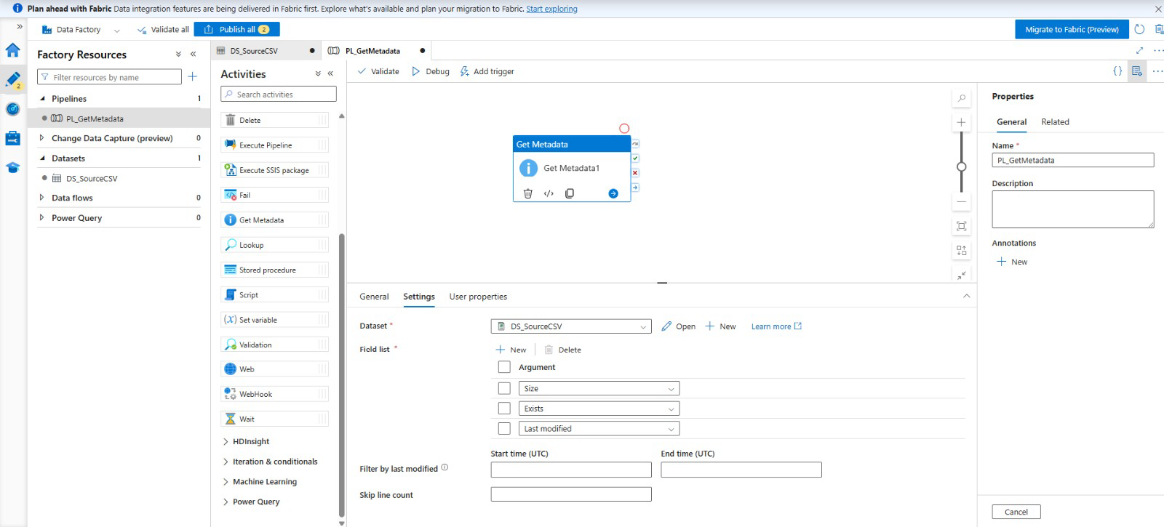

Figure 8: Copy Data Pipeline Creation
Task: Task 4 – Pipeline Development
Description:
A new pipeline named PL_CopyCSV was created in Azure Data Factory to implement the data movement process. The pipeline uses the Copy Data activity to transfer the Superstore CSV file from the source Blob Storage container to the destination location. The required source and destination datasets were configured, forming the core data pipeline for the assignment.
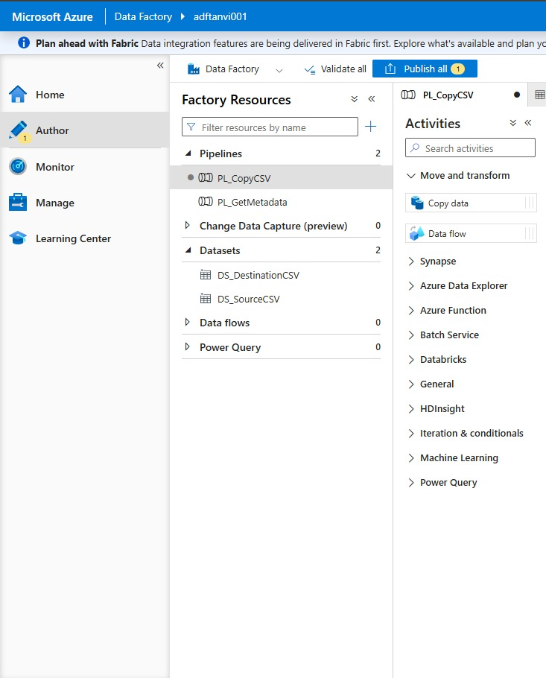

Figure 9: Copy Data Activity Configuration
Task: Task 4 – Pipeline Development
Description:
The Copy Data activity was configured inside the PL_CopyCSV pipeline. The DS_DestinationCSV dataset was selected as the sink (destination), completing the source-to-destination mapping for copying the Superstore CSV file from the Blob Storage source container to the destination container. This configuration enables automated data transfer within Azure Data Factory.
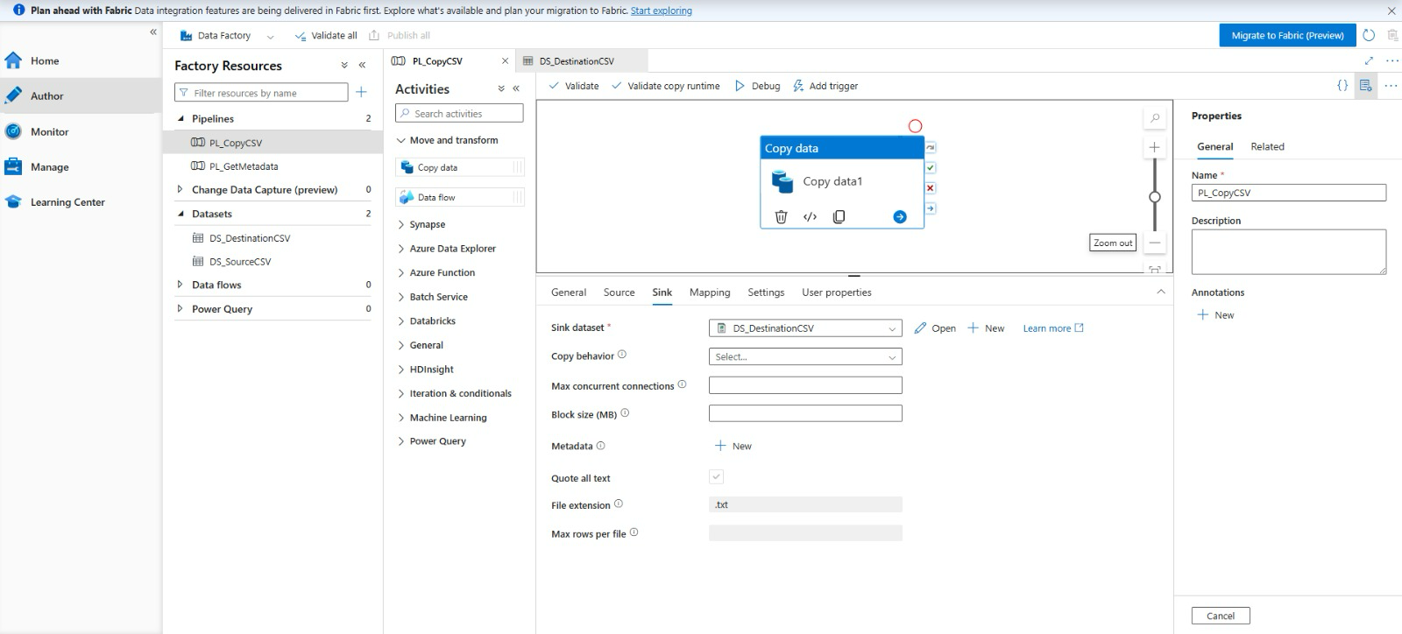

Figure 10: Source Dataset Configuration in Copy Data Pipeline
Task: Task 4 – Pipeline Development
Description:
The Source configuration of the Copy Data activity was completed by selecting the DS_SourceCSV dataset. The pipeline was configured to read the Sample-Superstore.csv file from the source-data Blob Storage container, establishing the source connection for data transfer.
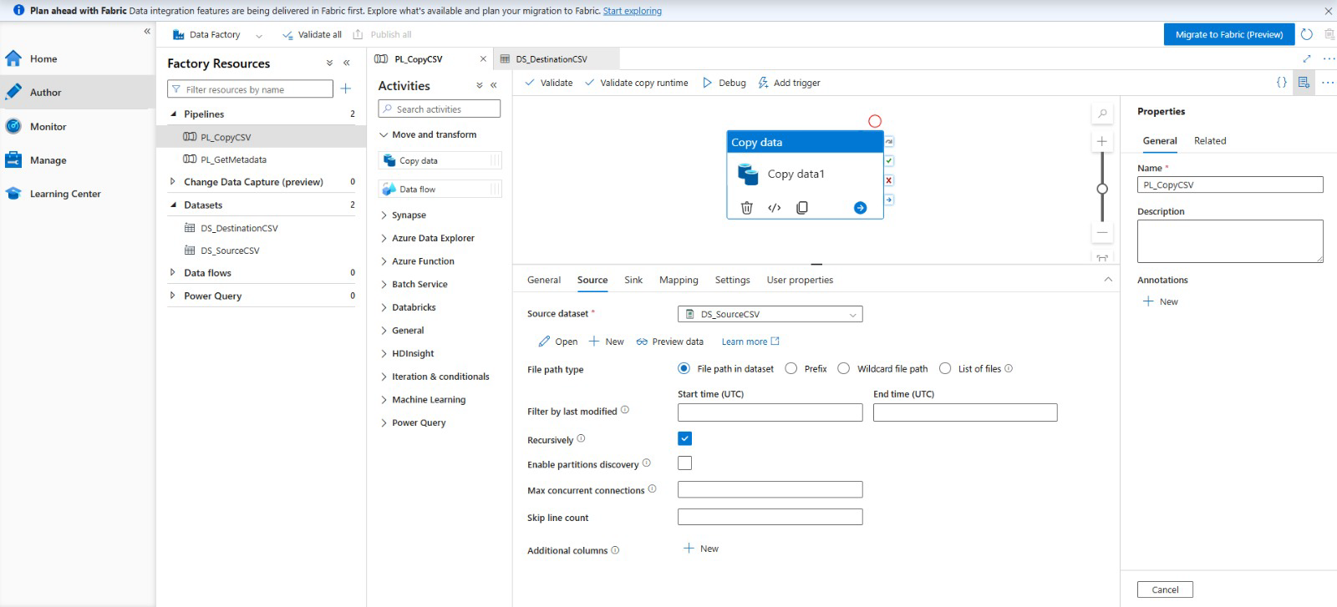

Figure 11: Pipeline Execution – Initial Debug Run
Task: Task 5 – Pipeline Execution (Initial Attempt)
Description:
The PL_CopyCSV pipeline was executed using the Debug option in Azure Data Factory. The execution status showed Failed, indicating that the pipeline configuration required further validation before successful execution. The debug output helped identify configuration issues during the development phase.

