CREATE DATABASE spj;
USE spj;
CREATE TABLE S (s# CHAR(5) NOT NULL, sname CHAR(20), status SMALLINT, city CHAR(15));
Insert into S values(‘S1’ , ’Smith’ , 20 , ‘London’);
Insert into S values(‘S2’ , ’Jones’ , 10 , ‘Paris’);
Insert into S values(‘S3’ , ’Blark’ , 30 , ‘Paris’);
Insert into S values(‘S4’ , ’Adams’ , 30 , ‘Athens’);
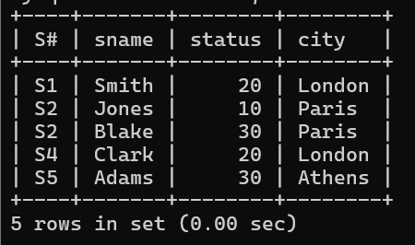
Create table P(`P#` char(6) not null , pname char(20) , color char(6) , weight smallint , city char(15));
Insert into P values(‘P1’ , ‘Nut’ , ‘Red’ , 12 , ‘London’);
Insert into P values(‘P2’ , ‘Bolt’ , ‘Green’ , 17 , ‘Paris’);
Insert into P values(‘P3’ , ‘Screw , ‘Blue’ , 17 , ‘Rome’);
Insert into P values(‘P1’ , ‘Screw’ , ‘Red’ , 14 , ‘London’);
