


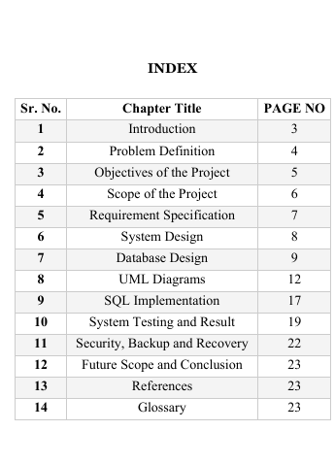
- INTRODUCTION
A Database Management System (DBMS) is a software system that enables users to store, manage, and retrieve data in an organized and efficient manner. It provides a structured way to handle large amounts of information while ensuring accuracy, security, and consistency. In today’s digital world, database systems play a vital role in almost every organization, including banks, hospitals, educational institutions, and law enforcement departments.
The Crime Report Management System is a database-based project developed using MySQL, an open-source relational database management system. The main purpose of this project is to design and implement a structured database system that can efficiently manage crime-related records. The system stores important information such as crime details, criminal records, victim information, FIR details, and police officer data in a well-organized format.
Traditionally, crime records are maintained manually in registers and physical files. This manual system leads to several issues such as data redundancy, inconsistency, difficulty in searching records, and risk of data loss. Maintaining large volumes of paper-based records is time-consuming and inefficient. Retrieving specific information from manual files requires significant effort and increases the chances of errors. Therefore, there is a need for a computerized database system that can store and manage crime data securely and efficiently.
The Crime Report Management System uses relational database concepts where data is stored in tables with proper relationships. Each table has a Primary Key to uniquely identify records, and Foreign Keys are used to maintain relationships between tables. Constraints such as NOT NULL and UNIQUE are applied to ensure data integrity and prevent invalid entries. SQL commands like CREATE, INSERT, UPDATE, DELETE, and SELECT are used to perform database operations.
This project helps in understanding practical DBMS concepts such as normalization, relational schema design, entity relationships, and query processing. It also demonstrates how MySQL can be used to build a real-world application for managing structured data.
In conclusion, the Crime Report Management System provides an efficient, secure, and reliable way to manage crime-related records digitally. It reduces manual work, improves data accuracy, and enables faster retrieval of information, thereby demonstrating the importance and usefulness of Database Management Systems in real-world applications.
The Crime Report Management System is mainly developed for academic purposes to understand how real-world database applications are designed and implemented. However, the basic structure of this system can be expanded and enhanced for real-time use in police departments or law enforcement agencies.
In conclusion, the Crime Report Management System highlights the importance of using database technology for efficient record management.
2. PROBLEM DEFINITION
In many police departments and small organizations, crime-related records are still maintained manually using paper files, registers, and physical documentation. This traditional method of record keeping creates several operational and management problems. As the number of crime cases increases, maintaining and managing large volumes of physical records becomes difficult, time-consuming, and inefficient.
One of the major problems of manual record management is data redundancy. The same information may be recorded multiple times in different registers, which leads to duplication of data. This duplication not only wastes storage space but also creates confusion when updates are required. If changes are made in one record but not updated in others, it results in data inconsistency.
Another significant issue is the difficulty in searching and retrieving records. When records are stored in physical files, finding specific details about a crime, criminal, or FIR requires manually checking multiple registers. This process is slow and inefficient, especially in urgent situations where quick access to information is necessary.
Manual systems also lack proper data security and backup mechanisms. Physical files can be damaged due to fire, water, or mishandling. There is also a risk of files being lost or misplaced. Without a proper backup system, recovering lost data becomes impossible. Furthermore, unauthorized access to sensitive crime information is difficult to control in manual systems.
Updating and maintaining records in a manual system is another challenge. Modifying information requires rewriting or manually editing entries, which increases the possibility of human errors. Generating reports, summaries, or statistical analysis from paper-based records is also complicated and time-consuming.
Therefore, there is a strong need for a computerized database system that can store, manage, and retrieve crime-related information efficiently. A structured relational database system like MySQL can solve these problems by reducing redundancy, ensuring consistency, maintaining data integrity, and providing faster access to information. The Crime Report Management System is developed to address these issues and provide a secure, organized, and reliable solution for managing crime records digitally
Another important issue is difficulty in searching and retrieving records. When crime records are stored in physical files, finding specific information such as details of a particular criminal or past crime history requires manually checking multiple registers.

3.OBJECTIVES OF THE PROJECT
The main objective of the Crime Report Management System is to design and implement a structured and efficient database system using MySQL for managing crime-related records. The project focuses on replacing the traditional manual record-keeping system with a computerized relational database that ensures accuracy, security, and easy accessibility of information.
One of the primary objectives of this project is to design a well-structured relational database that organizes data into separate tables such as Crime, Criminal, FIR, Victim, and Police Officer. Each table is created with appropriate attributes and constraints to maintain proper data organization and reduce redundancy.
Another important objective is to store and manage crime-related information efficiently. The system allows storage of detailed records including crime type, date, location, criminal details, victim information, and police officer involvement. By organizing data systematically, the system improves overall efficiency in record management.
The project also aims to implement SQL operations such as CREATE, INSERT, UPDATE, DELETE, and SELECT to perform various database tasks. Through these operations, users can add new records, modify existing data, remove unnecessary entries, and retrieve required information quickly.
Ensuring data integrity and accuracy is another major objective. The system uses constraints such as PRIMARY KEY, FOREIGN KEY, NOT NULL, and UNIQUE to maintain valid and consistent data. Relationships between tables are established using foreign keys to ensure referential integrity.
The project also focuses on reducing data redundancy and avoiding duplication through proper normalization techniques. By dividing data into related tables and eliminating repeating groups, the system ensures efficient storage and minimal repetition of data.
Another objective is to provide faster retrieval of information using SQL queries and JOIN operations. The system enables users to generate reports and summaries easily by combining data from multiple tables.
Additionally, the project aims to provide practical knowledge of Database Management Systems (DBMS) concepts such as relational model, entity-relationship design, normalization, and transaction management. It helps in understanding how real-world database applications are developed and managed using MySQL.
In conclusion, the overall objective of this project is to build a reliable, secure, and efficient Crime Report Management System that demonstrates the practical implementation of DBMS concepts while solving the problems associated with manual record management.

4. SCOPE OF THE PROJECT
The scope of the Crime Report Management System is focused on designing and implementing a structured database system using MySQL to manage crime-related information efficiently. This project is primarily developed for academic purposes to understand the practical application of Database Management System (DBMS) concepts such as relational models, normalization, constraints, and SQL queries.
The system covers the management of essential crime-related entities including Crime details, Criminal information, FIR records, Victim details, and Police Officer data. Each entity is stored in a separate table with proper relationships established using primary keys and foreign keys. The database structure ensures that all related information can be accessed and managed in an organized manner.
The project allows users to perform basic database operations such as inserting new records, updating existing information, deleting records, and retrieving data using SQL queries. It also supports JOIN operations to combine data from multiple tables, making it easier to generate meaningful reports and summaries. This improves efficiency in handling crime-related records compared to manual methods.
The scope of the system includes:
• Storing and managing crime case details
• Maintaining criminal records
• Recording FIR information
• Managing victim details
• Assigning police officers to cases
• Retrieving case-related information quickly
• Generating simple reports using SQL queries
The project is limited to a database-level implementation and does not include a web-based or graphical user interface. All operations are performed using MySQL Workbench through SQL commands. Advanced features such as real-time tracking, biometric verification, or online access are not included in the current scope.
Although the project is developed for learning purposes, its structure can be expanded in the future to support real-world applications in police departments or law enforcement agencies. Additional features such as web integration, role-based access control, advanced analytics, and automated reporting systems can be added to enhance its functionality.

5. REQUIREMENT SPECIFICATION
5.1 Hardware Requirements
The successful implementation and execution of the Crime Report Management System require basic hardware components that are sufficient to run the MySQL database server and related software tools smoothly. Since this project is developed for academic purposes and uses MySQL as an open-source database, it does not require high-end hardware. However, certain minimum specifications must be met to ensure proper performance and stability. Overall, the hardware requirements for this project are minimal and affordable. The system is designed to run efficiently on standard personal computers, making it suitable for academic environments and small-scale implementations.
5.2 Software Requirements
The Crime Report Management System is developed using open-source and widely available software tools. These software components are essential for designing, implementing, and managing the database effectively.
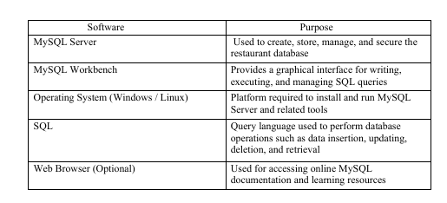

6. SYSTEM DESIGN
The Crime Report Management System follows a database-centered architecture, where the MySQL database acts as the core component of the system. The conceptual architecture describes how different components interact with each other to store, manage, and retrieve crime-related information efficiently.
At the highest level, the system consists of three main components:
- User (Admin / Police Staff)
- Application Interface (MySQL Workbench / SQL Interface)
- MySQL Database Server
The User interacts with the system to perform operations such as inserting new crime records, updating criminal details, viewing FIR information, or generating reports. The user does not directly manipulate database files but communicates with the database through SQL commands.
The Application Interface, such as MySQL Workbench, acts as a medium between the user and the MySQL server. It allows users to write and execute SQL queries in a structured manner. This interface helps in creating tables, defining relationships, applying constraints, and managing data easily. It also displays query results in a tabular format for better understanding.
The MySQL Database Server is the core component of the system. It is responsible for:
• Storing all crime-related data in structured tables
• Managing relationships between tables
• Enforcing constraints like PRIMARY KEY and FOREIGN KEY
• Processing SQL queries
• Ensuring data consistency and integrity
• Managing transactions
• Providing authentication and access control
Conceptually, the system works as follows:
- The user sends a request (for example, inserting a new crime record).
- The SQL query is executed through MySQL Workbench.
- The MySQL server processes the query.
- Data is stored or retrieved from the database tables.

7. DATABASE DESIGN

Database design is one of the most important stages in developing the Crime Report Management System. A well-structured database ensures efficient data storage, minimal redundancy, data consistency, and proper relationships
7.1 Entity Description
1. Crime Entity
The Crime entity stores information related to different crimes reported in the system. It represents the central entity because other entities are directly or indirectly related to it.
Attributes may include:
- crime_id (Primary Key)
- crime_type
- crime_date
- location
- description
The crime_id uniquely identifies each crime record. This entity helps in categorizing crimes based on type, date, and location.

2. Criminal Entity
The Criminal entity stores details of individuals involved in crimes. This entity maintains personal information of criminals and links them to specific crimes.
Attributes may include:
- criminal_id (Primary Key)
- criminal_name
- age
- gender
- address
- crime_id (Foreign Key)
The crime_id attribute establishes a relationship between Criminal and Crime entities. This ensures that each criminal record is associated with a valid crime.
7.2 Table Structure
1. Crime Table
The Crime table stores details of crimes reported in the system.
Attribute | Data Type
crime_id | INT (Primary Key, Auto Increment)
crime_type | VARCHAR(50)
crime_date | DATE
location | VARCHAR(100)

- Police_Officer Table
Attribute | Data Type
officer_id | INT PRIMARY KEY AUTO_INCREMENT
officer_name | VARCHAR(100) NOT NULL
Ranks | VARCHAR(50)
station | VARCHAR(100)

- Victim table
Attribute | Data Type
victim_id | INT PRIMARY KEY AUTO_INCREMENT
victim_name | VARCHAR(100) NOT NULL
contact | VARCHAR(15)
address | VARCHAR(200)

4.FIR TABLE
Attribute | Data Type
fir_id | INT PRIMARY KEY AUTO_INCREMENT
crime_id | INT
criminal_id | INT
victim_id | INT

7.3 Constraints Used
Constraints are rules applied to database tables to ensure the accuracy, reliability, and integrity of data. In the Crime Report Management System, various constraints are used while creating tables to prevent invalid data entry and maintain proper relationships between entities.
1. PRIMARY KEY
A Primary Key is a field that uniquely identifies each record in a table. It ensures that no two rows have the same value in that column. A primary key cannot contain NULL values and must be unique.
In this system, the following fields are used as primary keys:
- crime_id in Crime table
- criminal_id in Criminal table
- fir_id in FIR table
- victim_id in Victim table
- officer_id in Police_Officer table
These primary keys ensure that every record is uniquely identifiable.

2. FOREIGN KEY
A Foreign Key is a field in one table that refers to the primary key in another table. It is used to establish relationships between tables and maintain referential integrity.
For example:
- crime_id in Criminal table references crime_id in Crime table
- crime_id in Victim table references crime_id in Crime table
- officer_id in FIR table references officer_id in Police_Officer table
Foreign keys ensure that related records exist before inserting dependent data. This prevents invalid references and maintains consistency between tables.

3. NOT NULL
The NOT NULL constraint ensures that a column cannot have empty or NULL values. This is used for fields that must contain data.
For example:
- crime_type
- criminal_name
- fir_date
- officer_name
This constraint ensures that important information is always provided.

4. UNIQUE
The UNIQUE constraint ensures that all values in a column are different. It prevents duplicate entries.
For example:
- contact_number in Victim table
- contact_no in Police_Officer table

8.1 ER Diagram

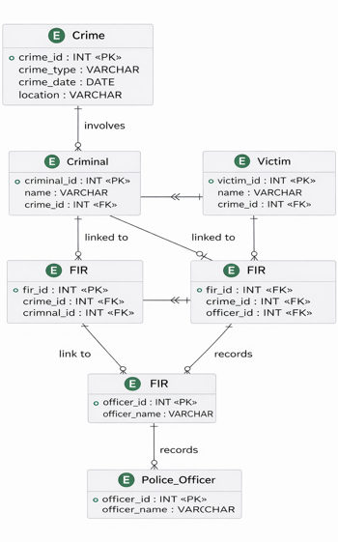
• Entities:crime,fir,vitim,criminal
• Relationships between entities using foreign keys
ER Diagram stands for Entity Relationship Diagram. It is a graphical representation of entities, their attributes, and the relationships between them in a database system.

.

8.2Use Case Diagram

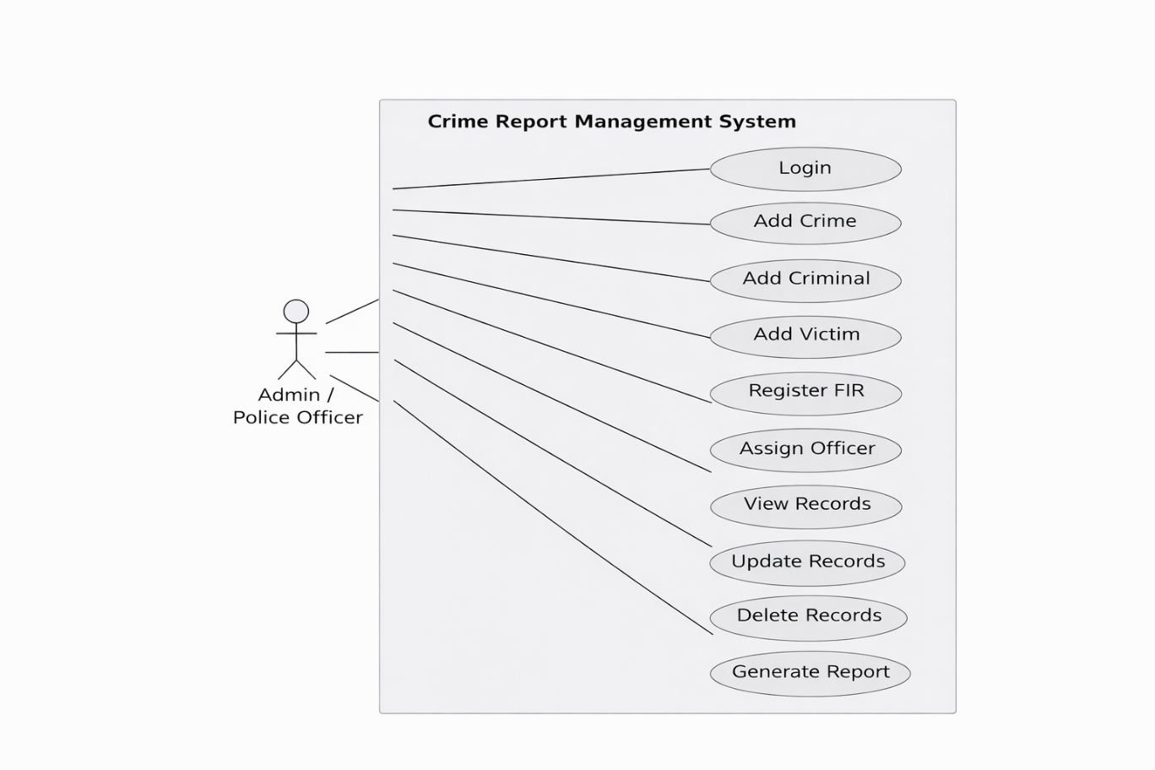
The Use Case Diagram shows the interaction between users and the system. It represents the different operations such as inserting, updating, viewing data, and generating reports performed by the admin

8.3Activity Diagram

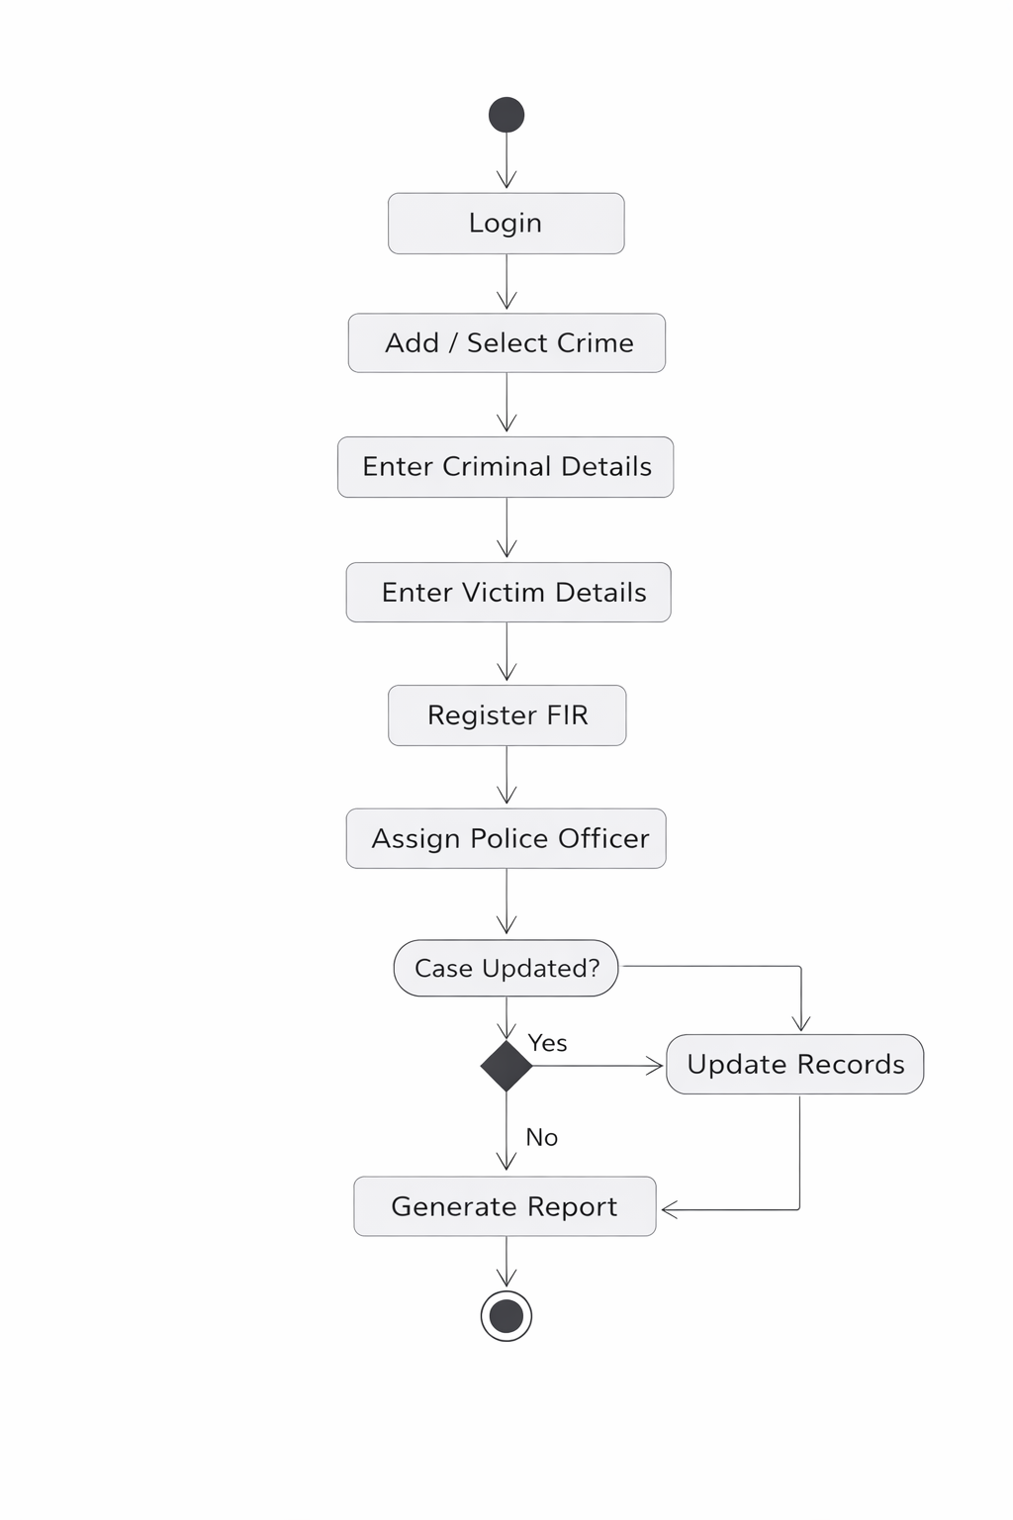
The process begins with the Start node, where the user logs into the system. After successful login, the user can add or select a crime record. The next step is to enter criminal details followed by entering victim details related to the crime.

8.4 Sequence Diagram

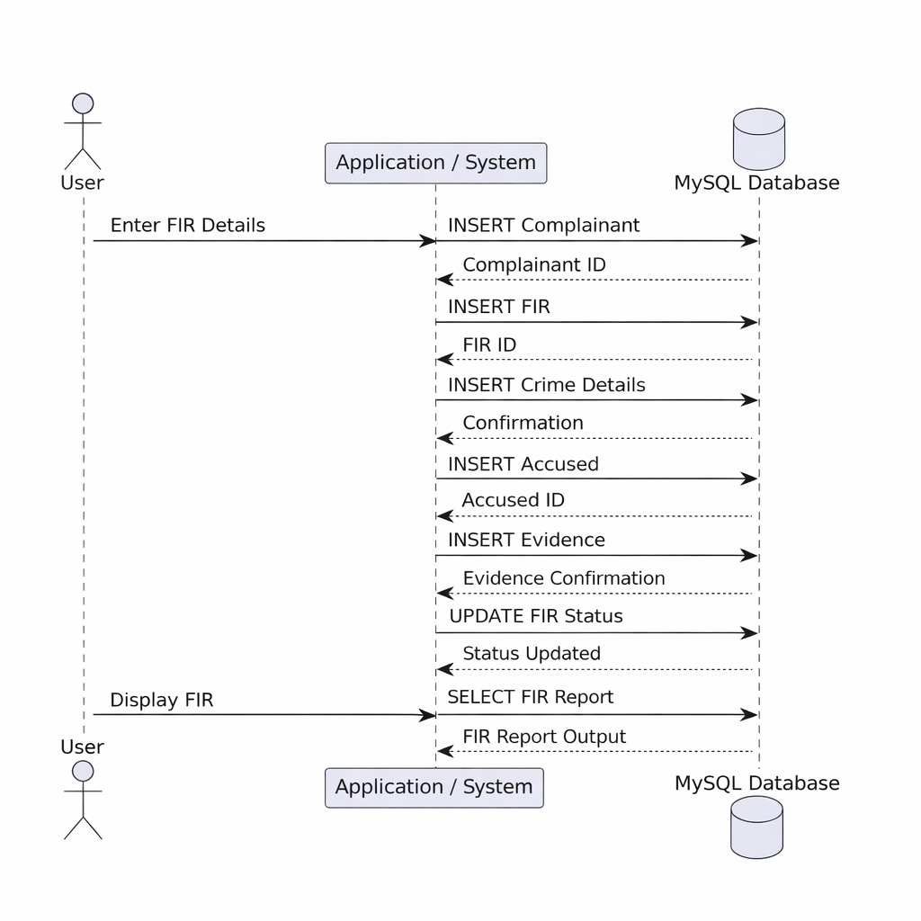
The Sequence Diagram illustrates the query execution flow in the system. It shows how user requests are processed by the system and how the database responds during order and billing operations.

9. SQL IMPLEMENTATION
CREATE DATABASE crime_report_db;
USE crime_report_db;

CREATE TABLE Criminals (
criminal_id INT PRIMARY KEY AUTO_INCREMENT,
name VARCHAR(100) NOT NULL,
age INT,
address VARCHAR(200)
);
CREATE TABLE Victims (
victim_id INT PRIMARY KEY AUTO_INCREMENT,
victim_name VARCHAR(100) NOT NULL,
contact VARCHAR(15),
address VARCHAR(200)
);

CREATE TABLE Firs (
fir_id INT PRIMARY KEY AUTO_INCREMENT,
crime_id INT,
criminal_id INT,
victim_id INT,
officer_id INT,
fir_date DATE NOT NULL,
FOREIGN KEY (crime_id) REFERENCES Crime(crime_id),
FOREIGN KEY (criminal_id) REFERENCES Criminal(criminal_id),
FOREIGN KEY (victim_id) REFERENCES Victim(victim_id),
FOREIGN KEY (officer_id) REFERENCES Police_Officer(officer_id)
);
INSERT INTO Crimesss (crime_type, crime_date, location)
VALUES ('Theft', '2025-01-10', 'Mumbai');

INSERT INTO Police_Officers (officer_name, ranks, station)
VALUES ('Sahil Shukla', 'Inspector', 'Andheri Police Station');

INSERT INTO Criminals (name, age, address)
VALUES ('Rohit Sharma', 28, 'Mumbai');

INSERT INTO Victims (victim_name, contact, address)
VALUES ('Amit Verma', '9876543210', 'Mumbai');

INSERT INTO Firs (crime_id, criminal_id, victim_id, officer_id, fir_date)
VALUES (1, 1, 1, 1, '2025-01-11');

SELECT * FROM Crimesss;

COMMIT;

SELECT
FIR.fir_id,
Crime.crime_type,
Criminal.name AS criminal_name,
Victim.victim_name,
Police_Officer.officer_name,
FIR.fir_date
FROM FIR
JOIN Crime ON FIR.crime_id = Crime.crime_id
JOIN Criminal ON FIR.criminal_id = Criminal.criminal_id
JOIN Victim ON FIR.victim_id = Victim.victim_id
JOIN Police_Officer ON FIR.officer_id = Police_Officer.officer_id;

9.1 Database Creation
The database for the system is created using the CREATE DATABASE command. This command initializes a new database where all restaurant-related tables are stored. Using a separate database helps in organizing data efficiently and avoids conflicts with other databases. Example: CREATE DATABASE CRIME

9.2 Table Creation
Tables are created using the CREATE TABLE command. Each table is designed to store specific information such as CRIME details, menu FIR, VITIM, Appropriate data types and constraints are applied to maintain data integrity and establish relationships between tables.
Example:
Crime table
CREATE TABLE Crime (
crime_id INT PRIMARY KEY AUTO_INCREMENT,
crime_type VARCHAR(100) NOT NULL,
crime_date DATE NOT NULL,
location VARCHAR(150) NOT NULL
);
Police_Officer
CREATE TABLE Police_Officer (
officer_id INT PRIMARY KEY AUTO_INCREMENT,
officer_name VARCHAR(100) NOT NULL,
Ranks VARCHAR(50),
station VARCHAR(100)
);
Victim
CREATE TABLE Victim (
victim_id INT PRIMARY KEY AUTO_INCREMENT,
victim_name VARCHAR(100) NOT NULL,
contact VARCHAR(15),
address VARCHAR(200)
);
FIR
CREATE TABLE FIR (
fir_id INT PRIMARY KEY AUTO_INCREMENT,
crime_id INT,
criminal_id INT,
victim_id INT,
officer_id INT,
fir_date DATE NOT NULL,
FOREIGN KEY (crime_id) REFERENCES Crime(crime_id),
FOREIGN KEY (criminal_id) REFERENCES Criminal(criminal_id),
FOREIGN KEY (victim_id) REFERENCES Victim(victim_id),
FOREIGN KEY (officer_id) REFERENCES Police_Officer(officer_id)
);

9.3 Data Insertion
Data is inserted into the tables using the INSERT command. This is used to add crime records, FIR, vitim details, police officer, into the database.
Example:
Insert into criminal
INSERT INTO Criminal (name, age, address)
VALUES ('Rohit Sharma', 28, 'Mumbai');
Insert into policerofficer
INSERT INTO Police_Officer (officer_name, Ranks, station)
VALUES ('Sahil Shukla', 'Inspector', 'Andheri Police Station');
Insert into victim
INSERT INTO Victim (victim_name, contact, address)
VALUES ('Amit Verma', '9876543210', 'Mumbai');
Insert into Crime
INSERT INTO Crime (crime_type, crime_date, location)
VALUES ('Theft', '2025-01-10', 'Mumbai');
Insert into FIR
INSERT INTO FIR (crime_id, criminal_id, victim_id, officer_id, fir_date)
VALUES (1, 1, 1, 1, '2025-01-11');

9.4 Data Retrieval
JOIN Crime ON FIR.crime_id = Crime.crime_id
JOIN Criminal ON FIR.criminal_id = Criminal.criminal_id
JOIN Victim ON FIR.victim_id = Victim.victim_id
JOIN Police_Officer ON FIR.officer_id = Police_Officer.officer_id;

9.5 Advanced Queries
Advanced queries are used to retrieve complex and meaningful information from multiple tables using JOIN, GROUP BY, Subqueries, Aggregate Functions, etc.

GROUP BY

The GROUP BY clause is used to arrange identical data into groups.
It is generally used with aggregate functions like COUNT(), SUM(), AVG(), MAX(), MIN().

SELECT column_name, aggregate_function(column_name)
FROM table_name
GROUP BY column_name;

HAVING

The HAVING clause is used with GROUP BY to filter grouped data. It allows conditions to be applied on aggregated results such as total amount or count.

Example:
SELECT column_name, aggregate_function(column_name)
FROM table_name
GROUP BY column_name
HAVING condition;

SUBQUERIES
Subqueries are queries written inside another SQL query. In this project, subqueries are used to retrieve data based on conditions derived from other tables, such as finding customers who have placed orders.

Example:
SELECT Name, Age
FROM Criminal
WHERE Age = (
SELECT MAX(Age)
FROM Criminal
);

VIEW::
Select * from crime;

10. SYSTEM TESTING AND RESULT
System Testing is the process of testing the complete and integrated system to verify that it meets the specified requirements Each module such as Police Officer, Criminal, Victim, and FIR was tested separately. In the Crime Report Management System, all modules were tested to ensure proper functioning.
10.1 Query Correctness Testing
All SQL queries such as CREATE, INSERT, SELECT, UPDATE, and transaction-related queries were tested individually. The queries were executed in proper sequence to verify that:
• Tables were created successfully without errors
• Data insertion was performed correctly
• Relationships between tables were maintained using foreign keys
• Transaction commands (START TRANSACTION, COMMIT, ROLLBACK) worked as expected
10.2 Data Validation
Data validation was performed using database constraints:
• PRIMARY KEY ensured unique identification of records
• FOREIGN KEY maintained valid relationships between tables
• NOT NULL prevented missing essential information
• UNIQUE avoided duplicate customer contact numbers
The PRIMARY KEY ensures that each record is unique and prevents duplicate entries.
10.3 Output Verification
Output verification is the process of checking whether the results generated by the Crime Report Management System are correct, accurate, and match the expected output. It ensures that all queries, reports, and database operations produce valid and reliable results.In this system, output verification is done by comparing the actual query results with expected values and checking data consistency across related tables.
- Ensures system accuracy
- Detects logical errors
- Confirms correct relationships
- Improves system reliability
- Maintains data consistency
10.4 Result Analysis
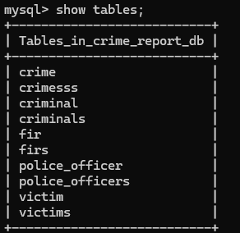
This output confirms that all required tables were created successfully in the database.
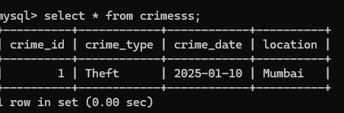
This output shows that crimess information was stored accurately in the crimesss table.

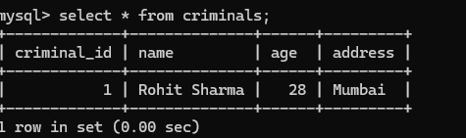
This output shows that criminals information was stored accurately in the criminals table.
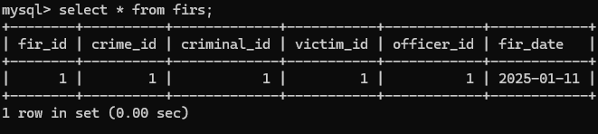
This output shows that firs information was stored accurately in the firs table

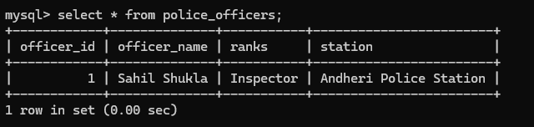
This output shows that police_officers information was stored accurately in the police_officers table
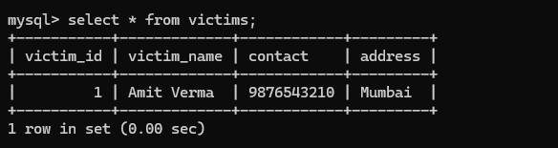
This output shows that victims information was stored accurately in the victims table
10.2 Data Validation
Data validation was performed using database constraints:
• PRIMARY KEY ensured unique identification of records
• FOREIGN KEY maintained valid relationships between tables
• NOT NULL prevented missing essential information
• UNIQUE avoided duplicate customer contact numbers

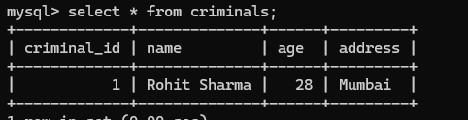

The PRIMARY KEY ensures that each record is unique and prevents duplicate entries.
10.3 Output Verification
Output verification is the process of checking whether the results generated by the Crime Report Management System are correct, accurate, and match the expected output. It ensures that all queries, reports, and database operations produce valid and reliable results.In this system, output verification is done by comparing the actual query results with expected values and checking data consistency across related tables.
- Ensures system accuracy
- Detects logical errors
- Confirms correct relationships
- Improves system reliability
- Maintains data consistency

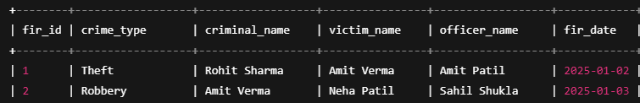

11. SECURITY, BACKUP AND RECOVERY
11.1 Security
Security is an important part of the Crime Report Management System. Since crime data is sensitive and confidential, proper security measures are required to protect the database.
🔹 Security Measures Used:
- User Authentication
  - Only authorized users can access the database.
  - MySQL username and password are required to log in.
- Access Control
  - Different users are given different permissions.
  - Example: Admin can INSERT, UPDATE, DELETE.
  - Normal user can only SELECT data.
- Privileges Management
  - MySQL provides GRANT and REVOKE commands to control access.

11.2 Backup
Backup is the process of creating a copy of the database to prevent data loss due to system failure, hacking, or accidental deletion.
1 Backup Method Used:
mysqldump Utility
  - MySQL provides mysqldump command to create backup.
2 Manual Export (Workbench)
- Go to Server → Data Export → Select Database → Export to file.
3 Regular Backup
- Backup should be taken regularly to ensure data safety.

11.3 Recovery
Recovery refers to restoring the database from a previously created backup file. In case of data loss or system failure, the database can be restored using the backup created by mysqldump. This process helps recover customer details, order records, and billing information, allowing the system to continue functioning without permanent data loss

12. FUTURE SCOPE AND CONCLUSION
12.1 Future Scope
The Crime Report Management System has great potential for future enhancement and expansion. Currently, the system is designed using MySQL for academic purposes, but it can be further developed into a full-scale real-world application. In the future, a web-based or mobile-based interface can be integrated so that police officers can access and update crime records online from different locations. Advanced features such as real-time crime tracking, automated report generation, and graphical data analysis can also be added to improve efficiency.

12.2 Conclusion

The Crime Report Management System successfully demonstrates how a database can be used to manage crime-related information efficiently. The project helps in understanding important database concepts such as table creation, constraints, relationships, joins, grouping, and transaction management. By replacing manual record-keeping methods with a computerized system, the project reduces data redundancy, improves accuracy, and provides faster access to information.

13. REFERENCES
The following references were used for understanding database concepts, SQL queries, and MySQL implementation during the development of the crime report management

- MySQL Official Documentation:
The official MySQL documentation was referred to for learning SQL syntax, database creation, table structures, constraints, transaction management, and query execution. It provided accurate and detailed information about MySQL features, commands, and functions used in this project. Website: https://dev.mysql.com/doc/

- Prescribed Textbooks:
Academic textbooks related to Database Management Systems (DBMS) were used to understand theoretical concepts such as relational database models, normalization, primary and foreign keys, constraints, entity relationships, and database design principles.

- Online Learning Sources:
Various online tutorials, educational websites, and learning platforms were used to understand the practical implementation of SQL queries and MySQL Workbench. These resources helped in learning joins, GROUP BY clauses, views, aggregate functions, and transaction commands used in the Restaurant Order and Billing Management System. Examples:
• www.w3schools.com
• www.geeksforgeeks.org
• www.tutorialspoint.com

