**Gender Identification from Smart Phone usage using Machine Learning Algorithm**

**by**

**Johora Akter Polin**

**ID: 153-15-6540**

**Omayer Khan**

**ID: 153-15-6693**

This Report Presented in Partial Fulfillment of the Requirements for the Degree of Bachelor of Science in Computer Science and Engineering

Supervised By

**Ahmed Al Marouf**

Lecturer

Department of CSE

Daffodil International University

Co-Supervised By

**Shah Md. Tanvir Siddiquee**

**Senior** Lecturer

Department of CSE

Daffodil International University



**DAFFODIL INTERNATIONAL UNIVERSITY**

**Dhaka, Bangladesh**

**NOVEMber 2019**

**APPROVAL**

This Research based Project titled **“Applying Text Analytics on Music Emotion Recognition**”, submitted by Johora Akter Polin (153-15-6540), Omayer Khan (153-15-6693) to the Department of Computer Science and Engineering, Daffodil International University, has been accepted as satisfactory for the partial fulfillment of the requirements for the degree of B.Sc. in Computer Science and Engineering (BSc) and approved as to its style and contents. The presentation has been held on 8th April 2018.

**Board of Examiners**

**Dr. Syed Akhter Hossain Chairman**

**Professor and Head**

Department of Computer Science and Engineering

Faculty of Science & Information Technology

Daffodil International University

**Dr. Sheak Rashed Haider Noori Internal Examiner**

**Associate Professor and Associate Head**

Department of Computer Science and Engineering

Faculty of Science & Information Technology

Daffodil International University

**Md. Zahid Hasan Internal Examiner**

**Assistant Professor**

Department of Computer Science and Engineering

Faculty of Science & Information Technology

Daffodil International University

**Dr. Mohammad Shorif Uddin External Examiner**

**Professor**

Department of Computer Science and Engineering

Jahangirnagar University

**Declaration**

We hereby declare that, this research project has been done by us under the supervision of **Ahmed Al Marouf, Lecturer, Department of CSE** Daffodil International University. We also declare that neither this project nor any part of this project has been submitted elsewhere for award of any degree or diploma.

**Supervised by:**

**Ahmed Al Marouf**

Lecturer

Department of CSE

Daffodil International University

**Co-Supervised by:**

**Shah Md. Tanvir Siddiquee**

Senior Lecturer

Department of CSE

Daffodil International University

**Submitted by:**

**Rafayet Hossaain**

ID: 142-15-3994

Department of CSE

Daffodil International University

**Md. Rahmatul Kabir Rasel Sarker**

ID: 142-15-3732

Department of CSE

Daffodil International University

**Mehejabin Mimo**

ID: 142-15-3453

Department of CSE

Daffodil International University

**ACKNOWLEDGEMENT**

First we express our heartiest thanks and gratefulness to almighty God for His divine blessing makes us possible to complete the final year research project successfully.

We really grateful and wish our profound our indebtedness to **Ahmed Al Marouf**, **Lecturer** and **Shah Md. Tanvir Siddiquee**, **Senior Lecturer,** Department of CSE, Daffodil International University, Dhaka. Deep Knowledge & keen interest of our supervisor and co-supervisor in the field of “*Human Computer Interaction*” to carry out this project. His endless patience, scholarly guidance, continual encouragement, constant and energetic supervision, constructive criticism, valuable advice, reading many inferior draft and correcting them at all stage have made it possible to complete this project.

We would like to express our heartiest gratitude to **Dr. Syed Akhter Hossain, Professor & Head, Department of CSE**, for his kind help to finish our research project and also to other faculty members and the staffs of CSE department of Daffodil International University.

We would like to thank our entire course mate in Daffodil International University, who took part in this discuss while completing the course work.

Finally, we must acknowledge with due respect the constant support and patients of our parents.

**Abstract**

**TABLE OF CONTENTS**

|  |  |
| --- | --- |
| **CONTENTS** | **PAGE** |
| Board of examiners | i |
| Declaration | ii |
| Acknowledgements | iii |
| Abstract | iv |
| Table of contents | v |
| List of figures | viii |
| List of tables | x |
| **CHAPTER** |  |
| **CHAPTER 1: INTRODUCTION** | **1-6** |
| 1.1 Introduction | 1 |
| 1.2 Motivation | 4 |
| 1.3 Rationale of the Study  1.4 research Questions | 4  4 |
| 1.5 Expected Outcome | 5 |
| 1.6 Report Layout | 5 |
| **CHAPTER 2: BACKGROUND** | **7-14** |
| 2.1 Introduction | 7 |
| 2.2 Related Works | 9 |
| 2.3 Research Summary | 11 |
| 2.4 Scope of the Problem | 13 |
| 2.5 Challenges | 14 |
| **CHAPTER 3: Research Methodology** | **15-** |
| 3.1 Introduction | 8 |
| 3.2 Research Subject and Instrumentation | 9 |
| 3.3 Data Collection Procedure | 10 |
| 3.4 Statistical Analysis | 14 |
| 3.5 Implementation Requirements | 14 |
| **CHAPTER 4: Experimental Results and Discussion** | **16-27** |
| 4.1 Introduction | 16 |
| 4.2 Experimental Results | 23 |
| 4.3 Descriptive Analysis  4.4 Summary | 26  28 |
| **CHAPTER 5: Summary, Conclusion, Recommendation,**  **and Implication for Future research** | **28-36** |
| 5.1 Summary of the study  5.2 Conclusion  5.3 Recommendations | 28  28  29 |
| 5.4 Implication for Further Study | 31 |
| **REFERENCES** | **38** |
| **APPENDIX**  Appendix A: Project Reflection  Appendix B: Related Applications | **39-40**  39  39 |
| **PLAGIARISM REPORT** |  |

**LIST OF FIGURES**

|  |  |
| --- | --- |
|  | **PAGE NO** |
| Figure 1.1: Gender Symbol | 2 |
| Figure 1.2: Figure 1.2: Flow of working process | 3 |
| Figure 2.1: Applications in smartphone | 7 |
| Figure 2.2: A day with smartphone | 8 |
| Figure 2.3: Gender identification Procedure | 8 |
| Figure 2.4: Experimental age group | 11 |
| Figure 2.5: Questionnaries form | 12 |
| Figure 2.6: Dataset | 13 |
| Figure 2.8: | 18 |
| Figure 3.1: | 19 |
| Figure 3.2: | 19 |
| Figure 3.3: | 20 |
| Figure 3.4: | 20 |
| Figure 3.5: | 21 |
| Figure 4.1: | 21 |
| Figure 4.2: | 22 |
| Figure 4.13: | 22 |
| Figure 4.14: | 23 |
| Figure 4.15: | 24 |
| Figure 4.6: | 24 |
| Figure 4.7: | 25 |
| Figure 4.8: | 25 25 |
| Figure 4.9: | 29 23 |
| Figure 4.10: | 29  30 24 |
| Figure 4.11: | 30 24 |
| Figure: Plagiarism Report  hghhg | 26 |

**CHAPTER 1**

**INTRODUCTION**

* 1. **Introduction**

Smart phone is now an important part of this digital world. Smart phone is used by almost every smart phone is used by almost every people in the world. But the usage varies from person to person. One group of people use smart phone for a particular purpose and another use for different purpose. It may differs from several factors like age, generation, personality, profession as well as gender. Gender is one of the important factor that shows smart phones are used differently. Gender refers male, female or others in the society, an individual’s concept of themselves, or it can be called identity of a human being that by which the person is known to the society. Challenging fact is a smart phone is not able to determine who is using the phone. We will build up the best solution that recognize gender. It may be the new addition for the digital world. We will find out the gender who is using the smart phone.

In the field of Human Computer Interaction (HCI), where interaction between human and machine are studied. Researchers, innovators always tries to find the innovative way to interact much more and better way between human and computer. They add new scheme, feature to collaborate the process having differences between human and computer so the interaction can be done. To work for the new world it is an essential and vital part to know more deep and innovate new ways to interact with computer. HCI is the major factor making life comfortable and easy. It works with behavior of human nature as well as computer and combine them to solve a problem. Human computer interaction is the must aspect of life that use for betterment. In the study of Human Computer Interaction, it is important to know the behavior of human to detect the gender. In this era, this project have the strength to recognize the gender having different personal behavior. Now world depends on computer. This project emphasized on usage of smart phone to detect gender.

Gender is not just refers what is the identity of a human in the society but it also gives the definition of the personality and behavior. In the term of biology male and female may different in some genetic but in the world identification of gender revels thousands of feeling, personality.



Figure 1.1: Gender symbol (Separate symbols)

The way we recognize a person is male or female by the face. Not only this, gender can be recognized by voice or behavior and most effective the physical appearance in the society. There are some dress code for male and female. But this process of recognition is applicable in everywhere. Because dress varies from culture, religious, community and countries. But when it comes to a smart phone it is not possible to identify the gender using smart phone.

Machine learning algorithm

Feature analysis

Performance evolution

Data set

Weka 3.9

Weka 3.9

Weka 3.9

Figure 1.2: Flow of working process

Researchers have introduced different application, features to detect gender. There are several research papers that say different ways. But gender is recognized by the face image, face structure, body language data at the beginning (e.g. [1], [2]). But now a days, gender can be recognized by voice. Gender detection through facial information can be classified in two class, first one is geometrical information and second one is texture information (e.g. [3], [4]). In this project we want to detect gender by the use of smart phone that the person is using. It is the kind of behavior difference of the person that we are mainly focusing to detect gender. It can be a unique and innovative way to detect gender.

**Scopes:**

This project creates several scopes for creating new features in application as well as can develop applications as per need. It opens the door for researchers for the further research on this field. The best part is, it can help in criminal sectors and research sector.

Like –

1. Prediction system
2. Criminal detection
3. Self-Protection
4. Behavior analysis
5. Personality detection
6. Customization
   1. **Motivation**

It is very important to know what you are and what you want. Male and female have difference in every sectors like taste, liking, disliking according to their role in the society. Every time they have to compromised. Smart is the most important part of everyone. So it is necessary to detect the gender and can use according to their wish. The person can have a better life if he or she don’t need to compromise. This project will create a new aspect in the field of robotics, artificial intelligence as well as the smart phone companies. Thus our project will help to determine gender according to the usage of smart phone.

* 1. **Rationale of study**

The most interesting and challenging fact is detection of personality. Smart phone is used for different purpose by similar age group and profession. It is also used for unnecessary works and misuse of its features. To analyze those things is not a simple task to perform. Huge quantities of different data is need to analyze. However, to get the solution means to detect the gender we are working in this project. To have a good accuracy rate and better performance our project need to go through different algorithms calculation and a set of valid data.

* 1. **Research Questions**

**“How gender can be identified from smartphone usage using Machine Learning algorithm?”**

Explanation

* 1. **Expected Output**

We are working with a particular age group of people. We need to analyze huge data to find out user identity male or female. In order to get the result we used ten algorithms to find out a good accuracy rate from our project. We have different expectation from different algorithm. In this modern world, smart phone is a must to have for all. Human have much dependency on smart phone. It is quite impossible without a smart phone. We have to do our many work by using smartphone. So we want to build up relationship with smartphone to human by detecting gender. So the person have their own choice using smartphone that reflects the personality. By detecting gender, our project will help to use the smartphone in own way.

**1.6 Report Layout**

**Chapter 1: Introduction**

This chapter is consist of some discussion on gender, importance of smartphones, relation between smartphone and human, usage of smart phone. However, there is discussion on introduction, motivation for the project, rationale of study, some figures related to project, pervious facts of gender detections and their ways. Moreover, research questions and expected outcomes also been discussed based on the project. Later followed by the report layout.

**Chapter 2: Background**

In this chapter we have discussed about the background history of our research based project. Moreover, we have discussed about our experiment that we have done. Here we have written about several related works, summary, scope of the problem as well as challenges that we faced for this research based project.

**Chapter 3: Research Methodology**

We have discussed in details about methodology of the project. In addition we talked about our search subject and instrumentation, data collection procedure, data sets. Not only this statistical analysis as well as implementation requirement that meet to reach our goal are also discussed.

**Chapter 4: Experimental results and discussion**

In this chapter, deals with experiment outcome and its description of the process. Algorithms that are used and its functions are also included. However, we have a discussion about experimental result, descriptive analysis based on our project. Lately, we have included a summary of our project.

**Chapter 5: Summary, Conclusion, recommendation and implication for future research**

This is the final step where we have summarized the whole study and end up with conclusion. Lastly there is also have some recommendation and discussion about future work of the project.

**CHAPTER 2**

**BACKGROUND**

**2.1 Introduction**

In general, gender is the identity of a human in the society he/she lives in. So it is very necessary to detect the gender that may help the person to use the smart more effectively. So, in our project we have collected some data to analyze personality. We are focusing on the usage of smart phone according to their personality.

However, for the experiment our main focus was collect some data that consist of some personal information and usage of smartphone. We target on a certain age group to analysis their personality and use of smart phone. We developed model for the process to get the goal.

Smart phone in this modern era is used for several purpose. Now it is not only used for calling but also used for using different kinds of social applications like Facebook, WhatsApp, Viber, IMO, Snapchat, Instagram etc. Moreover, there is also different types of camera application that makes image more interesting. Some applications for gamming are the most commonly used. But the fact is all these application varies on gender. Male are attracted with some particular applications and female are attracted by other applications. The below image is the common scenario in almost all smartphone.

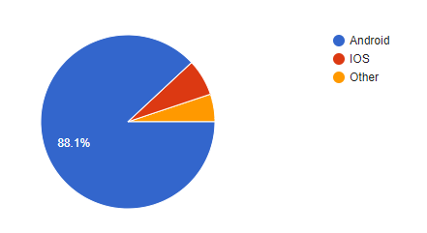

Figure 2.1: Pie-chart of smartphone users of a specific age group

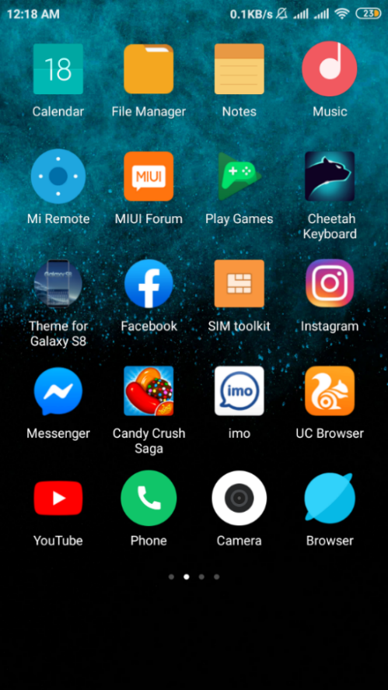

Figure 2.1: Applications in smartphone

These are the basic and commonly applications used in smartphone. People engage more and more as well as depend on some applications. Dependency have created on smartphone. Because a smartphone have all the features that a person need.

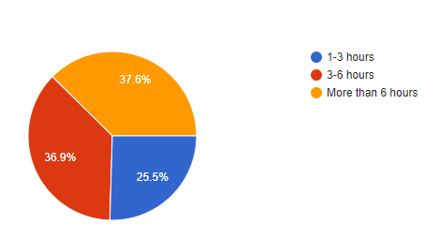

Figure 2.2: Daily usage of a smartphone

**2.2 Related Work**

In the study of human computer interaction, gender detection is one of the basic and interesting field. Many researchers have done different methodology, used several models, process to identify gender.

***Gender identification by facial image:***

Face identification is a major area in object recognition and can be deﬁned as identifying or verifying human subjects in various scenes from image or a video source**.** A rich amount of literacy work have done on gender recognition.Researchers have much interest in classification of gender by analysis facial image, texture, structure.

Chandrakamal Sinha have done a research paper by using facial image using data set of 50 male and 50 female using classifier for better success rate (e.g. [5]). Face region was detected from the image and extracted subjected to Principal Component Analysis (PCA) and Support Vector Machine (SVM). Another paper by Benyamin Ghojogh, Saeed Bagheri Shouraki, Hoda Mohammadzade, Ensieh Iranmehr, was gender recognization by facial image (e.g. [1]). Here, used four frame works for the experiment, starting with Local Binary Pattern (LBP), Principal Component Analysis (PCA), Support Vector Machine (SVM), Linear Discriminant Analysis (LDA**).** And the success rate was enough good using 100 male and 100 female face images. However, there is an article by Khalil Khan 1,*, Muhammad Attique 2,*, Ikram Syed 3 and Asma Gul 4 who discussed on gender recognition through face segmentation and proposed MSFS-CRFs model (e.g. [6]). Here used four dataset of face with 2400 number of images for the experiment select 100 among them randomly having 50 male and 50 female. After that they trained data and performed test to identify gender.

***Recognition of gender by Voice:***

Researchers have experiments not with just facial image to identify gender but also used several experiments with voice means audio files to determine the gender.

Mucahit Buyukyilmaz1,* and Ali Osman Cibikdiken2 have discussed in their paper about identification of gender trough voice (e.g. [8]). Here they used 3065 data for the test of male and female. All the codes of training, testing are written in python. And the accuracy rate was quite impressive. Another paper by T. Jayasankar1,∗, K. Vinothkumar2 and Arputha Vijayaselvi3 was discussed gender identification by speech genetic algorithm (e.g. [9]). Used around 80 speech as input data set for the experiment and developed a model as well as get a good accuracy rate. A Raahul, R Sapthagiri, K Pankaj and V Vijayarajan have also written a paper on this interesting topic. Here used Linear Discriminant Analysis (LDA), K-Nearest Neighbour (KNN), Classification and Regression Trees (CART), Random Forest (RF), and Support Vector Machine (SVM) on basis of eight different metrics on dataset. They work on the voice of male and female and after using five algorithms they meet the goal with a good accuracy rate (e.g. [10]).

***Gender detection based on smart phone:***

In order to get gender identification, there are less work. Most of the papers are related to the effects of smart phone on mental health, emotion control (e.g. [11], [12]). Some discussed about the personality traits, behavior change, heath risk and so many (e.g. [14], [15]). Emotion detection through the usage of smartphone or personality is the interesting and have several research and publications. So our project will be a new part that add new dimension in the field of artificial intelligence, Human Computer Interaction as well as in robotics.

**2.3 Research summary:**

Compare and analyze

Figure 2.3: Gender identification Procedure

We have collected 430 real data from using online platform and offline from a certain age group. We cleaned up our missing values and used them for the process to get a good accuracy rate.

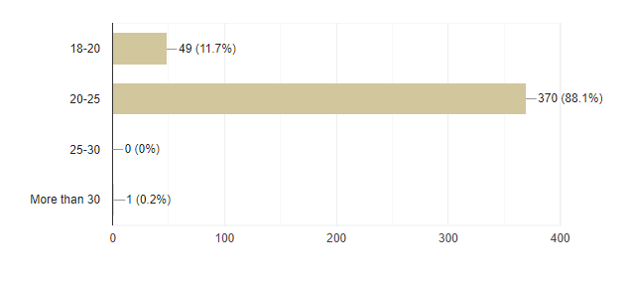

Figure2.4: Experimental age group

We have created a data set with 20 questions and participant have to answer all those questions.

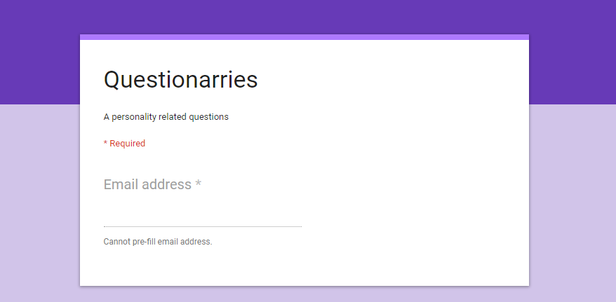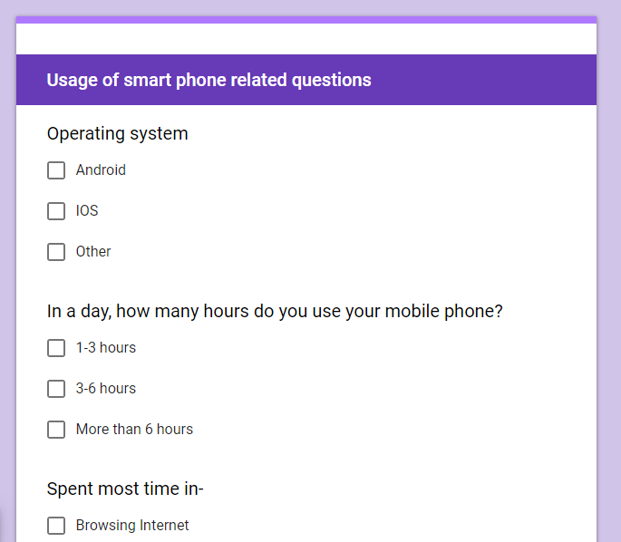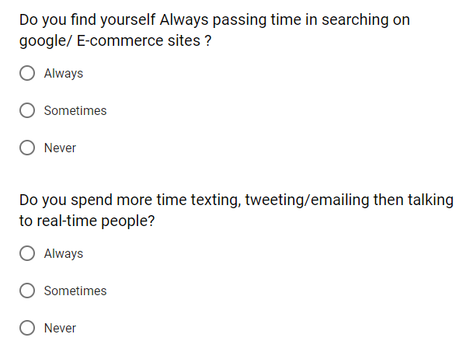

Figure 2.5: Questionnaries form

We have got the following datasetfor our research based project.

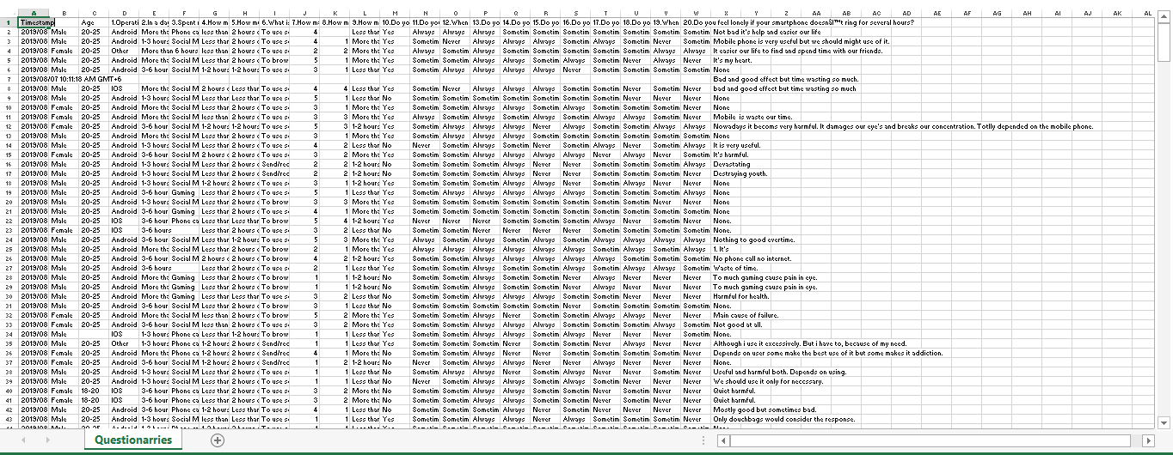

Figure 2.6: Dataset

**2.4 Scope of the problem:**

This research based project have tremendous scope. Some applications are given below-

* Criminal detection
* Safety for all
* Self-Assistant
* Establish equity
* User friendly environment
* Prediction system
* Smart identity recognition device
* Companion

**2.5 Challenges:**

This research based project have some challenges that need to be faced. We have to overcome all these to implement. Such as-

* Analyze huge number of data
* Choose appropriate questions for data set
* Data set maintenance
* Scoring and picking the accurate value
* Difficulties in processing
* Dataset of different age
* Concentrate on both male and female personality
* Discriminate from similar data

**CHAPTER 3**

**Research Methodology**

**3.1 Introduction:**

Research methodology is a combination of techniques to research, assemble and evaluate data. It includes research techniques, tools, methods that are required for the research .Basically it defines how has the work done. For experiment, we used ten (10) different types of machine learning algorithms in weak.

**3.2 Research Subject and Instrumentation:**

**Subject:** Gender Identification from smartphone usage using machine learning algorithm.

**Instrumentation**:

* Google survey form.
* Question form.

**Software Requirements:**

* Core i3 laptop.
* Weka 3.9.

**3.3 Data Collection Procedure:**

**Fig: 3.1**

Data collection is defines as the procedure of collecting data. Researchers can evaluate their hypothesis on the basis of collected data. Firstly, we set up a form containing questions of different aspects. Then we collect information’s from participants through this form. After collecting the information, we create a google form and inputs these information. Then we start to process our data and filtered out some data, which are not appropriate for our experiment. Finally, we store all data as .csv format.

**3.4 Statistical Analysis:**

For the experiment we took total Four Hundred and Thirty (430) data. There are twenty (20) questions which shows how much an individual involves, interacts and in which way they operate their mobile phones. These twenty (20) questions were same & mandatory for everyone. The pie graphs were indicating the percentage which makes the result understanding easier.

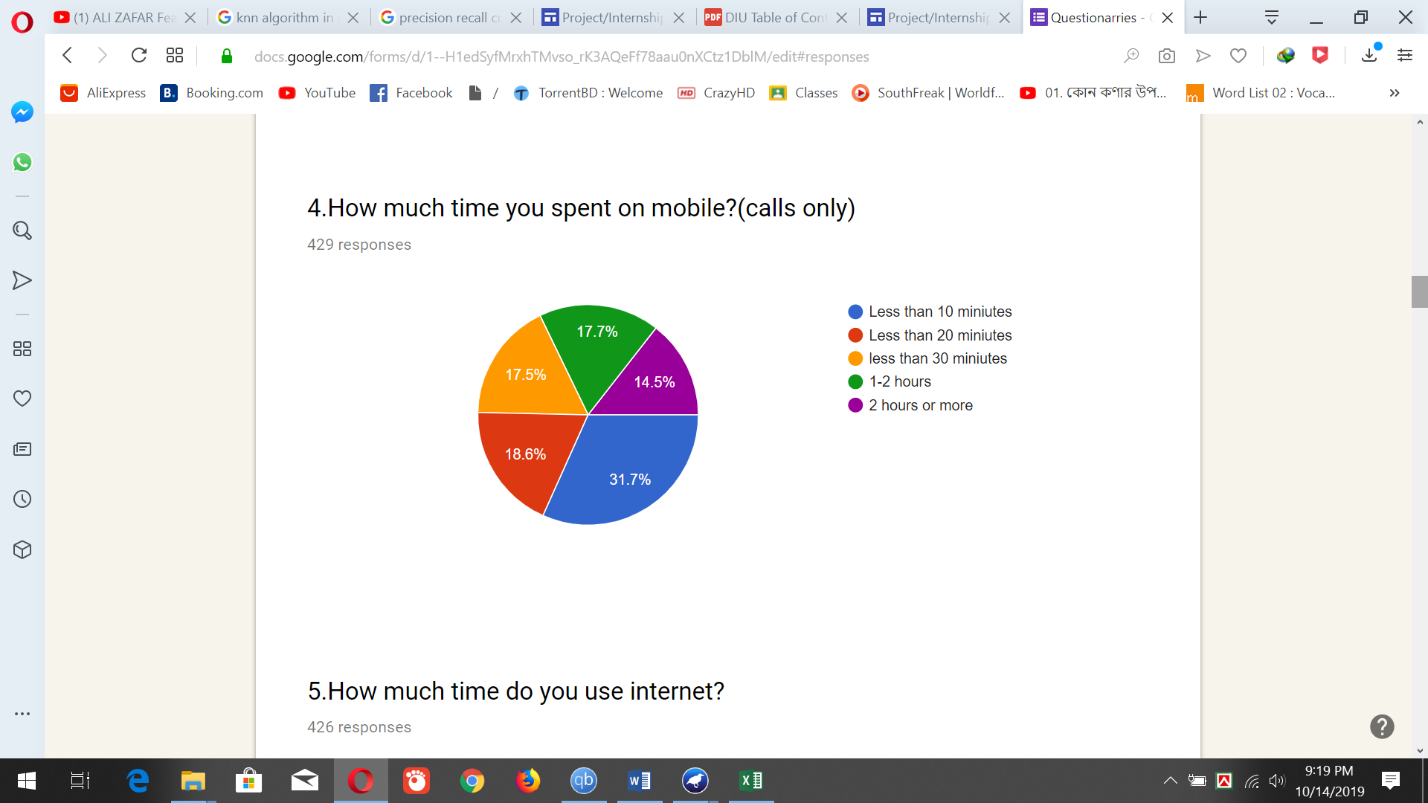

**Fig 3.2: Google form question(1)**

This graph represents the percentage of how much they talk with people on cell phone.

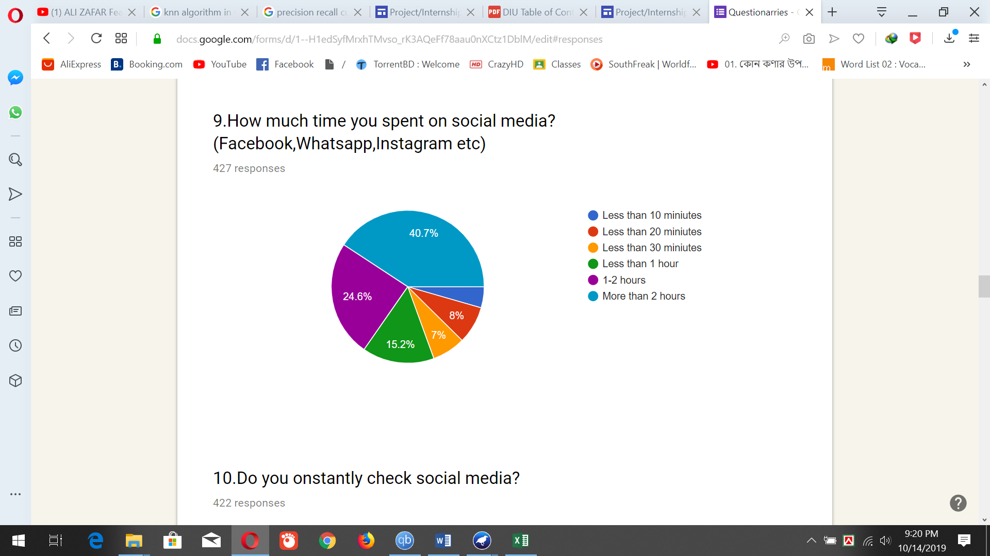

**Fig 3.3: Google form question (2)**

This graph shows how much time the spent on social media platform.

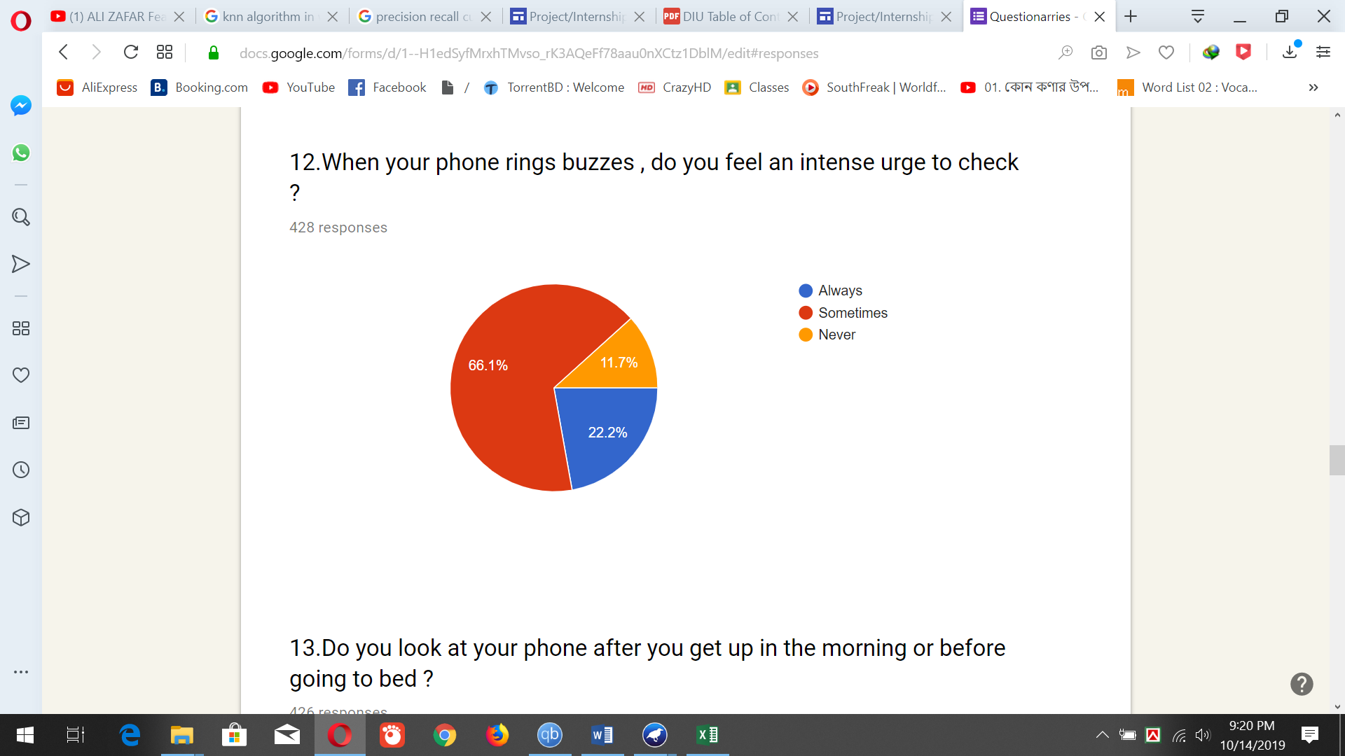

Fig 3.4 : **Google form question(3)**

This graph shows how they react when the phone gets any notification.

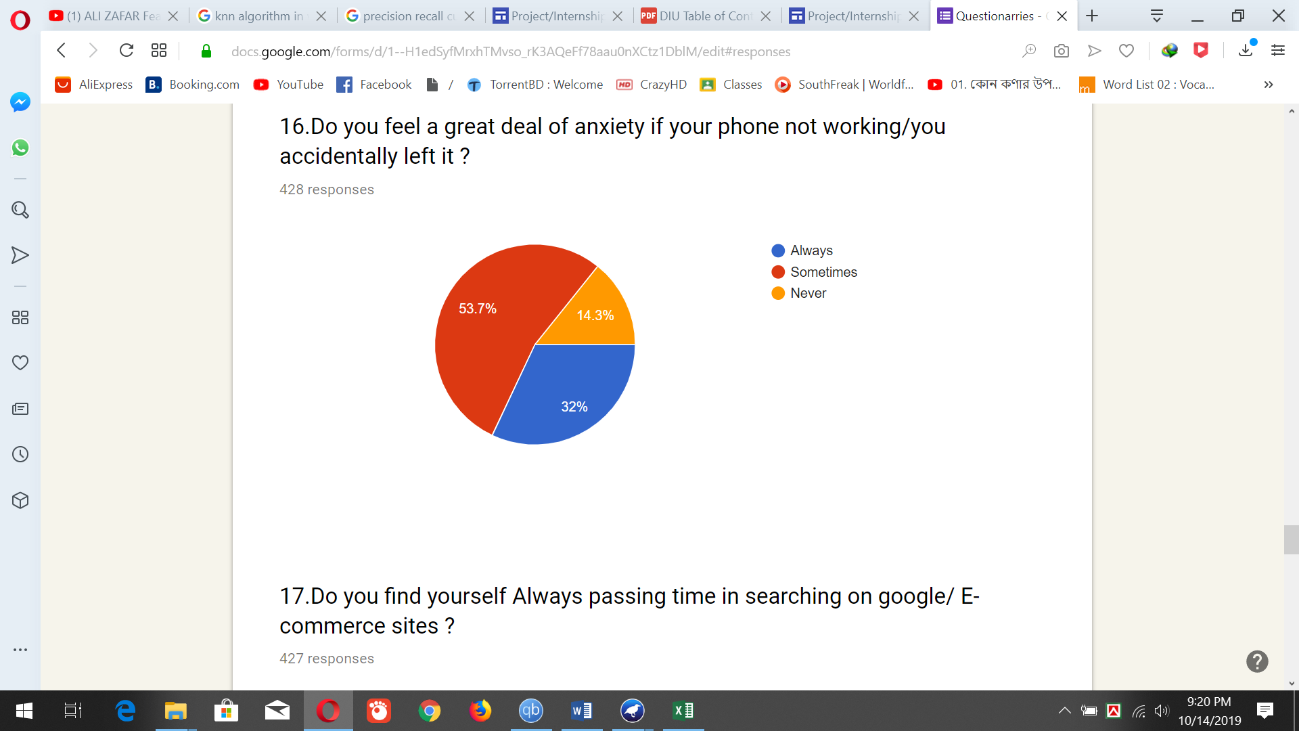

**Fig 3.5: Google form question(4)**

This graph illustrates how they feel themselves without their mobile phones. Maximum person feels the need of a mobile phone in their daily activities.

**3.5 Implementation Requirement:**

To implement the experiment we mainly used Weka 3.9. For this we were needed some algorithms.

**1. Participants:** Collecting information from participants through question form.

**2. Sorting and remove data:** After collecting data we have to sort the data and remove those data which were not relevant.

**3. Algorithms:** Applying different types of algorithms to evaluate data.

**CHAPTER 4**

**Experimental Results and Discussion**

**4.1 Introduction:**

For gender recognition, we have tried to predict the best output possible. For this, we have chosen better algorithms as it is clearly explained in (Research methodology).

Our focus was to create a dataset where we will be able to implement algorithms and track the records. We have also able to know about the barriers and possible outcomes of those barriers by this experiment.

**4.2 Experimental Results:**

We have analyzed our data in different algorithms. The best result we got in Random Forest algorithm.

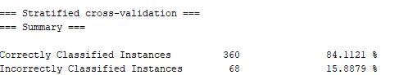

**Figure 4.1: RandomForest Algorithm CCI Result**

We also construct a table for showing result for ten (10) different algorithms.

Table 4.1: Performance Metrics of Machine Learning Algorithms

|  |  |  |  |  |  |  |  |
| --- | --- | --- | --- | --- | --- | --- | --- |
| Algorithm name | TP Rate | FP Rate | Precision | Recall | F-measure | MCC | ROC Area |
| NB | 0.745 | 0.631 | 0.699 | 0.745 | 0.707 | 0.158 | 0.663 |
| SLR | 0.7666 | 0.6444 | 0.727 | 0.766 | 0.715 | 0.201 | 0.664 |
| SMO | 0.750 | 0.610 | 0.709 | 0.750 | 0.716 | 0.187 | 0.569 |
| KNN | 0.827 | 0.353 | 0.820 | 0.827 | 0.822 | 0.503 | 0.698 |
| Ada Boost | 0.748 | 0.703 | 0.677 | 0.748 | 0.681 | 0.084 | 0.669 |
| Bagging | 0.783 | 0.633 | 0.765 | 0.783 | 0.729 | 0.269 | 0.730 |
| Stacking | 0.759 | 0.653 | 0.733 | 0.780 | 0.760 | 0.185 | 0.485 |
| DT | 0.792 | 0.497 | 0.772 | 0.792 | 0.772 | 0.358 | 0.639 |
| Random forest | 0.841 | 0.481 | 0.855 | 0.841 | 0.814 | 0.522 | 0.841 |
| REP Tree | 0.741 | 0.599 | 0.703 | 0.741 | 0.713 | 0.176 | 0.599 |

Algorithm table 4.1 shows the TP rate, FP rate, Precision, recall, F-measure, MCC and ROC-area values for 10 different algorithms.

**Bar graph for Accuracy**

Figure 4.2: Bar Chart for ACC

**Precision-recall (PRC) graph:**

Figure 4.3: Line Graph for PRC

**4.3 Descriptive Analysis:**

Here is our data collection procedure scenario. A form containing of desired questions.

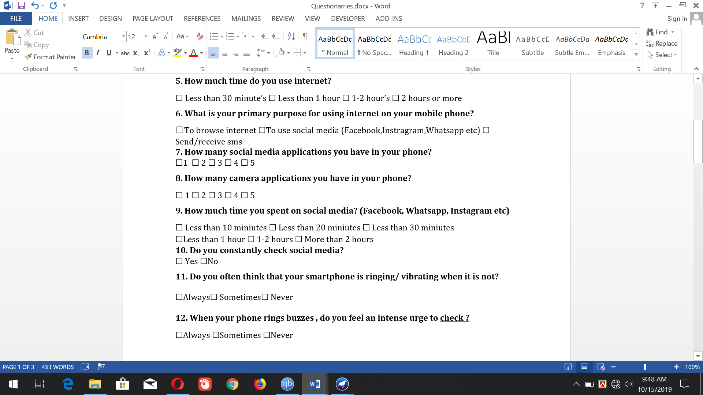

Figure 4.4: Hard copy of questionnaires

After collecting information’s we put it on the google form. Google form scenario:

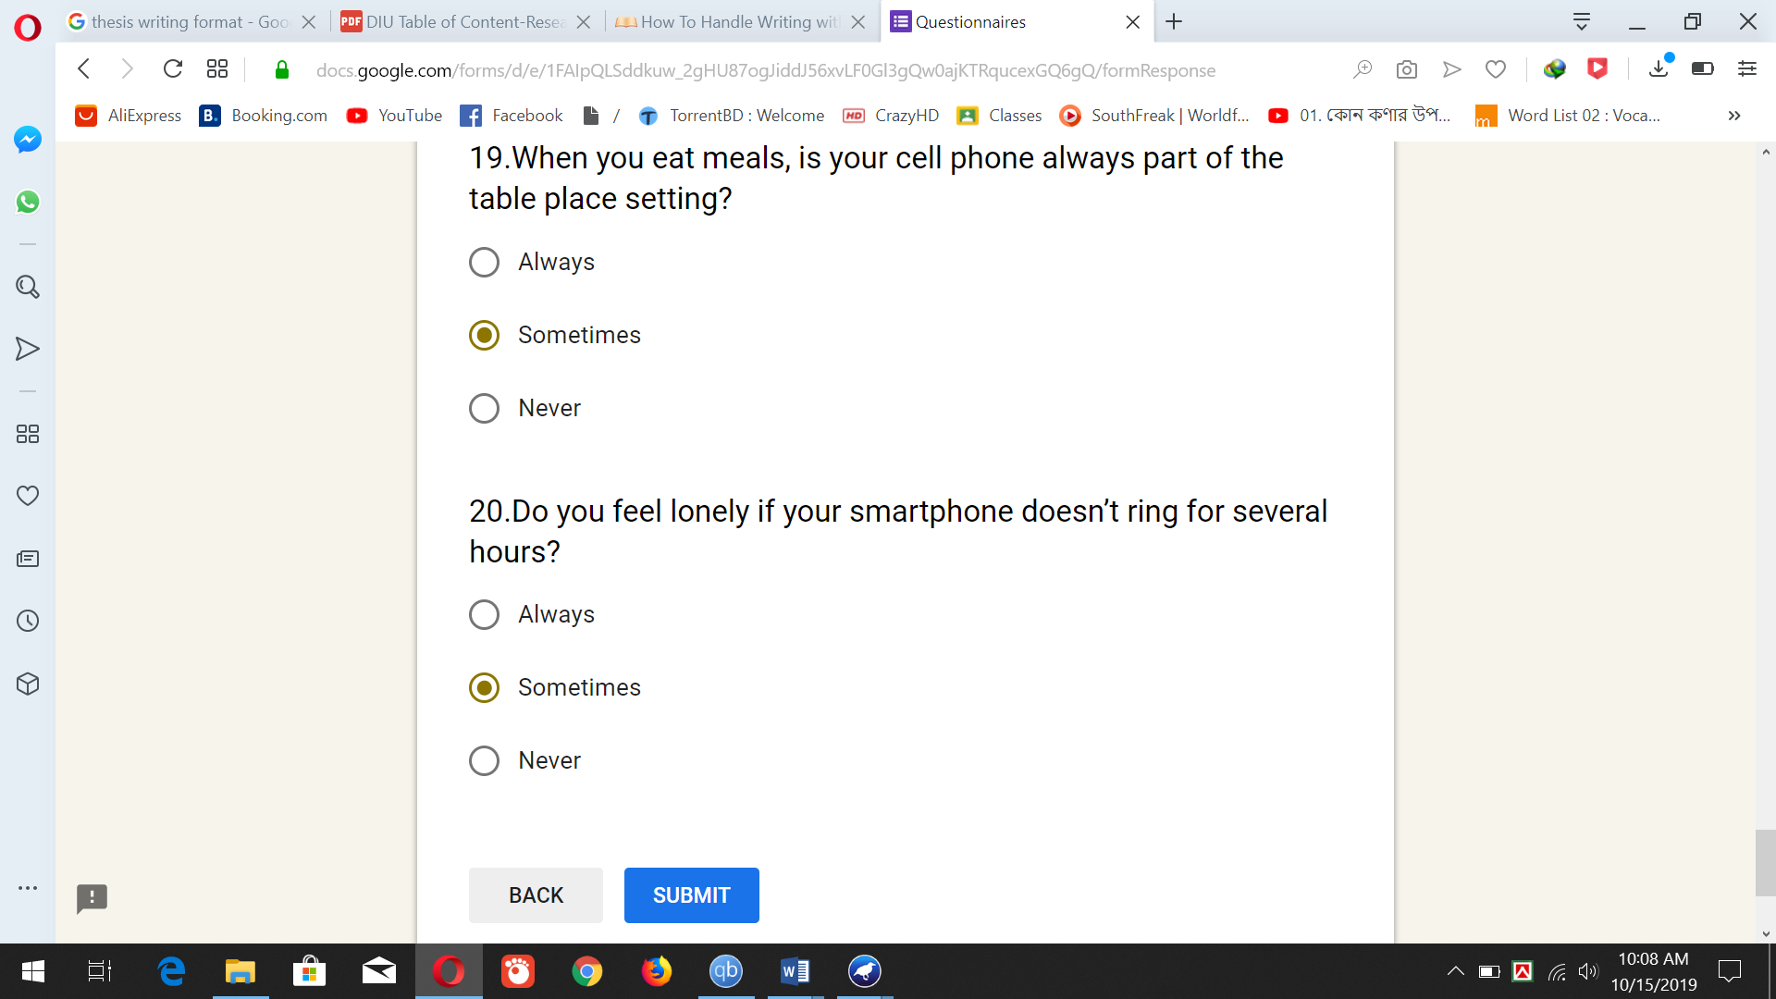

Figure 4.5: Google Form

About 430 participants’ data were collected. Then we apply different algorithms to see the result. Accuracy level was different for each algorithm. The best result was in Random Forest algorithm shown in (Fig: 03).Also we produce Precision-recall (PCR) plot (Fig: 04) .Precision recall curve is a successful measure of prediction when the classes are very imbalanced. A high area under the curve represents both high recall and high precision, where high precision relates to a low false positive rate, and high recall relates to a low false negative rate.

**Result comparison table:**

|  |  |  |  |
| --- | --- | --- | --- |
| Type | Algorithm name | Result(CCI) | Average |
| T1 | Naïve Bayes | 74.5327% | 74.5327% |
| T2 | SLR | 76.6355% | 75.81775% |
| SMO | 75% |
| T3 | KNN | 82.7103% | 82.7103% |
| T4 | Ada Boost | 74.7664% | 76.324% |
| Bagging | 78.271% |
| Stacking | 75.9346% |
| T5 | DT | 79.2056% | 79.1277% |
| Random Forest | 84.1121% |
| REP Tree | 74.0654% |

Table 4.6: Comparison Table

Categorize algorithms according to their types, we calculate the average CCI result. It indicates that Type-3 method is more efficient. On the other hand, Random Forest method was individually most efficient but in categorized value the efficiency have changed. So, in categorized way it sequenced T3>T5>T4>T2>T1.

**Summary:**

The revolution in the technology industry in past 20 years is unimaginable. In past 20 years the use of mobile phone has helped to improve lifestyles. Our study on the gender detection was excellent. We also tried it anonymously. Most of the time it predicted correctly.

When a person uses a mobile device it can predict the gender. This prediction will help in mobile phone distribution process.

**CHAPTER 5**

**Summary, Conclusion, Recommendation and Implication for Future**

**Research**

**5.1 Summary of the Study**

Everyone has their own perspective of using mobile phones. In developing countries women operate less mobile devices than mankind low and middle incoming countries 80% of woman now own a mobile phone. Among them 48% of women use internet. In south Asia there is 28% less women users than man and 57% less likely to use internet. The gender gap of mobile phone usage is widest in low and middle income countries. In today’s world, mobile phone is the basic of connecting to the world. It is also an easiest medium to learn things and solve problems. If there remains a wider gender gap in using mobile phones, a part of our society remains unconnected from the outside world and also lack behind in learning new things. It affects the GDP rate and economy also. This gender gap varies from region to region. So it is also important for the stockholder to understand before making any decision. The study also helps us to find the barriers and reason why women’s are lacking behind in mobile & mobile internet access. It is important for the stockholders to remove those barriers that are responsible for this gender gap. By providing full benefits for the users and removing these gender gaps, revolution of the mobile phone industry can be extended.

**5.2 Conclusions**

In this thesis, we have tried to recognize gender by their mobile phone usage. For this purpose we selected the most appropriate methods for recognition process.

Accordingly, we investigate these information’s in 10 different types of algorithms which are NaiveBayes,SLR,SMO,KNN,AdaBoost,Bagging,stacking,Decisiontree(DT),RandomForest,REPTree.Collected datasets were individually different from each other. It gives us better results. As the Random Forest gives the best result compared to other algorithms.

**5.3 Recommendations**

We recommend,

* There must be work to understand the needs of a user. Online consultancy can be included.
* Design and implementation policies must be improved according to the gender.
* Improve the quality of gender related data, create strategies and record progress.
* Raise awareness regarding the benefits of mobile phone and internet use. Consult users basically women in mobile design and implementation policies. Provide user friendly mobile environment.
* Enlarge marketing and distribution strategies. Make affordability cheaper.

**5.4 Implication for Further Study**

* **Commercial opportunity:** Addressing the gender gap could be impetus for the many mobile operators. If operators can close these gaps witching 2023, there will be a revenue of 140$ billion.
* **Potential economic growth:** Closing gender gap is a critical enabler of future economic growth. Removing gender gaps in mobile internet use can bring additional $700 billion GDP in these countries by the next five years. And the greatest opportunity is for the south Asia region as the gender gap is widest here.

**REFERENCES**

**IEEE format**

**Citethisforme.com**

1. Li, Hongmei & Liu, Shuangshen: Research and Implementation of Gender recognition based on Face Image (2011).
2. A Fusion-based Gender Recognition Method Using Facial Images Benyamin Ghojogh, Saeed Bagheri Shouraki, Hoda Mohammadzade*, Ensieh Iranmeh (2017)
3. Muhammad Nazir, Anwar. M. Mirza, “Multi-view Gender Classiﬁcation using hybrid Transformed Features,” International Journal of Multimedia and Ubiquitous Engineering, (2012)
4. Kanchan Tarwani, K. K. Bhoyar, “A Neural Network Approach to Gender Classiﬁcation using Facial Images,” International Conference on Industrial Automation and Computing, (2014)
5. Chandrakamal Sinha “Gender Classiﬁcation from Facial Images using PCA and SVM” (2013)
6. Khalil Khan, Muhammad Attique, Ikram Syed and Asma Gul “Automatic Gender Classiﬁcation through Face Segmentatio”(2019)
7. https://en.wikipedia.org/wiki/Gender (Last Accessed on 21/10/2019 at 2:05 PM)
8. Mucahit Buyukyilmaz1 and Ali Osman Cibikdiken2, “Voice Gender Recognition Using Deep Learning”(2016)
9. T. Jayasankar1,∗, K. Vinothkumar2 and Arputha Vijayaselvi3, “Automatic Gender Identiﬁcation in Speech Recognition by Genetic Algorith” (2017)
10. A Raahul, R Sapthagiri, K Pankaj and V Vijayarajan “Voice based gender classification using machine learning” (2017)
11. Seong-Soo Cha and Bo-Kyung Seo “Smartphone use and smartphone addiction in middle school students in Korea: Prevalence, social networking service, and game use”(2018)
12. Wilburn Lane* , Chris Manner “The Impact of Personality Traits on Smartphone Ownership and Use”
13. <https://en.wikipedia.org/wiki/Smartphone>
14. Mengwei Bian1 and Louis Leung1 “Linking Loneliness, Shyness, Smartphone Addiction Symptoms, and Patterns of Smartphone Use to Social Capital” (2016)
15. Arunrat TangmunkongvorakulID1, Patou Masika MusumariID2*, Kulvadee Thongpibul3, Kriengkrai Srithanaviboonchai1,4, Teeranee Techasrivichien2, S. Pilar Suguimoto2,5, Masako Ono-Kihara2, Masahiro Kihara2, “Association of excessive smartphone use with psychological well-being among university students in Chiang Mai, Thailand”(2019)
16. https://www.gsma.com/mobilefordevelopment/wp-content/uploads/2019/02/GSMA-The-Mobile-Gender-Gap-Report-2019.pdf
17. <https://arxiv.org/pdf/1511.06656.pdf>
18. http://earsiv.sehir.edu.tr:8080/xmlui/bitstream/handle/11498/39693/000130187002.pdf?sequence=1&isAllowed=y