**DOCTOR FINDER**

**BY**

**ISTIAQUE AHMED**

**ID: 153-15-6532**

**MD. RAKIB ULLAH HABIBEE**

**ID: 153-15-6345**

**SANZIDA ISLAM RUMPA**

**ID: 152-15-5929**

This Report is presented in Partial Fulfilment of the Requirements for the

Degree of Bachelor of Science in Computer Science and Engineering

Supervised B y

**MD. RAKIB HASAN**

Lecturer

Department of CSE

Daffodil International University

Co-Supervised By

Daffodil International University



**DAFFODIL INTERNATIONAL UNIVERSITY**

**DHAKA, BANGLADESH MAY 2018**

**APPROVAL**

This Project titled **“Doctor Finder**”, submitted by ISTIAQUE AHMED ID : 153-15-6532,MD. RAKIB ULLAH HABIBEE ID : 153-15-6345 and SANZIDA ISLAM RUMPA ID: 152-15-5929 to the Department of Computer Science and Engineering, Daffodil International University, has been accepted as satisfactory for the partial fulfillment of the requirements for the degree of B.Sc. in Computer Science and Engineering (BSc) and approved as to its style and contents. The presentation has been held in July 2019.

# BOARD OF EXAMINERS

### Dr. Syed Akhter Hossain Chairman

### Professor and Head

Department of Computer Science and Engineering

Faculty of Science & Information Technology

Daffodil International University

### Dr. Sheak Rashed Haider Noori Internal Examiner

### Associate Professor and Associate Head

Department of Computer Science and Engineering

Faculty of Science & Information Technology

Daffodil International University

### Md. Zahid Hasan Internal Examiner

### Assistant Professor

Department of Computer Science and Engineering

Faculty of Science & Information Technology

Daffodil International University

### Dr. Mohammad Shorif Uddin External Examiner

### Professor

Department of Computer Science and Engineering

Jahangirnagar University

# DECLARATION

We hereby declare that this project has been done by us under the supervision of MD. RAKIB HASAN**,** Lecturer, Department of CSE, and Daffodil International University in Partial of the requirements for the Degree of Bachelor of Computer Science. We also declare that neither this project report nor any part of this project report has been submitted elsewhere of any Degree or Diploma. We also declare that we collect information from our project work experience and Internet.

|  |  |  |  |
| --- | --- | --- | --- |
| **Supervised by:**  **MD. Rakib Hasan**  Lecturer  Department of CSE  Daffodil International University  **Submitted by:**  **Istiaque Ahmed**  ID : 153-15-6532  Department of CSE  Daffodil International University  **MD. Rakib Ullah Habibee**  ID : 153-15-6345  Department of CSE  Daffodil International University  **Sanzida Islam Rumpa**  ID: 152-15-5929  Department of CSE  Daffodil International University |  |  | **Co-Supervised by:**  Department of CSE  Daffodil International University |

# ACKNOWLEDGEMENT

First, we express our heartiest thanks and gratefulness to almighty God for his divine blessing makes us possible to complete the final year project successfully. We have been taken efforts in this project. However, it would not have been possible without the kind support and help of many individuals. We would like to ours extend sincere thanks to all of them.

We really grateful and wish our profound our indebtedness to **Md. Rakib Hasan**, Lecturer, Department of **Computer Science and Engineering**, Daffodil International University, Dhaka. Deep Knowledge & keen interest in our supervisor field in the of “**DOCTOR FINDER**” to carry out this project. His endless patience, continual encouragement scholarly guidance, constant and energetics supervision, constructive criticism, valuable advice, reading many inferior drafts and correcting them at all stage have made it possible to complete this project.

We would like to express our heartiest gratitude to **Dr. Syed Akhter Hossain**, **Professor and** **Head**, Department of **Computer Science and Engineering**, Daffodil International University, for his kind help to finish our project and we would also like to admit with much appreciation the crucial role of the staff of Daffodil International University (DIU), who gave me the permission to access all kind of library materials and equipment to gain knowledge and to clear out our understandings. We have to appreciate the guidance given by the other supervisors and lecturers who has helped us to clear our understanding and created a concern and importance of completing the project report carefully with maintain good knowledge and quality.

Finally, we would like to express our gratitude towards our parents & our supervisor **Md. Rakib Hasan** for their kind co-operation and encouragement which helped us in the completion of this project.

# ABSTRACT

The ultimate goal is to connect the patient with the doctors. Our proposed and developed solution

of android application including some basic information about doctor and help them to take

appointment from the doctor directly. Most of the time in our country many people don’t know

proper information about doctor and also don’t know about doctor’s assistant number to take an

appointment. By using our android application, they can easily take appointment from the doctor.

One more thing the doctors don’t need to take extra assistant for taking appointment. The paper

illustrates the features, development method, result, and uses of our android application named

**“DOCTOR FINDER”**.

**TABLE OF CONTENTS**

**CONTENTS PAGE NO**

BOARD OF EXAMINERS ii

DECLARATION iii

ACKNOWLEDGEMENT iv

ABSTRACT v

**LIST OF FIGURES ix**

**LIST OF TABLES x**

CHAPTER 1 1

INTRODUCTION 1

1.1 Introduction 1

1.2 Objectives 1

1.3 Motivation 2

1.4 Expected Result 2

1.5 Methodology 2

1.6 Report Layout 3

CHAPTER 2 4

BACKGROUND 4

2.1 Introduction 4

2.2 Some Other Projects Works 4

2.3 Scope of the Problem 5

2.4 Challenges 5

3.1 Introduction 6

3.2 General System Requirement of “Doctor Finder” 6

3.3 Use Case Model 10

3.4 Use Case Description 11

3.5 Class Diagram 14

3.6 Design Requirement 15

**CHAPTER 4 16**

DESIGN SPECIFICATION 16

4.1 Front-end Design 16

4.1.1 Home Page 16

4.1.2 Sign Up for Doctors 17

4.1.3 log in 21

4.1.4 Make appointment 22

4.1.5 Review 26

CHAPTER 5 27

IMPLEMENTATION AND TESTING 27

5.1 Interaction Design and UX 27

5.2 Implementation of Requirements 27

5.3 Implementation of Interaction 27

5.4 Testing Implementation 28

5.5 Test Result and Report 29

CHAPTER 6 30

Conclusion And Future Scope 30

6.1 Discussion and Conclusion 30

6.2 Scope for Further Development 30

REFERENCES 31

**LIST OF FIGURES**

**FIGURES PAGE NO**

Fig 3.3.1 Use case model 9

Fig 3.5.1 Class diagrams 13

Fig 4.1.1.1 Home page 15

Fig 4.1.2.1 Sign up page for doctor 16

Fig 4.1.2.2 Sign up page part 1 17

Fig 4.1.2.3 Sing up page part 2 18

Fig 4.1.2.4 Time for the appointment 19

Fig 4.1.3.1 Log in 20

Fig 4.1.4.1 Make an appointment 21

Fig 4.1.4.2 Making appointment part 1 22

Fig 4.1.4.3 Appointment part 2 23

Fig 4.1.4.4 Confirm appointment 24

Fig 4.15.1 Review 25

**LIST OF TABLES**

**TABLE PAGE NO**

Table 3.1: Use case description of Account Activation 10

Table 3.2: Use case description of Login 11

Table 3.3: Use case description of appointment 11

Table 3.4: Use case description of review 12

Table 3.5: Use case description of Logout 12

Table 5.4.1 Testing 27

# CHAPTER 1

# INTRODUCTION

## Introduction

Android has become very popular in the market for two mainstream reasons. First, the source code is completely free moreover, there are no royalty fees for JVM (Java Virtual Machine), second deriving from the first, Android is highly compatible with expansion as interactive android base mobile application.

Bangladesh is a developing country and also a digital country. So for being a digital we need to do everything digital. Our main purpose is to connect the patient with the doctor directly. They shouldn’t need any third party to connect them manually. We convert the manual system with digitally and properly. The doctors can also save their money by using this android application. Most of the thing is patient won’t be hassle anymore

## Objectives

The purpose of our project is to take appointment from the doctor directly. They will directly choose the patient direct. And the patient won’t need to pay any kind of fee for taking the appointment and we will also provide one more service and that is the patient won’t need to pay the doctor’s bill for the first three time by using this android application.

The Objectives are:

1. To provide appointment to the patient
2. The doctor can update and delete any appointment.
3. The patient can see all specialist lists from this application.
4. There is a third person which name can comment about a doctor.
5. To provide the best doctor for their disease.

## **Motivation**

Today's world is the digital world. Digital world means online-based services. Here people want everything in their hand. There is nothing which isn't in online. All information’s are going to online. In online all information's are stored in an individual database, which is maintained by a website, that is a system. The aim to design and develop the project is to help patient for Bangladesh, the application is to be user friendly tourist guide over android operating system for Bangladesh which is not available currently for smart- phones. Due to domestic and international tourist flow in

Bangladesh such application is helpful for the both doctors and patients. Nowadays folks choose to use humanoid application because of straightforward, conveyance usage.

## Expected Result

Nowadays there are too many mobile applications in our country. At this circumstance, a user faces great difficulties to choose the suitable application. The user has to face difficulty to pick up which application. This application will be helpful to overcome all these difficulties of the users. It changes the traditional techniques of calling the assistant of that doctor and take appointment. The traditional technique might create problems while decision making due to lack of information of guide.

## Methodology

We have undertaken several parts to make this project successfully. We researched existing manual process. The methodology of the functioning of the existing system gives the Idea for the design of the new system.

1. Log in to Doctor’s IDs.
2. Doctor select time for the patient.
3. Patient can take appointments.

## Report Layout

To complete this report, we add the layout. Layout is the process of add something in a short form or in a table to show the whole process in short time. We use layout because we want to show the all of my work in a short form, so that viewer can understand it clearly.

**Chapter 1:** is describing the introduction, objective, motivation, expected result, methodology of this project.

**Chapter 2:** is about the project background and the project overview. This chapter gives the information about related work, scope of the problem and project challenges.

**Chapter 3:** is shown the requirement and specification of this project.

**Chapter 4**: described the design specification. Also described front-end design, back-end design, UI design &functionality.

**Chapter 5**: is about Implementation and Testing of this project.

**Chapter 6:** is about conclusion and future scope.

# CHAPTER 2

# BACKGROUND

## 2.1 Introduction

For being in a digital world, we all have to do all work in digitalized way. From the beginning of

the world disease is a common word for all of us. Now a days we do phone call to the assistant of

that doctor and take appointment of that doctor. But now patient don’t need to do phone call for

appointment and don’t need to search on google for which doctor they should go for checkup.

Patient will just open the application and check the list of the doctors and take appointment of them

choice able doctor.

## 2.2 Some Other Projects Works

In Google Play Store, there are some similar type applications. Some of this are Find Local Doctors, Find the Doctor, Nearest doctor finder, Doctor Referral Finder etc. The team culture is not so easy to define in one world in short, the all connect of “Doctor Finder”. They work in different section but their intention is same to help the patient. Modern smart phone also includes high to resolution touch screens and android application that provided by Wi-Fi and mobile broadband. The most same mobile phone operating system android application used by modern smart. Phone connect can be install on google play store application apps different phone moderns and typically mobile phone models. Using smart mobile phone is not a show off it is a demand this modern time. The people think in world it is more popular than another country of world base.

## 2.3 Scope of the Problem

The scope of our project is mainly for the doctors and the patients. Moreover, Bangladeshi people who are new in city, they can also take appointment of a doctor. It also supports almost 90% android phones.

## 2.4 Challenges

The proposed application should have the following challenges to overcome the better service:

* To maintain simplicity.
* To maintain accessibility.
* To maintain the compatible platform.
* To maintain instant doctors.
* To identify the real doctors.

**CHAPTER 3**

**REQUIREMENT AND SPECIFICATION**

## 3.1 Introduction

“Doctor Finder” is very well-designed Android based application that provides people the information about doctors and can also take appointment from the doctors. As an android application, our project needs some software resource and support to run efficiently. So, in this chapter of our report, we will go to discuss the requirement specification for our project.

## 3.2 General System Requirement of “Doctor Finder”

There are some minimum requirements to build our android application. These requirements have to fulfill in order to run our project. A general list of software component is given below to get an idea of what we used to build our project-

* Software:
  + - Windows Operating System (Windows 10)

Windows 10 is a progression of PC working frameworks delivered by Microsoft as a component of its Windows NT group of working frameworks. It is the successor to Windows 8.1, and was discharged to assembling on July 15, 2015 and comprehensively discharged for retail deal on July 29, 2015.Windows 10 gets new expands on a continuous premise, which are accessible at no extra expense to clients, notwithstanding extra test works of Windows 10 which are accessible to Windows Insiders. Gadgets in big business situations can get these updates at a slow pace, or utilize long haul bolster achievements that just get basic updates, for example, security patches, over their ten-year life expectancy of broadened support.

* + - Android Studio

Android Studio is the official[7] incorporated advancement condition (IDE) for Google's Android working framework, based on JetBrains' IntelliJ IDEA programming and planned explicitly for Android development.[8] It is accessible for download on Windows, macOS and Linux based working systems.[9][10] It is a substitution for the Eclipse Android Development Tools (ADT) as the essential IDE for local Android application improvement.

* + XAMPP Control Panel

XAMPP is a free and open-source cross-stage web server arrangement stack bundle created by Apache Friends,[2] comprising for the most part of the Apache HTTP Server, MariaDB database, and translators for contents written in the PHP and Perl programming languages.[3][4] Since most genuine web server organizations utilize indistinguishable segments from XAMPP, it makes changing from a nearby test server to a live server conceivable.

* + Browser (Firefox, Chrome)

An internet browser (usually alluded to as a program) is a product application for getting to data on the World Wide Web. Every individual website page, picture, and video is distinguished by a particular Uniform Resource Locator (URL), empowering programs to recover these assets from a web server and show them on a client's gadget.

* Programming Language and Framework:
  + - Java

Java is a broadly useful programming language that is class-based, object-oriented [15] (despite the fact that not an unadulterated article arranged language, as it contains crude types[16]), and intended to have a couple of execution conditions as could be expected under the circumstances. It is expected to give application engineers a chance to compose once, run anyplace (WORA),[17] implying that assembled Java code can keep running on all stages that help Java without the requirement for recompilation.[18] Java applications are normally aggregated to bytecode that can keep running on any Java virtual machine (JVM) paying little heed to the fundamental PC design. The linguistic structure of Java is like C and C++, yet it has less low-level offices than both of them. Starting at 2018, Java was one of the most prevalent programming dialects being used by GitHub,[19][20] especially for customer server web applications, with a revealed 9 million engineers

* + - MySQL

MySQL is an open-source social database the executive’s framework (RDBMS). Its name is a blend of "My", the name of prime supporter Michael Widenius' daughter and "SQL", the shortened form for Structured Query Language.

MySQL is free and open-source programming under the provisions of the GNU General Public License, and is additionally accessible under an assortment of restrictive licenses. MySQL was claimed and supported by the Swedish organization MySQL AB, which was purchased by Sun Microsystems (presently Oracle Corporation). In 2010, when Oracle gained Sun, Widenius forked the open-source MySQL task to make MariaDB.

## 3.3 Use Case Model

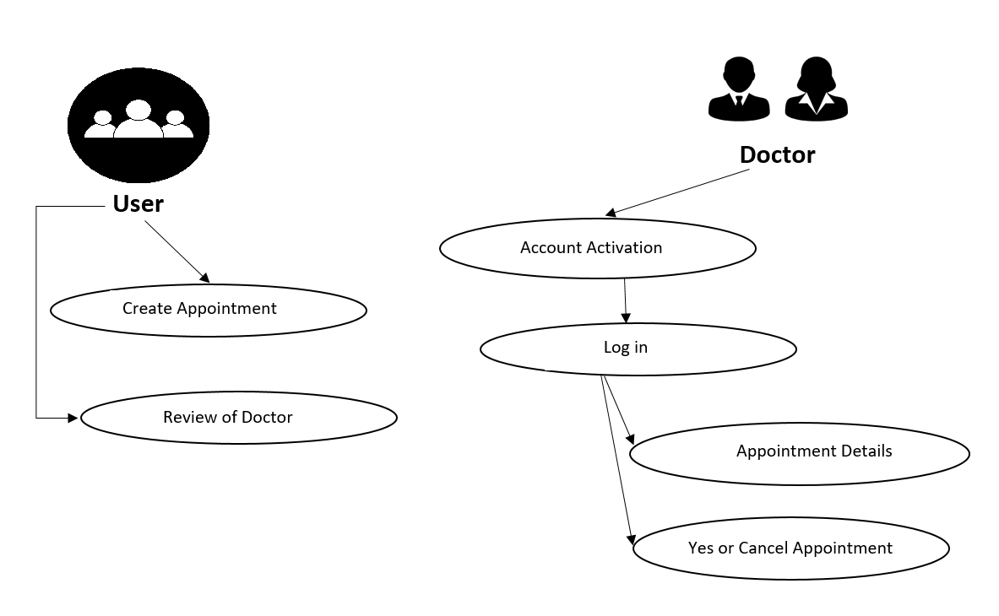

Fig 3.3.1: Use case model

## 3.4 Use Case Description

The description of the use case model of 3.3 (Figure 3.3.1) is given below. Every attribute will be discussing with a table containing “Primary Actor”, “Secondary Actor”, “Pre-condition”,” Scenario” and “Post-condition”. So that it could be understandable by all.

Table 3.1: Use case description of Account Activation

|  |  |
| --- | --- |
| Use Case | Sign up |
| Primary Actor | Doctor |
| Secondary Actor | NULL |
| Pre-condition | NULL |
| Scenario | . Enter Name  . Enter Email  . Enter Password  . Enter Time |
| Post-condition | Sign up successfully or failed |

Table 3.2: Use case description of Login

|  |  |
| --- | --- |
| Use Case | Login |
| Primary Actor | Doctor |
| Secondary Actor | NULL |
| Pre-condition | NULL |
| Scenario | . Enter Email  . Enter Password |
| Post-condition | Login Successfully or Failed |

Table 3.3: Use case description of appointment

|  |  |
| --- | --- |
| Use Case | Appointment |
| Primary Actor | Patient |
| Secondary Actor | NULL |
| Pre-condition | NULL |
| Scenario | . Enter Name  . Enter Age  . Enter Address  . Enter Date  . Enter Time |
| Post-condition | Appoint successfully or failed |

Table 3.4: Use case description of review

|  |  |
| --- | --- |
| Use Case | Review |
| Primary Actor | patient |
| Secondary Actor | NULL |
| Pre-condition | NULL |
| Scenario | . Enter number of stars |
| Post-condition | Review Successfully or fail |

Table 3.5: Use case description of Logout

|  |  |
| --- | --- |
| Use Case | Logout |
| Primary Actor | Doctor |
| Secondary Actor | NULL |
| Pre-condition | NULL |
| Scenario | . Give Notification about activity |
| Post-condition | Logout successfully or failed |

## 3.5 Class Diagram

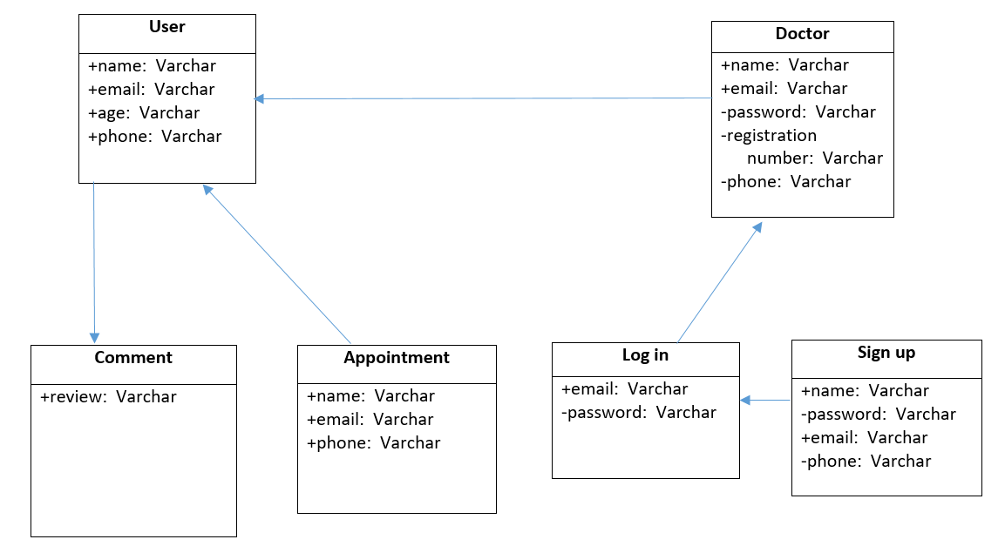

Fig 3.5.1: Class diagrams

## 3.6 Design Requirement

►In this application there are two users such as Doctors and Patients

►Doctor will set their own profile.

►Doctor will approve appointment

►User will sent appointment to doctors by their own.

►Doctors can manage account

►Doctors can approve the appointment

# CHAPTER 4

# DESIGN SPECIFICATION

## 4.1 Front-end Design

The main attraction of this application is its front-end design. This is the way of interaction between the users and the servers. Front-end design is also known as client-side development. We made a front-end design for the users to co-operate with the application very easily.

### 4.1.1 Home Page

In this home android application page, we provide the logo, sign-up option for doctors,

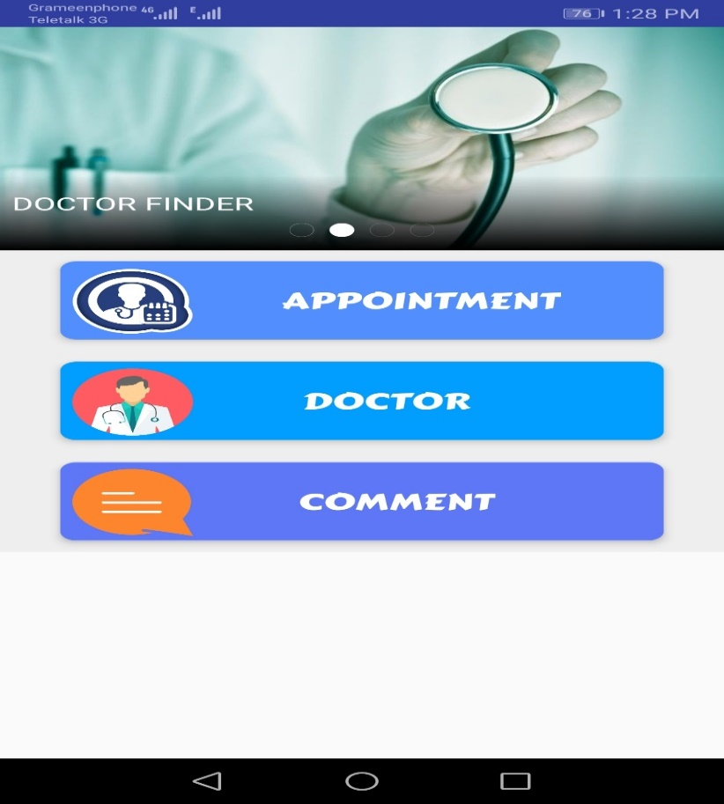appointment, comment option for the users.

Fig 4.1.1.1 Home page

### 4.1.2 Sign Up for Doctors

In this interface the doctor has to sign up for taking appointment. Doctors have to give them

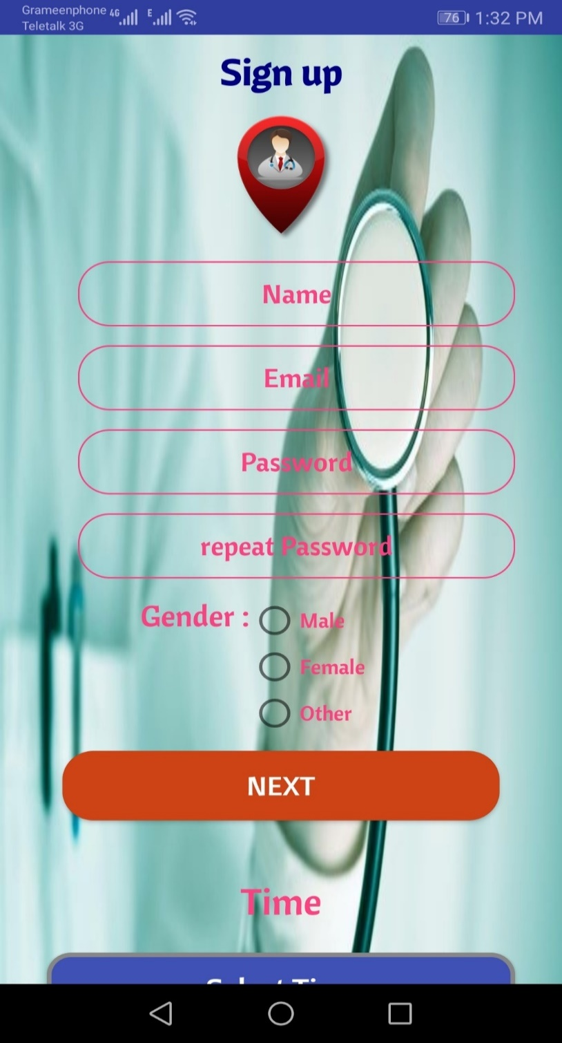name, email, password, gender for this first page.

Fig 4.1.2.1 Sign up page for doctors

After completing the first part of sign up then this second page will appear. And in this page doctors

have to provide their registration number, their specialty, their hospital name etc.

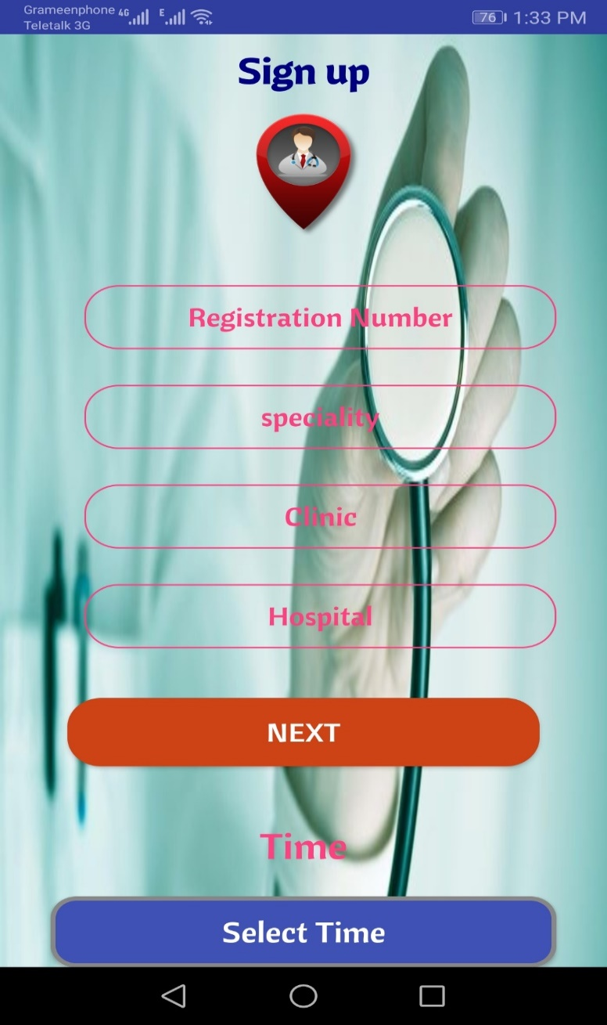

Fig 4.1.2.2: Signing up page part 2

After completing the second part of this sign up then they have to provide their day schedule

for appointment.

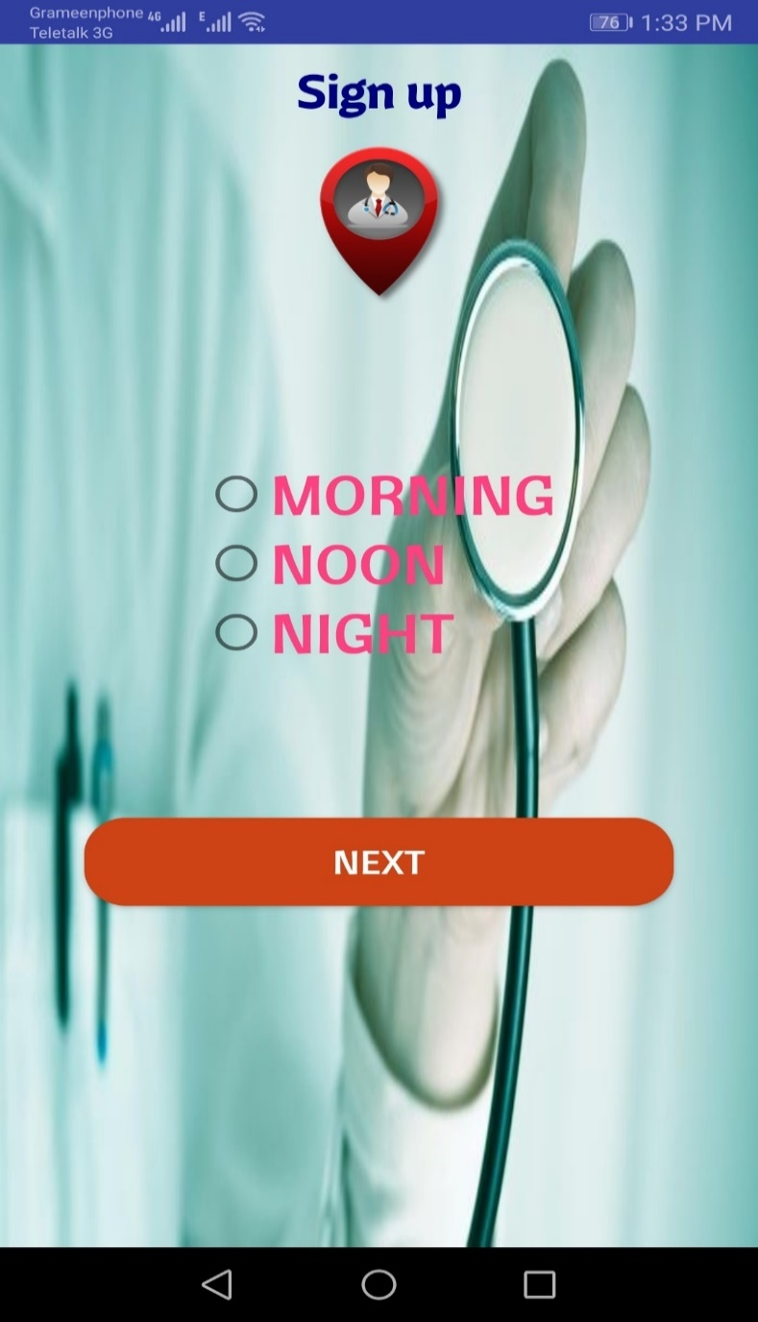

Fig 4.1.2.3: Signing up page part 2

After ding the day schedule they have to provide their time schedule for the appointment. After

then they can do sign up for this service.

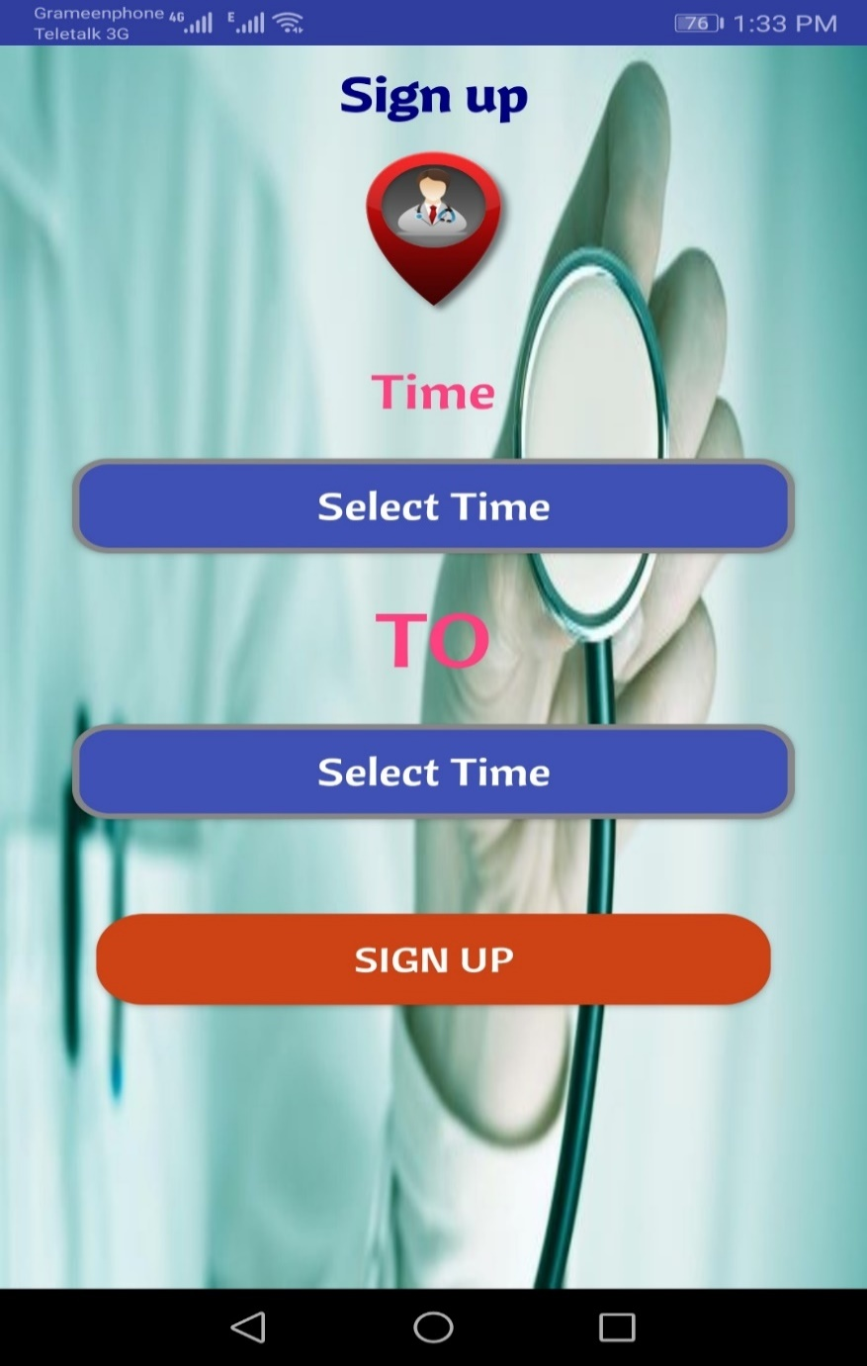

Fig 4.1.2.4: Time for the appointment

### 4.1.3 log in

We provide this interface for the log in for doctors. Doctors have to provide their email and password for log-in.

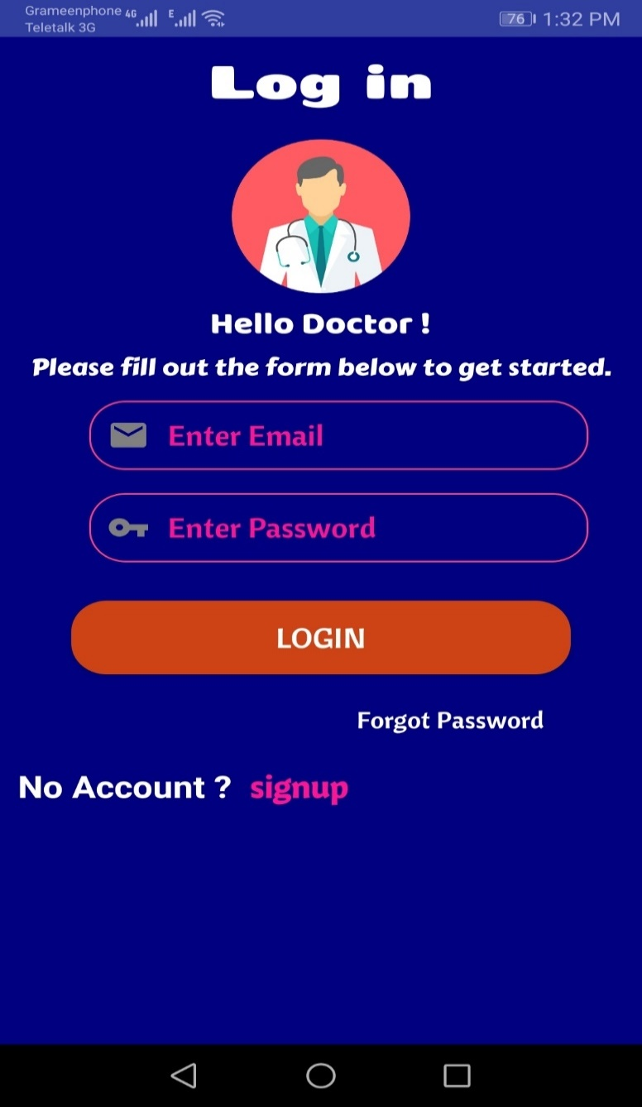

Fig 4.1.3.1: Log in

### 4.1.4 Make appointment

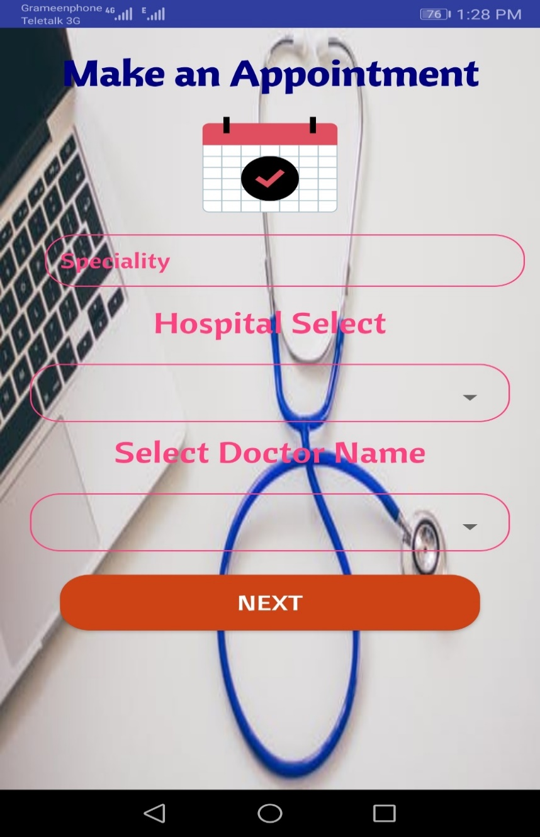In this interface the user can make appointment. Users have to select the specialty, hospital name, doctor’s name for the appointment.

Fig 4.1.4.1: Make an appointment

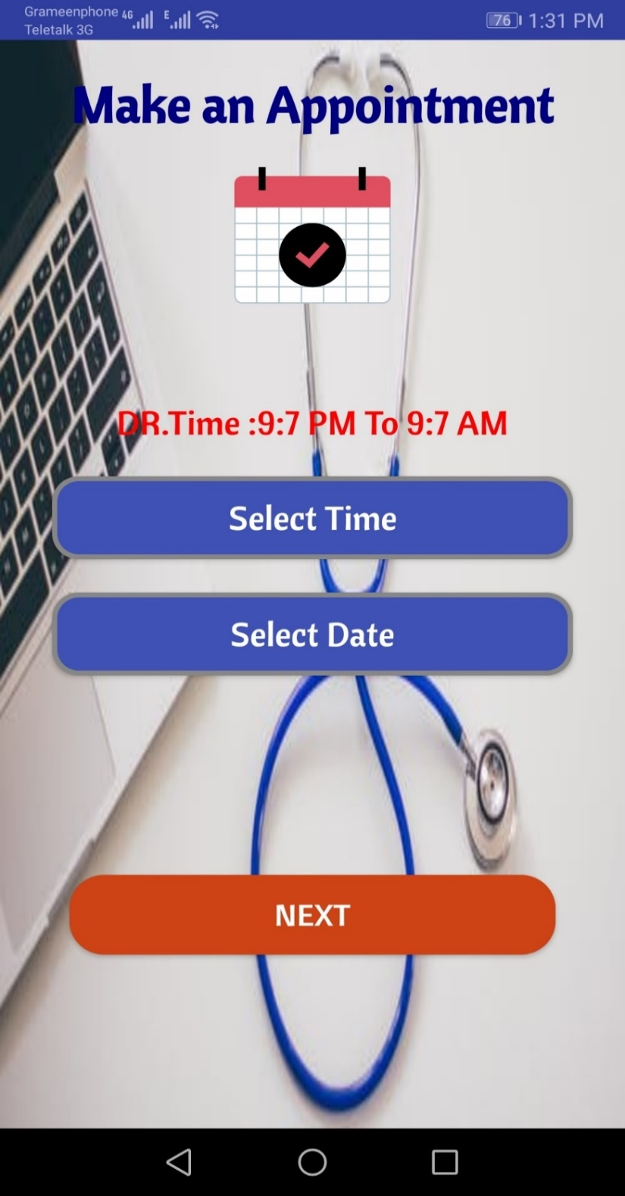After completing the first part, the users have to give their time and date for the appointment.

Fig 4.1.4.2: Making appointment part 2

After that the patient have to provide their name, age, phone number, their address, their gender and then they have to touch the confirm the button.

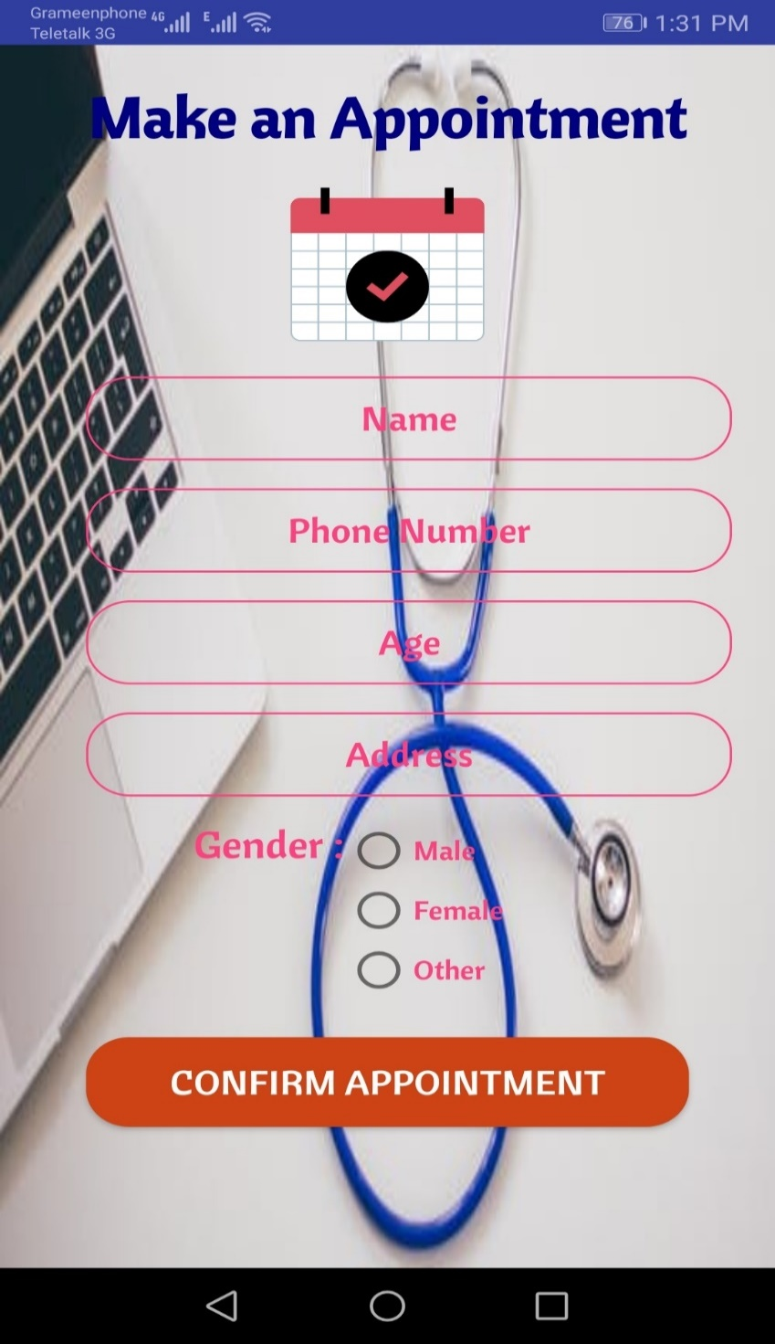

Fig 4.1.4.3: Appointment part 2

23

After touching the confirm button then we will give them another page to confirm it again. If they select yes then then appointment will send to the doctors.

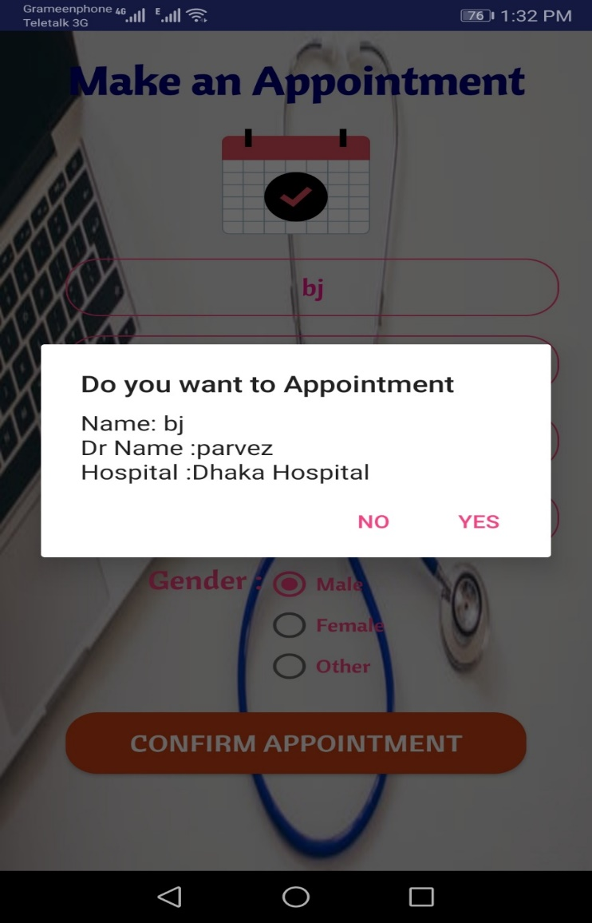

Fig 4.1.4.4: Confirm appointment

### 4.1.5 Review

The patients can give their review of doctors. They can rate from five star to one star. When they give the star they also have to doctor’s name.

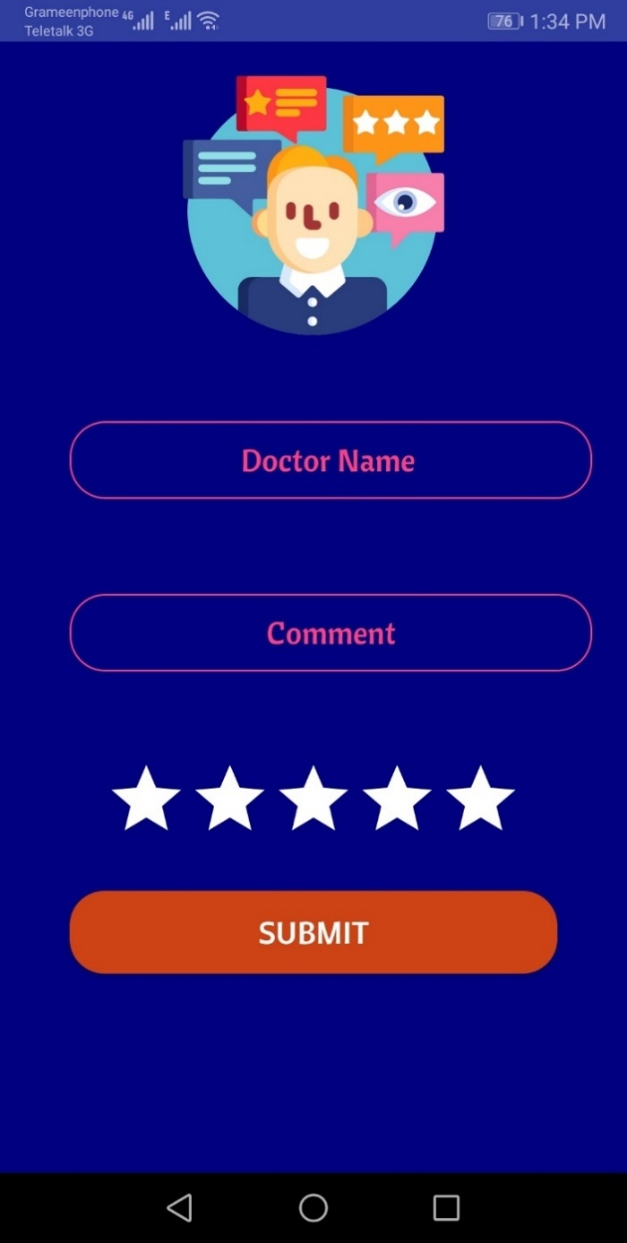

Fig 4.1.5.1: Review

# CHAPTER 5

# IMPLEMENTATION AND TESTING

## 5.1 Interaction Design and UX

We designed our android application using android studio. This application helps us to responsive and better visual experience with the user-friendly environment. The user experience is bringing better for the process of enhancing user satisfaction. With keep in mind we design it that, the successful interactive design user technology and principles of good communication to create desired user experiences.

## 5.2 Implementation of Requirements

* The UI design had to integrate into the android studio which is a java framework.
* The database should be in MySQL.
* Schedule-wise backup from the server.
* Unauthorized attach needed to prevent with maximum attach limits.
* Invalid data input should display an error message.

## Implementation of Interaction

In order to make our android application system (Data transaction: Meter to application) interactive we make the UI responsive and use buttons, icons, text, headlines and many more. The system design of our application is user-friendly. User will able to use the features as long as they are logged in.

## Testing Implementation

Testing implementation is a process of testing upcoming implementation of a system, where tester or system architect will see cases and specification, is it implemented or have limitations.

Table 5.4: Testing Implementation

Table 5.4.1: Testing

|  |  |  |  |  |  |
| --- | --- | --- | --- | --- | --- |
| **Test Case** | **Test Inputs** | **Expected Outcome** | **Obtained Outcome** | **Pass/Fail** | **Tested on** |
| 1.Sign up | Signup via android devices | Successfully signup | Successfully signup | pass | 25-06-2019 |
| 2.Login | Login via android devices | Successfully login | Successfully login | pass | 25-06-2019 |
| 3.Appointment | Appointment via android devices | Successfully appointment | Successfully appointment | pass | 25-06-2019 |
| 4.Password | Incorrect password or empty field | Warn the incorrect password or the field is empty | Show warning | pass | 25-06-2019 |

## 5.5 Test Result and Report

The test report is wanted to reflect testing results in a formal way, which gives a scope estimate testing result speedily. It is a paper that records info obtained from as analysis experiment in associate organized manner, describes the environmental or operation conditionals, and show the comparison of take a look at results with test objectives. The test report is very important and it is needed to know that the system is ready/ not ready for implementation? It is a document that records knowledge obtained from associate analysis experiment. We need to run through many types of testing. If the system passes through all these types of testing it is finally ready to launch so at the End, we can carry out the results as the benefits of usability testing.

* The system easier to use.
* Better UI for interaction.

# CHAPTER 6

# Conclusion and Future Scope

## 6.1 Discussion and Conclusion

The system will help users to get information about doctor within short time. It will save time and reduce difficulties. The system is already in testing service. The system will come with more upgrades and new features in future. It will be upgraded with its payment gateway, layout and features.

## 6.2 Scope for Further Development

* System features will upgrade day by day for a better experience.
* The new features will be added based on user feedback.
* The system will have implemented by new User Interface if needed.
* Artificial Intelligence enhancement will be implemented to make the system fast and more durable.
* Security will be more updated.
* We will take security as a major part to be improved.
* More security steps will be taken as many user’s information will be in our database.
* Individual payment gateway will be developed based on our user feedback.

# REFERENCES

1. Android Studio and SDK: <http://developer.android.com/sdk/index.html>[last Accessed Mar 10th 2019]
2. Java JDK: <http://www.oracle.com/technetwork/java/javase/downloads/index.html>[last Accessed Mar 20th, 2019]
3. About use case [https://www.lucidchart.com/documents/edit/3fd0666a-48e6-4276-b21703b6c5ff9050/0](https://www.lucidchart.com/documents/edit/3fd0666a-48e6-4276-b217-03b6c5ff9050/0)

[3]Android XML: <https://developer.android.com/guide/topics/resources/complex-xml-resources>[last Accessed JAN 20th 2019]

1. Android API15 Samples: <http://developer.android.com/samples/index.html>[last Accessed Mar 05th 2019]
2. Android Activities Demos: [https://android.googlesource.com/platform/development/+/master/samples/ApiDemos/src/com/exampl e/android/apis/app/FragmentRetainInstance.java](https://android.googlesource.com/platform/development/+/master/samples/ApiDemos/src/com/example/android/apis/app/FragmentRetainInstance.java)[last Accessed JAN 20th 2019]
3. Firebase Database: https://firebase.google.com/docs/storage/android/create-reference [last Accessed JAN 20th 2019]
4. Android Plug-ins: <http://developer.android.com/tools/help/adt.html>[last Accessed Mar 20th 2019]
5. About the mobile app: <https://en.wikipedia.org/wiki/Mobile_app>[last Access JAN 20th 2019]
6. Android market share: https://www.idc.com/promo/smartphone-market-share/os [last access JAN 20th 2019]
7. [10] Appointment information: <https://www.squarehospital.com/appointment> [last access JAN 20th 2019]
8. [11] Android Material Design: <https://material.io/develop/android/> [last access FEB 15th 2019]
9. [12] Doctor finder by ZIMO-IT: <https://github.com/ZIMO-IT/Doctor-Finder> [last access JAN 20th 2019]
10. [13] Doctor finder by Sansatyaki: <https://github.com/sensatyaki/Doctor-FInder-android-application> [last access JUL 10th 2019]
11. [14] Network Issues: <https://stackoverflow.com/questions/6343166/how-do-i-fix-android-os-networkonmainthreadexception> [last access JUN 25th 2019]