**TOUR GUIDE**

**BY**

**MD.SALAH UDDIN**

**ID: 143-15-4580**

**MST. JANNATUL NIYEM**

**ID: 143-15-4578**

This Report is presented in Partial Fulfilment of the Requirements for the

Degree of Bachelor of Science in Computer Science and Engineering

Supervised By

**MD. RIAZUR RAHMAN**

Sr Lecturer

Department of CSE

Daffodil International University

Co-Supervised By

Daffodil International University



**DAFFODIL INTERNATIONAL UNIVERSITY**

**DHAKA, BANGLADESH MAY 2018**

**APPROVAL**

This Project titled **“Tour Guide**”, submitted by Salah Uddin ID : 143-15-4580 and Jannatul Niyem ID : 143-15-4578 to the Department of Computer Science and Engineering, Daffodil International University, has been accepted as satisfactory for the partial fulfillment of the requirements for the degree of B.Sc. in Computer Science and Engineering (BSc) and approved as to its style and contents. The presentation has been held in Aug 2018.

# BOARD OF EXAMINERS

### Dr. Syed Akhter Hossain

### Chairman

### Professor and Head

Department of Computer Science and Engineering

Faculty of Science & Information Technology

Daffodil International University

### Dr. Sheak Rashed Haider Noori Internal Examiner

### Associate Professor and Associate Head

Department of Computer Science and Engineering

Faculty of Science & Information Technology

Daffodil International University

### Md. Zahid Hasan Internal ExaminerAssistant Professor

Department of Computer Science and Engineering

Faculty of Science & Information Technology

Daffodil International University

### Dr. Mohammad Shorif Uddin External Examiner

### Professor

Department of Computer Science and Engineering

Jahangirnagar University

# DECLARATION

We hereby declare that this project has been done by us under the supervision of MD. RIAZUR RAHMAN**,**SrLecturer, Department of CSE, and Daffodil International University in Partial of the requirements for the Degree of Bachelor of Computer Science. We also declare that neither this project report nor any part of this project report has been submitted elsewhere of any Degree or Diploma. We also declare that we collect information from our project work experience and Internet.

|  |  |  |  |
| --- | --- | --- | --- |
| **Supervised by:**  **MD. RIAZUR RAHMAN**  Sr Lecturer  Department of CSE  Daffodil International University  **Submitted by:**  **Md. Salah Uddin**  ID : 143-15-4580  Department of CSE  Daffodil International University  **Mst. Jannatul Niyem**  ID : 143-15-4578  Department of CSE  Daffodil International University |  |  | **Co-Supervised by:**  Department of CSE  Daffodil International University |

## ACKNOWLEDGMENT

First, we express our heartiest thanks and gratefulness to almighty God for his divine blessing makes us possible to complete the final year project successfully. We have been taken efforts in this project. However, it would not have been possible without the kind support and help of many individuals. We would like to our extend sincere thanks to all of them.

We really grateful and wish our profound our indebtedness to **Md. Riazur Rahman**, Sr Lecturer, Department of CSE, Daffodil International University, Dhaka. Deep Knowledge & keen interest in our supervisor field in the of “**Tour Guide**” to carry out this project. His endless patience, continual encouragement scholarly guidance, constant and energetics supervision, constructive criticism, valuable advice, reading many inferior drafts and correcting them at all stage have made it possible to complete this project.

We would like to express our heartiest gratitude to **Dr. Syed Akhter Hossain** Head, Department of CSE, for his kind help to finish our project and we would also like to admit with much appreciation the crucial role of the staff of Daffodil International University (DIU), who gave me the permission to access all kind of library materials and equipment to gain knowledge and to clear out our understandings. We have to appreciate the guidance given by the other supervisors and lecturers who has helped us to clear our understanding and created a concern and importance of completing the project report carefully with maintain good knowledge and quality.

Finally, we would like to express our gratitude towards our parents & our supervisor **Md. Riazur Rahman** for their kind co-operation and encouragement which helped us in the completion of this project.

# ABSTRACT

The ultimate goal is to explore the requirements of travelers in Bangladesh and our proposed and developed solution of android application including some basic guidance for the travelers . Every year thousands of foreigners from diverse countries come to visit Bangladesh for different purposes. Most of them come for religious, study, and business purposes. Besides, tourists also visit different places of natural beauty and history of the country. However, being foreigners, the travelers face different types of problem including limited transportation information, problem in understanding Bengali language and so on. Based on travelers’ requirement, we have come up with our online mobile application which can solve their problem during visiting Chittagong city of Bangladesh. The paper illustrates the features, development method, result, and uses of our android application named “Tour Guide”.

# TABLE OF CONTENTS

### CONTENTS PAGE

Board of Examiners ……………………………………………………….. i

Declaration ………………………………………………………………… ii

Acknowledgments………………………………………………………….. iii

Abstract …………………………………………………………………….. iv

## CHAPTER 1: INTRODUCTION 1-4

1.1Introduction…………………………………………………………….....1

1.2Objectives…………………………………………………………………1

1.3Motivation…………………………………………………………………2

1.4Expected Result …………………………………………………………..2

1.5Methodology ……………………………………………………………...3

1.6Report Layout ……………………………………………………………3-4

## CHAPTER 2: BACKGROUND 5-6

2.1 Introduction ………………………………………………………………5

2.2 Some of Other Project Work………………………………………………5

2.3 Scope of the Problem ……………………………………………………...5-6

2.4 Challenges …………………………………………………………………6

|  |  |
| --- | --- |
| **CHAPTER 3: METHODOLOGY** | **7-16** |
| 3.1 Android Architecture……………………………………………………..  3.2 Life Cycle Of Android Application………………………………………  3.2.1 Active & Running State………………………………………………...  3.2.2 Paused State…………………………………………………………….  3.2.3 Stopped State……………………………………………………………  3.2.4 Destroyed/Dead State……………………………………………………  3.3 Android Versions &It`s Latest Comparison ……………………………..  3.4 Project Contribution ……………………………………………………..  3.4.1 Direction………………………………………………………………..  3.4.2 Location………………………………………………………………..  3.4.3 NearBy Places………………………………………………………….  3.4.4 Weather…………………………………………………………………  3.4.5 Map Marker Information……………………………………………….  3.4.6 Moments…………………………………………………………………  3.4.7 Expenses…………………………………………………………………  3.5 Fundamental Of Applications…………………………………………….  3.6 Development Of Software…………………………………………………  3.7 Summary Of Guide………………………………………………………..  **CHAPTER 4: DESIGN SPECIFICATION**……………………… | 7-9  9  9  9  10  10-11  11-12  13  13  13  13  13  14  14  14  14-15  15  15-16  **17-27** |
| 4.1 Front-end Design…………………………………………………………..  4.1.1 XML Design and Functionality…………………………………………  4.2 Back-end Design ………………………………………………………….  4.2.1 Menu Bar Set…………………………………………………………….  4.3 UI Design & Functionality………………………………………………...  4.3.1 XML Design and Functionality …………………………………………  4.3.2 Update & Delete Event………………………………………………….  4.3.3 NearBy Places & Default Maps…………………………………………  4.3.4 Moment………………………………………………………………….  4.3.5 Expense………………………………………………………………….  4.3.6 Weather…………………………………………………………………. | 17  18  19  20  21  22  22-23  24  25  26  27 |

### CHAPTER 5: CONCLUSION & FUTURE SCOPE 28-29

5.1 Conclusion ………………………………… …………………………… 28

5.2 Future Scope……………………………………………………………... 28-29

5.3 Limitation………………………………………………………………… 29

REFERENCES ……………………………………………………………… 30

Plagiarism Check ……………………………………………………………. 31

|  |  |  |
| --- | --- | --- |
| **LIST OF FIGURES**  Figure 3.1: Android Architecture Reprinted from androidhavies.com  Figure 3.2: Android Application Life Cycle Reprinted from strawflower.com  Figure 3.3: Android Version& It`s Latest comparison( picture reprinted from phonDroid.com)  Figure 4.1: Front-end Design  Figure 4.2: XML From Home Page  Figure 4.3: Application Demo Set Logo  Figure 4.4: Menu Bar Set  Figure 4.5: Application Login/Sign Up& Home Page  Figure 4.6: Add New Event  Figure 4.7: Update & Delete Event  Figure 4.8: NearBy Places and Default Maps  Figure 4.9: Moment  Figure 4.10: Expense  Figure 4.11: Weather |  | |
| **PAGE** | 8  10  15  17  18  19  20  21  22  23  24  25  26  27 |

### 

## CHAPTER 1

## INTRODUCTION

#### 1.1 Introduction

Android has become very popular in the market for two mainstream reasons. First, the source code is completely free moreover, there are no royalty fees for JVM (Java Virtual Machine), second deriving from the first, Android is highly compatible with expansion as interactive android base mobile application.

Bangladesh, a country with natural beauty and historical places, is visited by many

foreigners from different countries. The purpose of foreigners‟ visit to this country is

diverse. The most dominant purpose is tourism. Thecountry was listed by

Lonely Planetin 2011 as the "best value destination. There are some other reasons to travel

the country such as political, business, official, and education purpose, and so on. However,

being foreignersin Bangladesh, they face some challenges during residing in the country

such as lack of getting language and transport information. For meeting up some of the

requirements by the travelers, we have come upwith an online solution by developing

android application.The chapter describesthe objective of our project. Besides, it describes

the motivation, expected result and methodology of our system.

#### 1.2 Objectives

The purpose of our project is to provide the basic idea on some common conversation in

the different places that the travelers need to go after coming to Bangladesh. Besides, the

project provides the travelers concept of transportation cost of different transport medium in

Bangladesh.

The Objectives are:

* To provide location base services for tourist using GPS coordinates.
* To avoid getting services from people which we need to engage as guides. The application serves as virtual guide to facilitate to a tourist with interactive Google Maps.
* To calculate distance between current locations to desired location.
* To provide basic information about the tourist spot.
* To provide nearby restaurant, café, hospital and bank direction..
* To provide weather information.
* To create a event where destination, budget and travel date are introduced.
* User can also update or delete the event.
* Can calculate all expenses.
* To add moment by capturing pictures.

#### 1.3 Motivation

Today's world is the digital world. Digital world means online-based services. Here people want everything in their hand. There is nothing which isn't in online. All information’s are going to online. In online all information's are stored in an individual database, which is maintained by a website, that is a system. The aim to design and develop the project is to produce a tourist guide for Bangladesh, the application is to be user friendly tourist guide over android operating system for Bangladesh which is not available currently for smart- phones. Due to domestic and international tourist flow in

Bangladesh such application is helpful for the tourists. Nowadays people prefer to use android application due to easy, con-veyance usage.

#### 1.4 Expected Result

Nowadays there are too many mobile applications in our country. At this circumstance, a user faces great difficulties to choose the suitable application. The user has to face difficulty to pick up which application. This application will be helpful to overcome all these difficulties of the users. It changes the traditional techniques of human guides by using printed maps and written information. The traditional technique might create problems while decision making due to lack of information of guide.

#### 1.5 Methodology

We have undertaken several parts to make this project successfully. We researched existing manual process. The methodology of the functioning of the existing system gives the Idea for the design of the new system.

1. Log in to User Id.
2. Add new event.
3. Update the event.
4. Delete the event.
5. Can add expenses.
6. Add moments.
7. Can search nearby restaurant, bank, hospital and cafe.
8. Also know the weather information.

#### 1.6 Report Layout

To complete this report, we add the layout. Layout is the process of add something in a short form or in a table to show the whole process in short time. We use layout because we want to show the all of my work in a short form, so that viewer can understand it clearly.

**Chapter 1:** is describing the introduction, objective, motivation, expected result, methodology of this project.

**Chapter 2**: is about the project background and the project overview. This chapter gives the information about related work, scope of the problem and project challenges.

**Chapter 3**: is shown the methodology of this project. Also described android architecture, life cycle of android application, android versions and it`s latest comparison, project contribution( direction, location, nearby places, weather, map marker, information, moments, expense), fundamental of applications, development of software, summary of guide.

**Chapter 4**: described the design specification. Also described front-end design, back-end design, UI design &functionality (update & delete event, nearby places & default maps, moment, expense, weather).

**Chapter 5**: is about Conclusion, Future Scope and limitation of this project.

**CHAPTER 2**

**BACKGROUND**

#### 2.1 Introduction

The number of people interested in tourism is increasing day by day. They travel to

Bangladeshfor different purposes such as visiting, religious, job, businessand so on.

Statistics indicates “Tourism is the strongestand largest industry in the global economy

world, generating an estimated 11% of the global gross domestic product (GDP) and

employing 200million people and serving 700 million tourists worldwide-a figure which is

expected to double by the year 2020”.

#### 2.2 Some Other Projects Works

In Google Play Store, there are some similar type applications. Some of this are Travel Guide Bangladesh, Tour Today Bd, Tourists places in Bangladesh, Bangladesh Travel Guide, Tourism In Bangladesh etc. The team culture is not so easy to define in one world in short the all connect of “Tour Guide”. They work in different section but their intention is same to help the tourism. Modern smart phone also includes high to resolution touch screens and android application that provided by Wi-Fi and mobile broadband. The most same mobile phone operating system android application used by modern smart.

Phone connect can be install on google play store application apps different phone moderns and typically mobile phone models. Using smart mobile phone is not a show off it is a demand this modern time. The people think in world it is more popular than another countries of world base.

#### 2.3 Scope of the Problem

The scope of our project is mainly for the travelers of Bangladesh. Moreover Bangladeshi people particularly the new comers can also use the application for knowing the route and source to destination cost by different transportation medium. It also supports almost 90% android phones. After searching a location using internet we can use that location date off-line.

#### 2.4 Challenges

The proposed application should have the following challenges to overcome the better service:

* To maintain simplicity.
* To maintain accessibility.
* To maintain the compatible platform.
* To maintain instant location.
* To maintain picture as moments.
* To maintain nearby restaurant, hospital, bank and cafe location.
* To maintain the current weather.
* To maintain the distance from current location to destination.
* To maintain the all expenses.
* To maintain modernization of people.
* To increased demand for smartphones.
* To support a smart phone.
* To share GPS/Location.
* To maintain login and userId validation.
* To update from internet connection.

**CHAPTER 3**

**Methodology**

### 3.1 Android Architecture

The Android operating system composed of five main layers as shown in figure 3.1. These layers included Application, libraries of different nature, Kernal of Linux which is core of OS, framework of application and the last is runtime android. Top level layer is called android application layer in any android system. Here we can find some important feathers like short messaging service applications, electronic mail applications, calls, calenders, browsers, maps, contacts. Java is main language to develop these components.

Framework of application is the next and second layer of android architecture. This is outline or framework which uses by software application developers. Application programming interfaces are available for development purposes.it consist of basic tools and use to create more complex applications in android.

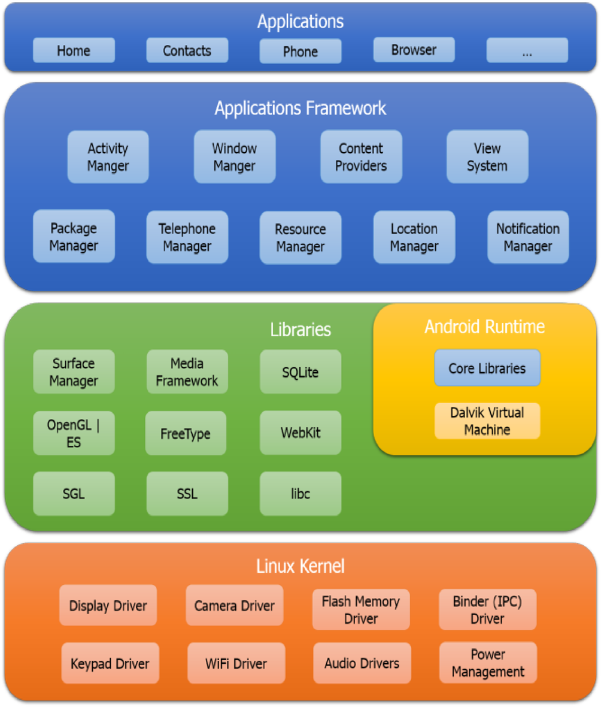

Figure 3.1: Android Architecture Reprinted from androidhavies.com

The layer which is use by different Android system components. Developers fallow the available libraries in framework of Application. Developer use these libraries for common tasks or reuse system functions for their own purpose. The layer four of this architecture is the Android Runtime. Dalvik virtual machine is use by android as Java uses virtual machine to provide environment to application on runtime. It is a special software which create new processes independently for android application.

Linux kernel is the last and fifth layer in android architecture. Linux kernel’s Linux version 2.6 is use by the android. It is used for memory management, power management software, file system access, networking, inter process communication, security settings and several drivers for hardware. The Kernel hides the hardware from the user of software.

#### 3.2 Life Cycle of Android Application

An Activity in Android can exist in four states as described below: In android an activity could be use in four states as written and shown in figure 3.2

**3.2.1 Active and Running state**

In this state the activity runs in front and shows focus on it. It user uses actively and observable completely.

**3.2.2 Paused state**

In this state, the program is partly observable to the user but it is not visible to user and unfocused. This happen when some other activity is running which doesn’t cover up the whole screen or having some clearness so that the partly visible activity is the original Activity. The activity which paused activity is entirely alive and keeps its state but it can be stop by task manager where we have an option to clear currently running applications.

#### 

Figure 3.2: Android Application Life Cycle reprinted from strawflower.com

**3.2.3 Stopped state**

When the main screen not showing the activity is called stopped state. It completely unclear the view and running another activity. In this stopped state also the activity running in background and uses resources like memory etc, but it can be stop by task manager where we have an option to clear currently running applications.

**3.2.4 Destroyed/Dead state**

When a running application is no more in memory called a dead/destroyed state. May be the application is not started or after starting the application is cleared from memory to save memory resources. The figure 3.2 below shows the android activity life cycle flow chart. It need be studied by

the developers as it`s an important state. Life cycle of an android application can be shown as under.

above Life cycle of an android application flow figure can be explained as under:

• On starting of an Activity in Android smartphone, it calls the onCreate() function. In this time it initializes the data essentials and creates User Interface.

• onStart() function is called even user have not seen the activity yet. The activity is still stopped so we should know why.

• With the onResume() function, user can interact with activity and can see it on screen. In activity stack the position of activity will be at the top. Now the application is in running state and inputs can receives from the user.

• When it is in the Active state, onPause() function could be accessed the application is ready to resume when the user presses the home button or one other activity is running on the top of this one.

• One activity or notification is on top of it doesn’t totally unclear the visibility of actual activity. The smartphone goes to sleep.

The activity could goes to paused state in below three conditions: The user resumes the Activity by closing the new Activity or notification and the paused Activity gets Active/Runs as calling onResume() functions. If the battery is totally low condition then it gets killed. Then it is not possible to call any other functions beforedestroying the Activity and it required to be run again from the starting by getting onCreate() and restoring the last configuration from the bundle object. Otherwise it calls onStop() function to move it to stop state.When the user presses back button this action is performed by default. or it resumes on the top by totally covering by a new activity.

• In stopped state there could be three distinct cases as under:

To free the memory resources the OS could kill: An activity under stopped sate is more probably to be clear from the memory by the system than one in the paused state. It needs to start the restart again with onCreate(). It get start again by calling onRestart() , onStart() and onResume() functions properly if the user presses back button to the Activity again. In this scenario, the User Interface is on its place and it is not necessary to restart. onDestroy() function is called and the Activity is dead/destroyed. This is the final function we can call before the Activity is dead. This happen in two cases: 1. The Activity is completed the its job. 2. The application is temporarily cleated to save the memory space.

#### 3.3 Android Versions and Its latest comparison

An important aspect of Android operating system is its different versions. These version are improving and providing new services to users. As the smartphones’ hardware improving and capable to provide

more services the Android operating system also side by side improves itself. The latest usage comparison is as under.

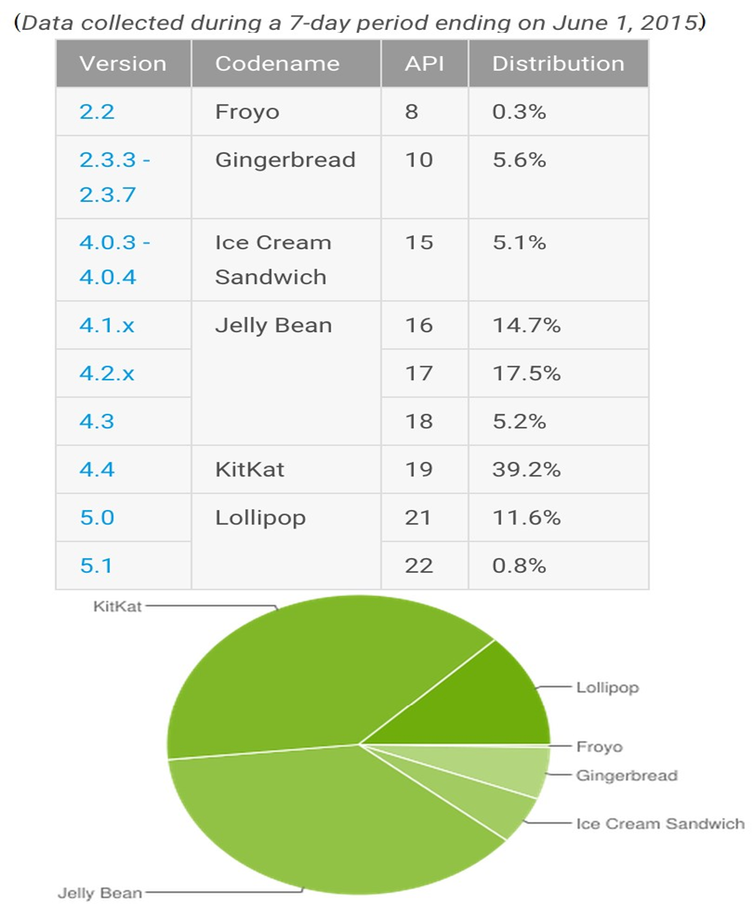

Figure 3.3: Android Versions and It`s latest comparison (Picture Reprinted from PhonDroid.com)

**3.4 Project Contribution**

The actual contribution by this project is to show a comprehensive understanding and realization of tour guide on the android operating system as new developmental platform. Now we can see many examples of tour guide on other platforms such as Windows Mobile, IPhone etc. However, there are no any tour guides. This project encapsulated basic features of tour guide such as showing Google maps, locating user`s location, getting information of tourist spots, basic information, showing different routes by directions, and choose off-line information about different facilitates like hospitals, shopping centers, banks, restaurants, car rentals, checking about the latest weather conditions, keep in touch on social networking and looking for nearby places on the map. This project have seven main parts as under

**3.4.1 Direction**

This activity fetch Google maps and give the user opportunity to select location and find distances among the places. It uses Google’s direction API to complete this tasks. It also shows source to destination path of tourist by drawing lines. It also shows users current location by using GPS coordinates. It requires Internet and GPS enabled.

**3.4.2 Locations**

It`s an important part of this application which shows location like hospitals, banks , restaurants, atm booths, and many other location offline.

**3.4.3 Nearby Places**

Google have its another important API called Google places API which detects current coordinates of tourist andaccording to its location shows nearby places it helps users to locate nearby places.

#### 3.4.4 Weather

This part can show to the tourist latest weather updates. It shows hourly, daily and weekly weather forecast to facilitate the user of this guide.

**3.4.5 Map Marker Information**

This option shows the map and customize markers which shows the required information about a location. A picture and some text briefly describes a location on the map.

**3.4.6 Moments**

Nowadays the role of social networking is obvious, so people capture their every moment to upload it social networking and make their moment special. Here tourist can take their picture and save it with the current dates and other descriptions.

**3.4.7 Expense**

This is the important part for the tourists, because every tourist make their own budget for traveling and most of the time they spent it more from their budget. Also they forget later where they spent more cost. So here expense help them to memories all budget and exact amount. Tourist actually here add every expense with the title and amount.

**3.5 Fundamentals of Application**

This component of application shows key aspects of application development. It consists of four parts. Services, receivers, content providers, activity and broadcast. An android application may contain one or many of these components types.

• **Activity** shows interfaces for user that the users will use it for communication.in short messaging component,one activity shows the user interface to users for writing a short message to others. Activities are entirely written by extending Activity main( base) class.

• **Services** do not run in background and user interface is not exits. If we play a music in background. Service extends Service base class.

• **Broadcast Receivers** this part receives and give reaction to broadcast announcements. If it shows the battery is low, it necessary to convey this message to mobile users. The receivers extend Broadcast Receiver base class.

• **Content Provider** this part provides data and stores it. It extends Content Provider base class but applications do not call directly to the methods in Content Provider, in place of this they call methods in the object Content Resolver, which call Content Provider.

The following technique is used by android for retrieving and storing the data. Network, database, files and preferences

The Android API contains support for creating and using SQLite databases. Each database is private to the application that creates it. The SQLiteDatabase object represents a database and has methods for interacting with it by creating the database, making queries and managing the data.

**3.6 Development of Software**

The development of Software is start with a software process. The software model shows how a developer can develop a software and which approach is better to develop a particular software application. The model which I have selected is Rapid Application Development (RAD) model. The main reason to select the model is that the RAD model not emphasis on planning tasks and emphasis on application development. It is flexible model. In other models like water fall is rigid and it is necessary to know detailed plan about the software development. I was new in the Android Software Development so I was blank about to develop this application. In this model we can built prototype of software demonstrates it, refine it until the required application goals meet. Then we deploy it.

**3.7 Summary of Guide**

All the snap shots and other details shows the activities, along with the navigational and location based services given to the user. The icons shows different links to the application’s functionality of the tour guide. The first activity provide a user main menu where they can choose different options. The other activities would result in the listing of the said functionalities on the location and coordinate basis which the user has requested for and also they can fulfill their guidance needs by giving the criteria. The application provide different kinds of information for tourist like Markers information, Images, Maps, and text information in their smartphones.

**CHAPTER 4**

**DESIGN SPECIFICATION**

**4.1 Front-end Design:**The screenshots below show the main project view. Capture an image of what you see on your mobile screen and how use it

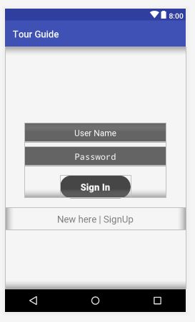

Figure 4.1: front-end Design

This application Staring sign up then another user conduct with us by the userName and password from Sign page .Be careful don’t forgot userName and password. The high tech skill required to architect, develop, and maintain your app on front end platforms. You’ll want a team that explores all real, and leaves no stone unturned for your business and development needs; a team that helps to investigates total our business needs and future aspirations to enable your app to bloom into its fullest potential.

### 4.1.2: XML Design and Functionality

Home pages create design demo TextView, Button and so long.

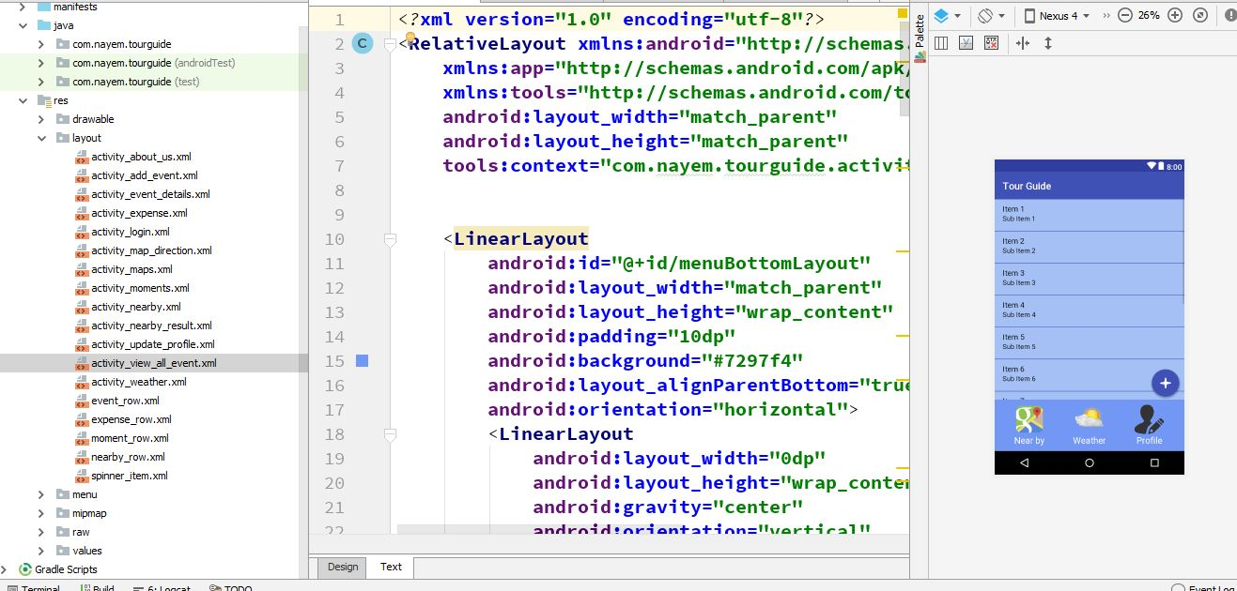

Figure 4.2: XML from home page.

The Layout Editor is particularly intense when assembling another format with ConstraintLayout—a design director gave in a help library that is good with Android 2.3 (API level 9) and higher.

#### 4.2 Back-end Design:

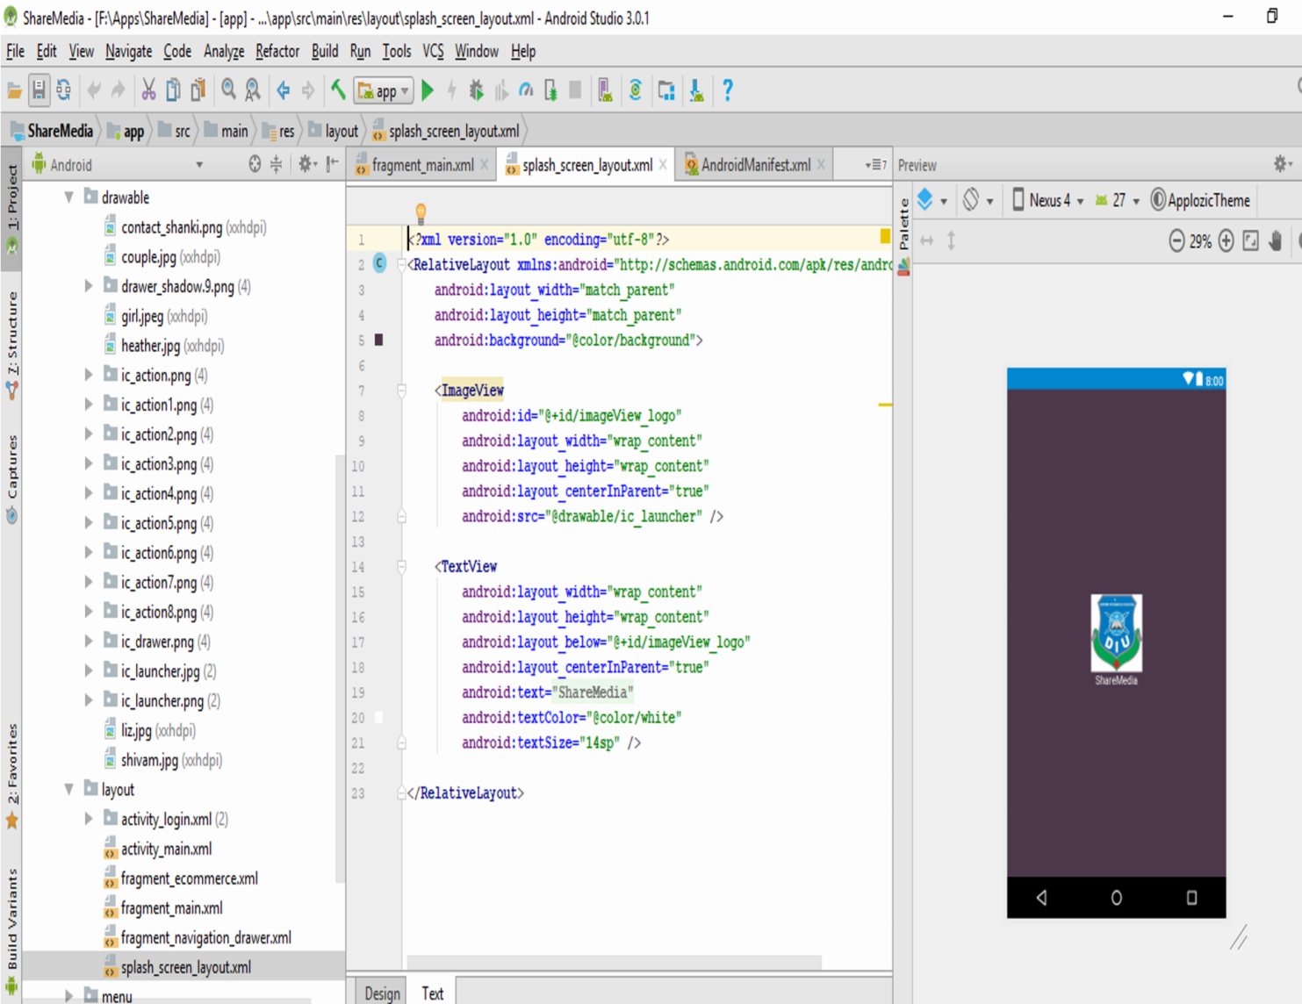

Figure 4.3: Application demo set logo

In the Layout Editor, you can rapidly construct formats by dragging UI components into a visual plan proofreader as opposed to composing the design XML by hand. The outline proofreader can review your format on various Android gadgets and variants, and you can progressively resize the design to make certain it functions admirably on various screen sizes.

##### 4.2.1 Menu Bar Set

The following accounts menu page. Create by xml helping source android developer web page [3].

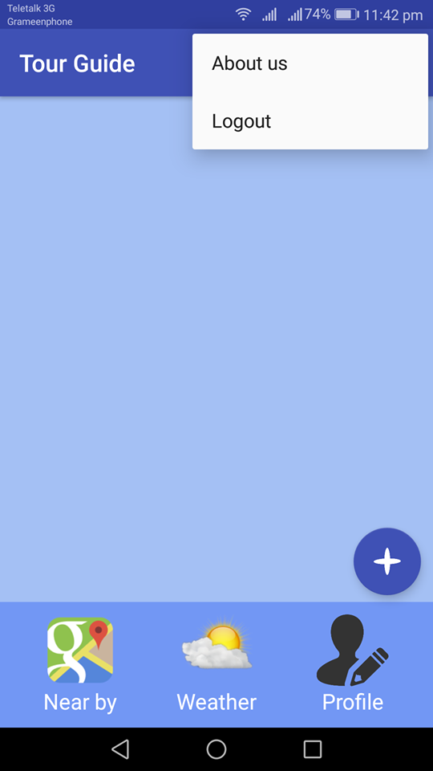

Figure: 4.4: Menu Bar set.

The Layout Editor is particularly intense when assembling another format with ConstraintLayout—a design director gave in a help library that is good with Android

2.3 (API level 9) and higher.

#### 4.3 UI Design and Functionality

The following Login and home page. Layout and activity connect find by id. Then calculation valid email matching password. UserId user admin page permission.

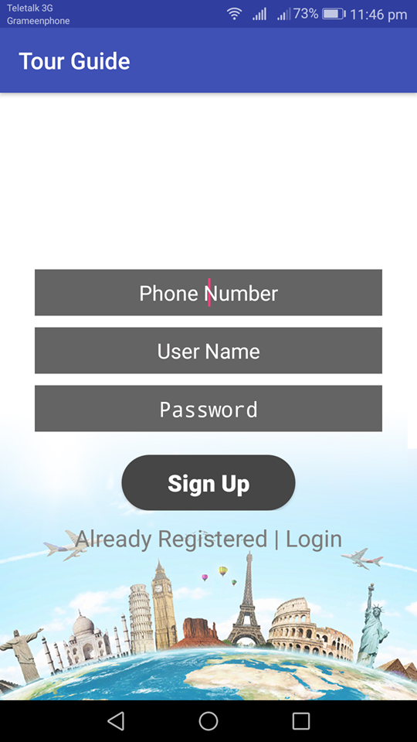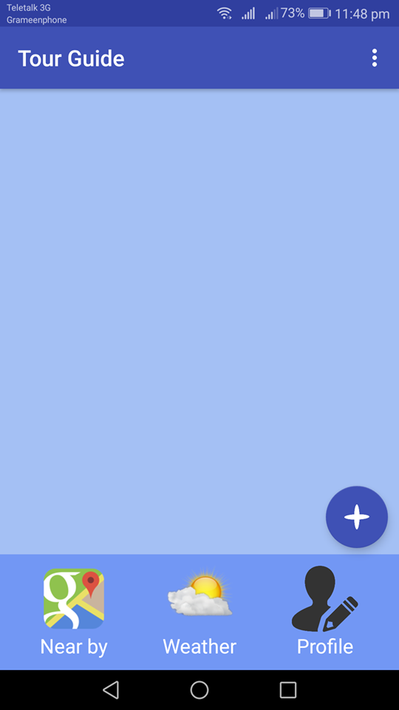

Figure 4.5: application login/sign up and Home page

This application Staring sign up then another user conduct with us by the userName, Phone number and password from Sign page. If valid email and password sign in or sign up then access the application for this account [5].

##### 4.3.1 XML Design and Functionality

Here is demo of Add New Event. User can add travel description, estimated budget, travel beginning date to comeback date. It’s depending on user base.

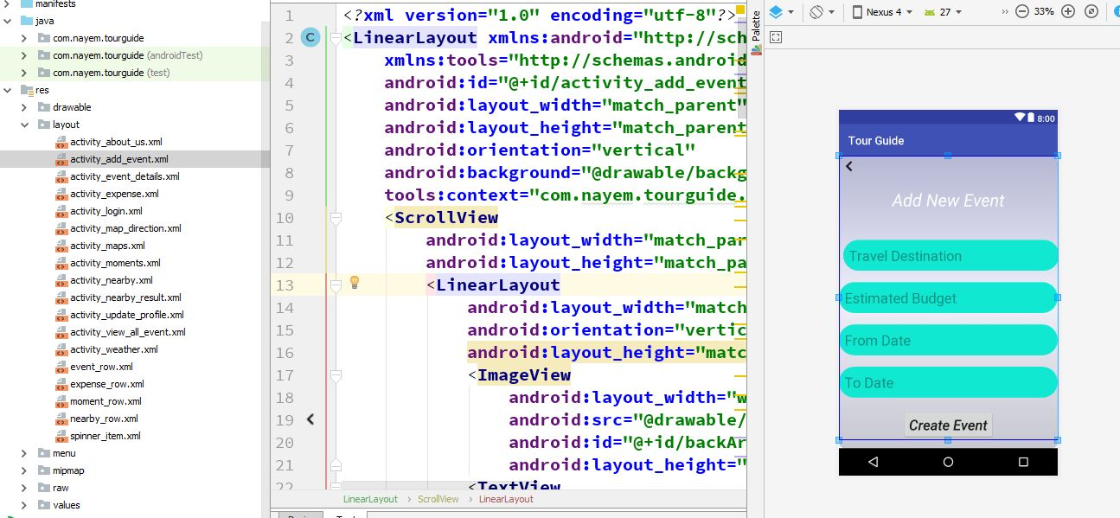

Figure 4.6: Add New Event

### 4.3.2: Update & Delete Event

Tourist can update their event before their traveling. They can change the location, budget, and traveling time. Tourist can also delete the event.

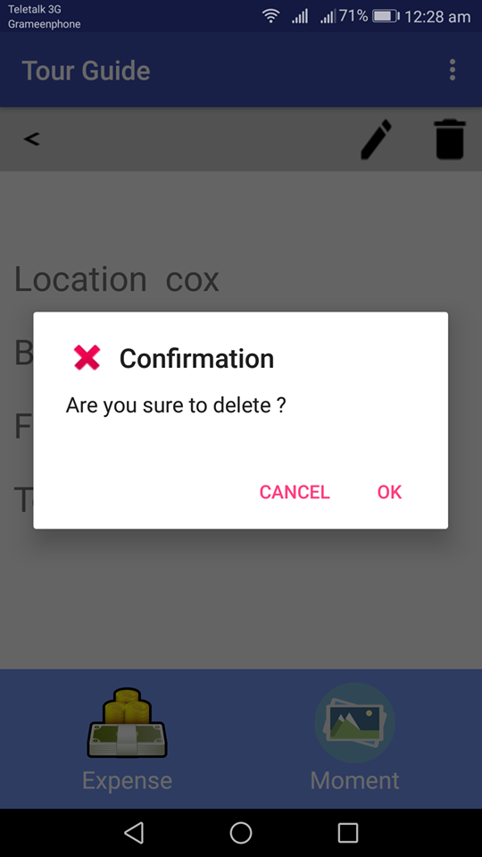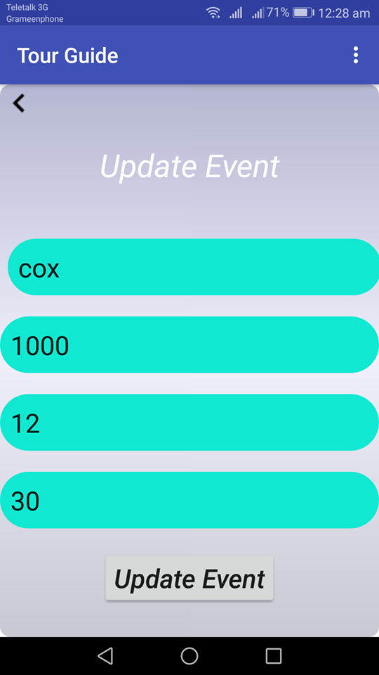

Figure 4.7**:** Update & Delete Event

##### 4.3.3 NearBy Places and default Maps

##### 

Figure 4.8:NearBy Places and default maps**.**

Tourist can search their nearby restaurant, cafe, hospital and using google maps and can get the exact location of every places. Here a demo of nearby hospitals, we can see so many hospitals which are located from my exact location. Here also a google map which helps to search the exact location to the tourists.

##### 4.3.4 Moment:

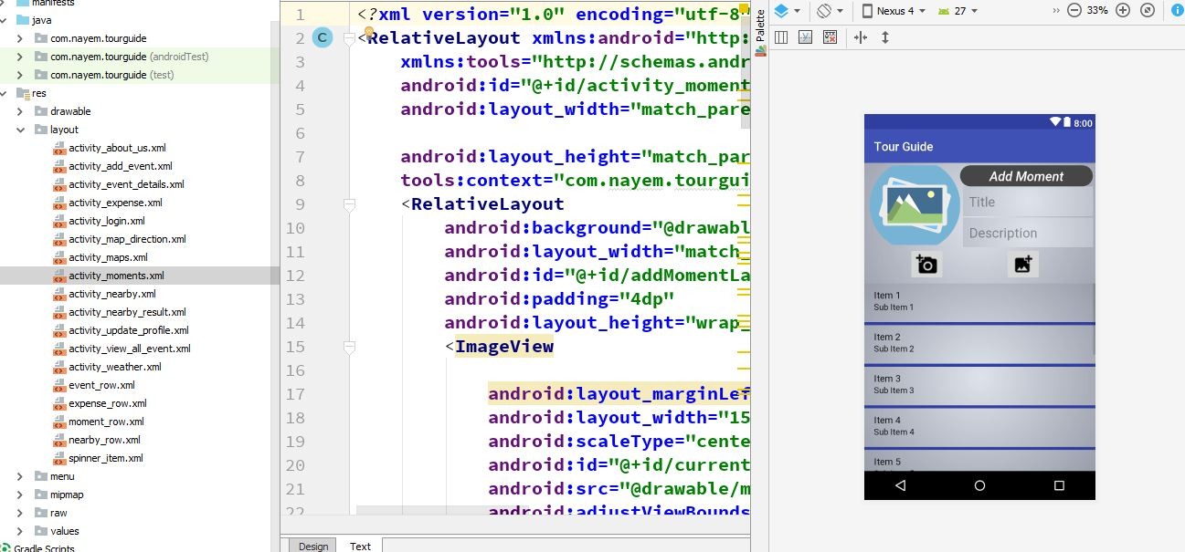

Figure 4.9: Moment

Here the tourist can capture their pictures and save them with date and description. It helps them to upload their beautiful capture with exact date.

##### 4.3.5 Expense:

The user can all expenses with adding title and amount.

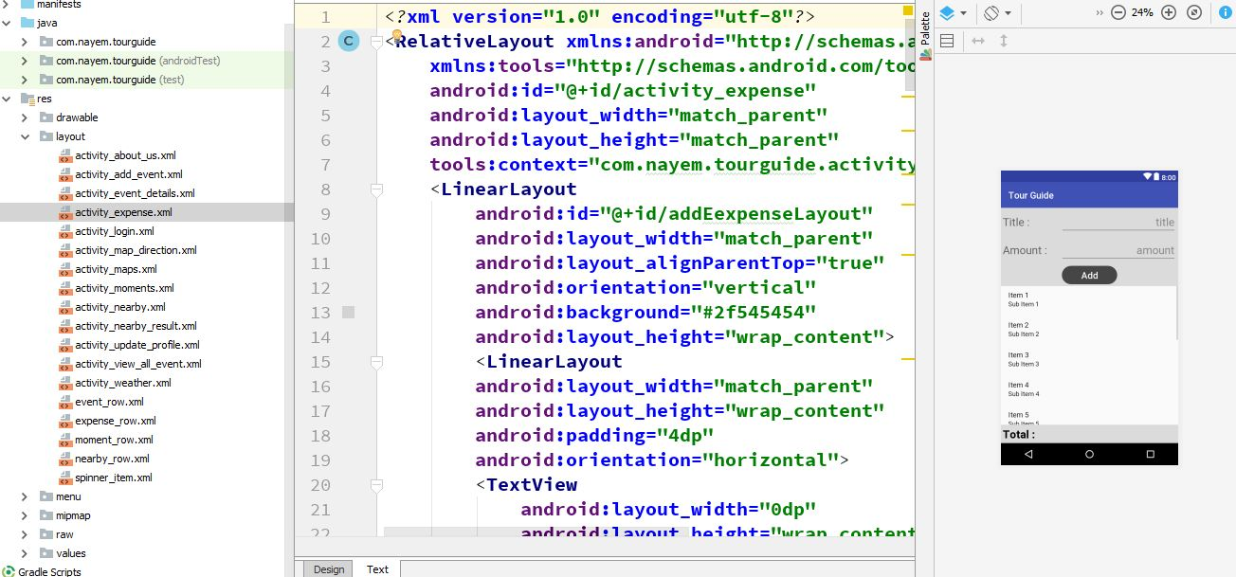

Figure 4.10: Expense

##### 4.3.6 Weather

Here tourist can show the current weather before traveling. But if the internet connection off this portion will not work.

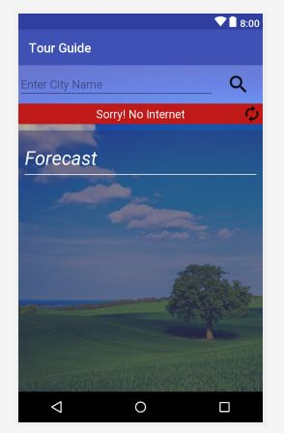

Figure 4.11: Weather

**CHAPTER 5**

**CONCLUSION & FUTURE SCOPE**

#### 5.1 Conclusion

The tour guide application is an important tool for a traveler.Most of the traditional methods are time consuming and required skilled human resources who supposed to guide the tourist in field. The main purpose of the proposed project is to ensuring to save the time of tourist, provide proper guidance and

directions to the tourist.

The tour guide system provides an easy to use menu where user can select different buttons according their needs. The selects directions, locations, distances and some other options according to their needs. The user can use these services using Internet, Global Positioning Systems (GPS) and Google maps. The Google maps are interactive so the user easily locate the places and the map draws a line to show proper direction. Theselines helps to reach the destination. The user can also get latest

weather forecast information.

This tour guide uses latest maps which can display locations on the basis of latitude and longitude provided by users.

#### 5.2 Future Scope

* Adding Google street view

The proposed system shows pictures and images of a location but we can show three dimensional images of the place using Google Street view map API. It helps the user a to see the location on every angle. Which is definitely helpful to make any decision regarding that location and clear visualization of the location.

* Off line version

In future the proposed system could be converted into off line version. Then this guide will be more helpful for the tourist who do not have access to Internet facility. Making it off line will increase its storage but it could be compromised as the tourist will be more benefits.

I hope that this project will helpful for other students and developers to understand Android programming, Java language and XML. In their research they will use Android application development and they will use it and make more enhancements in future research by identifying more research topics in these directions.

### Scope for further developments

|  |  |
| --- | --- |
|  | To make the system less time consuming. |
|  | This project is not effective in remote areas with limitation of internet. |
|  | Application user demand |
|  | Internet update version. |
|  | Currently have to facility to play store apps. |

#### 5.3 Limitation

After evaluating our project, we have found some areas that are kept under special consideration and still need to work on. The phrases that we have developed so far are not real time interactive. Therefore, it might not be that meaningful to the target users (foreigners) as it`s not helping them in real time conversation through language translation. Another issue is that we are not keeping track of the user`s current location through GPS location tracker. Here in our system, a user has to provide his current location and destination to the map which is not that efficient. Furthermore, there may be different number of local buses around the city which information the user doesn`t know but really need to know so that he/she can have the idea of local buses going to different routes.

**REFERENCES**

1. Application Maps: <https://developers.google.com/maps/documentation/android-api/start>
2. Android Studio and SDK: <http://developer.android.com/sdk/index.html>[last Accessed Mar 10th 2018]
3. Java JDK: <http://www.oracle.com/technetwork/java/javase/downloads/index.html>[last Accessed Mar 20th, 2018]
4. About use case [https://www.lucidchart.com/documents/edit/3fd0666a-48e6-4276-b21703b6c5ff9050/0](https://www.lucidchart.com/documents/edit/3fd0666a-48e6-4276-b217-03b6c5ff9050/0)

[3]Android XML: <https://developer.android.com/guide/topics/resources/complex-xml-resources>[last Accessed JAN 20th 2018]

1. Android API15 Samples: <http://developer.android.com/samples/index.html>[last Accessed Mar 05th 2018]
2. Android Activities Demos: [https://android.googlesource.com/platform/development/+/master/samples/ApiDemos/src/com/exampl e/android/apis/app/FragmentRetainInstance.java](https://android.googlesource.com/platform/development/+/master/samples/ApiDemos/src/com/example/android/apis/app/FragmentRetainInstance.java)[last Accessed JAN 20th 2018]
3. Firebase Database: https://firebase.google.com/docs/storage/android/create-reference [last Accessed JAN 20th 2018]
4. Android Plug-ins: <http://developer.android.com/tools/help/adt.html>[last Accessed Mar 20th 2017]
5. About the mobile app: <https://en.wikipedia.org/wiki/Mobile_app>[last Access JAN 20th 2017]
6. Android market share: https://www.idc.com/promo/smartphone-market-share/os [last access JAN 20th 2017]

Plagiarism Check:

