**TEXT, FACE, AND OBJECT DETECTION USING MACHINE LEARNING**

**BY**

**RAFIKUL ISLAM KHAN**

**ID: 153-15-6423**

**MOHAMMAD MASUM BILLAH**

**ID: 153-15-6415**

**SHUVASHISH SARKER**

**ID: 141-15-3177**

This Report Presented in Partial Fulfillment of the Requirements for the Degree of Bachelor of Science in Computer Science and Engineering

Supervised By

**Ms. Most. HASNA HENA**

Senior Lecturer

Department of CSE

Daffodil International University



**DAFFODIL INTERNATIONAL UNIVERSITY**

**DHAKA, BANGLADESH**

**OCTOBER 2019**

**APPROVAL**

This Project titled **“TEXT, FACE AND OBJECT DETECTION USING MACHINE LEARNING**”, submitted by Mohammad Masum Billah, Rafikul Islam Khanand Shuvashis Sarkerto the Department of Computer Science and Engineering, Daffodil International University, has been accepted as satisfactory for the partial fulfillment of the requirements for the degree of B.Sc. in Computer Science and Engineering (BSc) and approved as to its style and contents.

**BOARD OF EXAMINERS**

**Dr. Sayed Akhter Hossain**

**Professor and Head Chairman**

Department of CSE

Faculty of Science & Information Technology

Daffodil International University

**Dr. Sheak Rashed Haider Noori Internal Examiner**

**Associate Professor and Associate Head**

Department of CSE

Faculty of Science & Information Technology

Daffodil International University

**(Name) External Examiner**

**Designation**

Department of -------

University

**DECLARATION**

We hereby declare that, this project has been done by us under the supervision of **Ms. Most. HASNA HENA,** Senior Lecturer**, Department of CSE** Daffodil International University. We also declare that neither this project nor any part of this project has been submitted elsewhere for award of any degree or diploma.

**Supervised by:**

**Ms. Most. HASNA HENA**

Senior Lecturer

Department of CSE

Daffodil International University

**Submitted by:**

**MOHAMMAD MASUM BILLAH**

ID: 153-15-6415

Department of CSE

Daffodil International University

**RAFIKUL ISLAM KHAN**

ID: 153-15-6423

Department of CSE

Daffodil International University

**SHUVASHISH SARKER**

ID: 141-15-3177

Department of CSE

Daffodil International University

**ACKNOWLEDGEMENT**

First, we express our heartiest thanks and gratefulness to almighty God for His divine blessing makes us possible to complete the final year project/internship successfully.

We really grateful and wish our profound our indebtedness to **Ms. Most. HASNA HENA** Senior Lecturer Department of CSE Daffodil International University, Dhaka. Deep Knowledge & keen interest of our supervisor to carry out this project. Her endless patience, scholarly guidance, continual encouragement, constant and energetic supervision, constructive criticism, valuable advice, reading many inferior drafts and correcting them at all stage have made it possible to complete this project

We would like to express our heartiest gratitude to Ms. Most. Hasna Hena, Senior Lecturer, Syed Akhter Hossain,Head**,** Department of CSE, for his kind help to finish our project and also to other faculty member and the staff of CSE department of Daffodil International University.

We would like to thank our entire course mate in Daffodil International University, who took part in this discuss while completing the course work.

Finally, we must acknowledge with due respect the constant support and patients of our parents.

**ABSTRACT**

This report is a intend to guideline for the user to recognize text & translate the text into any language as well as facial recognition, detecting products by using smartphone camera view finder & more from an image and also predict information of an user like age, happiness percentage & gender by detecting facial landmarks. The purpose of this project is to develop a user-friendly android mobile application that will help to understand and interact with what’s in our camera’s viewfinder. Because the smartphone camera won’t just see what we see, but will also understand what we see to help us take action. So, with that thought why don’t make a mobile application that can perform smart action with the help of our smartphone camera. Well, to achieve this purpose we have to use toolkit and languages like Android Studio, Machine learning kit, java etc.

**TABLE OF CONTENTS**

**CONTENTS PAGE**

Board of examiners X

Declaration X

Acknowledgments X

Abstract X

List of figures X

List of Tables X

**CHAPTER**

**CHAPTER 1: INTRODUCTION X**

* 1. Introduction
  2. Motivation
  3. Objectives
  4. Expected Outcome
  5. Report Layout

**CHAPTER 2: BACKGROUND X**

* 1. Introduction
  2. Related Work
  3. Comparative Studies
  4. Scope of Problems
  5. Challenges

**CHAPTER 3: REQUIRMENT SPECIFICAITON X**

* 1. Business Process Modeling
  2. Requirement Collection and Analysis
  3. Use Case Modeling and Description
  4. Logical Data Model
  5. Design Requirements

**CHAPTER 4: DESIGN SPECIFICATION X**

* 1. Front-end Design
  2. Back-end Design
  3. Interaction Design and UX
  4. Implementation Requirements

**CHAPTER 5: IMPLEMENTATION AND TESTING X**

* 1. Implementation of Database
  2. Implementation of Front-end Design
  3. Implementation of Interactions
  4. Testing Implementation
  5. Test Result and Reports

**CHAPTER 6: CONCLUSION AND FUTURE SCOPE X**

* 1. Discussion and Conclusion
  2. Scope for Further Developments

**REFERENCES X**

**APPENDICHES X**

**CHAPTER 1**

**INTRODUCTION**

* 1. **Introduction**

Smartphones are more advanced than ever. They’re packed with tons of features, like front- and rear-facing cameras, heart rate monitors, fingerprint screen lock, and access to apps galore.

There’s no denying it, from the moment we get up to the moment we go to bed, we’re all glued to our smartphones. A new work email. A new Facebook notification. The weather app tells us a storm is on the way. There’s always another reason to pick up our phones because they do so much.

* 1. **Motivation**

Smartphone is the most widely used mobile technology right now. We can’t think live without a smartphone. It became a part of our day to day life. We do a lot of day to day activities with our smartphone. We all have one in our pocket and that has cameras. Typically, with camera all we do is take photos, videos or make video calls etc. but a smartphones camera can do a lot more than that. The smartphone camera won’t just see what we see, but will also understand what we see to help us take action. With that thought why don’t make a mobile application that can perform smart action with the help of our smartphone camera.

* 1. **Objectives**

The objective of our project is to develop a user-friendly android mobile application that will help to understand and interact with what’s in our camera’s viewfinder such as.

### Text Recognition

* Detecting the text from an image. It can be used for photos of signs, labels, documents and so on. It can be useful for many cases like detecting text from an image and make a copy of that text.

### Image Labeling

* Taking an image, and detecting entities it contains, such as objects, animals, fruits, activities and more.

### Face Detection

* Not to be confused with face recognition, which can recognize who is the person in the image, or knowing that we see the same person on multiple photos. This is about detecting face features, their position on the screen, their angle, whether the mouth is smiling and so on.

### Barcode Scanning

* Read data encoded using most standard barcode formats.
* Respond intelligently when a user scans a barcode.

Language Identification

* Identify a language based on the user input.
  1. **Expected Outcome**

To design and develop a smart user-friendly application that will help a user to recognize text from an image, copy that text & translate the text into any language. Identifying objects from an image. Identify key facial features. Getting encoded data from barcodes by scanning using most standard barcode formats.

* 1. **Report Layout**

**Chapter 1: Introduction**

In this chapter we’ve discussed about the motivation of ours for doing this project and also objectives and expected outcome of the project.

**Chapter 2: Background**

In this chapter we’ve discussed about the related work application and comparative studies between our developed application and existing related application as well as the problems and challenges that we’ve faced.

**Chapter 3: Requirements Specification**

In this chapter, we’ve discussed about the business process model that we followed, requirement collection and analysis with use case modeling and description and logical data model based on our application.

**Chapter 4: Design Specification**

In this chapter, we’ve discussed about the design of our application with proper front-end and back-end description.

**Chapter 5: Specification and Testing**

In this chapter, we’ve discussed about the Implementation of our application and testing as well as the testing results.

**Chapter 6: Conclusion and Future Scope**

We’ve discussed the conclusion and the scope for further development.

**CHAPTER 2**

**BACKGROUND**

**2.1 Introduction**

Machine Learning has started to reshape how we live, everything around us nowadays has a touch of ML in it, so has mobile applications. Google has re-introduced Firebase with the support of some ready to use machine learning models like — Text recognition, Face detection, Image labeling, and more and support to implement custom models using TensorFlow Lite for iOS, Android and Web apps.

In our application Firebase ml kit is the core part. ML Kit comes with a set of ready-to-use APIs for common mobile use cases: recognizing text, detecting faces, identifying landmarks, scanning barcodes, labeling images, and identifying the language of text.

**2.2 Related Work**

Our developed application is based on Google’s own firebase machine learning kit which was first introduced in google I/O 2018. After researching about related work we found only “**Google Lens**” which matches with our developed application.

**2.2.1 Google Lens [1]**

[Google Lens](https://lens.google.com/) is one of the newest additions to the world of AI services. Introduced in 2017 at Google I/O, Google Lens is an image recognition mobile app that can tell you about an object, landmark, or product by scanning it through a lens.

**2.3 Comparative Studies**

Our developed application is lite, so simple and easy to use. In the above “Related Work” section we discussed about Google Lens which can work only when the device has an internet connection but in our developed application it can work without internet connection, everything is on device. Beside that we implemented feature like face detection, Language identification which aren’t available on the google lens as the time of writing this.

**2.4 Scope of Problems**

As we wanted to make an application by which a user can interact with what’s in our mobile device cameras viewfinder. Our developed application working principle is dependent on the device camera. Considering that these are the problems we can face while using the application.

* Camera hardware of the device may cause problems or false identification.
* If the captured image quality is not good enough the result may not be accurate.

**2.4 Requirements**

While working on a project selecting the appropriate properties for building the project is important. In this chapter we will discuss about the requirements that followed for our application.

**2.4.1 Android Platform**

When it comes down to mobile app development platforms, it is mainly about the clash of two big tech clans – Android (powered by Google) and iOS (engineered by Apple). Google and Apple both have entirely different ways of running the platforms, and vary greatly from each other in terms of restrictions, costs, and functionality. However, the market share statistics hugely favor Android application development.

There is no denying that the community of Android developers is well-established. Android has more than 300 carriers, software, and hardware partners, who can help you build your app with ease and push it in the right business direction. Unlike other platforms, Android application developers often work together on an open platform and share their app development knowledge, experience and skills with each other during the app development process.

An open platform like Android is always better because any programmer can work on it, irrespective their technical expertise (with the right logins of course). The Software Development Kit for Android application development, also known as Android SDK, can be downloaded anytime along with Eclipse, Android’s official Integrated Development Environment (IDK).

With a few efforts and skills on the part of Android application developers, a business app can be ready within hours. What comes in striking contrast to other platforms here is that all these Android tools come for free. This means that you get not only great and functional app but save on operational cost too.

Android Studio has also been remarkably revamped by Google with cutting-edge tools, functionalities, and features. Some of the latest highlights include:

* Live visual editing guide for coders
* Availability of lint tools for version control, performance, and usability
* Good integration capability with Google Cloud
* Remarkable ability to generate APK files
* Editing purview running on multiple screens
* App layout rendering in real-time
* Building variants

Android application developers use Java for software programming, which is highly regarded among global enterprises for its widening scope and user-friendliness. Unlike other platforms, you will get multiple software development frameworks with Android with varying capacities that can promptly address your changing business demands, whenever you need it.

And there’s more to it. Popular frameworks pertaining to Java and Android also render support to Linux hardware and related tools, which can help you explore various advantages of such open source platforms.

**2.4.2 IDE (Android Studio)**

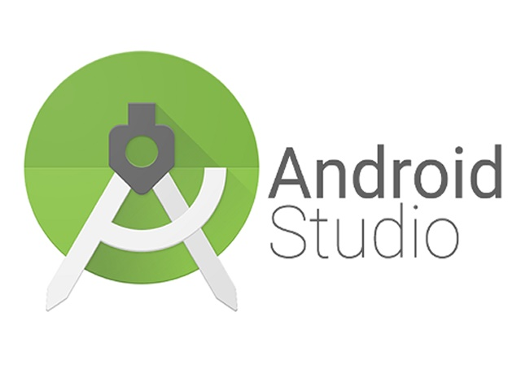

Android Studio is the official integrated development environment ([IDE](https://searchsoftwarequality.techtarget.com/definition/integrated-development-environment)) for Android application development. It is based on the [IntelliJ IDEA](https://www.theserverside.com/definition/IntellJ-IDEA), a [Java](https://www.theserverside.com/definition/Java) integrated development environment for software, and incorporates its code editing and developer tools.

To support application development within the Android operating system, Android Studio uses a Gradle-based build system, [emulator](https://whatis.techtarget.com/definition/emulator), code templates, and [GitHub](https://searchitoperations.techtarget.com/definition/GitHub) integration. Every project in Android Studio has one or more modalities with source code and resource files. These modalities include Android app modules, Library modules, and Google App Engine modules.

Android Studio uses an Instant Push feature to push code and resource changes to a running application. A code editor assists the developer with writing code and offering code completion, refraction, and analysis. Applications built in Android Studio are then compiled into the [APK format](https://whatis.techtarget.com/definition/APK-file-Android-Package-Kit-file-format) for submission to the Google Play Store.

The software was first announced at Google I/O in May 2013, and the first stable build was released in December 2014. Android Studio is available for Mac, Windows, and Linux desktop platforms. It replaced Eclipse Android Development Tools (ADT) as the primary IDE for Android application development. Android Studio and the Software Development Kit can be downloaded [directly from Google](https://developer.android.com/studio/).

**2.4.3 Firebase**

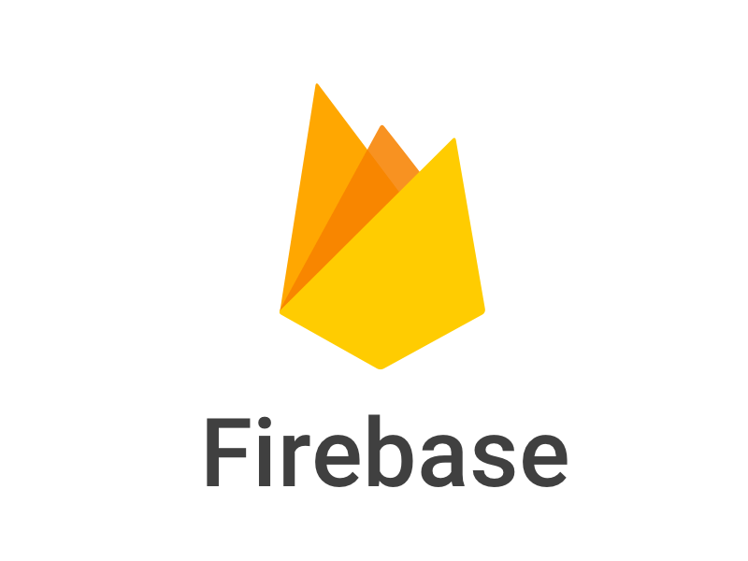

Firebase is a back-end service that your app can interact with. It has a lot of features such as Real-time database, User Authentication, File Storage and much more.

With Firebase, we do not have to create database schema up front because Firebase is very flexible to make changes to the schema as we progress with our application.

As our application evolves over the period of time, it’s recommended to build an app with Firebase and change a schema simultaneously based on the requirements.

Firebase let you query data from the real-time database which is completely different than traditional SQL queries.

### **Realtime Database**

The Firebase Realtime Database is a cloud-hosted NoSQL database that lets you store and sync between your users in Realtime. The Realtime Database is really just one big JSON object that the developers can manage in Realtime. Realtime syncing makes it easy for your users to access their data from any device, be it web or mobile. Realtime Database also helps your users collaborate with one another.

Another amazing benefit of Realtime Database is that it ships with mobile and web SDKs, allowing you to build your apps without the need for servers.

When your users go offline, the Realtime Database SDKs use local cache on the device to serve and store changes. When the device comes online, the local data is automatically synchronized.

The Realtime Database can also integrate with Firebase Authentication to provide a simple and intuitive authentication process.

* **Better Scalability**

Though Firebase’s Realtime Database is capable of scaling, things will start to get crazy when your app becomes really popular or if your database becomes really massive.

Cloud Firebase is based on Googles Cloud infrastructure. This allows it to scale much more easily and to a greater capacity than the Realtime Database.

**2.4.4 Machine Learning**

Machine learning is

* Considered as a sub-field of Artificial intelligence
* Involves learning models which allow the program to make predictions on data
* More than just a list of instructions which clearly defines what the algorithmic should do
* Closely linked to computational statistics, which uses computers to make predictions

The third option here probably needs some explaining. A key difference between a regular algorithm and a machine learning algorithm is the “learning” model which allows the algorithm to learn from the data and make its own decisions. This allows machines to perform tasks which are otherwise are impossible for it to perform. Such tasks can be as simple as recognizing human handwriting or as complex as self-driving cars!

For example, say an algorithm is supposed to correctly distinguish between a male and a female face from ID-card photos.

**Input**

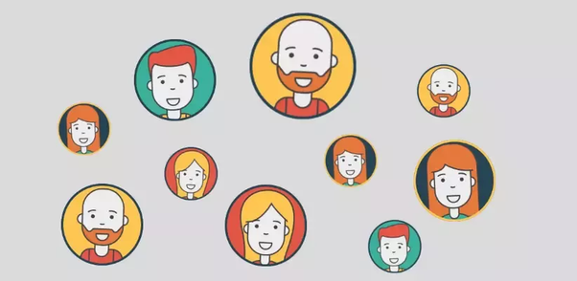

A machine learning (ML) algorithm would be trained on a training data to ‘learn’ to recognize any face. Where a simple algorithm would not be capable of performing this task, a ML also would not only be able to categorize the photos as trained, it would continuously learn from testing data and add to its “learning” to become more accurate in its predictions! Recall how often Facebook prompts you to tag right the person in the picture! Among billions of users, Facebook ML algorithms are able to correctly match different pictures of the same person and identify her!

**Output**

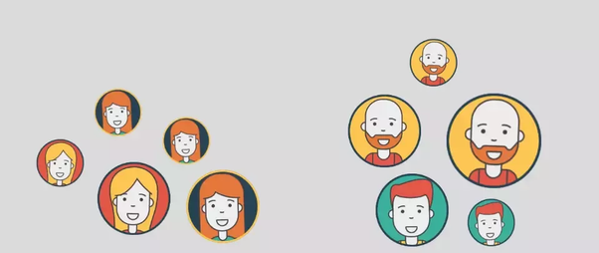

Machine learning is one of the most popular approaches in Artificial Intelligence. One of the key aspects of ML is the usage of new/continuous data to iterate and keep on learning. There are many key industries where ML is making a huge impact: Financial services, Delivery, Marketing and Sales, Health Care to name a few. It is expected that in a couple of decades the mechanical, repetitive tasks will be over. Machine learning and improvements in Artificial intelligence techniques have made impossible possible, from self-driving cars to computerized healers.

**Machine Learning Kit**



Google is providing a software development kit, called ML Kit, that offers the company’s machine learning technologies to developers building Android and iOS mobile apps. Featuring a set of base APIs to build machine learning into apps, ML Kit is now in public beta. It works with the [Firebase mobile development platform](https://www.infoworld.com/article/3197745/application-development/googles-firebase-taps-serverless-cloud-functions.html).

ML Kit’s base APIs cover:

* Barcode scanning, to scan and process barcodes.
* Text recognition.
* Face detection.
* Landmark detection, to identify popular landmarks.
* Image labeling, to identify objects, locations, activities, products, and animal species.

ML Kit acts as an API layer to custom models to make it easy to use these models. Developers can use their existing [TensorFlow Lite](https://www.infoworld.com/article/3197413/artificial-intelligence/heres-how-google-is-preparing-android-for-the-ai-laden-future.html) models with ML Kit. By being linked to Firebase, developers can experiment with different machine learning models using A/B testing. Google is also releasing an experimental model compression flow to reduce model sizes.

**2.5 Challenges**

As our motive of making this application user friendly, easy to use and lite weight. These are the challenges

* Building a user-friendly user interface.
* Easy to operate.
* Run smoothly on device with low configuration.

**CHAPTER 3**

**REQUIREMENT SPECIFICATION**

**3 Introduction**

**“**Text, FACE, And Object Detection Using Machine Learning” is an application which will allow user to help understanding what’s in their mobile phones comer’s viewfinder by using the camera. A user simply just can open the application take a picture of a text documents and the application will help to recognize the text and will allow user to copy that following text or translate it to any language. The application also can help to read encoded barcode data, identify language, detect facial key feature and image leveling. As our project is based on Android platform. In this chapter of our report we will go through the discuss about the Requirement Specification of our application.

**3.1 Business Process Modeling**

**3.1.1 Development Method**

There are several methods which can support developing process of any project such as:

* Waterfall.
* Prototyping.
* Incremental development.
* Spiral development.
* Rapid application development.
* Agile software development.
* Object oriented.
* Top-down programming.
* Unified process.
* System testing.

But for our needs, Rapid application developing is suitable because part of it is prototyping and also system testing.

**3.2.2 Rapid Application Development Method**

Rapid application development is a form of Agile [software development methodology](https://blog.capterra.com/what-is-sdlc/). Unlike Waterfall methods, Rapid application development emphasizes working software and user feedback over strict planning and requirements recording.

In other words, Rapid application development is less talk, more action and testing.

While Rapid application development de-emphasizes strict planning, there are still a handful of steps or phases each development project goes through when using the rapid application development methodology, which we’ll discuss below.

It focuses on input-output source and destination of the information. It emphasizes on delivering projects in small pieces; the larger projects are divided into a series of smaller projects. The main features of RAD model are that it focuses on the reuse of templates, tools, processes, and code.

* Flexible and adaptable to changes.
* It is useful when you have to reduce the overall project risk.
* It is adaptable and flexible to changes.
* It is easier to transfer deliverables as scripts, high-level abstractions and intermediate codes are used.
* Due to code generators and code reuse, there is a reduction of manual coding.
* Due to prototyping in nature, there is a possibility of lesser defects.
* Each phase in RAD delivers highest priority functionality to client.
* With less people, productivity can be increased in short time.

**3.4 Use Case Model and Description**

This following Use Case Diagram shows the basic model of our application also the relation between user and functional model.

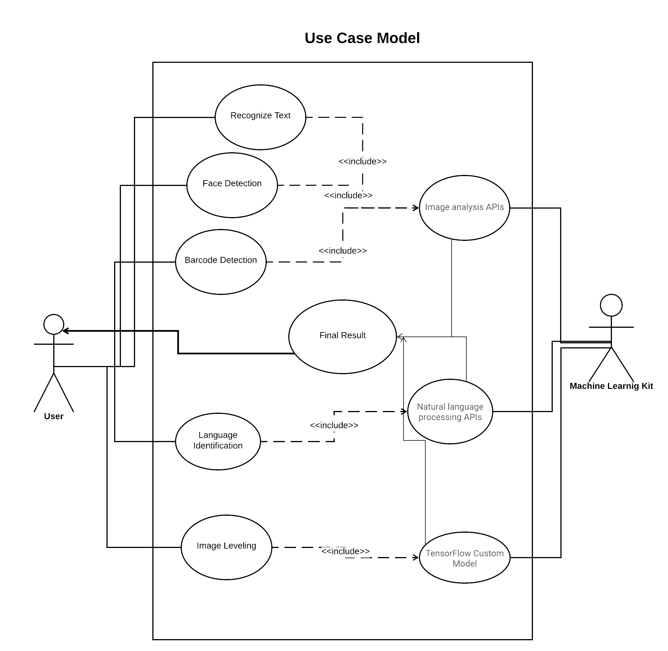

**Recognize Text**

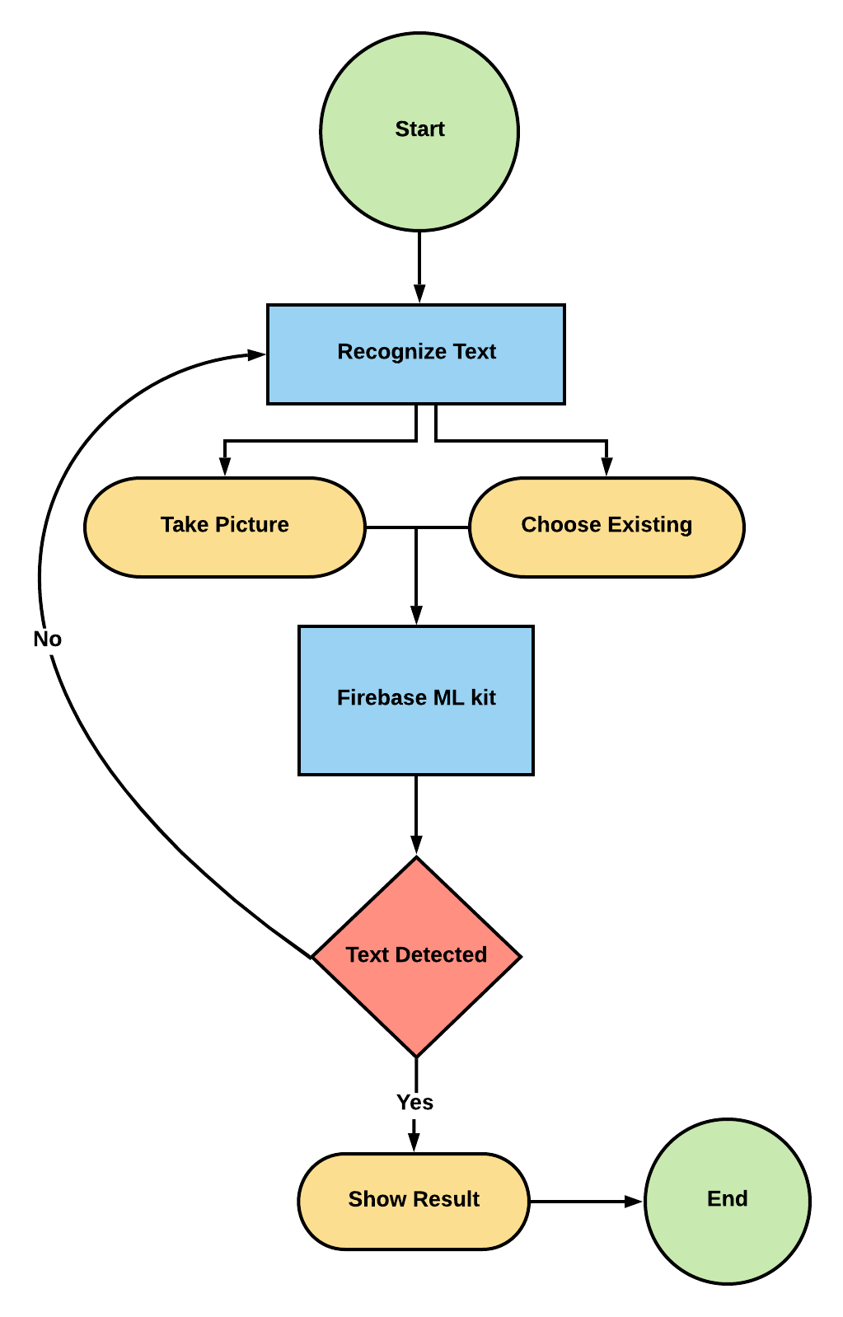

**Face Detection**

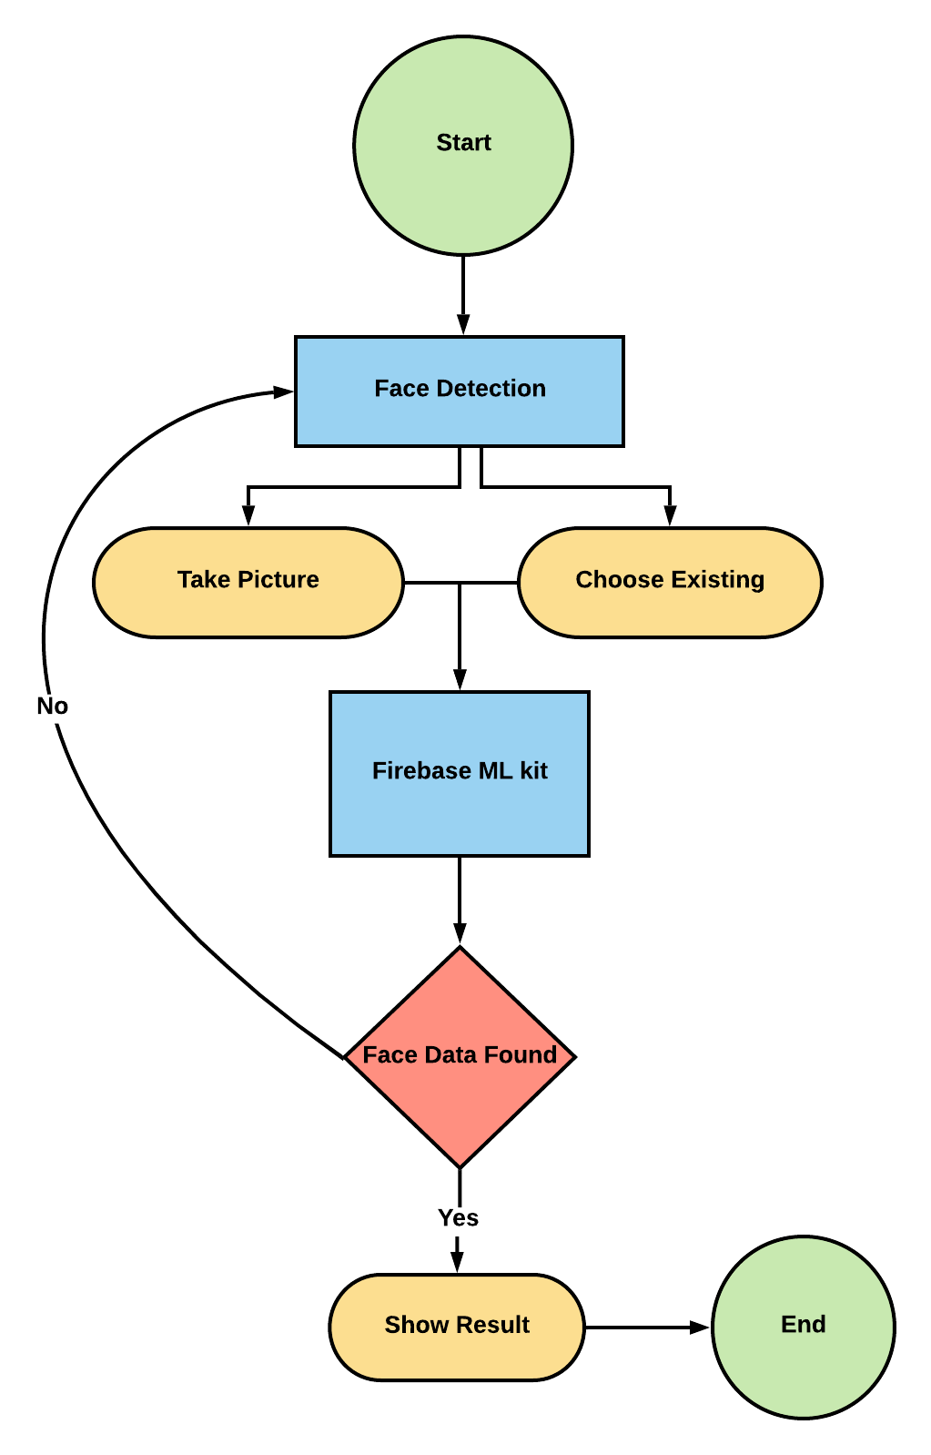

**Barcode Scanning**

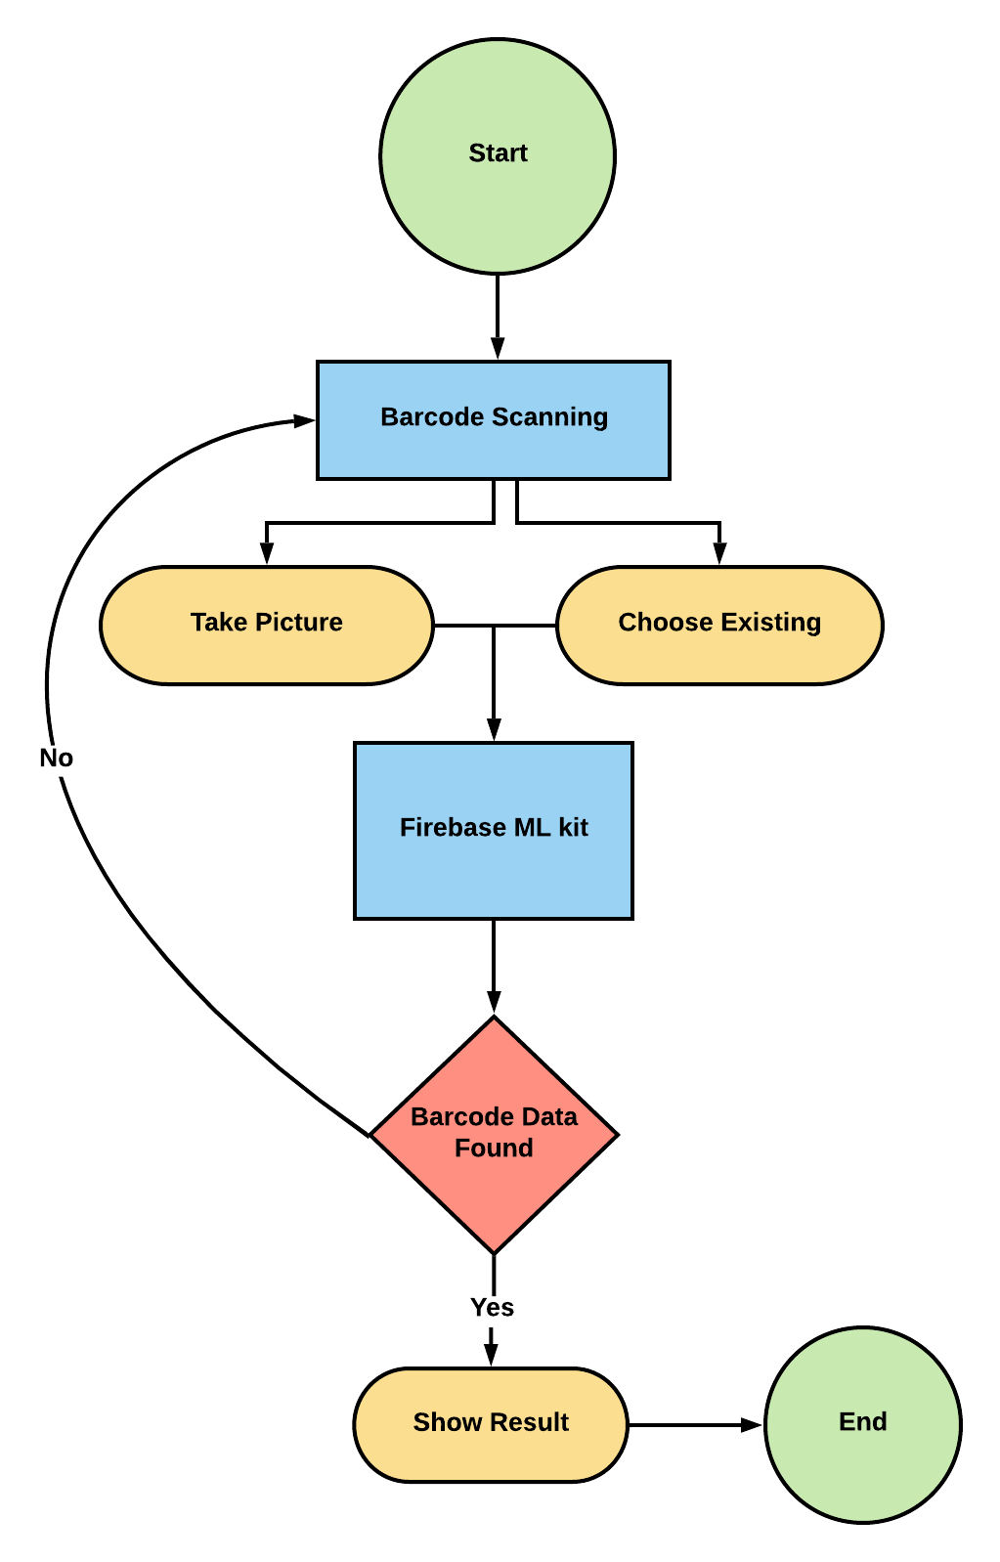

**Language Identification**

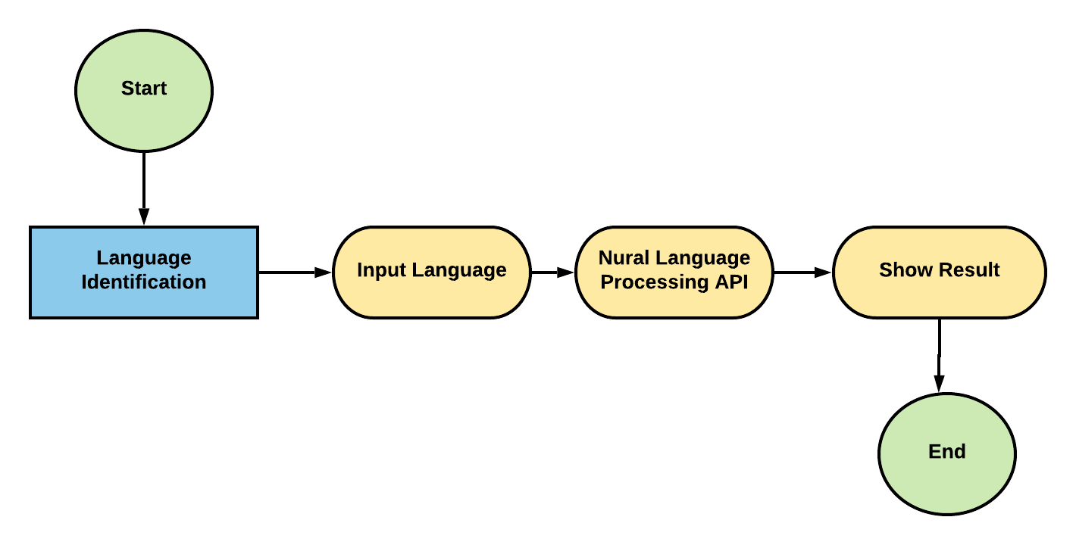

**Image Leveling**

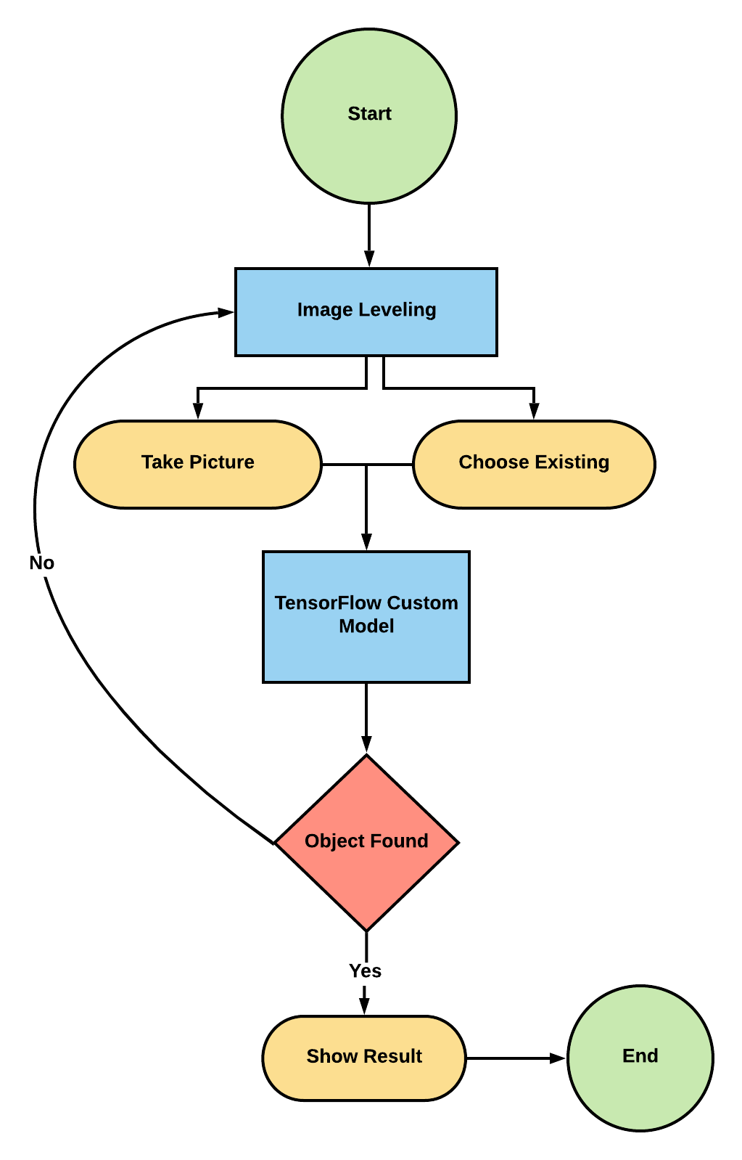

**3.5 Logical Data Model**

**3.6 Design Requirement**

As we are developing an Android Application, there is some requirements that we need to maintain in order to build our application.

* Software & IDE
* Android Studio
* Operating Systems (Windows / Mac / Linux)
* Programming Language & Framework
* Java
* Android XML
* Firebase
* Machine Learning Kit

**CHAPTER 4**

**Design Specification**

**4.1 Front-end Design**

Front-end design of an application is one of the most important and challenging part. While using an application a user generally depends on the front-end of that application to navigate throughout the user interface and use the functionality. Our main goal was to achieve while developing the Front-end portion of our application is to:

* Simple and easy to use user interface.
* Fast loading speed.
* Browser compatibility.
* Easy Functionality Features.

Tools that we are using for developing the font-end of our application is

* Android Studio.
* XML (extensible markup language).

**Reference**

**2.4.2** <https://www.hokuapps.com/blogs/5-reasons-to-choose-android-application-development-over-other-platforms/>

[2.4.2](https://www.hokuapps.com/blogs/5-reasons-to-choose-android-application-development-over-other-platforms/) <https://searchmobilecomputing.techtarget.com/definition/Android-Studio>

[2.4.4](https://searchmobilecomputing.techtarget.com/definition/Android-Studio) <https://www.quora.com/What-is-machine-learning-4>

[2.4.5](https://www.quora.com/What-is-machine-learning-4) <https://www.infoworld.com/article/3270731/ml-kit-google-brings-machine-learning-apis-to-mobile-developers.html>