**HOMEPAGE**

Registered users ( Examiners/ Students ) login to the TestRight from here ( Login ).

New visitors need to register to use the functionalities provided by the TestRight portal.

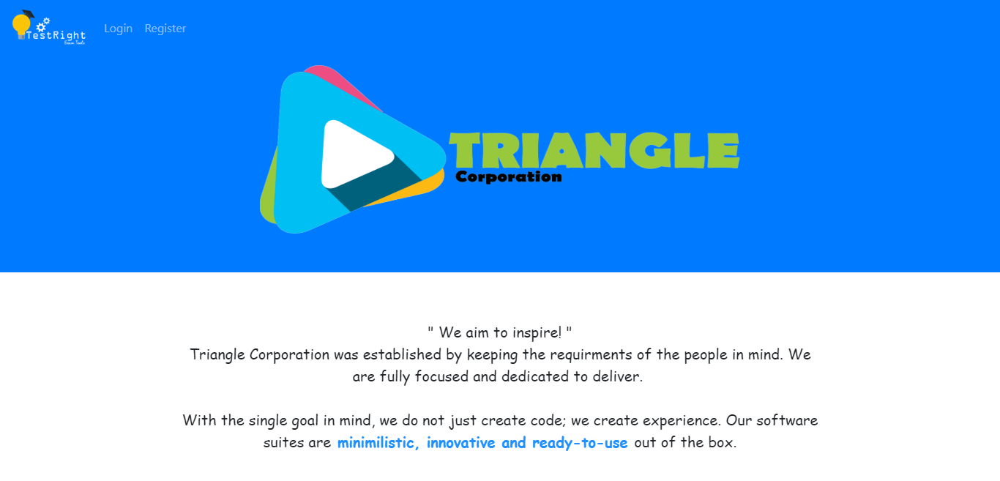

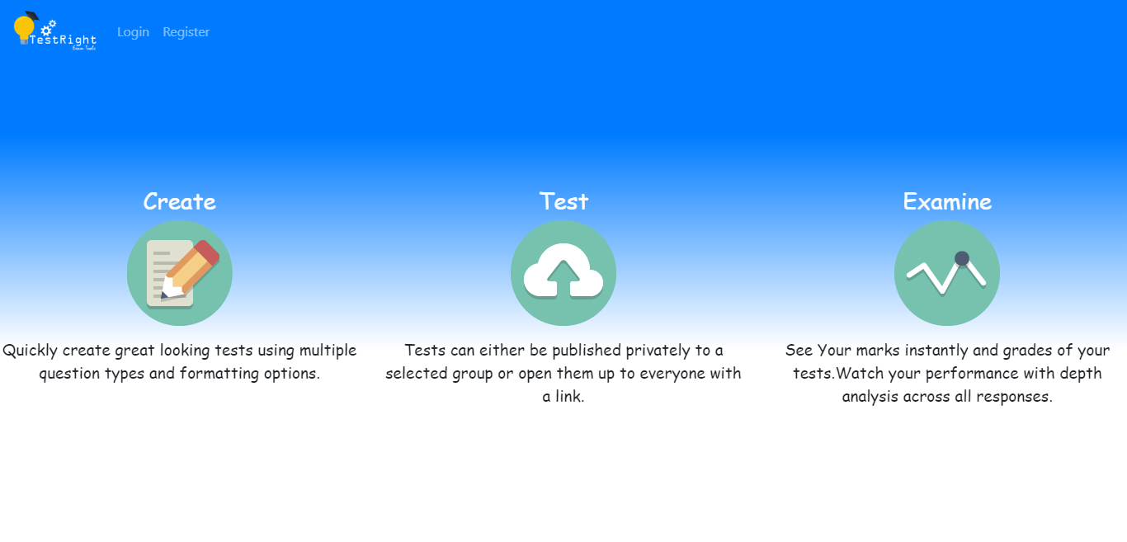

**REGISTRATION**

Two Types of users can register . They are **1. Examiner 2. Student**

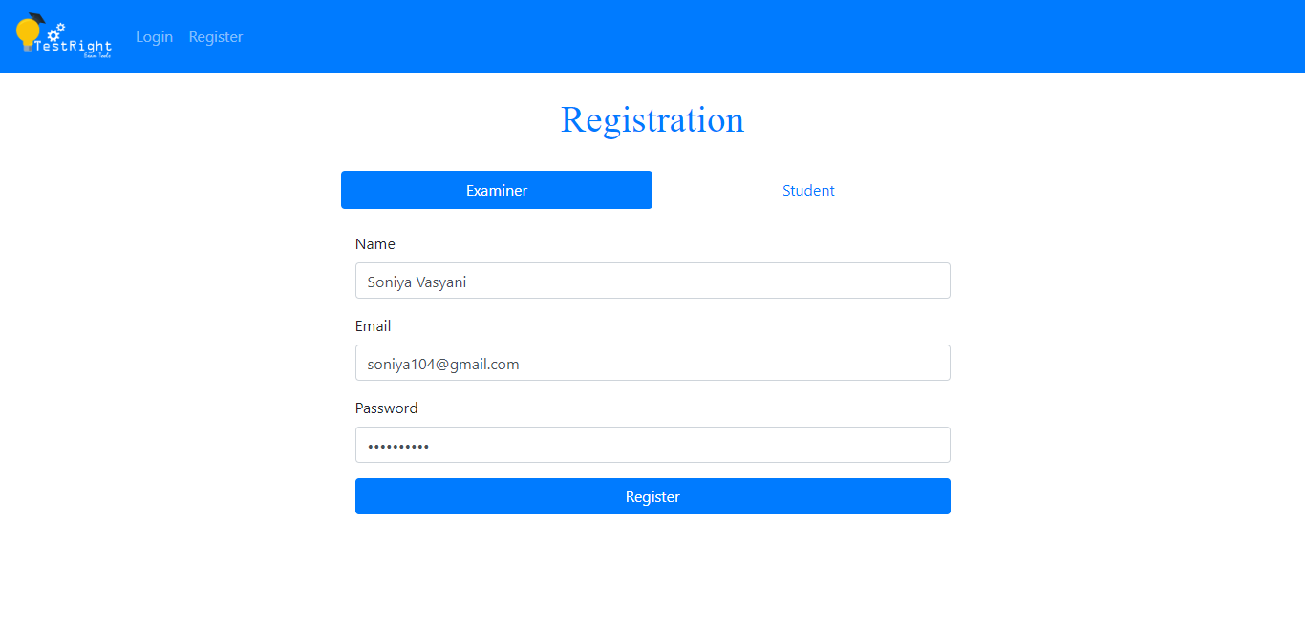

The user need to mention the email address as it will be unique for every user.

The user need to mention the username .

By clicking on the register button, the respective user will be successfully registered to the TestRight portal.

The user need to mention the password so that he/she can login to the portal by using the password.

**Login**

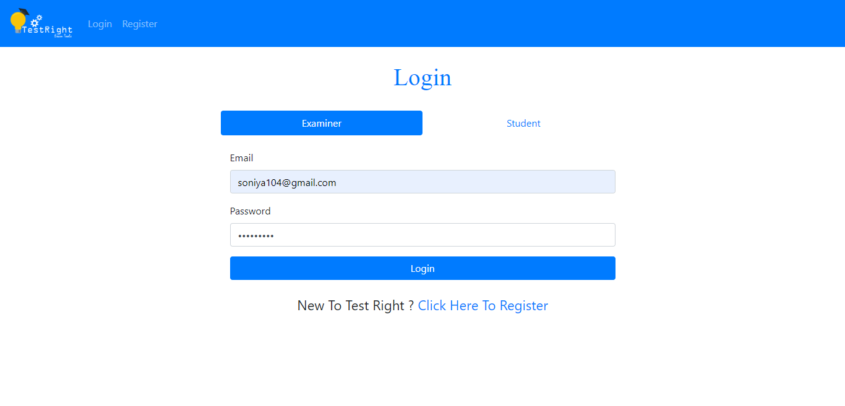

New users can click on this link to get themselves registered.

By clicking on login button, user will be login to the portal and can utilise the additional functionalities.

The examiner need to provide the correct password to successfully login to the portal.

The examiner need to provide the Email Id that had been mentioned during registration.

**CREATE TEST**

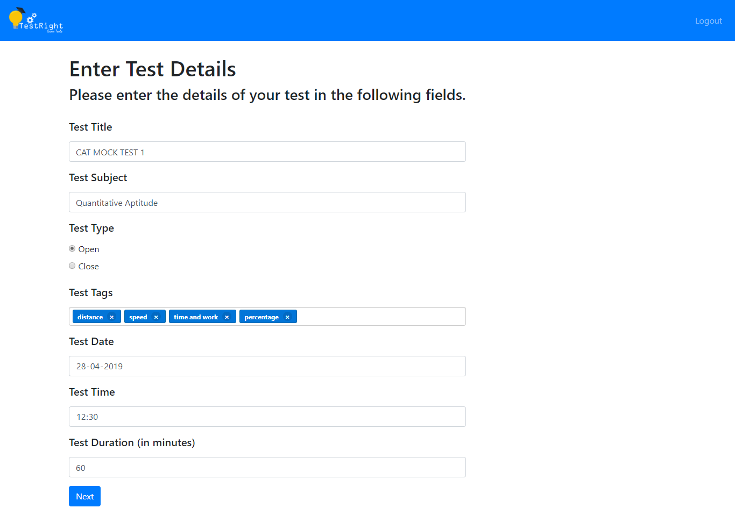

The examiner can create the test by providing the test details such as Test Title, Subject, Tags, Duration, Test Date, Test Time and Type.

By clicking on the **NEXT** button, the Add Questions page will be rendered where examiner can add Multiple Choice Questions for the specific test.

B

**Add QUESTIONS**

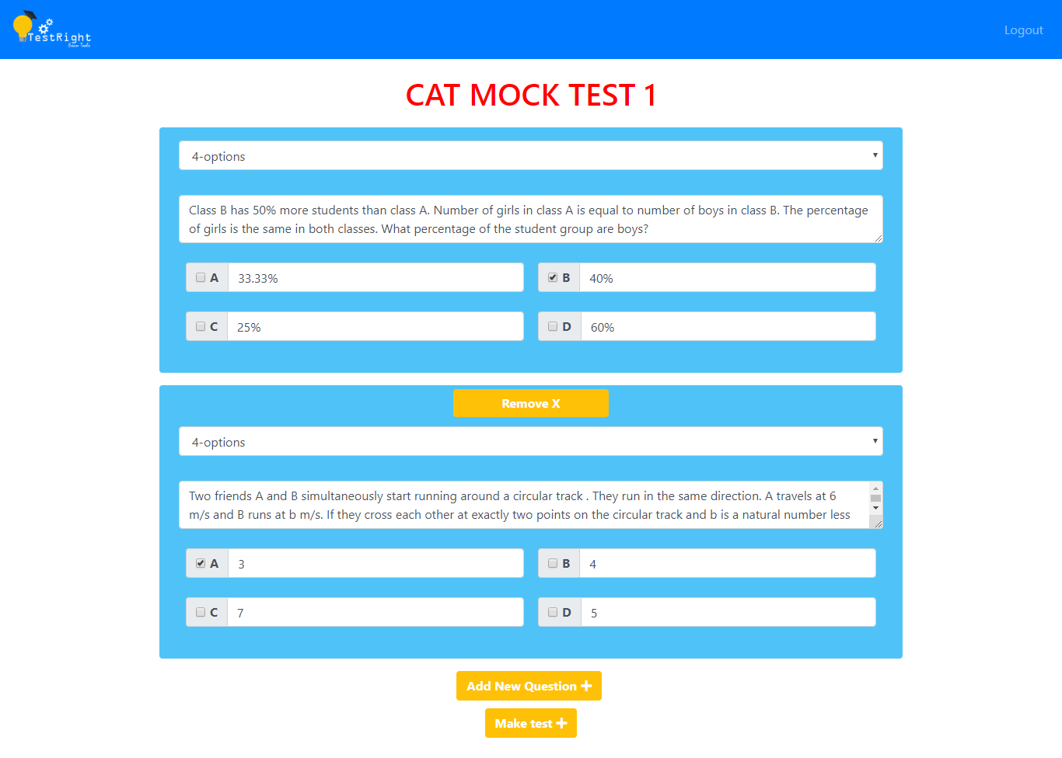

By clicking on **MAKE TEST** button, the test will be created and will be displayed on the **DASHBOARD**.

By clicking on **Add New Question** button, the examiner can add question to the respective test.

By clicking on **REMOVE** button, the respective question will be deleted from the respective test.

The examiner need to provide options among which one will be the correct answer.

The examiner need to mention the question.

The examiner can choose whether to provide 4 options or 2 options for the question.

**DASHBOARD**

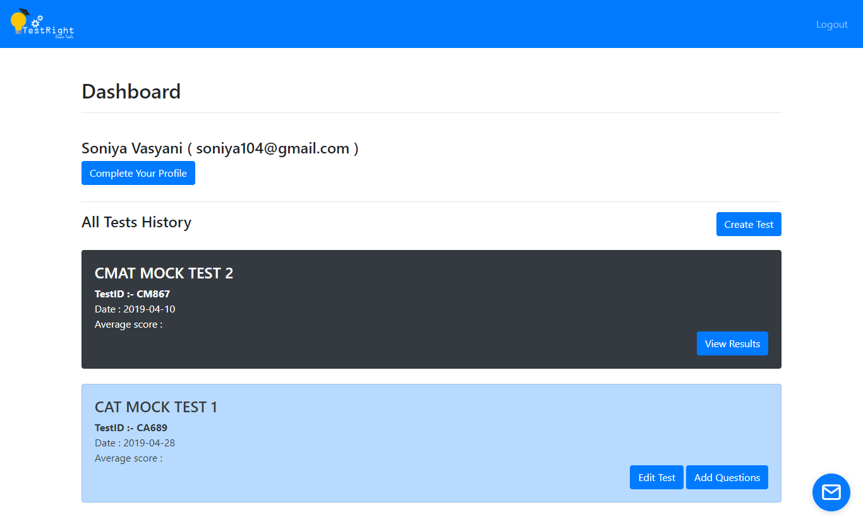

This button will provide the offline help form.

The examiner can view the results of the respective test.

The examiner can add more questions in the respective test.

The examiner can edit the test details such as modify the test start date and time, etc.

The upcoming tests will be displayed with blue background colour blue.

The test that had already been created by the examiner will be displayed here. The test that had been passed will be displayed with black background colour.

By clicking on **CREATE TEST**, the examiner can create new test.

By clicking on **COMPLETE YOUR PROFILE** button, the examiner can provide additional information such as Contact details, Institute Name, etc.

The Name and Email ID of the logged in user will be displayed here.

**COMPLETE YOUR PROFILE**

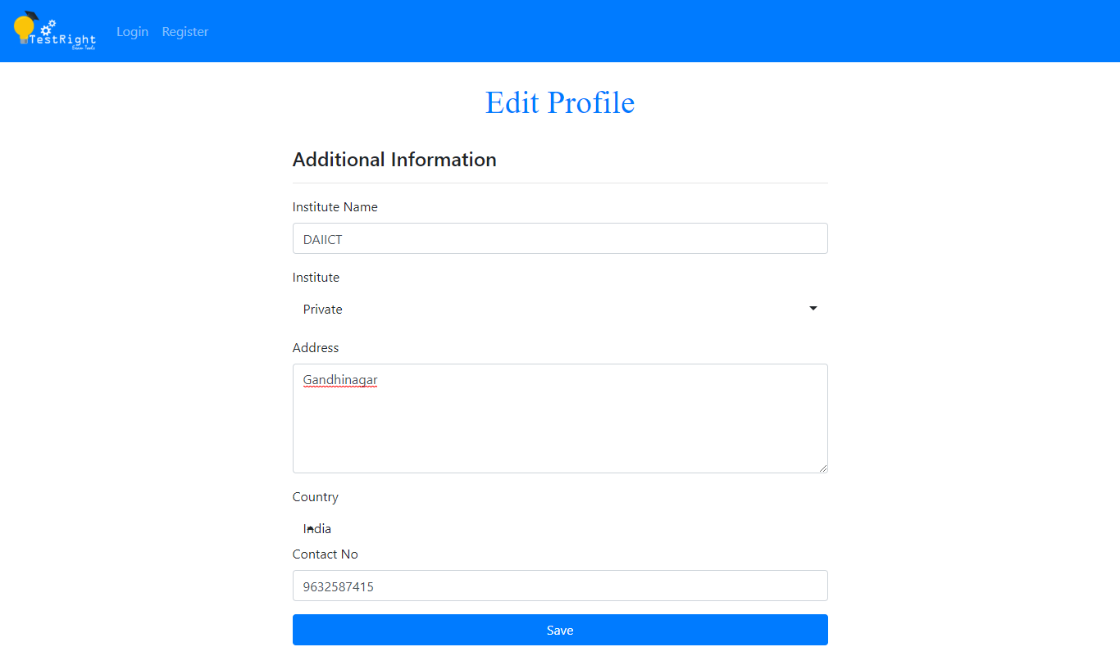

By clicking on the **SAVE** button, the examiner’s profile will be updated and will be displayed on the dashboard.

The examiner can complete the profile by providing the details such as Institute Name, Institute, Address, Country and Contact Number.

**EDIT PROFILE**

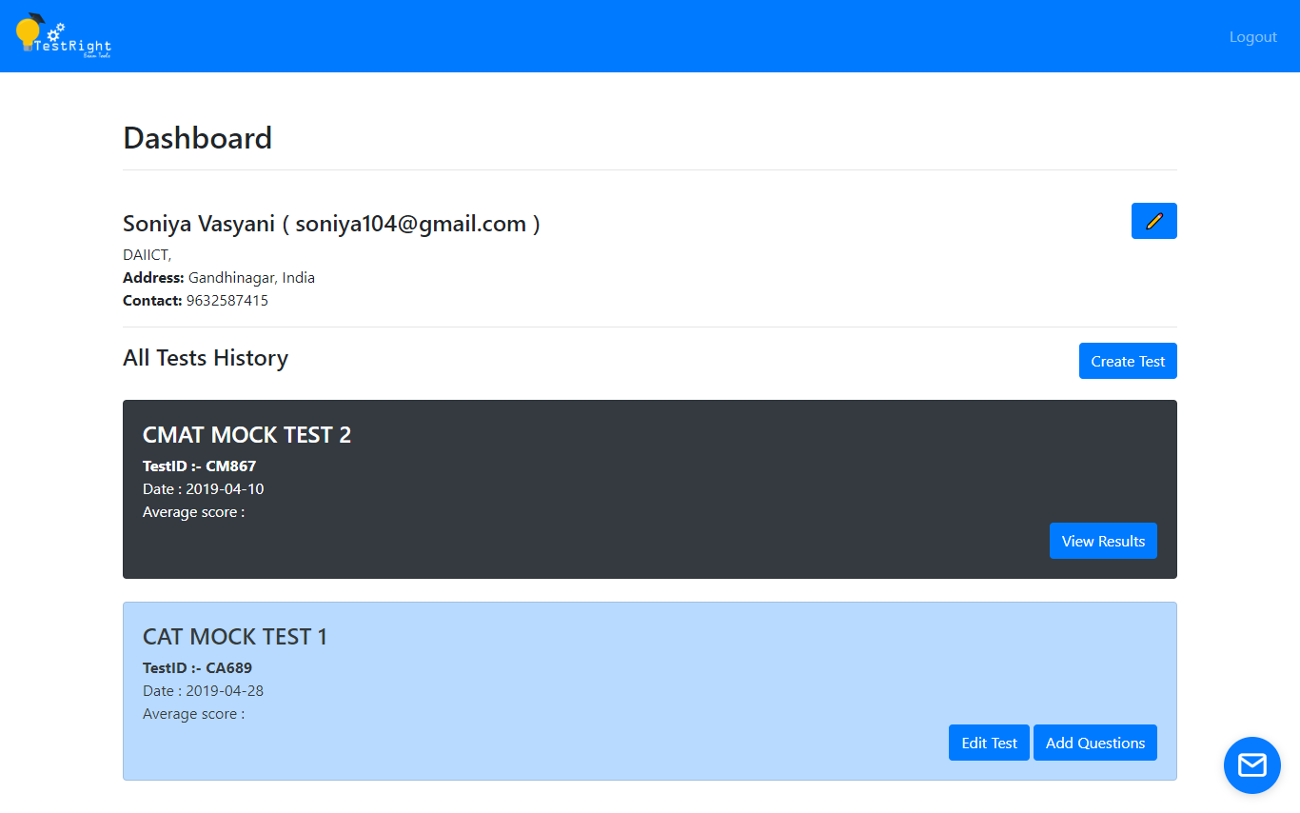

The profile of the logged in user will be displayed after completing the profile.

After completing the profile, **EDIT PROFILE** button will be displayed so that examiner can update the profile if needed.