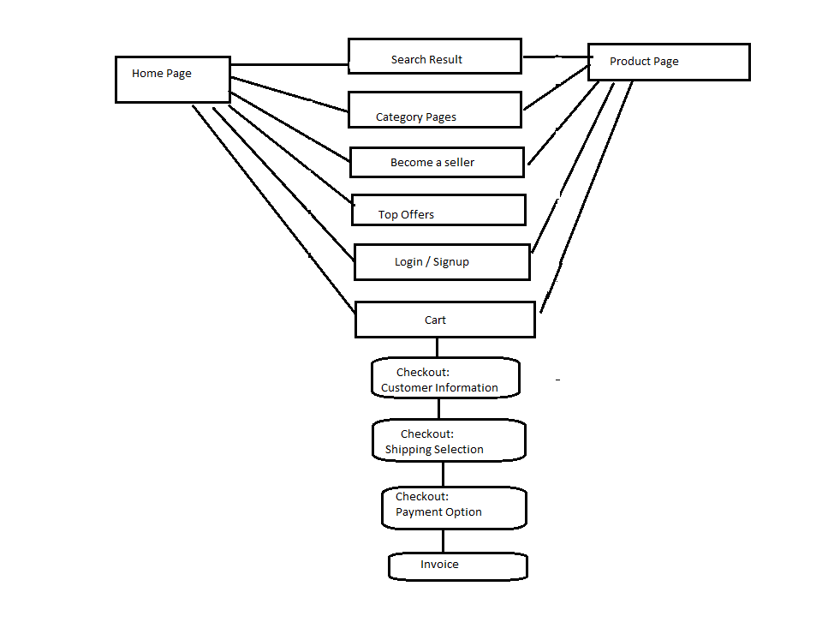

Manual Testing Report:

1. Testing scrolling functionality on various pages, including listings, category pages and homepage. And observed smoothness and responsiveness of scrolling on both desktop and mobile devices. And checked for any lag or delay while scrolling through large amounts of content.
2. Verified pagination controls on product listing pages. Tested navigation through different pages of products. And ensured correct display of page numbers and navigation buttons.
3. Measured the time taken for pages to load fully, including images and dynamic content and analyzed any significant differences in load times under varying network conditions.
4. Tested the checkout process from adding items to the cart to finalizing the purchase.
5. Ensured secure transmission of payment data.
6. Verified successful transactions and order confirmation.
7. Analyzed page response times for both partial and full page loads. Checked for any delays or timeouts in loading dynamic content
8. Identified static and dynamic content elements across the website.
9. Verified the correctness and relevance of product descriptions, images, and prices.