PROJECT REPORT ON CLINIC APPOINTMENT SYSTEM

Submitted By: Simran , Shivam , Suryansh

Roll :[2410030730],[2410030653],[2410030526]
Class: 2CSE11
University: IILM University, Greater Noida

TOPIC:- CLINIC APPOINTMENT SYSTEM

PROBLEM STATEMENT
"Currently, many small clinics manage patient records and appointments on paper. This manual process is time-consuming, prone to errors, and makes it difficult to retrieve patient history quickly.

INTRODUCTION
"The Clinic Appointment System is a database-driven project developed to automate and manage the daily operations of a medical clinic. This system is designed to store and manage critical information regarding Patients, Doctors, Appointments, and Medical Records. By using a Relational Database Appointment System (RDBMS), it ensures data integrity, reduces paperwork, and provides quick access to patient history and billing details."

Software & Technology Used:
- Database: MySQL 8.0
- Tool: MySQL Workbench
- Language: SQL (Structured Query Language)
- Operating System: Windows 11
ENTITY RELATIONSHIP (ER) DIAGRAM:

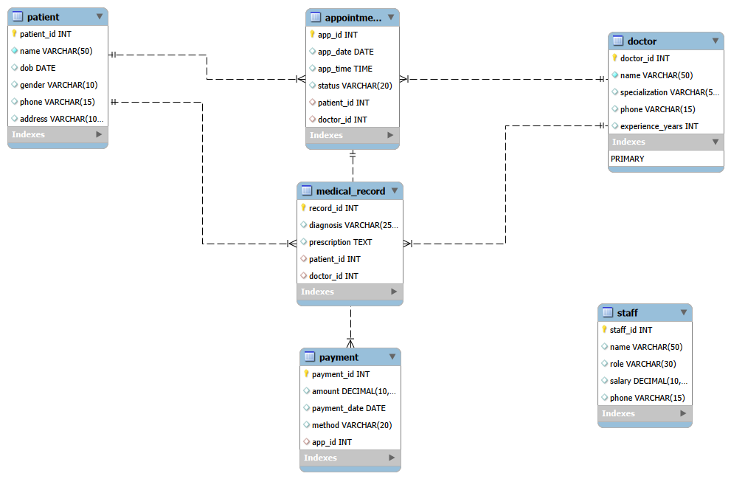
Key Entities and Relationships
Doctor Table: Stores information about medical staff, specialized by department.
Patient Table: Keeps track of patient demographics and contact details.
Appointment Table: This is the central table that connects Doctors and Patients, storing the date, time, and status of each visit.
Relational Schema:-
Patients (PatientID, Name, Age, Gender, Phone, Address)
Doctors (DoctorID, Name, Specialization, Phone, Cabin no.)
Appointments (AppID, PatientID, DoctorID, AppDate, AppTime, Status)

DATABASE IMPLEMENTATION

Tables in Clinic Database
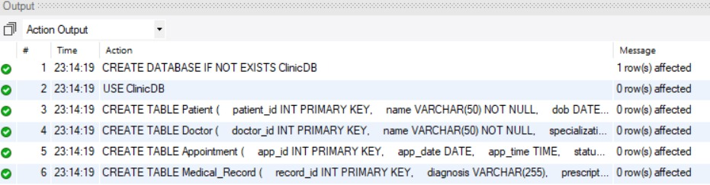

Table Structure
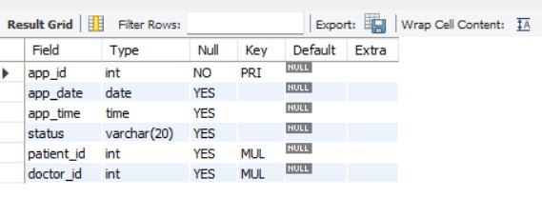

SQL SOURCE CODE
DROP DATABASE IF EXISTS ClinicDB;
CREATE DATABASE ClinicDB;
USE ClinicDB;

-- 2. Patient Table
CREATE TABLE Patient (
patient_id INT PRIMARY KEY AUTO_INCREMENT,
name VARCHAR(100) NOT NULL,
dob DATE,
gender VARCHAR(10),
phone VARCHAR(15),
email VARCHAR(100)
);

-- 3. Doctor Table
CREATE TABLE Doctor (
doctor_id INT PRIMARY KEY AUTO_INCREMENT,
name VARCHAR(100) NOT NULL,
specialization VARCHAR(100),
phone VARCHAR(15),
email VARCHAR(100)
);

CREATE TABLE Appointment (
app_id INT PRIMARY KEY AUTO_INCREMENT,
app_date DATE,
app_time TIME,
status VARCHAR(20),
patient_id INT,
doctor_id INT,
FOREIGN KEY (patient_id) REFERENCES Patient(patient_id),
FOREIGN KEY (doctor_id) REFERENCES Doctor(doctor_id)
);

-- 5. Medical Record Table
CREATE TABLE Medical_Record (
record_id INT PRIMARY KEY AUTO_INCREMENT,
patient_id INT,
doctor_id INT,
diagnosis TEXT,
treatment TEXT,
record_date DATE,
FOREIGN KEY (patient_id) REFERENCES Patient(patient_id),
FOREIGN KEY (doctor_id) REFERENCES Doctor(doctor_id)
);

-- 6. Payment Table
CREATE TABLE Payment (
payment_id INT PRIMARY KEY AUTO_INCREMENT,
app_id INT,
amount DECIMAL(10,2),
payment_date DATE,
method VARCHAR(50),
FOREIGN KEY (app_id) REFERENCES Appointment(app_id)
);

-- 7. Staff Table
CREATE TABLE Staff (
staff_id INT PRIMARY KEY AUTO_INCREMENT,
name VARCHAR(100),
role VARCHAR(50),
phone VARCHAR(15),
email VARCHAR(100)
);

SHOW TABLES;
DESC Appointment;

CONCLUSION

"The Clinic Appointment System has been successfully designed and implemented using MySQL. This project provides a structured way to manage patient records, doctor details, and appointments efficiently. It ensures data integrity through various SQL constraints and offers a scalable solution for medical data Appointment."

