TUGAS DNCC JARINGAN (DHCP SERVER & DNS)
- Status DNS (BIND9)
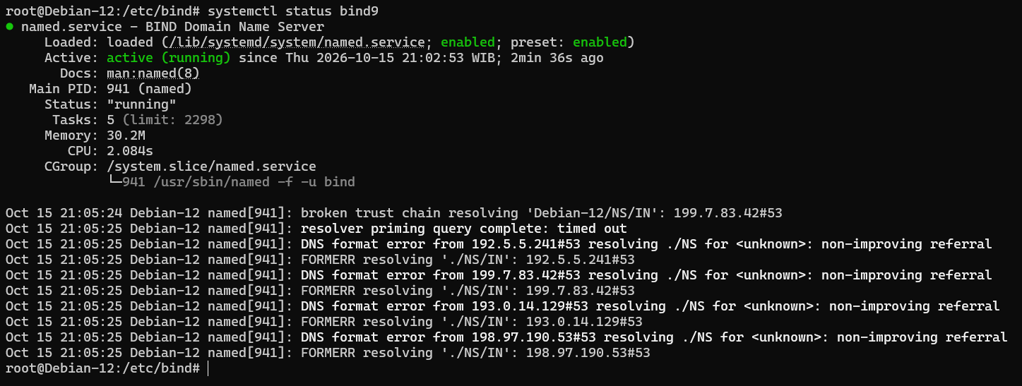

- Status DHCP Server
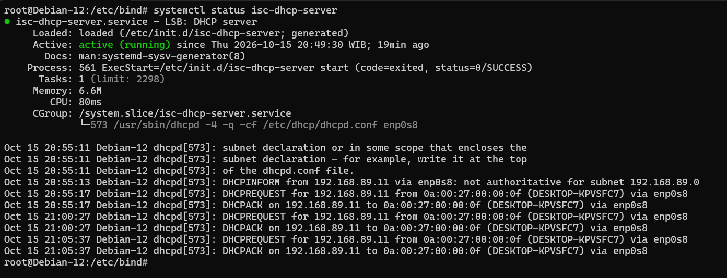

- Test Nslookup DNS
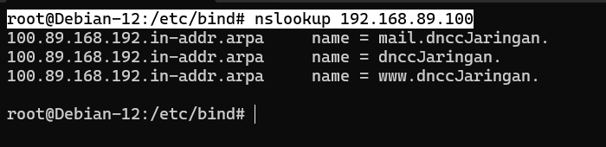

- Cek IP Client (Laptop)
