Assignment2 Project
Xin Tan
National University
CSC615
Professor Geoge H. Tanabe

Overview:
IDE: vim
Date: May 4th 2009
Compiler: SUN JDK 6.0 Linux 64bit (1.6)
Ant Makefile: build.xml
Project URL: http://github.com/tanxin/xin_csc615

Version Control Information:
commit 405fae1721fcc41d8e086f59a130549130795359
Author: Xin <tanxincn@gmail.com>
Date: Sun May 10 12:02:31 2009 -0700

add lab1 lab2 assignment2

build.xml | 32 ++--
.../exception/InvalidInputException.java | 5 +
src/edu/nu/csc615/assignment2/Assign2.java | 16 ++
src/edu/nu/csc615/assignment2/Calculator.java | 248 ++++++++++++++++++++
src/edu/nu/csc615/lab1/SimpleCalc.java | 69 ++++++
src/edu/nu/csc615/lab2/MainRunner.java | 45 ++++
6 files changed, 401 insertions(+), 14 deletions(-)

Get SourceCode:
From Git (newest version):
tanxin@laptop ~/.workspace-java/csc615 $ git clone git://github.com/tanxin/xin_csc615.git
From CD-ROM:
tanxin@laptop ~/.workspace-java/csc615 $ cp -r /mnt/cdrom/* .

Compile:
tanxin@laptop ~/.workspace-java/csc615 $ ant compile
Buildfile: build.xml

init:
[mkdir] Created dir: /home/tanxin/documents/school/nu/CSC615/project/build

compile:
[javac] Compiling 6 source files to /home/tanxin/documents/school/nu/CSC615/project/build

BUILD SUCCESSFUL
Total time: 1 second

Run:
tanxin@laptop ~/.workspace-java/csc615 $ ant runa2
Buildfile: build.xml

init:

compile:

run:

BUILD SUCCESSFUL
Total time: 11 seconds

Screenshots:

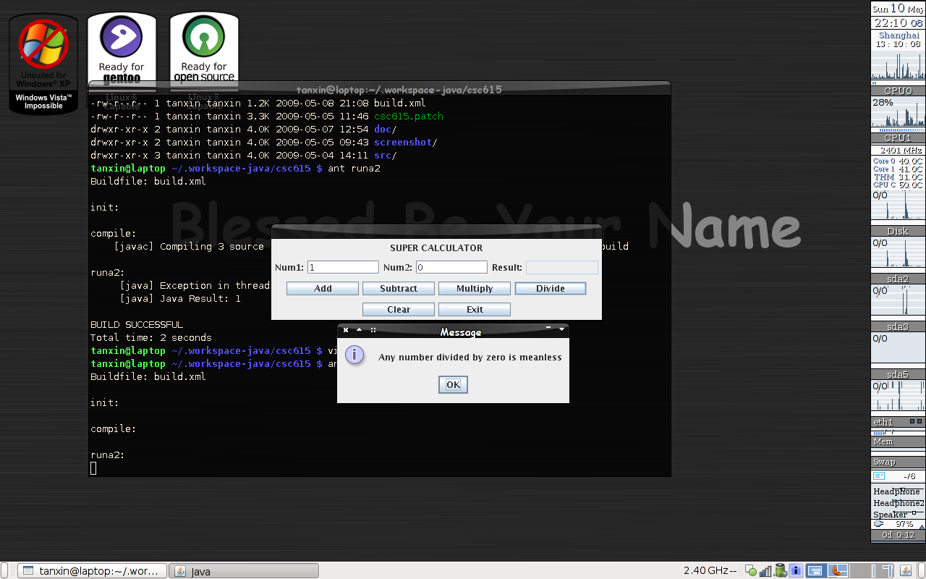

Memo:
If the computer has not ant build toolkit, it can be also compiled and run as this way.
tanxin@laptop ~/.workspace-java/csc615 $ rm -rf build
tanxin@laptop ~/.workspace-java/csc615 $ mkdir build
tanxin@laptop ~/.workspace-java/csc615 $ javac -cp src -d build src/edu/nu/csc615/assignment2/*.java
tanxin@laptop ~/.workspace-java/csc615 $ java -cp build edu.nu.csc615.assignment2.Assign2

Code List:
edu.nu.csc615.assignment2.Assign2.java
package edu.nu.csc615.assignment2;

import java.awt.EventQueue;

public class Assign2 {

/* entrance point */
public static void main(String[] args) {
EventQueue.invokeLater(new Runnable() {
public void run() {
new Calculator().setVisible(true);
}
});
}

}

edu.nu.csc615.assignment2.Calculator.java
package edu.nu.csc615.assignment2;

import java.awt.Container;
import java.awt.Dimension;
import java.awt.event.ActionEvent;
import java.awt.event.ActionListener;

import javax.swing.BoxLayout;
import javax.swing.JButton;
import javax.swing.JLabel;
import javax.swing.JOptionPane;
import javax.swing.JPanel;
import javax.swing.JTextField;
import javax.swing.WindowConstants;

import edu.nu.csc615.assignment1.exception.InvalidInputException;

public class Calculator extends javax.swing.JFrame {

private JButton addButton;
private JButton clearButton;
private JButton divideButton;
private JButton multiplyButton;
private JLabel numLabel3;
private JLabel numLable1;
private JLabel numLable2;
private JTextField numText1;
private JTextField numText2;
private JTextField numText3;
private JButton subtractButton;
private JLabel titleLabel;
private JButton exitButton;
private JPanel titlePane;
private JPanel inputPane;
private JPanel buttonPane;
private JPanel systemPane;

/* constructure */
public Calculator() {

/* initialize object */
titleLabel = new JLabel();
numLable1 = new JLabel();
numText1 = new JTextField();
numLable2 = new JLabel();
numText2 = new JTextField();
numLabel3 = new JLabel();
numText3 = new JTextField();
addButton = new JButton();
subtractButton = new JButton();
multiplyButton = new JButton();
divideButton = new JButton();
clearButton = new JButton();
exitButton = new JButton();
titlePane = new JPanel();
inputPane = new JPanel();
buttonPane = new JPanel();
systemPane = new JPanel();

/* create uniform dimension for objects */
Dimension dimension = new Dimension(100, 19);

/* close button can exit */
setDefaultCloseOperation(WindowConstants.EXIT_ON_CLOSE);

/* labels initialization */
titleLabel.setText("SUPER CALCULATOR");
numLable1.setText("Num1:");
numText1.setPreferredSize(dimension);
numLable2.setText("Num2:");
numText2.setPreferredSize(dimension);
numLabel3.setText("Result:");
numText3.setEditable(false);
numText3.setPreferredSize(dimension);

/* buttons initialization */
addButton.setText("Add");
addButton.setPreferredSize(dimension);
addButton.addActionListener(new ActionListener() {
public void actionPerformed(ActionEvent evt) {
AddButtonActionPerformed(evt);
}
});

subtractButton.setText("Subtract");
subtractButton.setPreferredSize(dimension);
subtractButton.addActionListener(new ActionListener() {
public void actionPerformed(ActionEvent evt) {
SubtractButtonActionPerformed(evt);
}
});

multiplyButton.setText("Multiply");
multiplyButton.setPreferredSize(dimension);
multiplyButton.addActionListener(new ActionListener() {
public void actionPerformed(ActionEvent evt) {
MultiplyButtonActionPerformed(evt);
}
});

divideButton.setText("Divide");
divideButton.setPreferredSize(dimension);
divideButton.addActionListener(new ActionListener() {
public void actionPerformed(ActionEvent evt) {
DivideButtonActionPerformed(evt);
}
});

clearButton.setText("Clear");
clearButton.setPreferredSize(dimension);
clearButton.addActionListener(new ActionListener() {
public void actionPerformed(ActionEvent evt) {
ClearButtonActionPerformed(evt);
}
});

exitButton.setText("Exit");
exitButton.setPreferredSize(dimension);
exitButton.addActionListener(new ActionListener() {
public void actionPerformed(ActionEvent evt) {
exitButtonActionPerformed(evt);
}
});

/* layout definition */
Container contentPane = getContentPane();
contentPane.setLayout(new BoxLayout(contentPane, BoxLayout.Y_AXIS));

contentPane.add(titlePane);
contentPane.add(inputPane);
contentPane.add(buttonPane);
contentPane.add(systemPane);

titlePane.add(titleLabel);
inputPane.add(numLable1);
inputPane.add(numText1);
inputPane.add(numLable2);
inputPane.add(numText2);
inputPane.add(numLabel3);
inputPane.add(numText3);
buttonPane.add(addButton);
buttonPane.add(subtractButton);
buttonPane.add(multiplyButton);
buttonPane.add(divideButton);
systemPane.add(clearButton);
systemPane.add(exitButton);

/* apply layout */
pack();
}

/* clearButton Action */
private void ClearButtonActionPerformed(ActionEvent evt) {
numText1.setText("");
numText2.setText("");
numText3.setText("");
}

/* exitButton Action */
private void exitButtonActionPerformed(ActionEvent evt) {
System.exit(0);
}

/* addButton Action */
private void AddButtonActionPerformed(ActionEvent evt) {
try {
Double result = parseDouble(numText1) + parseDouble(numText2);
numText3.setText(result.toString());
} catch (InvalidInputException e) {
JOptionPane.showMessageDialog(this, "Please enter the number in textbox");
}

}

/* subtractButton Action */
private void SubtractButtonActionPerformed(ActionEvent evt) {
try{
Double result = parseDouble(numText1) - parseDouble(numText2);
numText3.setText(result.toString());
} catch (InvalidInputException e) {
JOptionPane.showMessageDialog(this, "Please enter the number in textbox");
}
}

/* multiplyButton Action */
private void MultiplyButtonActionPerformed(ActionEvent evt) {
try{
Double result = parseDouble(numText1) * parseDouble(numText2);
numText3.setText(result.toString());
} catch (InvalidInputException e) {
JOptionPane.showMessageDialog(this, "Please enter the number in textbox");
}
}

/* diviveButton Action */
private void DivideButtonActionPerformed(ActionEvent evt) {
if(Double.parseDouble(numText2.getText()) == 0){
JOptionPane.showMessageDialog(this, "Any number divided by zero is meanless");
return;
}

try{
Double result = parseDouble(numText1) / parseDouble(numText2);
String resultString = result.toString();
numText3.setText((resultString.length()>12 ? resultString.substring(0,12):resultString));
} catch (InvalidInputException e) {
JOptionPane.showMessageDialog(this, "Please enter the number in textbox");
}
}

/* function to correct textfield */
public Double parseDouble(JTextField text) throws InvalidInputException{
try{
return Double.parseDouble(text.getText());
}catch (NumberFormatException e) {
throw new InvalidInputException("Divide by Zero");
}
}
}

