Assignment1 Project
Xin Tan
National University
CSC615
Professor Geoge H. Tanabe

Overview:
IDE: vim, eclipse
Date: May 4th 2009
Compiler: SUN JDK 6.0 Linux 64bit (1.6)
Ant Makefile: build.xml

Version Control Information:
tanxin@laptop ~/.workspace-java/csc615 $ git log --stat
commit 5246470270c0a62d2fb16807fd37fdd2e21b2dd9
Author: Xin <tanxincn@gmail.com>
Date: Mon May 4 15:54:27 2009 -0700

Refactor and comment

src/edu/nu/csc615/assignment1/Grade.java | 69 +++++++------------
src/edu/nu/csc615/assignment1/GradeAccessor.java | 53 ++++++++++++++
src/edu/nu/csc615/assignment1/GradeAgent.java | 75 ++++++++++++++++++++
src/edu/nu/csc615/assignment1/GradeReader.java | 49 -------------
src/edu/nu/csc615/assignment1/MainRunner.java | 31 +++++----
.../exception/InvalidInputException.java | 2 +-
6 files changed, 171 insertions(+), 108 deletions(-)

commit 15e6e158930ae17368ef6ddb4dda2be384632b5a
Author: Xin <tanxincn@gmail.com>
Date: Mon May 4 14:25:08 2009 -0700

Initial commit

build.xml | 37 ++++++++++
src/edu/nu/csc615/assignment1/Grade.java | 77 ++++++++++++++++++++
src/edu/nu/csc615/assignment1/GradeReader.java | 49 +++++++++++++
src/edu/nu/csc615/assignment1/MainRunner.java | 53 ++++++++++++++
.../assignment1/exception/ExitException.java | 27 +++++++
.../exception/InvalidInputException.java | 27 +++++++
6 files changed, 270 insertions(+), 0 deletions(-)

Compile:
tanxin@laptop ~/.workspace-java/csc615 $ ant compile
Buildfile: build.xml

init:
[mkdir] Created dir: /home/tanxin/documents/school/nu/CSC615/project/build

compile:
[javac] Compiling 6 source files to /home/tanxin/documents/school/nu/CSC615/project/build

BUILD SUCCESSFUL
Total time: 1 second

Run:
tanxin@laptop ~/.workspace-java/csc615 $ ant run
Buildfile: build.xml

init:

compile:

run:
[java] A:4.0
[java] B+:3.3
[java] Please enter A-F
[java] F:0.0
[java] Thank you for your using.

BUILD SUCCESSFUL
Total time: 11 seconds

Screenshots:

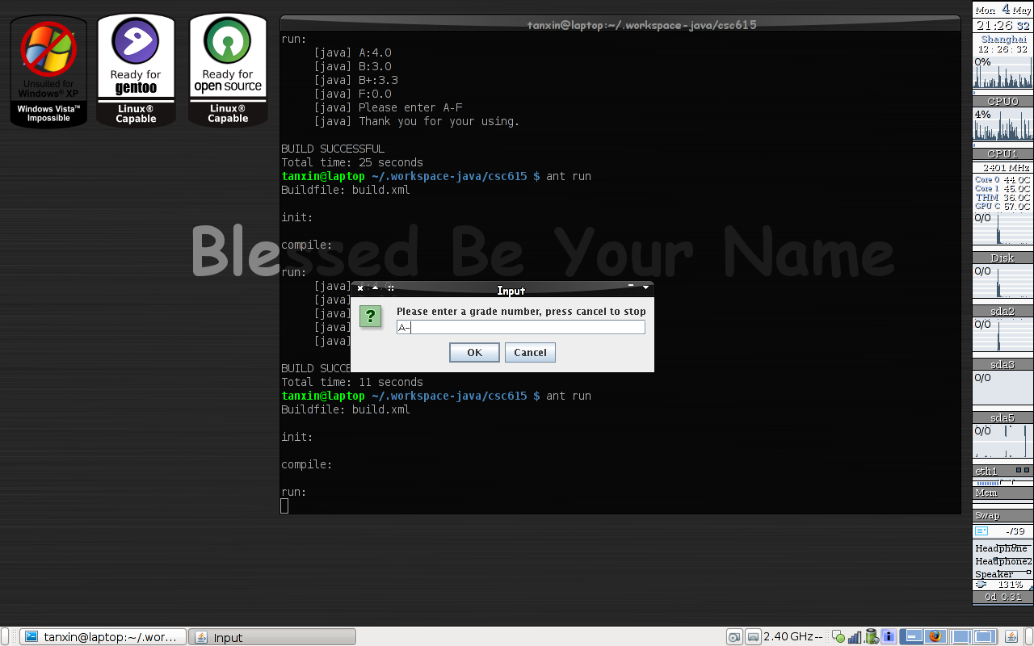

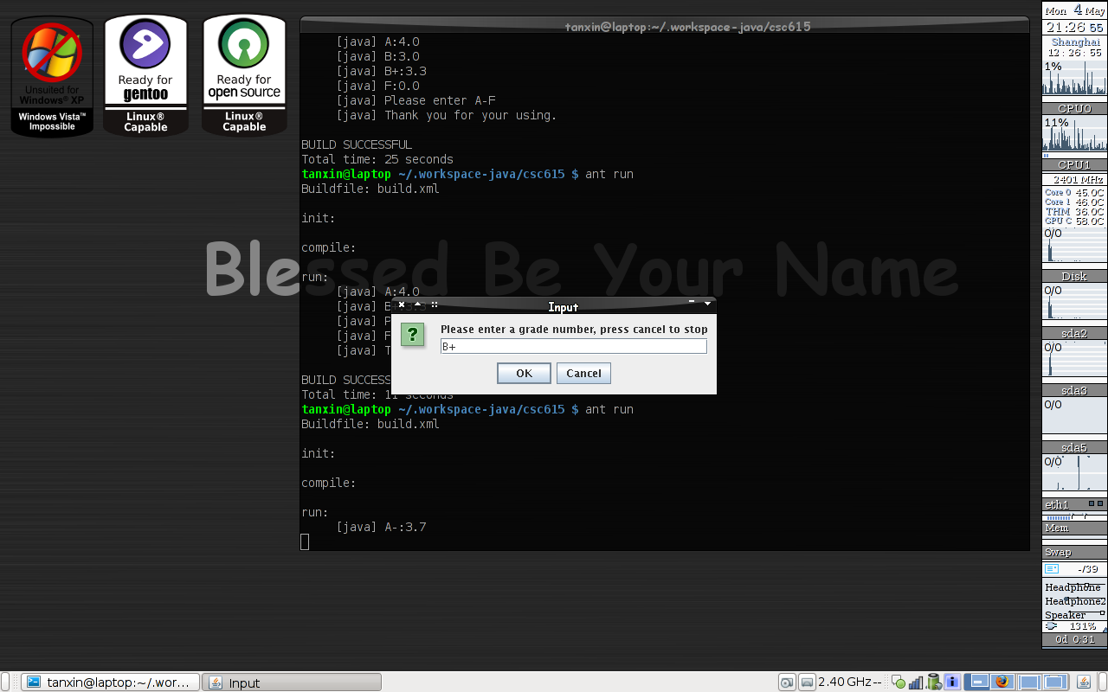
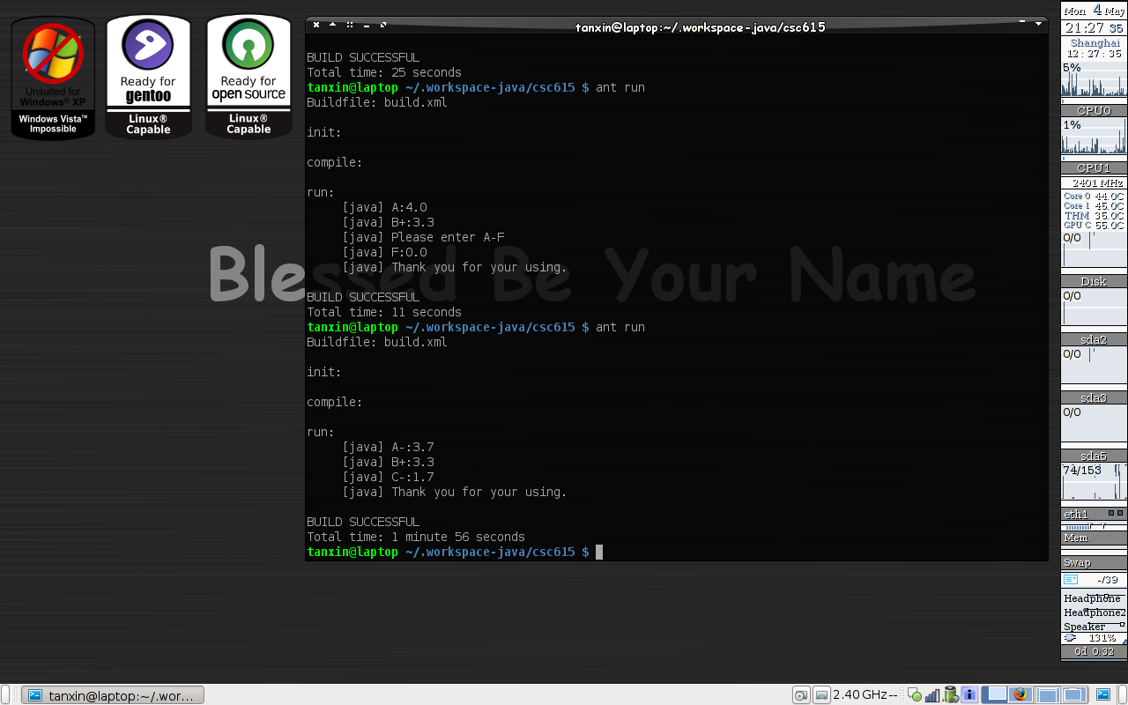

Memo:
If the computer has not ant build toolkit, it can be also compiled and run as this way.
tanxin@laptop ~/.workspace-java/csc615 $ rm -rf build
tanxin@laptop ~/.workspace-java/csc615 $ mkdir build
tanxin@laptop ~/.workspace-java/csc615 $ javac -cp src -d build src/edu/nu/csc615/assignment1/*.java
tanxin@laptop ~/.workspace-java/csc615 $ java -cp build edu.nu.csc615.assignment1.MainRunner

Code List:
edu.nu.csc615.assignment1.MainRunner.java
package edu.nu.csc615.assignment1;

import edu.nu.csc615.assignment1.exception.ExitException;
import edu.nu.csc615.assignment1.exception.InvalidInputException;

/**
* Assigment 1 CSC615
* @author Xin Tan
* IDE: vim & eclipse
* Date: May 4th 2009
* Compiler:JDK 6.0 64bit(1.6)
* Makefile:build.xml
*/
public class MainRunner {

/* exit code to the shell */
public final static int EXIT_NORMAL = 0;
public final static int EXIT_FATAL = 9;

/**
* Entrance point
* @param args unless so far
*/
public static void main(String[] args) {

/* allocate the instance */
GradeAccessor gradeAccessor = new GradeAccessor();

while(true){
try{
/* read by opening the dialog according to the requirement */
gradeAccessor.readFromDialog();
/* output to stdout according to the requirement */
gradeAccessor.writeToTerminal();
}catch(InvalidInputException e /* invalid grade, print error message and keep going*/){
System.err.println("Please enter A-F");
}catch(ExitException e /* exit exception by clicking cancel button and exit with normal signal*/){
System.out.println("Thank you for your using.");
System.exit(EXIT_NORMAL);
}catch(Exception e /* impossible exception catch, could not happen generally. if that happen, need debug stack */){
System.err.println("impossible exception occured, debug information:");
e.printStackTrace();
System.exit(EXIT_FATAL);
}
}
}
}

edu.nu.csc615.assignment1.Grade.java
package edu.nu.csc615.assignment1;

/**
* Object Grade
*
*/
public class Grade {

public static final double NUM_A = 4.0;
public static final double NUM_AM = 3.7;
public static final double NUM_BP = 3.3;
public static final double NUM_B = 3.0;
public static final double NUM_BM = 2.7;
public static final double NUM_CP = 2.3;
public static final double NUM_C = 2.0;
public static final double NUM_CM = 1.7;
public static final double NUM_DP = 1.3;
public static final double NUM_D = 1.0;
public static final double NUM_DM = 0.7;
public static final double NUM_F = 0.0;

protected String gradeString;

protected double gradeDouble;

public String getGradeString() {
return gradeString;
}

public void setGradeString(String gradeString) {
this.gradeString = gradeString;
}

public double getGradeDouble() {
return gradeDouble;
}

public void setGradeDouble(double gradeDouble) {
this.gradeDouble = gradeDouble;
}

}
edu.nu.csc615.assignment1.GradeAgent.java
package edu.nu.csc615.assignment1;

import java.util.HashMap;

import edu.nu.csc615.assignment1.exception.InvalidInputException;

/**
* GradeAgent grade with the logic
*/
public class GradeAgent extends Grade {
HashMap<String, Double> gradeList;

/**
* Constructor with initial gradeList
*/
public GradeAgent(){
gradeList = new HashMap<String, Double>();
gradeList.put("A", NUM_A);
gradeList.put("A-", NUM_AM);
gradeList.put("B+", NUM_BP);
gradeList.put("B", NUM_B);
gradeList.put("B-", NUM_BM);
gradeList.put("C+", NUM_CP);
gradeList.put("C", NUM_C);
gradeList.put("C-", NUM_CM);
gradeList.put("D+", NUM_DP);
gradeList.put("D", NUM_D);
gradeList.put("D-", NUM_DM);
gradeList.put("F", NUM_F);
}

/**
* Generate grade point from input grade "A-F"
* @param gradeString the grade from A to F
* @throws InvalidInputException invalid grade string
*/
public void setGrade(String gradeString) throws InvalidInputException {
this.gradeString = gradeString;

try{
this.gradeDouble = gradeList.get(gradeString);
}catch(NullPointerException e){
throw new InvalidInputException();
}
}

/**
* TODO: unimplemented!!
* Generate grade from input grade point
* @param gradeDouble the grade from 0.0-4.0
*/
public void setGrade(Double gradeDouble){
this.gradeDouble = gradeDouble;
this.gradeString = null;
throw new RuntimeException("This method has not been implemented!!");
}

}
edu.nu.csc615.assignment1.GradeAccessor.java
package edu.nu.csc615.assignment1;

import javax.swing.JOptionPane;

import edu.nu.csc615.assignment1.exception.ExitException;
import edu.nu.csc615.assignment1.exception.InvalidInputException;

/**
* Accessor with Input Output
*
*/
public class GradeAccessor {
private GradeAgent grade;

public GradeAccessor(){
grade = new GradeAgent();
}

/**
* Read grade from Dialog, JOptionPane is required to be used in assignment requirement
* @throws ExitException ask for exit if press cancel button
* @throws InvalidInputException invalid grade string from A to F
*/
public void readFromDialog() throws ExitException, InvalidInputException {
String input = JOptionPane.showInputDialog("Please enter a grade number, press cancel to stop");
if(input == null)
throw new ExitException();
grade.setGrade(input);
}

/**
* Write result to stdout followed by assignment requirement
*/
public void writeToTerminal() {
System.out.println(grade.getGradeString() + ":" + grade.getGradeDouble());
}
}
edu.nu.csc615.assignment1.ExitException.java
package edu.nu.csc615.assignment1.exception;

public class ExitException extends Exception {
public ExitException(){
super("Exit Exception");
}
}
edu.nu.csc615.assignment1.InvalidInputException.java
package edu.nu.csc615.assignment1.exception;

public class InvalidInputException extends Exception {
public InvalidInputException(){
super("Invalid Input Exception");
}
}

