Assignment5 Project
Xin Tan
National University
CSC615
Professor Geoge H. Tanabe

Overview:
IDE: vim
Date: May 25th 2009
Compiler: SUN JDK 6.0 Linux 64bit (1.6)
Ant Makefile: build.xml
Project URL: http://github.com/tanxin/xin_csc615

Version Control Information:
commit 757085b9a53876e8f1f7020a76ae0a617c84bff6
Author: Xin <tanxincn@gmail.com>
Date: Thu May 25 10:27:00 2009 -0700

added assignment5

src/edu/nu/csc615/assignment5/NuAdmission.java | 287 +++++
1 files changed, 287 insertions(+), 0 deletions(-)

Get SourceCode:
From Git (newest version):
tanxin@laptop ~/.workspace-java/csc615 $ git clone git://github.com/tanxin/xin_csc615.git
From CD-ROM:
tanxin@laptop ~/.workspace-java/csc615 $ cp -r /mnt/cdrom/* .

Compile:
tanxin@laptop ~/.workspace-java/csc615 $ ant compile
Buildfile: build.xml

init:
[mkdir] Created dir: /home/tanxin/documents/school/nu/CSC615/project/build

compile:
[javac] Compiling 6 source files to /home/tanxin/documents/school/nu/CSC615/project/build

BUILD SUCCESSFUL
Total time: 1 second

Run:
tanxin@laptop ~/.workspace-java/csc615 $ ant runa5
Buildfile: build.xml

init:

compile:

run:

BUILD SUCCESSFUL
Total time: 11 seconds

Screenshots:
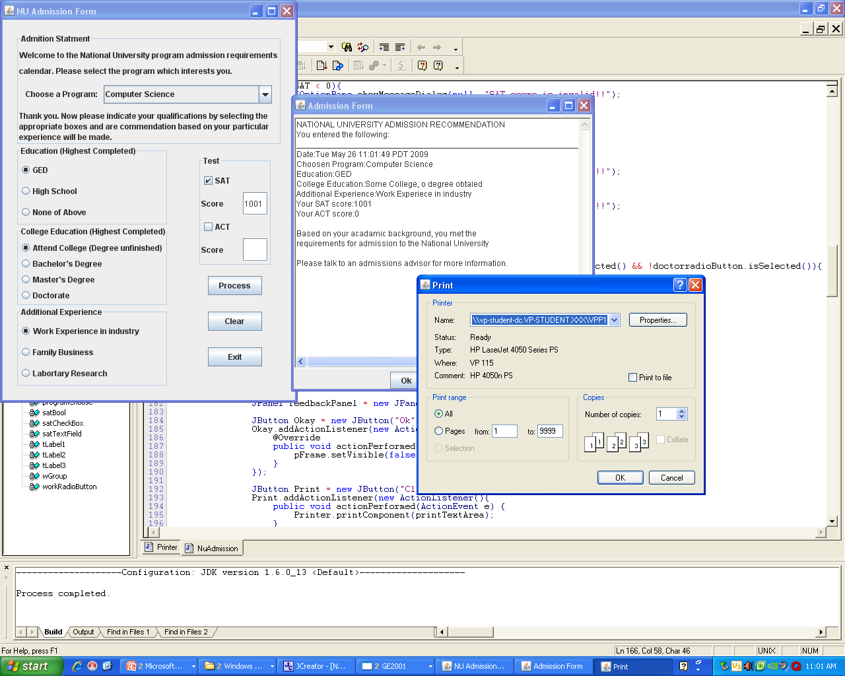

Memo:
If the computer has not ant build toolkit, it can be also compiled and run as this way.
tanxin@laptop ~/.workspace-java/csc615 $ rm -rf build
tanxin@laptop ~/.workspace-java/csc615 $ mkdir build
tanxin@laptop ~/.workspace-java/csc615 $ javac -cp src -d build src/edu/nu/csc615/assignment5/*.java
tanxin@laptop ~/.workspace-java/csc615 $ java -cp build edu.nu.csc615.assignment5.NuAdmission

Code List:
edu.nu.csc615.assignment5.NuAdmission.java
import java.awt.BorderLayout;
import java.awt.Dimension;
import java.awt.GridLayout;
import java.awt.TextArea;
import java.awt.event.ActionEvent;
import java.awt.event.ActionListener;
import java.util.Calendar;

import javax.swing.BorderFactory;
import javax.swing.BoxLayout;
import javax.swing.ButtonGroup;
import javax.swing.JButton;
import javax.swing.JCheckBox;
import javax.swing.JComboBox;
import javax.swing.JComponent;
import javax.swing.JFrame;
import javax.swing.JLabel;
import javax.swing.JOptionPane;
import javax.swing.JPanel;
import javax.swing.JRadioButton;
import javax.swing.JTextField;

public class NuAdmission extends JPanel{

private boolean satBool;
private boolean actBool;
private boolean admitBool;
private int iSAT=0;
private int iACT=0;
private String degreeString="";

private JCheckBox satCheckBox;
private JCheckBox actCheckBox;
private JRadioButton gedRadioButton;
private JRadioButton hsRadioButton;
private JRadioButton noRadioButton;
private JRadioButton collogeRadioButton;
private JRadioButton bachelorRadioButton;
private JRadioButton masterRadioButton;
private JRadioButton doctorradioButton;
private JRadioButton workRadioButton;
private JRadioButton familyRadioButton;
private JRadioButton labRadioButton;
private JComboBox programChoose;
private JLabel tLabel1;
private JLabel tLabel2;
private JLabel tLabel3;
private TextArea printTextArea;
private ButtonGroup eGroup;
private ButtonGroup dGroup;
private ButtonGroup wGroup;
private JFrame pFrame;
private JTextField satTextField = new JTextField();
private JTextField actTextField = new JTextField();

public NuAdmission() {
super(new BorderLayout());

collogeRadioButton = new JRadioButton("Attend College (Degree unfinished)");

bachelorRadioButton= new JRadioButton("Bachelor's Degree");

masterRadioButton = new JRadioButton("Master's Degree");
doctorradioButton = new JRadioButton("Doctorate");

dGroup = new ButtonGroup();
dGroup.add(collogeRadioButton);
dGroup.add(bachelorRadioButton);
dGroup.add(masterRadioButton);
dGroup.add(doctorradioButton);

gedRadioButton = new JRadioButton("GED");
gedRadioButton.setSelected(false);

hsRadioButton = new JRadioButton("High School");

noRadioButton = new JRadioButton("None of Above");

eGroup = new ButtonGroup();
eGroup.add(gedRadioButton);
eGroup.add(hsRadioButton);
eGroup.add(noRadioButton);

workRadioButton = new JRadioButton("Work Experience in industry");

familyRadioButton = new JRadioButton("Family Business");

labRadioButton = new JRadioButton("Labortary Research");

wGroup = new ButtonGroup();
wGroup.add(workRadioButton);
wGroup.add(familyRadioButton);
wGroup.add(labRadioButton);

satCheckBox = new JCheckBox("SAT");
satCheckBox.setSelected(false);
actCheckBox = new JCheckBox("ACT");
satCheckBox.addActionListener(new ActionListener(){
@Override
public void actionPerformed(ActionEvent e) {
satBool = satCheckBox.isSelected();
}
});
actCheckBox.addActionListener(new ActionListener(){
@Override
public void actionPerformed(ActionEvent e) {
actBool=actCheckBox.isSelected();
}
});

JLabel scoreLabel = new JLabel("Score");
JLabel actScoreLabel = new JLabel("Score");

JButton processJButton = new JButton("Process");
JButton clearJButton = new JButton("Clear");
clearJButton.addActionListener(new ActionListener(){
@Override
public void actionPerformed(ActionEvent e) {
clearAll();
}
});
JButton exitJButton = new JButton("Exit");
exitJButton.addActionListener(new ActionListener(){
@Override
public void actionPerformed(ActionEvent e) {
System.exit(0);
}
});

processJButton.addActionListener(new ActionListener(){
@Override
public void actionPerformed(ActionEvent e) {
pFrame = new JFrame("Admission Feedback");

if(programChoose.getSelectedIndex()==0){
JOptionPane.showMessageDialog(null, "Please choose the program");
return;
}

if(satBool){
try{
iSAT = Integer.parseInt(satTextField.getText());
}catch (Exception ex) {
JOptionPane.showMessageDialog(null, "SAT score is invalid!!");
return;
}
if(iSAT < 0){
JOptionPane.showMessageDialog(null, "SAT score is invalid!!");
return;
}
}

if(actBool){
try{
iACT = Integer.parseInt(actTextField.getText());
}catch (Exception ex) {
JOptionPane.showMessageDialog(null, "ACT score is invalid!!");
return;
}
if(iACT < 0){
JOptionPane.showMessageDialog(null, "ACT score is invalid!!");
return;
}
}

admitBool = true;

if(!bachelorRadioButton.isSelected() && !masterRadioButton.isSelected() && !doctorradioButton.isSelected()){
if((satBool&&iSAT>=1000) || (actBool&&iACT>=15)){
admitBool = true;
}else{
admitBool = false;
}

}
printTextArea = new TextArea();

printTextArea.setSize(450, 400);
printTextArea.setPreferredSize(new Dimension(450,380));
printTextArea.setRows(50);

printTextArea.setText(getPrintString());

JPanel feedbackPanel = new JPanel();

JButton Okay = new JButton("Ok");
Okay.addActionListener(new ActionListener(){
@Override
public void actionPerformed(ActionEvent e) {
pFrame.setVisible(false);
}
});

JButton Print = new JButton("Click to print");
Print.addActionListener(new ActionListener(){
public void actionPerformed(ActionEvent e) {
Printer.printComponent(printTextArea);
}
});

feedbackPanel.add(printTextArea);
feedbackPanel.add(Okay);
feedbackPanel.add(Print);
pFrame.add(feedbackPanel);
pFrame.setPreferredSize(new Dimension(460, 450));
pFrame.pack();
pFrame.setVisible(true);

}
});

JPanel testPanel = new JPanel(new GridLayout(0,1));
testPanel.setBorder(BorderFactory.createTitledBorder("Test"));

JPanel satPanel = new JPanel(new GridLayout(1,2,25,25));
JPanel actPanel = new JPanel(new GridLayout(1,2,25,25));

satPanel.add(scoreLabel);
satPanel.add(satTextField);

actPanel.add(actScoreLabel, BorderLayout.EAST);
actPanel.add(actTextField, BorderLayout.WEST);

testPanel.add(satCheckBox);
testPanel.add(satPanel);
testPanel.add(actCheckBox);
testPanel.add(actPanel);

JPanel actionPanel = new JPanel(new GridLayout(0,1,10,25));
actionPanel.setBorder(BorderFactory .createEmptyBorder(15, 15, 15, 15));

actionPanel.add(processJButton);
actionPanel.add(clearJButton);
actionPanel.add(exitJButton);
JPanel eastPanel = new JPanel(new GridLayout(0,1));
eastPanel.setBorder(BorderFactory.createEmptyBorder(15, 15, 15, 15));
eastPanel.add(testPanel);
eastPanel.add(actionPanel);

String programs[] = {"Please select a program:",
"Computer Science",
"Teaching",
"Business Administration",
"Arts & Sciences"};
programChoose= new JComboBox(programs);
programChoose.addActionListener(new ActionListener(){
@Override
public void actionPerformed(ActionEvent e) {
degreeString = "";
JComboBox cb = (JComboBox)e.getSource();
String newSelection = (String)cb.getSelectedItem();
degreeString = newSelection;
tLabel1.setText("Thank you. Now please indicate your qualifications by selecting the");
tLabel2.setText("appropriate boxes and are commendation based on your particular");
tLabel3.setText("experience will be made.");

}
});

JLabel chooseLabel = new JLabel("Choose a Program: ");
JLabel welcomeLabel1 = new JLabel("Welcome to the National University program admission requirements");
JLabel welcomeLabel2 = new JLabel("calendar. Please select the program which interests you.");

JPanel welcomePanel = new JPanel(new GridLayout(2, 1));
welcomePanel.add(welcomeLabel1);
welcomePanel.add(welcomeLabel2);

JPanel thankyouPanel = new JPanel(new GridLayout(3, 1));
tLabel1 = new JLabel("");
tLabel2 = new JLabel("");
tLabel3 = new JLabel("");
thankyouPanel.add(tLabel1);
thankyouPanel.add(tLabel2);
thankyouPanel.add(tLabel3);

JPanel choosePanel = new JPanel();
choosePanel.setLayout(new BoxLayout(choosePanel, BoxLayout.X_AXIS));
choosePanel.setBorder(BorderFactory.createEmptyBorder(10, 10, 10, 10));

choosePanel.add(chooseLabel);
choosePanel.add(programChoose);

JPanel nuPanel = new JPanel(new GridLayout(0, 1));
nuPanel.setBorder(BorderFactory.createTitledBorder("Admition Statment"));
nuPanel.add(welcomePanel);
nuPanel.add(choosePanel);
nuPanel.add(thankyouPanel);

JPanel educationPanel = new JPanel(new GridLayout(0, 1));
educationPanel.add(gedRadioButton);
educationPanel.add(hsRadioButton);
educationPanel.add(noRadioButton);
educationPanel.setBorder(BorderFactory.createTitledBorder("Education (Highest Completed)"));

JPanel collegePanel = new JPanel(new GridLayout(0, 1));
collegePanel.add(collogeRadioButton);
collegePanel.add(bachelorRadioButton);
collegePanel.add(masterRadioButton);
collegePanel.add(doctorradioButton);
collegePanel.setBorder(BorderFactory.createTitledBorder("College Education (Highest Completed)"));

JPanel workPanel = new JPanel(new GridLayout(0, 1));
workPanel.add(workRadioButton);
workPanel.add(familyRadioButton);
workPanel.add(labRadioButton);
workPanel.setBorder(BorderFactory.createTitledBorder("Additional Experience"));

JPanel groupButtonPanel = new JPanel(new GridLayout(0, 1));

groupButtonPanel.add(educationPanel, BorderLayout.NORTH);
groupButtonPanel.add(collegePanel, BorderLayout.CENTER);
groupButtonPanel.add(workPanel, BorderLayout.SOUTH);
clearAll();
add(nuPanel, BorderLayout.NORTH);
add(groupButtonPanel, BorderLayout.WEST);
add(eastPanel, BorderLayout.EAST);

setBorder(BorderFactory.createEmptyBorder(20,20,20,20));
}

private String getPrintString() {
String string = String.format("NATIONAL UNIVERSITY ADMISSION RECOMMENDATION\n" +
"You entered the following:\n" +
"_______________________________________________________________\n" +
"Date:%s\n" +
"Choosen Program:%s\n" +
"Education:%s\n" +
"College Education:%s\n" +
"Additional Experience:%s\n" +
"Your SAT score:%s\n" +
"Your ACT score:%s\n\n" +
"Based on your acadamic background, you %s the\n" +
"requirements for admission to the National University\n\n" +
"Please talk to an admissions advisor for more information.\n",
Calendar.getInstance().getTime(), degreeString, getEdu(), getDegree(), getWork(), iSAT, iACT,
admitBool?"met":"do NOT meet");
return string;
}

public String getEdu(){
if(gedRadioButton.isSelected())
return "GED";
if(hsRadioButton.isSelected())
return "High School Graduate";
if(noRadioButton.isSelected())
return "None";
return "";
}

public String getDegree(){
if(collogeRadioButton.isSelected())
return "Some College, o degree obtaied";
if(bachelorRadioButton.isSelected())
return "Bachelor's Degree";
if(masterRadioButton.isSelected())
return "Master's Degree";
if(doctorradioButton.isSelected())
return "Doctorate";
return "";
}

public String getWork(){
if(workRadioButton.isSelected())
return "Work Experiece in industry";
if(familyRadioButton.isSelected())
return "Family Business";
if(labRadioButton.isSelected())
return "Laboratory Research";
return "";
}

public void clearAll()
{
satBool=false;
actBool=false;
satTextField.setText("");
actTextField.setText("");
tLabel1.setText("");
tLabel2.setText("");
tLabel3.setText("");
satCheckBox.setSelected(false);
actCheckBox.setSelected(false);
eGroup.clearSelection();
dGroup.clearSelection();
wGroup.clearSelection();
programChoose.setSelectedIndex(0);
}

public static void main(String[] args) {
try {
javax.swing.SwingUtilities.invokeLater(new Runnable() {
public void run() {
JFrame frame = new JFrame("NU Admission Form");
frame.setDefaultCloseOperation(JFrame.EXIT_ON_CLOSE);

JComponent newContentPane = new NuAdmission();
newContentPane.setOpaque(true);
frame.setContentPane(newContentPane);

frame.pack();
frame.setVisible(true);
}
});
} catch (Exception e) {}
}
}

edu.nu.csc615.assignment5.Printer.java
import java.awt.*;
import javax.swing.*;
import java.awt.print.*;

public class Printer implements Printable {
private Component componentToBePrinted;

public static void printComponent(Component c) {
new Printer(c).print();
}

public Printer(Component componentToBePrinted) {
this.componentToBePrinted = componentToBePrinted;
}

public void print() {
PrinterJob printJob = PrinterJob.getPrinterJob();
printJob.setPrintable(this);
if (printJob.printDialog())
try {
printJob.print();
} catch(PrinterException pe) {
System.out.println("Error printing: " + pe);
}
}

public int print(Graphics g, PageFormat pageFormat, int pageIndex) {
if (pageIndex > 0) {
return(NO_SUCH_PAGE);
} else {
Graphics2D g2d = (Graphics2D)g;
g2d.translate(pageFormat.getImageableX(), pageFormat.getImageableY());
disableDoubleBuffering(componentToBePrinted);
componentToBePrinted.paint(g2d);
enableDoubleBuffering(componentToBePrinted);
return(PAGE_EXISTS);
}
}

public static void disableDoubleBuffering(Component c) {
RepaintManager currentManager = RepaintManager.currentManager(c);
currentManager.setDoubleBufferingEnabled(false);
}

public static void enableDoubleBuffering(Component c) {
RepaintManager currentManager = RepaintManager.currentManager(c);
currentManager.setDoubleBufferingEnabled(true);
}
}

