Lab5 Project
Xin Tan
National University
CSC615
Professor Geoge H. Tanabe

Overview:
IDE: vim
Date: May 20th 2009
Compiler: SUN JDK 6.0 Linux 64bit (1.6)
Ant Makefile: build.xml
Project URL: http://github.com/tanxin/xin_csc615

Get SourceCode:
From Git (newest version):
tanxin@laptop ~/.workspace-java/csc615 $ git clone git://github.com/tanxin/xin_overlay.git

Compile:
tanxin@laptop ~/.workspace-java/csc615 $ ant compile
Buildfile: build.xml

init:
[mkdir] Created dir: /home/tanxin/documents/school/nu/CSC615/project/build

compile:
[javac] Compiling 7 source files to /home/tanxin/documents/school/nu/CSC615/project/build

BUILD SUCCESSFUL
Total time: 1 second

Run:
tanxin@laptop ~/.workspace-java/csc615 $ ant runl5
Buildfile: build.xml

init:

compile:
[javac] Compiling 1 source file to /home/tanxin/documents/school/nu/CSC615/project/build

runl5:
[java] edu.nu.csc615.lab5.Quadrilateral: java.awt.Point[x=1,y=3], java.awt.Point[x=5,y=4], java.awt.Point[x=6,y=-4], java.awt.Point[x=0,y=-5]
[java] edu.nu.csc615.lab5.Trapezoid: java.awt.Point[x=2,y=3], java.awt.Point[x=7,y=3], java.awt.Point[x=10,y=10], java.awt.Point[x=0,y=10]
[java] Height:7.0, Area:52.5
[java] edu.nu.csc615.lab5.Parallelogram: java.awt.Point[x=2,y=3], java.awt.Point[x=10,y=3], java.awt.Point[x=4,y=10], java.awt.Point[x=12,y=10]
[java] Width:8.0, Height:7.0, Area:56.0
[java] edu.nu.csc615.lab5.Rectangle: java.awt.Point[x=2,y=3], java.awt.Point[x=8,y=3], java.awt.Point[x=8,y=10], java.awt.Point[x=2,y=10]
[java] Width:6.0, Height:7.0, Area:42.0
[java] edu.nu.csc615.lab5.Square: java.awt.Point[x=0,y=0], java.awt.Point[x=0,y=5], java.awt.Point[x=5,y=5], java.awt.Point[x=5,y=0]
[java] Width:5.0, Height:5.0, Area:25.0

BUILD SUCCESSFUL
Total time: 1 second

Screenshot:
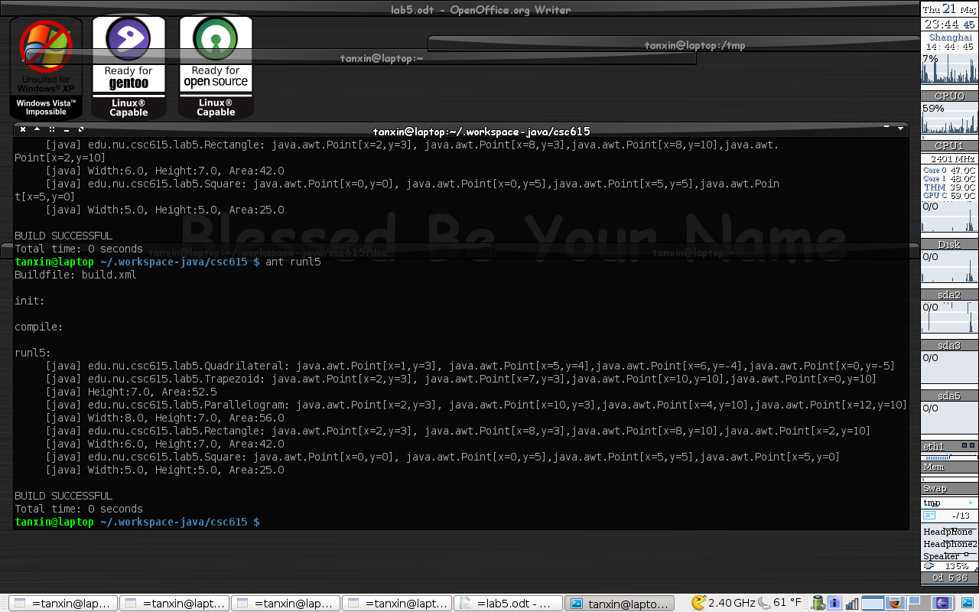

Code List:
edu.nu.csc615.lab5.Test.java
/**
* Lab5
*
* Copyright 2005-2009 Shin Tan <tanxincn@gmail.com>
*
*
* This program is free software; you can redistribute it and/or
* modify it under the terms of the GNU General Public License
* as published by the Free Software Foundation; either version 2
* of the License, or (at your option) any later version.
*
* This program is distributed in the hope that it will be useful,
* but WITHOUT ANY WARRANTY; without even the implied warranty of
* MERCHANTABILITY or FITNESS FOR A PARTICULAR PURPOSE. See the
* GNU General Public License for more details.
*
* You should have received a copy of the GNU General Public License
* along with this program; if not, write to the Free Software
* Foundation, Inc., 51 Franklin Street, Fifth Floor, Boston, MA 02110-1301, USA.
*
*
* @author tanxin
* Editor: vim
* Compile: sun-jdk-1.6.0.13 64bit
* Date: May 20th 2009
* Makefile:build.xml (runl5)
*/
package edu.nu.csc615.lab5;

import java.awt.Point;

public class Test {

/* for test */
public static void main(String[] args){
Quadrilateral shape1 = new Quadrilateral(new Point(1,3), new Point(5,4), new Point(6,-4), new Point(0,-5));

Trapezoid shape2 = new Trapezoid(new Point(2,3), new Point(7,3), new Point(10,10), new Point(0,10));
System.out.println(shape2);

Parallelogram shape3 = new Parallelogram(new Point(2,3), new Point(10,3), new Point(4,10), new Point(12,10));
System.out.println(shape3);

Rectangle shape4 = new Rectangle(new Point(2,3), new Point(8,3), new Point(8,10), new Point(2,10));
System.out.println(shape4);

Square shape5 = new Square(new Point(0,0), new Point(0,5), new Point(5,5), new Point(5,0));
System.out.println(shape5);
}

}
edu.nu.csc615.lab5.Quadrilateral.java
package edu.nu.csc615.lab5;

import java.awt.Point;

public class Quadrilateral{
private Point p1;
private Point p2;
private Point p3;
private Point p4;

public Quadrilateral( Point p1, Point p2, Point p3, Point p4 ){
this.p1 = p1;
this.p2 = p2;
this.p3 = p3;
this.p4 = p4;
System.out.println(getInfo());
}

@Override
public String toString(){
return getInfo();
}

private String getInfo(){
String string = String.format( "%s: %s, %s, %s, %s", this.getClass().getName(), p1, p2, p3, p4 );
return string;
}

/* getters and setters */
public Point getP1() {
return p1;
}

public void setP1(Point p1) {
this.p1 = p1;
}

public Point getP2() {
return p2;
}

public void setP2(Point p2) {
this.p2 = p2;
}

public Point getP3() {
return p3;
}

public void setP3(Point p3) {
this.p3 = p3;
}

public Point getP4() {
return p4;
}

public void setP4(Point p4) {
this.p4 = p4;
}

}
edu.nu.csc615.lab5.Trapezoid.java
package edu.nu.csc615.lab5;

import java.awt.Point;

public class Trapezoid extends Quadrilateral{

public Trapezoid(Point p1, Point p2, Point p3, Point p4){
super(p1, p2, p3, p4);
}

public double getHeight(){
return (getP1().getY()==getP2().getY())?Math.abs(getP2().getY()-getP3().getY()):Math.abs( getP1().getY()-getP2().getY());
}

public double getArea(){
double height = getHeight();
double base = (getP1().getY()==getP2().getY())?Math.abs(getP1().getX()-getP2().getX())+Math.abs(getP3().getX()-getP4().getX()):Math.abs(getP2().getX()-getP3().getX())+Math.abs(getP4().getX()-getP1().getX());
return height * base / 2.;
}

@Override
public String toString(){
return String.format("Height:%s, Area:%s", getHeight(), getArea());
}
}
edu.nu.csc615.lab5.Parallelogram.java
package edu.nu.csc615.lab5;

import java.awt.Point;

public class Parallelogram extends Trapezoid{
public Parallelogram(Point p1, Point p2, Point p3, Point p4){
super(p1, p2, p3, p4);
}

public double getWidth(){
return (getP1().getY()==getP2().getY())?Math.abs(getP1().getX()-getP2().getX()):Math.abs(getP2().getX()-getP3().getX());
}

@Override
public String toString(){
return String.format("Width:%s, Height:%s, Area:%s", getWidth(), getHeight(), getArea());
}
}
edu.nu.csc615.lab5.Rectangle.java
package edu.nu.csc615.lab5;

import java.awt.Point;

public class Rectangle extends Parallelogram{
public Rectangle(Point p1, Point p2, Point p3, Point p4){
super(p1, p2, p3, p4);
}
}
edu.nu.csc615.lab5.Square.java
package edu.nu.csc615.lab5;

import java.awt.Point;

public class Square extends Rectangle{
public Square(Point p1, Point p2, Point p3, Point p4){
super(p1, p2, p3, p4);
}
}

