Lab6 Project
Xin Tan
National University
CSC615
Professor Geoge H. Tanabe

Overview:
IDE: vim
Date: May 20th 2009
Compiler: SUN JDK 6.0 Linux 64bit (1.6)
Ant Makefile: build.xml
Project URL: http://github.com/tanxin/xin_csc615

Get SourceCode:
From Git (newest version):
tanxin@laptop ~/.workspace-java/csc615 $ git clone git://github.com/tanxin/xin_overlay.git

Compile:
tanxin@laptop ~/.workspace-java/csc615 $ ant compile
Buildfile: build.xml

init:
[mkdir] Created dir: /home/tanxin/documents/school/nu/CSC615/project/build

compile:
[javac] Compiling 7 source files to /home/tanxin/documents/school/nu/CSC615/project/build

BUILD SUCCESSFUL
Total time: 1 second

Run:
tanxin@laptop ~/.workspace-java/csc615 $ ant runl6
Buildfile: build.xml

init:

compile:
[javac] Compiling 1 source file to /home/tanxin/documents/school/nu/CSC615/project/build

runl6:

BUILD SUCCESSFUL
Total time: 1 second

Screenshot:
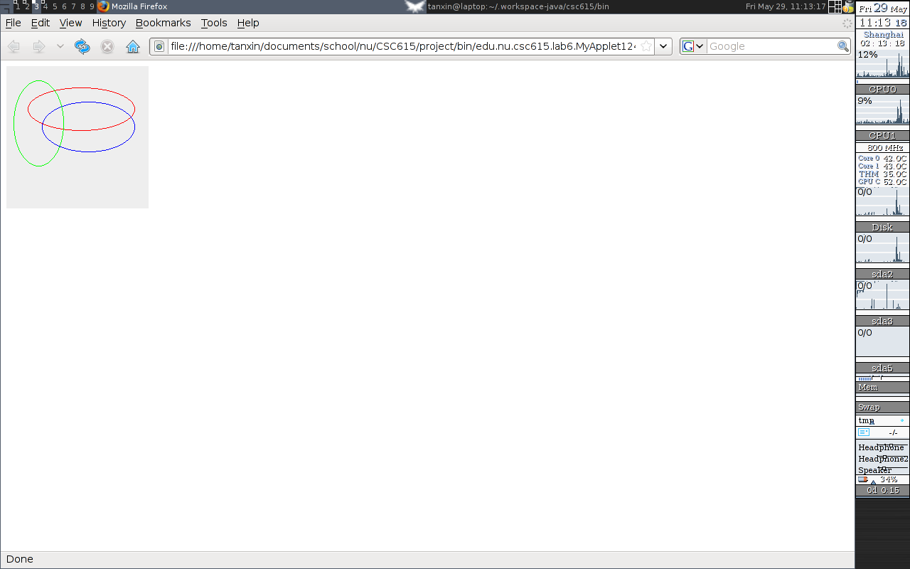

Code List:
edu.nu.csc615.lab6.MyApplet.java
package edu.nu.csc615.lab6;

import java.awt.Color;

import java.awt.Graphics;
import java.awt.event.MouseEvent;
import java.awt.event.MouseListener;

import javax.swing.JApplet;

public class MyApplet extends JApplet implements MouseListener {

int step=0;

public void init() {
addMouseListener(this);
}

public void paint(Graphics g){
super.paint(g);
if(step % 2 == 0){
g.setColor(Color.red);
g.drawOval(30, 30, 150, 60);
g.setColor(Color.blue);
g.drawRect(30, 30, 150, 60);
}else{
g.setColor(Color.red);
g.drawOval(30, 30, 150, 60);
g.setColor(Color.blue);
g.drawOval(50, 50, 130, 70);
g.setColor(Color.green);
g.drawOval(10, 20, 70, 120);
}
}

@Override
public void mouseClicked(MouseEvent e) {
step++;
repaint();
}

@Override
public void mouseEntered(MouseEvent e) {
// TODO Auto-generated method stub

}

@Override
public void mouseExited(MouseEvent e) {
// TODO Auto-generated method stub

}

@Override
public void mousePressed(MouseEvent e) {
// TODO Auto-generated method stub

}

@Override
public void mouseReleased(MouseEvent e) {
// TODO Auto-generated method stub

}
}

