Assignment3 Project
Xin Tan
National University
CSC615
Professor Geoge H. Tanabe

Overview:
IDE: vim
Date: May 14th 2009
Compiler: SUN JDK 6.0 Linux 64bit (1.6)
Ant Makefile: build.xml
Project URL: http://github.com/tanxin/xin_csc615

Version Control Information:
commit 757085b9a53876e8f1f7020a76ae0a617c84bff6
Author: Xin <tanxincn@gmail.com>
Date: Thu May 14 10:27:00 2009 -0700

added assignment3 lab3

src/edu/nu/csc615/assignment3/Assign3.java | 44 +++++
src/edu/nu/csc615/assignment3/FlashThread.java | 32 ++++
src/edu/nu/csc615/assignment3/PassCode.java | 224 ++++++++++++++++++++++++
src/edu/nu/csc615/lab3/Lab3.java | 105 +++++++++++
4 files changed, 405 insertions(+), 0 deletions(-)

Get SourceCode:
From Git (newest version):
tanxin@laptop ~/.workspace-java/csc615 $ git clone git://github.com/tanxin/xin_csc615.git
From CD-ROM:
tanxin@laptop ~/.workspace-java/csc615 $ cp -r /mnt/cdrom/* .

Compile:
tanxin@laptop ~/.workspace-java/csc615 $ ant compile
Buildfile: build.xml

init:
[mkdir] Created dir: /home/tanxin/documents/school/nu/CSC615/project/build

compile:
[javac] Compiling 6 source files to /home/tanxin/documents/school/nu/CSC615/project/build

BUILD SUCCESSFUL
Total time: 1 second

Run:
tanxin@laptop ~/.workspace-java/csc615 $ ant runa3
Buildfile: build.xml

init:

compile:

run:

BUILD SUCCESSFUL
Total time: 11 seconds

Screenshots:

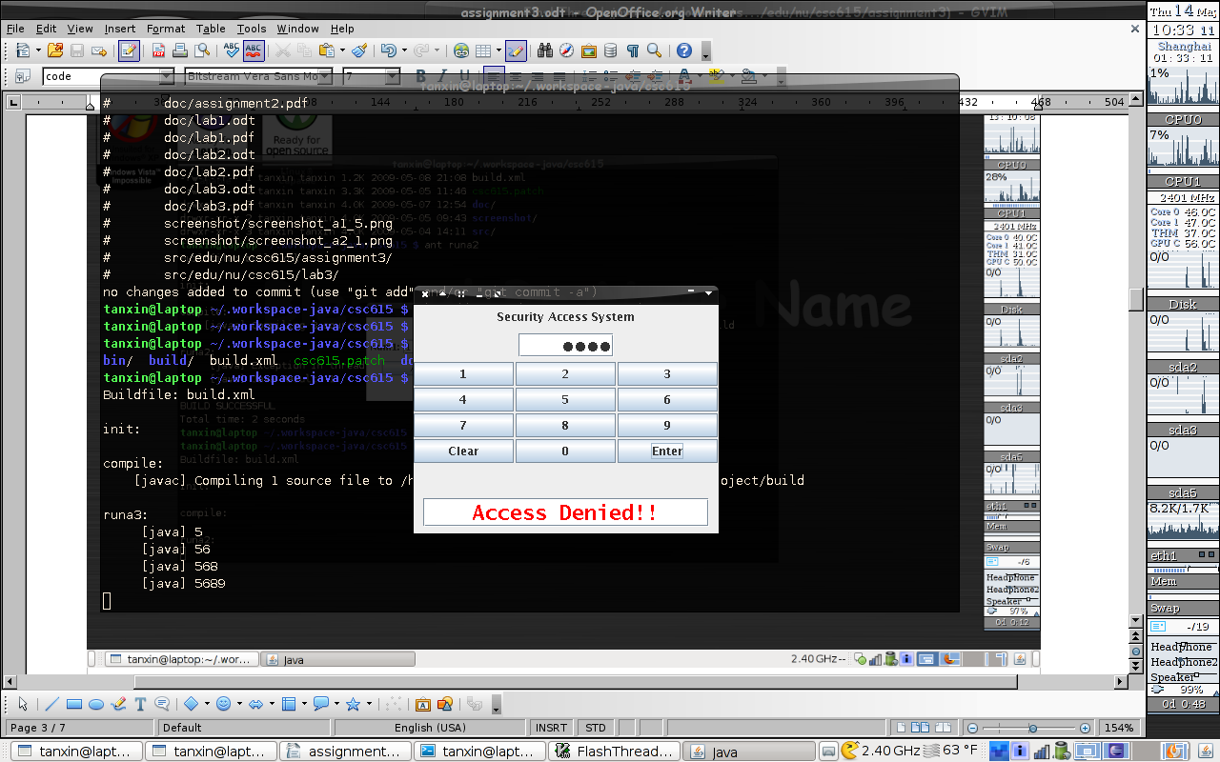

Memo:
If the computer has not ant build toolkit, it can be also compiled and run as this way.
tanxin@laptop ~/.workspace-java/csc615 $ rm -rf build
tanxin@laptop ~/.workspace-java/csc615 $ mkdir build
tanxin@laptop ~/.workspace-java/csc615 $ javac -cp src -d build src/edu/nu/csc615/assignment3/*.java
tanxin@laptop ~/.workspace-java/csc615 $ java -cp build edu.nu.csc615.assignment2.Assign3

Code List:
edu.nu.csc615.assignment3.Assign3.java
package edu.nu.csc615.assignment3;

import java.awt.EventQueue;

public class Assign3 {

/* entrance point */
public static void main(String[] args) {
EventQueue.invokeLater(new Runnable() {
public void run() {
new PassCode().setVisible(true);
}
});
}

}

edu.nu.csc615.assignment3.FlashThread.java
package edu.nu.csc615.assignment3;

import java.awt.Color;

import javax.swing.JFormattedTextField;

public class FlashThread extends Thread {

public JFormattedTextField textField;
public final static Color COLOR = Color.white;

public FlashThread(JFormattedTextField outputField){
this.textField = outputField;
}

public void run(){
Color buff;
buff = textField.getForeground();

for(int j=0; j<5; j++){
try {
Thread.sleep(500);
textField.setForeground(COLOR);
Thread.sleep(500);
textField.setForeground(buff);
} catch (InterruptedException e) {
//TODO: i eat it
}
}
}

}

edu.nu.csc615.assignment3.Passcode.java
package edu.nu.csc615.assignment3;

import java.awt.Color;
import java.awt.Container;
import java.awt.Dimension;
import java.awt.Font;
import java.awt.GridLayout;
import java.awt.event.ActionEvent;
import java.awt.event.ActionListener;

import javax.swing.BoxLayout;
import javax.swing.JButton;
import javax.swing.JFormattedTextField;
import javax.swing.JFrame;
import javax.swing.JLabel;
import javax.swing.JPanel;
import javax.swing.JPasswordField;
import javax.swing.JTextField;
import javax.swing.WindowConstants;
import javax.swing.border.EmptyBorder;

public class PassCode extends JFrame {

public final static int BUTTON_NUM = 12;
public final static int STATUS_NORMAL = 0;
public final static int STATUS_RESULT = 1;

private JPanel titlePane;
private JPanel passPane;
private JPanel buttonPane;
private JPanel outputPane;
private JButton[] buttonArray;

private JLabel titleLabel;
private JTextField passField;
private JFormattedTextField outputField;

private int status;
FlashThread flashThread;

/* constructure */
public PassCode() {

/* initialize object */
buttonArray = new JButton[BUTTON_NUM];
titleLabel = new JLabel("Security Access System");
passField = new JPasswordField();
outputField = new JFormattedTextField();

titlePane = new JPanel();
passPane = new JPanel();
buttonPane = new JPanel();
outputPane = new JPanel();

/* fields initialization */
Font font = new Font(Font.MONOSPACED, Font.BOLD, 22);
passField.setPreferredSize(new Dimension(100,25));
passField.setHorizontalAlignment(JPasswordField.RIGHT);
passField.setFont(font);
outputField.setPreferredSize(new Dimension(300,30));
outputField.setHorizontalAlignment(JTextField.CENTER);
outputField.setFont(font);
outputPane.setBorder(new EmptyBorder(5,0,0,0));

/* create uniform dimension for objects */
Dimension dimensionB = new Dimension(100, 30);

/* buttons initialization */
int j;
String[] buttonText = { "1", "2" , "3", "4", "5", "6" , "7", "8", "9", "Clear" , "0", "Enter"};
for(j=0; j<buttonArray.length ; j++){
buttonArray[j] = new JButton();
buttonArray[j].setText(buttonText[j]);
buttonArray[j].setSize(dimensionB);

switch(j){
case 0:
case 1:
case 2:
case 3:
case 4:
case 5:
case 6:
case 7:
case 8:
case 10:
buttonArray[j].addActionListener(new ActionListener() {
public void actionPerformed(ActionEvent evt) {
numButtonActionPerformed(evt);
}
});
break;

case 9:
buttonArray[j].addActionListener(new ActionListener() {
public void actionPerformed(ActionEvent evt) {
clearButtonActionPerformed(evt);
}
});
break;

case 11:
buttonArray[j].addActionListener(new ActionListener() {
public void actionPerformed(ActionEvent evt) {
enterButtonActionPerformed(evt);
}
});
}
}

/* layout definition */
Container contentPane = getContentPane();
contentPane.setLayout(new BoxLayout(contentPane, BoxLayout.Y_AXIS));
buttonPane.setLayout(new GridLayout(5,6,2,2));

contentPane.add(titlePane);
contentPane.add(passPane);
contentPane.add(buttonPane);
contentPane.add(outputPane);

titlePane.add(titleLabel);
passPane.add(passField);
for(j=0; j<buttonArray.length; j++){
buttonPane.add(buttonArray[j]);
}

outputPane.add(outputField);

contentPane.setPreferredSize(new Dimension(320,240));

/* apply layout */
pack();
/* close button can exit */
setDefaultCloseOperation(WindowConstants.EXIT_ON_CLOSE);
}

/* clearButton Action */
private void clearButtonActionPerformed(ActionEvent evt) {
clearAll();
}

/* exitButton Action */
private void enterButtonActionPerformed(ActionEvent evt) {
status = STATUS_RESULT;
if(flashThread != null && flashThread.isAlive())
flashThread.interrupt();

flashThread = new FlashThread(outputField);
int intText;
try{
intText = Integer.parseInt(passField.getText());
}catch (Exception e) {
intText = 0;
}

if( intText < 1000){
outputField.setText("Access Denied!!");
outputField.setForeground(Color.RED);
}else if(intText >= 1645 && intText <=1689){
outputField.setText("Technical Personnel!!");
outputField.setForeground(Color.GREEN);
}else if(intText == 8345){
outputField.setText("Custodian Services!!");
outputField.setForeground(Color.GREEN);
}else if(intText == 55875){
outputField.setText("Special Services!!");
outputField.setForeground(Color.GREEN);
}else if(intText == 999898 || (intText >= 1000006 && intText <= 1000008)){
outputField.setText("Science Personnel!!");
outputField.setForeground(Color.GREEN);
}else{
outputField.setText("Access Denied!!");
outputField.setForeground(Color.RED);
}

flashThread.start();
}

private void numButtonActionPerformed(ActionEvent evt) {
if(status==STATUS_RESULT)
clearAll();
JButton btm = (JButton) evt.getSource();
passField.setText(passField.getText() + btm.getText());
System.out.println(passField.getText());
}

private void clearAll(){
passField.setText("");
outputField.setText("");
status = STATUS_NORMAL;
}
}

