Assignment4 Project
Xin Tan
National University
CSC615
Professor Geoge H. Tanabe

Overview:
IDE: vim
Date: May 17th 2009
Compiler: SUN JDK 6.0 Linux 64bit (1.6)
Ant Makefile: build.xml
Project URL: http://github.com/tanxin/xin_csc615

Version Control Information:
commit 757085b9a53876e8f1f7020a76ae0a617c84bff6
Author: Xin <tanxincn@gmail.com>
Date: Thu May 17 10:27:00 2009 -0700

added assignment4

src/edu/nu/csc615/assignment4/DrugTester.java | 287 +++++
1 files changed, 287 insertions(+), 0 deletions(-)

Get SourceCode:
From Git (newest version):
tanxin@laptop ~/.workspace-java/csc615 $ git clone git://github.com/tanxin/xin_csc615.git
From CD-ROM:
tanxin@laptop ~/.workspace-java/csc615 $ cp -r /mnt/cdrom/* .

Compile:
tanxin@laptop ~/.workspace-java/csc615 $ ant compile
Buildfile: build.xml

init:
[mkdir] Created dir: /home/tanxin/documents/school/nu/CSC615/project/build

compile:
[javac] Compiling 6 source files to /home/tanxin/documents/school/nu/CSC615/project/build

BUILD SUCCESSFUL
Total time: 1 second

Run:
tanxin@laptop ~/.workspace-java/csc615 $ ant runa4
Buildfile: build.xml

init:

compile:

run:

BUILD SUCCESSFUL
Total time: 11 seconds

Screenshots:

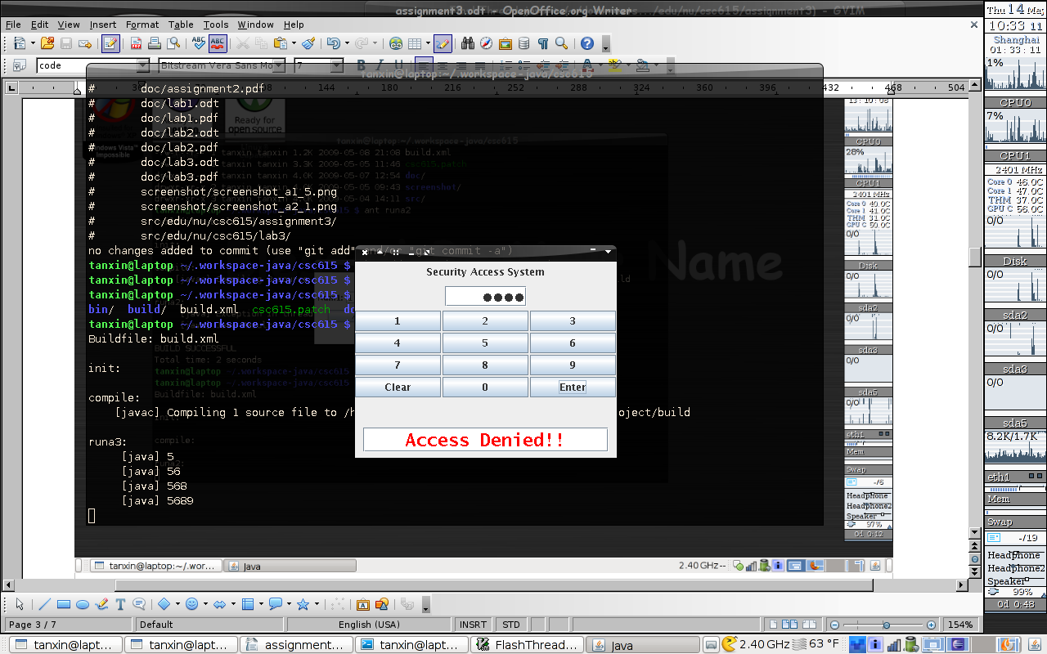

Memo:
If the computer has not ant build toolkit, it can be also compiled and run as this way.
tanxin@laptop ~/.workspace-java/csc615 $ rm -rf build
tanxin@laptop ~/.workspace-java/csc615 $ mkdir build
tanxin@laptop ~/.workspace-java/csc615 $ javac -cp src -d build src/edu/nu/csc615/assignment4/*.java
tanxin@laptop ~/.workspace-java/csc615 $ java -cp build edu.nu.csc615.assignment4.DrugTester

Code List:
edu.nu.csc615.assignment4.DrugTester.java
/**
* Assignment 4
*
* Copyright 2005-2009 Shin Tan <tanxincn@gmail.com>
*
*
* This program is free software; you can redistribute it and/or
* modify it under the terms of the GNU General Public License
* as published by the Free Software Foundation; either version 2
* of the License, or (at your option) any later version.
*
* This program is distributed in the hope that it will be useful,
* but WITHOUT ANY WARRANTY; without even the implied warranty of
* MERCHANTABILITY or FITNESS FOR A PARTICULAR PURPOSE. See the
* GNU General Public License for more details.
*
* You should have received a copy of the GNU General Public License
* along with this program; if not, write to the Free Software
* Foundation, Inc., 51 Franklin Street, Fifth Floor, Boston, MA 02110-1301, USA.
*
*
* @author tanxin
* Editor: vim
* Compile: sun-jdk-1.6.0.13 64bit
* Date: May 17th 2009
* Makefile:build.xml (runa4)
*/

package edu.nu.csc615.assignment4;

import java.awt.event.ActionEvent;
import java.util.ArrayList;
import java.util.Random;

import javax.swing.AbstractListModel;
import javax.swing.BorderFactory;
import javax.swing.BoxLayout;
import javax.swing.JButton;
import javax.swing.JFrame;
import javax.swing.JLabel;
import javax.swing.JList;
import javax.swing.JOptionPane;
import javax.swing.JPanel;
import javax.swing.JScrollPane;
import javax.swing.JTextField;
import javax.swing.WindowConstants;

public class DrugTester extends JFrame {

private JButton startButton;
private JButton resetButton;
private JButton undoButton;
private JButton exitButton;
private JLabel jLabel1;
private JLabel jLabel2;
private JLabel jLabel3;
private JList jList1;
private JList jList2;
private JPanel jPanel1;
private JPanel jPanel2;
private JPanel jPanel3;
private JPanel jPanel4;
private JScrollPane jScrollPane1;
private JScrollPane jScrollPane2;
private JTextField jTextField1;
private ArrayList<String> selectList;
private ArrayList<String> candidateList;
private ArrayList<ArrayList<String>> undoList1;
private ArrayList<ArrayList<String>> undoList2;

/** Creates new form NewJFrame1 */
public DrugTester() {
resetData();
initGUI();
}

private void resetData() {
selectList = new ArrayList<String>();
candidateList = new ArrayList<String>();
undoList1 = new ArrayList<ArrayList<String>>();
undoList2 = new ArrayList<ArrayList<String>>();
candidateList.add("Hakeem Olajuwon");
candidateList.add("Yao Ming");
candidateList.add("Clyde Drexler");
candidateList.add("Moses Malone");
candidateList.add("Robert Horry");
candidateList.add("Sam Cassell");
candidateList.add("Elvin Hayes");
candidateList.add("Cutino Mobley");
candidateList.add("John Lucas");
candidateList.add("Kenny Smith");
candidateList.add("Mario Ellie");
candidateList.add("Robert Reid");
candidateList.add("Stevie Francis");
candidateList.add("Tracy McGrady");
candidateList.add("Buck Johnson");
candidateList.add("Chuck Hayes");
candidateList.add("Eddie Johnson");
candidateList.add("Eric Sleepy Floyd");
candidateList.add("Jim Peterson");
candidateList.add("Larry Smith");
}

private void initGUI() {
jPanel1 = new JPanel();
jLabel1 = new JLabel();
jPanel2 = new JPanel();
jLabel2 = new JLabel();
jTextField1 = new JTextField();
jLabel3 = new JLabel();
jPanel3 = new JPanel();
startButton = new JButton();
resetButton = new JButton();
undoButton = new JButton();
exitButton = new JButton();
jPanel4 = new JPanel();
jScrollPane1 = new JScrollPane();
jList1 = new JList();
jScrollPane2 = new JScrollPane();
jList2 = new JList();

setDefaultCloseOperation(WindowConstants.EXIT_ON_CLOSE);
setTitle("NFL Drug Testing System v1.0");
setMinimumSize(new java.awt.Dimension(640, 480));
getContentPane().setLayout(new BoxLayout(getContentPane(), BoxLayout.Y_AXIS));

jPanel1.setLayout(new BoxLayout(jPanel1, BoxLayout.LINE_AXIS));
jPanel1.setBorder(BorderFactory.createEmptyBorder(20, 0, 20, 0));

jLabel1.setFont(new java.awt.Font("Dialog", 3, 24)); // NOI18N
jLabel1.setText("NFL Drug Testing Program");
jPanel1.add(jLabel1);

getContentPane().add(jPanel1);

jPanel2.setBorder(BorderFactory.createEmptyBorder(10, 120, 1, 120));
jPanel2.setLayout(new BoxLayout(jPanel2, BoxLayout.X_AXIS));

jLabel2.setText("No. of Candidates");
jPanel2.add(jLabel2);

jTextField1.setText("0");
jTextField1.setPreferredSize(new java.awt.Dimension(10, 30));
jTextField1.setSize(new java.awt.Dimension(10, 30));
jPanel2.add(jTextField1);

jPanel2.add(jLabel3);

getContentPane().add(jPanel2);

jPanel3.setLayout(new java.awt.GridLayout(1, 0, 10, 0));

startButton.setText("Start");
startButton.addActionListener(new java.awt.event.ActionListener() {
public void actionPerformed(java.awt.event.ActionEvent evt) {
startButtonActionPerformed(evt);
}
});
jPanel3.add(startButton);

resetButton.setText("Reset");
resetButton.addActionListener(new java.awt.event.ActionListener() {
public void actionPerformed(java.awt.event.ActionEvent evt) {
resetButtonActionPerformed(evt);
}
});
jPanel3.add(resetButton);

undoButton.setText("Undo");
undoButton.addActionListener(new java.awt.event.ActionListener() {
public void actionPerformed(java.awt.event.ActionEvent evt) {
undoButtonActionPerformed(evt);
}
});
jPanel3.add(undoButton);

exitButton.setText("Exit");
exitButton.addActionListener(new java.awt.event.ActionListener() {
public void actionPerformed(java.awt.event.ActionEvent evt) {
exitButtonActionPerformed(evt);
}
});
jPanel3.add(exitButton);

getContentPane().add(jPanel3);

jPanel4.setBorder(BorderFactory.createTitledBorder("Selection Results"));
jPanel4.setLayout(new java.awt.GridLayout(1, 0, 10, 0));

jScrollPane1.setViewportView(jList1);

jPanel4.add(jScrollPane1);

jScrollPane2.setViewportView(jList2);
jScrollPane2.setPreferredSize(new java.awt.Dimension(110, 340));

jPanel4.add(jScrollPane2);

getContentPane().add(jPanel4);

pack();

myrefresh();
}

public static void main(String args[]) {
java.awt.EventQueue.invokeLater(new Runnable() {
public void run() {
new DrugTester().setVisible(true);
}
});
}

private void startButtonActionPerformed(ActionEvent evt) {
int num;
try{
num = Integer.parseInt(jTextField1.getText());
}catch (NumberFormatException e) {
JOptionPane.showMessageDialog(this, "Please enter the number in textbox");
return;
}

int i;
String tmp;
ArrayList<String> undo = new ArrayList<String>();

if(candidateList.size()<num)
num = candidateList.size();
if(num<1) return;

undoList1.add(new ArrayList<String>(selectList));
selectList.clear();

Random random = new Random();
for(int j=0;j<num;j++){
i = random.nextInt(candidateList.size());
tmp = candidateList.remove(i);
undo.add(tmp);
selectList.add(tmp);
}
undoList2.add(undo);
myrefresh();
}

private void myrefresh() {
jList1.setModel(new AbstractListModel() {
public int getSize() { return selectList.size(); }
public Object getElementAt(int i) { return selectList.get(i); }
});

jList2.setModel(new AbstractListModel() {
public int getSize() { return candidateList.size(); }
public Object getElementAt(int i) { return candidateList.get(i); }
});
jLabel3.setText("(Remaining candidates: " + candidateList.size() + ")");
if(undoList1.size()>0)
undoButton.setEnabled(true);
else
undoButton.setEnabled(false);
}

private void exitButtonActionPerformed(ActionEvent evt) {
System.exit(0);
}
private void resetButtonActionPerformed(ActionEvent evt) {
resetData();
myrefresh();
}
private void undoButtonActionPerformed(ActionEvent evt) {
if(undoList1.size()>0 && undoList2.size()>0){
selectList= undoList1.remove(undoList1.size()-1);
candidateList.addAll(undoList2.remove(undoList2.size()-1));
}
myrefresh();
}

}

