Lab4 Project
Xin Tan
National University
CSC615
Professor Geoge H. Tanabe

Overview:
IDE: vim
Date: May 18th 2009
Compiler: SUN JDK 6.0 Linux 64bit (1.6)
Ant Makefile: build.xml
Project URL: http://github.com/tanxin/xin_csc615

Get SourceCode:
From Git (newest version):
tanxin@laptop ~/.workspace-java/csc615 $ git clone git://github.com/tanxin/xin_overlay.git

Compile:
tanxin@laptop ~/.workspace-java/csc615 $ ant compile
Buildfile: build.xml

init:
[mkdir] Created dir: /home/tanxin/documents/school/nu/CSC615/project/build

compile:
[javac] Compiling 7 source files to /home/tanxin/documents/school/nu/CSC615/project/build

BUILD SUCCESSFUL
Total time: 1 second

Run:
tanxin@laptop ~/.workspace-java/csc615 $ java -cp build edu.nu.csc615.lab4.Time2Test
Enter the time
Hours:11
Minutes:22
Seconds:33
1. Add 1 second
2. Add 1 Minute
3. Add 1 Hour
4. Add seconds
5. Exit
Choice:1
Universal time: 11:22:34 Standard time: 11:22:34 AM
1. Add 1 second
2. Add 1 Minute
3. Add 1 Hour
4. Add seconds
5. Exit
Choice:2
Universal time: 11:23:34 Standard time: 11:23:34 AM
1. Add 1 second
2. Add 1 Minute
3. Add 1 Hour
4. Add seconds
5. Exit
Choice:3
Universal time: 12:23:34 Standard time: 12:23:34 PM
1. Add 1 second
2. Add 1 Minute
3. Add 1 Hour
4. Add seconds
5. Exit
Choice:4
Enter seconds to tick:20
Universal time: 12:23:54 Standard time: 12:23:54 PM
1. Add 1 second
2. Add 1 Minute
3. Add 1 Hour
4. Add seconds
5. Exit
Choice:5

Screenshot:
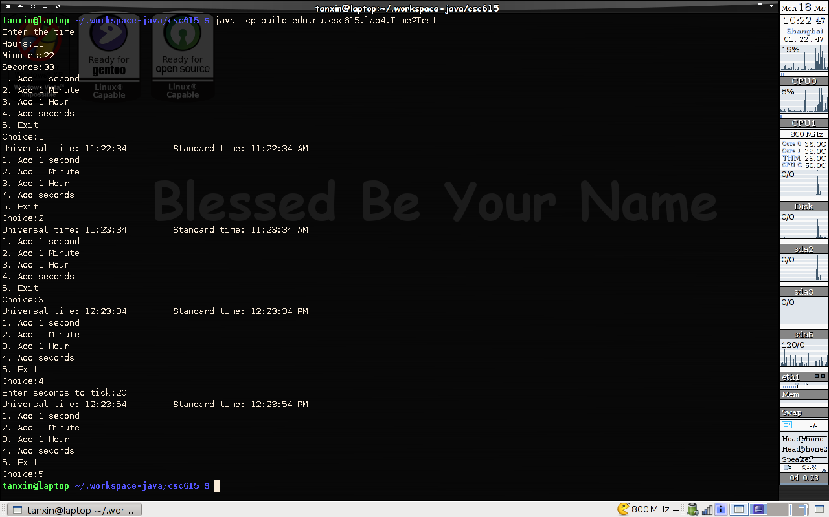

Code List:
edu.nu.csc615.lab4.Time2Test.java
/**
* Lab4
*
* Copyright 2005-2009 Shin Tan <tanxincn@gmail.com>
*
*
* This program is free software; you can redistribute it and/or
* modify it under the terms of the GNU General Public License
* as published by the Free Software Foundation; either version 2
* of the License, or (at your option) any later version.
*
* This program is distributed in the hope that it will be useful,
* but WITHOUT ANY WARRANTY; without even the implied warranty of
* MERCHANTABILITY or FITNESS FOR A PARTICULAR PURPOSE. See the
* GNU General Public License for more details.
*
* You should have received a copy of the GNU General Public License
* along with this program; if not, write to the Free Software
* Foundation, Inc., 51 Franklin Street, Fifth Floor, Boston, MA 02110-1301, USA.
*
*
* @author tanxin
* Editor: vim
* Compile: sun-jdk-1.6.0.13 64bit
* Date: May 17th 2009
* Makefile:build.xml (runa4)
*
* Copyright: Fig. 8.6: Time2Test.java
*/
package edu.nu.csc615.lab4;

import java.util.Scanner;

public class Time2Test
{
public static void main( String args[] )
{
/* input buffer */
int input;

/* initialize time */
Time2 t = new Time2();

System.out.println("Enter the time");

System.out.print("Hours:");
Scanner scanner = new Scanner(System.in);
t.setHour(scanner.nextInt());

System.out.print("Minutes:");
t.setMinute(scanner.nextInt());

System.out.print("Seconds:");
t.setSecond(scanner.nextInt());

/* show menu in loop */
while(true){
System.out.println("1. Add 1 second");
System.out.println("2. Add 1 Minute");
System.out.println("3. Add 1 Hour");
System.out.println("4. Add seconds");
System.out.println("5. Exit");

System.out.print("Choice:");
input = scanner.nextInt();

switch(input){
/* add 1 second */
case 1:
t.setSecond(t.getSecond()+1);
break;
/* add 1 minute */
case 2:
t.setMinute(t.getMinute()+1);
break;
/* add 1 hour */
case 3:
t.setHour(t.getHour()+1);
break;
/* add particular seconds */
case 4:
System.out.print("Enter seconds to tick:");
input = scanner.nextInt();
t.setSecond(t.getSecond() + input);
break;
case 5:
System.exit(0);

default:
System.out.println("Wrong choice !!");
break;
}

/* output result */
System.out.printf( "Universal time: %s\t Standard time: %s\n", t.toUniversalString(), t.toString());
}

}
}

/**************************************************************************
* (C) Copyright 1992-2007 by Deitel & Associates, Inc. and *
* Pearson Education, Inc. All Rights Reserved. *
* *
* DISCLAIMER: The authors and publisher of this book have used their *
* best efforts in preparing the book. These efforts include the *
* development, research, and testing of the theories and programs *
* to determine their effectiveness. The authors and publisher make *
* no warranty of any kind, expressed or implied, with regard to these *
* programs or to the documentation contained in these books. The authors *
* and publisher shall not be liable in any event for incidental or *
* consequential damages in connection with, or arising out of, the *
* furnishing, performance, or use of these programs. *
*
edu.nu.csc615.lab4.Time.java
package edu.nu.csc615.lab4;

public class Time2
{
private int hour; // 0 - 23
private int minute; // 0 - 59
private int second; // 0 - 59

// Time2 no-argument constructor: initializes each instance variable
// to zero; ensures that Time2 objects start in a consistent state
public Time2()
{
this( 0, 0, 0 ); // invoke Time2 constructor with three arguments
} // end Time2 no-argument constructor

// Time2 constructor: hour supplied, minute and second defaulted to 0
public Time2( int h )
{
this( h, 0, 0 ); // invoke Time2 constructor with three arguments
} // end Time2 one-argument constructor

// Time2 constructor: hour and minute supplied, second defaulted to 0
public Time2( int h, int m )
{
this( h, m, 0 ); // invoke Time2 constructor with three arguments
} // end Time2 two-argument constructor

// Time2 constructor: hour, minute and second supplied
public Time2( int h, int m, int s )
{
setTime( h, m, s ); // invoke setTime to validate time
} // end Time2 three-argument constructor

// Time2 constructor: another Time2 object supplied
public Time2( Time2 time )
{
// invoke Time2 three-argument constructor
this( time.getHour(), time.getMinute(), time.getSecond() );
} // end Time2 constructor with a Time2 object argument

// Set Methods
// set a new time value using universal time; ensure that
// the data remains consistent by setting invalid values to zero
public void setTime( int h, int m, int s )
{
setHour( h ); // set the hour
setMinute( m ); // set the minute
setSecond( s ); // set the second
} // end method setTime

// validate and set hour
public void setHour( int h )
{
hour = ( ( h >= 0 && h < 24 ) ? h : 0 );
} // end method setHour

// validate and set minute
public void setMinute( int m )
{
minute = ( ( m >= 0 && m < 60 ) ? m : 0 );
} // end method setMinute

// validate and set second
public void setSecond( int s )
{
second = ( ( s >= 0 && s < 60 ) ? s : 0 );
} // end method setSecond

// Get Methods
// get hour value
public int getHour()
{
return hour;
} // end method getHour

// get minute value
public int getMinute()
{
return minute;
} // end method getMinute

// get second value
public int getSecond()
{
return second;
} // end method getSecond

// convert to String in universal-time format (HH:MM:SS)
public String toUniversalString()
{
return String.format(
"%02d:%02d:%02d", getHour(), getMinute(), getSecond() );
} // end method toUniversalString

// convert to String in standard-time format (H:MM:SS AM or PM)
public String toString()
{
return String.format( "%d:%02d:%02d %s",
( (getHour() == 0 || getHour() == 12) ? 12 : getHour() % 12 ),
getMinute(), getSecond(), ( getHour() < 12 ? "AM" : "PM" ) );
} // end method toString
} // end class Time2

/**************************************************************************
* (C) Copyright 1992-2007 by Deitel & Associates, Inc. and *
* Pearson Education, Inc. All Rights Reserved. *
* *
* DISCLAIMER: The authors and publisher of this book have used their *
* best efforts in preparing the book. These efforts include the *
* development, research, and testing of the theories and programs *
* to determine their effectiveness. The authors and publisher make *
* no warranty of any kind, expressed or implied, with regard to these *
* programs or to the documentation contained in these books. The authors *
* and publisher shall not be liable in any event for incidental or *
* consequential damages in connection with, or arising out of, the *
* furnishing, performance, or use of these programs. *
*

