Team Member: Tanya Peddi

1. **An Enhanced Visualization Process Model for Incremental Visualization**

The concept of incremental visualization is very helpful to analyze the data when the data is changing frequently. Incremental visualization approaches are a means to address this challenge, as they permit the user to interact with, steer, and change the visualization at intermediate time points and not just after it has been completed. This will be a great asset to Daimler as this gives instant visualization of data and make decisions more precisely. This visualization makes data comparing more easily and realistic. The model provides for a high-level representation of the incremental visualization process and presents a suitable means to interact with the visualization pipeline

References: <http://ieeexplore.ieee.org/document/7172541/>

1. **StretchPlot: Interactive visualization of multi-dimensional trajectory data**

The visualization of space-time trajectory data is challenging since, in most cases, the data inherently exists in more than two dimensions. In many space-time visualizations, additional variables must be mapped into other visual attributes such as color or size. Given that substantive analyses of trajectory data will likely be concerned with variables beyond space and time, we propose a method that allows trajectory positions to be determined by an arbitrary number of variables in a multi-dimensional space-time dataset. We can make use of this type of visualization in Daimler item-short dataset with TS_LOAD, SHORT_TYPE and RESOLVED acting as multi-dimensional attributes.

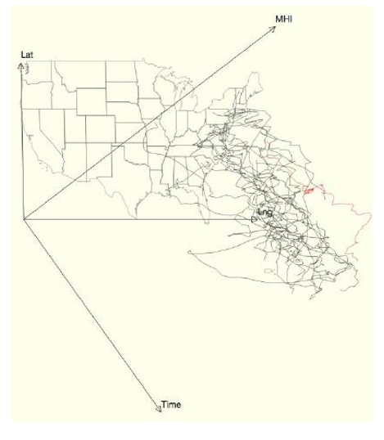

References: <http://ieeexplore.ieee.org/document/7042520/>

1. **An Interactive Method for Activity Detection Visualization.**

This paper is about understanding the data and phenomena by visualizing each time step in an activity from a scientific dataset. In this paper, the author presents a Graphical User Interface (GUI) to first graphically model an activity, then detect any activities that match the model, and finally visualize the detected activities in time varying scientific data sets. As a graphical and state based interactive approach, an activity detection framework is implemented by the GUI as a tool for modelling, hypothesis testing and searching for interested activities from the phenomena evolution of the data set. Also, some features of the GUI are also demonstrated, for e.g. a histogram is used to visualize the number of activities detected as a function of time and to allow the user to focus on a moment in time. Using the given Daimler dataset, we can use this feature to visualize the ongoing activities in timely manner. A sample (used on a different dataset) is given below:

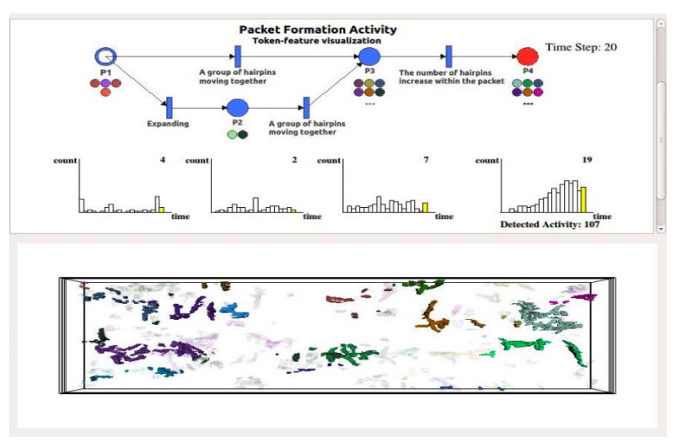

References: <http://ieeexplore.ieee.org/document/6675173/>

1. **Comparative Case Study Between D3 & Highcharts on Lustre Metadata Visualization**

This paper is about the challenging tasks in visual analytics in order to target clustered time-series data sets, since it is important for data analysts to discover patterns changing over time while keeping their focus on particular subsets. A web-based application to monitor the Lustre file system for system administrators and operation teams has been developed using D3 and Highcharts. This application is a use case to compare those JavaScript libraries demonstrating the differences in capabilities of using them. We have had a lot of papers which are based on pure data visualization part, but we also wanted to include one paper which gives us a little more detail about the practical implementation of such charts with D3.js. Hence, we plan to include this paper in our Literature survey as well.

References: <http://ieeexplore.ieee.org/document/6675172/>

1. **How to visualize data with cartoonish Faces**

The goal of chernoff faces is to show a bunch of variables at once VIA facial features like face, lips, hair, ear etc. We can use this in our project to perfectly know the plants overall performance like if the plant has dull performance and the number of people who attended the firm is low then they are represented by small chernoff faces whereas the larger face indicates that the plant performance is good.

References: http://flowingdata.com/2010/08/31/how-to-visualize-data-with-cartoonish-faces/

1. **Saito, Takafumi, Hiroko Nakamura Miyamura, Mitsuyoshi Yamamoto, Hiroki Saito, Yuka Hoshiya, and Takumi Kaseda. "Two-tone pseudo coloring: Compact visualization for one-dimensional data." In Information Visualization, 2005. INFOVIS 2005. IEEE Symposium on, pp. 173-180. IEEE, 2005.**

Paper discuss the new pseudo coloring technique for large scale one-dimensional datasets. In large scale data set, visualization is indispensable for selecting focus areas. The goal of this research is to develop techniques for visualizing details as precisely as possible. The proposed method is based on pseudo coloring; however, each scalar value corresponds to two discrete colors. By painting with two colors at each value, users can read out the value precisely. This method has many advantages: it requires little image space for visualization; both the overview and details of the dataset are visible in one image without distortion; and implementation is very simple. Several application examples, such as meteorological observation data and train convenience evaluation data, show the effectiveness of the method. We have the record of employees of a company that is very large data set. Two-tone pseudo coloring is all about precising the data into two colors. So, on single window we can visualize the data easily and user will be able to read the data value.