# **Project #1 Exploring Weather Trends**

**Step 1**

For project I used SQL query to extract the data:

query was used to look for list of Russia's cities

select * from city_list

WHERE country='Russia';

query was used to look for list of Canada's cities

select * from city_list

WHERE country='Canada';

query was used to extract data for Moscow

SELECT * FROM city_data

WHERE city='Moscow';

query was used to extract data for Toronto

SELECT * FROM city_data

WHERE city='Toronto';

query was used to extract Global data

SELECT * FROM global_data;

**Step 2**

I used Google Sheets to work with data, where I have calculated 10 Year Moving Averages because Moving Averages helps to smooth out data to make it easier to observe long term trends.

I did it using the formula AVERAGE by dragging it down and applying it for all years.

*Example*

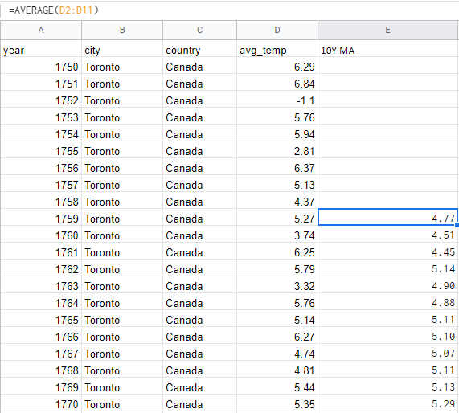

**Step 3**

Smooth line chart was created based on 10 Year Moving Averages data.

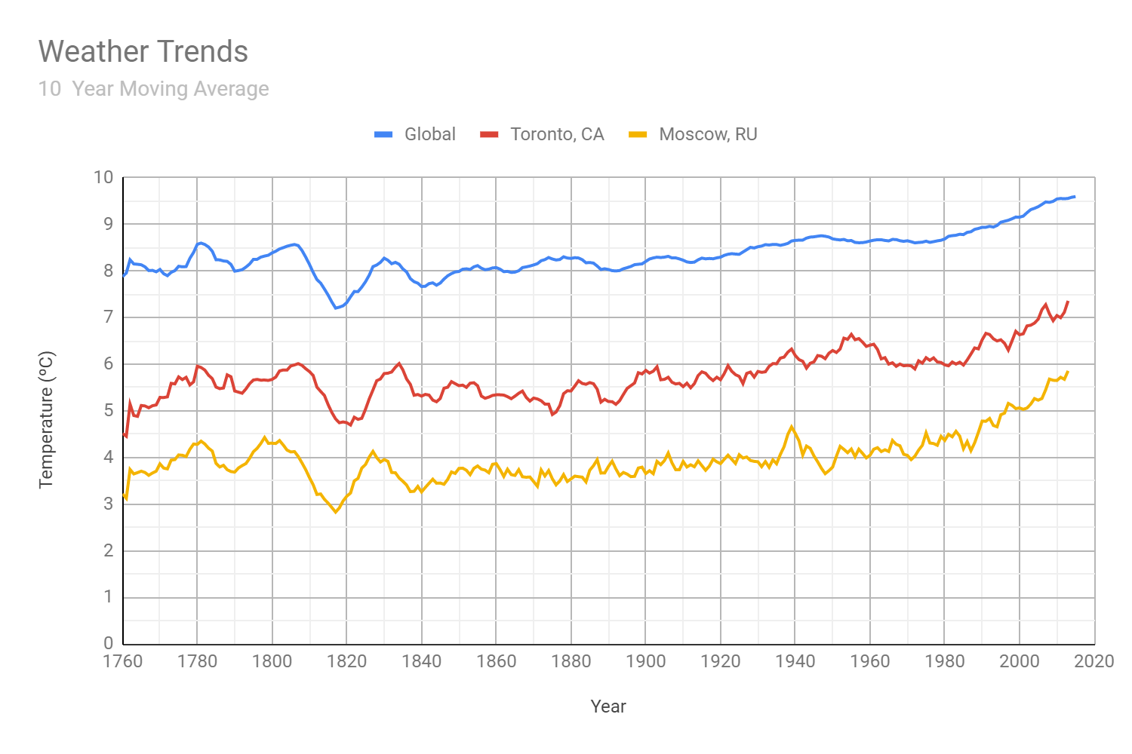

At first glance trends look pretty much similar but if we look at some specific periods we are able to see the differences.

1760 - 1780

Toronto temperature is increasing for almost for 1.5ºC from 4.5ºC to 6ºC similar to temperature in Moscow from 3.0ºC to 4.5ºC, when Global temperature changes for 0.5ºC from 8.0ºC to 8.5ºC.

1780 - 1800

These two decades begin with decreasing for 0.5ºC but end with rising back Global, Toronto and Moscow temperatures. The exception is that Toronto also has a fast rise and down of temperature in the middle of decades.

1800 - 1840

The most fluctuated decades. From 1800 to 1820 temperatures fell almost for 1.5ºC globally as in Toronto and Moscow. After year 1820 temperatures grow fast for almost 1.5ºC back and then drop for 0.75ºC by 1840.

1840 - 1940

During this century Global temperature more or less smoothly grows for 1.0ºC from 7.75ºC to 8.75ºC as temperature in Toronto from 5.25ºC to 6.25ºC and Moscow from 3.5ºC to 4.5ºC. The line of temperatures in Toronto fluctuates more than Moscow’s, but just before 1940 temperature rises sharply in Moscow for more than 0.5ºC.

1940 - 1980

During these decades Global temperature doesn’t change mach, when temperature in Toronto increases for 0.5ºC from 6.0ºC to 6.5ºC but then goes back to 6.0ºC after 1960. First decade after 1940 temperature in Moscow decreases for 1.0ºC from 4.5ºC to 3.5ºC but after that starts to grow back to 4.5ºC by 1980.

1980 - 2020

During the last 4 decades global temperature and temperatures in Toronto and Moscow have been increasing for almost for 1.5ºC. Global from 8.5ºC to 9.5ºC, Toronto from 6.0ºC to 7.5ºC and Moscow from 4.5ºC to 6.0ºC

To conclude, trends of global temperature and cities temperatures may differ during a short period of time, nevertheless the main trend is the same and it is temperature increasing. Since 1760 Global temperature has grown for 1.5ºC from 8.0ºC to 9.5ºC, temperature in Toronto have grown for 3.0ºC from 4.5ºC to 7.5ºC, and temperature in Moscow have grown for 3.0ºC from 3.0ºC to 6ºC.