MOBILE PRICE PREDICTION USING MACHINE LEARNING
Prepared By: Tanya Gera
Company: NextHikes IT Solutions
Submission Date: 15/11/2025

Executive Summary
This project focuses on predicting mobile phone prices using machine learning models. The goal is to understand which smartphone features most strongly influence price, and to develop predictive models capable of estimating price based on specifications. Through exploratory data analysis (EDA), feature engineering, and evaluation across multiple algorithms, the project finds that Decision Tree and XGBoost models provide the highest accuracy. The study demonstrates the full workflow of data preprocessing, model training, testing, and interpretation.

1. Introduction
With thousands of smartphones available in the market, pricing depends on numerous factors such as hardware, design, brand, and performance. Understanding how different features impact smartphone pricing helps businesses optimize pricing strategies and predict market demand. This project builds a machine learning pipeline to analyze these relationships and predict mobile phone prices accurately.

2. Problem Statement
The objective of this project is to predict the price of a mobile phone based on its hardware and performance features. Using machine learning, we aim to identify the key factors that influence price and create a model capable of accurate prediction.

3. Dataset Description
The dataset contains 541 records and 11 features related to mobile phone specifications. The features include:
- Model: Phone model name
- Colour: Device color
- Memory: Storage capacity (GB)
- RAM: Random access memory (GB)
- Battery_: Battery capacity in mAh
- Rear_camera: Rear camera MP
- Front_camera: Front camera MP
- AI_lens: AI camera support
- Mobile_height: Physical height (cm)
- Processor_: CPU chipset
- Price: Target variable

4. Exploratory Data Analysis (EDA)

4.1 Numerical Summary
The numerical features show substantial variation. Memory ranges from 16GB to 256GB, RAM ranges from 2GB to 8GB, and battery values cluster around 5000 mAh. Camera megapixels have high variability, with some premium phones featuring advanced camera modules.
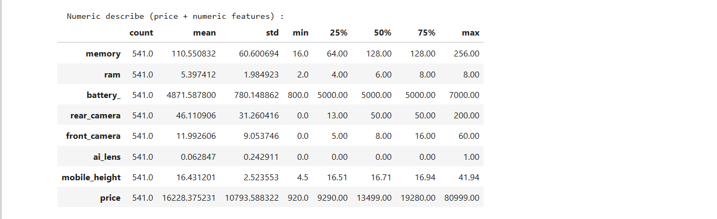

4.2 Price Distribution
Price distribution is right-skewed with skewness ~2.41 and kurtosis ~9.5. This indicates a long tail caused by high-end smartphones. Most phones fall into mid-range pricing, while flagship models appear as extreme outliers.
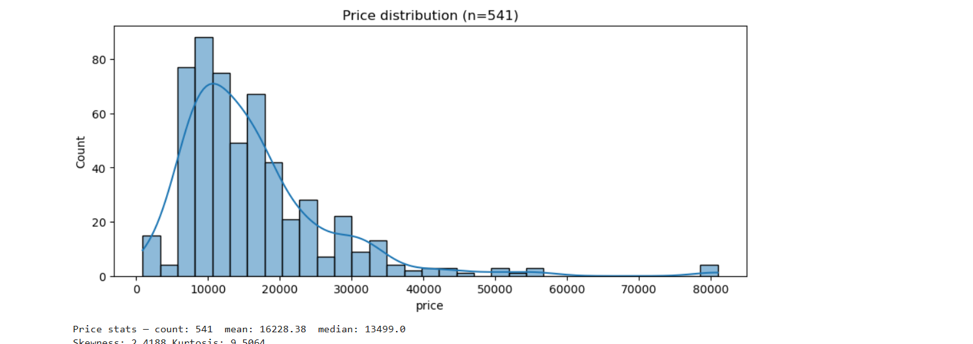

4.3 Outlier Detection
Several price outliers exist between ₹50,000–₹80,000, representing premium smartphones. These outliers increase the mean and affect the overall distribution.
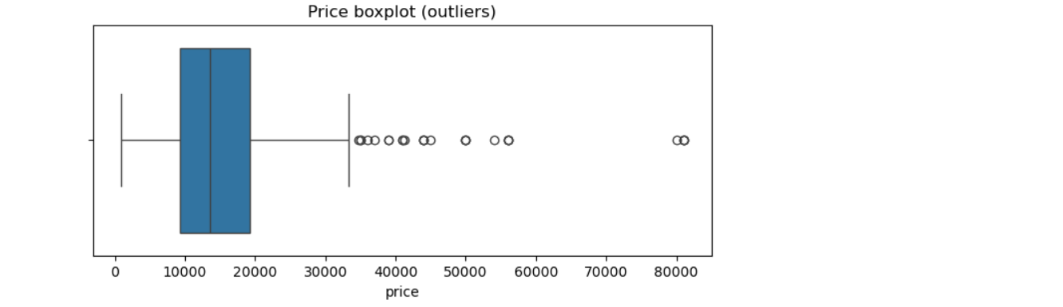

4.4 Correlation Analysis
Correlation heatmaps show that memory, RAM, battery, and camera features moderately correlate with price. Categorical features require encoding to analyze properly.
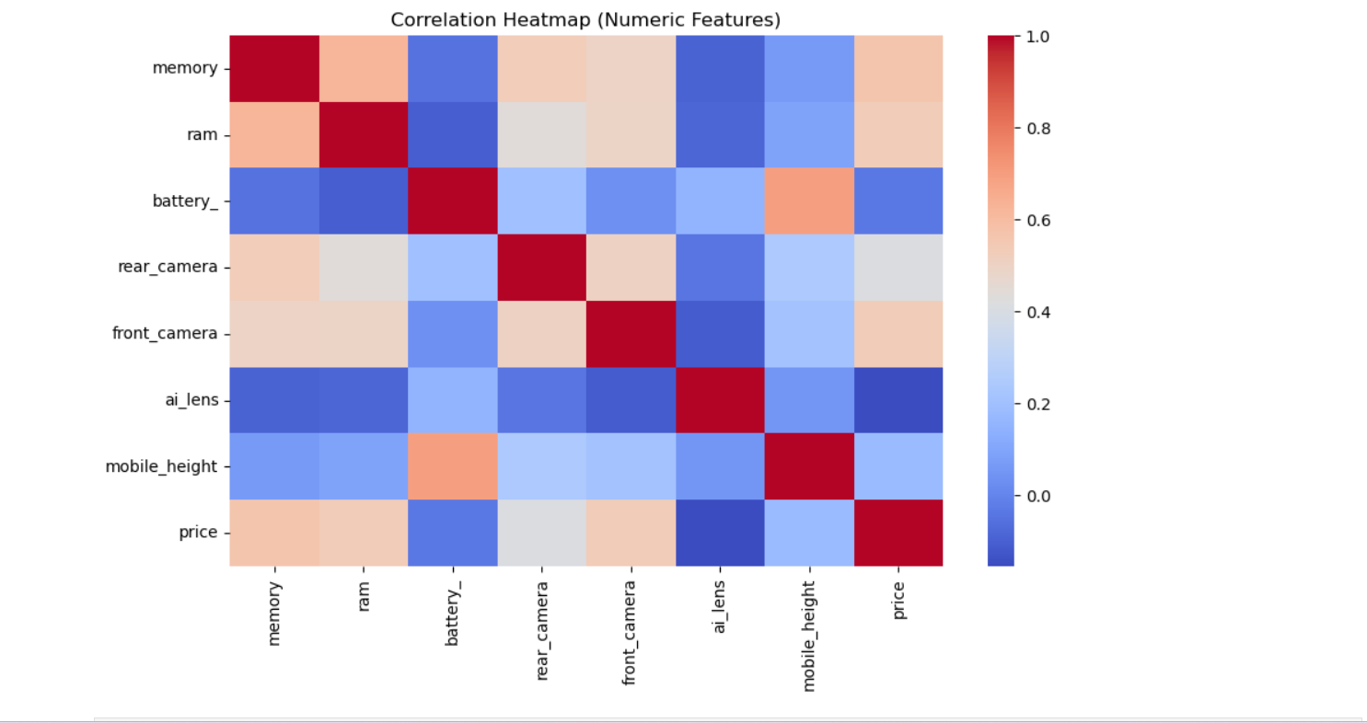

4.5 RAM VS Price

Phones with higher RAM generally cost more. Trend is positively correlated, but with lots of variance. RAM alone is not enough to predict price.

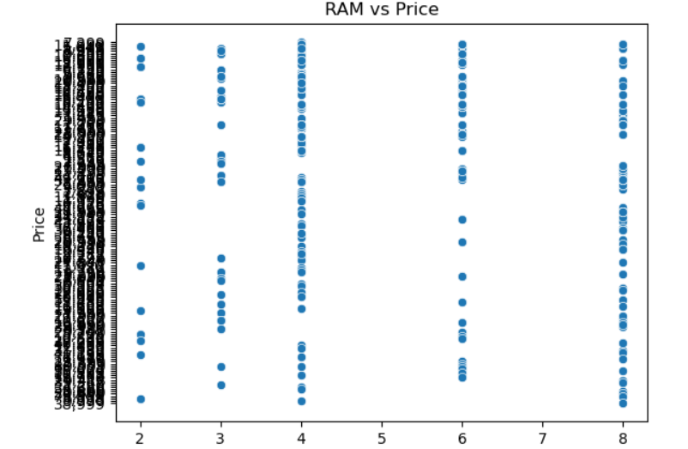

4.6 Battery Capacity vs Price
Battery capacity does not strongly correlate with price. Even cheaper phones may come with high battery. 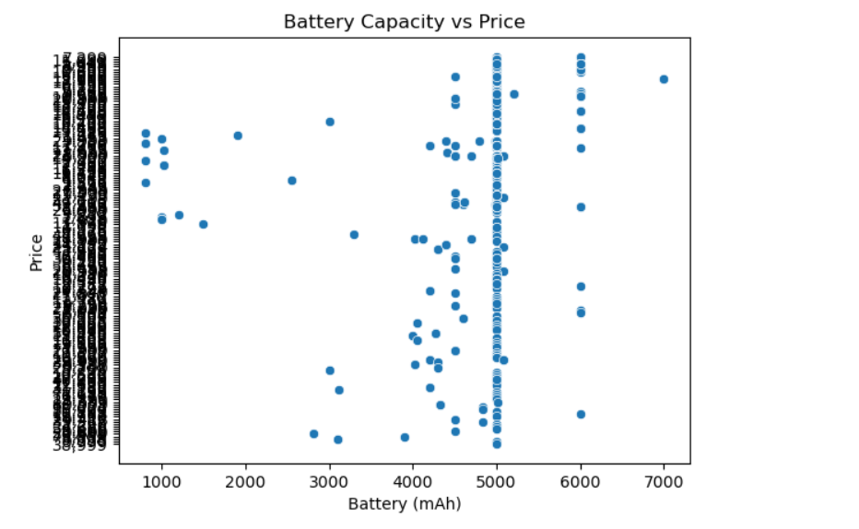

5. Feature Engineering
Categorical features such as model, colour, and processor were converted into numerical form using One-Hot Encoding. This expanded the dataset to approximately 590 columns. The dataset was then split into training and testing sets with an 80–20 ratio.

6. Model Building
Five machine learning models were implemented:
1. Linear Regression
2. Decision Tree Regressor
3. Random Forest Regressor
4. Gradient Boosting Regressor
5. XGBoost Regressor

7. Model Evaluation
The performance of each model was measured using Mean Absolute Error (MAE), Root Mean Squared Error (RMSE), and R² score.

- Linear Regression: Performed poorly due to high dimensionality and non-linearity.
- Decision Tree Regressor: Best model with R² ≈ 0.8899.
- Random Forest Regressor: Strong performance with R² ≈ 0.8466.
- Gradient Boosting Regressor: Moderate performance with R² ≈ 0.8226.
- XGBoost Regressor: Second-best performer with R² ≈ 0.8790.
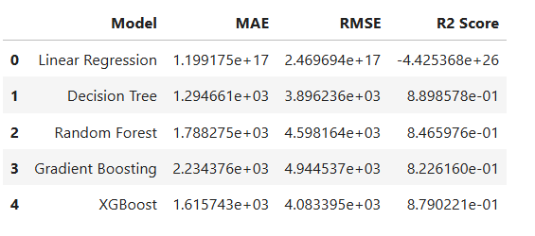

8. Feature Importance
Feature importance analysis using Random Forest and XGBoost revealed that processor type, front camera, battery capacity, memory, and RAM play critical roles in determining smartphone prices. High-end phone models such as iPhone 14 and Pixel 7 also contribute significantly.
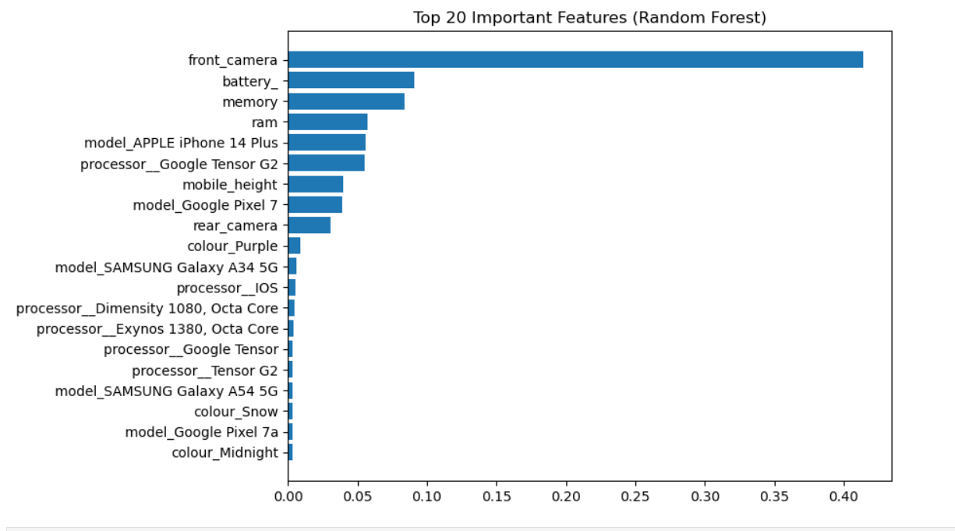
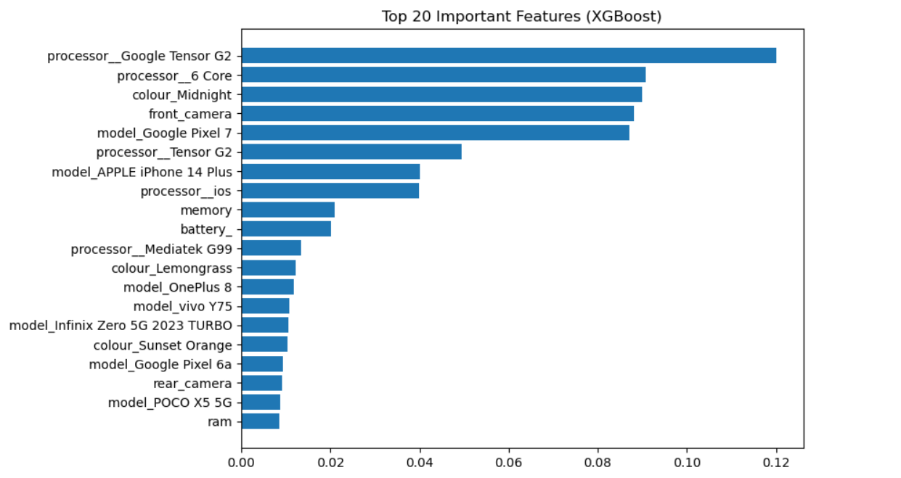

9. Conclusion
The Decision Tree model outperformed all others in predicting mobile phone prices with high accuracy. The dataset has non-linear relationships and high-cardinality categorical variables, making tree-based models more suitable. Key factors affecting price include processor, camera specs, battery, RAM, and memory.

10. Future Improvements
• Apply dimensionality reduction (PCA) to handle high feature space.
• Use brand-level grouping instead of raw model names.
• Experiment with CatBoost and LightGBM for improved handling of categorical data.
• Deploy the model as a web application for real-time price prediction.

