**ENGLISH**

1. **Essay on going to school and online classes**

**Going to school is always fun, children enjoy learning , but online classes is one thing that makes children sit in one place in front of a machine which becomes hot hour by hour. Children miss their parents saying ‘Hurry, you are getting late to school, yet you did not eat your breakfast and also the bus has arrived be quick’. Many children are not allowed to go out to play because of COVID-19. COVID-19 has made the whole world to sit at home because of lockdown. Children are eagerly waiting for the school to re-open so that they can meet their friends and play and learn with them. Now the government has announced a good news that schools are going to re-open on November 1st.**

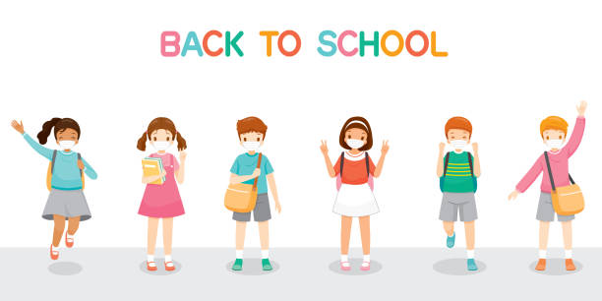

**2. Short story – The tale of a turtle’s tail**

**Once upon a time there was a turtle in the jungle which lived half of its time in the river in the jungle and the rest of its time outside the river, in the wild.**

**Many animals wondered about how the turtle was able to live in both water and land.**

**All the animals in the jungle started to speak about the turtle and soon this talk spread to the whole jungle. Then, one day the turtle boasted out about itself. The animals were very annoyed about the turtle boasting about itself and they decided to teach a lesson to it. So the animals requested the rabbit to come and help them by running a race with the turtle so that the turtle stops boasting and understands others talents too.**

**The animals asked the turtle if it was fine to run in the race with the rabbit. The turtle replied that it will run in the race and win it.**

**The next day the race started and the rabbit won the race, but the turtle did not still stop boasting about itself, so the animals did not know what to do to stop it. Then the animals thought that cutting its tail off might make it feel that it was not famous anymore because of its odd look without a tail .The thought worked out and finally the turtle stopped boasting about itself, but it was a still a mystery for the animals that how it was able to be in both water and land.**

**Moral: We should not boast out.**

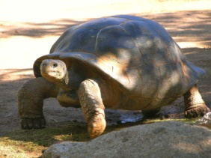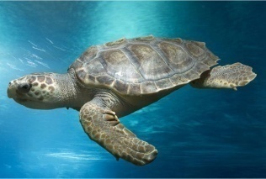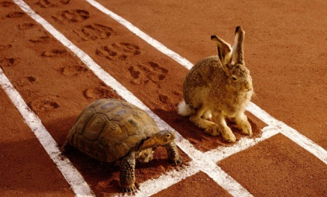

**3. Poem**

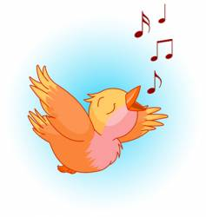**Today is my birthday ,** 

**I like to bake a cake,**

**I like to make a fluffy one that makes my day.**

**Birds chirping in the garden , happy birthday,**

**Tons of gifts on my hand on the happy day.**

**The clouds dance in the sky with a smile,**

**The wind says whoosh whoosh whoosh,**

**The cows say moo moo,**

**I say “what a day”.**

**BY:**

**TANYA ALAGAR**

**VI - B**

**4. Descriptive Writing :** 