

Department of Aerospace Engineering
JGI Global Campus, Jakkasandra Post, Kanakapura Taluk,
Ramanagara District, Karnataka, India – 562112

BACHELOR OF TECHNOLOGY
in
COMPUTER SCIENCE AND ENGINEERING

PROJECT REPORT
on
DYNAMIC SOFT-THRESHOLDING FOR FEATURE SELECTION USING ADAPTIVE LASSO
by

Yashvi Rajiv Vyas (23BTRCL124)
⁠Tanya Singh (23BTRCL087)
Y Mokshita Roy (23BTRCL123)
⁠

BONAFIDE CERTIFICATE

This is to certify that this Mini Project report on “DYNAMIC SOFT-THRESHOLDING FOR FEATURE SELECTION USING ADAPTIVE LASSO” is a Bonafide work of Yashvi Rajiv Vyas (23BTRCL124), Tanya Singh (23BTRCL087) & Y Mokshita Roy (23BTRCL123) who carried out the mini project work under supervision of Dr. Sujeet S Jagtap.

SUPERVISOR HEAD OF THE DEPARTMENT
Dr. SUJEET S JAGTAP Dr. CHANDRASEKAR V
Dept. of Computer Science Dept. of Computer Science
and Engineering-AIML and Engineering-AIML
JAIN (Deemed-to-be) University JAIN (Deemed-to-be) University

DATE OF THE VIVA VOCE EXAMINATION: ………………………………

ACKNOWLEDGEMENT

It is a great pleasure for us to acknowledge the assistance and support of a large number of individuals who have been responsible for the successful completion of this Project report on “DYNAMIC SOFT-THRESHOLDING FOR FEATURE SELECTION USING ADAPTIVE LASSO”.
First, we take this opportunity to express our sincere gratitude to Department of Computer Science and Engineering, JAIN (Deemed-to-be University), for providing us with a great opportunity to pursue our Project report on “DYNAMIC SOFT-THRESHOLDING FOR FEATURE SELECTION USING ADAPTIVE LASSO”.
We express our heartfelt gratitude to our esteemed guide, Dr. Sujeet S Jagtap, for his invaluable advice, encouragement, and unwavering support throughout our project. His guidance and insightful suggestions have been instrumental in shaping this work.
We extend our sincere appreciation to our respected Program Head, Dr. CHANDRASEKAR V, for his continuous support and encouragement, which enabled us to undertake and successfully complete our project on “DYNAMIC SOFT-THRESHOLDING FOR FEATURE SELECTION USING ADAPTIVE LASSO”.
We are also deeply grateful to our friends for their assistance, constructive feedback, and motivation, which played a crucial role in refining our work.
Finally, we express our profound gratitude to our parents, whose unconditional support, sacrifices, and encouragement have been the foundation of our academic and personal growth. Their unwavering belief in us has been our greatest strength.
We are also grateful to our family and friends who provided us with every requirement throughout the course.
We would like to thank one and all who directly or indirectly helped us in completing our internship project work successfully.

ABSTRACT

Feature selection plays a critical role in improving the efficiency and interpretability of machine learning models, particularly when dealing with high-dimensional datasets. Traditional regression techniques often struggle with large numbers of features, leading to issues such as overfitting, multicollinearity, and increased computational complexity. Regularization methods such as Ridge Regression and Least Absolute Shrinkage and Selection Operator have been widely used to address these challenges by introducing penalty terms that constrain model parameters.
This project investigates the use of Adaptive LASSO, an enhanced regularization technique that improves feature selection through weighted penalization of regression coefficients. Unlike standard LASSO, Adaptive LASSO assigns different penalty weights to different features, allowing the model to distinguish more effectively between important and irrelevant variables. This dynamic soft-thresholding mechanism results in improved sparsity and more reliable feature selection.
The proposed approach was implemented on a high-dimensional housing dataset where multiple regression models—including Linear Regression, Ridge Regression, LASSO, and Adaptive LASSO—were trained and compared. Data preprocessing steps such as missing value handling, categorical encoding, and feature scaling were applied prior to model training.
Experimental results demonstrate that Adaptive LASSO effectively reduces the number of active features while maintaining strong predictive performance. The findings highlight the effectiveness of adaptive regularization techniques in improving model interpretability, reducing computational complexity, and enhancing generalization capability in regression problems.

SL  No | CHAPTER | TITLE | PAGE No.
1. | Introduction | 1.1 Overview of the Project | 6
 |  | 1.2 Objectives of the Project | 7
 |  | 1.3 Future Scope | 8
2. | Problem Statement | - | 9
3. | Dataset Description | - | 10
4. | Data Processing | - | 11
5. | Regression Model Used | 5.1 Liner Regression  5.2 Ridge Regression  5.3 LASSO Regression | 12  13  13
6. | Adaptive LASSO | - | 14
7. | Dynamic Soft-Threshold | - | 15
8. | Methodology | - | 16
9. | Experimental Results | 9.1 MSE Comparison | 17
 |  | 9.2 Feature Selection Comparison | 18
 |  | 9.3 Coefficient Shrinkage | 18
 |  | 9.4 Adjust Weight Distribution | 19
 |  | 9.5 Top Selected Feature | 19
10. | Discussion | - | 20
11. | Limitations | - | 21
12. | Conclusions | - | 22
13. | References | - | 23
TABLE OF CONTENTS

CHAPTER 1
INTRODUCTION

  - OVERVIEW OF THE PROJECT
In modern data-driven applications, datasets often contain a very large number of features. While having more data can improve predictive capability, it also introduces significant challenges such as model complexity, computational cost, and overfitting. Many of these features may be redundant, irrelevant, or weakly correlated with the target variable.
Feature selection is therefore a critical step in building efficient machine learning models. By identifying the most relevant predictors and removing unnecessary ones, feature selection improves:
- model interpretability
- training efficiency
- generalization performance
Regression-based models are widely used for prediction tasks involving continuous outputs. However, traditional regression techniques struggle when datasets contain high-dimensional feature spaces. Regularization methods such as Ridge and LASSO were introduced to address these challenges by penalizing model complexity.
However, standard LASSO applies the same penalty strength to all features, which may lead to biased selection when features are highly correlated. To overcome this limitation, the Adaptive LASSO method was proposed. Adaptive LASSO assigns different penalty weights to different features, allowing the model to treat important features differently from less important ones.
This project explores the use of Adaptive LASSO for dynamic soft-thresholding based feature selection on a high-dimensional dataset. The performance of Adaptive LASSO is compared with traditional regression models including:
- Linear Regression
- Ridge Regression
- Standard LASSO
The goal is to demonstrate how adaptive regularization improves feature selection while maintaining strong predictive performance.
  - OBJECTIVE OF THE PROJECT
The primary objective of this project is to develop an efficient feature selection framework using adaptive regularization techniques for regression-based prediction tasks. The specific objectives of the study include:
- To study the impact of high-dimensional data on regression models and understand the challenges associated with large feature spaces.
- To implement and analyze different regression techniques, including Linear Regression, Ridge Regression, and LASSO, for predictive modeling.
- To apply Adaptive LASSO for dynamic feature selection, enabling the identification of the most significant predictors in the dataset.
- To compare the performance of traditional and regularized regression models using evaluation metrics such as Mean Squared Error (MSE).
- To analyze coefficient shrinkage and feature importance to understand how regularization techniques affect model parameters.
- To evaluate the effectiveness of adaptive regularization in reducing model complexity while maintaining predictive accuracy.
Through these objectives, the project aims to demonstrate how optimization-based feature selection methods can significantly enhance machine learning model performance.

  - FUTURE SCOPE

Although Adaptive LASSO provides effective feature selection capabilities, several opportunities exist for further improvement and research.
One possible direction for future work is the integration of Adaptive LASSO with advanced optimization algorithms from Convex Optimization, such as proximal gradient methods and coordinate descent techniques. These methods can improve computational efficiency when dealing with extremely large datasets.
Another potential extension involves applying Adaptive LASSO to non-linear machine learning models, including kernel methods and neural networks. Combining adaptive regularization with deep learning architectures may further enhance feature learning in complex data environments.
Future research can also explore the use of cross-validation and automated hyperparameter tuning to determine optimal regularization parameters. This would improve model robustness and ensure better generalization on unseen data.
Additionally, the proposed approach can be applied to other domains such as:
- financial risk prediction
- medical diagnosis systems
- bioinformatics data analysis
- real estate price prediction
Finally, hybrid feature selection methods that combine Adaptive LASSO with dimensionality reduction techniques such as Principal Component Analysis may further improve model performance and scalability.

CHAPTER 2
PROBLEM STATEMENT
Many real-world datasets contain hundreds or even thousands of variables, but only a small subset of them contributes significantly to predicting the target variable. Including irrelevant variables in a model leads to several problems.
High Dimensionality
When the number of features increases significantly, the model must estimate a large number of parameters. This increases computational complexity and may reduce the reliability of parameter estimates.
Multicollinearity
In many datasets, multiple features are highly correlated with each other. Multicollinearity makes it difficult for traditional regression models to determine which features are truly important.
Overfitting
A model with too many features may learn noise from the training data rather than meaningful patterns. This reduces its ability to generalize to unseen data.
Interpretability Issues
Models that use hundreds of variables are difficult to interpret, especially in applications where understanding the influence of individual features is important.
The main objective of this project is therefore:
- to develop a regression model capable of automatic feature selection
- to reduce model complexity without sacrificing predictive performance
- to evaluate how adaptive regularization improves feature selection
This is achieved using the Adaptive LASSO optimization framework.

CHAPTER 3
DATASET DESCRIPTION

The dataset used in this project is the House Prices dataset, commonly used for regression benchmarking tasks. The dataset contains detailed information about residential homes, including structural characteristics, location attributes, and construction details.
Dataset Characteristics
Number of samples: 1460
Number of original features: approximately 80
Target variable: Sale Price
After preprocessing and one-hot encoding of categorical variables, the number of features increases to more than 200 variables.
Examples of dataset features include:
- lot area
- number of bedrooms
- construction year
- neighborhood category
- garage capacity
- overall quality rating
The large number of features makes this dataset ideal for studying feature selection and regularization methods.

CHAPTER 4
DATA PROCESSING

Before applying machine learning algorithms, several preprocessing steps were performed to prepare the dataset.
Handling Missing Values
Real-world datasets often contain missing values. These missing entries were handled using appropriate imputation techniques such as:
- replacing numerical missing values with mean or median values
- filling categorical variables with the most frequent category
Encoding Categorical Variables
Machine learning algorithms require numerical inputs. Therefore, categorical variables were transformed using one-hot encoding, which converts each category into a binary feature.
Although this increases the dimensionality of the dataset, it allows regression models to process categorical information.
Feature Scaling
Many optimization algorithms perform better when features are scaled to similar ranges. Standardization was applied to ensure that each feature has:
- mean = 0
- standard deviation = 1
Train-Test Split
The dataset was divided into:
- training set (80%)
- testing set (20%)
The training data is used to build the model, while the testing data evaluates its predictive performance.

CHAPTER 5
REGRESSION MODEL USED

Four regression models were implemented and compared in this project.

5.1 Linear Regression
Linear Regression models the relationship between input variables and the target variable using a linear function.
The model assumes that the output can be expressed as a weighted combination of input variables.
Mathematically:
$$y=Xβ+ϵ$$
Where,
- $X$is the feature matrix
- $β$is the coefficient vector
- $ε$is the error term
The objective of linear regression is to minimize the squared difference between predicted and actual values.
Although simple and interpretable, linear regression does not handle high-dimensional data well and cannot perform feature selection.

5.2 Ridge Regression
Ridge Regression addresses overfitting by introducing an L2 regularization penalty.
The optimization objective becomes:
$$min⁡∣∣y-Xβ∣∣^{2}+λ∣∣β∣∣^{2}$$
The penalty term discourages large coefficient values, making the model more stable when features are highly correlated.
However, Ridge regression does not set coefficients exactly to zero, meaning it cannot perform feature selection.

5.3 LASSO Regression
Least Absolute Shrinkage and Selection Operator introduce an L1 penalty on the regression coefficients.
$$min⁡∣∣y-Xβ∣∣^{2}+λ∣∣β∣∣_{1}$$
The L1 penalty encourages sparsity in the coefficient vector. As a result, some coefficients become exactly zero.
This property allows LASSO to perform automatic feature selection.
However, standard LASSO applies the same penalty strength to all variables, which can lead to biased feature selection.

CHAPTER 6
ADAPTIVE LASSO

The Adaptive LASSO method improves upon standard LASSO by introducing feature-specific penalty weights.
The optimization problem becomes:
$$min⁡∣∣y-Xβ∣∣^{2}+λ∑w_{j}∣β_{j}∣$$
where $w_{j}$is a weight assigned to each feature.
These weights are calculated using an initial estimate of the regression coefficients:
$$w_{j}=\frac{1}{∣{\hat{β}}_{j}∣^{γ}}$$
Features with larger initial coefficients receive smaller penalties, while less important features receive larger penalties.
This adaptive weighting mechanism leads to more accurate feature selection.

CHAPTER 7
DYNAMIC SOFT-THRESHOLDING

The concept of soft thresholding plays a central role in LASSO-based optimization.
During optimization, coefficients are shrunk toward zero. If the magnitude of a coefficient falls below a certain threshold, it becomes zero.
This process effectively removes unimportant features from the model.
Adaptive LASSO introduces dynamic soft thresholding, where the threshold depends on feature-specific weights. This allows the algorithm to preserve strong predictors while aggressively eliminating weak ones.

CHAPTER 8
METHODOLOGY

The workflow of the project follows these steps:
- Load and inspect the dataset
- Clean and preprocess the data
- Perform feature encoding and scaling
- Train baseline regression models
- Implement Adaptive LASSO optimization
- Compare model performance using evaluation metrics
Visualization techniques were also used to analyze:
- coefficient shrinkage
- feature importance
- model performance
.

CHAPTER 9
EXPERIMENTAL RESULTS
The models were evaluated using test set predictions.
Performance Metric
Mean Squared Error (MSE):
$$MSE=\frac{1}{n}∑(y_{i}-{\hat{y}}_{i})^{2}$$

Lower values indicate better performance.
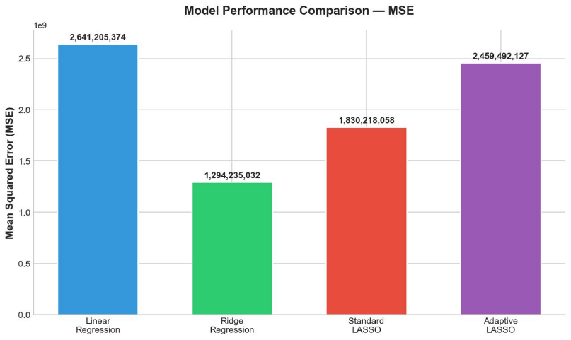
9.1 MSE Comparison

Fig. 1
The comparison shows that Adaptive LASSO achieves competitive prediction performance while reducing feature dimensionality.

9.2 Feature Selection Comparison
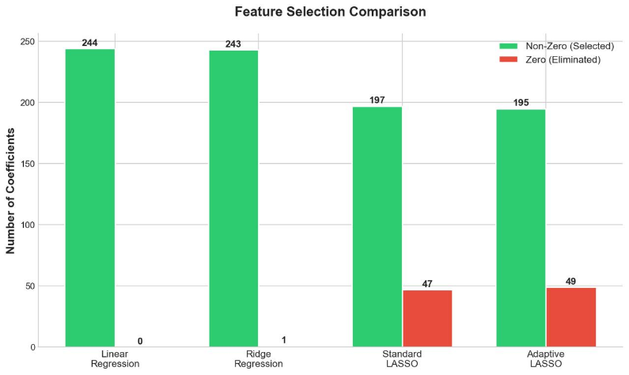

Fig. 2
Adaptive LASSO removes a larger number of irrelevant features compared to standard LASSO and Ridge regression.

9.3 Coefficient Shrinkage
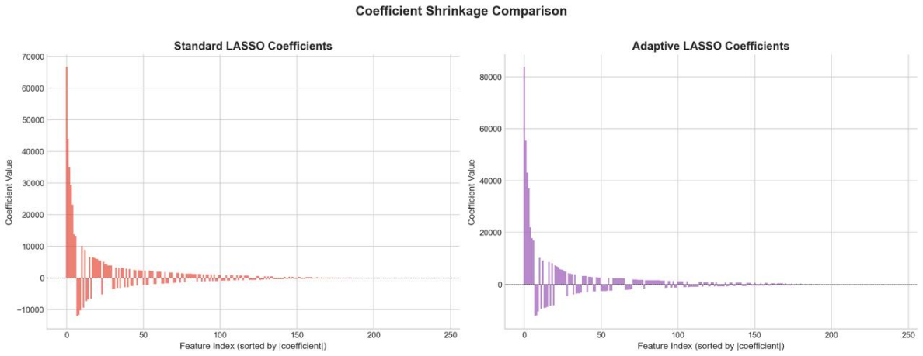

Fig. 3

This graph illustrates how Adaptive LASSO shrinks less important coefficients toward zero.

9.4 Adaptive Weight Distribution
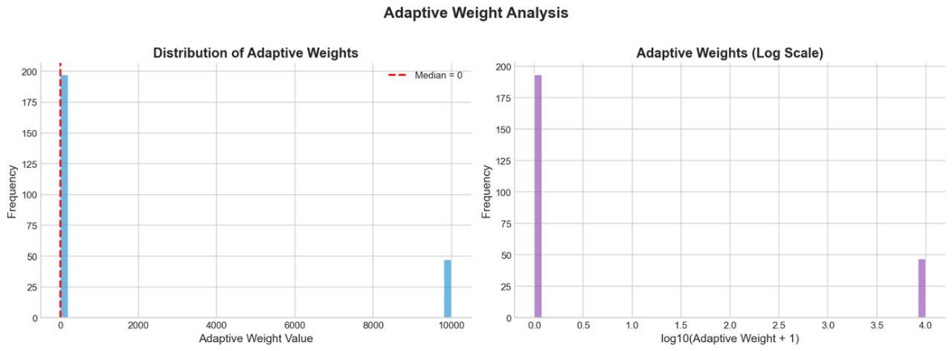

Fig. 4
Adaptive weights determine how strongly each feature is penalized during optimization.

9.5 Top Selected Features
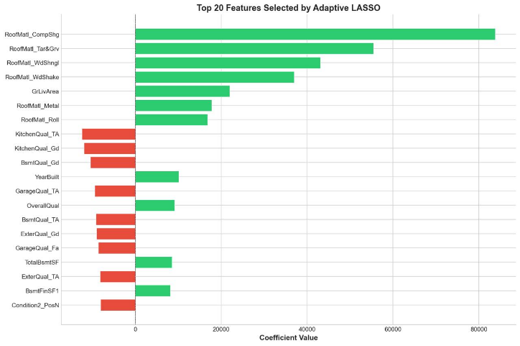

Fig. 5
Important predictors identified by the model include variables related to:
- building quality
- property size
- location characteristics
- number of rooms

CHAPTER 10
DISCUSSION

The experimental results highlight several advantages of Adaptive LASSO:

10.1 Improved Feature Selection
Adaptive weighting allows the algorithm to distinguish between important and unimportant predictors more effectively.

10.2 Reduced Model Complexity
By eliminating irrelevant variables, the final model becomes more interpretable.

10.3 Better Handling of Correlated Features
Adaptive LASSO mitigates the bias introduced by standard LASSO in the presence of correlated predictors.

CHAPTER 11
LIMITATIONS

Despite its advantages, Adaptive LASSO has certain limitations:
- it requires an initial estimator to compute weights
- parameter tuning may be necessary for optimal performance
- computational complexity increases for extremely large datasets

CHAPTER 12
CONCLUSION

This project demonstrated how Adaptive LASSO can be used for effective feature selection in high-dimensional regression problems. By introducing feature-specific penalty weights, Adaptive LASSO improves upon standard regularization techniques and provides a powerful tool for building sparse and interpretable models.
The experimental results confirm that adaptive regularization can reduce model complexity while maintaining strong predictive accuracy, making it highly valuable for real-world machine learning applications.

CHAPTER 13
REFERNECES
•Robert Tibshirani (1996). Regression Shrinkage and Selection via the LASSO. Journal of the Royal Statistical Society: Series B, 58(1), 267–288.
•Hui Zou (2006). The Adaptive LASSO and Its Oracle Properties. Journal of the American Statistical Association, 101(476), 1418–1429.
•Trevor Hastie, Robert Tibshirani, & Jerome Friedman (2009). The Elements of Statistical Learning: Data Mining, Inference, and Prediction. Springer.
•Gareth James, Daniela Witten, Trevor Hastie, & Robert Tibshirani (2013). An Introduction to Statistical Learning. Springer.
•Christopher M. Bishop (2006). Pattern Recognition and Machine Learning. Springer.
•Stephen Boyd & Lieven Vandenberghe (2004). Convex Optimization. Cambridge University Press.
•Kevin P. Murphy (2012). Machine Learning: A Probabilistic Perspective. MIT Press.
•Jerome Friedman, Trevor Hastie, & Robert Tibshirani (2010). Regularization Paths for Generalized Linear Models via Coordinate Descent. Journal of Statistical Software.
•Leo Breiman (2001). Statistical Modeling: The Two Cultures. Statistical Science.
•Peter Bühlmann & Sara van de Geer (2011). Statistics for High-Dimensional Data: Methods, Theory and Applications. Springer.
•Scikit-learn Documentation. Machine Learning in Python. Available at: https://scikit-learn.org
•Kaggle. House Prices: Advanced Regression Techniques Dataset. Available at: https://www.kaggle.com

