INTERNSHIP PROJECT REPORT
Task 3: Website Traffic Analysis

Submitted By:

[Tanya Ansari]
Internship Program | [Internspark]
Date: 20 June 2026

Introduction
This report presents the findings of Task 3 of the Data Analytics Internship, which focuses on analysing website traffic data. The objective is to explore how various metrics—such as Page Views, Session Duration, Bounce Rate, and Traffic Source—relate to each other and to identify patterns that can inform business or product decisions.
Website traffic analysis is a critical component of digital marketing and product management. Understanding how users interact with a website helps organisations improve user experience, optimise content strategy, and ultimately increase conversions.

Dataset Overview
The dataset used for this analysis is website_Data.csv, which contains 2,000 records with no missing values. Each record represents a website session and includes the following 7 features:
- Page Views — Number of pages visited in a session (integer)
- Session Duration — Total time spent on the website in seconds (float)
- Bounce Rate — Proportion of sessions where the user left without interacting (float, 0–1)
- Traffic Source — Channel through which the user arrived (Organic, Social, Paid, etc.)
- Time on Page — Average time spent on a single page in seconds (float)
- Previous Visits — Number of prior visits by the same user (integer)
- Conversion Rate — Proportion of sessions resulting in a desired action (float)

Data Quality Check
The dataset was verified for completeness and structural integrity. The results are summarised below:
- Total records: 2,000
- Missing values: None (0 nulls across all columns)
- Data types: Mix of integer, float, and categorical (object) — all appropriate for their respective features

Summary Statistics
Descriptive statistics were computed to understand the central tendency and spread of each numerical feature:

Metric | Mean | Std Dev | Min / Max
Page Views | 4.95 | 2.18 | 0 / 10
Session Duration (s) | 3.02 | 3.10 | 0.003 / 18.7
Bounce Rate | 0.285 | 0.160 | 0.008 / 0.79
Time on Page (s) | 4.03 | 2.89 | 0.07 / 14.5
Previous Visits | ~ | ~ | Integer counts
Conversion Rate | ~ | ~ | Float values
Table 1: Summary Statistics of Key Numerical Features
On average, users viewed approximately 5 pages per session with a moderate bounce rate of ~28.5%. Session durations varied widely (std ≈ 3.1 s), indicating a diverse user base ranging from quick bounces to deep explorers.

Data Visualisations & Analysis

Website Traffic Trend — Page Views Over Time
The line chart below plots Page Views across all 2,000 records (indexed sequentially). This visualisation captures the overall variability in daily or session-level traffic.
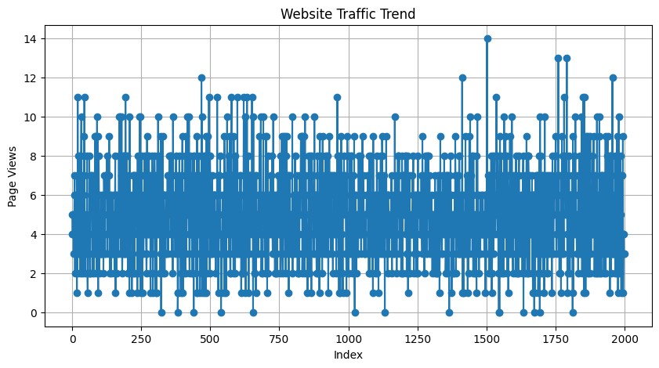
Figure 1: Website Traffic Trend — Page Views vs. Index
The chart reveals significant fluctuations in page views over time. Traffic does not follow a smooth trend, suggesting that external factors such as campaigns, seasonal events, or content updates may be driving spikes. The presence of near-zero values at certain points may indicate periods of very low traffic or inactive sessions.

Bounce Rate Distribution
The histogram below shows the frequency distribution of Bounce Rate across all sessions, using 20 bins to capture the shape of the data.
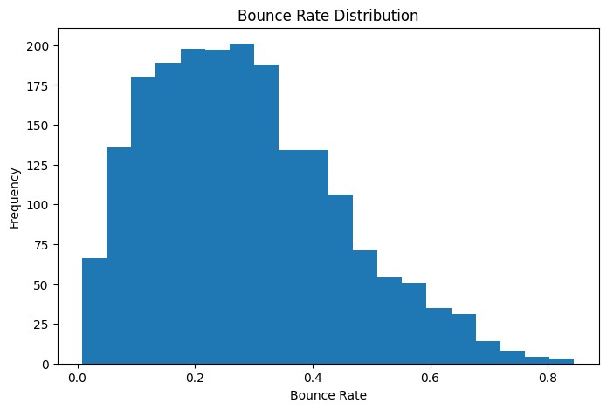
Figure 2: Bounce Rate Distribution (Histogram, 20 bins)
The distribution is roughly right-skewed, with the majority of sessions exhibiting a bounce rate between 0.1 and 0.4. This suggests that most users do engage beyond the landing page. However, a notable tail extends towards higher bounce rates (0.6–0.8), highlighting a segment of sessions with poor engagement that may require further investigation.

Session Duration vs. Page Views
The scatter plot below examines the relationship between Session Duration and Page Views, providing insight into whether longer sessions correlate with higher page consumption.
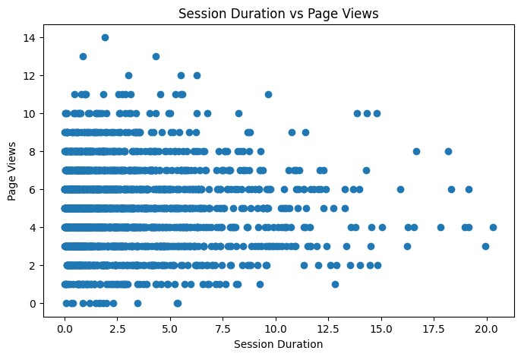
Figure 3: Session Duration vs. Page Views (Scatter Plot)
The scatter plot shows a broadly positive trend: users with longer session durations tend to view more pages. However, the relationship is not strictly linear — short-duration sessions can still yield multiple page views (possibly bots or quick navigators), while some long sessions record few page views (possibly users reading a single long article). This supports a nuanced, multifactor view of engagement.

Key Insights
- Website traffic fluctuated considerably across sessions, indicating that traffic is eventdriven rather than stable. Campaign-level analysis would be recommended to pinpoint traffic drivers.
- Higher session duration generally correlates with more page views, confirming that engaged users explore more of the website. Strategies to increase average session time (e.g., better internal linking, recommended content) could improve overall page view metrics.
- The bounce rate analysis reveals that while most users engage with the site, a non-trivial proportion (high bounce rate tail) leave quickly. Landing page optimisation and relevance of traffic sources should be reviewed to reduce unnecessary bounce.
- No missing values were found, which indicates the data pipeline producing this dataset is reliable and clean — a positive indicator for production-level analytics.
- The presence of multiple traffic sources (Organic, Social, Paid) suggests an opportunity for source-level segmentation to determine which channel brings the most engaged users.

Recommendations
- Segment the analysis by Traffic Source to compare engagement quality (bounce rate, session duration, conversion rate) across Organic, Social, and Paid channels.
- Investigate the time dimension more deeply — if a timestamp column is available, a time-series decomposition (trend, seasonality) would yield actionable calendar insights.
- Build a predictive model (e.g., logistic regression or decision tree) to predict Conversion Rate from the available features, enabling proactive optimisation.
- Monitor and reduce high-bounce-rate sessions by A/B testing landing page content and call-to-action placements.

Conclusion
This analysis of the website traffic dataset has provided meaningful insights into user behaviour and engagement patterns. The three visualisations — traffic trend, bounce rate distribution, and session duration vs. page views — together paint a comprehensive picture of how users interact with the website.
The data is clean and well-structured, making it suitable for further advanced analysis. With appropriate segmentation and predictive modelling, the findings from this task can directly inform digital marketing strategy and website optimisation efforts.
This task has strengthened practical skills in data loading, exploratory data analysis (EDA), and visualisation using Python's pandas and matplotlib libraries — core competencies for any data analytics role.

References
- Python Software Foundation. pandas — Python Data Analysis Library.
https://pandas.pydata.org
- Hunter, J. D. (2007). Matplotlib: A 2D Graphics Environment. Computing in Science & Engineering, 9(3), 90–95.
- Dataset: website_Data.csv — provided as part of Internship Task 3.

