
MINOR PROJECT REPORT

Gwalior Urban Intelligence System
  - CityBrain AI: Real-Time Monitoring, Forecasting and Decision Support
Submitted in partial fulfillment of the requirements for the
Bachelor of Technology in Computer Science and Engineering
Submitted By:- Tanya Arya
Roll number : 2401ECSB069
School of Engineering and Technology
Vikrant University, Gwalior
B.Tech CSE III Year V Semester • Batch 2024–2028
October 2026

PROJECT DETAILS

Project Identification and Submission
This report presents CityBrain AI, a single-city urban intelligence prototype configured for Gwalior, Madhya Pradesh. It follows the 17-section sequence shown in the university project-guideline image supplied with this request.
Item | Project detail
University | Vikrant University, Gwalior
School | School of Engineering and Technology
Programme | B.Tech Computer Science and Engineering
Academic designation in current guideline image | III Year, V Semester; Batch 2024–2028
Project category | Minor Project
Title in report | Gwalior Urban Intelligence System (GUIS): Real-Time Monitoring, Forecasting and Decision Support
Application name in code | CityBrain AI
Students listed | Tanya Arya; Himanshu Patel
Roll number as printed | 2401ECSB069
Faculty listed | Prof. Bulbul Agrawal
Session in source report | July–December 2026

Source note The supplied report states IV Semester, while the current guideline image says III Year V Semester. This report follows the newer guideline image and retains the report names and roll-number field as printed.

The project is described by two related names. GUIS is the formal system name in the report, while CityBrain AI is the repository/application name. UrbanSense Gwalior is also used as a product label in the report. This document uses CityBrain for the code and GUIS for the academic system description, so readers can trace the requirements to both artifacts.

ABSTRACT

Abstract
Cities produce weather, air-quality, traffic, energy, and safety information through different sources. CityBrain AI brings these streams together for Gwalior and presents them in a browser dashboard. The supplied implementation collects current weather and air-pollution data through OpenWeatherMap, backfills hourly weather and modeled air-quality history through Open-Meteo, stores records in PostgreSQL on Supabase, and uses Python and scikit-learn models for AQI and supporting predictions.
The central feature is a six-hour recursive AQI forecast. Its RandomForestRegressor uses 200 estimators, maximum depth 6, random state 42, and weather, temporal, lag, and rolling features. The dashboard also contains health guidance, historical charts, Pearson correlations, plain-language trend summaries, a What-If AQI predictor, a four-component City Stress Index, energy demand estimation, commute-speed estimates, and an accident-count simulator.
Traffic, electricity, and accident data are synthetic demonstration data. Open-Meteo air-quality history is modeled rather than local monitor data. The supplied SQL schema and dependency list are incomplete for the current app source. Model scores are runtime outputs and were not supplied as verified values; this report does not invent them.
Keywords Gwalior; urban intelligence; AQI forecast; Streamlit; Supabase; synthetic data; decision support.
The application stores weather and air-quality records at hourly granularity when data are available. The dashboard combines rows by hour and shows recent history alongside estimates. Its secondary features demonstrate how the same stored data can support more than one view: daily aggregation for energy and accident models, and hourly alignment for commute speed.
The term AI-driven in the source report refers to the use of supervised regression models and rule-based analytics. The AQI predictor is a Random Forest regression model; the energy predictor is Linear Regression; the commute and accident predictors are Random Forest regressors. Advisory text and the City Stress Index are rules or formulas rather than generative AI.

CONTENTS

Table of Contents
Pagination is arranged as 40 explicit page blocks. Page numbers in this table correspond to the intended layout.
No. | Section | Pages
1 | Introduction | 6–7
2 | Problem Statement | 8
3 | Objectives | 9
4 | Existing System | 10
5 | Proposed System | 11–12
6 | Scope and Applications | 13
7 | Requirements | 14–15
8 | System Analysis | 16–17
9 | System Design | 18–24
10 | Technology Stack | 25
11 | Implementation | 26–32
12 | Testing | 33–34
13 | Results | 35–36
14 | Limitations | 37
15 | Future Scope | 38
16 | Conclusion | 39
17 | References | 40

The report places the required academic sections first and allocates separate pages to analysis, system design, implementation, testing, and results. This organization follows the supplied guideline’s minimum documentation sequence. Flowcharts and data-flow diagrams are included in the design chapter, with their captions tied to the project’s own sources.
The Results section reports only values that can be read from the provided archive files. It does not report current AQI, database totals, or performance scores because those would require a live or reproducible run. That distinction keeps the contents aligned with the evidence included in the submission.
NAVIGATION

Figures, Tables, and Abbreviations
Abbreviation | Meaning
AQI | Air Quality Index
API | Application Programming Interface
CAMS | Copernicus Atmosphere Monitoring Service
CPCB | Central Pollution Control Board
DFD | Data-Flow Diagram
ER | Entity–Relationship
MAE | Mean Absolute Error
ML | Machine Learning
NCAP | National Clean Air Programme
PM2.5 / PM10 | Particulate Matter up to 2.5 / 10 micrometres
R² | Coefficient of determination

- Figure 1. System architecture (p. 18)
- Figure 2. Complete project flowchart (p. 19)
- Figure 3. System working flowchart (p. 20)
- Figure 4. Context-level DFD (p. 21)
- Figure 5. Level 1 DFD (p. 22)
- Figure 6. ER diagram (p. 23)
- Figure 7. AQI feature pipeline (p. 27)
- Figure 8. AQI conversion bands (p. 28)
- Figure 9. Dashboard interaction flow (p. 30)
- Figure 10. Archive data row counts (p. 35)
- Figure 11–12. Correlation and scatter plots (p. 36)
Figures 1–6 are diagrams embedded in the supplied project report, including the architecture, project lifecycle, working flow, two DFD levels, and ER design. The other figures are generated from code facts or included exploratory plots. The dashboard interaction figure is explicitly a schematic rather than a captured product screen.
Terms such as “forecast,” “estimate,” and “prediction” refer to outputs of the supplied models. They should not be read as official warnings. Throughout the report, “modeled” describes Open-Meteo atmospheric-composition output, while “synthetic” describes generated operational CSV rows.

1 INTRODUCTION

Urban Data and Local Air Quality
Weather, particulate matter, traffic flow, energy demand, and road incidents each describe a different part of daily urban life. When these indicators sit in separate systems, residents must interpret them independently and planners lack a single place to compare conditions. CityBrain AI demonstrates data integration and short-horizon environmental decision support for one city.
The prototype focuses on Gwalior, Madhya Pradesh. Its configured coordinates are latitude 26.2183 and longitude 78.1828. Gwalior appears in the Central Pollution Control Board’s published list of non-attainment cities [1]. The local focus makes the dashboard concrete: one city record and one map marker drive the current implementation.
CPCB’s National AQI framework distinguishes Good, Satisfactory, Moderate, Poor, Very Poor, and Severe categories and derives an index from pollutant sub-indices [2]. CityBrain’s live code calculates an EPA-style AQI from PM2.5, while its Open-Meteo historical data uses `us_aqi`. This difference matters because the application labels should not be mistaken for official CPCB AQI compliance.
Project boundary The prototype is for monitoring, forecasting, and awareness. Its own caption says air-quality values are modeled estimates rather than raw sensor readings.
The data source matters as much as the displayed number. A ground monitor, a weather provider, and a chemical-transport model differ in spatial coverage, timing, and measurement basis. CityBrain’s one-marker map should therefore be read as a city-level overview from provider data, not as a street-by-street sensor network.
The report’s use case is to make environmental information easier to view in one place. The map, recent readings, history plot, and forecast are complementary views: the map establishes location, the readings summarize current context, history exposes variation, and the forecast extends the view by six hours. None of these views independently proves pollution cause or source.

1 INTRODUCTION

Motivation and Project Rationale
The project’s motivation is the gap between a raw environmental reading and a useful next action. A person seeing an AQI value still needs help interpreting whether to exercise outdoors, commute by bicycle, or limit exposure. A short-term forecast adds planning context, while a combined dashboard can show how environmental conditions relate to traffic, energy, and safety demonstrations.
CityBrain follows a sequence: collect observations, retain local history, construct model features, calculate predictions or rules, and display the result in plain language. Its intended audiences are residents and commuters, people who may be more sensitive to air pollution, and students or planners examining urban indicators.
The system is intentionally modest in scope. It does not replace government monitoring networks or provide emergency instructions. Traffic, electricity, and accident modules demonstrate an integration pattern with generated values; they do not establish real Gwalior statistics.
- Single Gwalior dashboard for supported environmental and demonstration domains.
- Six-hour AQI trend from stored history and a regression model.
- Health guidance tied to predicted AQI bands.
- Extensible baseline for future multi-city or sensor-based work after data validation.
The integration goal is useful for classroom demonstration because it connects data engineering, database design, regression modeling, interaction design, and documentation. A single project can show how raw API responses become normalized records, how lag features are formed, and how a model prediction is translated into a readable dashboard card.
The project’s expected outcome is a prototype rather than a city operations platform. A future version would need source licensing, sensor calibration, access controls, monitoring, and carefully defined AQI semantics. The current work establishes a modular starting point, but its values should remain labeled with their source and confidence limitations.

2 PROBLEM STATEMENT

Problem Statement
Urban information is fragmented across services and formats. Weather, pollutant measurements, and city-operation indicators are not naturally presented together. A current AQI reading alone offers limited planning time; a number alone may not tell users which precautions to take. Smaller-city planning also benefits from local analysis rather than a generic city view.
Problem | Effect | CityBrain response
Scattered data | Users switch between services. | Shared database and dashboard.
Reactive information | Current value gives little planning time. | Six hourly AQI estimates.
Raw numbers | Users need help translating AQI to action. | Rule-based advice by band and activity.
No scenario exploration | Users cannot vary weather inputs. | What-If predictor.
Limited local integration | Local indicators remain disconnected. | Gwalior-focused map and modules.

Problem statement Develop an integrated, AI-driven Gwalior platform that collects weather, air-quality, traffic, electricity, and accident data, forecasts air quality, and presents understandable guidance and analysis through an interactive dashboard.
The primary user impact is uncertainty: people may see separate readings but cannot easily compare current conditions with recent patterns or a near-term estimate. A planner also cannot evaluate an illustrative scenario from an integrated view if every dataset is in a different interface. The project responds by consolidating the supported records and providing a common set of charts and controls.
The system does not solve the underlying causes of pollution or provide authoritative intervention thresholds. It addresses an information presentation problem. Its value is in helping a user inspect a forecast and guidance in context, then understand how weather and the stored indicators vary together.

3 OBJECTIVES

Objectives of the Project
Main objective: develop a Gwalior urban-intelligence prototype that integrates environmental and demonstration data, forecasts AQI for the next six hours, and presents insights through a Streamlit dashboard.
- Collect live weather and air-pollution readings using OpenWeatherMap.
- Backfill hourly weather and modeled AQI history from Open-Meteo for past_days=30.
- Store city and observations in PostgreSQL on Supabase.
- Train an AQI prediction model with weather, temporal, lag, and rolling features.
- Evaluate regression models with MAE and R² where the source implements them; report RMSE only when computed from an actual run.
- Provide AQI guidance, plain-language trends, and What-If inputs.
- Demonstrate City Stress, energy, commute, and road-safety modules using supplied sample data.
- Document limitations and separate current behavior from future scope.

Expected outcome A documented prototype whose demonstration values are clearly distinguished from actual city measurements.

The objectives translate into observable software outputs. Data integration is evidenced by the collectors and database queries; central storage by the PostgreSQL connection; forecasting by the six-step loop; guidance by the rule function; and visualization by the Streamlit controls and Plotly figures. The synthetic-data modules are included as demonstrations of integration, not as validated city analytics.
Model evaluation is an objective that requires a recorded training run. The source code implements MAE and R², but a report should state the dataset size, training period, test period, and resulting values together. The current archive does not supply a stable set of verified scores, so this report records the evaluation method without assigning a result.

4 EXISTING SYSTEM

Existing Systems and Their Limits
The project report compares the proposed dashboard with services that solve useful subproblems. This summary compares scope without asserting unverified current service outages or performance.
System type | Typical focus | Gap motivating this project
CPCB Sameer / National AQI | Indian AQI readings and pollution information. | No unified weather, traffic, energy, safety view in the project comparison.
SAFAR | Air-quality monitoring and forecasts in covered locations. | Report notes limited coverage; current Gwalior availability is not asserted here.
International AQI apps | Current pollutants and index values. | Index methods may differ; local planning tools are outside the core scope.
Weather apps | Temperature, humidity, wind, precipitation. | Do not combine all CityBrain modules.
Navigation apps | Routes and traffic visualization. | Do not supply this AQI/energy/risk prototype together.

Comparison boundary This is a scope comparison, not a claim that existing services lack every feature described.
The proposed system differs mainly in how it composes information. An AQI portal is designed around air-quality communication; a weather app around weather; and a traffic service around travel routes. CityBrain’s educational aim is to place several indicators and demonstration analytics into one local dashboard. The comparison should not be interpreted as a substitute for any authoritative provider.
The source report includes draft statements about response times, outages, and city coverage. Such claims change or require evidence from each provider. They are not repeated here unless supported by an official source or the project’s own artifact. This keeps the comparison focused on intended scope rather than unsupported rankings.

5 PROPOSED SYSTEM

Proposed System Overview
The system gathers weather and air-quality feeds, loads historical records, and combines them with generated traffic, electricity, and accident tables. Python scripts normalize and insert data into PostgreSQL. The dashboard reads data, loads model bundles, computes interactive views, and presents them to users.
Module | Purpose in supplied application
Live monitoring | Latest weather, AQI, pollutants, and Gwalior map marker.
AQI forecast | Six one-hour-ahead recursive predictions.
Health advisory | Maps AQI to activity and condition guidance.
Historical trends | Plots AQI, PM2.5, and weather across selectable ranges.
Correlation and insights | Pearson correlation and recent trend summary.
What-If predictor | User-selected weather/time inputs with recent AQI context.
City Stress Index | Four normalized environmental/operational components.
Energy, commute, safety | Secondary regression demonstrations.

System status The supplied schema, dependencies, data types, and model implementation gaps are documented in later sections.
The dashboard’s main path begins with current measurements and recent data. The user can move from a current AQI card to a trend plot, inspect the forecast, and then open either a scenario control or advisory output. Secondary modules reuse city inputs to demonstrate other model targets. This interaction structure helps users move from observation to interpretation without changing pages.
The report describes a live map and an Environmental Dark theme. In code, the map consists of a single scatter marker centered on the Gwalior coordinates, and theme colors are set in `.streamlit/config.toml`. The dashboard’s city focus is fixed in the supplied app; multi-city selection is not implemented in the reviewed snapshot.

5 PROPOSED SYSTEM

System Flow at a Glance
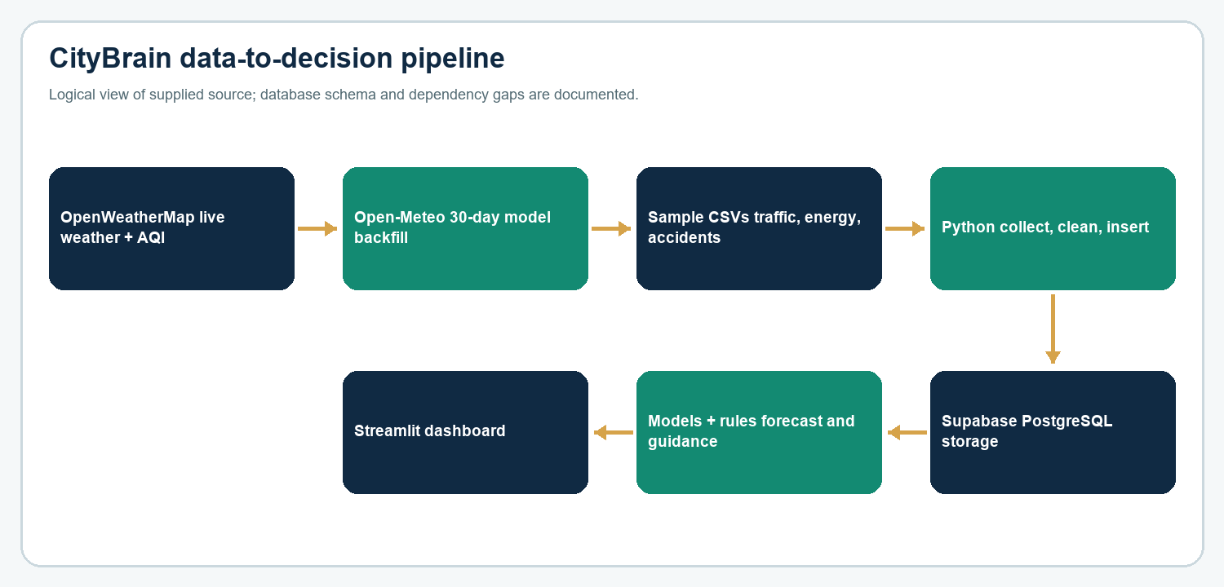
Figure: Logical path from sources to dashboard. Derived from supplied report and code.
Three sources—live OpenWeatherMap, historical Open-Meteo, and sample CSV files—feed Python ingestion and database storage. Model outputs and rule-based guidance then feed the dashboard. Database tables and saved model files must exist before all app modules can render.
The first three inputs have different provenance. OpenWeatherMap supplies current weather and pollutants; Open-Meteo supplies the historical backfill; and generated CSVs supply sample urban operations data. Python scripts normalize these inputs into database columns. The model layer reads aligned weather/AQI features and the dashboard layer renders the latest values and derived outputs.
The architecture also shows a dependency chain. A missing API key prevents live collection; missing database tables prevent data queries; missing serialized models prevent prediction modules; and missing imports prevent the app from starting. These dependencies are why schema completeness and requirements management are operational requirements, not merely documentation details.
The three inputs do not arrive at the same cadence or certainty level. Current weather and pollutant collection is attempted by the hourly loop, Open-Meteo contributes a finite backfill window, and generated operational tables are loaded separately. The database provides a common place to join these streams, but source and time metadata must be retained so that the dashboard does not hide those differences.

6 SCOPE AND APPLICATIONS

Scope and Applications
Dimension | Included in this minor project
Geography | Gwalior only; city_id 1; 26.2183, 78.1828.
Environmental data | Live weather and pollutants plus 30 past days of hourly Open-Meteo backfill.
Synthetic domains | Traffic, electricity, and accident demonstration data.
Forecast horizon | AQI six one-hour steps; commute speed 24-hour profile; secondary daily estimates.
Interface | Streamlit, Plotly, map, controls, text advisories.
Intended users | Citizens, commuters, sensitive-group caregivers, students, researchers, operators.
Out of scope | Official monitoring, emergency dispatch, clinical advice, live utility or traffic feeds.

- Residents can check current and forecast context before outdoor activity.
- Schools may use the dashboard as an environmental-awareness demonstration.
- Students can review the feature pipeline and weather/AQI associations.
- Planners can explore a prototype city score while recognizing synthetic inputs.
Applications are conditional on data availability and the prototype’s intended use. A citizen can inspect conditions and read a model-based outlook, but should use official sources for authoritative public-health alerts. A school can demonstrate relationships in the sample charts, but should not infer actual school-day exposure from generated traffic or accident records.
For planners and students, the dashboard is most useful as a visual integration exercise. It can support questions such as whether AQI varies with wind or time of day in the supplied dataset, or how the stress index changes with its four inputs. It cannot attribute cause, quantify policy impact, or recommend infrastructure decisions without validated sources and analysis.

7 REQUIREMENTS

Functional Requirements
ID | The system shall…
FR-01 | Display latest joined Gwalior weather and air-quality readings.
FR-02 | Collect current temperature, humidity, wind speed, and description from OpenWeatherMap.
FR-03 | Collect PM2.5, PM10, CO, NO2, SO2, O3 and calculate live AQI from PM2.5.
FR-04 | Apply the exact PM2.5-to-AQI intervals in fetch_aqi.py.
FR-05 | Skip unchanged live readings based on comparison with the most recent row.
FR-06 | Backfill 30 past days of hourly weather and modeled air-quality fields.
FR-07 | Skip timestamps already in the database during backfill.
FR-08 | Offer historical chart ranges: 24 hours, 3 days, 7 days, full range.
FR-09 | Calculate Pearson correlations for supported weather/AQI/pollutant variables.
FR-10 | Generate six recursive hourly AQI estimates and present +1h, +3h, +6h.
FR-11 | Provide What-If weather/time controls and predicted AQI.
FR-12 | Provide AQI health guidance by band, activity, and selected conditions.
FR-13 | Compute a 0–100 four-domain City Stress Index.
FR-14 | Estimate daily kWh, 24 hourly commute speeds, and accident counts.

Additional functional behavior includes loading four local model bundles, generating a Gwalior map marker, and summarizing the last 24 observations against the previous 24 when at least 48 rows are available. The interface uses the most recent joined record for summary cards and builds historical ranges from rows in the joined frame.
When a live collector finds identical pollutant values to the latest stored row, it skips insertion. This reduces repeated records but means a scheduler run does not guarantee a new database row. The requirement is therefore about a collection attempt and duplicate policy, not a promise of exactly one new reading per hour.

7 REQUIREMENTS

Nonfunctional, Data, and Platform Requirements
Area | Requirement or exact supplied condition
Refresh | Dashboard data cache TTL is 600 seconds.
Scheduler | run_scheduler.py pauses 3,600 seconds between runs.
Usability | Interactive controls, plain-language advice, and risk labels.
Model evaluation | AQI script calculates MAE and R²; supplied final script does not compute RMSE.
Secrets | DATABASE_URL and OPENWEATHER_API_KEY are environment variables; values are not reproduced.
Software | Python; Streamlit, pandas, NumPy, joblib, Plotly, scikit-learn, SQLAlchemy, psycopg2-binary, python-dotenv, requests.
Database | PostgreSQL on Supabase.
Hardware in report | Dual-core laptop/PC, 4 GB RAM or more, stable internet.
Cost statement | Report says free tiers; actual plans/quotas depend on providers.

Dependency gap requirements.txt lists SQLAlchemy, psycopg2-binary, pandas, python-dotenv, requests; it omits several imported packages.
Reliability is currently achieved primarily through stored history and a backfill script. The code prints collection errors, but the materials do not describe alert delivery, retry policy, or a recovery objective. Operationally, users need a visible indication of stale data before the app is used for time-sensitive decisions.
Maintainability would improve through a pinned dependency manifest, database migrations, and a documented run sequence. The dashboard imports packages beyond those in requirements.txt, and its queries expect more tables than SchemaCB.sql creates. These are concrete environment and schema gaps that should be resolved before a clean installation is considered reproducible.

8 SYSTEM ANALYSIS

Feasibility Analysis
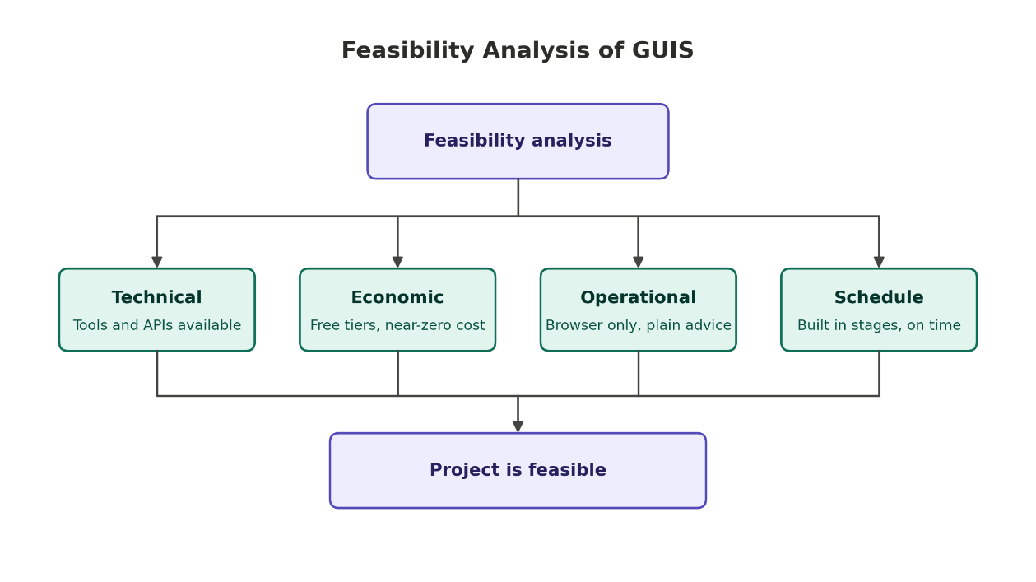
Figure: Feasibility summary reproduced from the supplied report.
Area | Analysis
Technical | Python, Streamlit, PostgreSQL, APIs, and ML packages support a prototype. Incomplete schema/dependencies constrain reproducibility.
Economic | Project report states free tiers and existing personal hardware; no audited cost statement supplied.
Operational | Browser dashboard and plain-language advice; access controls not documented.
Schedule | Report describes staged database/API/data/features/dashboard work; schedule independently unverified.

Technical feasibility is supported by the fact that the source contains the collectors, model scripts, a Streamlit dashboard, and model artifacts. The main engineering risk is not whether the libraries can perform these tasks; it is whether all referenced objects, dependencies, model versions, and data fields are present together in a fresh environment.
Economic feasibility is described in the project report as near-zero-cost use of free tiers. This is a project-era statement, not a permanent guarantee. Provider quotas, commercial-use terms, and service limits can change. Operational feasibility also depends on the dashboard showing data freshness and communicating that several data streams are samples.
The main feasibility conditions are completeness and provenance. A fresh environment needs the missing tables and libraries; the source APIs need valid credentials and network access; and synthetic records need explicit labels. Addressing these items is achievable within a student prototype, but they should be resolved before a public demonstration is described as reliable.

8 SYSTEM ANALYSIS

Data Analysis and Decisions
Modeled atmospheric history and generated operation records can demonstrate software integration, but they are not equivalent to calibrated local monitors or administrative records.
Issue in materials | Current decision / implementation
Few initial live rows | Wait for collection, then backfill 30 past days from Open-Meteo.
Earlier WAQI pipeline reported problematic | Current live collectors use OpenWeatherMap.
Need for AQI history | Open-Meteo data includes `us_aqi` and pollutant fields.
No city-level operational feeds in scope | Generate traffic, electricity, and accident demonstration records.
Traffic period differs | Report says 30 days; generator and CSV cover 90 days.
AQI scale ambiguity | Live PM2.5 uses EPA-style breaks; historical values use US AQI. CPCB uses its own six-category index [2].

The supplied archive includes 994 joined hourly rows for weather and air quality, 2,160 traffic rows, and 43 daily rows each for electricity and accidents. The traffic series spans 90 days, while the daily samples span 43 calendar records in the supplied files. A model trained from overlapping tables can have fewer rows than any single file because timestamps must join.
Synthetic data generation uses deterministic random seeds in the source scripts, but the data are still constructed examples. Their relationships are designed into formulas—for example, vehicle count affects speed and congestion, temperature influences generated electricity, and rain/fog increases generated accident counts. Models can learn those designed patterns without demonstrating real-world predictive skill.

9 SYSTEM DESIGN

System Architecture
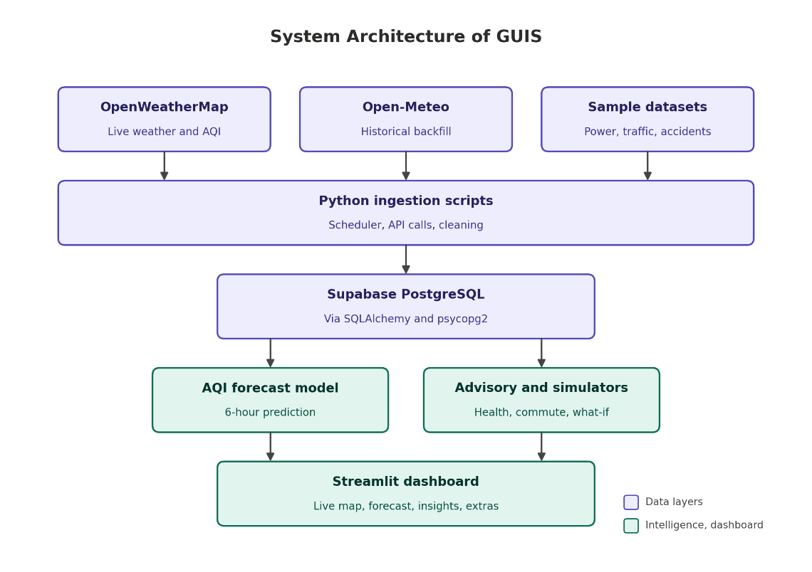
Figure 1. Architecture from the supplied report: data sources, ingestion, storage, intelligence, presentation.
The architecture separates collection, storage, computation, and presentation. Code implements this through fetch scripts, training scripts, a PostgreSQL database, serialized models, and app.py. The diagram shows six child-domain tables; SchemaCB.sql defines only cities, weather, and air_quality. Full deployment depends on additional table definitions.
At the source layer, the current collectors call provider endpoints and use environment configuration rather than embedding database credentials. At the ingestion layer, Python performs field extraction and duplicate checks. The storage layer is relational and uses city_id to associate rows with Gwalior. The intelligence layer comprises the saved AQI/secondary models plus advice and analytics functions.
The presentation layer is a Streamlit app with Plotly charts. The supplied architecture is conceptual and does not show deployment infrastructure, user authentication, database backup policy, or model-serving separation. Those omissions are appropriate to document for a minor-project prototype, but they matter if the system is later exposed to public users.

9 SYSTEM DESIGN

Complete Project Flowchart
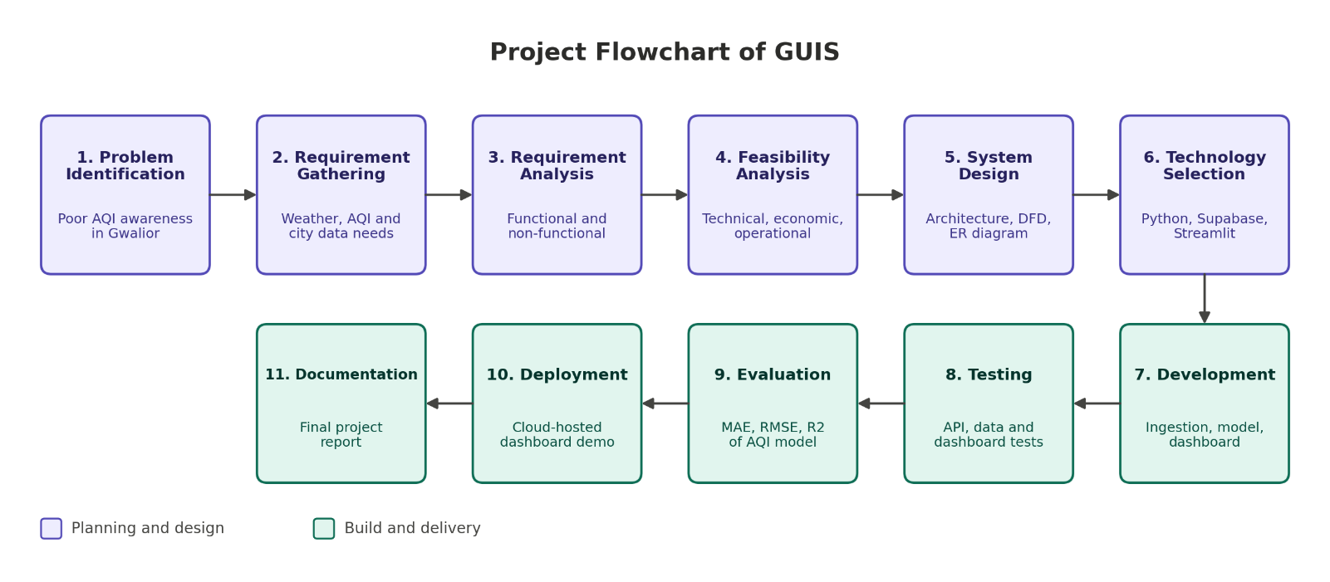
Figure 2. The 11 project lifecycle stages from the university guideline image.
The flow begins with problem identification and requirement gathering, then moves through feasibility, system design, technology selection, development, testing, evaluation, deployment/demonstration, and documentation. Project-specific labels connect those stages to Gwalior AQI data, Supabase, Python/Streamlit, and model evaluation.
The project lifecycle is shown as eleven stages: problem identification, requirement gathering, requirement analysis, feasibility analysis, system design, technology selection, development, testing, evaluation, deployment/demonstration, and documentation. Each stage has a project-specific label in the provided figure, making it more useful than an unmodified generic lifecycle chart.
The flowchart also clarifies that testing and evaluation are separate. Testing checks whether collectors, features, controls, and database operations behave as specified. Evaluation measures prediction errors on held-out time periods. A model can pass software tests and still have weak predictive value; both forms of evidence are needed.
The lifecycle also creates review gates. Requirements should be mapped to observable outputs before coding; design artifacts should agree with the actual schema and data flow; testing should distinguish functional behavior from model quality; and documentation should state the evidence and known gaps. The flowchart therefore serves as a checklist for both the project team and the final evaluator.

9 SYSTEM DESIGN

System Working Flowchart
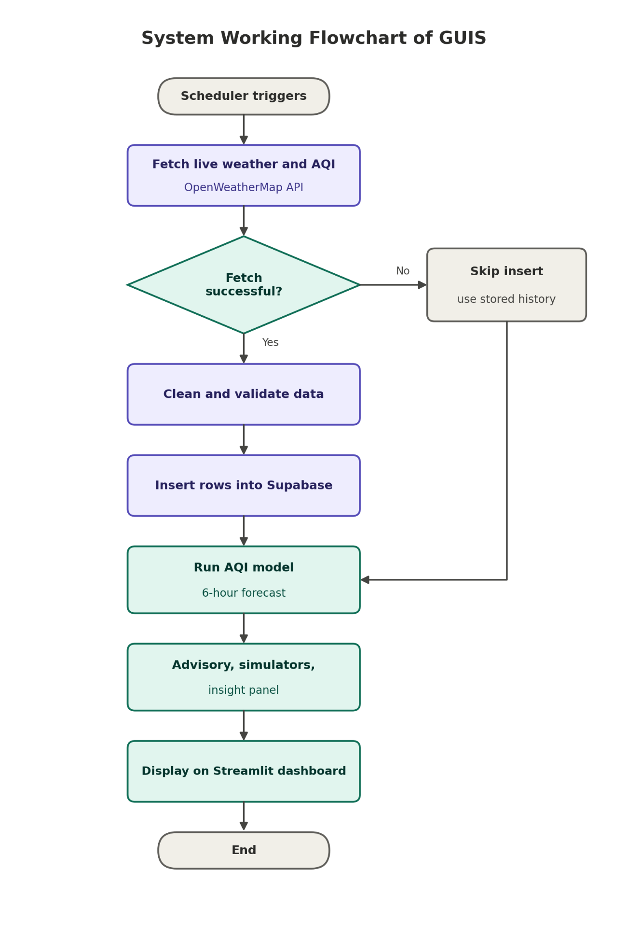
Figure 3. System working flowchart reproduced from the supplied report.
The scheduler requests weather and AQI, checks the result, cleans valid observations, and inserts records. Model and rule modules produce values used by the dashboard. If a live fetch fails, stored history remains available, subject to the required tables and model files being present.
The runtime flow repeats on a scheduled interval. It requests the current weather and air-pollution readings, validates the returned fields, and attempts insertion. Stored observations then supply the dashboard and model context. The app loads model bundles from disk and computes the outputs when rendering, while training remains a separate operation.
If provider data are unavailable, the collector reports an error and stored history may still support some dashboard views. This fallback is not a promise that all modules continue to work: empty or missing tables, missing model files, or incompatible feature columns can still stop the page. The diagram’s error branch covers API fetch failure only.

9 SYSTEM DESIGN

Data-Flow Diagram: Context Level
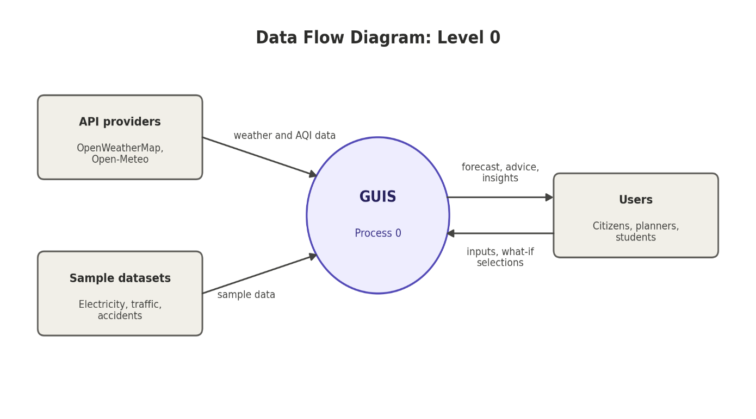
Figure 4. Context DFD: external APIs and sample data feed GUIS; users receive outputs and provide scenario inputs.
GUIS is treated as one process. API providers and sample datasets supply inputs. Citizens, students, and planners receive forecasts, guidance, and insights; users may submit What-If selections. The system boundary excludes official sensor networks and emergency dispatch.
The context DFD identifies the external entities and system boundary. API providers contribute weather and air-quality records; sample datasets contribute traffic, energy, and accident records; and users supply scenario selections. GUIS returns visual summaries, forecast outputs, insights, and rule-based advice.
The diagram intentionally treats all users as one external entity because the app does not define separate access roles. User interactions are limited to dashboard controls. No profile, authentication, write-back to provider systems, or operational command channel is evidenced in the code.
Examples of user inputs are activity selections and scenario settings, while outputs include a forecast chart, the selected AQI band, a commute window, and generated insight sentences. Database writes are performed by ingestion scripts rather than ordinary dashboard users. That separation helps explain why the system boundary includes both external data providers and interactive users.

9 SYSTEM DESIGN

Data-Flow Diagram: Level 1
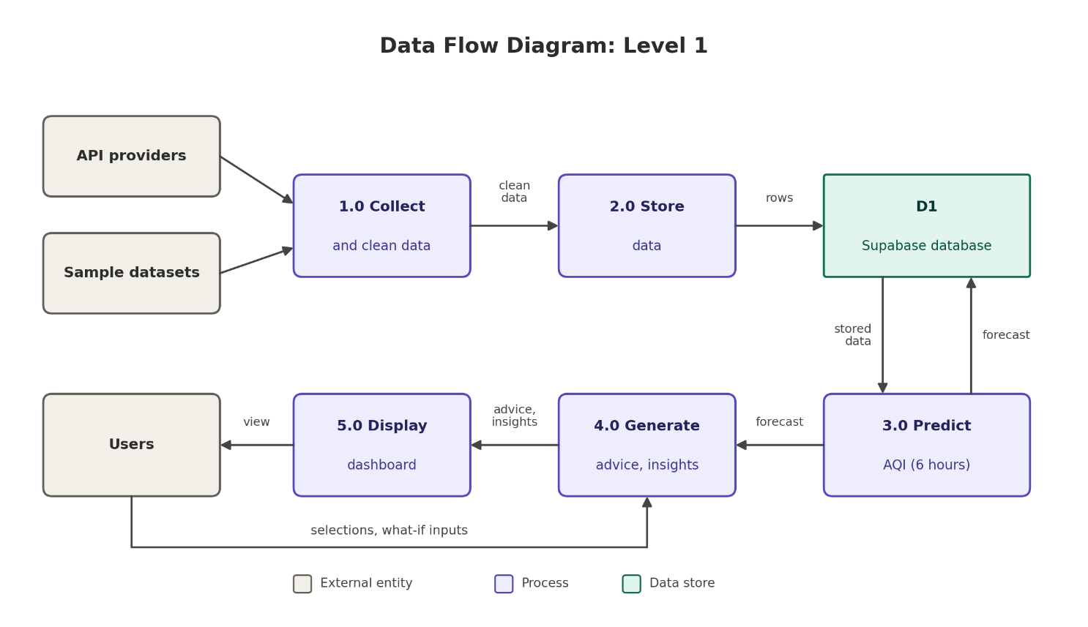
Figure 5. Level 1 DFD separates collection, storage, prediction, advice/insight, and presentation.
Process | Responsibility
1.0 Collect and clean | Request external observations and map fields.
2.0 Store data | Insert into D1 database.
3.0 Predict AQI | Read history and forecast six hours.
4.0 Generate advice and insights | Apply rules, scenarios, and summaries.
5.0 Display dashboard | Render charts, map, predictions, and controls.

Process 1.0 handles collection and cleaning, while process 2.0 persists rows to the shared data store D1. Process 3.0 reads historical context and produces the AQI forecast. Process 4.0 applies rules and creates insight text. Process 5.0 displays the assembled result to the user. These boundaries provide a useful map from diagram to source files.
The present implementation is not a separate microservice for each process. Most runtime analytics execute inside the Streamlit application, and the database is the shared persistence layer. The DFD is a logical decomposition used for documentation rather than a claim about independent deployment units.

9 SYSTEM DESIGN

Database Entity–Relationship Diagram
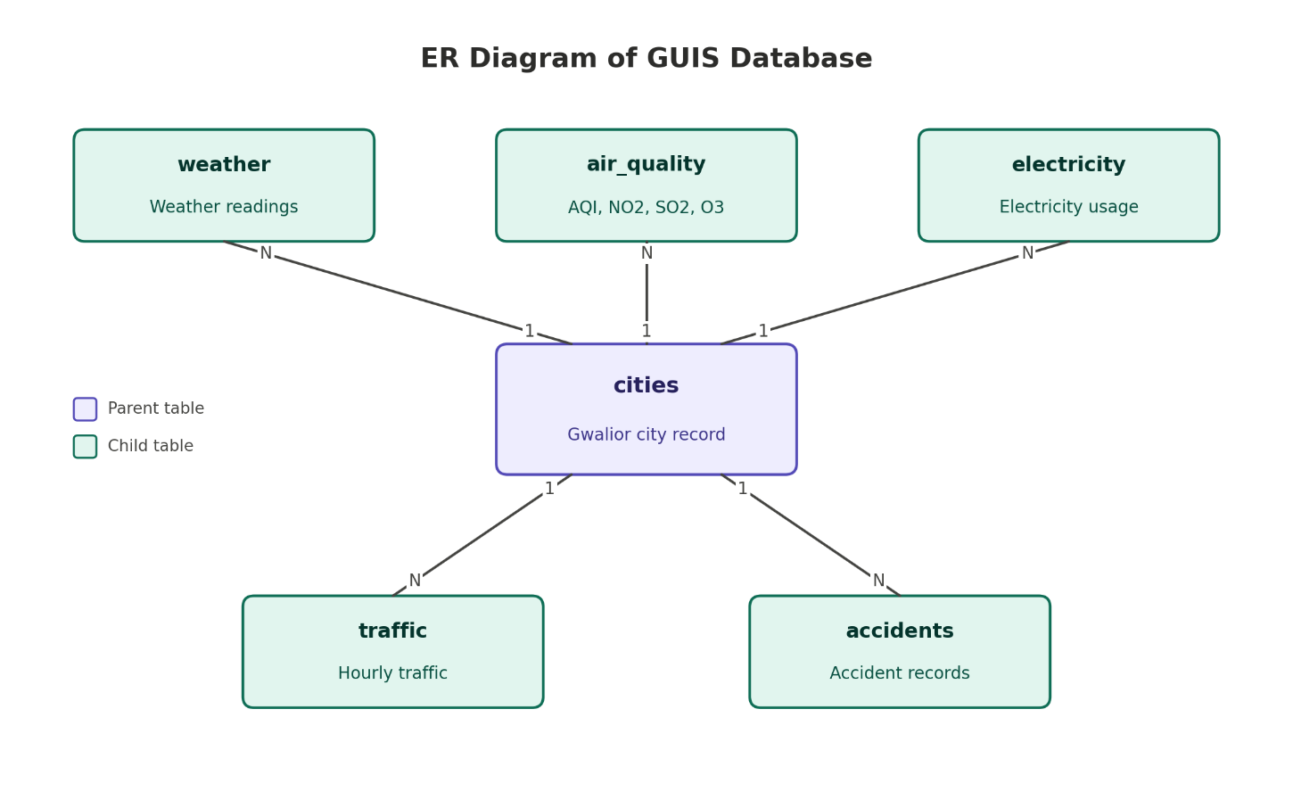
Figure 6. ER diagram from the supplied report; cities is the parent record.
The intended model has a cities parent with one-to-many relationships to weather, air_quality, electricity, traffic, and accidents. This matches the report concept. The supplied SQL does not define electricity_usage, traffic, or accidents, despite application queries; the ER diagram is not an executable migration.
The city record is the parent because all observations are scoped by city_id. Weather and air_quality store timestamped measurements; electricity and accidents are daily records; traffic is hourly. This difference in time grain affects joins and model construction: daily tables constrain the secondary daily models, while commute modeling joins hourly weather and traffic.
The SQL schema includes indexes on city_id and recorded_at for weather and air_quality, which match common city/time filters. It does not include constraints or indexes for the three operational tables because their definitions are absent. The ER image should therefore be treated as a design representation until a complete migration script is added.
The intended one-to-many relationship means a single city row may be associated with many observations over time. The city reference allows queries to be filtered consistently and supports future extension to additional locations if CITY_ID is parameterized. In the current code, the city relationship is effectively fixed to one row, so this is a future-ready schema pattern rather than active multi-city behavior.

9 SYSTEM DESIGN

Data Model and Schema
Indexes exist on (city_id, recorded_at) for weather and air_quality. The SQL seed row is Gwalior at 26.2183, 78.1828; app code fixes CITY_ID=1.
Table | Important fields and types evidenced
cities | city_id SERIAL PK; city_name VARCHAR(100) NOT NULL; latitude/longitude DECIMAL(9,6).
weather | weather_id; city_id FK; recorded_at TIMESTAMP NOT NULL; temperature, humidity, wind_speed DECIMAL(5,2); weather_condition VARCHAR(50).
air_quality | aqi_id; city_id FK; recorded_at TIMESTAMP NOT NULL; aqi_value INT; PM2.5, PM10, CO, NO2, SO2, O3 DECIMAL(6,2).
traffic (expected) | recorded_at, vehicle_count, avg_speed_kmph, congestion_level, city_id referenced by app/loaders.
electricity_usage (expected) | usage_date, consumption_kwh, city_id referenced by app/loaders.
accidents (expected) | accident_date, minor_count, major_count, fatal_count, total_count, city_id referenced by app/loaders.

The city table uses a serial primary key and stores name and coordinates. Weather and air_quality rows carry city_id foreign keys and timestamps. The weather measurements use decimal precision suitable for fractional temperature, humidity, and wind values; pollutant fields also use decimal types. The design makes the location explicit rather than repeating the city name on every reading.
The timestamps are SQL TIMESTAMP rather than TIMESTAMP WITH TIME ZONE in the supplied schema. Since the dashboard floors timestamps to the hour and joins weather to air quality, inconsistent timezone handling could shift rows or omit matches. A production revision should choose one timezone convention, normalize at ingestion, and preserve unit metadata.

10 TECHNOLOGY STACK

Technology Stack
Technology | Role | Evidence
Python | Ingestion, modeling, dashboard logic. | Project scripts.
Streamlit | Browser dashboard. | app.py and theme config.
PostgreSQL / Supabase | Relational storage. | Schema and SQLAlchemy connection.
SQLAlchemy / psycopg2-binary | Python database access. | requirements.txt.
OpenWeatherMap | Live weather and air pollution. | Collector scripts.
Open-Meteo | Historical weather and modeled AQI. | 30-day backfill.
pandas / NumPy | Tabular transforms and features. | App/training imports.
scikit-learn | RandomForestRegressor, LinearRegression. | Training scripts.
joblib | Serialized model bundles. | `.pkl` artifacts.
Plotly | Interactive charts and map. | app.py.
Git / GitHub | Version control. | Report names City-Brain-AI.

Reproducibility The supplied dependency file does not include all imported libraries or pin package versions.
The stack aligns with the project’s educational goal: Python supports both data handling and model training, Streamlit provides an interactive interface without a separate frontend, PostgreSQL stores structured observations, and Plotly supports interactive charts. Joblib stores trained models so the dashboard can load them without fitting a model on every page run.
The current requirements file does not fully describe this stack. Streamlit, NumPy, joblib, Plotly, and scikit-learn appear in source imports but are absent from the listed requirements. A clean setup therefore needs an expanded, version-pinned dependency file and a reproducible installation check.

11 IMPLEMENTATION

Data Collection and Ingestion
The live weather collector requests current Gwalior weather from OpenWeatherMap with metric units and stores temperature, humidity, wind speed, description, and timestamp. The air-pollution collector requests pollutant components at 26.2183, 78.1828, converts PM2.5 to the dashboard’s AQI scale, and inserts an air_quality row.
run_scheduler.py calls both collectors and sleeps for 3,600 seconds between cycles. run_once.py performs one round and is documented for an external scheduler. Each live collector compares incoming values with the latest row and skips unchanged readings.
collected_data.py requests past_days=30 from Open-Meteo for weather and air quality, including hourly PM2.5, PM10, CO, NO2, SO2, O3, and `us_aqi`. It skips timestamps already in the database. Open-Meteo identifies air-quality outputs as CAMS model products and separates US AQI from European AQI [3].
Timestamp note The SQL uses TIMESTAMP without an explicit time-zone type. A single authoritative time-zone policy is not specified.
The weather API path queries Gwalior by name and requests metric units. The air-pollution path uses latitude and longitude. Pollutant components are extracted from the first returned reading, and a parameterized SQL statement inserts them. Before insertion, the most recent row is read and compared to avoid writing a duplicate unchanged observation.
Open-Meteo backfill uses requested hourly time arrays and maps weather codes into text descriptions. Wind is converted from kilometres per hour into metres per second before storage. For AQI history, the code stores the provider’s `us_aqi` value alongside pollutants. These source-specific steps should remain documented because they affect what the dashboard’s units and index values mean.

11 IMPLEMENTATION

Data Preparation and Feature Engineering
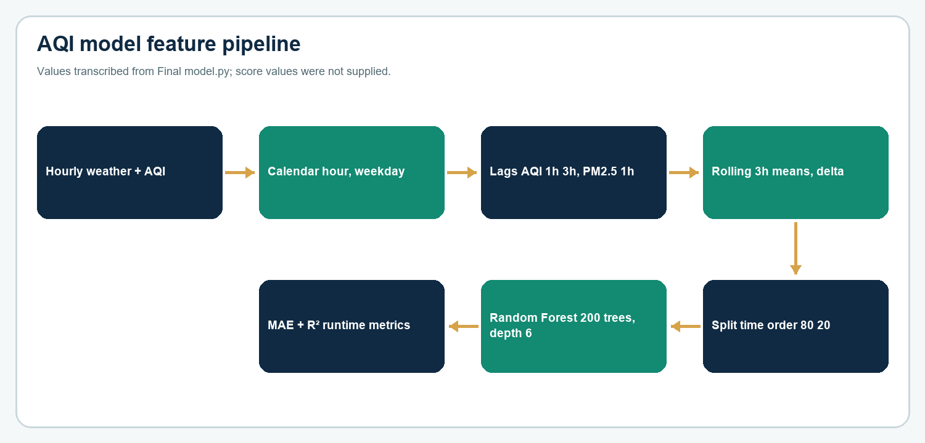
Figure 7. Feature pipeline derived from Final model.py.
The AQI predictor has 15 features: temperature, humidity, wind_speed, hour_sin, hour_cos, is_rush_hour, is_night, day_of_week, is_weekend, aqi_lag_1h, aqi_lag_3h, pm25_lag_1h, temp_rolling_3h, wind_rolling_3h, temp_change_1h. Hour is represented with sine and cosine so adjacent times around midnight remain close.
Lag and rolling features create missing values at the start of a series; the training script drops those rows. Data are loaded from weather_aqi_merged.csv as an ordered hourly index, then split chronologically 80/20 rather than shuffled.
The time-derived features distinguish rush-hour and night periods. Rush hour is coded for hours 7, 8, 9, 18, 19, and 20; night is coded for hours 0 through 5. Weekdays use the index convention where Monday is 0, and weekend is true for Saturday or Sunday. The cyclic hour features use sine and cosine of the 24-hour cycle.
Lag features capture recent AQI and PM2.5 context. Rolling means summarize the latest three observations of temperature and wind, while temperature change measures a one-step difference. These inputs provide the model with short-term state information, but also make correct chronological ordering and complete hourly coverage important.
For training, these features depend on an ordered, regular series. If the joined source skips an hour, a one-row lag no longer necessarily means one hour; similarly, a three-row rolling mean may cover more than three clock hours. The collection process suppresses unchanged readings, which can create irregular timestamps. Resampling and gap handling should therefore be defined before interpreting the lag labels literally.

11 IMPLEMENTATION

AQI Model and Forecast
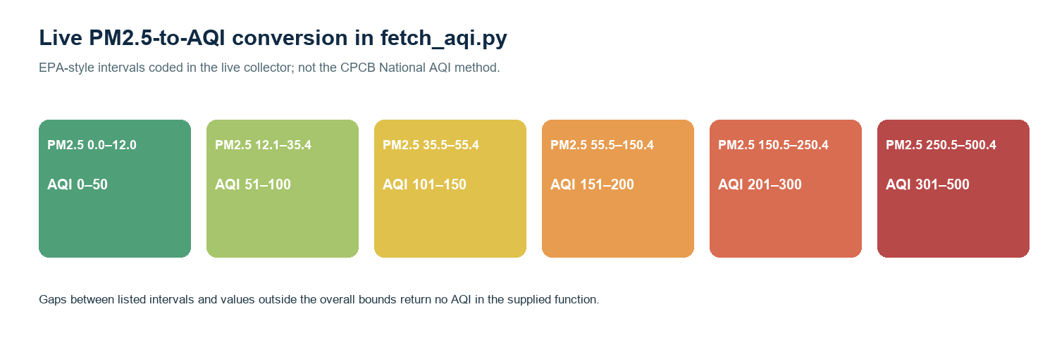
Figure 8. Exact live AQI conversion intervals in fetch_aqi.py; not the CPCB National AQI method.
Forecast steps reuse the latest temperature, humidity, wind, and PM2.5; time indicators advance hourly; earlier predicted AQI values update lag history; temp_change_1h is fixed to 0. This is a short-term model scenario under held weather features, not a separate weather forecast.
Property | Supplied value
Estimator | scikit-learn RandomForestRegressor
Parameters | n_estimators=200; max_depth=6; random_state=42
Target | aqi_value
Split | First 80% train; last 20% test in time order
Metrics | MAE and R² stored; RMSE not computed in supplied final script
Features | 15 listed on page 27
Forecast | Six recursive one-hour steps

The live collector’s AQI function linearly interpolates between concentration and index breakpoints. Its breakpoints use the intervals shown in Figure 8; values in gaps such as 12.05 µg/m³ do not match an interval and return None. The OpenWeatherMap air-pollution endpoint has its own provider index, but the code uses the locally calculated PM2.5-based value instead.
Evaluation uses a chronological holdout: the last 20 percent of feature rows is reserved for scoring. MAE gives average absolute error in AQI units, while R² summarizes variation explained relative to a mean baseline. The script does not compute RMSE, so that metric should not be quoted unless it is added to the training procedure and recorded from an actual run.

11 IMPLEMENTATION

Secondary Predictors
The dashboard caption calls energy demand a Random Forest, but secondary_model.py trains LinearRegression. This report follows the training code. Numeric training scores were not supplied as stable verified values.
The training source cautions that energy and accident models have few daily rows and should be treated as proof-of-concept. The commute model has more hourly examples, but its traffic labels remain synthetic.
Module | Estimator | Inputs → target | Data status
Energy | LinearRegression. | avg_temp, day_of_week, is_weekend → consumption_kwh. | Synthetic consumption; generator uses recorded temperatures.
Road safety | RandomForestRegressor; 150 trees; depth 5; seed 42. | avg_temp, avg_humidity, is_rain_day, avg_vehicle_count, high_congestion_hours → total_count. | Accident target generated.
Commute speed | RandomForestRegressor; 150 trees; depth 5; seed 42. | hour_sin, hour_cos, day_of_week, is_weekend, temperature, is_rain → avg_speed_kmph. | Traffic target generated.

The energy generator first aggregates weather observations by date. It uses average temperature, adds a weekend adjustment, and includes random noise with seed 42 to create daily consumption values. The accident generator flags rain/fog days and uses weekday/weekend baselines plus random variation to create counts. The traffic generator sets time-of-day patterns and derives congestion labels from vehicle-count thresholds.
These data-generation formulas can make the secondary models appear plausible and repeatable, but they also encode the relationships that the models are expected to learn. A useful report must disclose that circularity. Real deployment would need independently collected outcomes and evaluation on later, unseen periods.

11 IMPLEMENTATION

Dashboard Layout and User Interaction
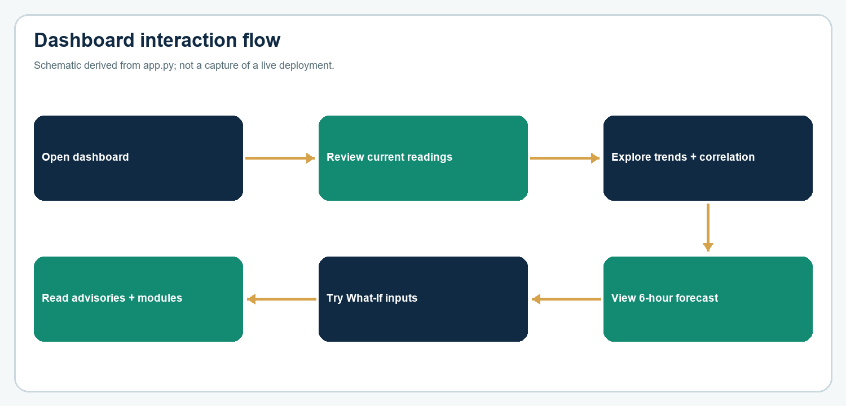
Figure 9. Dashboard interaction schematic derived from app.py; not a capture of a running deployment.
The Streamlit interface combines current cards, a map marker, historical trend tabs, AQI forecast, correlation view, insights, and interactive predictors. Theme values are primary #1D9E75, background #0B1220, secondary background #101B2D, and text #E6F1FB.
Database data is cached for 600 seconds with st.cache_data. Model bundles are cached as resources. Trend filters provide Last 24h, Last 3 days, Last 7 days, and Full range; default is Last 7 days. The map centers on the configured Gwalior coordinates at zoom 11.
The application starts with a location-aware summary, then offers historical controls and forecasts. The map uses a single marker, zoom level 11, height 380 pixels, and a marker size of 22. The historical filter defaults to Last 7 days and maps that selection to the latest 168 hourly rows. The app groups charts into AQI/PM2.5 and Weather tabs.
The interface also exposes the correlation matrix, an automatically generated insight panel, and the lower-page decision modules. The theme uses dark navy backgrounds and teal accents. The exact user-facing dashboard appearance can depend on Streamlit and Plotly versions; the figure on this page describes the interaction sequence rather than pixel-level styling.
The dashboard is organized as a long page rather than a role-based workflow. Users scroll from current conditions through trends and forecast into analysis and secondary modules. The design keeps the prototype compact, though a public version could benefit from sections or tabs that separate citizen guidance from planner-oriented sample analytics.

11 IMPLEMENTATION

Forecast and What-If Simulator
The six-hour forecast feeds earlier predictions back into AQI lag features. Hour-of-day and weekday advance while the last observed weather is held constant. The What-If module lets a user change the conditions while retaining recent AQI and PM2.5 context. It answers what the model estimates under the selected inputs; it does not establish causation.
Input | Exact UI range | Use in prediction
Temperature | 15.0–45.0 °C | Selected value; also temp_rolling_3h.
Humidity | 0–100% | Selected value.
Wind | 0.0–15.0 m/s | Selected value.
Hour | 0–23 | Cyclical hour, rush/night flags.
Weekday | 0–6 | 0=Monday; weekend flag derived.
Recent AQI/PM2.5 | Latest stored values | Lag context, not user-entered.

The What-If interface accepts temperature from 15.0 to 45.0 °C, humidity from 0 to 100 percent, wind from 0.0 to 15.0 m/s, hour 0–23, and weekday 0–6. Recent AQI values supply lag context. The chosen hypothetical temperature is used as its own rolling three-hour mean, and the one-hour change is set to zero.
Because only selected features change, results should be interpreted as model sensitivity under those assumptions. The controls do not alter stored data, call a weather forecast, or estimate causal interventions. A future interface could explain which features were held constant and display the training range alongside each scenario.

11 IMPLEMENTATION

Health Advice and City Intelligence Modules
Feature | Exact rules in source
AQI advice | ≤50 good; ≤100 moderate; ≤150 sensitive; ≤200 unhealthy; >200 hazardous.
Activities | general, exercise, commute.
Conditions | asthma, heart_disease, elderly, children, pregnant, outdoor_worker.
City Stress | Equal mean of normalized AQI, vehicle count, consumption, and accident count; constant series becomes 50.
Stress labels | <35 Low; 35–64 Moderate; ≥65 High.
Commute advisor | Predict speeds for 24 hours; recommend maximum-speed hour.
Accident simulator | Clamp count to 0 minimum; <2 low; 2–<5 moderate; ≥5 high risk.

Guidance limit Application rules are not medical advice. CPCB’s national category boundaries/names differ from several app labels [2].
Health advice is selected from five bands, with activity-specific text and condition-specific additions. Conditions include asthma, heart disease, older age, children, pregnancy, and outdoor work. The dashboard allows general, exercise, and commute guidance. The values are rule thresholds embedded in app.py, so future clinical review or local policy alignment would require changing and documenting those rules.
The City Stress Index first maps each latest value against its historical series using min-max scaling, clips the result to 0–100, assigns 50 to a constant series, and averages four components equally. This construction makes the display easy to explain, but the chosen indicators and equal weights are project design choices rather than a validated municipal stress measure.

12 TESTING

Testing Strategy
This section documents a verification plan derived from code. It does not claim a new end-to-end test against Supabase or live API credentials.
Test area | Method | Expected result
API mapping | Compare response fields with insert payloads. | Columns map to expected table fields.
Duplicate guard | Repeat a fetch without changed data. | Collector skips insert.
Backfill idempotence | Run backfill twice. | Existing hour not reinserted.
Feature builder | Use ordered fixture rows. | 15 features built; initial null rows dropped.
Forecast recursion | At least three historical observations. | Six consecutive estimates with rolling lag history.
Health boundaries | Test 50/51,100/101,150/151,200/201. | Correct adjacent bands.
Scenario controls | Inspect widgets and model input columns. | Bounds and feature order match source.
Schema completeness | Run app query names against supplied SQL. | Additional operations tables required.
Dependencies | Install in clean environment from requirements.txt. | Imports absent from dependency file will remain unresolved.

Unit tests should cover AQI breakpoints, feature construction, forecast recursion, and health-band boundaries. Integration checks should verify provider response mapping, database writes, duplicate handling, and the hourly joins. UI checks should inspect date-range selection, empty-data messages, model-file errors, and the behavior when a supporting table is unavailable.
Model evaluation is distinct from software testing. The training script should record the feature-row count, chronological split boundary, MAE, and R² for the AQI model. Secondary models should report their smaller sample counts clearly. This report contains the test design, not results from a new execution against the user’s environment.

12 TESTING

Verification Status and Reproducibility
Check | Available evidence | Status
AQI parameters | Final model.py specifies model, split, metrics. | Static source review only.
Secondary models | Training script specifies estimators/features. | Static source review only.
CSV row counts | Four archive CSVs counted. | Archive snapshot verified.
Live database | No connection performed for this report. | Unverified.
Live APIs | No response captured here. | Unverified.
Model score values | No stable verified score output supplied. | Not claimed.
UI behavior | Controls and charts visible in code. | No live screenshot used.
Page layout | 40 explicit page blocks in document source. | Visual pagination could not be rendered here; check final Word layout.

Evaluation practice Report MAE and R² from a recorded run; add RMSE only after calculating it. State held-out dates and sample counts.
A reproducibility package should include a complete schema migration, a dependency lock, sample environment-variable names, instructions for creating the city record, and a deterministic training/run sequence. The submitted archive includes some of these parts but not all. The test status table separates static code review from runtime verification to avoid implying that a live service was exercised.
The user-facing prototype should also show when a reading was last updated and whether a value is live, backfilled, modeled, or generated. Such provenance indicators would help prevent users from treating synthetic examples or stale data as current measurements.

13 RESULTS

Data Profile in the Supplied Archive
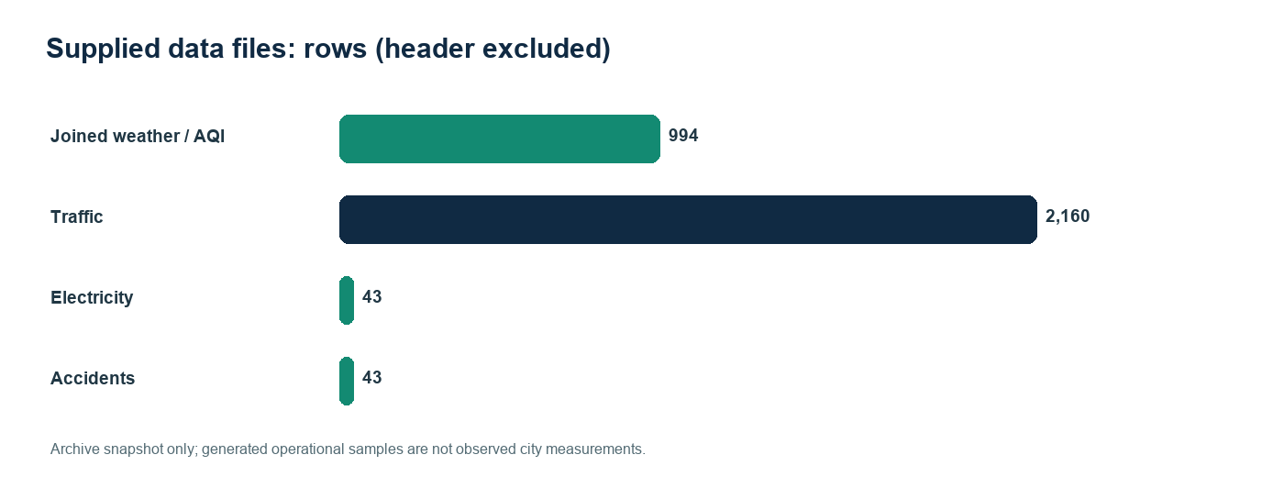
Figure 10. Supplied CSV row counts, excluding header rows.
These counts describe CSV files in the supplied archive, not database totals or current live readings. Dataset sizes vary by module and date coverage.
File | Rows | Date range | Type
weather_aqi_merged.csv | 994 | 2026-08-12 00:00 – 2026-09-22 09:00 | Joined hourly; modeled AQI.
traffic_sample.csv | 2,160 | 2026-06-28 00:00 – 2026-09-25 23:00 | Generated hourly; 90 days.
electricity_sample.csv | 43 | 2026-08-01 – 2026-09-22 | Synthetic daily consumption.
accidents_sample.csv | 43 | 2026-08-01 – 2026-09-22 | Synthetic daily counts.

The traffic file contains 2,160 hourly rows over 90 days, while the report’s earlier scope describes 30 days. Electricity and accidents each contain 43 daily rows from August 1 through September 22, 2026. The joined weather/AQI CSV contains 994 rows from August 12, 2026 at 00:00 through September 22 at 09:00.
The row profile shows why the secondary models may be unstable. The traffic source has many hourly observations, but the energy and accident target files contain only 43 daily records each. The exact training sample after joining can be smaller again when dates are missing in any contributing table.

13 RESULTS

Exploratory Weather–AQI Charts
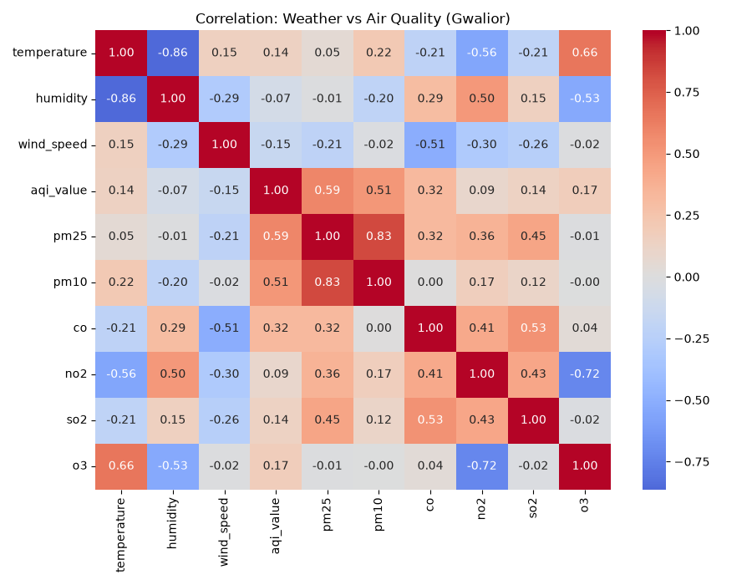
Figure 11. Correlation heatmap supplied in the project archive.
The archive also contains temperature, humidity, and wind-speed scatterplots. Figure 12 reproduces the temperature plots. These plots are exploratory associations, not causal evidence. The code calculates Pearson correlation; temporal validation remains necessary before treating relationships as predictive.
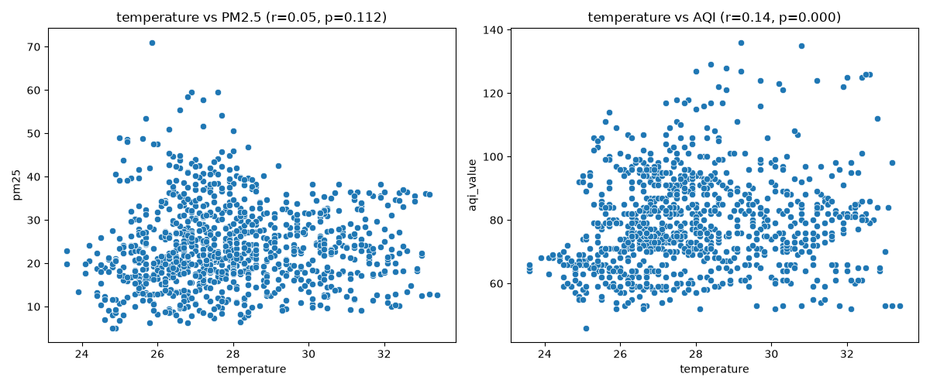
Figure 12. Temperature versus PM2.5 and AQI scatterplots supplied in the archive.
The supplied heatmap reports pairwise Pearson correlations in the joined archive dataset. The scatterplots show dispersion and outliers that a single correlation coefficient cannot describe. Environmental variables can move together for many reasons, and the small sample period does not support broad seasonal or causal conclusions.
The charts are included as exploratory artifacts from the source archive. They are not a new analysis executed for this report, and no p-values or confidence intervals are asserted. A stronger evaluation would use a temporal split, compare persistence or seasonal baselines, and test on a later interval.

14 LIMITATIONS

Limitations
- Single-city configuration; CITY_ID=1 and one Gwalior map point.
- Traffic, electricity, and accident values are synthetic, not observed city measurements.
- Open-Meteo historical air quality is modeled and uses `us_aqi`; local monitor data are not demonstrated.
- Live AQI conversion uses EPA-style PM2.5 intervals, not CPCB National AQI [2].
- Forecast weather features remain fixed at the latest observed values across the six-hour horizon.
- Energy and accident training data are small daily samples; all three operational targets are synthetic.
- No verified model scores, confidence intervals, external validation, or current runtime logs were supplied.
- SchemaCB.sql omits tables queried by app.py; requirements.txt omits imported packages.
- No sign-in, roles, audit trail, uptime target, recovery plan, or retraining schedule is evidenced.
- The AQI function returns no value in small gaps between breakpoints or outside its bounds.
The limitations affect how the system should be presented. A city-wide index inferred from one coordinate is spatially coarse; modeled air quality is not a calibrated sensor; and synthetic operational values cannot support real commute or safety advice. Model outputs should therefore be labeled as estimates and accompanied by the source date and data category.
Technical readiness is also limited by the incomplete schema and requirements file. Without the missing table definitions and imports, a clean installation may fail even though serialized models and dashboard code are present. Authentication, access controls, backups, and stale-data behavior should be addressed before any public deployment.
A further limitation is that health bands, city stress, and risk labels are selected by project code and are not shown as calibrated against an agency protocol. The stress index assigns equal weight to four normalized components, while the road-risk labels use fixed accident-count cutoffs. Those rules are easy to demonstrate but should not be interpreted as official risk classifications.

15 FUTURE SCOPE

Future Scope
The report’s roadmap proposes a broader urban platform. Each addition should follow verified data access, reproducible engineering, and evaluation before stronger user-facing claims are made.
Enhancement | Recommended next step
Complete schema | Define/version all domain tables, keys, constraints, units, indexes.
Pin dependencies | Publish a complete tested lock with Python/scikit-learn versions.
Align AQI method | Choose CPCB or explicitly named scale; label sources consistently.
Replace synthetic data | Integrate documented city or agency traffic, energy, accident records.
Evaluate forecasts | Use time-aware validation, MAE/RMSE/R², baseline, sample period.
Improve forecast inputs | Use weather forecasts rather than holding current weather constant.
Model lifecycle | Record data version, training time, parameters, scores, and retraining.
Expand city/sensor support | Parameterize locations; calibrate sensors before integrating.
Security/operations | Add authentication, access controls, monitoring, backups, stale-data notices.

A practical sequence is to first make the current single-city prototype reproducible: complete the schema, pin dependencies, document environment variables, and add a smoke run. Next, choose and label a consistent AQI scale, then add automated data-quality checks. After that, replace synthetic samples with sourced operational records and repeat the training/evaluation process.
Only after validation should the project expand to multi-city feeds, IoT sensors, hospital information, or large-scale tools such as Spark, Kafka, and Airflow mentioned in the report. Each new data source should have documented permissions, update cadence, units, geographic coverage, retention, and fallback behavior.

16 CONCLUSION

Conclusion
CityBrain AI demonstrates a student-project approach to integrating environmental data, a small machine-learning forecast, rule-based advice, and an interactive city dashboard. Its concrete features include a Gwalior-focused pipeline, a 15-feature AQI regressor, a six-step recursive forecast, and chart-based summaries.
The supplied files also show why precise documentation matters. Open-Meteo AQI history is modeled; traffic, electricity, and accident datasets are synthetic; the live AQI calculation uses PM2.5-to-US-style conversion; and schema/dependency artifacts are incomplete. Numeric model scores were unavailable as stable evidence and are not invented here.
The system is best described as a single-city awareness and decision-support prototype. The next development phase should prioritize schema completeness, reproducible dependencies, AQI-scale clarity, and validation against observed data before using predictions for operational decisions.
Final statement This prototype is not an official urban monitoring or emergency-response system.
The report’s strongest contribution is the combination of data ingestion, database storage, engineered time-series features, forecasting, and readable interaction in one student prototype. The use of a time-ordered split and regression metrics is a sound starting point for evaluating AQI predictions, provided the actual score values and test period are recorded in a future run.
The project can progress from demonstration to stronger evidence through reproducible dependencies, complete table definitions, consistent index semantics, real supporting datasets, and later-period validation. Until then, the dashboard is best presented as a prototype that illustrates integration and short-term estimation rather than an operational decision authority.
In summary, the system connects several important software concepts in one understandable project: API ingestion, a relational store, time-series feature construction, supervised regression, rule-based explanation, and interactive visualization. The report records exact parameters and data-file facts where they are present, while keeping runtime results and real-world validity conditional on future verification.

17 REFERENCES

References
[1] Central Pollution Control Board. List of 131 Non-Attainment Cities. https://cpcb.nic.in/uploads/non-attainment_cities.pdf (accessed 30 October 2026).
[2] Central Pollution Control Board. About National Air Quality Index. https://www.cpcb.nic.in/displaypdf.php?id=bmF0aW9uYWwtYWlyLXF1YWxpdHktaW5kZXgvQWJvdXRfQVFJLnBkZg (accessed 30 October 2026).
[3] Open-Meteo. Air Quality API documentation. https://open-meteo.com/en/docs/air-quality-api (accessed 30 October 2026).
[4] OpenWeather. Weather APIs and Air Pollution API overview. https://openweathermap.org/api (accessed 30 October 2026).
[5] Streamlit. Documentation. https://docs.streamlit.io/ (accessed 30 October 2026).
[6] Supabase. Database overview and PostgreSQL documentation. https://supabase.com/docs/guides/database/overview (accessed 30 October 2026).
[7] scikit-learn. RandomForestRegressor API. https://scikit-learn.org/stable/modules/generated/sklearn.ensemble.RandomForestRegressor.html (accessed 30 October 2026).
[8] Arya, T. and Patel, H. Minor Project: Gwalior Urban Intelligence System (GUIS): Real-Time Monitoring, Forecasting and Decision Support. Supplied report, July–December 2026.
[9] CityBrain AI source archive supplied by the project team: app.py, model/ingestion scripts, SchemaCB.sql, requirements.txt, CSV and image artifacts.
[10] Vikrant University. Guidelines for the Minor Project, B.Tech CSE III Year V Semester, Batch 2024–2028. Page 6 shown in the user-provided image.
Source note: Project-specific counts, parameters, bounds, and behaviors are transcribed from the supplied report and archive. External references support AQI, API, database, and software descriptions; they do not validate runtime data or model quality.

