CLOUD PRT MAY 2026
SUBMITTED BY TANYA CHAUDHARY
Terraform Setup | VPC, subnets, routing, security groups
Task1

1. Infrastructure Provisioning using Terraform

Requirements:
Create one control node manually for orchestration.

Terraform must:
- Create a custom VPC
- Configure:
  - 2 Public Subnets
  - 2 Private Subnets
- Create:
  - Internet Gateway
  - NAT Gateway
- Define Security Groups for:
  - Bastion Node
  - Application Nodes
  - Database Node

Launch the following EC2 instances:
- 1 Bastion / DevOps Control Node
- 2 Application Nodes
- 1 Database Node (PostgreSQL)

Output:
- Public IP of Bastion Node
- Private IPs of all Application & DB nodes (for Ansible inventory)

Screenshots –
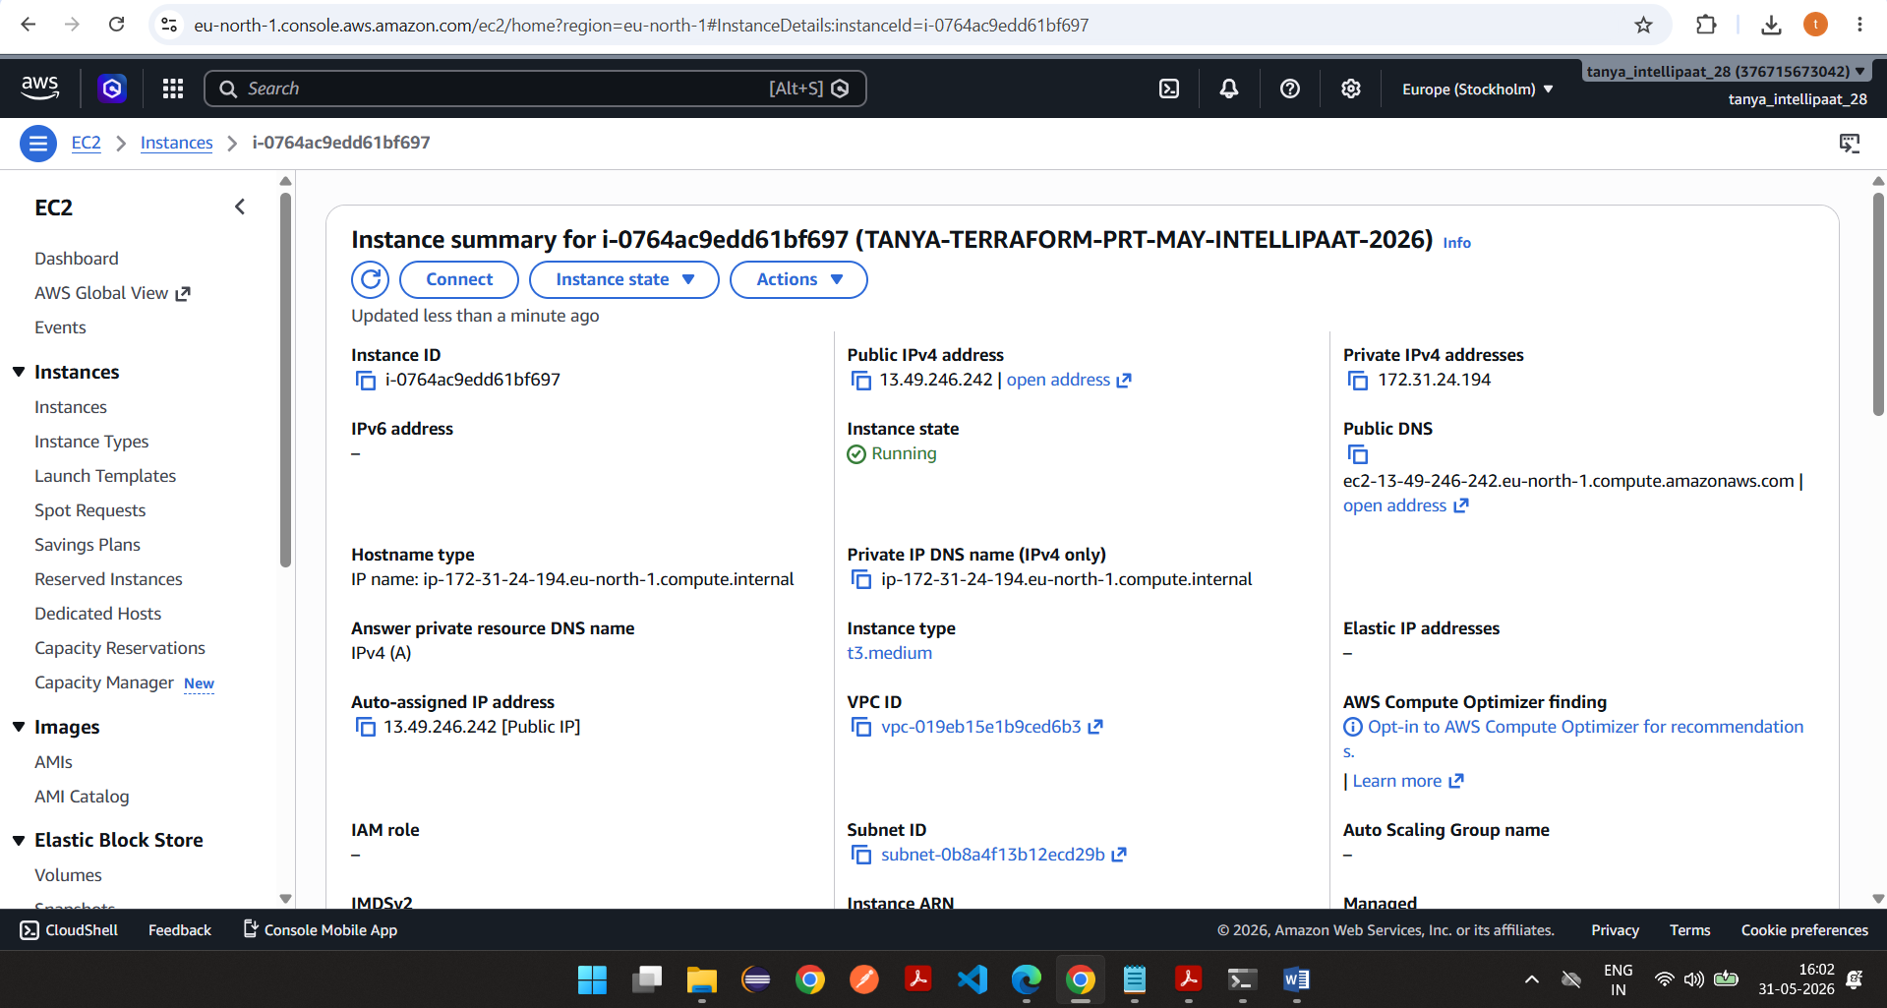

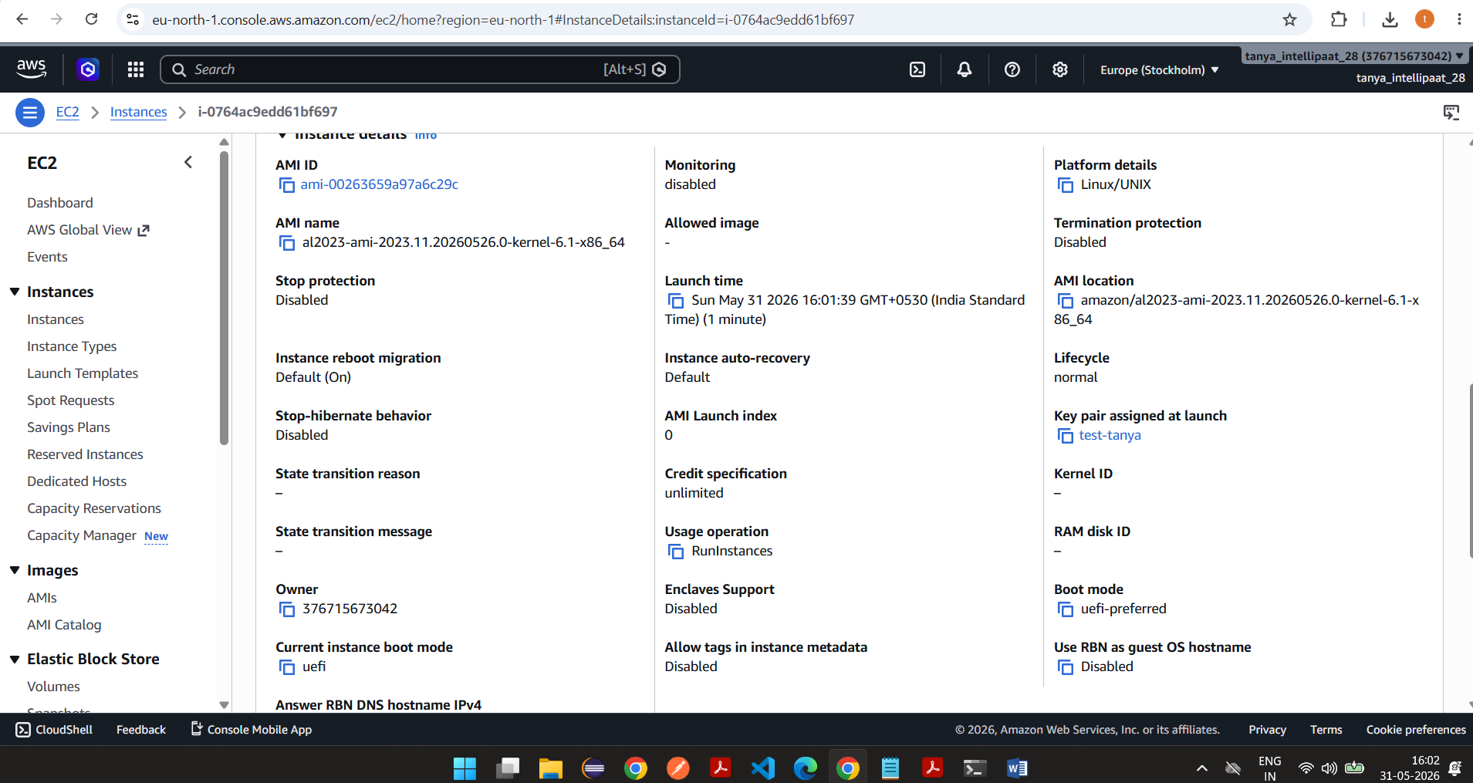

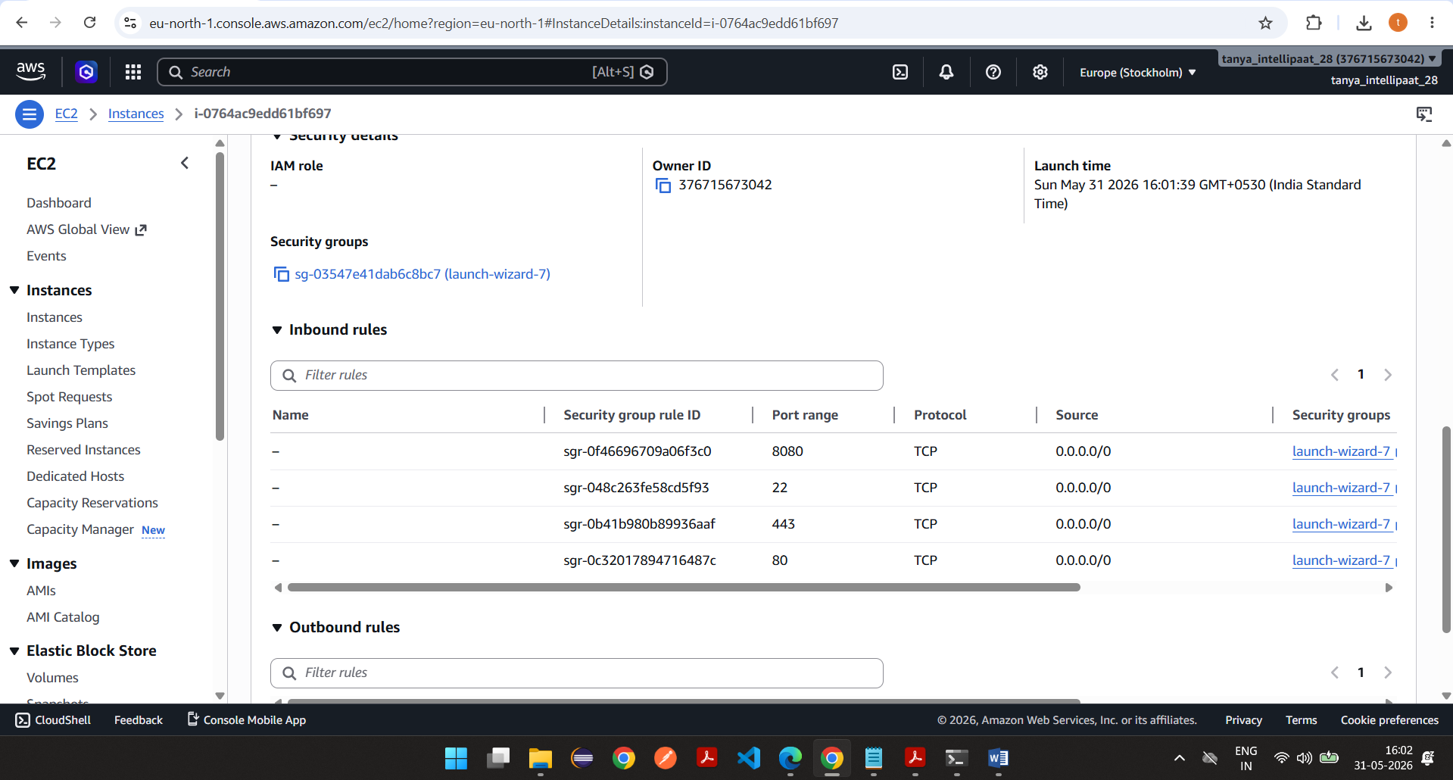

Connect and do AWS configure
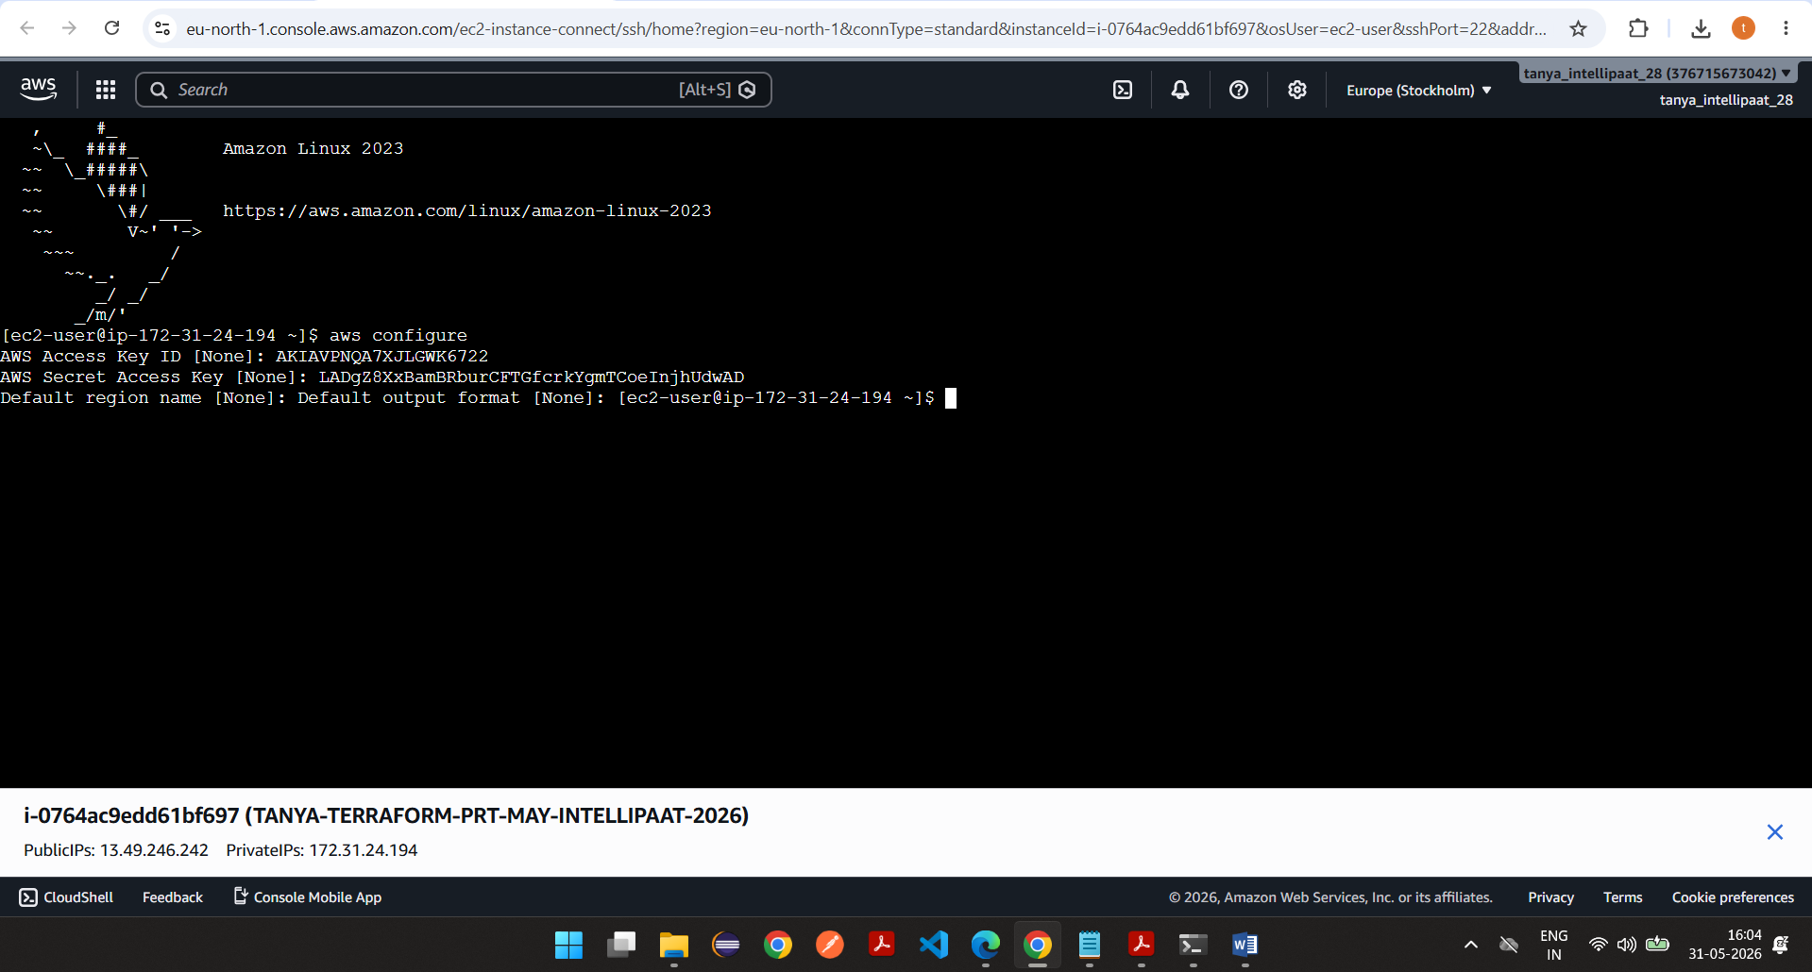

Download terraform
Terraform installation
To install Terraform on Amazon Linux 2023 EC2, run the following commands:

1. Update the system
sudo dnf update -y
2. Install required packages
sudo dnf install -y yum-utils unzip
3. Add HashiCorp repository
sudo dnf config-manager --add-repo https://rpm.releases.hashicorp.com/AmazonLinux/hashicorp.repo
4. Install Terraform
sudo dnf -y install terraform
5. Verify installation
terraform version
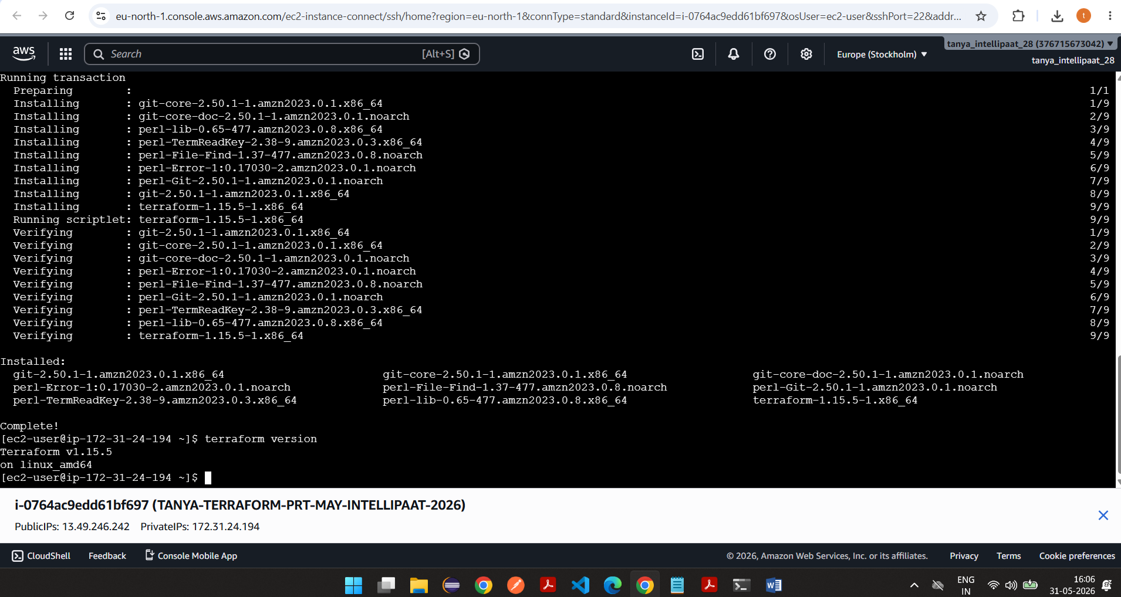

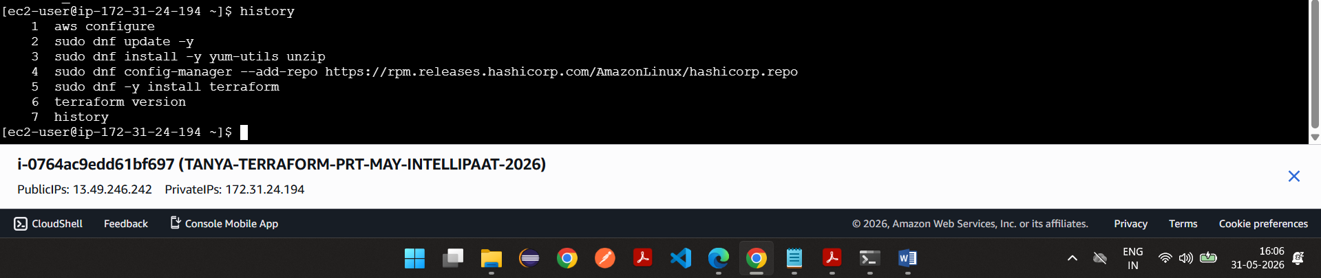

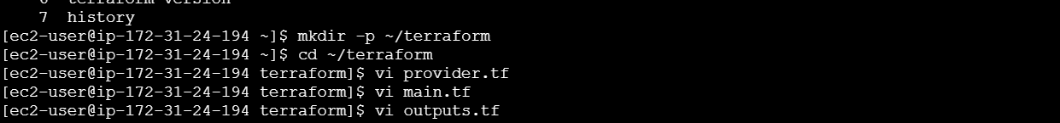

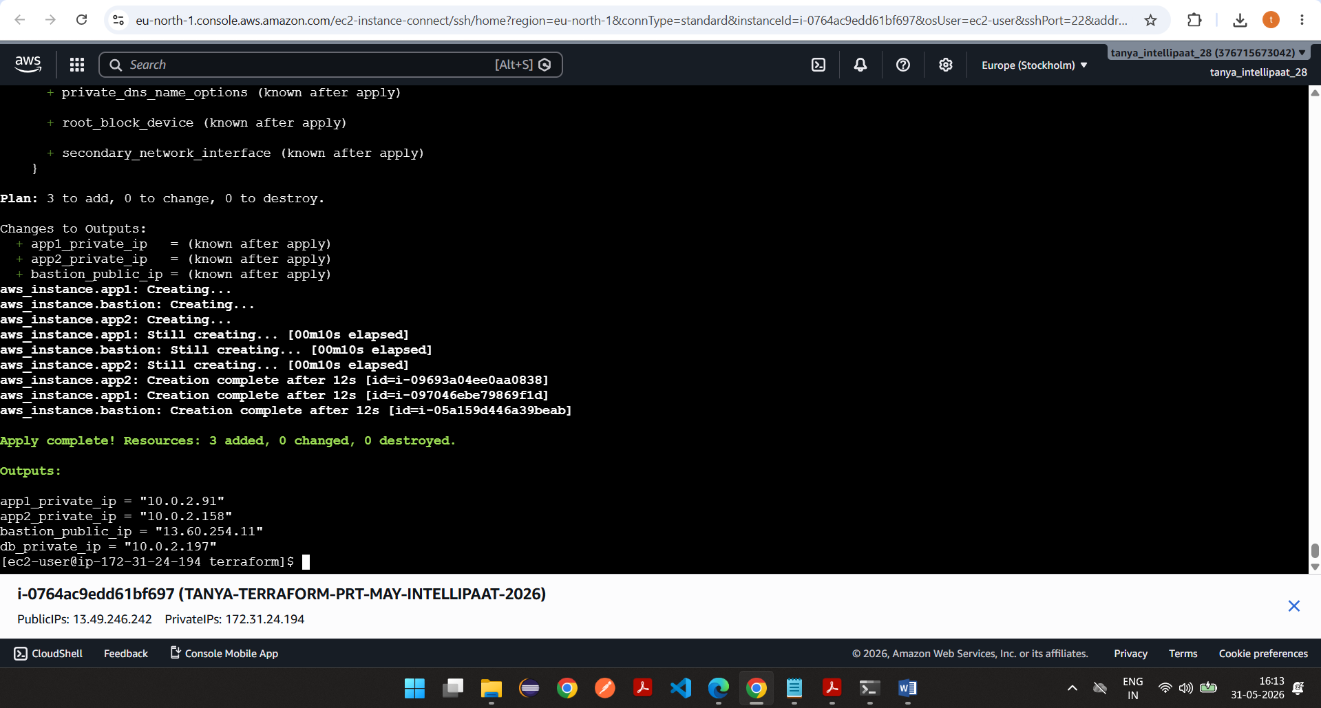

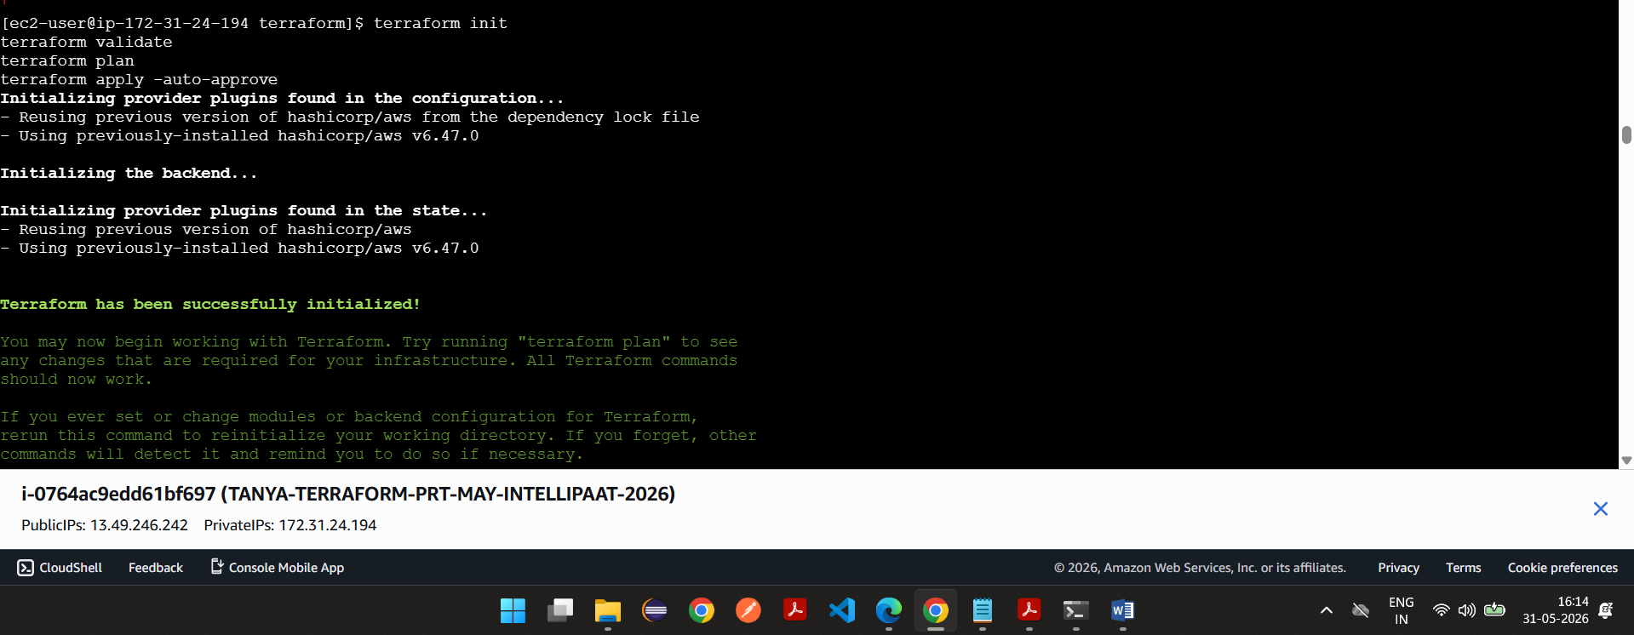

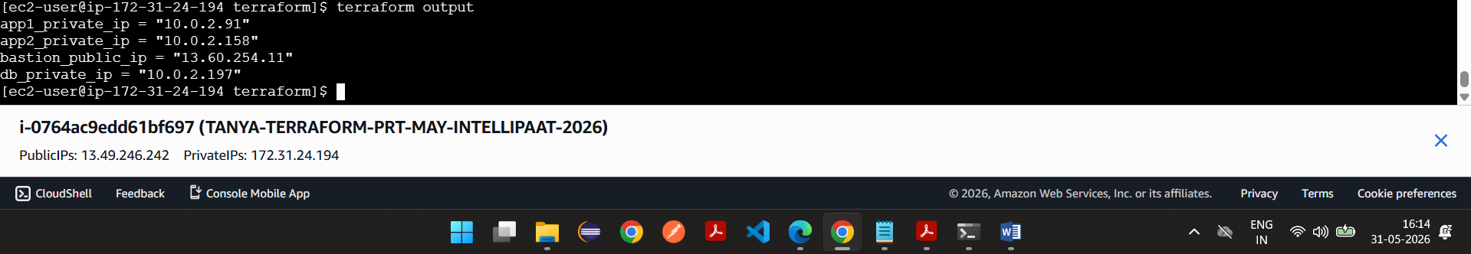

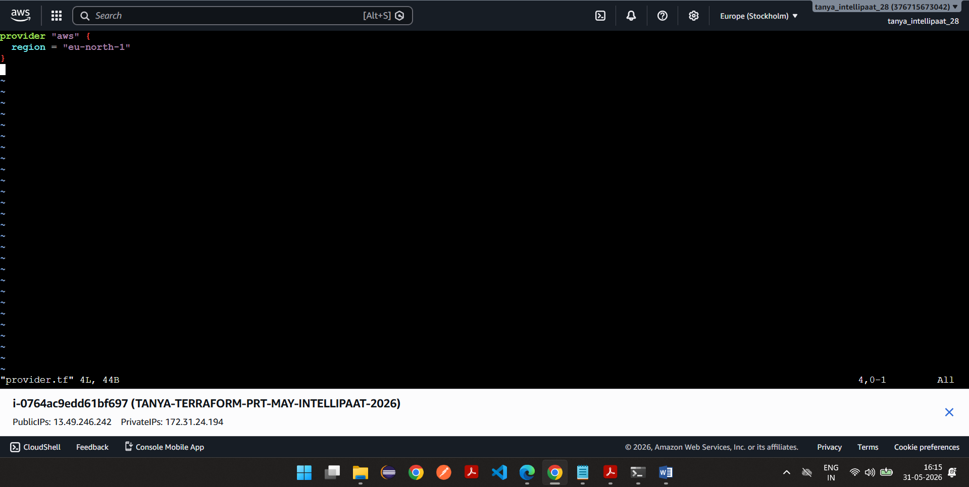

Main.tf
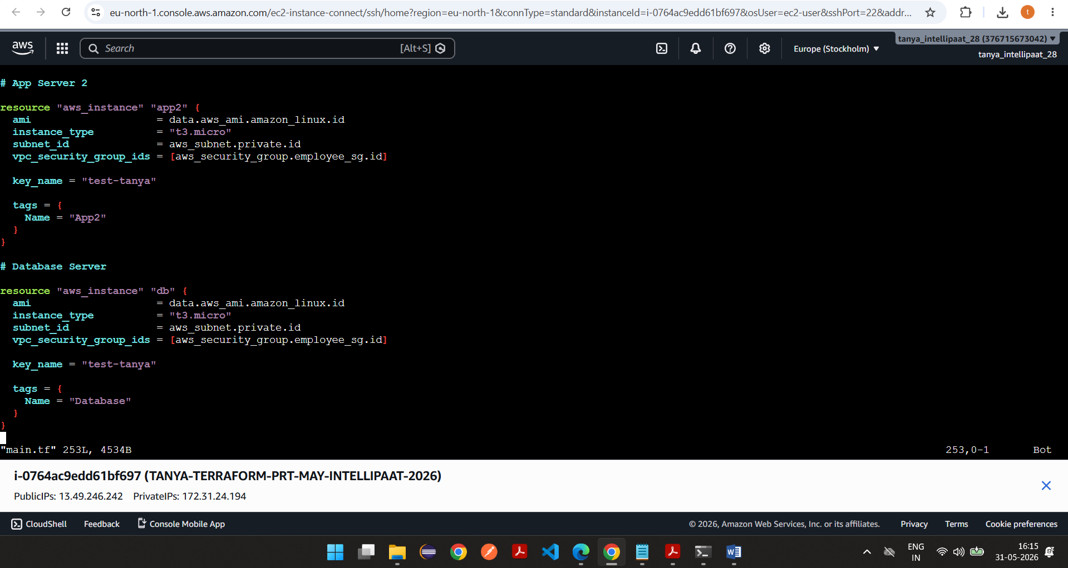

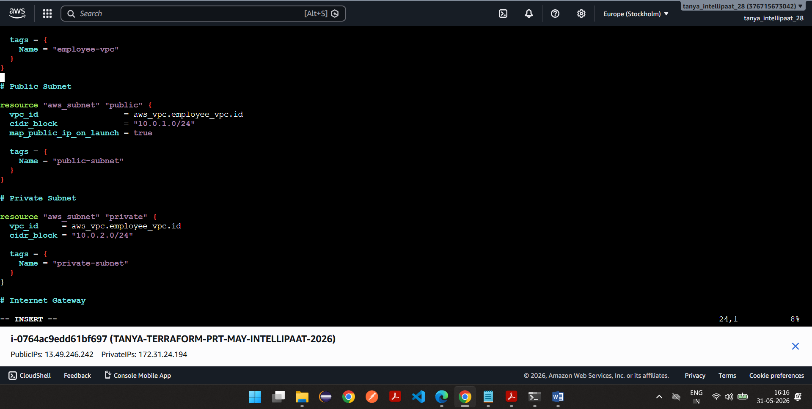

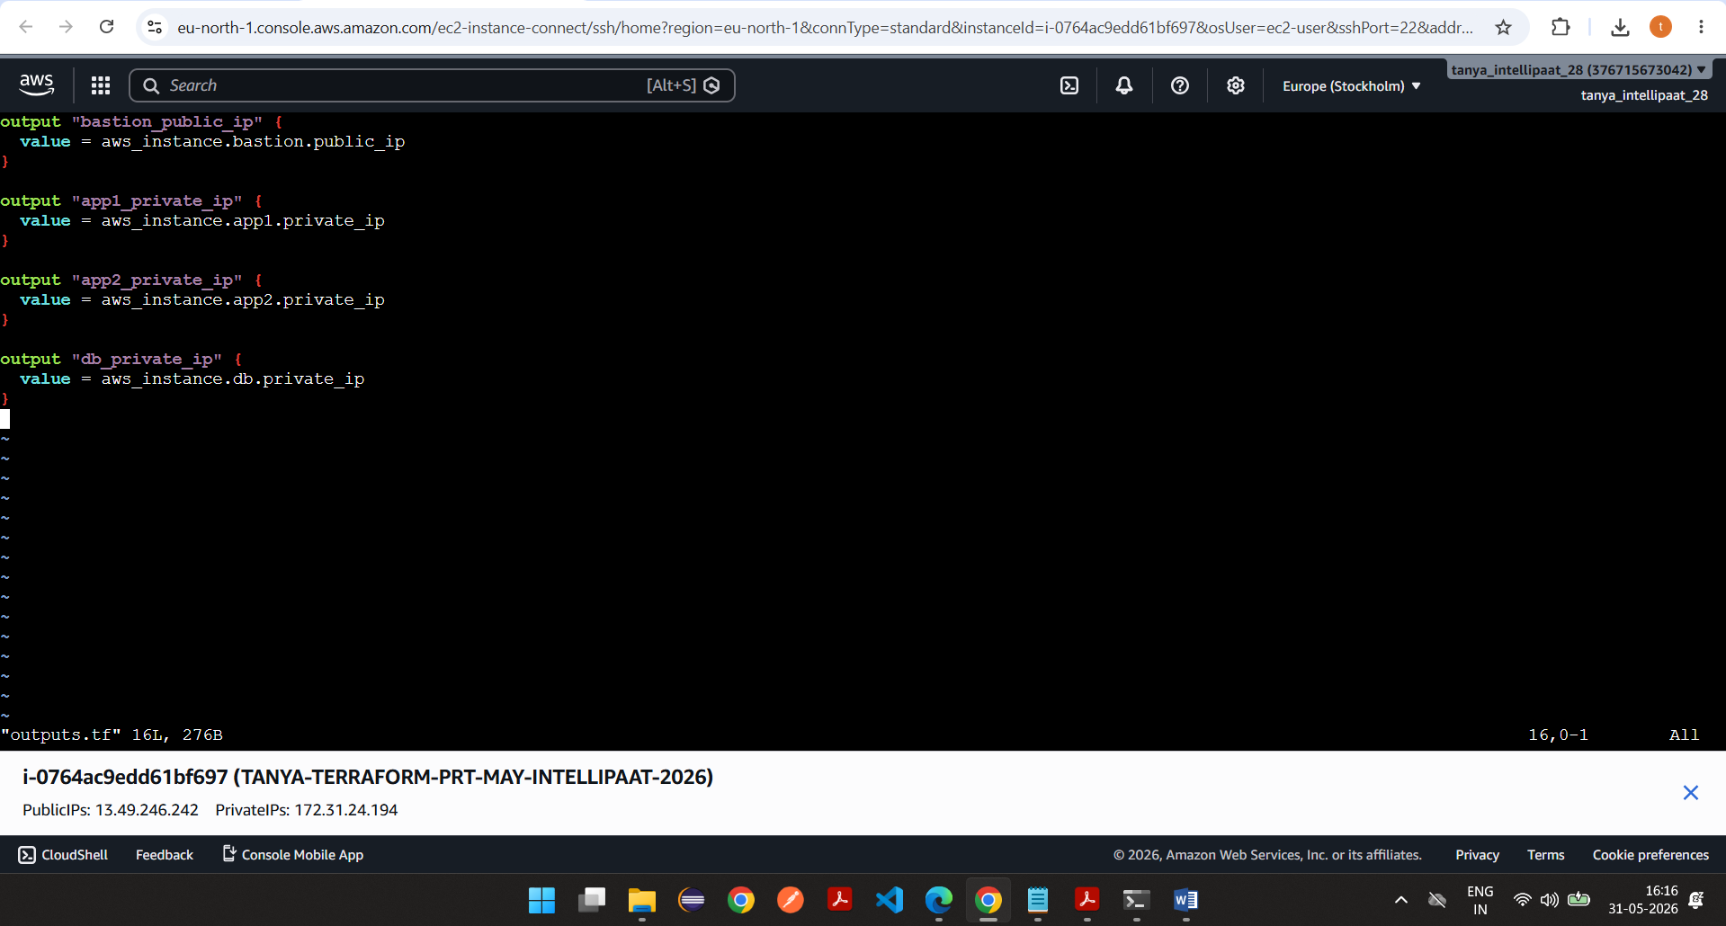

provider "aws" {
region = "eu-north-1"
}

# Latest Amazon Linux 2023 AMI

data "aws_ami" "amazon_linux" {
most_recent = true

owners = ["amazon"]

filter {
name = "name"
values = ["al2023-ami-2023*"]
}
}

# VPC

resource "aws_vpc" "employee_vpc" {
cidr_block = "10.0.0.0/16"
enable_dns_hostnames = true

tags = {
Name = "employee-vpc"
}
}

# Public Subnet

resource "aws_subnet" "public" {
vpc_id = aws_vpc.employee_vpc.id
cidr_block = "10.0.1.0/24"
map_public_ip_on_launch = true

tags = {
Name = "public-subnet"
}
}

# Private Subnet

resource "aws_subnet" "private" {
vpc_id = aws_vpc.employee_vpc.id
cidr_block = "10.0.2.0/24"

tags = {
Name = "private-subnet"
}
}

# Internet Gateway

resource "aws_internet_gateway" "igw" {
vpc_id = aws_vpc.employee_vpc.id

tags = {
Name = "employee-igw"
}
}

# Elastic IP for NAT

resource "aws_eip" "nat_eip" {
domain = "vpc"

depends_on = [
aws_internet_gateway.igw
]

tags = {
Name = "nat-eip"
}
}

# NAT Gateway

resource "aws_nat_gateway" "nat" {
allocation_id = aws_eip.nat_eip.id
subnet_id = aws_subnet.public.id

depends_on = [
aws_internet_gateway.igw
]

tags = {
Name = "employee-nat"
}
}

# Public Route Table

resource "aws_route_table" "public_rt" {
vpc_id = aws_vpc.employee_vpc.id

route {
cidr_block = "0.0.0.0/0"
gateway_id = aws_internet_gateway.igw.id
}

tags = {
Name = "public-rt"
}
}

resource "aws_route_table_association" "public_assoc" {
subnet_id = aws_subnet.public.id
route_table_id = aws_route_table.public_rt.id
}

# Private Route Table

resource "aws_route_table" "private_rt" {
vpc_id = aws_vpc.employee_vpc.id

route {
cidr_block = "0.0.0.0/0"
nat_gateway_id = aws_nat_gateway.nat.id
}

tags = {
Name = "private-rt"
}
}

resource "aws_route_table_association" "private_assoc" {
subnet_id = aws_subnet.private.id
route_table_id = aws_route_table.private_rt.id
}

# Security Group

resource "aws_security_group" "employee_sg" {
name = "employee-sg"
description = "Employee Portal Security Group"
vpc_id = aws_vpc.employee_vpc.id

ingress {
description = "SSH from VPC"
from_port = 22
to_port = 22
protocol = "tcp"
cidr_blocks = ["10.0.0.0/16"]
}

ingress {
description = "SSH Public Bastion"
from_port = 22
to_port = 22
protocol = "tcp"
cidr_blocks = ["0.0.0.0/0"]
}

ingress {
description = "HTTP"
from_port = 80
to_port = 80
protocol = "tcp"
cidr_blocks = ["0.0.0.0/0"]
}

ingress {
description = "Jenkins"
from_port = 8080
to_port = 8080
protocol = "tcp"
cidr_blocks = ["0.0.0.0/0"]
}

ingress {
description = "Employee Portal"
from_port = 3000
to_port = 3000
protocol = "tcp"
cidr_blocks = ["0.0.0.0/0"]
}

ingress {
description = "PostgreSQL"
from_port = 5432
to_port = 5432
protocol = "tcp"
cidr_blocks = ["10.0.0.0/16"]
}

egress {
from_port = 0
to_port = 0
protocol = "-1"
cidr_blocks = ["0.0.0.0/0"]
}

tags = {
Name = "employee-sg"
}
}

# Bastion Host

resource "aws_instance" "bastion" {
ami = data.aws_ami.amazon_linux.id
instance_type = "t3.micro"
subnet_id = aws_subnet.public.id
vpc_security_group_ids = [aws_security_group.employee_sg.id]

key_name = "test-tanya"

tags = {
Name = "Bastion"
}
}

# App Server 1

resource "aws_instance" "app1" {
ami = data.aws_ami.amazon_linux.id
instance_type = "t3.micro"
subnet_id = aws_subnet.private.id
vpc_security_group_ids = [aws_security_group.employee_sg.id]

key_name = "test-tanya"

tags = {
Name = "App1"
}
}

# App Server 2

resource "aws_instance" "app2" {
ami = data.aws_ami.amazon_linux.id
instance_type = "t3.micro"
subnet_id = aws_subnet.private.id
vpc_security_group_ids = [aws_security_group.employee_sg.id]

key_name = "test-tanya"

tags = {
Name = "App2"
}
}

# Database Server

resource "aws_instance" "db" {
ami = data.aws_ami.amazon_linux.id
instance_type = "t3.micro"
subnet_id = aws_subnet.private.id
vpc_security_group_ids = [aws_security_group.employee_sg.id]

key_name = "test-tanya"

tags = {
Name = "Database"
}
}

output "bastion_public_ip" {
value = aws_instance.bastion.public_ip
}

output "app1_private_ip" {
value = aws_instance.app1.private_ip
}

output "app2_private_ip" {
value = aws_instance.app2.private_ip
}

output "db_private_ip" {
value = aws_instance.db.private_ip
}

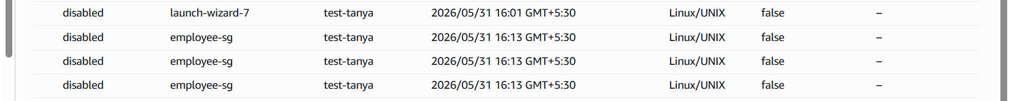

VPC
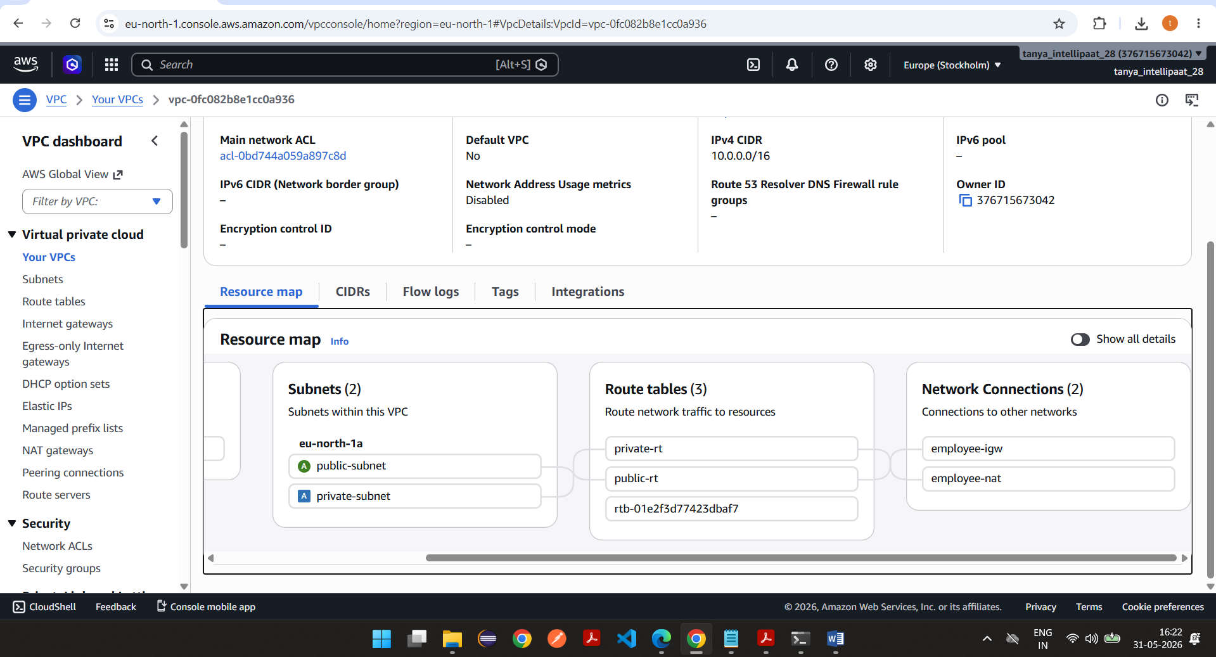

Task 2

2. Configuration Management using Ansible

Requirements:
- Configure passwordless SSH from Bastion node to all other nodes.

Using Ansible Playbooks:
- Install Docker & Docker Compose on Application Nodes
- Install PostgreSQL on Database Node
- Deploy E-Commerce microservices using Docker containers

Screenshots-
Install ansible
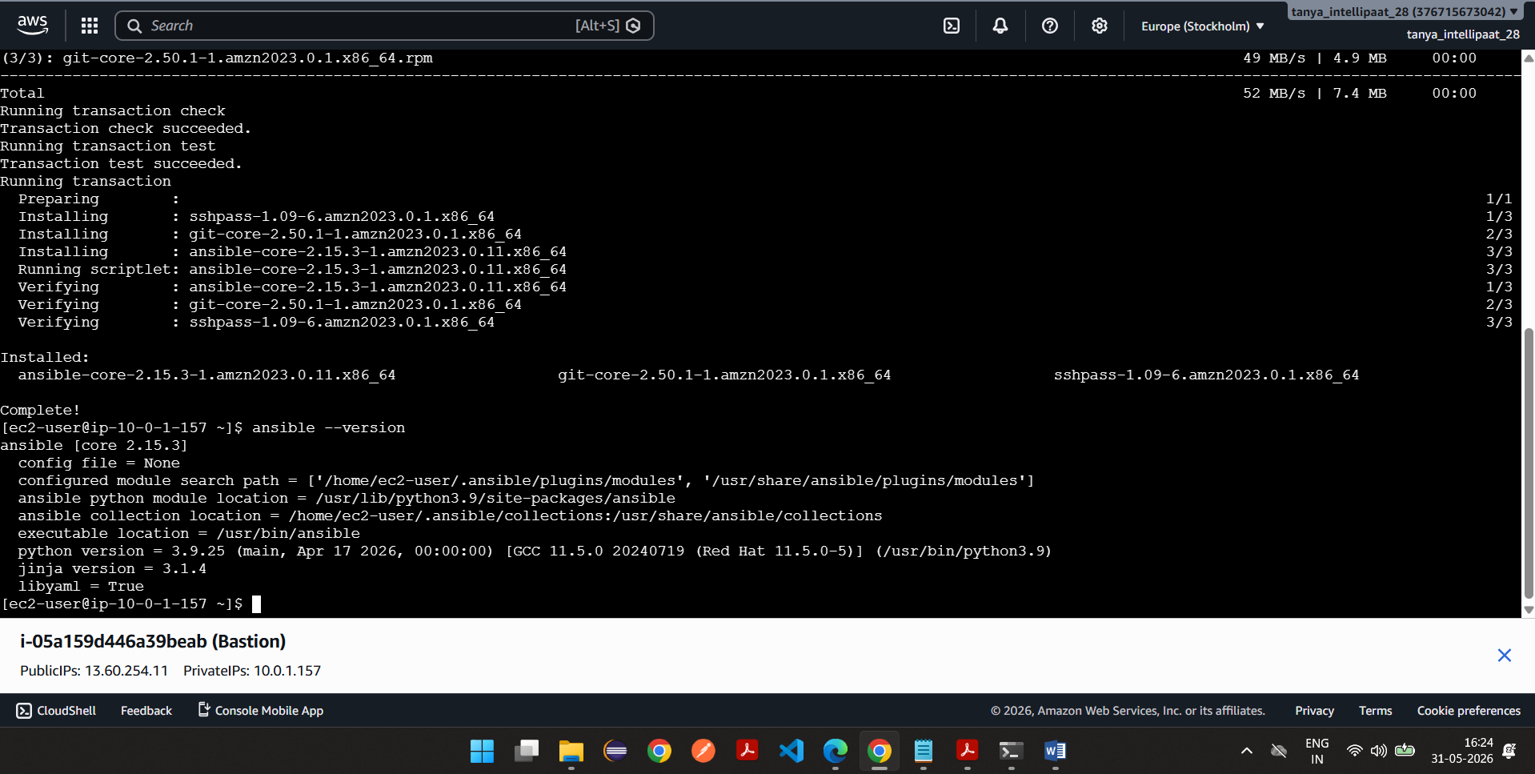

app1_private_ip = "10.0.2.91"
app2_private_ip = "10.0.2.158"
bastion_public_ip = "13.60.254.11"
db_private_ip = "10.0.2.197"

[bastion]
bastion ansible_host=13.60.254.11

[appservers]
app1 ansible_host=10.0.2.91 ansible_user=ec2-user ansible_ssh_private_key_file=/home/ec2-user/test-tanya.pem
app2 ansible_host=10.0.2.158 ansible_user=ec2-user ansible_ssh_private_key_file=/home/ec2-user/test-tanya.pem

[database]
db ansible_host=10.0.2.197 ansible_user=ec2-user ansible_ssh_private_key_file=/home/ec2-user/test-tanya.pem
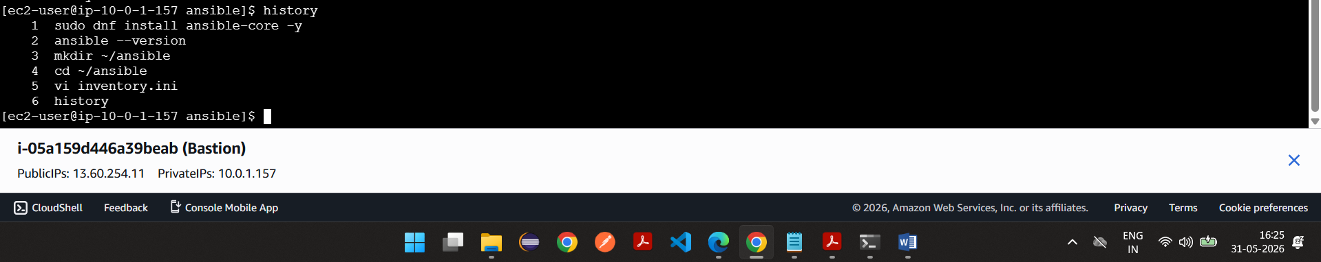

Inventory.ini
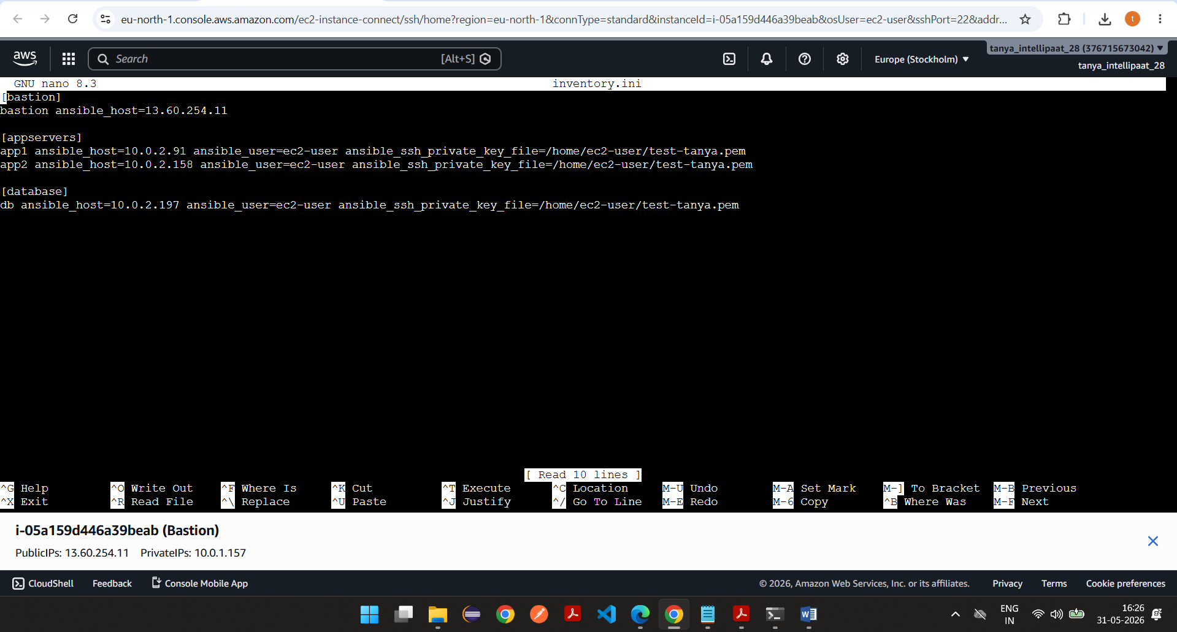

Do following from local machine>windows>cmd
scp -i test-tanya.pem test-tanya.pem ec2-user@13.60.254.11:~
cd /home/ec2-user
chmod 400 ~/test-tanya.pem
Do for all three from bastion ec2
App1
ssh -i ~/test-tanya.pem ec2-user@10.0.2.91
app2
ssh -i ~/test-tanya.pem ec2-user@10.0.2.158
database
ssh -i ~/test-tanya.pem ec2-user@10.0.2.197
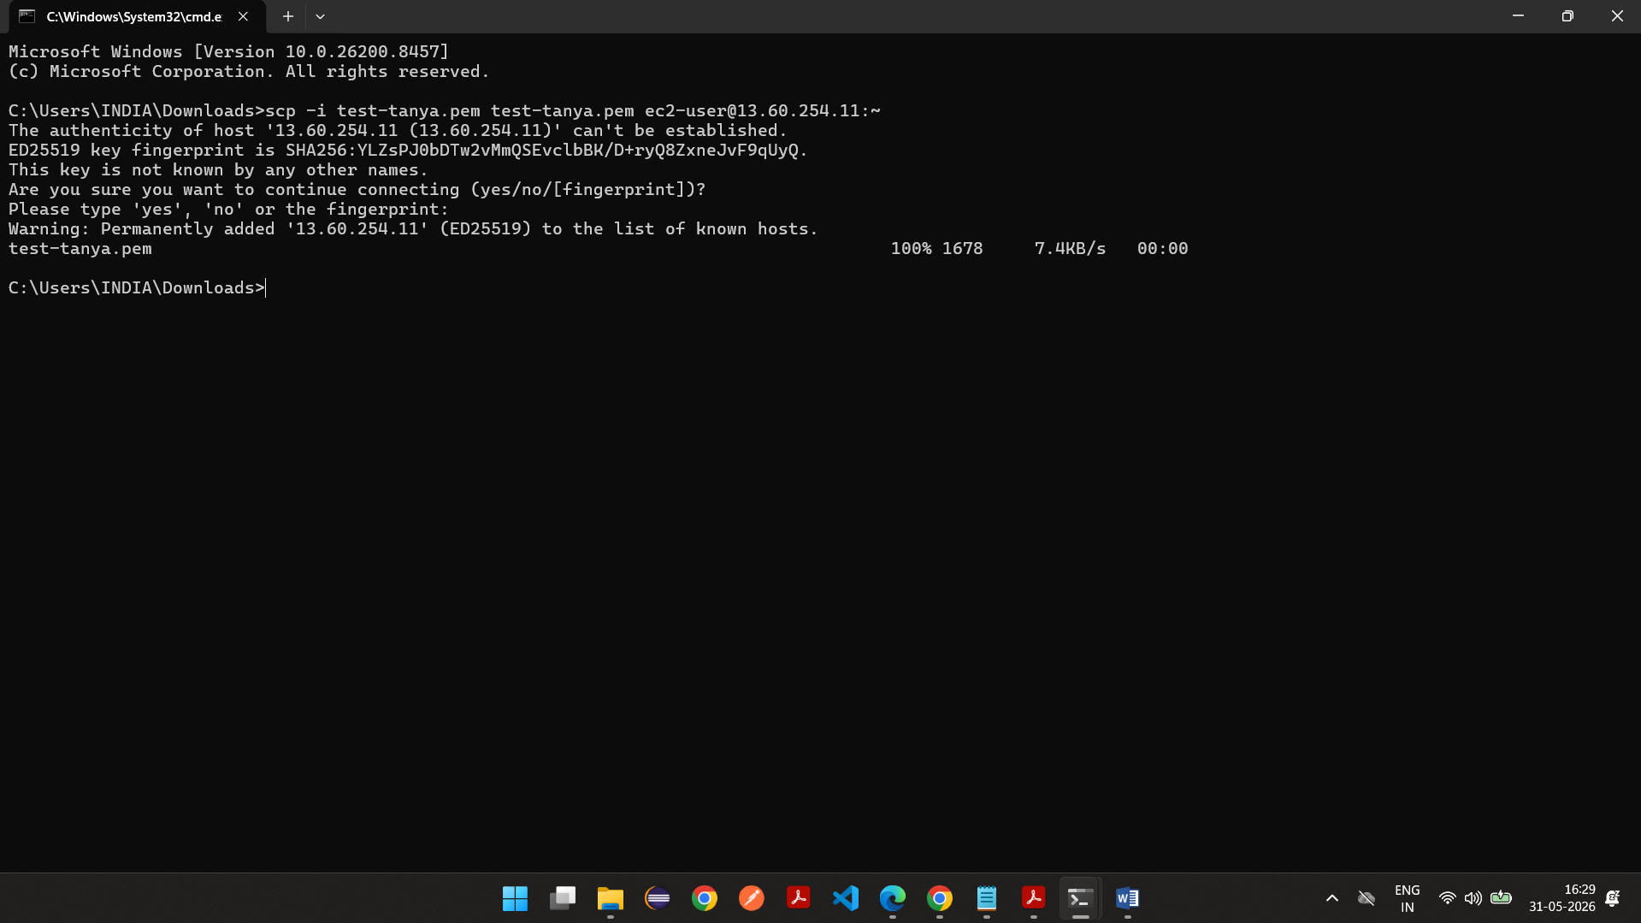

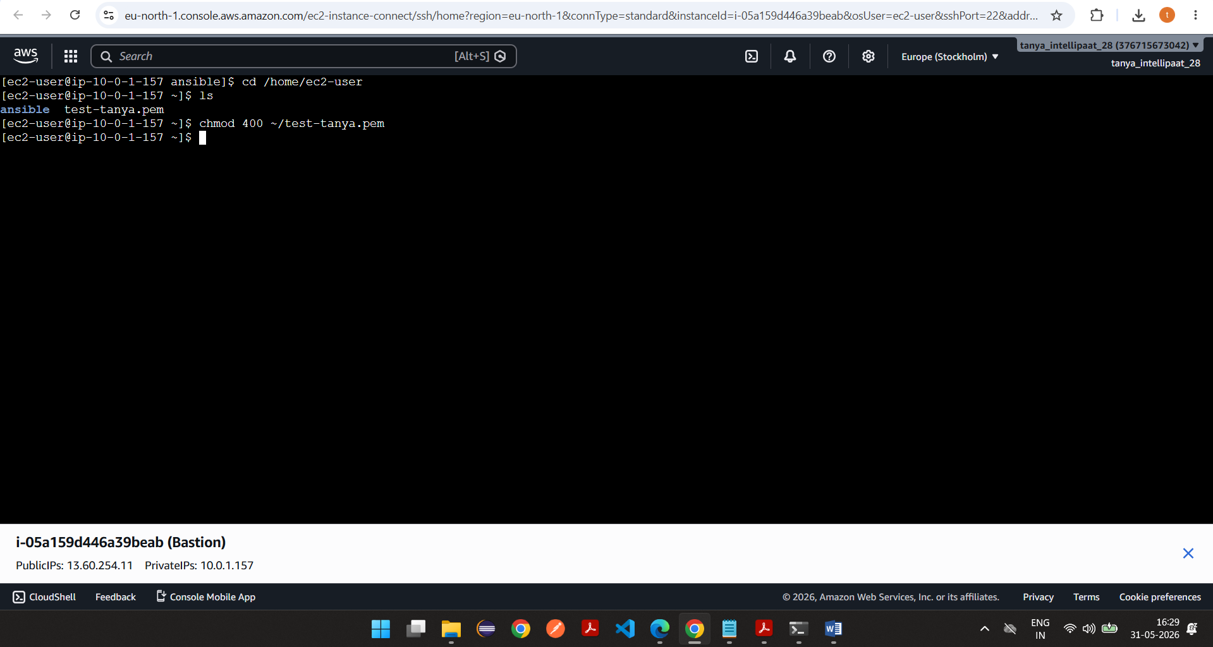

APP1 connectivity using bastion
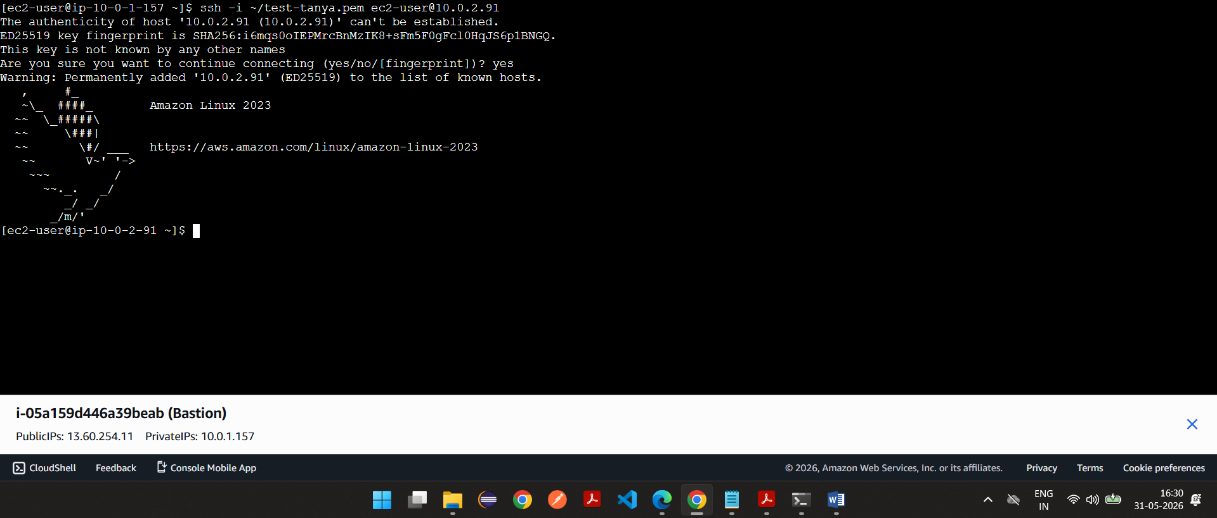

APP2 connectivity using bastion
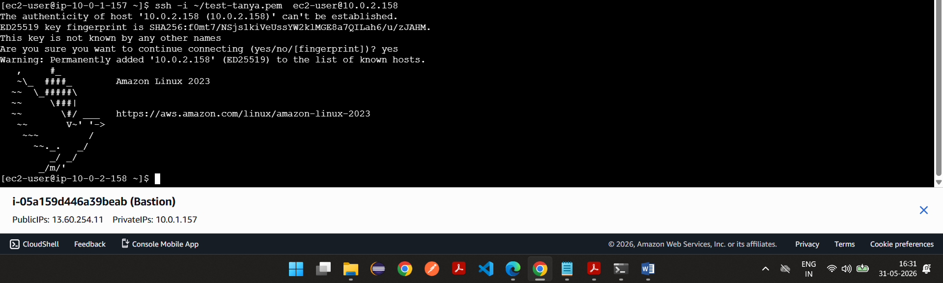

Database connectivity using bastion
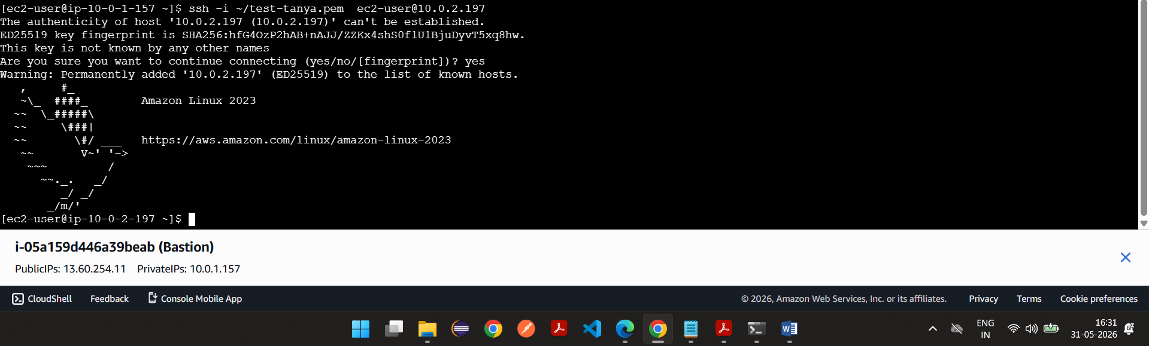

Ping all servers
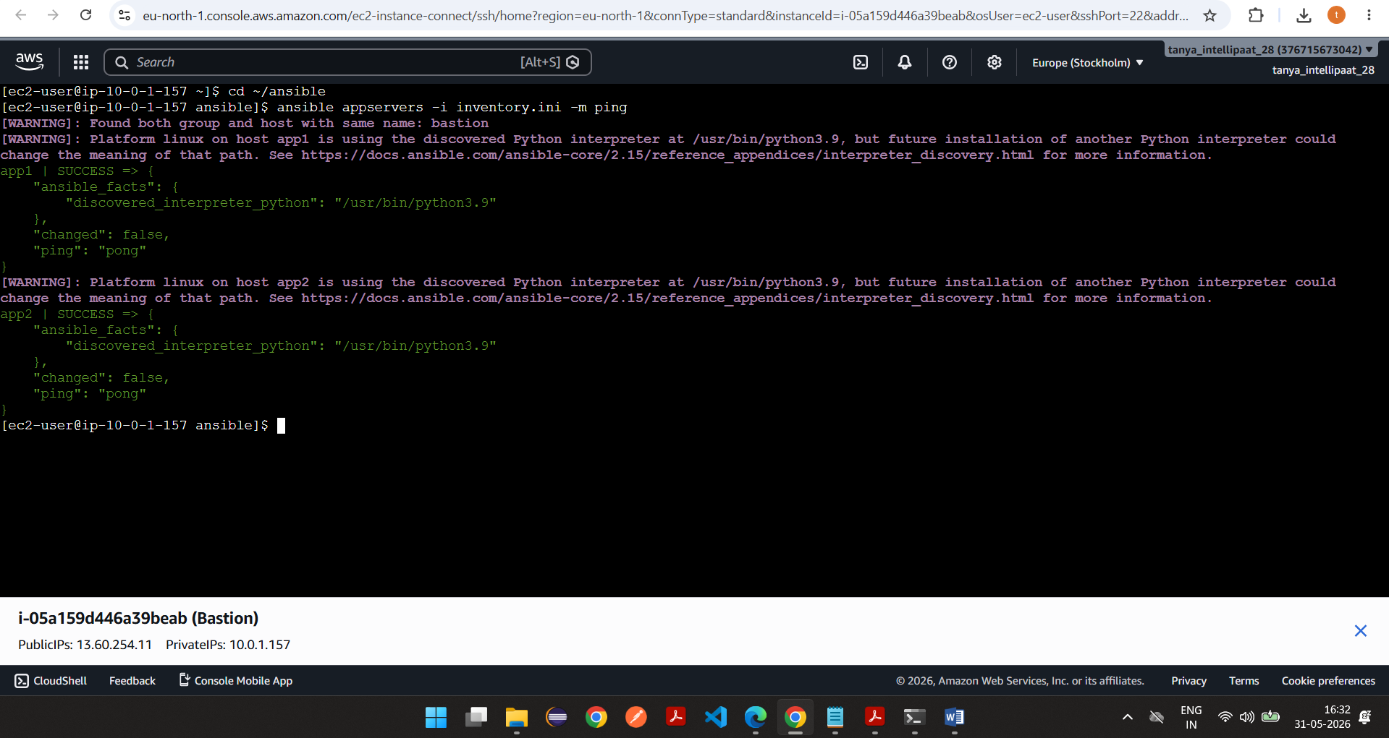

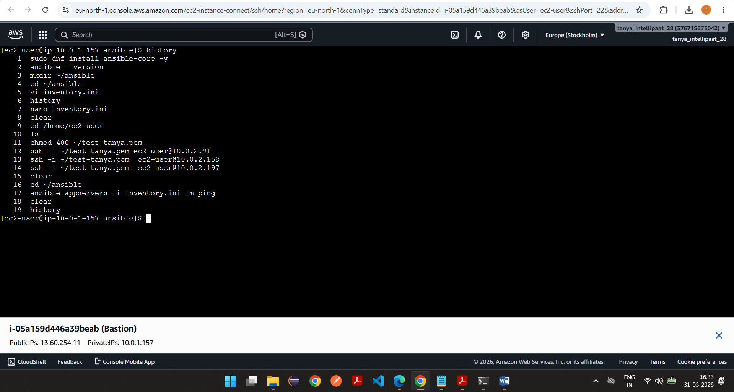

Install docker and docker-compose in app servers using bastion ec2 instance
vi appservers.yml
---
- hosts: appservers
become: yes
tasks:
- name: Update packages
dnf:
name: "*"
state: latest
- name: Install Docker
dnf:
name: docker
state: present
- name: Start and Enable Docker
service:
name: docker
state: started
enabled: yes
- name: Add ec2-user to docker group
user:
name: ec2-user
groups: docker
append: yes
- name: Download Docker Compose
get_url:
url: https://github.com/docker/compose/releases/latest/download/docker-compose-linux-x86_64
dest: /usr/local/bin/docker-compose
mode: '0755'
- name: Create symbolic link for docker-compose
file:
src: /usr/local/bin/docker-compose
dest: /usr/bin/docker-compose
state: link
- name: Verify Docker Compose installation
command: docker-compose --version
register: compose_version
changed_when: false
- name: Display Docker Compose version
debug:
var: compose_version.stdout

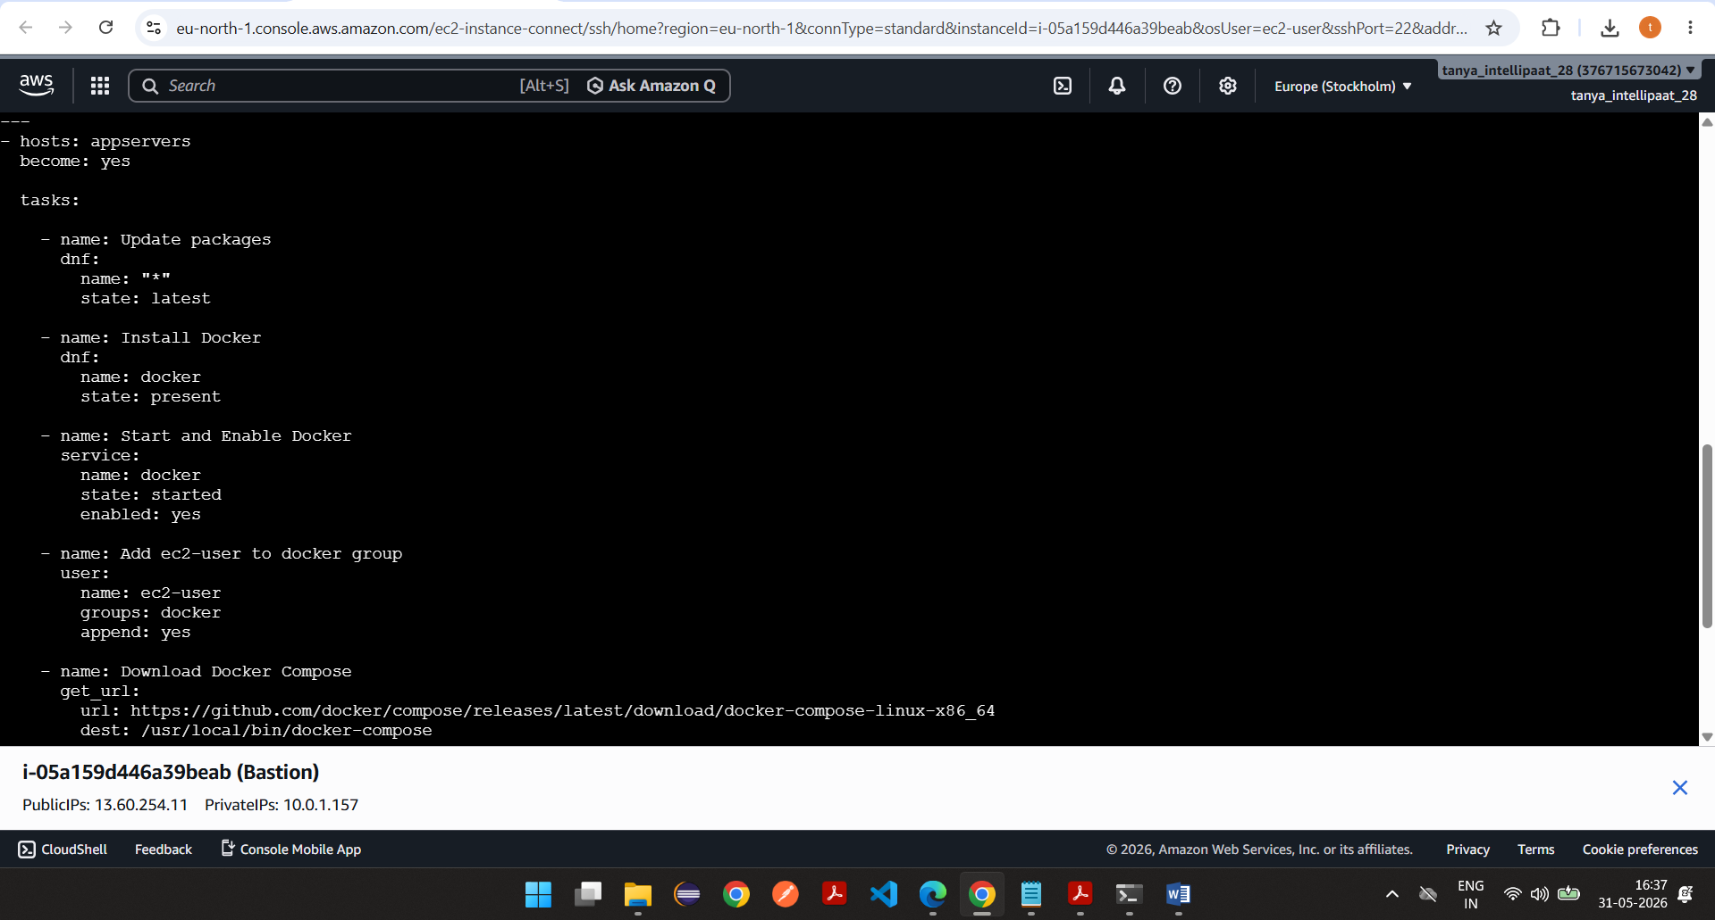

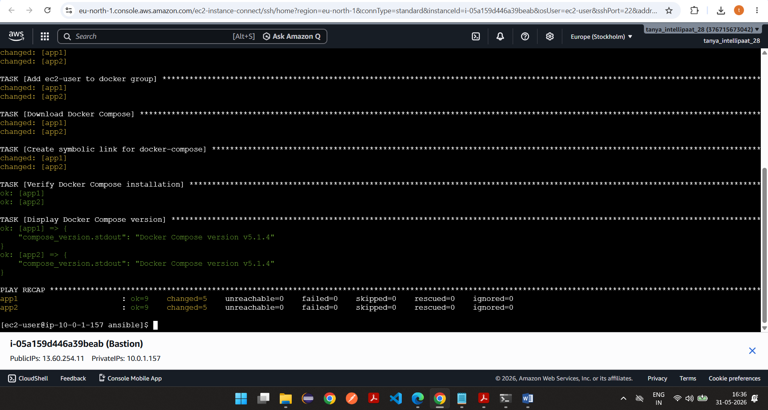

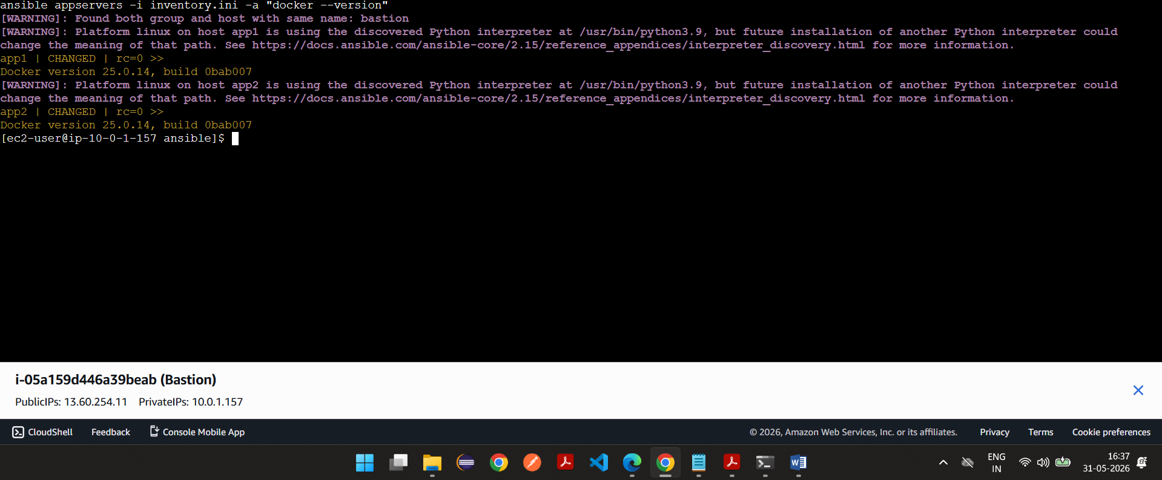

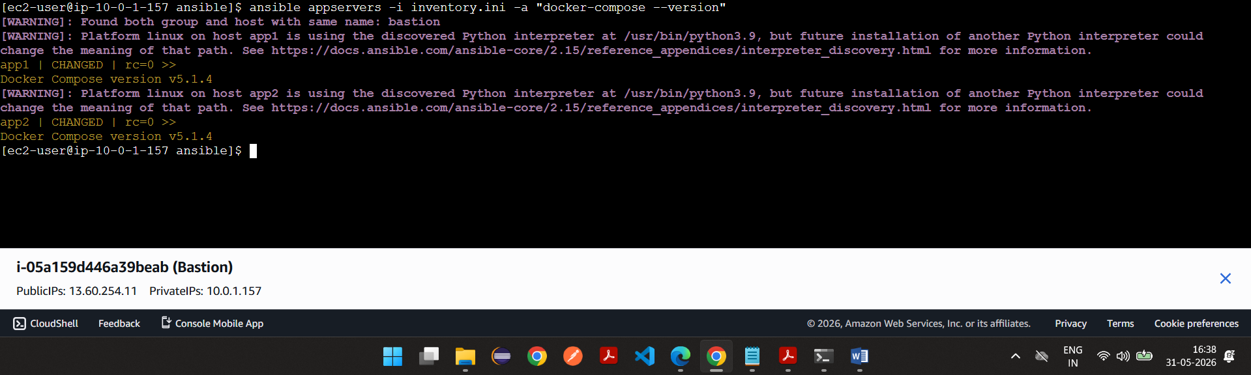

Install postgres in database node using bastion server
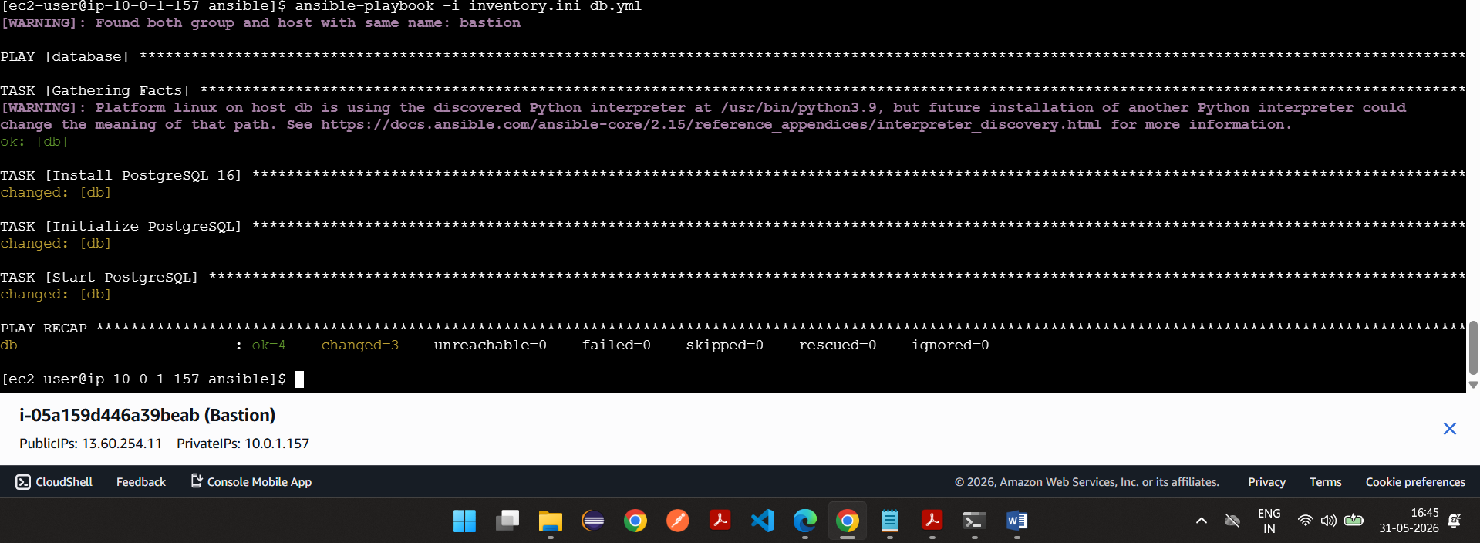

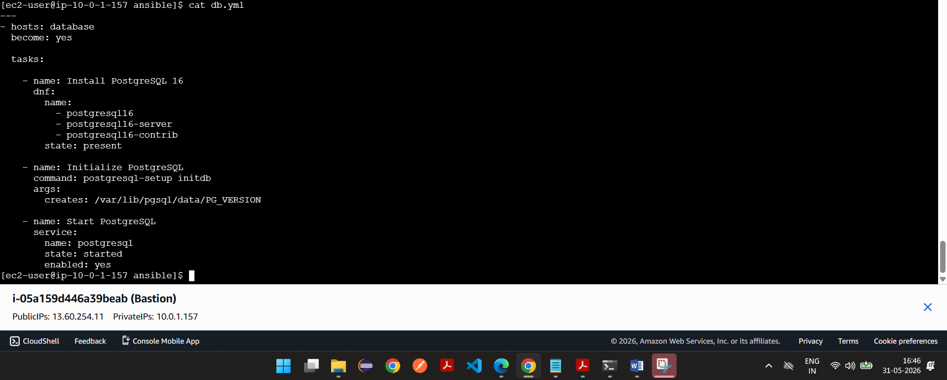

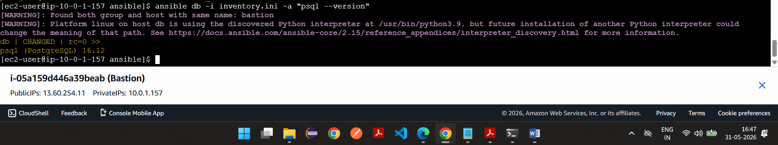

Vi db.yml
---
- hosts: database
become: yes

tasks:

- name: Install PostgreSQL 16
dnf:
name:
- postgresql16
- postgresql16-server
- postgresql16-contrib
state: present

- name: Initialize PostgreSQL
command: postgresql-setup initdb
args:
creates: /var/lib/pgsql/data/PG_VERSION

- name: Start PostgreSQL
service:
name: postgresql
state: started
enabled: yes

Deployment using docker in appservers using bastion ec2 instance
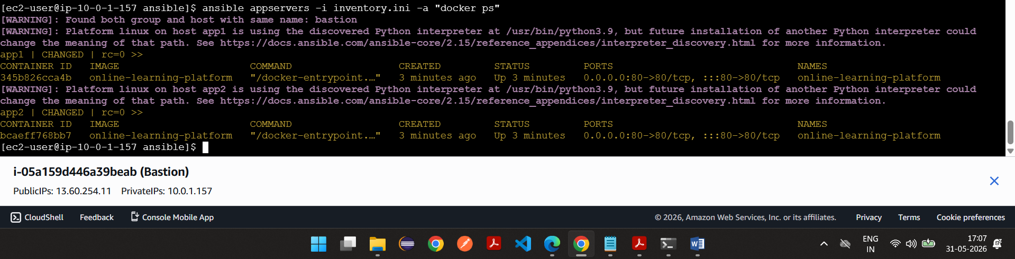
app.yml, deploying using ansible script

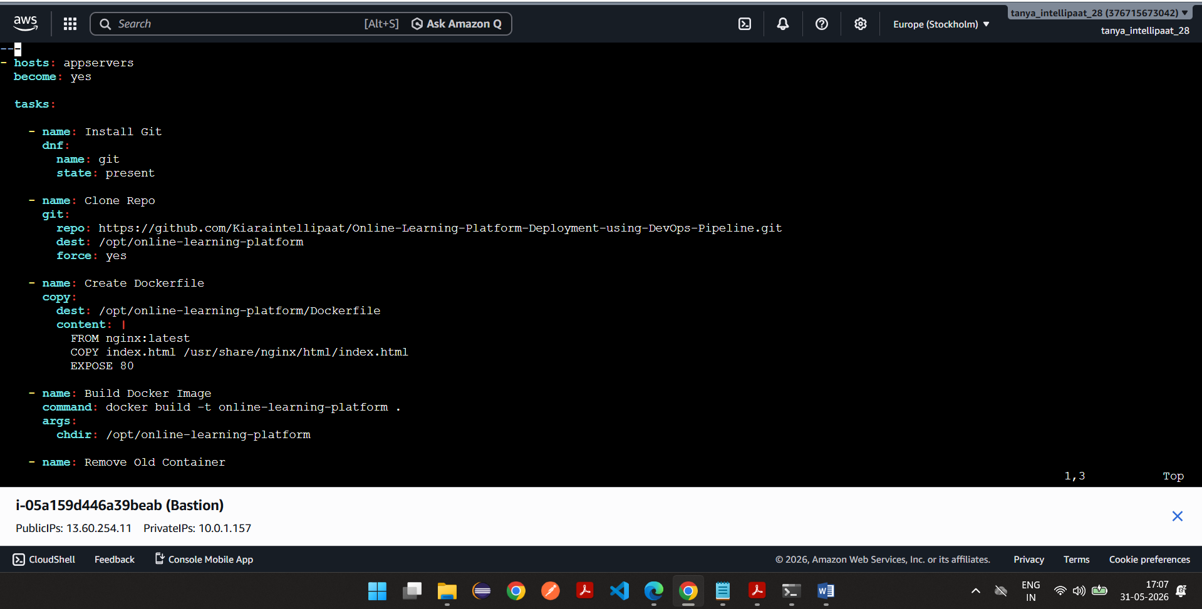

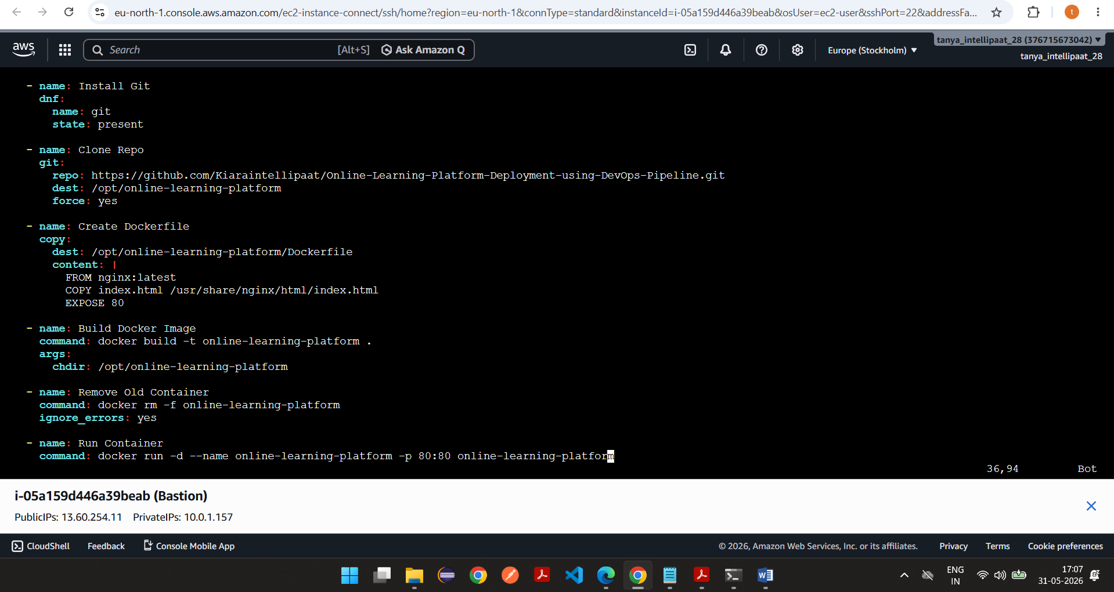

Vi app.yml
---
- hosts: appservers
become: yes

tasks:

- name: Install Git
dnf:
name: git
state: present

- name: Clone Repo
git:
repo: https://github.com/Kiaraintellipaat/Online-Learning-Platform-Deployment-using-DevOps-Pipeline.git
dest: /opt/online-learning-platform
force: yes

- name: Create Dockerfile
copy:
dest: /opt/online-learning-platform/Dockerfile
content: |
FROM nginx:latest
COPY index.html /usr/share/nginx/html/index.html
EXPOSE 80

- name: Build Docker Image
command: docker build -t online-learning-platform .
args:
chdir: /opt/online-learning-platform

- name: Remove Old Container
command: docker rm -f online-learning-platform
ignore_errors: yes

- name: Run Container
command: docker run -d --name online-learning-platform -p 80:80 online-learning-platform

Output->
ssh -i test-tanya.pem -L 8080:10.0.2.91:80 ec2-user@13.60.254.11
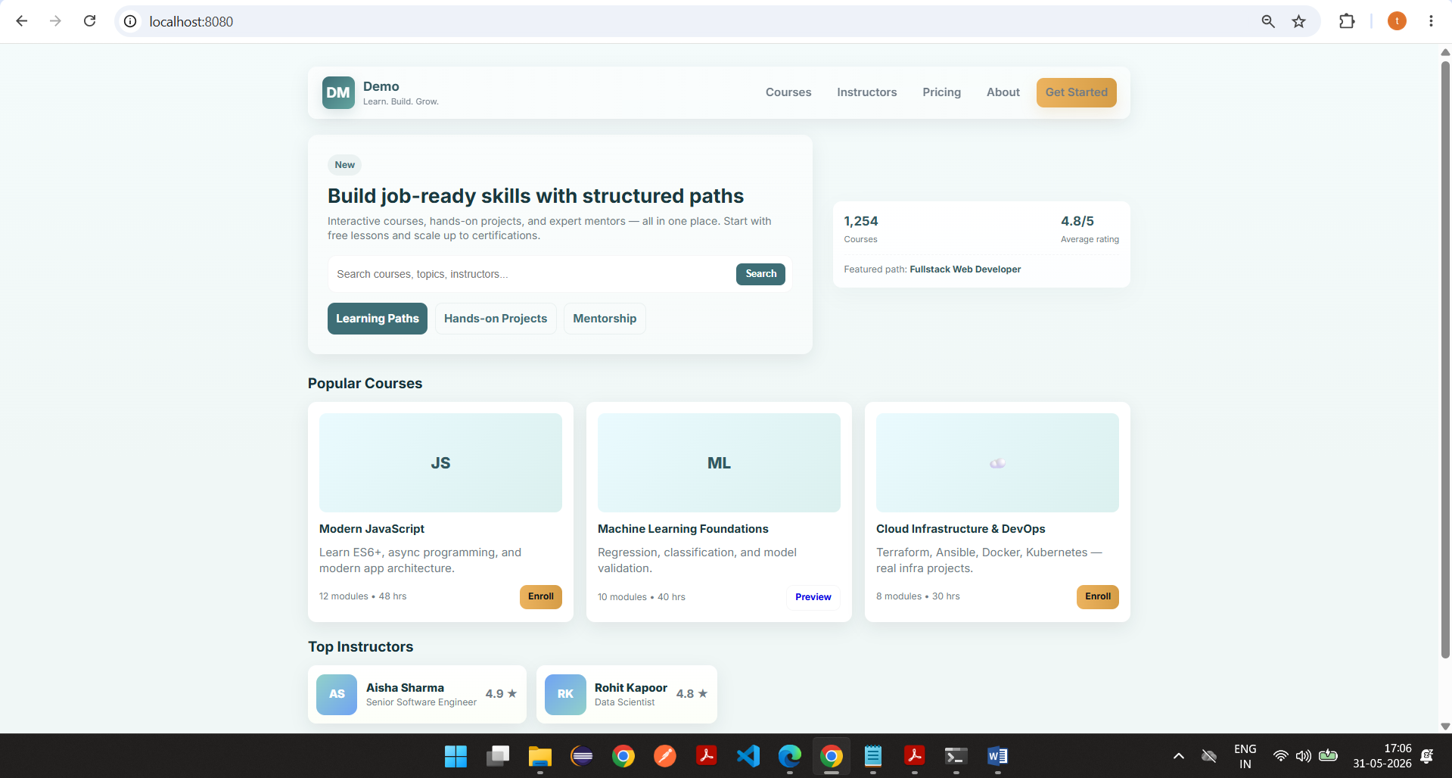

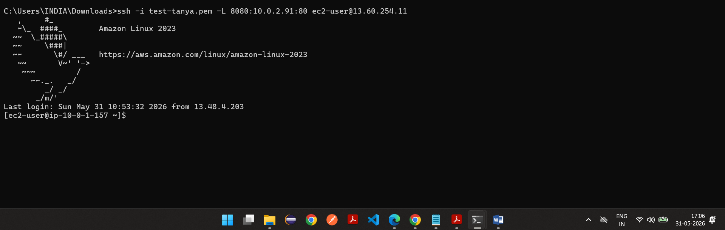

Task 3

3. CI/CD Pipeline using Jenkins

Jenkins Setup:
- Install Jenkins on Bastion Node using Ansible
- Configure required plugins:
  - Git
  - Docker
  - Pipeline

Jenkins Pipeline must:
- Pull latest code from GitHub
- Run unit tests
- Build Docker images
- Push images to Docker Hub

Screenshots
Vi jenkins.yml
---
- hosts: bastion
become: yes

tasks:
---
- hosts: bastion
become: yes

tasks:

- name: Install Java 21
dnf:
name: java-21-amazon-corretto
state: present

- name: Add Jenkins Repository
get_url:
url: https://pkg.jenkins.io/redhat-stable/jenkins.repo
dest: /etc/yum.repos.d/jenkins.repo

- name: Import Jenkins GPG Key
rpm_key:
state: present
key: https://pkg.jenkins.io/redhat-stable/jenkins.io-2023.key

- name: Install Jenkins
dnf:
name: jenkins
state: present

- name: Install Git
dnf:
name: git
state: present

- name: Install Docker
dnf:
name: docker
state: present

- name: Start Docker
service:
name: docker
state: started
enabled: yes

- name: Start Jenkins
service:
name: jenkins
state: started
enabled: yes

- name: Add Jenkins user to Docker group
user:
name: jenkins
groups: docker
append: yes

- name: Restart Jenkins
service:
name: jenkins
state: restarted

Downloaded Jenkins,docker in bastion server suing bastion ec2 instance
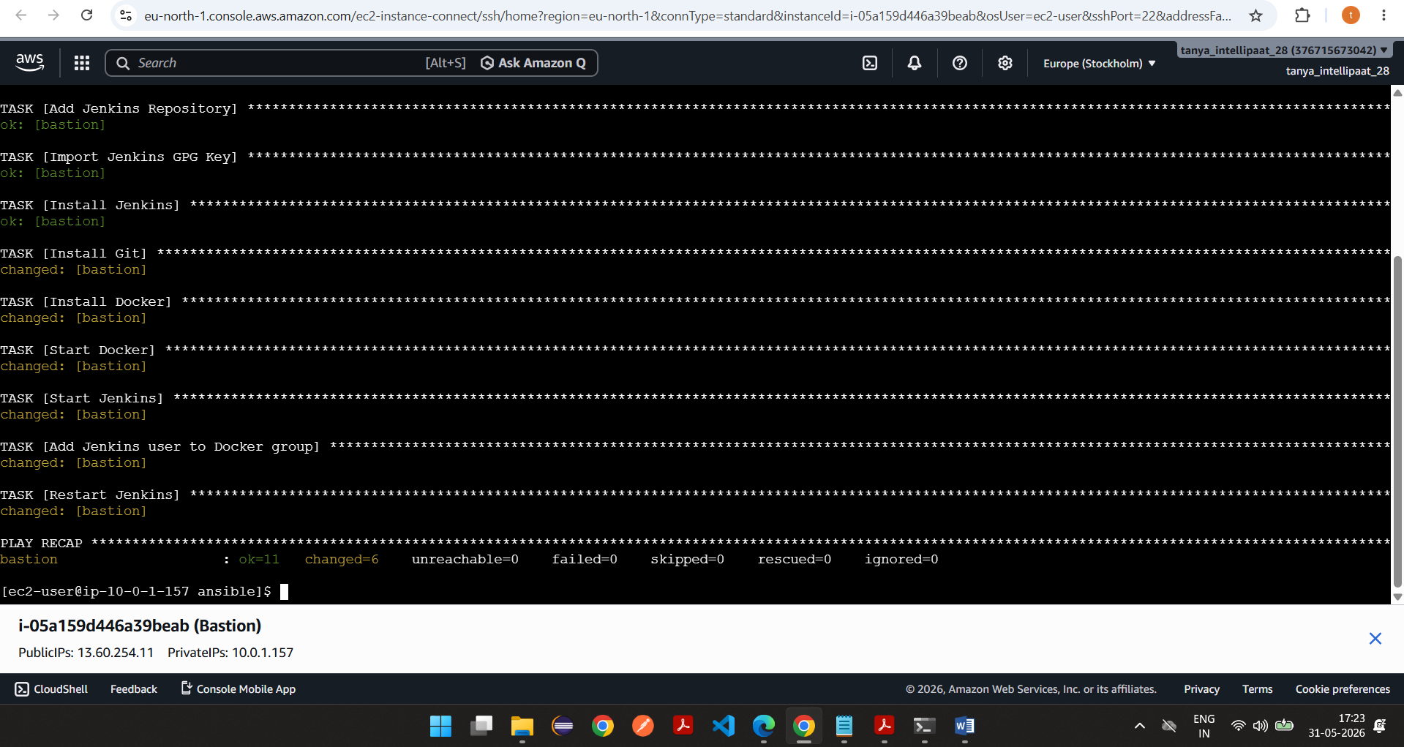

Vi Jenkins.yml
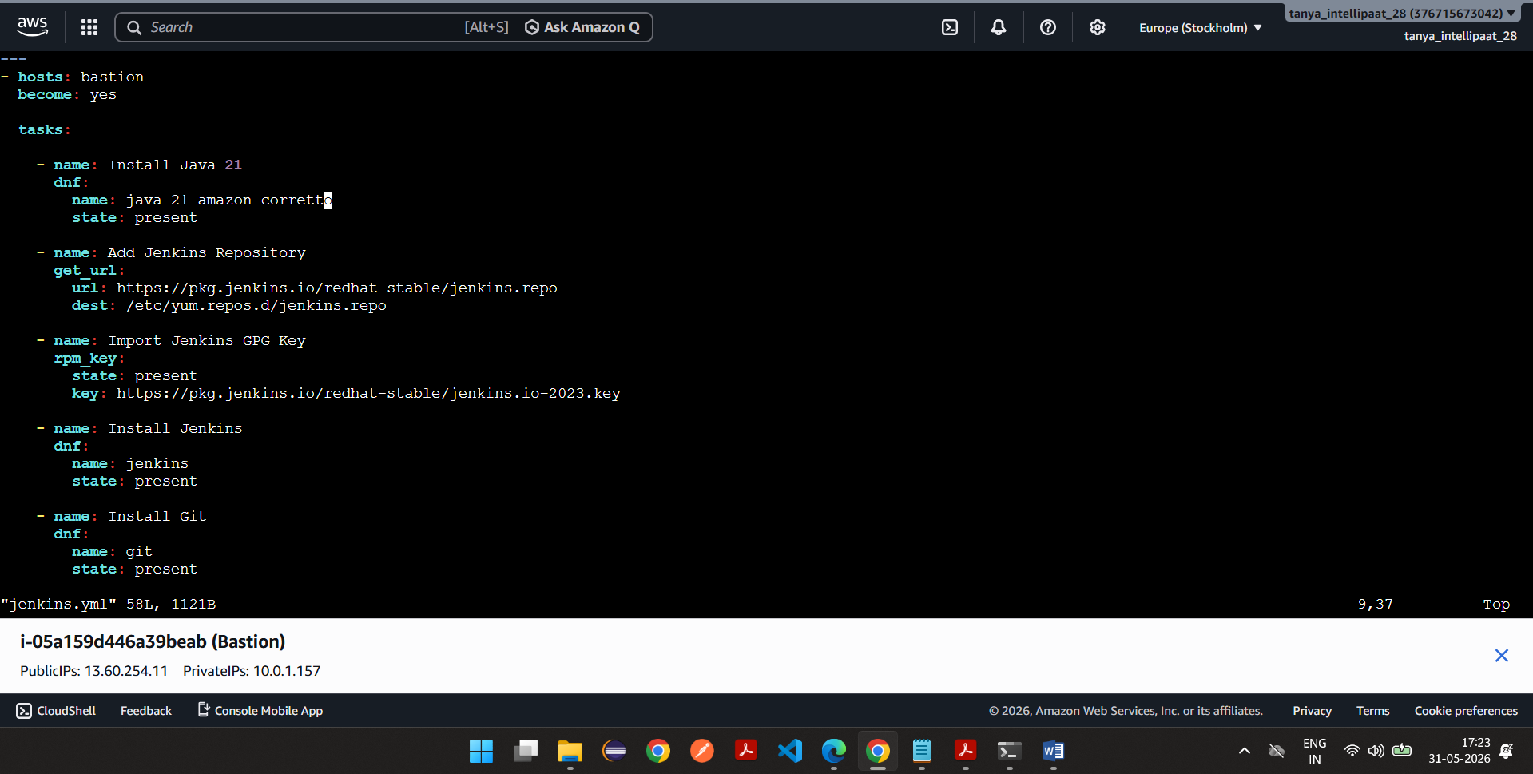

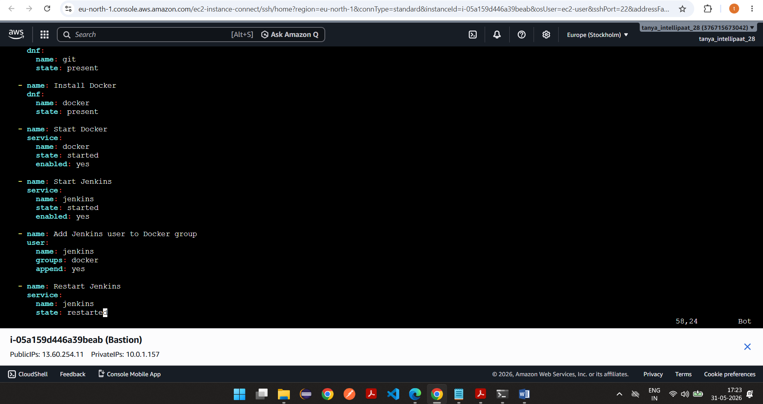

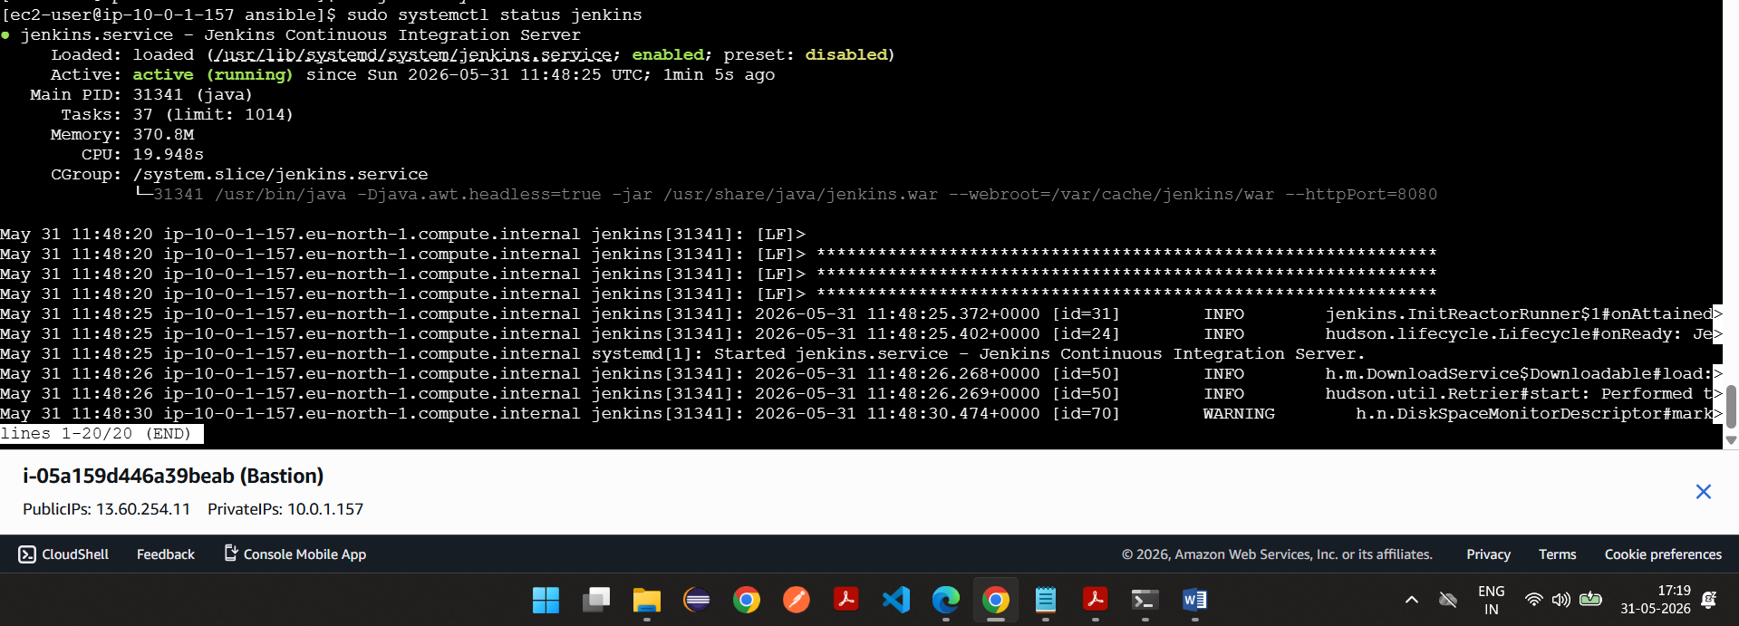

Bastion security group
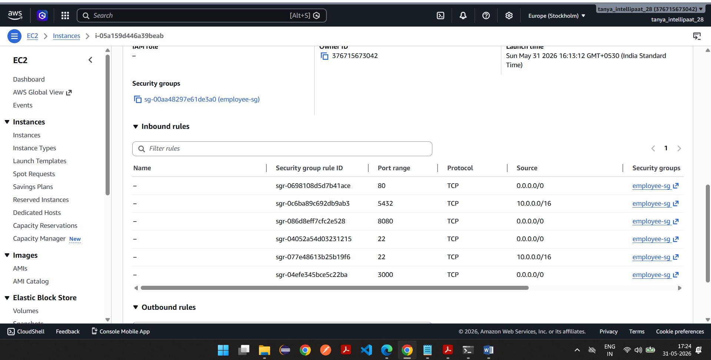

Jenkins is started
Jenkins password
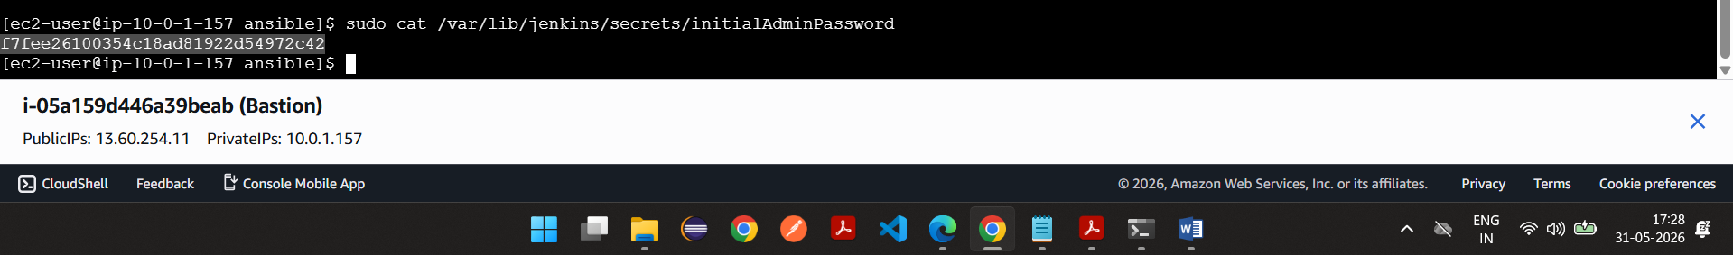
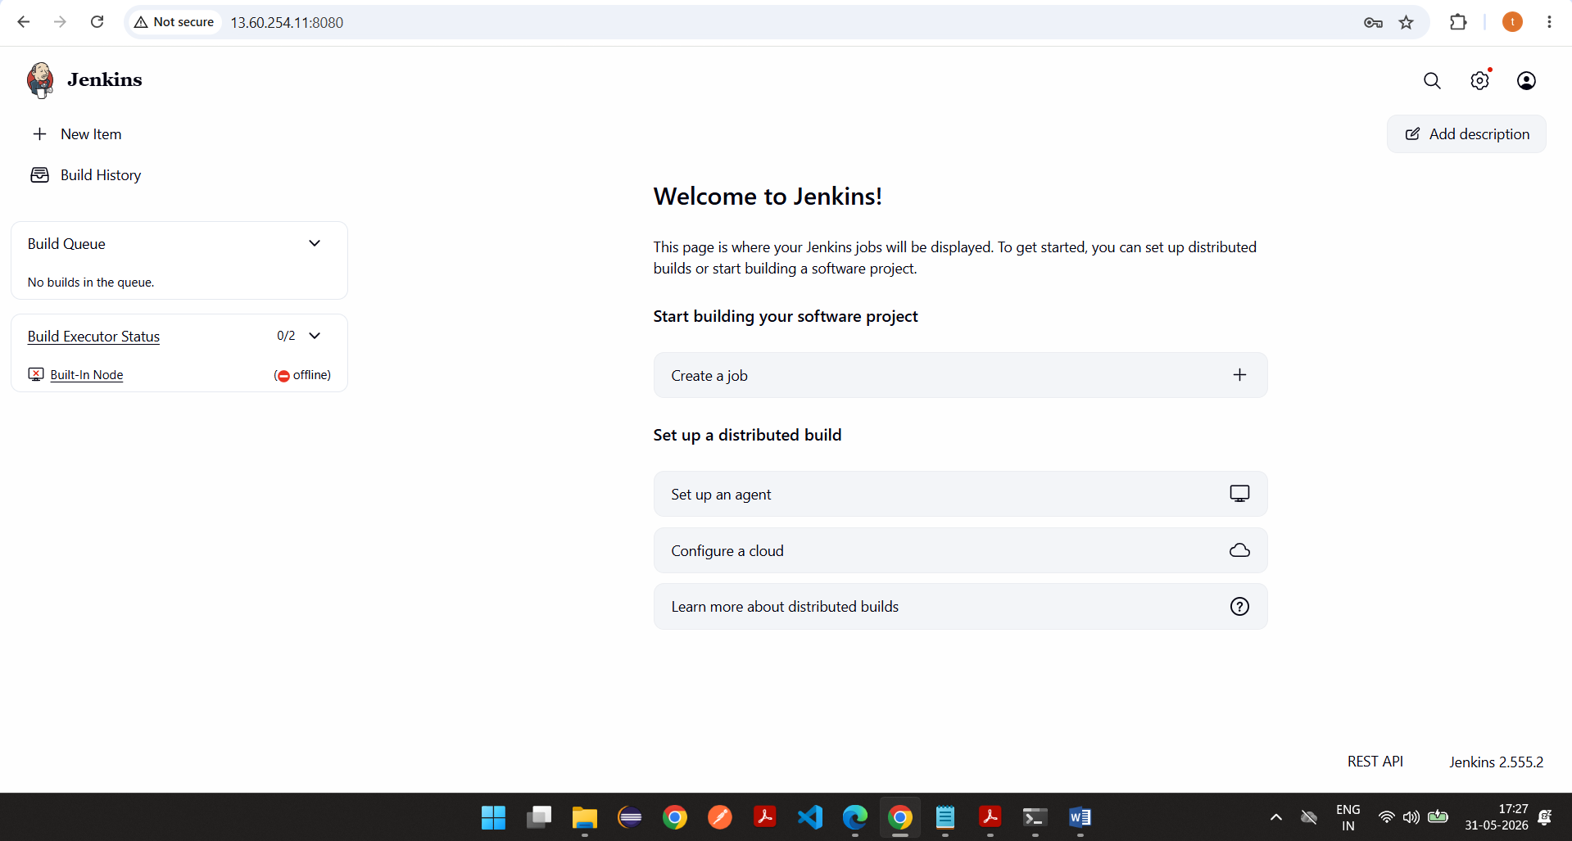

CREATED credentials for docker
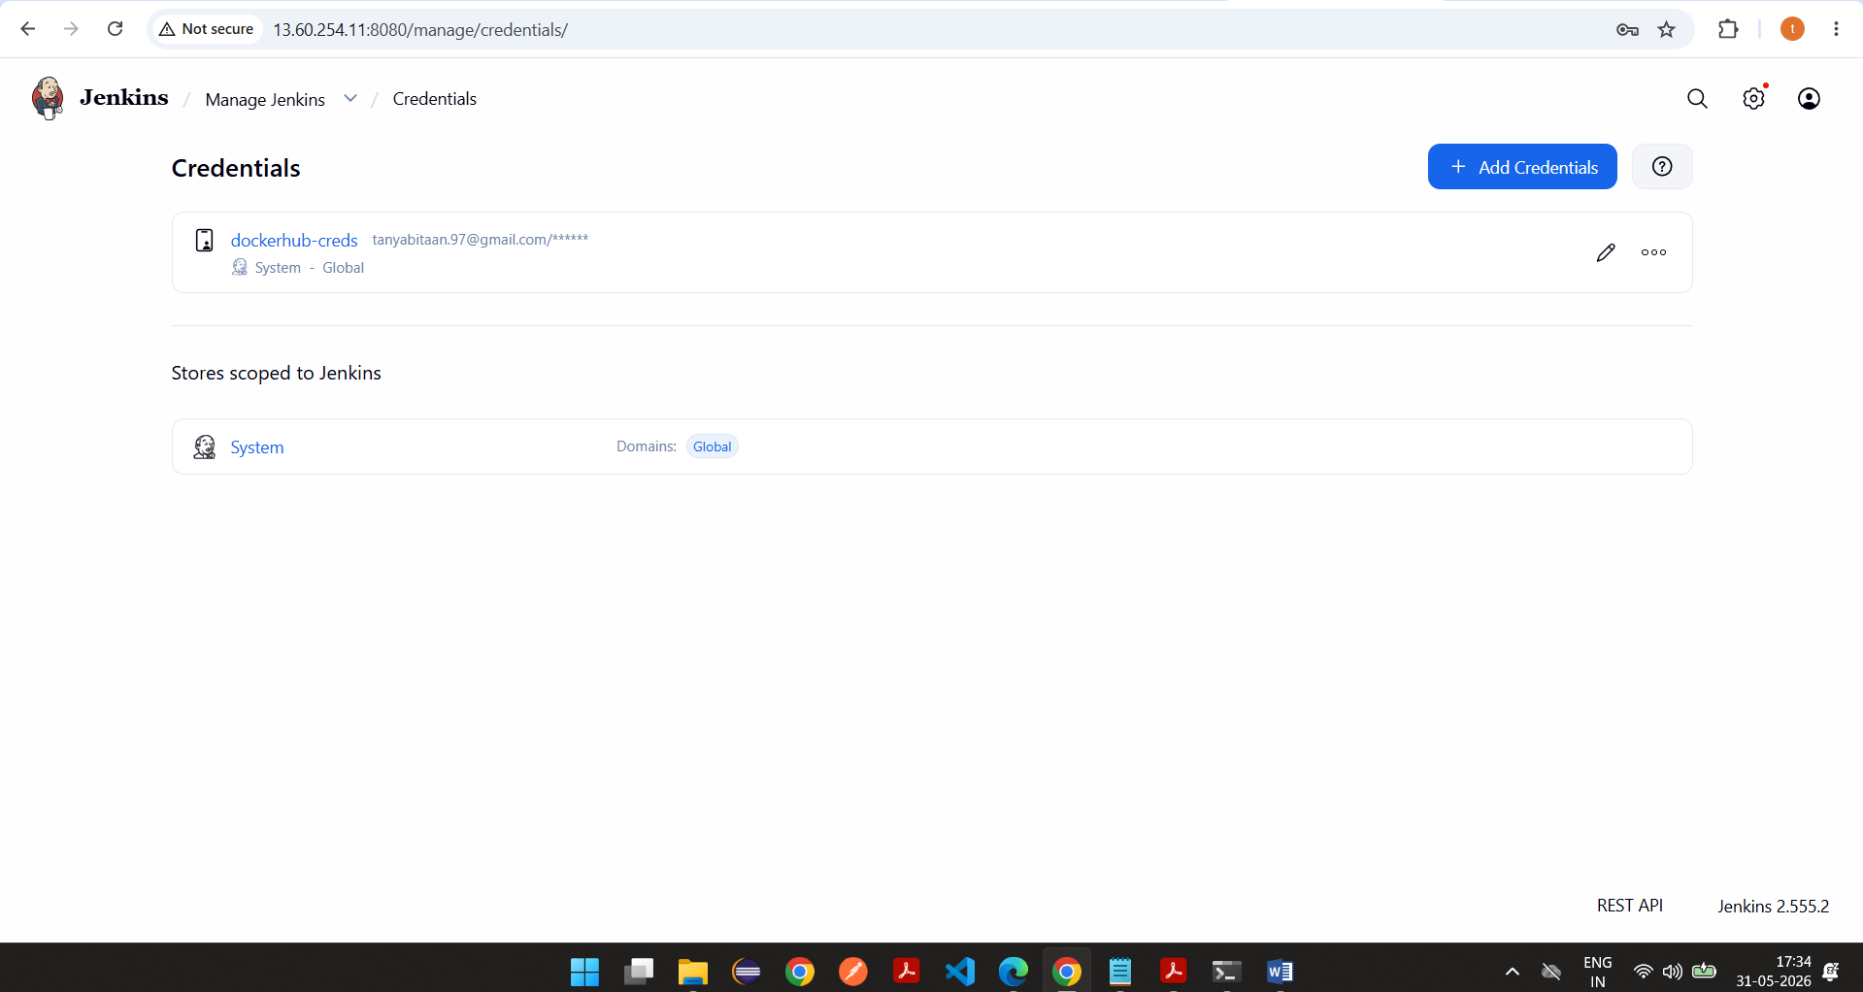

Changed t3.micro to t3.medium as Jenkins space was less to run builds
Jenkins job-> pipeline
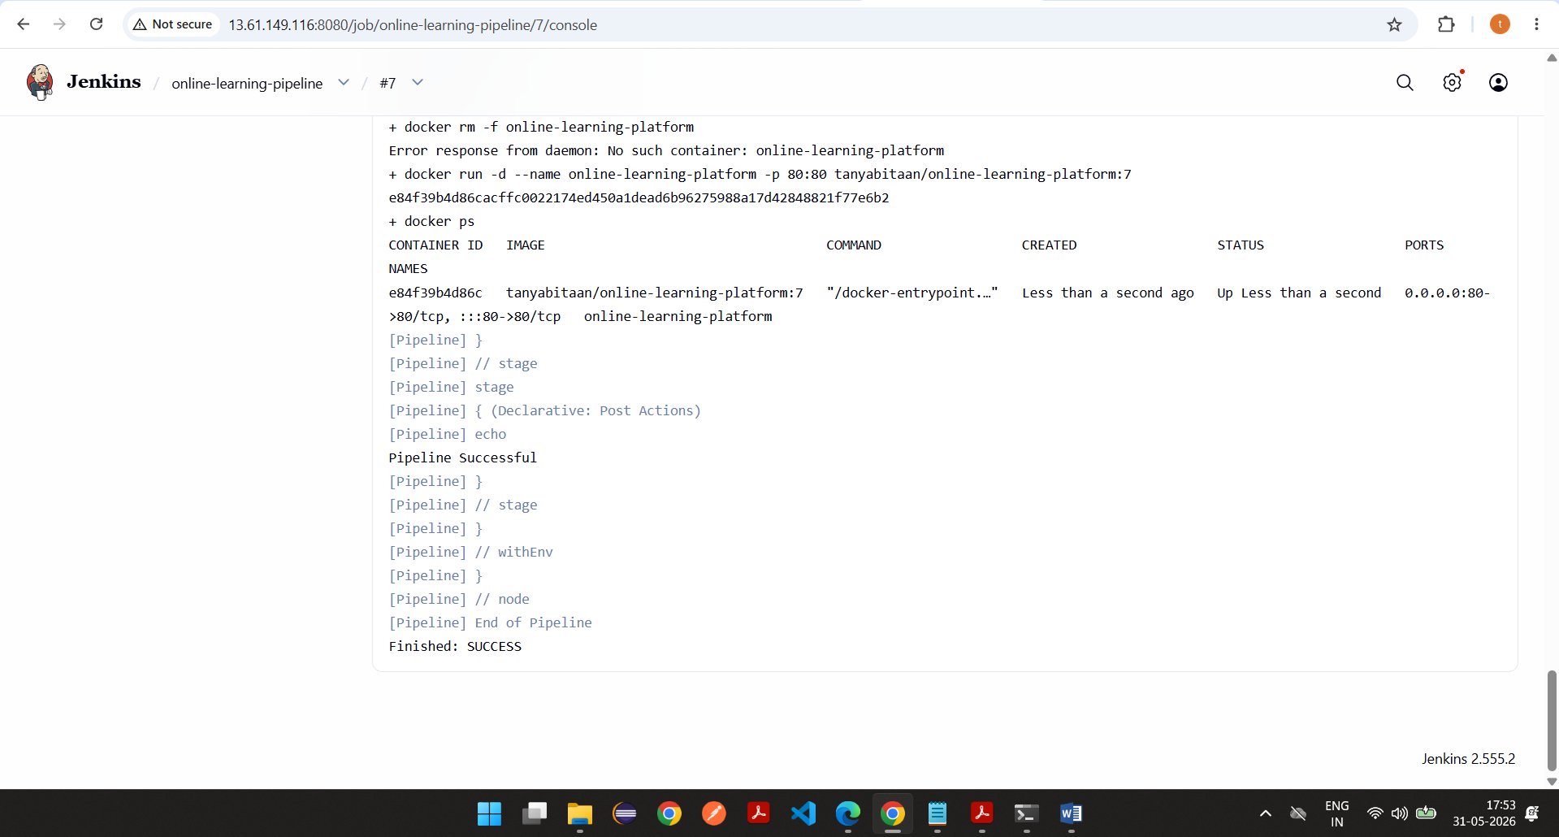

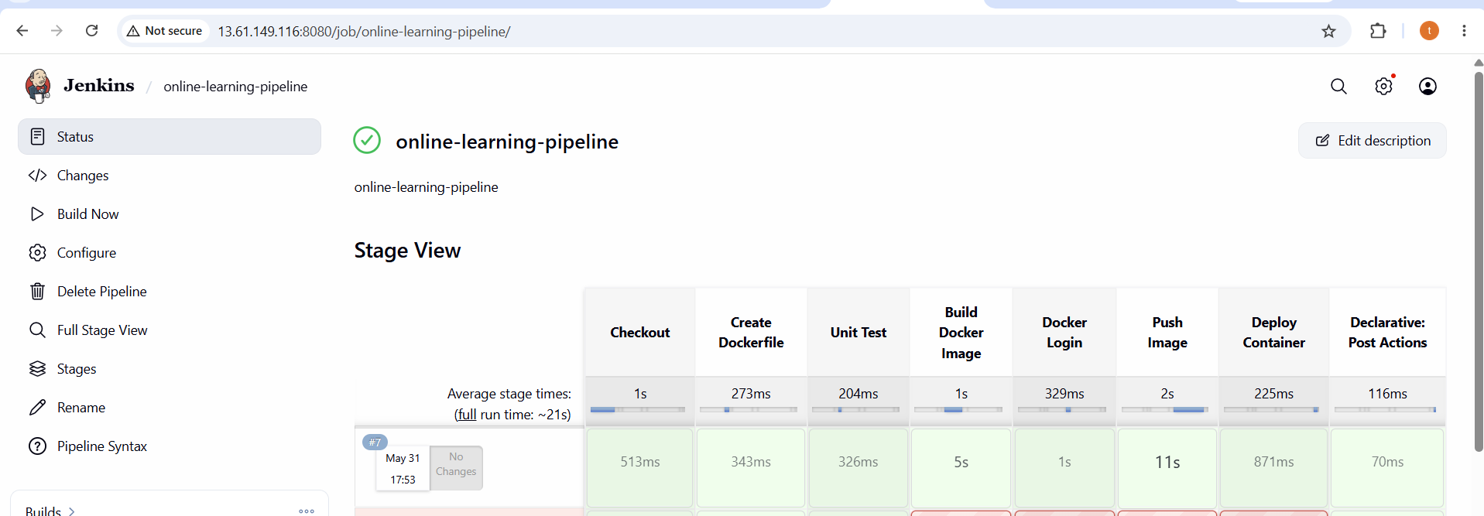

Following is pipeline script
pipeline {
agent any

environment {
IMAGE_NAME = "tanyabitaan/online-learning-platform"
IMAGE_TAG = "${BUILD_NUMBER}"
CONTAINER_NAME = "online-learning-platform"
}

stages {

stage('Checkout') {
steps {
git branch: 'main',
url: 'https://github.com/Kiaraintellipaat/Online-Learning-Platform-Deployment-using-DevOps-Pipeline.git'
}
}

stage('Create Dockerfile') {
steps {
sh '''
cat > Dockerfile <<EOF
FROM nginx:latest
COPY index.html /usr/share/nginx/html/index.html
EXPOSE 80
EOF

cat Dockerfile
'''
}
}

stage('Unit Test') {
steps {
sh '''
echo "Running Unit Tests..."
echo "Tests Passed"
'''
}
}

stage('Build Docker Image') {
steps {
sh '''
docker build -t $IMAGE_NAME:$IMAGE_TAG .
'''
}
}

stage('Docker Login') {
steps {
withCredentials([
usernamePassword(
credentialsId: 'dockerhub-creds',
usernameVariable: 'DOCKER_USER',
passwordVariable: 'DOCKER_PASS'
)
]) {
sh '''
echo $DOCKER_PASS | docker login -u $DOCKER_USER --password-stdin
'''
}
}
}

stage('Push Image') {
steps {
sh '''
docker push $IMAGE_NAME:$IMAGE_TAG

docker tag $IMAGE_NAME:$IMAGE_TAG $IMAGE_NAME:latest

docker push $IMAGE_NAME:latest
'''
}
}

stage('Deploy Container') {
steps {
sh '''
docker rm -f $CONTAINER_NAME || true

docker run -d \
--name $CONTAINER_NAME \
-p 80:80 \
$IMAGE_NAME:$IMAGE_TAG

docker ps
'''
}
}
}

post {
success {
echo 'Pipeline Successful'
}

failure {
echo 'Pipeline Failed'
}
}

}

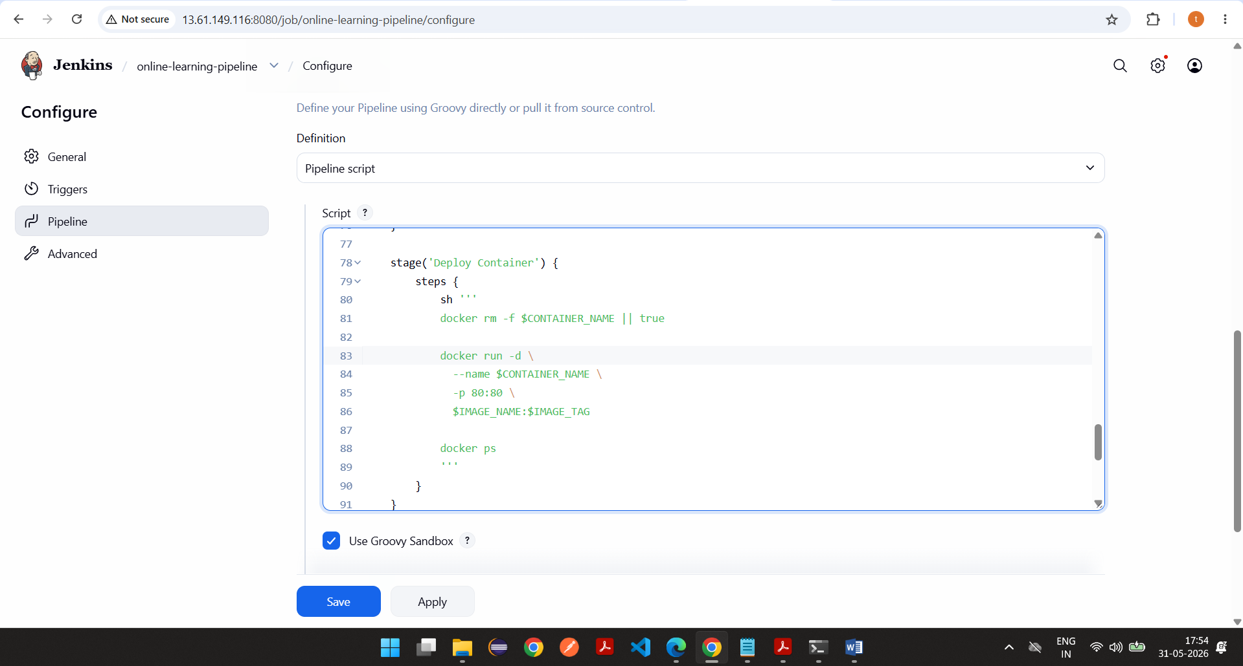

Output->
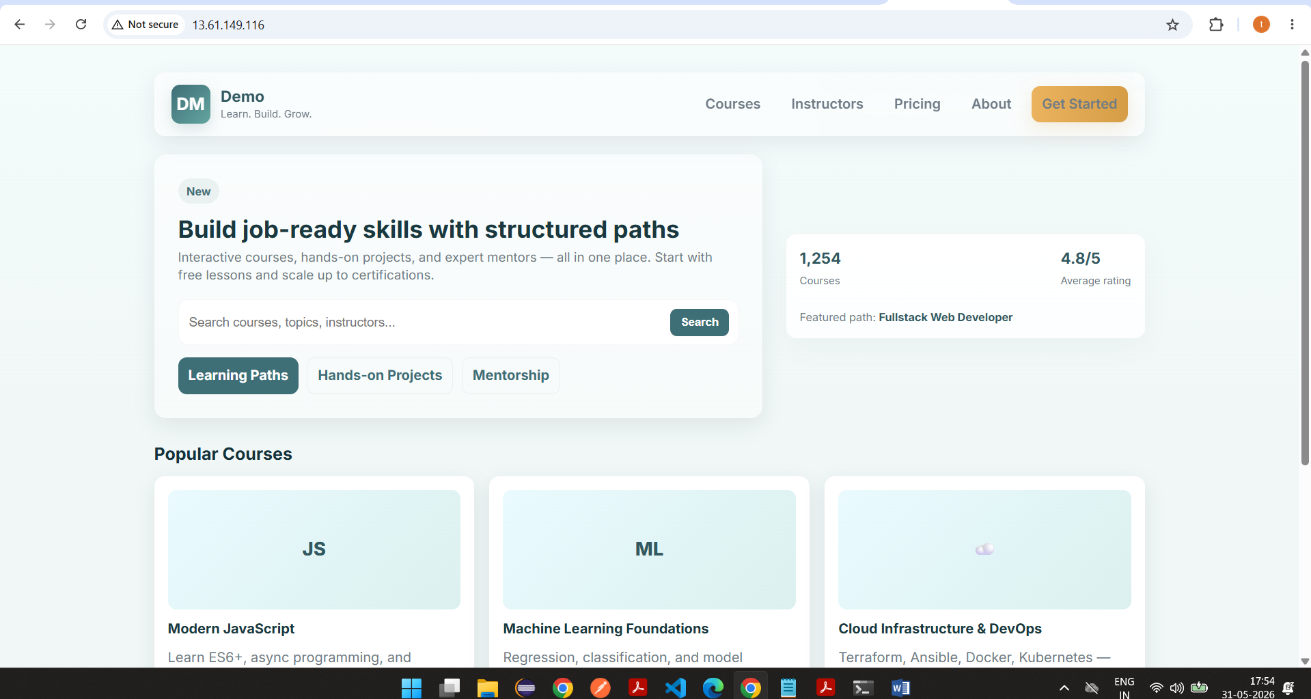

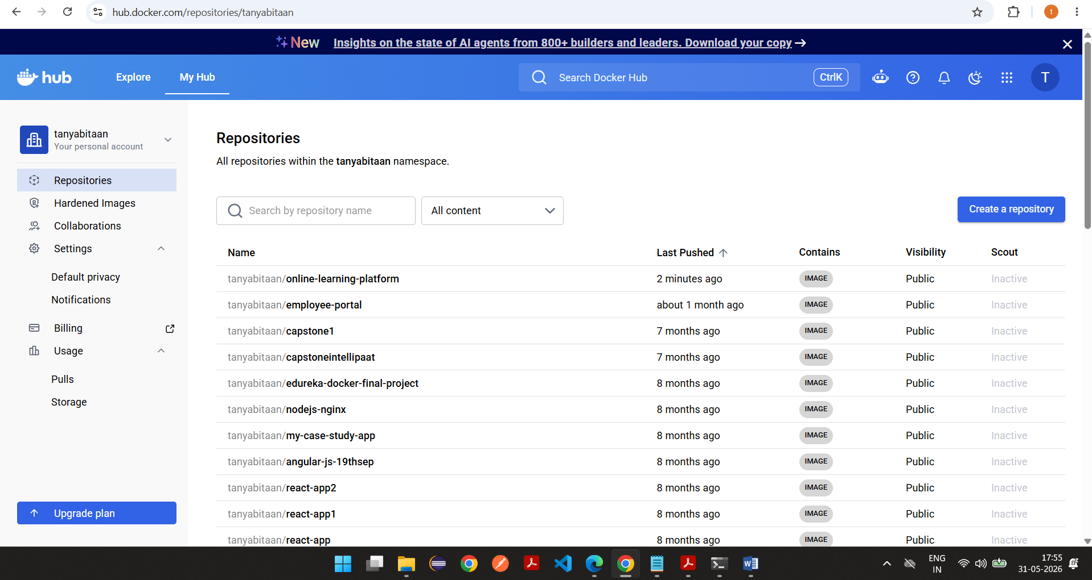

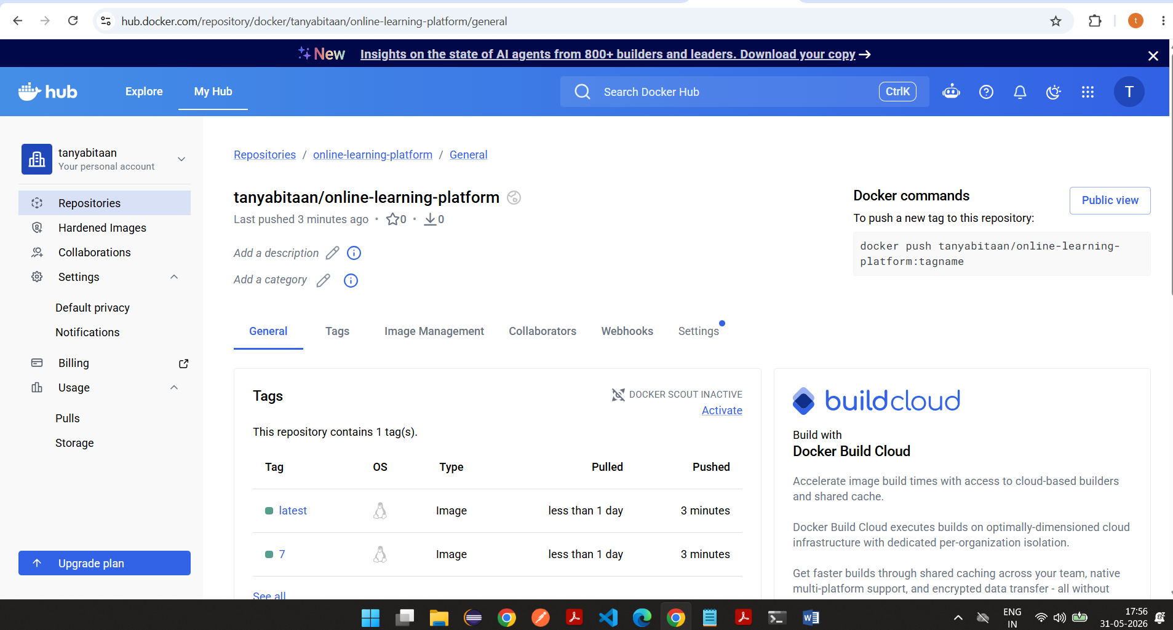

Task 5

5. Validation & Testing

Perform the following validations:
- Access E-Commerce application via public IP / Load Balancer
- Push a new commit to GitHub
- Confirm Jenkins automatically:
  - Builds
  - Pushes
  - Deploys the updated version

Screenshots
For automated build->
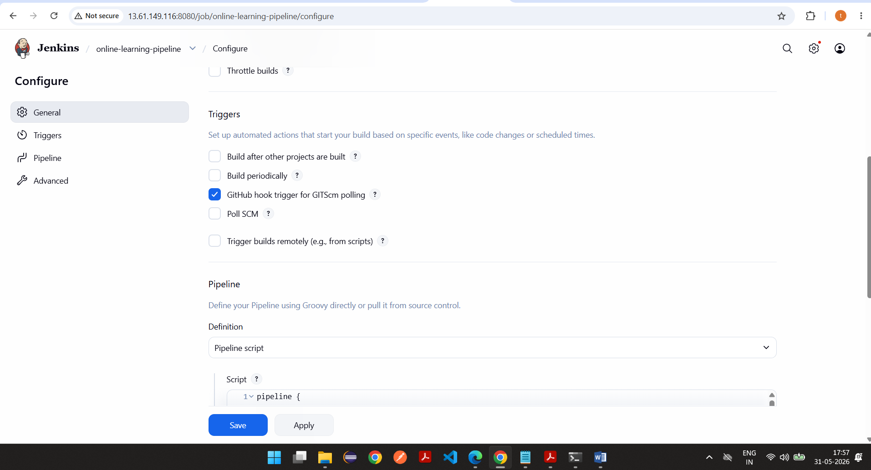

Create github webhook
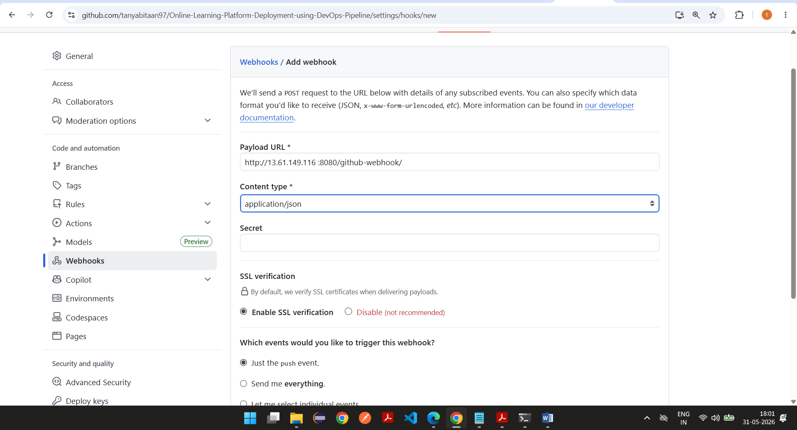

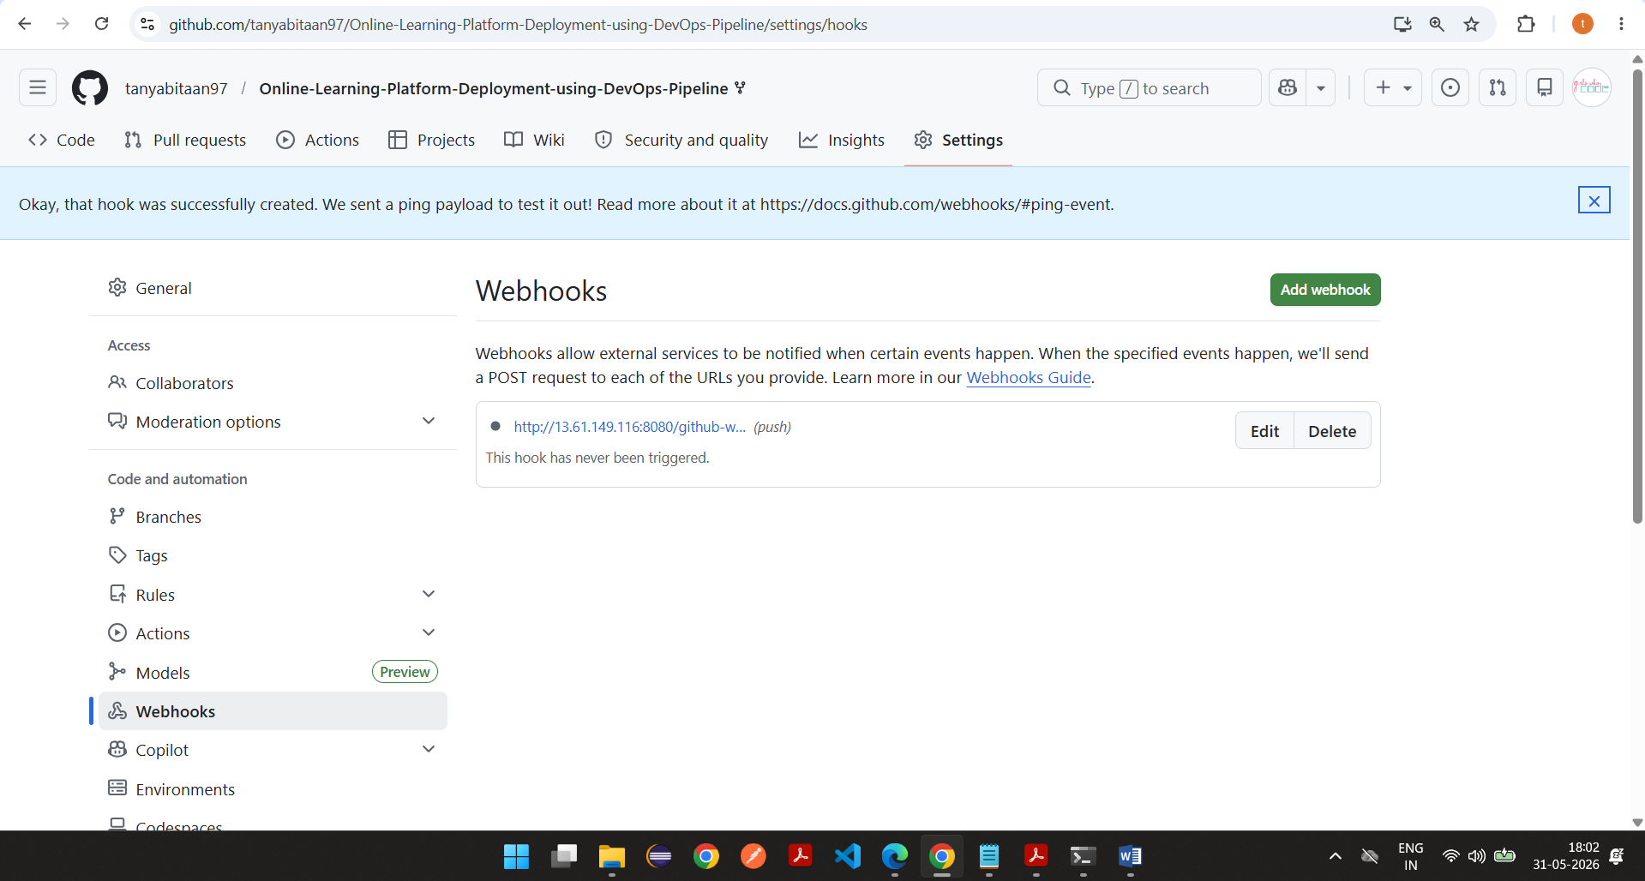

Cloned the repository and edit the title
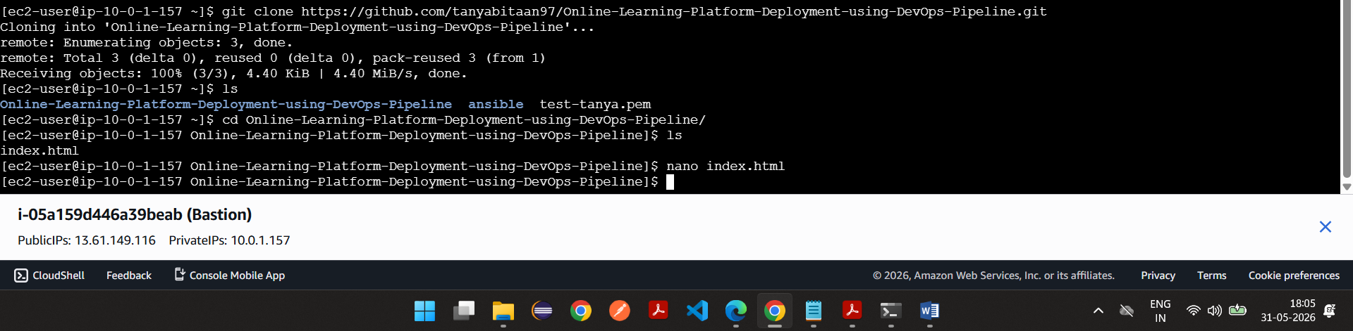
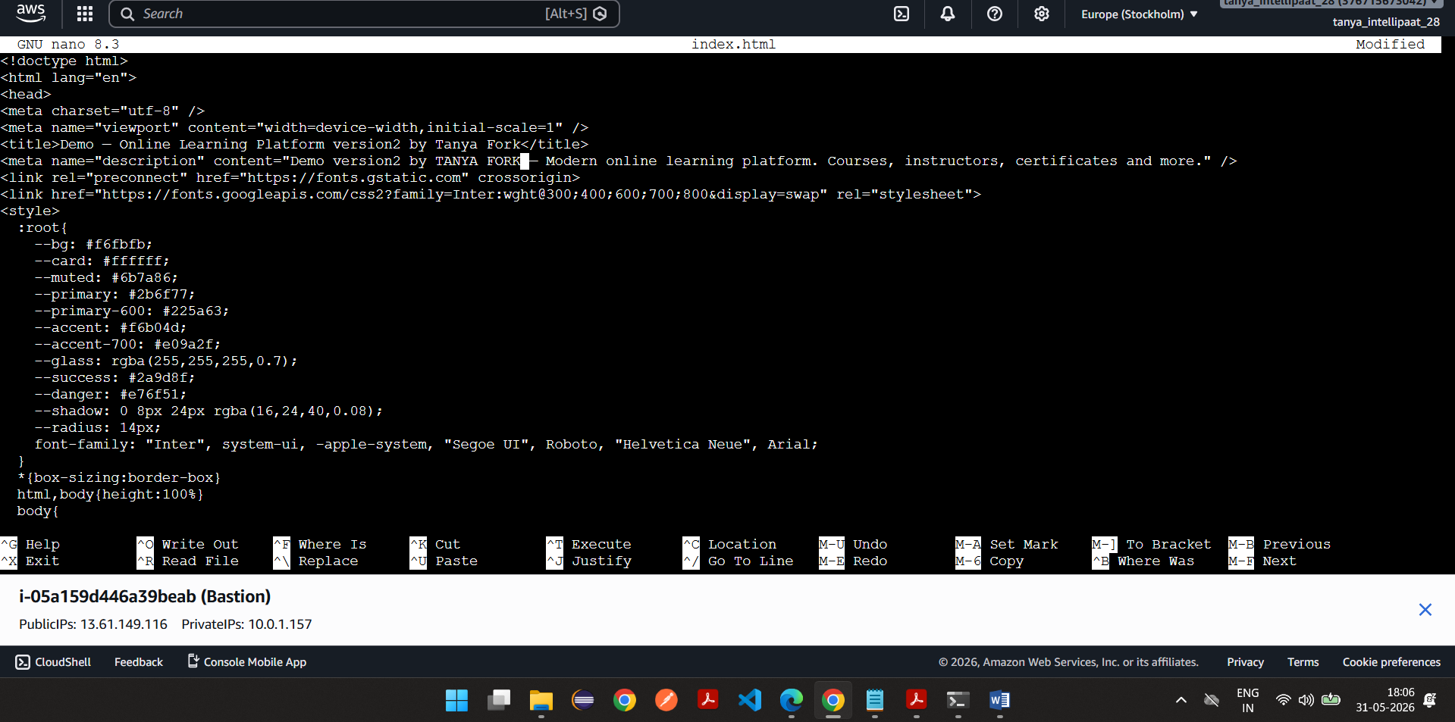

Once push id one the build automatically triggered
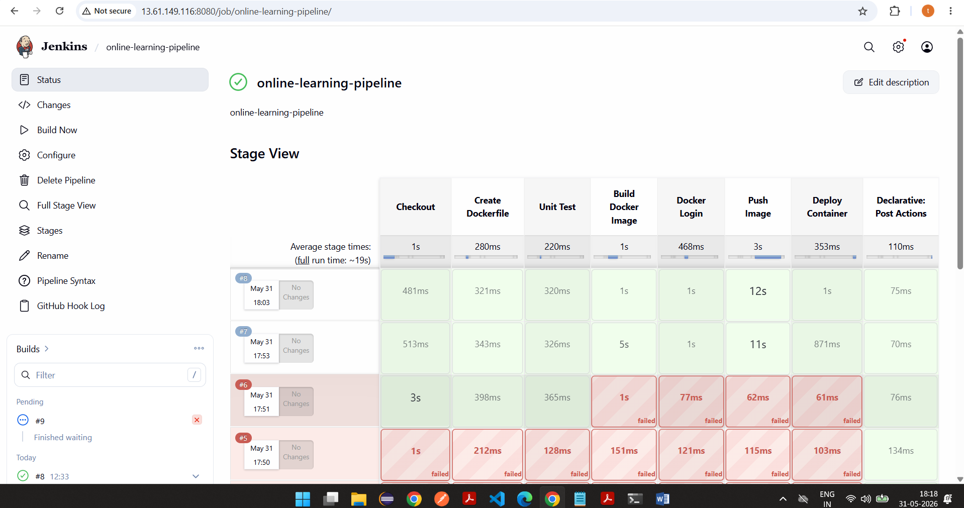

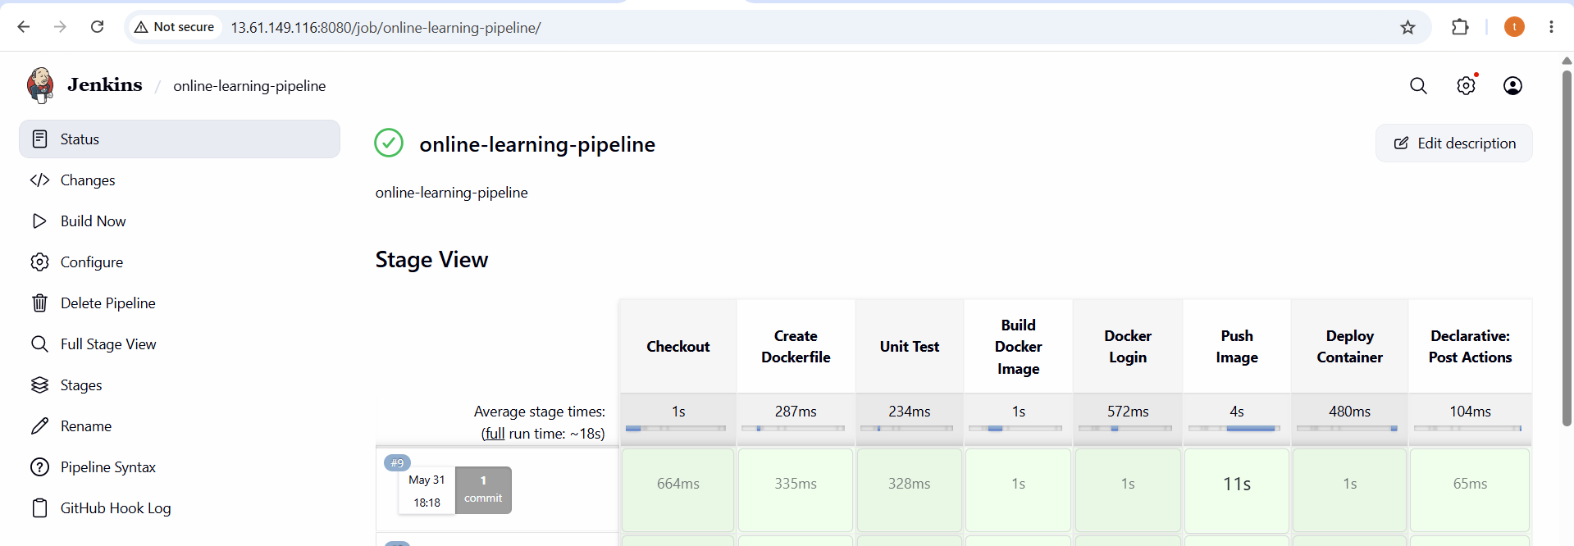

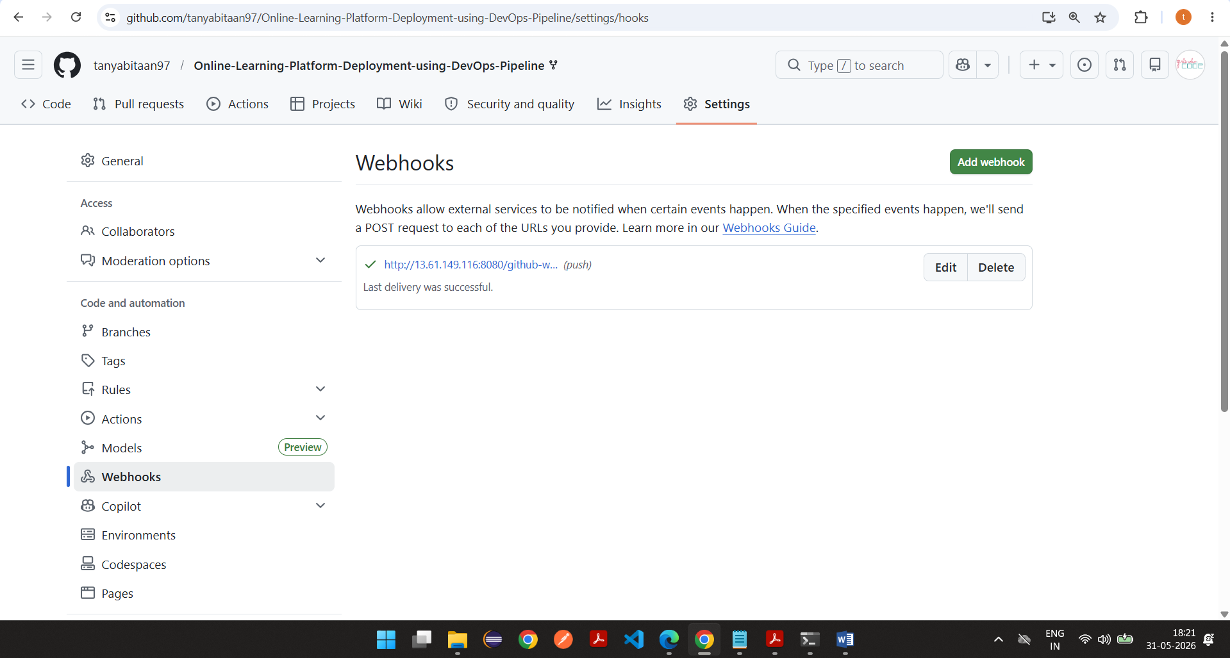

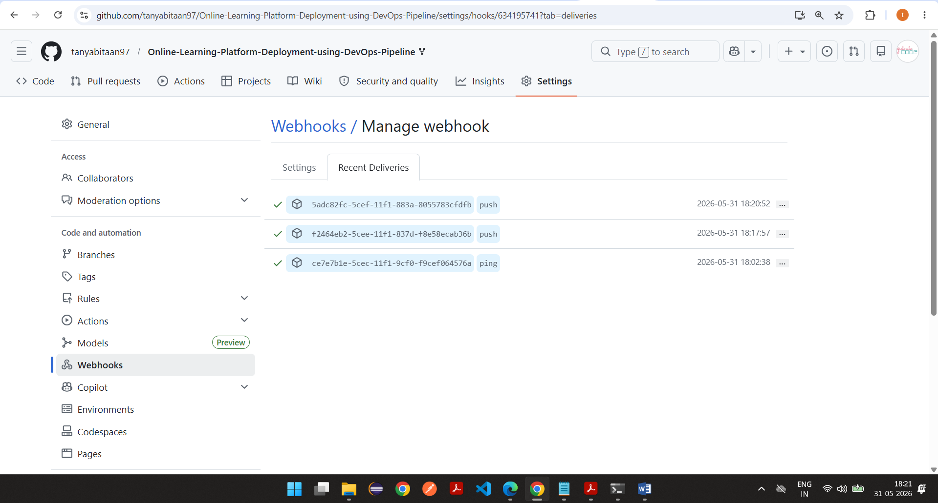
Changes got reflected
