Cloud PRT May 2026
AWS
Ques2
- S3 buckets creation
- IAM role configuration
- Lambda function working
- S3 trigger configured
- CloudWatch logs execution proof

Region- eu-north-1
Bucket 1
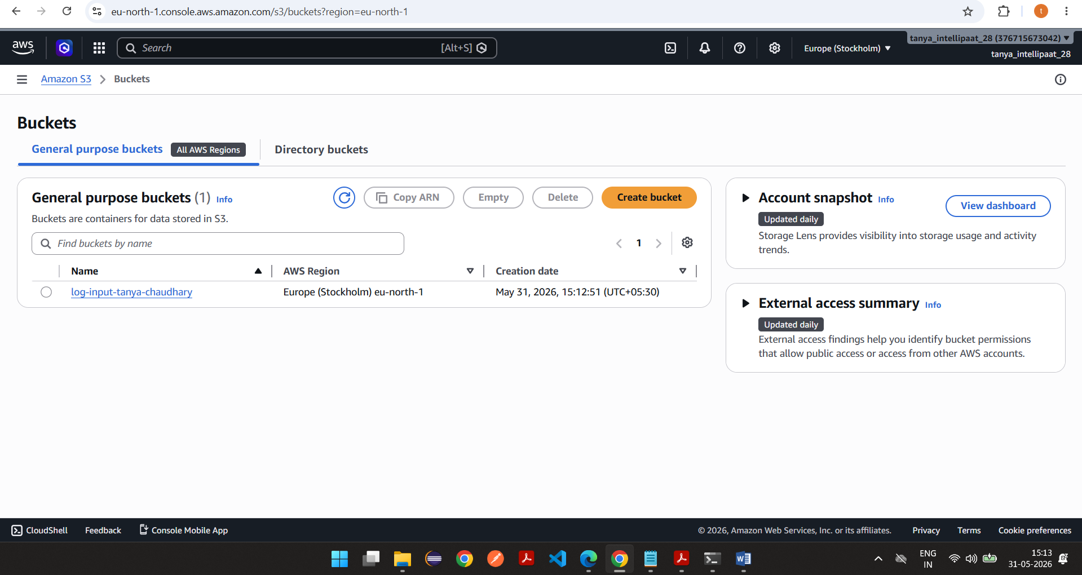

Versioning is enabled
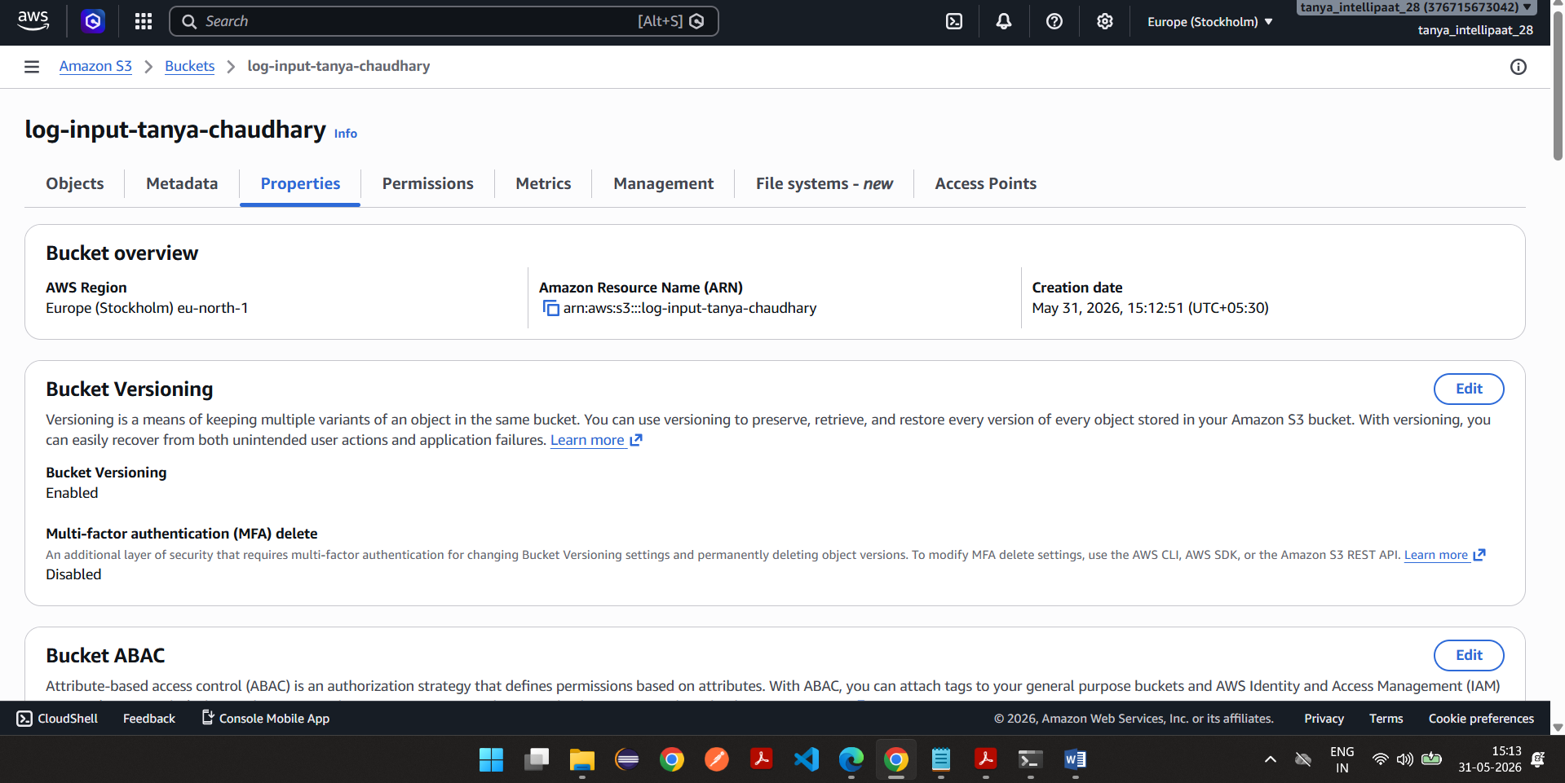

Bucket 2 is created
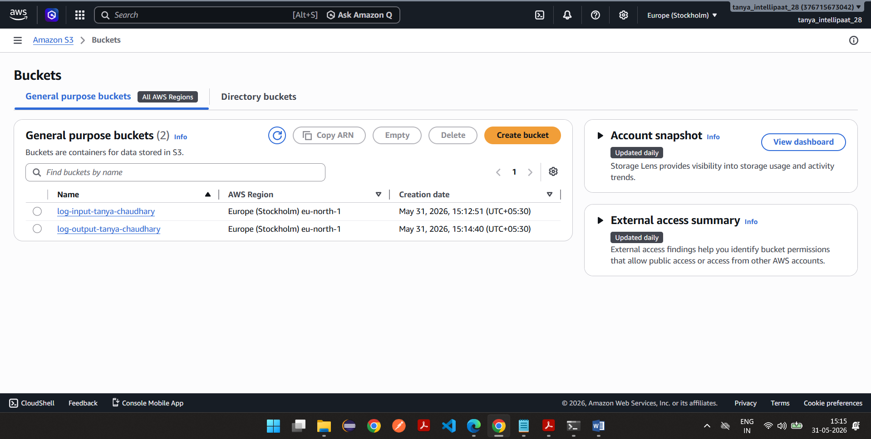

Bucket2 versioning is enabled
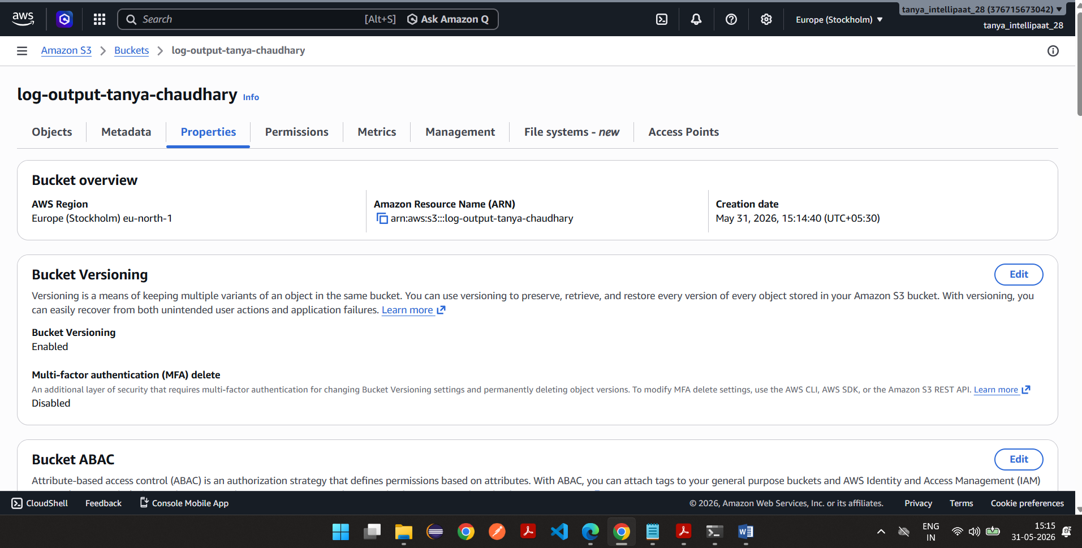

Uploaded samplelog.txt file to bucket1
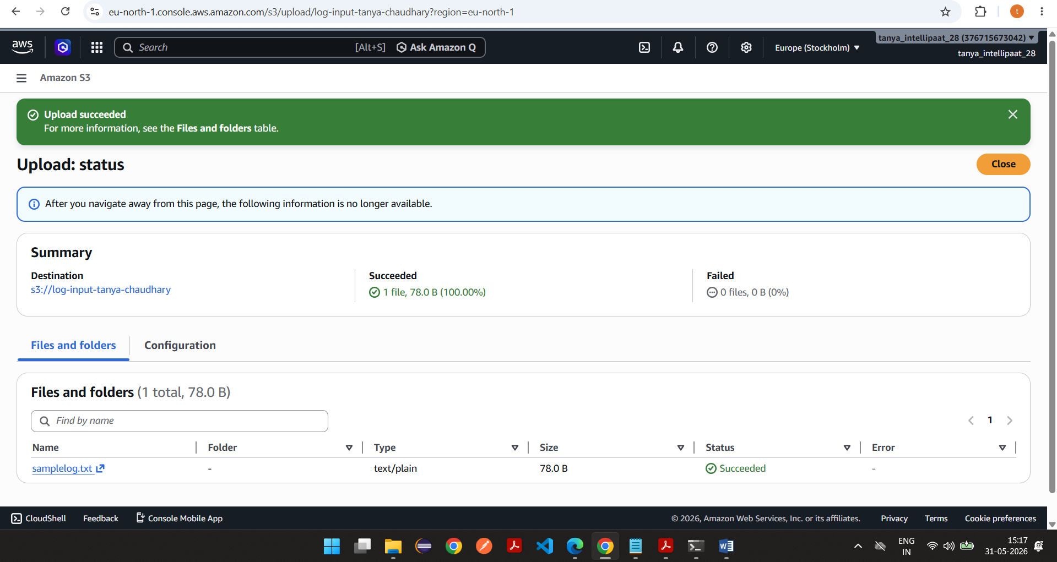
Role creation in IAM
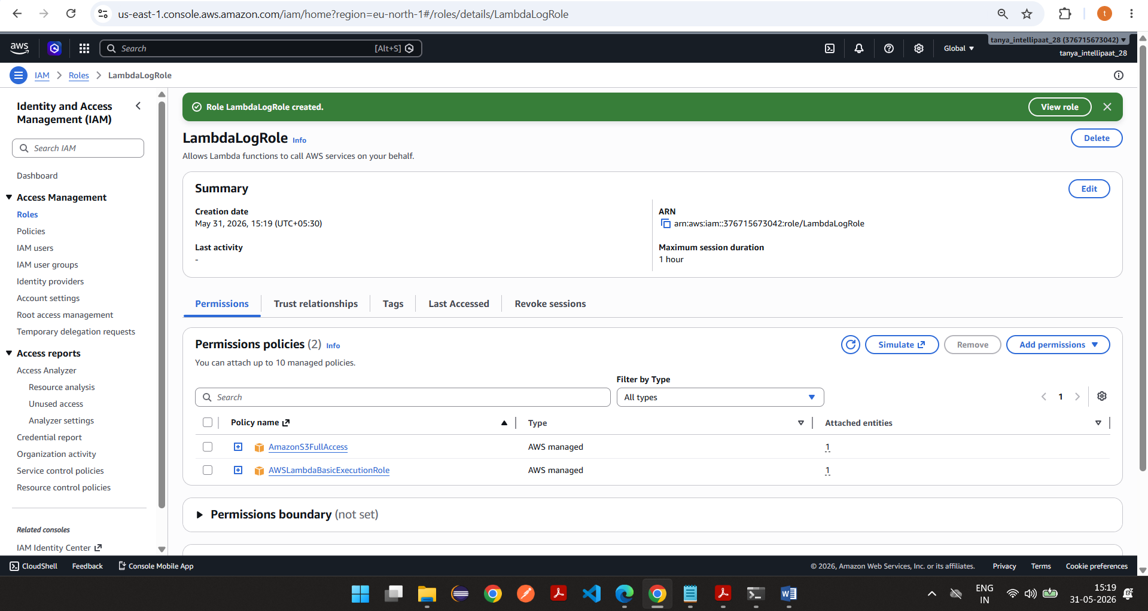

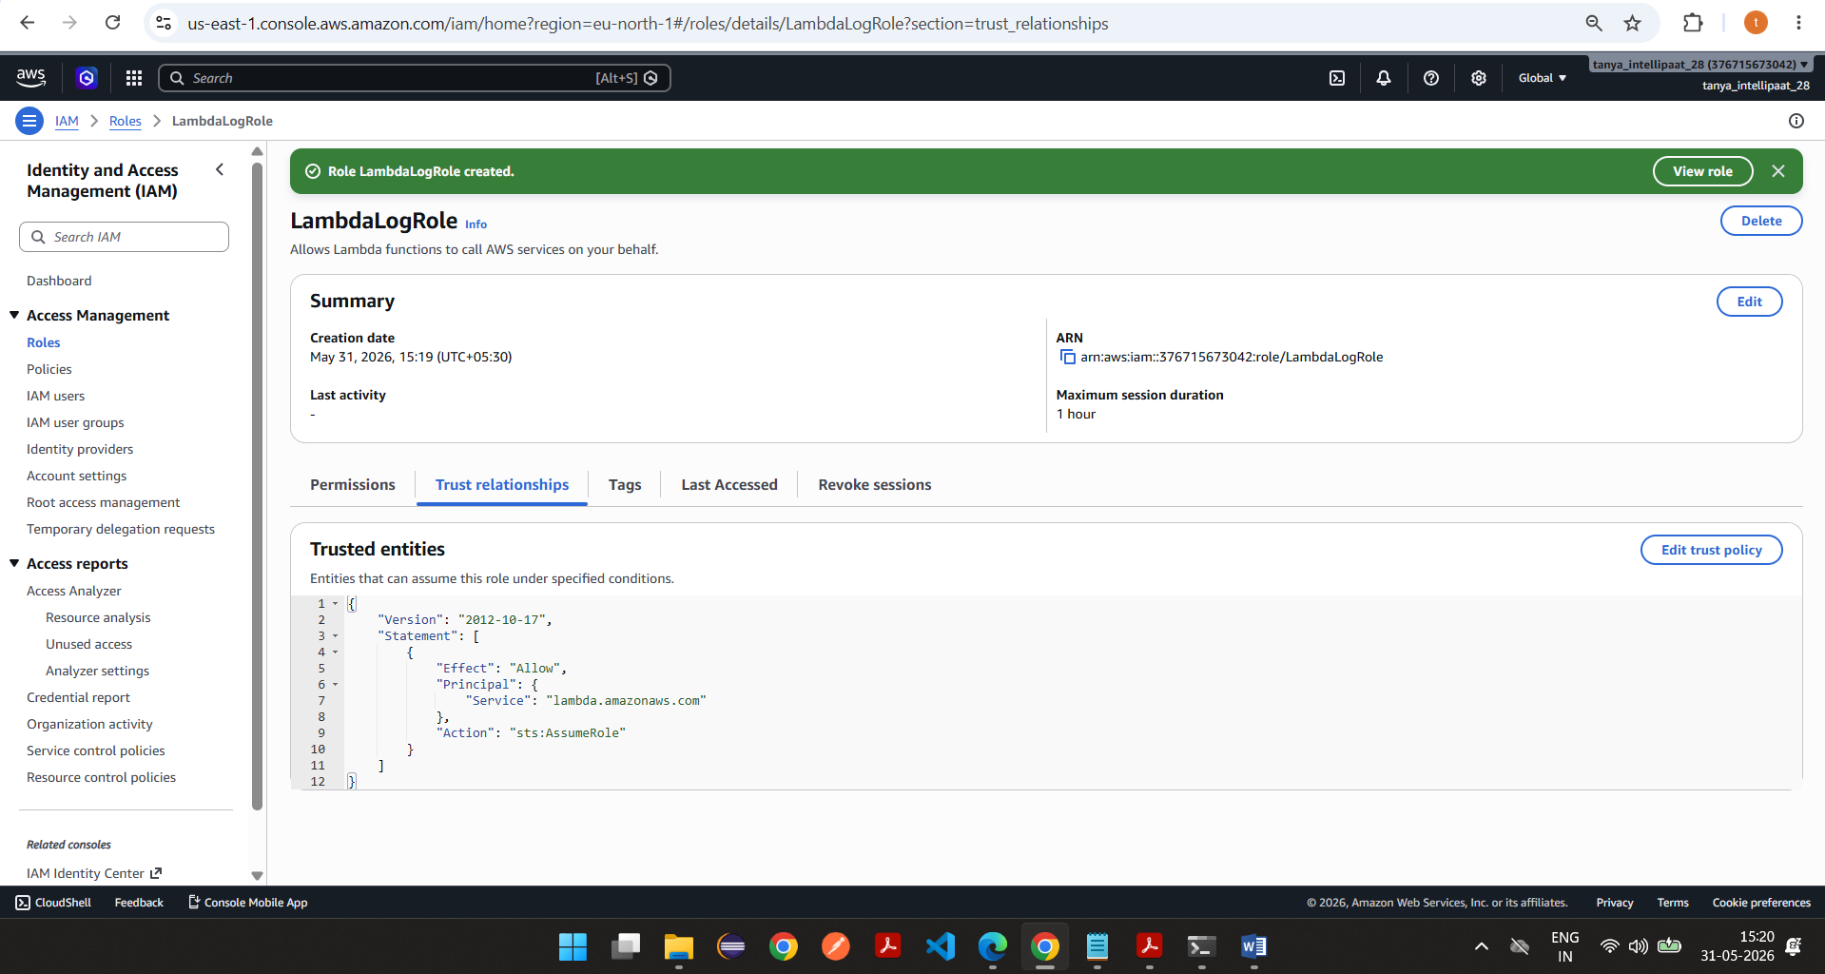

Lambda
Created lambda function
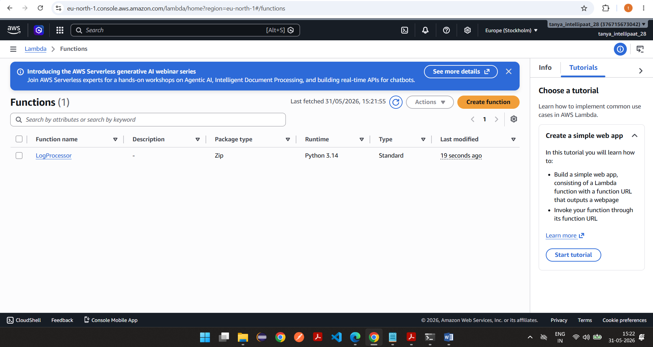

Attached above created role to lambda
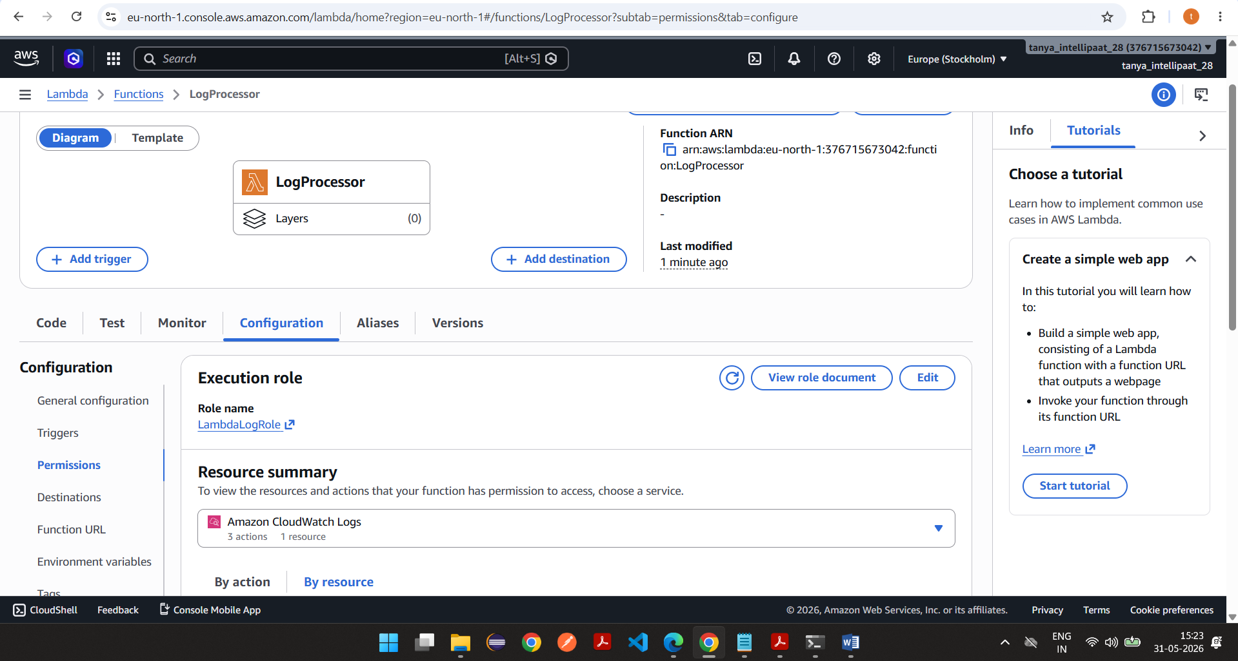
Lambda code
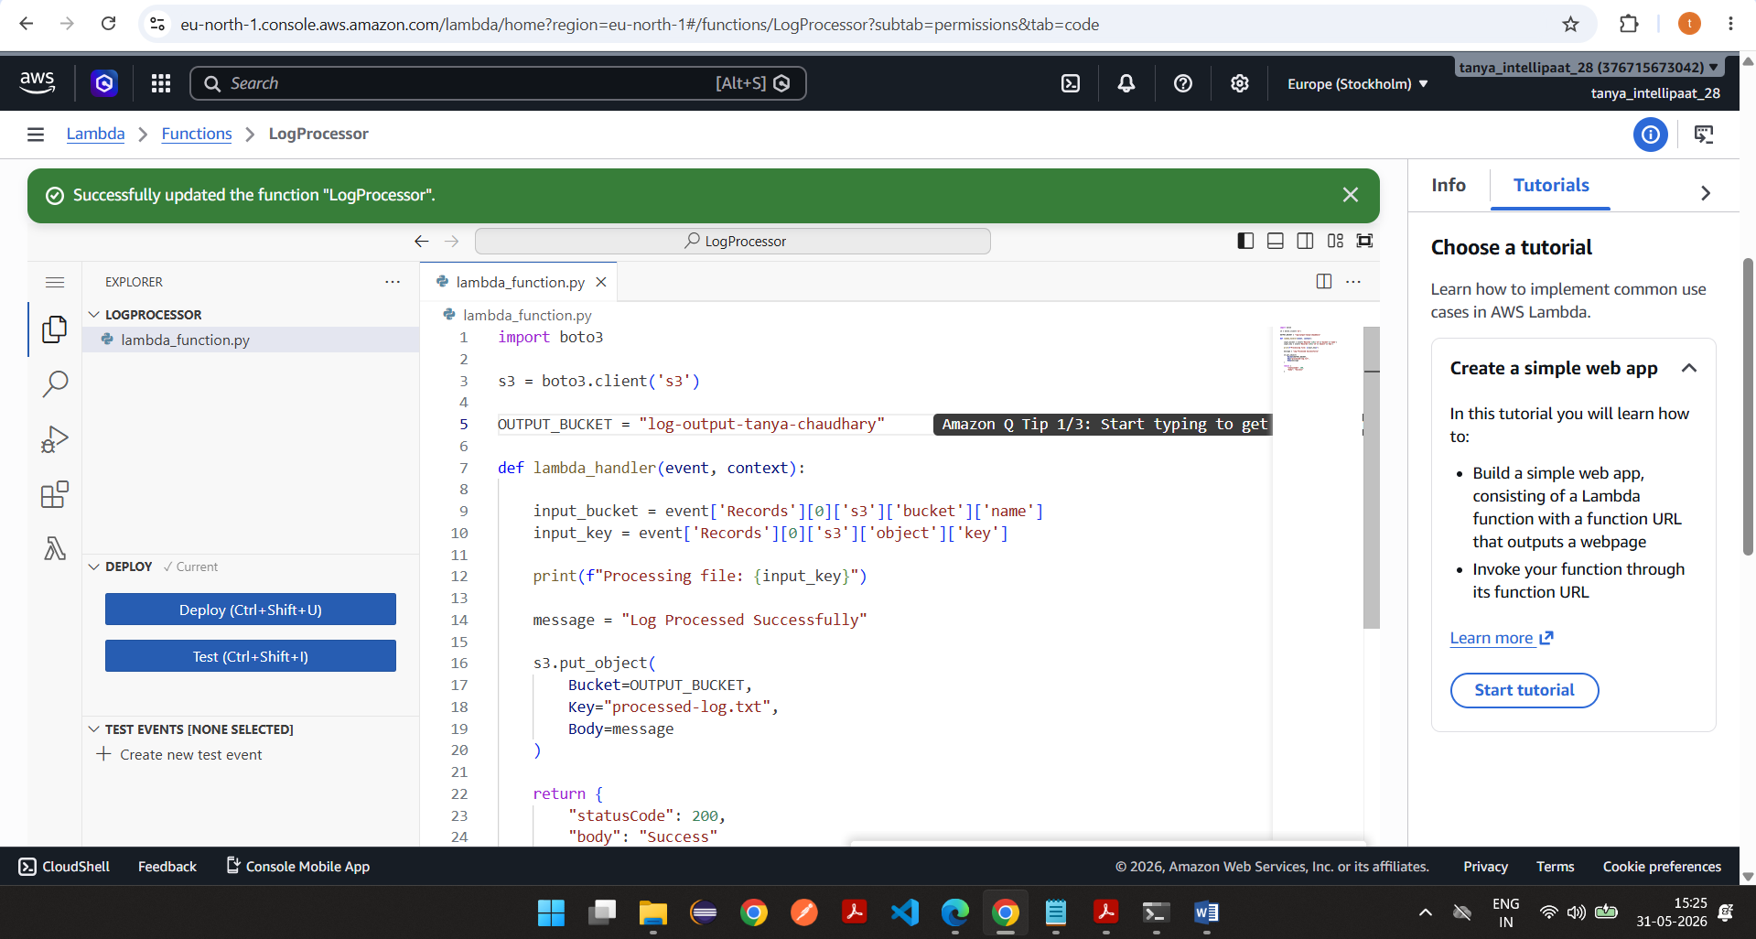

Trigger is added
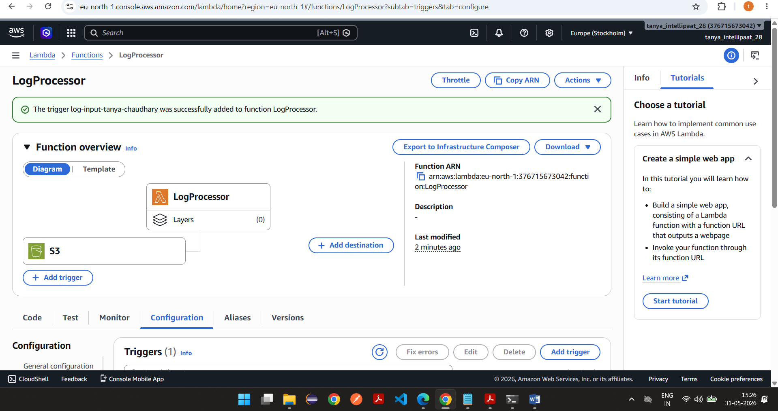

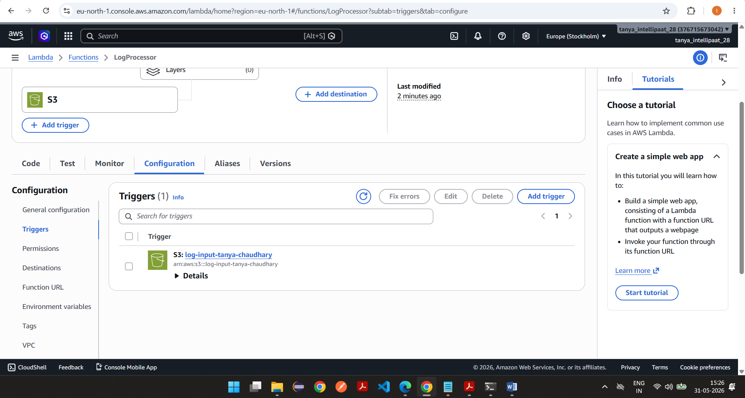

Testing-
Uploaded the another file called smaplelog2.txt in log-input- bucket
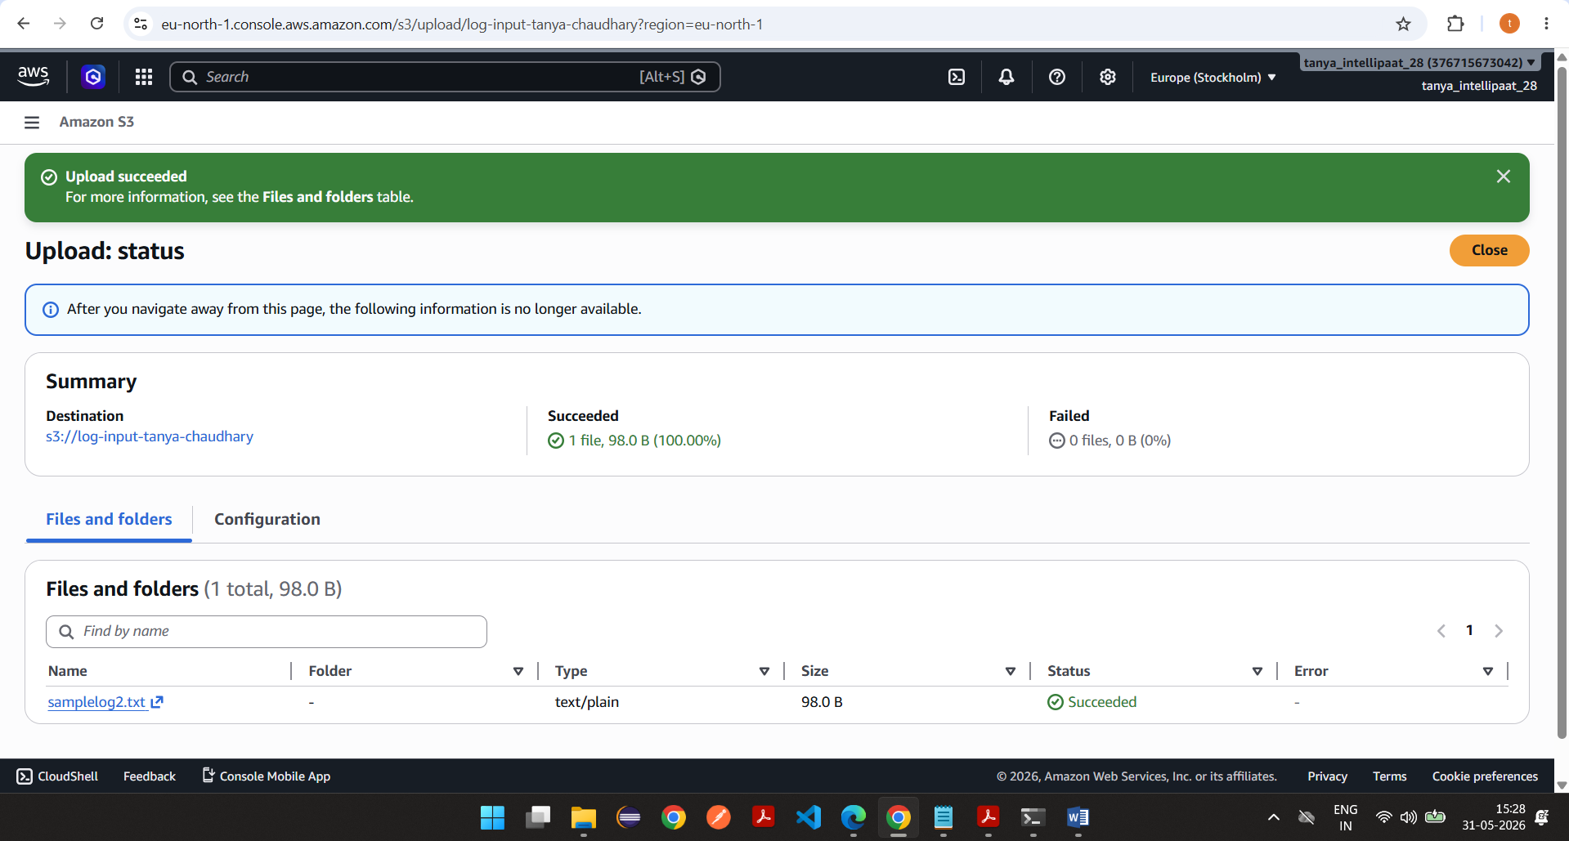

Lambda has created file in output bucket
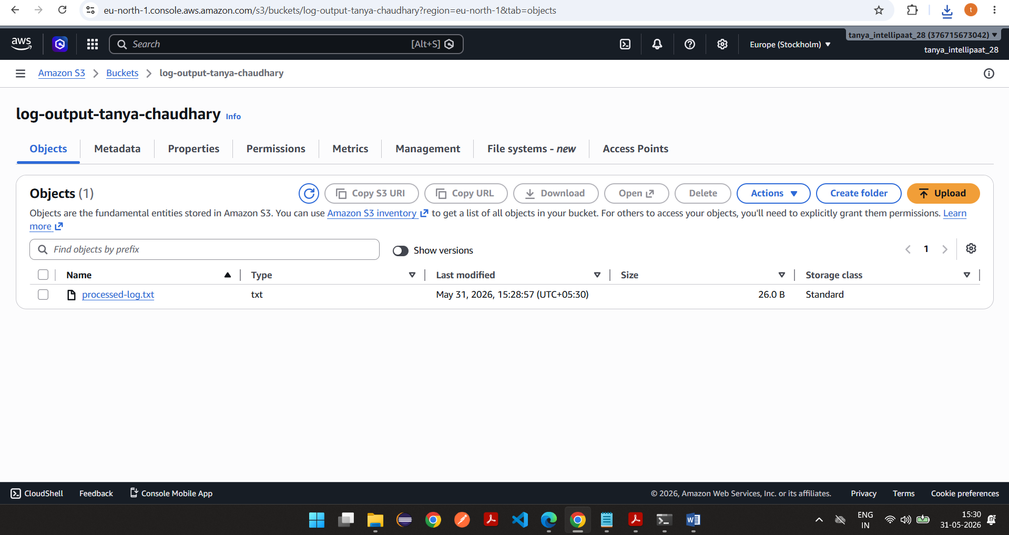

ACL ENABLED to access object URL in browser
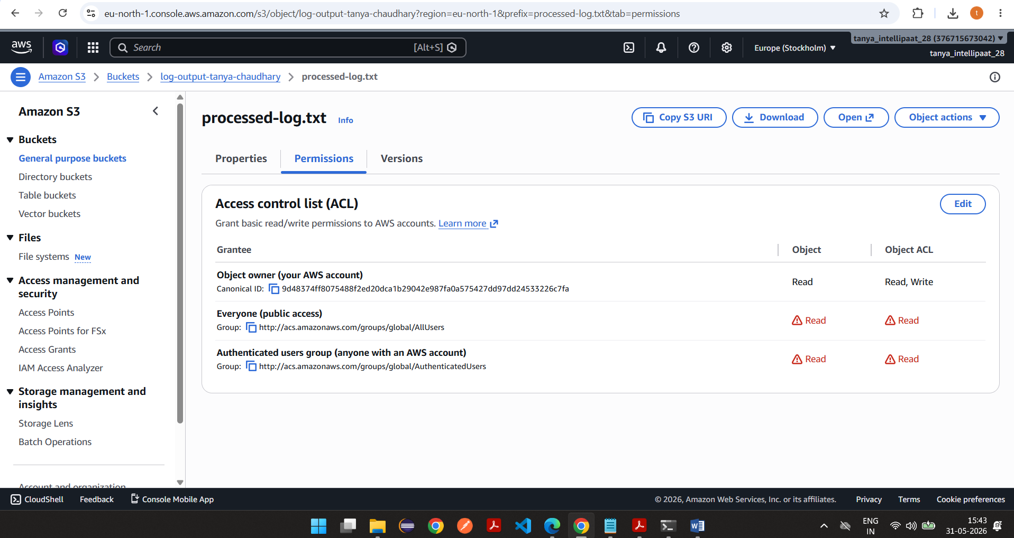

On accessing object url, file is downloaded and it has content
https://log-output-tanya-chaudhary.s3.eu-north-1.amazonaws.com/processed-log.txt

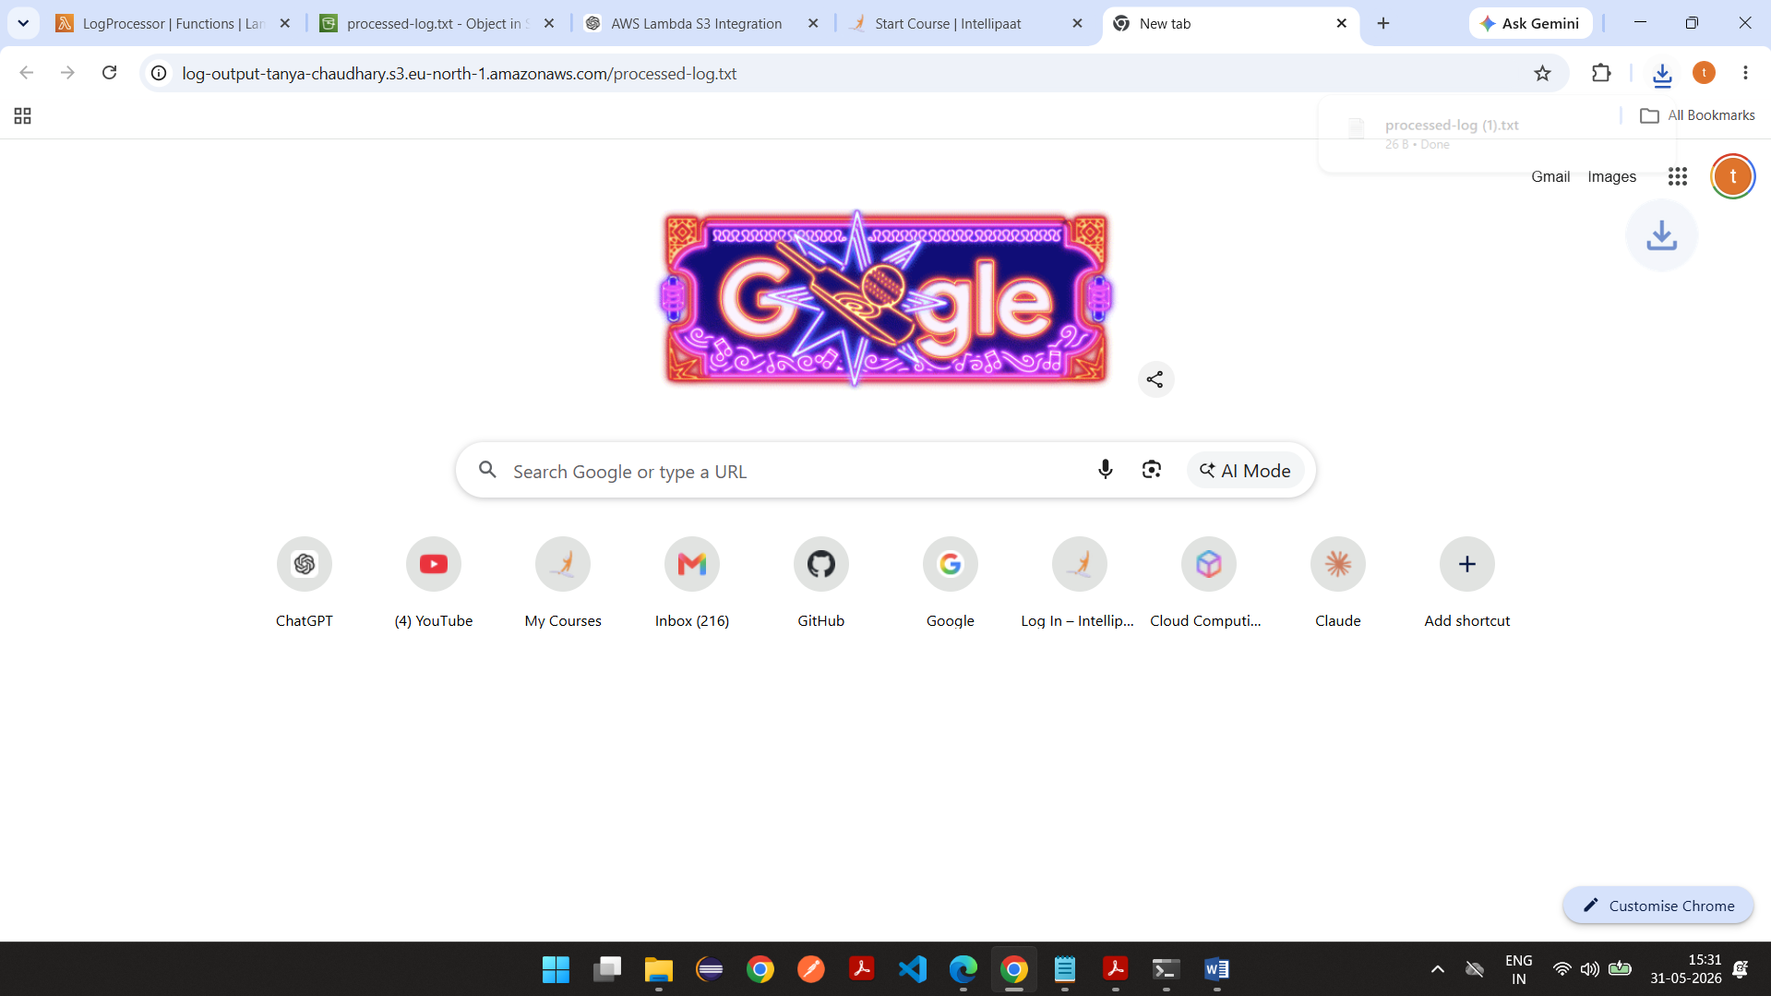

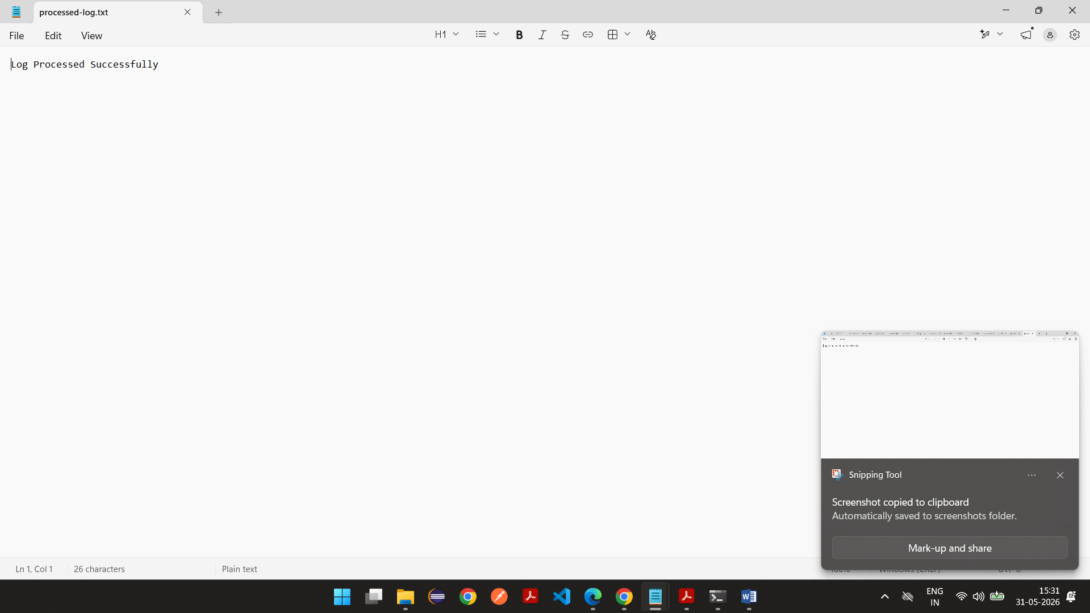

Logs
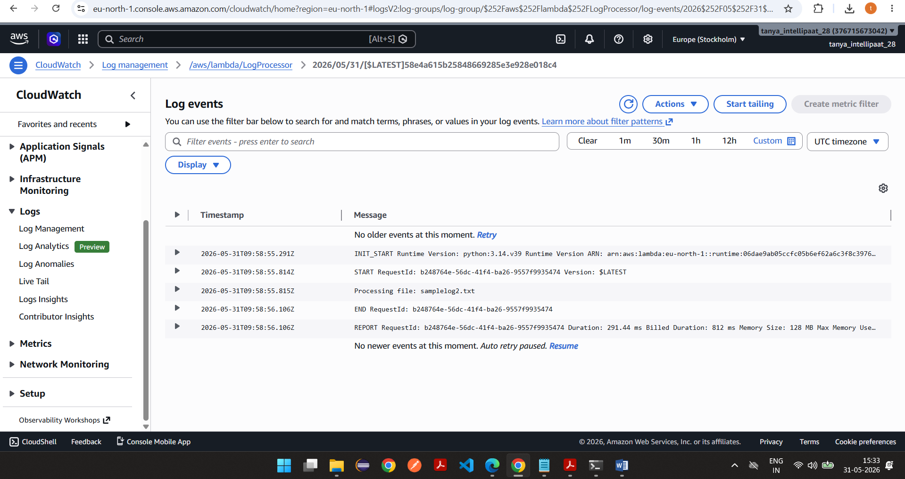

Using Test Event
Created test event with S3 PUT
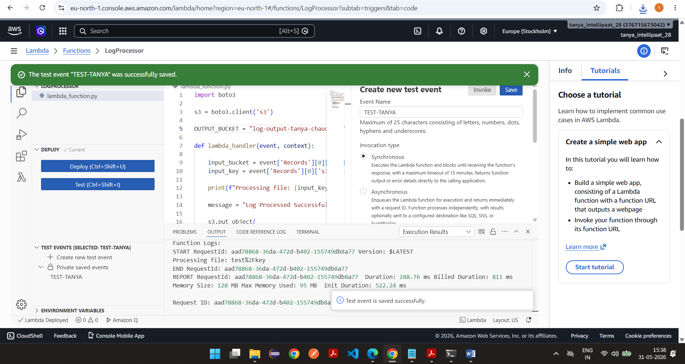

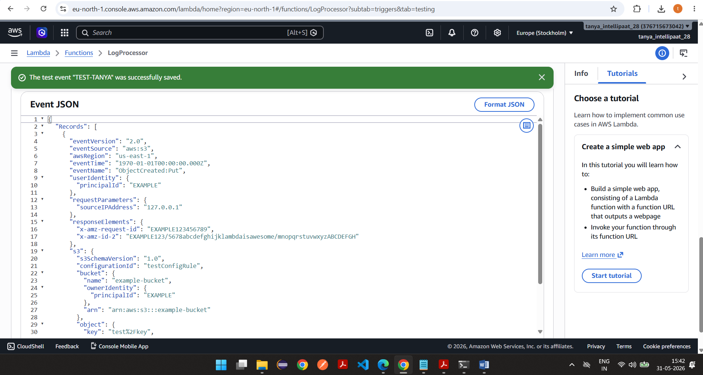

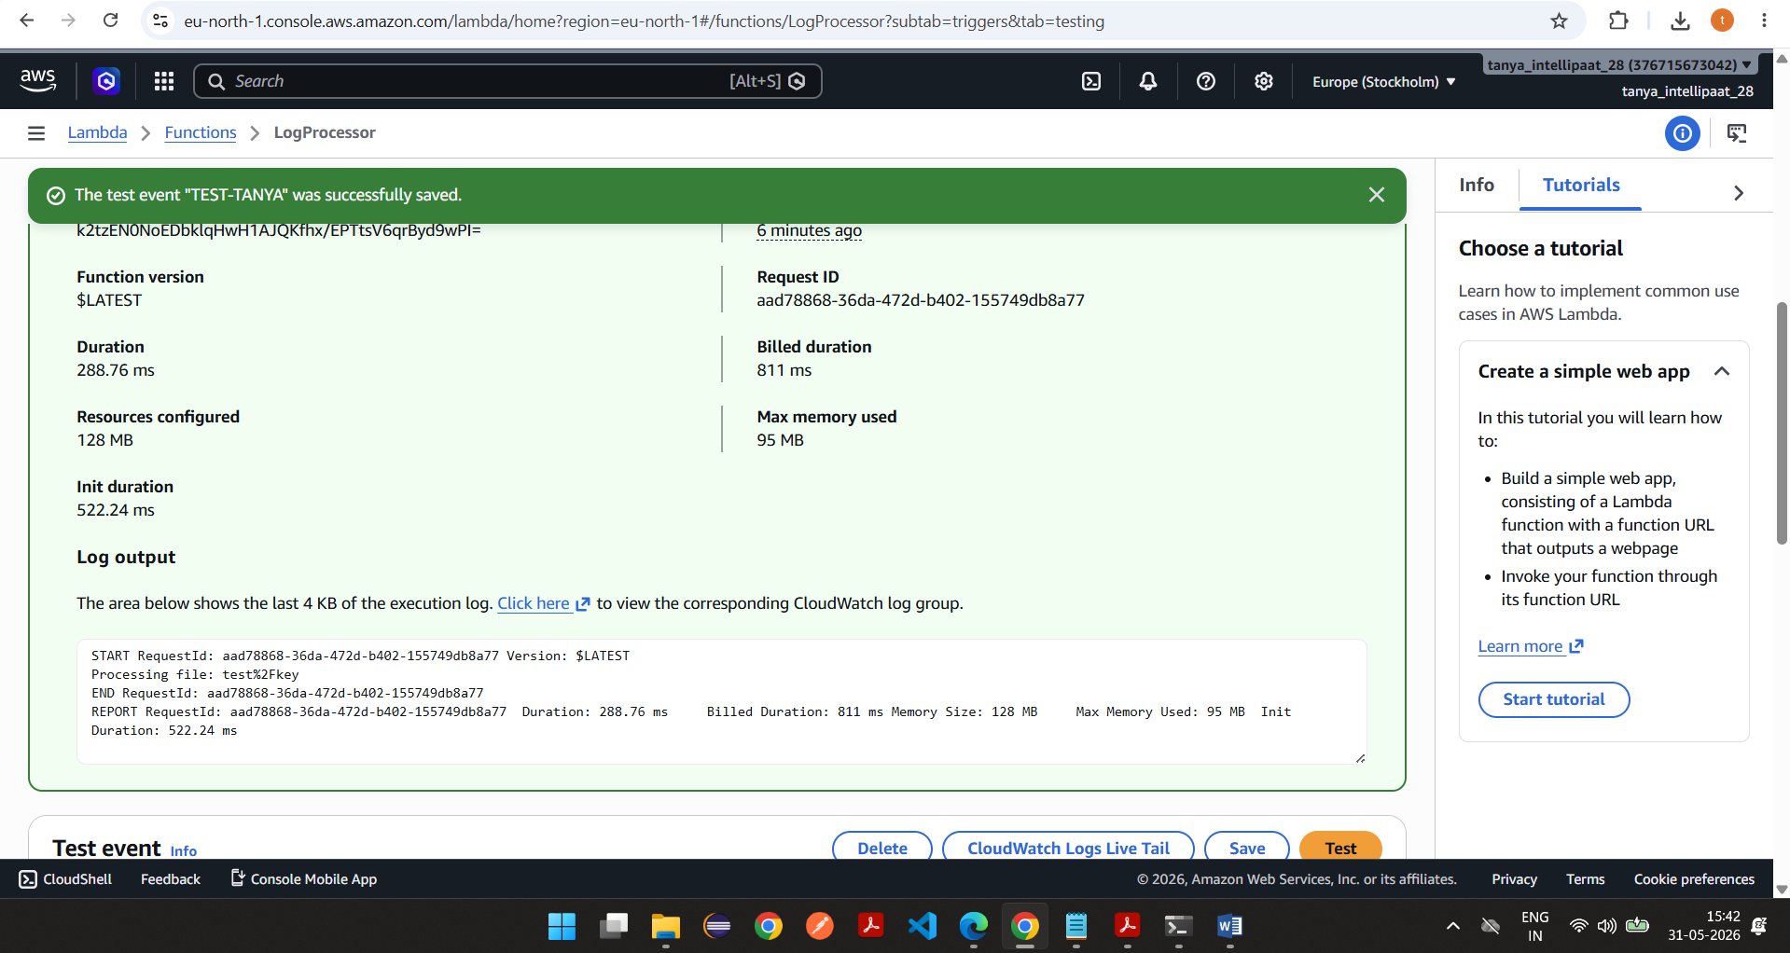

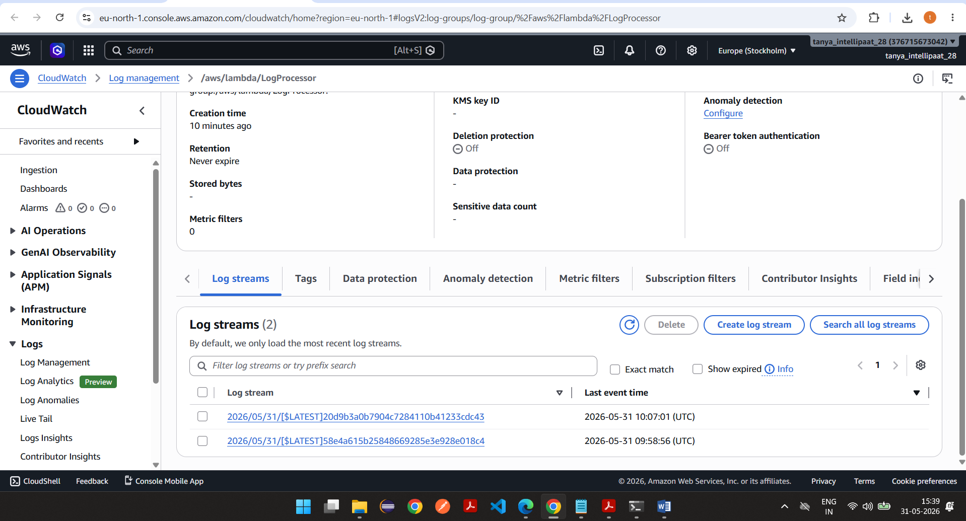

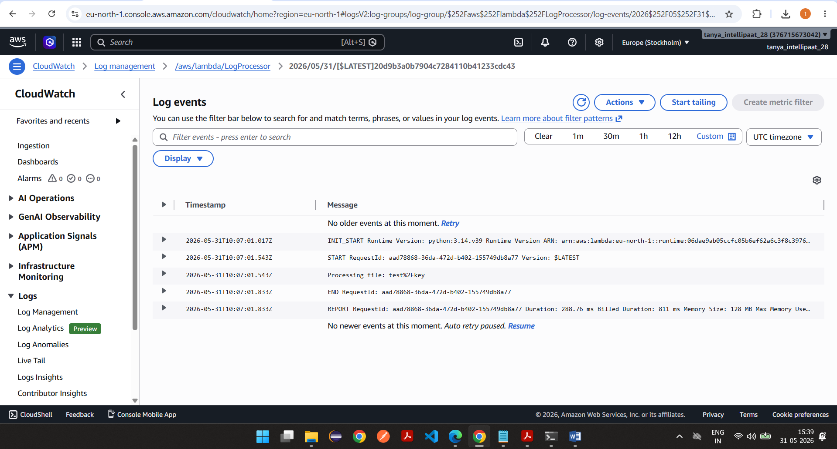

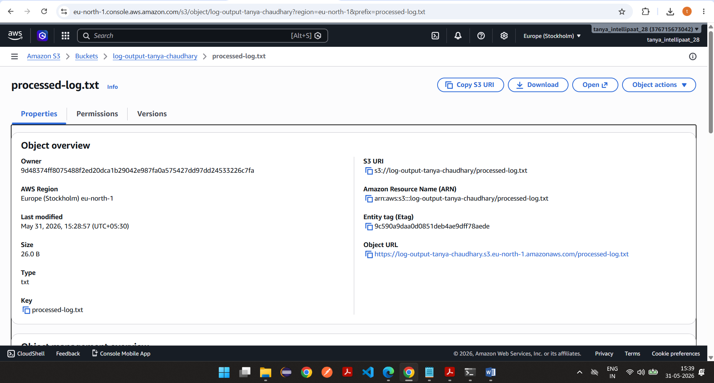

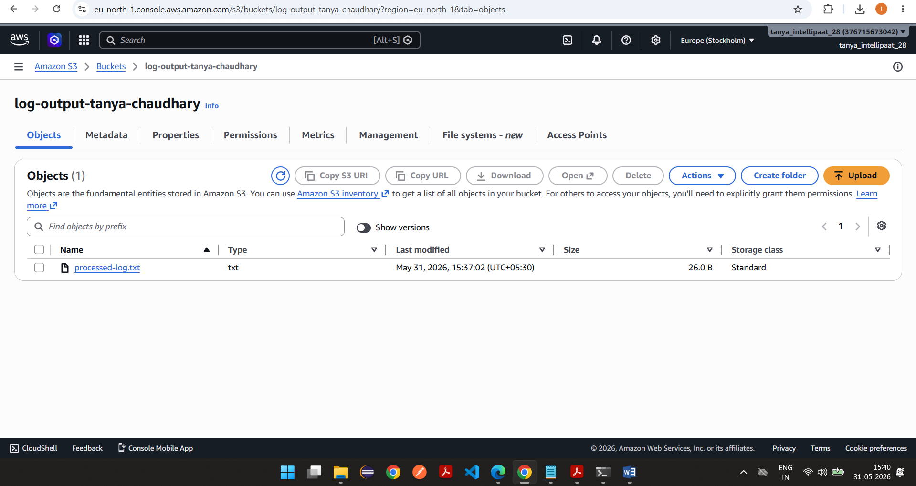

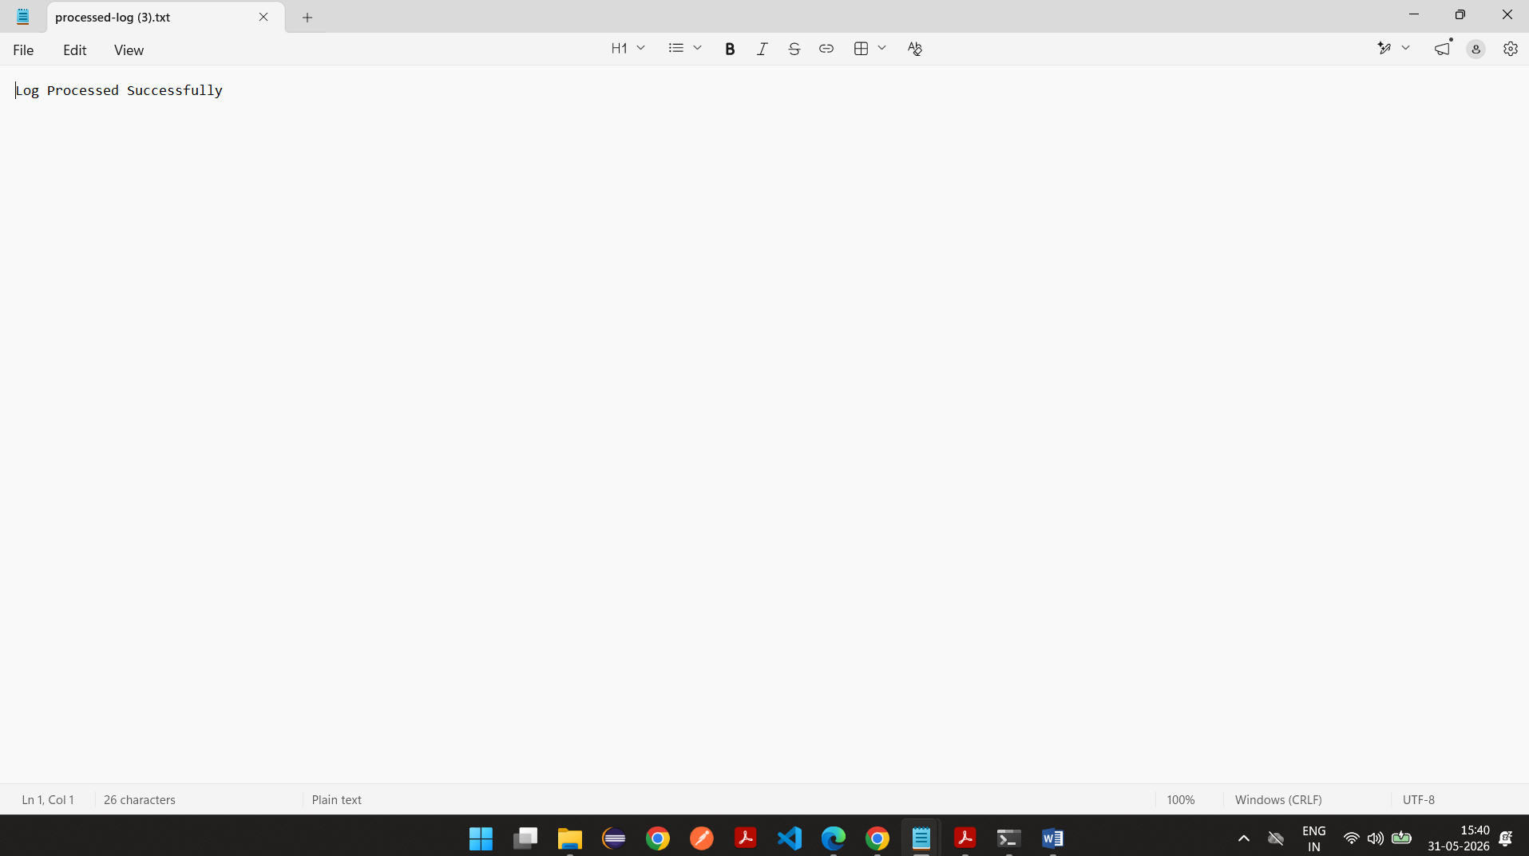

Expected Result:
Input bucket created with versioning enabled
Output bucket created
IAM role LambdaLogRole configured
Lambda function LogProcessor deployed
S3 upload automatically triggers Lambda
Output file created in output bucket
Execution logs visible in CloudWatch Logs
LAMMBDA TEST EVENT ALSO CREATED, CHECKED CLOUD WATCH LOGS AND S3 BUCKET

