Agenda
AWS-DevOps

AWS:
Amazon web service:
It is a cloud platform
-store data
-run app
-host websites
-build servers
-deploy software
-manage databases

DevOps:
DevOps=Development + Operations

Earlier:
-Developers only wrote code
-Operations team handled sever/deployment

Problem:
-deployment were slow
-many bugs
-communication gaps

Devops is a culture+ process+automation +approach
Where:
-Developers
-Tester
-Ops
They all work together

3.DevSecOps:
development+Security+Operations

Security is integrated in every stage
Earlier problem:
Security testing happened only after deployment

Bugs become expensive

DevSecOps Solution:
Security is added:
-during coding
-during build
-during testing
-during deployment

What is AWS DevOps?

Using AWS cloud services to implement
DevOps Practice
Instead of using separate external tools everywhere
Aws,provides its Own devops services

Example:
DevOps activity Aws services
Source code storage CodeCommit
CI/CD pipeline CodePipeline
Build automation CodeBuild
Deployment CodeDeploy
Monitoring Cloud watch
Infrastructure CloudFormation

4.Why companies prefer AWS DevOPs instead of
Standalone DevOps tools:

Traditional standalone devops tools:
Companies use:
- Jenkins
- Github/Gitlab
- Docker
- K8s
- Ansible

But managing all these things can be very difficult

Problems:
-seperate installations
-maintenance overhead
-plugins management
-Security handling
-sever maintenance
-scaling issues

AWS DevOps advantages:

AWS provides managed services
Aws manages infra automatically
We only configure the services acc to our need

Easy example:

Standalone devops:
Like
Buy the things
Utenstils
Gas

Aws Devops:
It is a fully managed system

Benefits of AWS devops:

1.No server maintenance
AWS automatically manages the server

2.Easy scaling
It traffic increase:
AWS automatically scales resources

3.Security:
Aws Provides:
IAM roles
Encryption
Monitoring

4.Faster CI/CD

5.High availability

6.Pay-as-you-go

Real company scenarios:

1.Captial One: Accelerating Infra deployment
2.Etsy:Embracing cd
3.Netflix : Scaling with microservices on AWS
Tool name:chaos monkey
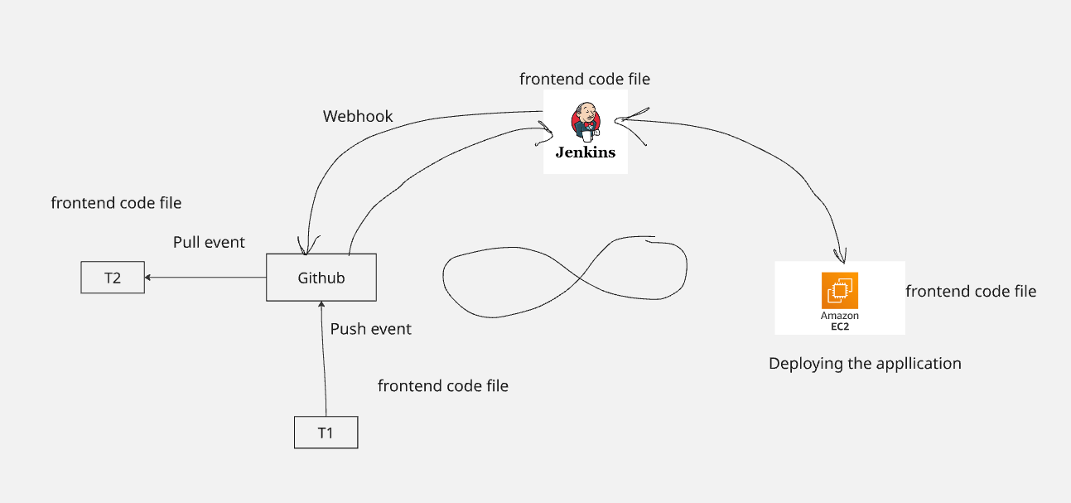

AWS-DevOps Workflow:

Step 1->Developer write the code
Java, nodejs, react, index.html

Step 2-> Push code to CodeCommit

It is a fully managed source control service that allows
team to create their own private git repo
It eliminates the need for self managed git server
We can collaborate with other services

Step 3- CodePipelines
It is a fully managed CI/CD service that automates
The build,test and deployment of applications.
It integrates with diff AWS services:
S3
Codebuild

Step 4- Code Build

It is a fully managed Continuous Integration
Service that complies the source code, runs test,
And deployable artifacts .

Codebuild:
-compile the code
-Install dependencies
-run tests
-create artifacts

Artifacts:
Final outputs/generated files after build process

Example
Suppose:
Source code- raw ingredients
Index.html, style.css,node.js,python->raw source code

After build:
You get:
.jar file
.war file
.zip package

Artifacts are stored where?
S3 bucket where you store the artifacts

Buildspec.yml: during our code build
This file tells CodeBuild:
“What steps should I perform during the build?”

Version:02
Phases:
Install:
Commands:
-npm install
Build:
Commands:
-npm run build

Step 5: Aws CodeDeploy:
Aws CodeDeploy is a fully managed Deployment
Service that automates software deployment
To various env
-AWS Ec2
-AWS lambda
-on-permises servers

What codeDeploy actually does:
-Copies artifacts from S3 bucket
-install files
-run scripts
-restart services
-manages deployment lifecycle

Appspec.yml file:

This file is used by code deploy
Purpose:
It tells CodeDeploy that:
-where to copy the files
-what scripts i have to run
-on what web server i have to host the application

Version: 0.0
Os:linux

Files:
-source:
Destination

Hooks

Buildspec.yml appspec.yml
Used by code build used by code deploy
Defines build commands defines deployment steps
Create artifacts deploys artifacts
Handles compiles/test/ handles install/start/step
Packages

Step 6: Monitoring Tools in AWS DevOps:
1.Cloudwatch
2.CloudTrail
3.AWS X-Ray
4.SNS

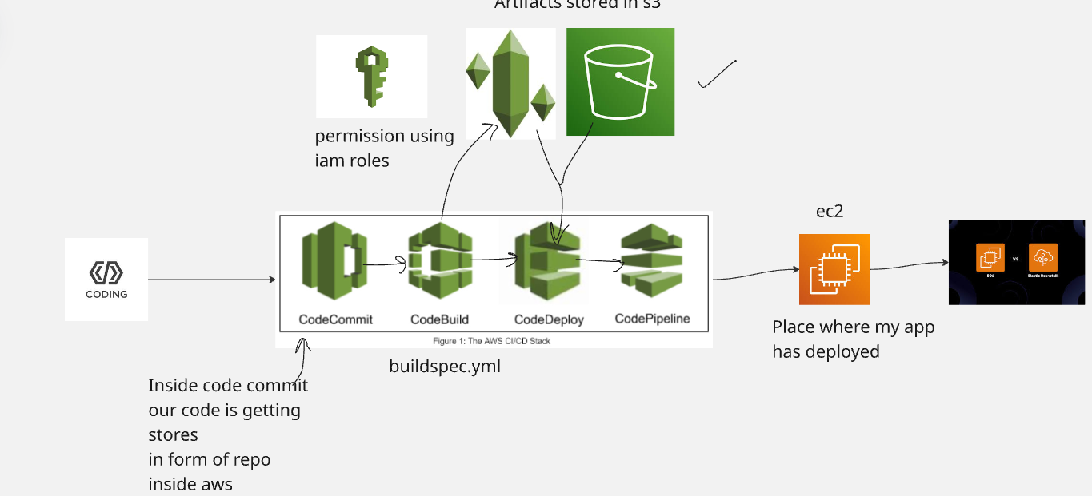

Day 2:
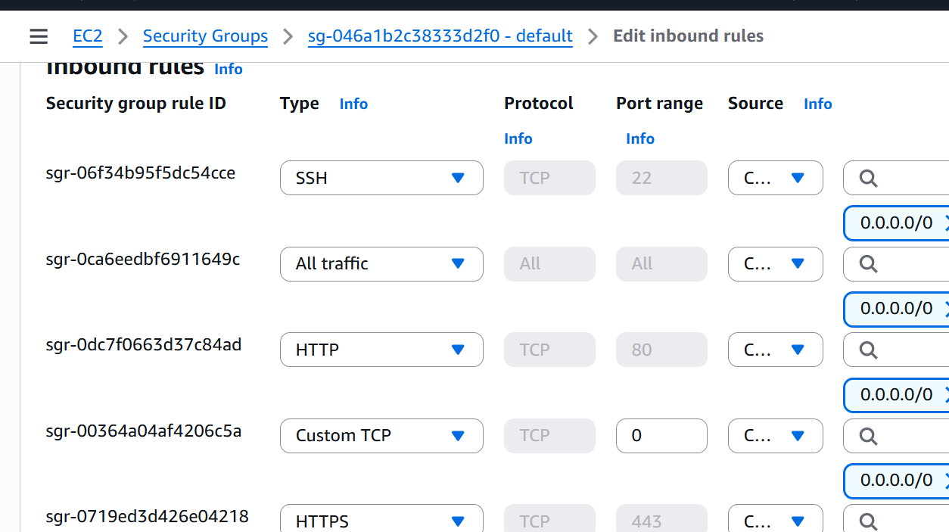

1.index.html-> html and css
2.buildspec.yml-> code build
Artifacts- .zip, .tar->s3
3.appspec.yml-> code deploy
4.mkdir script
2 files
Install_nginx.sh
start_nginx.sh

#html code
<!DOCTYPE html>
<html lang="en">
<head>
<meta charset="UTF-8">
<meta name="viewport" content="width=device-width, initial-scale=1.0">
<title>Simple Website</title>

<style>

*{
margin:0;
padding:0;
box-sizing:border-box;
font-family:Arial, sans-serif;
}

body{
background-color:#f4f4f4;
color:#333;
}

/* Navbar */

nav{
display:flex;
justify-content:space-between;
align-items:center;
padding:20px 50px;
background-color:#0d6efd;
}

.logo{
color:white;
font-size:28px;
font-weight:bold;
}

.nav-links{
list-style:none;
display:flex;
}

.nav-links li{
margin-left:20px;
}

.nav-links a{
text-decoration:none;
color:white;
font-size:18px;
transition:0.3s;
}

.nav-links a:hover{
color:yellow;
}

/* Hero Section */

.hero{
height:90vh;
display:flex;
justify-content:center;
align-items:center;
text-align:center;
color:white;

background:
linear-gradient(rgba(0,0,0,0.5), rgba(0,0,0,0.5)),
url('https://images.unsplash.com/photo-1498050108023-c5249f4df085?q=80&w=1200&auto=format&fit=crop');

background-size:cover;
background-position:center;
}

.hero-content h1{
font-size:55px;
margin-bottom:20px;
}

.hero-content p{
font-size:22px;
margin-bottom:25px;
}

.hero-content button{
padding:12px 25px;
border:none;
background-color:#0d6efd;
color:white;
font-size:18px;
border-radius:5px;
cursor:pointer;
transition:0.3s;
}

.hero-content button:hover{
background-color:#084298;
}

/* About Section */

.about{
padding:60px 20px;
text-align:center;
background:white;
}

.about h2{
font-size:38px;
margin-bottom:20px;
}

.about p{
max-width:700px;
margin:auto;
line-height:1.8;
font-size:18px;
}

/* Services */

.services{
padding:60px 20px;
text-align:center;
}

.services h2{
font-size:38px;
margin-bottom:40px;
}

.service-container{
display:flex;
justify-content:center;
gap:20px;
flex-wrap:wrap;
}

.service-box{
background:white;
width:300px;
padding:30px;
border-radius:10px;
box-shadow:0 4px 10px rgba(0,0,0,0.1);
transition:0.3s;
}

.service-box:hover{
transform:translateY(-10px);
}

.service-box h3{
margin-bottom:15px;
color:#0d6efd;
}

/* Footer */

footer{
background:#0d6efd;
color:white;
text-align:center;
padding:20px;
}

/* Responsive */

@media(max-width:768px){

nav{
flex-direction:column;
}

.nav-links{
margin-top:15px;
}

.hero-content h1{
font-size:40px;
}

.hero-content p{
font-size:18px;
}

}

</style>
</head>

<body>

<!-- Navbar -->

<nav>

<div class="logo">MyWebsite</div>

<ul class="nav-links">
<li><a href="#">Home</a></li>
<li><a href="#">About</a></li>
<li><a href="#">Services</a></li>
<li><a href="#">Contact</a></li>
</ul>

</nav>

<!-- Hero Section -->

<section class="hero">

<div class="hero-content">
<h1>Welcome to My Website</h1>

<p>
Create beautiful and responsive websites using HTML and CSS.
</p>

<button>Get Started</button>
</div>

</section>

<!-- About -->

<section class="about">

<h2>About Us</h2>

<p>
This is a simple responsive website created using HTML and CSS in a single file.
You can customize colors, text, images, and sections according to your project.
</p>

</section>

<!-- Services -->

<section class="services">

<h2>Our Services</h2>

<div class="service-container">

<div class="service-box">
<h3>Web Design</h3>
<p>Modern responsive web designs for businesses and portfolios.</p>
</div>

<div class="service-box">
<h3>Development</h3>
<p>Fast and optimized website development services.</p>
</div>

<div class="service-box">
<h3>Support</h3>
<p>24/7 support and maintenance for your website.</p>
</div>

</div>

</section>

<!-- Footer -->

<footer>
<p>© 2026 MyWebsite | All Rights Reserved</p>
</footer>

</body>
</html>

#buildspec.yml file
version: 0.2

phases:
install:
commands:
- echo "Install phase"

pre_build:
commands:
- echo "Pre-build phase"
- ls -la

build:
commands:
- echo "Build phase started"
- mkdir -p build
- cp index.html build/
- chmod +x script/*.sh

post_build:
commands:
- echo "Build completed"
- ls -R

artifacts:
files:
- appspec.yml
- script/**/*
- build/**/*

#appspec.yml

version: 0.0
os: linux

files:
- source: /
destination: /var/www/html

file_exists_behavior: OVERWRITE

permissions:
- object: /var/www/html
pattern: "**"
owner: www-data
group: www-data
mode: 755
type:
- file
- directory

hooks:
BeforeInstall:
- location: script/install_nginx.sh
timeout: 300
runas: root

ApplicationStart:
- location: script/start_nginx.sh
timeout: 300
runas: root

# install_nginx.sh

#!/bin/bash

set -e

echo "Updating packages..."

apt-get update -y

echo "Installing nginx..."

apt-get install -y nginx

echo "Nginx installation completed"

#start_nginx.sh

#!/bin/bash

set -e

echo "Starting nginx..."

systemctl start nginx

echo "Enabling nginx..."

systemctl enable nginx

echo "Nginx started successfully"

Role for ec2 deploy instance
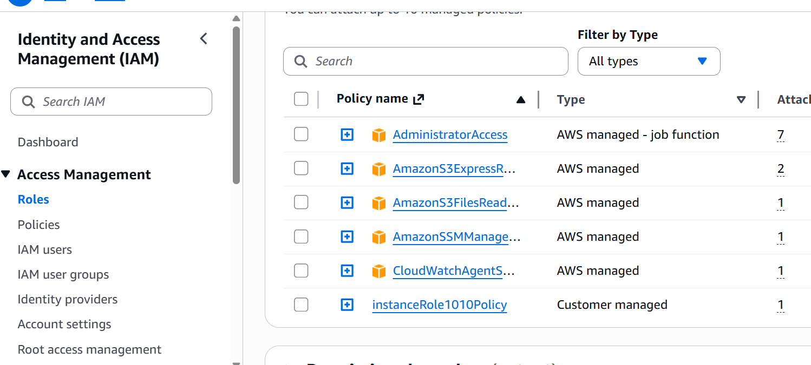

Command for code-deploy agent

#!/bin/bash
set -e

echo "===== Updating system ====="
sudo apt update -y
sudo apt upgrade -y

echo "===== Installing required packages ====="
sudo apt install -y ruby wget curl

echo "===== Moving to ubuntu home directory ====="
cd /home/ubuntu

echo "===== Downloading CodeDeploy agent installer (us-east-1) ====="
wget https://aws-codedeploy-us-east-1.s3.us-east-1.amazonaws.com/latest/install

echo "===== Making installer executable ====="
chmod +x ./install

echo "===== Installing CodeDeploy agent ====="
sudo ./install auto

echo "===== Enabling CodeDeploy agent ====="
sudo systemctl enable codedeploy-agent

echo "===== Starting CodeDeploy agent ====="
sudo systemctl start codedeploy-agent

echo "===== Verifying CodeDeploy agent status ====="
sudo systemctl status codedeploy-agent --no-pager

echo "===== CodeDeploy agent installation completed successfully ====="

