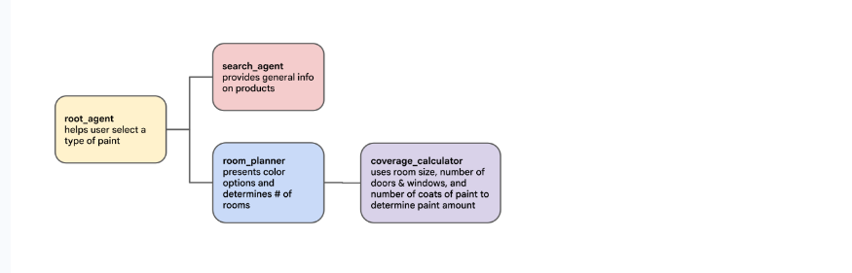

Task 1. Create an Agent Search app for paint product info
In this task, you will deploy an Agent Search data store. This data store will import a datasheet describing Cymbal Shops' paint (which you can preview in a tab in your Incognito window at https://storage.cloud.google.com/qwiklabs-gcp-01-07da7a7fcef4-bucket/Cymbal_Shops_Paint_Datasheets.pdf. This datasheet will serve as the grounding data source for user queries about your paints.
A data store and search app allow your agent to quickly find your organization's content. It can then use that information to provide an appropriate response to the user based on your data.
- In the Google Cloud Console, navigate to Agent Platform > Agents > Search.
- Create an Agent search app with the following configuration:
Field | Value
App type | Custom search (general)
App name | Paint Search
Company name | Cymbal Shops
Location | global
- Create an Agent Search data store with the following configuration:
Field | Value
Data source | Cloud Storage
Data type | Documents
Folder or File | File
File to import | qwiklabs-gcp-01-07da7a7fcef4-bucket/Cymbal_Shops_Paint_Datasheets.pdf
Location | global
Data store name | Cymbal Paint
Document parser | Layout Parser
Enable table annotation | Enabled
Include ancestor headings in chunks | Enabled
- Select the Pricing Model as General for both the App and Data store.

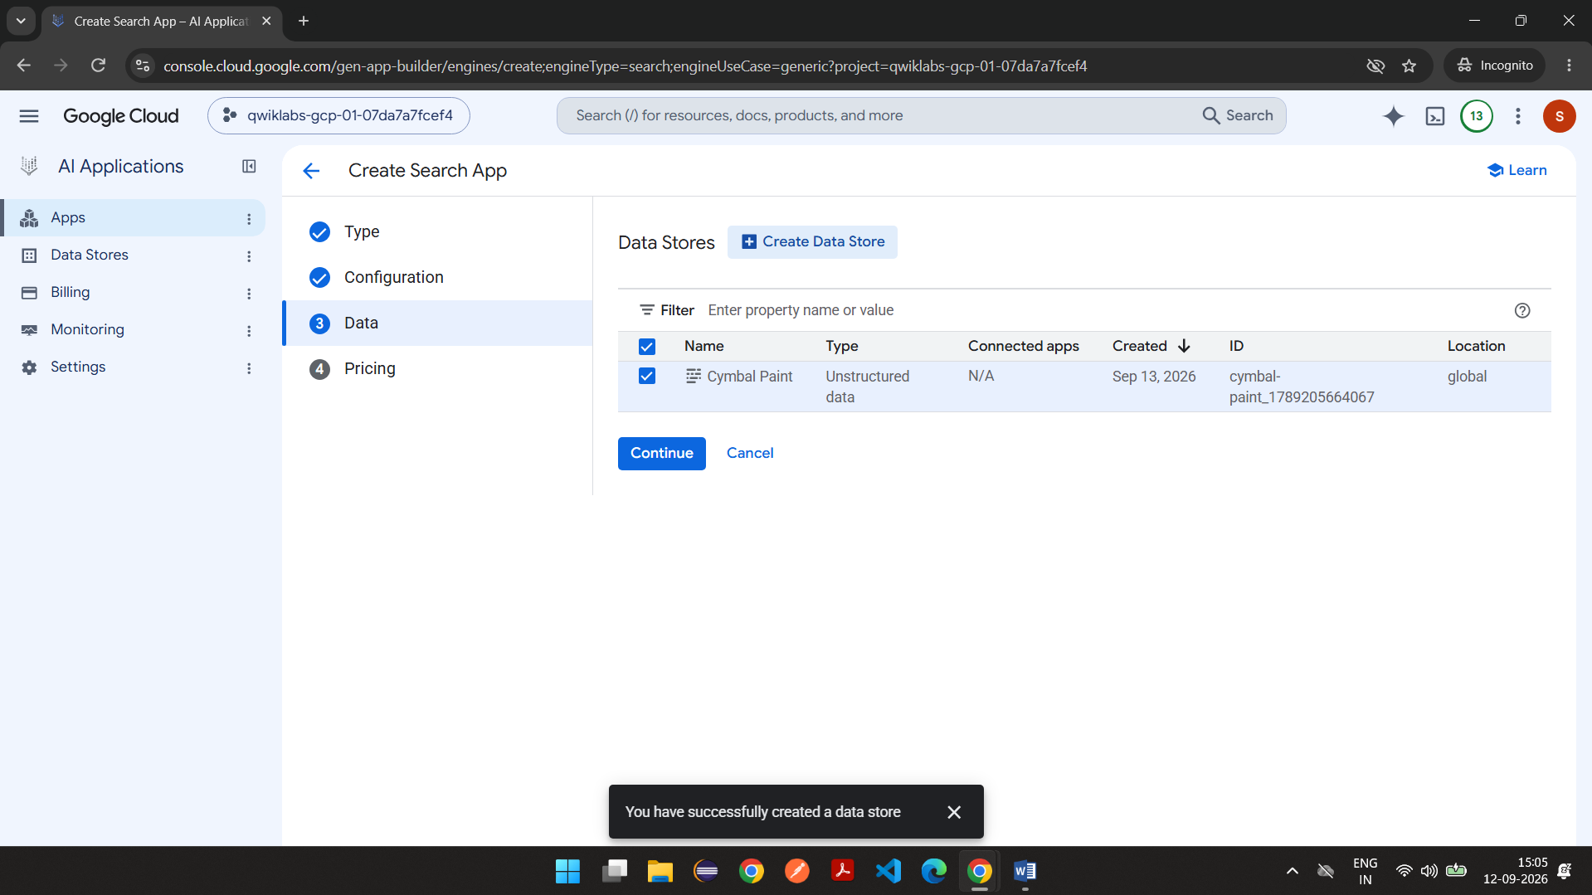

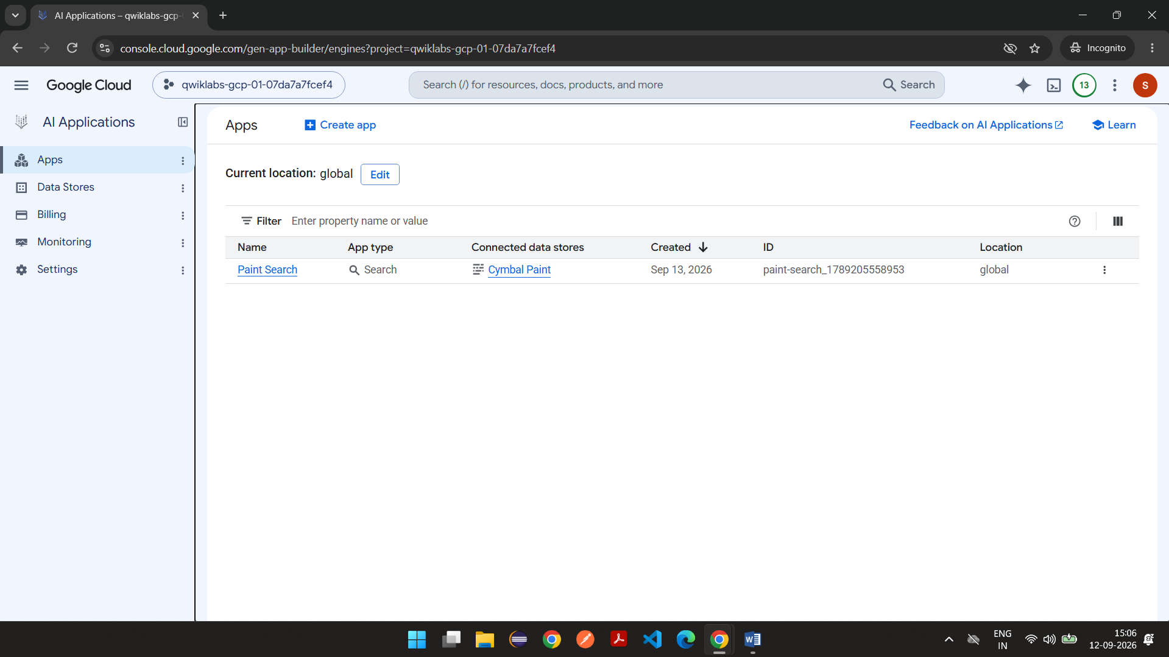

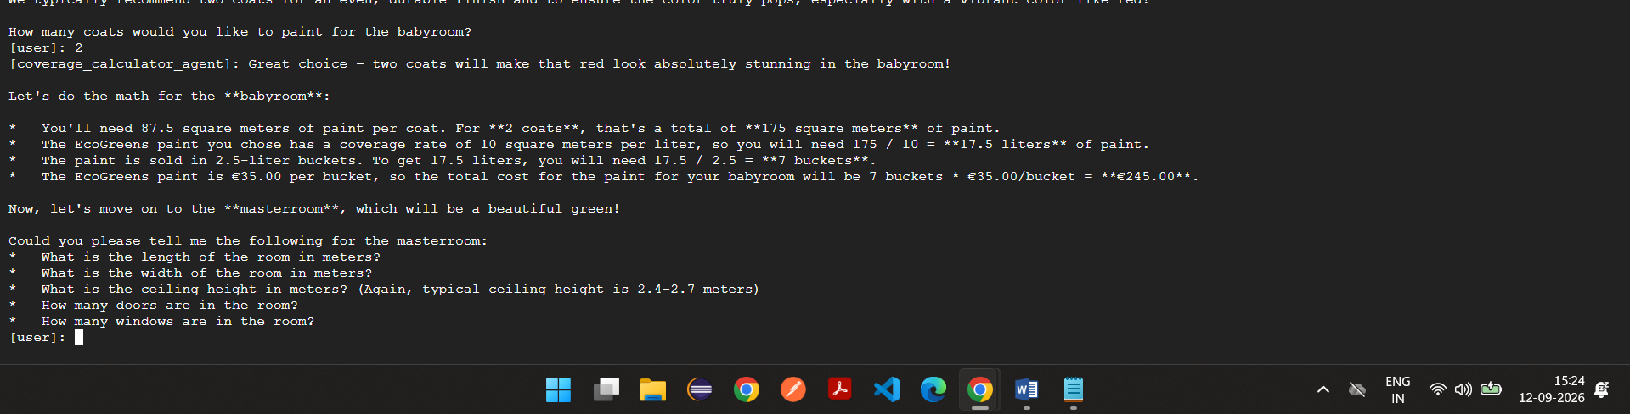

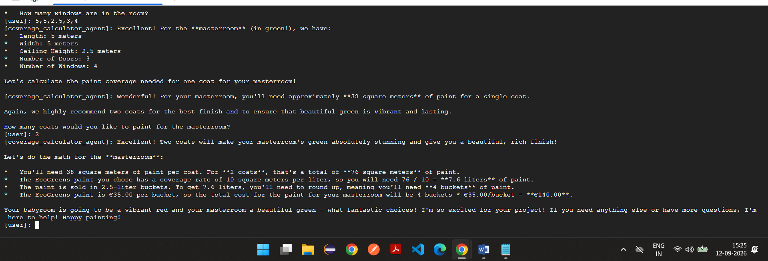

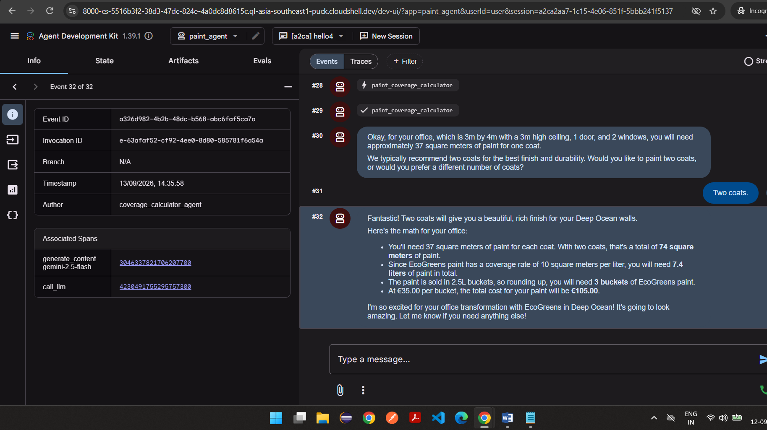

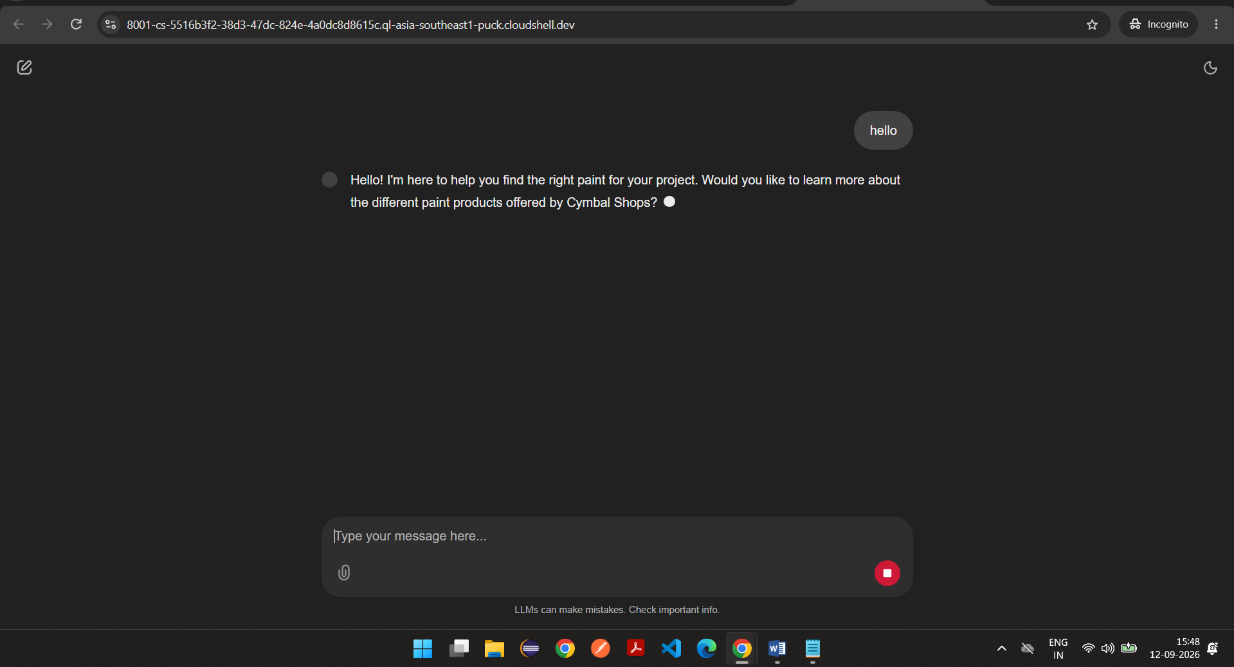

Agents.py
# Copyright 2025 Google LLC
#
# Licensed under the Apache License, Version 2.0 (the "License");
# you may not use this file except in compliance with the License.
# You may obtain a copy of the License at
#
# http://www.apache.org/licenses/LICENSE-2.0
#
# Unless required by applicable law or agreed to in writing, software
# distributed under the License is distributed on an "AS IS" BASIS,
# WITHOUT WARRANTIES OR CONDITIONS OF ANY KIND, either express or implied.
# See the License for the specific language governing permissions and
# limitations under the License.

from dotenv import load_dotenv
import google.auth
from google.adk.agents import Agent
from google.adk.tools import AgentTool
from google.adk.models import Gemini
from google.genai import types
import google.cloud.logging
import os

from .callback_logging import log_query_to_model, log_model_response

from .sub_agents.room_planner.agent import room_planner_agent
from .sub_agents.search_agent.agent import search_agent

from .tools import set_session_value

# Load env
load_dotenv()

RETRY_OPTIONS = types.HttpRetryOptions(initial_delay=1, max_delay=3, attempts=30)

# Configure logging to the Cloud
cloud_logging_client = google.cloud.logging.Client()
cloud_logging_client.setup_logging()

root_agent = Agent(
name="paint_agent",
model=Gemini(model=os.getenv("MODEL"), retry_options=RETRY_OPTIONS),
instruction="""
You represent the paint department of Cymbal Shops.

Information about Cymbal Shops paint, including prices, is available to you
through the 'search_agent' tool.

- At the start of a conversation, let the user know you're here to
help them find the right paint for their project. Ask them if they'd
like to learn more about the different paint products offered by
Cymbal Shops.
- If they say yes, include information about all paint products including
coverage rate and price.
- If price and coverage rate aren't returned for some products, look them
up individually.
- After they have selected a paint product, use your set_session_value tool
to store their selection in the session dictionary with the key
'SELECTED_PAINT', its coverage rate in 'COVERAGE_RATE', and its price
per 2.5L container in 'PRICE'.
- Transfer to the 'room_planner_agent'
""",
before_model_callback=log_query_to_model,
after_model_callback=log_model_response,
sub_agents=[room_planner_agent],
tools=[
set_session_value,
AgentTool(
agent=search_agent,
skip_summarization=False,
),
],
)

Tools.py
from dotenv import load_dotenv
import os
from google.adk.tools import ToolContext

load_dotenv()

async def set_session_value(tool_context: ToolContext, key: str, value: str):
"""Sets a value in the tool_context's state dictionary."""

tool_context.state[key] = value

return {"status": f"stored '{value}' in '{key}'"}

searchagent.py
import os
from dotenv import load_dotenv

from google.adk.agents import Agent
from google.adk.models import Gemini
from google.adk.tools import VertexAiSearchTool, ToolContext
from google.genai import types

load_dotenv()

RETRY_OPTIONS = types.HttpRetryOptions(initial_delay=1, max_delay=3, attempts=30)

SEARCH_ENGINE_PATH = f"projects/{os.getenv('GOOGLE_CLOUD_PROJECT')}/locations/global/collections/default_collection/engines/{os.getenv('SEARCH_ENGINE_ID')}"
paint_search_tool = VertexAiSearchTool(search_engine_id=SEARCH_ENGINE_PATH)

search_agent = Agent(
name="search_agent",
model=Gemini(model=os.getenv("MODEL"), retry_options=RETRY_OPTIONS),
instruction="""
If the user asked for specific paints, look up information on requested paints.
Otherwise, provide the user information about all Cymbal Shops paints, including price
and coverage rate.
""",
tools=[paint_search_tool],
)

Roomplanner.py
import os
from dotenv import load_dotenv
from google.adk.agents import Agent
from google.adk.models import Gemini
from google.genai import types
from .sub_agents.coverage_calculator.agent import coverage_calculator_agent

load_dotenv()

RETRY_OPTIONS = types.HttpRetryOptions(initial_delay=1, max_delay=3, attempts=30)

room_planner_agent = Agent(
name="room_planner_agent",
model=Gemini(model=os.getenv("MODEL"), retry_options=RETRY_OPTIONS),
description="""
after paint product is selected, determine how many rooms and
present color options.""",
instruction=f"""
- Find out how many rooms the user would like to paint and what we should call each room.
- Based on the {{SELECTED_PAINT?}}, show the corresponding images
in an img tag with a height attribute of 300px:
- Project Paint: https://storage.cloud.google.com/{os.getenv("RESOURCES_BUCKET")}/project_paint.png
- SureCoverage: https://storage.cloud.google.com/{os.getenv("RESOURCES_BUCKET")}/surecoverage.png
- EcoGreen: https://storage.cloud.google.com/{os.getenv("RESOURCES_BUCKET")}/ecogreens.png
- Forever Paint: https://storage.cloud.google.com/{os.getenv("RESOURCES_BUCKET")}/forever_paint.png
- Have them pick a color for each room.
- To calculate the paint needed for each room, transfer to the 'coverage_calculator_agent'
""",
sub_agents=[coverage_calculator_agent],
)

Coverage calculator.py
import os
from dotenv import load_dotenv
from google.adk.agents import Agent
from google.adk.models import Gemini
from google.genai import types
from .tools import paint_coverage_calculator
from .....callback_logging import log_query_to_model, log_model_response

load_dotenv()

RETRY_OPTIONS = types.HttpRetryOptions(initial_delay=1, max_delay=3, attempts=30)

coverage_calculator_agent = Agent(
name="coverage_calculator_agent",
model=Gemini(model=os.getenv("MODEL"), retry_options=RETRY_OPTIONS),
instruction="""
- Ask the user for the following for each room:
- The room length and width
- The room height (a typical ceiling height is 2,4-2,7M)
- The number of doors and windows
- Use the 'paint_coverage_calculator' to estimate the amount of
coverage they will need for each coat. Let them know that two
coats are recommended and ask them to confirm the number of
coats they'd like to paint. Store their result as 'coats'
(default to 2 if they respond with something like 'yes').
- Talk them through the following math for each room:
- The square meters of paint they need multiplied by
the number of coats
- The coverage rate of the paint they have chosen is {COVERAGE_RATE?},
so they will need X liters.
- The paint is sold in 2,5L buckets, so rounding up they will
need Y buckets.
- The price is {PRICE?} per bucket, so the total cost is:
[provide total cost].
- Express enthusiasm for their project and the color they chose.
Let them know you are there if they need anything else.
""",
before_model_callback=log_query_to_model,
after_model_callback=log_model_response,
tools=[paint_coverage_calculator],
)

Paint coverage calculator as tools.py
async def paint_coverage_calculator(
ceiling_height_in_m: float,
room_length_in_m: float,
room_width_in_m: float,
num_windows: int,
num_doors: int,
):
"""Calculates the square-meters of paint required for the walls of a room.

Args:
ceiling_height_in_m: float - ceiling height in meters
room_length_in_m: float - Room length in meters
room_width_in_m: float - Room width in meters
num_windows: int - Number of windows
num_doors: int - Number of doors

Returns a dictionary with:
{"square_meters": float - Square meters of paint required}
"""

sq_meters = (
(((2 * room_length_in_m) + (2 * room_width_in_m)) * ceiling_height_in_m)
- (1.5 * num_windows)
- (2 * num_doors)
)
return {"square_meters": sq_meters}

